

SunPlus Start-Up Manual

Version 6.3

Table of Contents
Data Preparation 8
GDCOA Preparation 8
Static Data Preparation 10
Creditor Records 10
Employee Records 11
Analysis Codes Other Than WHO 13
Financial Data Preparation 20
Budget 20
Payroll 21
Trial Balance 21
Beginning Balances 22
Fixed Assets 24
Upload Procedure 25
1. Create New Business Unit 31
2. Copy A0A to New Business Unit 36
3. Put Business Unit Online 40
4. Localize Business Unit Settings 41
5. Change Business Unit 46
6. Run Report Model – RMD 46
7. Name Business Unit 46
8. Amend Ledger Setup 47
9. Create Site’s Basic Address Codes 50
10. Create Currency Codes 53
11. Period Currency Rates Setup <CNP> 54
12. Daily Currency Rates Setup 55
13. Define Asset Depreciation Timing Rule (as needed) 56
14. Create Payment Terms (as needed) 57
15. Create/Amend Budget Labels 59
16. Setup/Amend Analysis Dimensions (as needed) 60
17. Amend Analysis Structure Setup (as needed) 61
18. Voucher Number Stream Setup <VNS> 62
19. Transaction Reference Format <TRS> 64
20. Journal Class Setup 65
21. Journal Types 66
22. Check Journal Classes in Ledger Setup 67
23. Create Users 67
24. Assign User Groups 69
25. Upload Chart of Accounts 72
26. Upload Analysis Codes 81
27. Upload Addresses 85
28. Upload Fixed Assets 88
29. Upload Beginning Balances 92
30. Upload Budget 97
31. Upload Asset Values 100
End User Training 101
Post-Implementation Checklist 103
System Design 103
System Setup 103
Fixed Assets 104
End-users’ Training 104
Payroll 104
Routine SunPlus Tasks 105
Starting and Ending SunSystems Session 105
Logging In To SunSystems 105
Authentication Methods 105
Logging Out of SunSystems 105
Main SunSystems Menu Screen 106
Change / Open Period 111
Change Period 112
Ledger Setup 112
Change Business Unit 113
Change Password 113
Change Ledger 113
Operator 114
Filing Reference 114
Filing In SunSystems Forms 114
Data Entry 116
Ledger Entry 116
Other Data Entry Processes 119
Copy a Journal 119
Reverse a Journal 125
Held Journals 127
Retrieve Held Journals 130
Printing Held Journals 132
Void Journal 134
Static Data Creation / Maintenance 137
Natural Accounts Setup 137
Printing Chart of Accounts 141
Change Account Status 141
Supplier Setup 142
Contact Setup 149
Analysis Code Setup 151
Address Setup 153
Linking Ordering Address to a Supplier 155
Currency Maintenance 156
Currency Code Setup 156
Daily Conversion Rates 157
Period Conversion Rates 158
Inquiries 160
Account Inquiry 160
Account Balance Inquiry 164
Budget Check Inquiry 166
Ledger Inquiry – Archive 166
Ledger Inquiry 168
Journal Inquiry 169
Account Allocation 171
Journal Types 176
Journal Presets Setup 183
Fixed Assets 189
Asset Class 189
Asset Records 191
Asset Analysis Posting Presets 192
Asset Notes 193
Asset Budgets 196
Asset Inquiry 197
Fixed Asset Entries 198
Fixed Asset Purchase Entry 198
Fixed Asset Appreciation Entry 199
Fixed Asset Depreciation Entry 200
Fixed Asset Disposal Entry 200
Depreciation Calculation 201
Fixed Asset Disposal 205
Processes 210
Accounts Payable Process 210
Produce and Review List of Invoices Due for Payment 210
Process Manual Checks 211
Withhold and/or Force Payments 211
Payment Run 212
Print Remittances/Checks 212
Void/Cancel Checks After Payment Run 213
Print Payment Listing 213
Payments to One-Off Suppliers 213
Prevent Payments Being Made 214
Prevent a Payment Account From Being Overdrawn 214
Accounts Receivable Process 214
Customer Setup 214
Chart of Accounts – Receivable Accounts 220
Analyzing Customers, Accounts, and Transactions 220
Managing Disputes with Clients 220
Recording Transactions 221
Matching Transactions 221
Inquiring on Receivables 221
Receivables Reports 221
Payment Collection Run 221
Reconciliations 228
Reconciliation Steps 228
Reports 235
Report Parameters 235
Action Menu 235
Report Manager 238
Monthly SunPlus Tasks 243
Change Period 243
Change Period 243
Ledger Setup 243
Open Dates 244
Post Exchange Rates 244
Currency Period Rates 245
Ledger Revaluation (Multi-Currency sites only) 246
Ledger Revaluation Profiles 246
Ledger Revaluation 250
Ledger Cleardown 252
Running Ledger Cleardown 252
Function Funding 254
Works in Progress 254
Year-End Tasks 255
Security 256
Menu Groups 256
Add Function to Menu 256
New User 258
Set Up New System User 258
Unlock Locked Out User 261
Operator Activity 262
Setup for Report Corrections 264
Special Processes 264
Additional Fields Setup 264
Reset Default Forms 265
Setup for Special, Rarely Used, Processes 267
Configuring SunSystems to do Authorizations 267
Accounts Payable Setup 273
Payment Profiles 273
Payment Terms Setup 277
Link Payment Terms to Journal Transactions 279
Ignore Payment Terms on Journal Type 280
Bank Details Setup 280
Document Format Setup 282
Form Designer 289
Filter Designer 301
Create New Filter Process 301
Create Filter From Existing Filter 308
Business Rules 314
Setup Business Rules 314
SunSystems Features Available, But Rarely Used in SunPlus World 327
Standard Text 327

Pre-Implementation – Application

When you are contacted about an implementation, collect the following data:
- Organization’s Name
- Business Unit Type
  - ADV = Tithe-based
  - EDU = Education
  - MED = Medical
  - PUB = Publishing
- Currency Platform
  - Single Currency (get the Currency Code)
  - Multi-Currency (get the Base Currency Code and all other currency codes)
- Fiscal Year
  - January 1 – December 31
  - April 1 – March 31
  - July 1 – June 30
  - October 1 – September 30
- Check Processing
  - Manual
  - Automation Required
  - Print their own check
  - Print Bank-supplied checks
  - How many banks write system checks?
- Payroll Information
  - Will the site continue to use their current Payroll software?
  - Does the site need automatic Payroll data conversion?
  - Is the site currently using MS Excel for Payroll?
  - Will the site use Q&A XL and the SunPlus Payroll Upload template?
  - Will the site use APS?
- Users’ Information
  - SunSystems – number of users
  - Q&A – number of users
- Fund Accounting Structure
  - Separate Operating (10) and Property (20) funds
  - Combined Operating and Property Funds (10 & 20)
  - Other funds required
- Beginning Balances
  - To be uploaded during Implementation
  - To be uploaded later
  - To be uploaded by SASC (need Trial Balance)
  - Detail transactions to be imported
- Fixed Assets
  - Currently in balance
  - Currently out of balance
  - To be uploaded during implementation
  - To be uploaded by SASC
  - To be uploaded later
- Accounts Payable Process
  - Implement complete Payable Module
  - Pay via Invoice / Demand Check
- Dimensions to be used
  - RSCE
  - TFWW
  - FUND
  - FNCT
  - RSTR
  - ORGIS
  - WHO
  - FLAG
  - PROJ
  - DTLS
  - Other:
- Report Requirements
  - SDAAM Standard Financial Statements
  - Local Requirements
- Languages
- Business Rules
  - Follow Core rules
  - Any special rules required?
- Journal Types & Presets
  - Any special Journal Types required?
- Reconciliations
  - Manual on paper or Excel?
  - Manual through Account Allocations
  - Automated Bank Reconciliations
- Security Groups needed
  - Core Groups
  - Additional Groups
  - Data Access Groups

Data Preparation

GDCOA Preparation

- Get a copy of the site’s current Chart of Accounts in an Excel file.
- Copy the current account numbers and account descriptions into the Old Account Number and Account Description columns in the GDCOA worksheet of the Key Concepts Instrument.
- Assign new GDCOA natural account numbers to each account in the Natural Account Column of the Key Concepts Instrument worksheet.
- For each account, assign the appropriate MOP settings for the 10 Analysis Dimensions.
  - Be sure to assign GDCOA codes depending on the correct classification in the new system.
- Refer to the GDCOA Description worksheet for detailed explanation of each code.
  - Some existing P&L accounts will become FNCT Dimension Codes in the new GDCOA.
    - Discuss the Dimensional Account Concept with site personnel.
  - Existing Allocated Fund accounts will become FNCT Dimension Codes in the new GDCOA.
    - Discuss this with site personnel so that they understand.
  - ORGID codes issued by the GC’s Archives and Statistics Department will be the natural account codes for all SDA organizations.
  - For Clearing accounts, consider using one natural account tagged with DTLS dimension analysis codes rather than opening a new account for each existing clearing account.
  - All Employee, Creditor, Debtor, and Trust Fund accounts must be assigned alpha numeric codes in compliance with SunPlus standards.
  - Be sure to comply with account section classifications as illustrated in Appendix 4B of the SDA Accounting Manual.

MOP Setting Rules
Standard SunPlus Mandatory / Optional / Prohibited Settings:

Dimension | MOP Settings
RSCE | M – 6-799z, 8-991z, 992-997z
FUND | M – all accounts
FNCT | M – 16-179; 500; all P&L
RSTR | M – 500; all P&L
WHO | M – 288; 811 – 841; 897
FLAG | M – 361; 368; 995 – 997; A
PROJ | M – 203WIP; 621; 671 – 808; 811 – 841; 868-951; 988 - 991
DTLS | M – 162 – 165

- Run a sample Financial Statement from the SunPlus Demonstration Business Unit to use in explaining how each section of the new Global Dimensional Chart of Accounts impacts the Financial Statements.

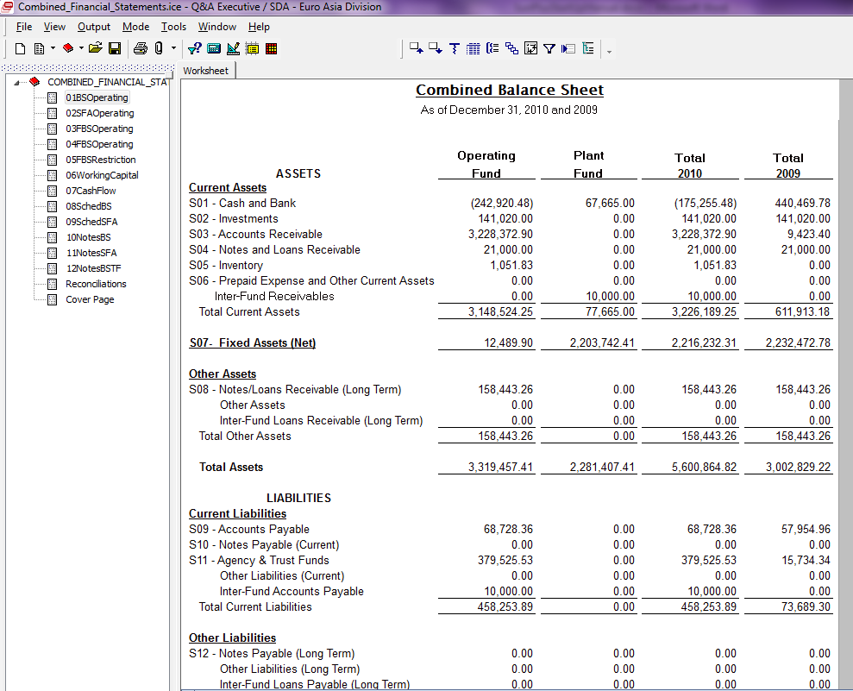
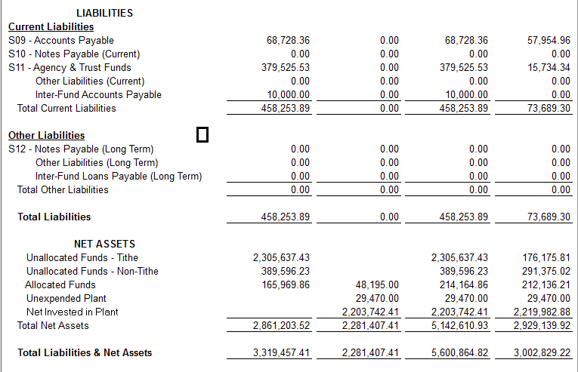

Static Data Preparation

Creditor Records

- In Excel, create a list of all of the organization’s creditors. For each creditor, compile:
  - Company title or Individual Creditor given name and surname
  - Address
  - Currency Code (for Multi-Currency sites)
- Assign a unique code to each creditor. Creditor codes must comply with the following:

VAAABBNN | INDIVIDUALS SERVING AS CREDITORS
V (OR C) | Creditors
AAA | 1st 3 characters of surname
BB | 1st 2 characters of given name
NN | 01 (numeric value to avoid duplicates)
VAAAAANN | COMPANIES SERVING AS CREDITORS
V (or C) | Creditors
AAAAA | 1st 5 characters of company title
NN | 01 (numeric value to avoid duplicates)
- For each creditor, three records must be set up in SunSystems:
  - Chart of Account natural account
  - WHO Analysis Dimension Code (see Analysis Codes section)
  - Address Record (see Addresses section)
- For Natural Creditor Accounts, use the Natural Account upload worksheet. For each creditor, populate a row with the following information:

CREDITOR UPLOAD SETTINGS
Layout Identifier (LID) | 1;3
Account Type | T
Account Code | VAAABBNN (see #2 above)
Account Name | - Creditor’s Name – Surname, Given Name  - Company Title
Short Heading | 1st 55 characters of Account Name
Lookup Code | 1st 15 characters of Account Name, CAPS
Balance Type | B
Status | O
Default Currency | XXX1 – i.e., USD1
T1 | O
T2 | O
T3 | M
T4 | O
T5 | O
T6 | O
T7 | O
T8 | O
T9 | O
T10 | O
A2 (Class) | 337
- Use the Address Codes worksheet to create Creditors’ WHO Analysis Codes at the same time as their Address Codes.
- For each Creditor, set up a row of information as follows:

CREDITOR WHO ANALYSIS AND ADDRESS CODES UPLOAD SETTINGS
LID | 1
Address Code | Same code as Natural Account
Name | - Given Name Surname - Individual as Creditor  - Company Title – Company as Creditor
Address2 – 5 | Creditor’s Address – set up as it should appear on envelope
Short Heading | Same as Natural Account
Lookup Code | Same as Natural Account
Status | O

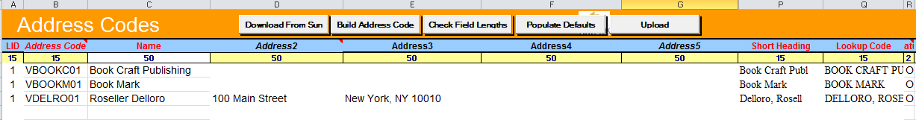

Employee Records

- In Excel, create list of all organization employees. For each Employee, compile:
  - Employee’s name – given name and surname
  - Address
  - Currency Code (Multi-Currency sites)
- Assign a unique code to each Employee. Codes must comply with:

REGULAR EMPLOYEE CODE SUNPLUS CONVENTIONS
ERAAABBNN | Regular Employee Code
AAA | 1st 3 characters of surname
BB | 1st 2 characters of given name
NN | 01 (numeric value to avoid duplicates)

- Set up 3 records for each Employee:
  - Chart of Accounts natural account
  - WHO Analysis Dimension Code (see Analysis Codes section)
  - Address Record (see Addresses section)

- Populate a row for each Employee in the Natural Account Upload spreadsheet with the following:

EMPLOYEE UPLOAD SETTINGS
LID | 1;3
Account Type | T
Account Code | ERAAABBNN (see #2 above)
Account Name | Employee’s Name – Surname, Given Name
Short Heading | 1st 15 characters of Account Name
Lookup Code | 1st 15 characters of Account Name - CAPS
Balance Type | B
Status | O
Default Currency | XXX1 – i.e., USD1
T1 | O
T2 | O
T3 | M
T4 | O
T5 | O
T6 | O
T7 | O
T8 | O
T9 | O
T10 | O
A2 (Class) | 133

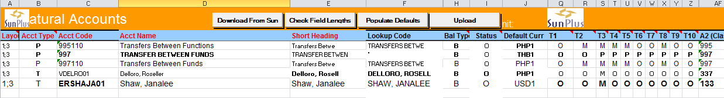

- Set up Employees’ WHO Analysis Codes at the same time as the Employees’ Address codes.
- For each Employee, add a row with the following information to the Addresses upload:

EMPLOYEE ADDRESS CODES UPLOAD SETTINGS
LID | 1
Address Code | Same as Employee’s Natural Account
Name | Employee’s Given Name Surname
Address2 - 5 | Employee’s Address in front of the envelope form
Short Heading | Same as Natural Account Short Heading
Lookup Code | Same as Natural Account Lookup
Status | O
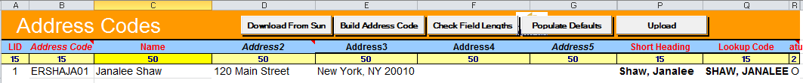

Analysis Codes Other Than WHO

Use an Analysis Codes upload for all Analysis Codes other than WHO Analysis Codes.

NOTE: Upload Analysis Codes individually by Analysis Dimension or create a single upload worksheet of all Analysis Codes to upload at once.

Individual Uploads

To upload each Dimension’s codes individually, use the worksheet for each Dimension. As long as CLASS Codes have been uploaded, Analysis Codes for all other Analysis Dimensions can be uploaded in any order.

RSCE

Standard RSCE codes come pre-created with the Core Business Unit.

STANDARD RSCE ANALYSIS CODES
* | NOT TO BE ANALYZED
AF | Allocated Fund Resources
AFC | Allocated Fund for Capital
AFO | Allocated Fund for Operating
UF | Unallocated Fund
UFIN | Unallocated Invested in Plant
UFNT | Unallocated Fund for Nontithe
UFTF | Unallocated Fund for Tithe
UFUN | Unallocated Unexpended in Plant

TFWW
STANDARD TFWW ANALYSIS CODES
* | NOT TO BE ANALYZED
FUND Codes | All Fund Analysis codes
FNCT Codes | All Function Codes
UFTF | Allocated Tithe Resource

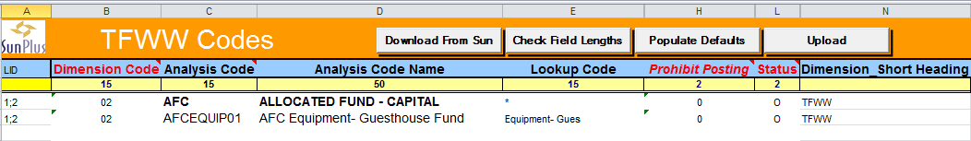

For Accounting purposes, the codes used for the FNCT Dimension must also be set up as TFWW codes. Copy the data from the FNCT upload spreadsheet into the TFWW spreadsheet with the following differences:
Dimension Code | 02 (enter on every row of TFWW data)
Dimension Short Heading | TFWW

FNCT
STANDARD FNCT ANALYSIS CODES
* | NOT TO BE ANALYZED
AS | Administrative Services
AU | Administrative Support
DP | Departmental Services
DT | District
IN | Industrial Services
IS | Instructional Services
PS | Program Services
SU | Support Services
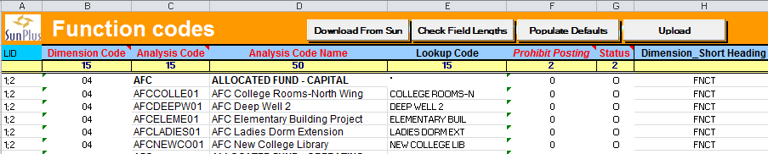

\

For each FNCT Analysis Code, add a row with the following information:

FUNCTION ANALYSIS CODE UPLOAD SETTINGS
Layout Identifier (LID) | 1;2
Dimension Code | 04 (required for every row of data)
Analysis Code | Code assigned to the Function
Analysis Code Name | Name of Department / Function
Lookup Code | 1st 15 characters of Analysis Code Name, CAPS
Prohibit Posting | 0
Status | O
Dimension Short Heading Heading | FNCT
Prohibit Posting on Header Analysis Codes.
  - To Prohibit Posting enter a Prohibit Posting value of 1.

RSTR

RSTR ANALYSIS CODE UPLOAD SETTINGS
* | NOT TO BE ANALYZED
0 | Unrestricted
3 | Tithe Restricted
7 | Temporarily Restricted
9 | Permanently Restricted

RSTR ANALYSIS CODE UPLOAD SETTINGS
LID | 1;2
Dimension Code | 05 (required on every row of data)
Analysis Code | RSTR Code
Analysis Code Name | Name of the RSTR
Lookup Code | 1st 15 characters of RSTR name
Prohibit Posting | 0
Status | O (for Open)
Dimension Short Heading | RSTR

ORGIDs

STANDARD SUNPLUS ORGID ANALYSIS CODES
A | Adventist Organization Codes
C | Church Codes

ORGID ANALYSIS CODE UPLOAD SETTINGS
LID | 1;2
Dimension Code | 06 (required on every row of data)
Analysis Code | AXXXXXX – code assigned by GC Archives
Analysis Code Name | Name of the organization
Lookup Code | 1st 15 characters of organization’s name
Prohibit Posting | 0
Status | O (for Open)
Dimension Short Heading | ORGID

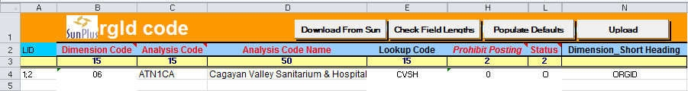

FLAG

STANDARD SUNPLUS FLAG ANALYSIS CODES
* | NOT TO BE ANALYZED
IN | In/Transfer In/TF Receipt
OUT | Out/Transfer Out/TF Disbursement
T | Tithe Memo Printing
Y | Yes for Memo Printing
Z | Other FLAG Dimension
ZM | Other Memo Flag Dimension
ZMA | Administration Accounts Monitor
ZMAEMPLO01 | Employee Board Members
ZMAEXECU01 | Executive Secretary
ZMANONEM01 | Non-Employee Board Members
ZMAPRESI01 | President
ZMATREAS01 | Treasurer

PROJ

STANDARD SUNPLUS PROJ ANALYSIS CODES
C | Congress Project Dimension
W | Work in Progress Project
WAPART01 | WIP Apartment Building Construction
WGUEST01 | WIP Guest House Construction

For each PROJ Code, add a row with the following to the upload:

PROJ ANALYSIS CODE UPLOAD SETTINGS
LID | 1;2
Dimension Code | 09 (required on every row of data)
Analysis Code | PROJ Code
Analysis Code Name | Name of the PROJ
Lookup Code | 1st 15 characters of PROJ’s name
Prohibit Posting | 0
Status | O (for Open)
Dimension Short Heading | PROJ

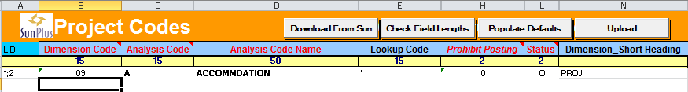

DTLS
STANDARD SUNPLUS DTLS ANALYSIS CODES
1 | Investment Codes
C | Congress Detail
CACCOM01 | Accommodation
CFACIL01 | Facility Rental
CHANDO01 | Handouts
CTRANS01 | Transportation
I | Inventory Codes
IBOOKS01 | Books Inventory
IOFFIC01 | Office Supplies Inventory
V | Vehicle Details
W | Work in Progress Details

For each DTLS Analysis Code, add a row with the following information to the DTLS upload:

DTLS ANALYSIS CODE UPLOAD SETTINGS
LID | 1;2
Dimension Code | 10 (required on every row of data)
Analysis Code | DTLS Code
Analysis Code Name | Name of the DTLS
Lookup Code | 1st 15 characters of DTLS’s name
Prohibit Posting | 0
Status | O (for Open)
Dimension Short Heading | DTLS
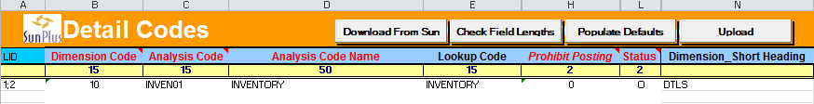

Single Upload
      - To upload all Analysis Codes (except WHO) in one upload, create an upload sheet with the following columns:

LID
Dimension Code
Analysis Code
Analysis Code Name
Lookup Code
Prohibit Posting
Status
Dimension Short Heading

- Create your list of Analysis Codes.
  - Be very careful not to mix up codes and dimensions.
  - I start with TFWW codes. When all values for the TFWW codes are on the upload, enter the FNCT codes, etc.
- Every row of data to be included in the upload must have a LID value of 1;2.
- Enter the correct Dimension Code for the type of Analysis (be very careful! If you enter the wrong Dimension Code, your Analysis Codes will be all messed up.)

STANDARD SUNPLUS CORE DIMENSION CODES
15 | Barcode
12 | Class
10 | DTLS
08 | FLAG
04 | FNCT
03 | FUND
13 | Location
06 | ORGID
09 | PROJ
01 | RSCE
05 | RSTR
11 | Statutory
02 | TFWW
14 | TYPE

If the site is using Dimensions other than Core SunPlus Dimensions and you are unsure of the Dimension Code, go into Analysis Dimensions Setup. The Analysis ID number is the Analysis ID.
- The Dimension Short Heading is the Dimension’s code:

STANDARD SUNPLUS CORE SHORT HEADING
Barcode
CLASS
DTLS
FLAG
FNCT
FUND
LOCN
ORGID
PROJ
RSCE
RSTR
STAT
TFWW
TYPE

- CLASS, FLAG, FUND, and RSTR codes come as part of the SunPlus core. These usually do not have to be uploaded unless the site makes some changes to them.

- Your upload would look a little like this:
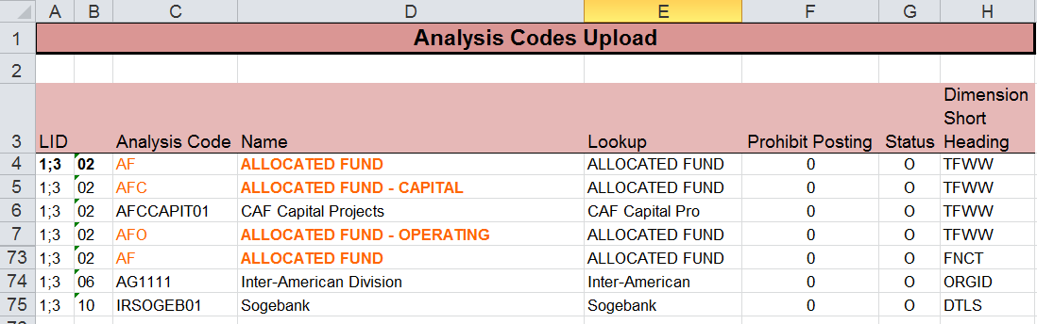

Financial Data Preparation

Budget

Budget information can be uploaded using a regular Ledger Import template. Be sure to post into the correct periods.

An alternative import template is the much more complicated template below. The following explanation relates for the complicated import. Don’t worry, it is not difficult to use.

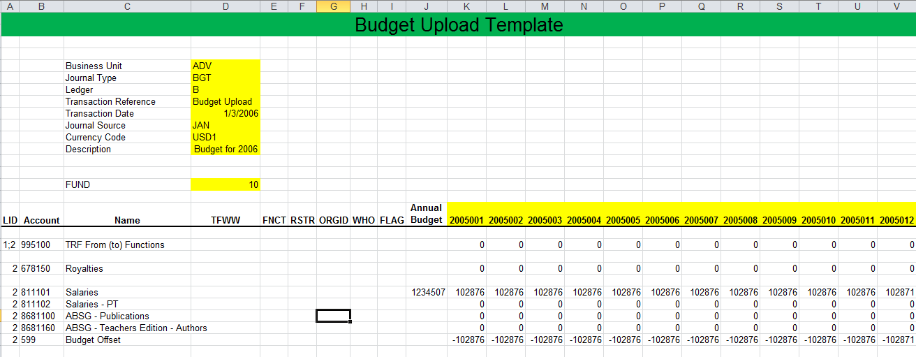

- Populate the Budget upload spreadsheet.
- Items in cells highlighted yellow are entered once, only in that cell, and apply to all entry lines.
- For each natural account to be included in the Budget upload, enter the Account Code in column B and the Account Name in column C.
- If the account requires an Analysis Code, that Analysis Code must be entered in the appropriate column: D – I.
  - To enter a budget for 7 employees under Salary, add 6 rows under the Salary Account
  - Enter Salaries Account Code and Account Name on each row
  - Enter WHO code for each Salary entry row
- While the best practice is to enter a weighted amount, you can also enter 1/12th of the budget for each natural account into each of the month columns. If the amount does not divide evenly, place any excess into the first month of the year
- Open Q&A XL and map the Data Send. (See the Mapping section of this document.)

Payroll

Many SunPlus sites use the following Excel spreadsheet to handle monthly (bi-monthly) Payroll needs.

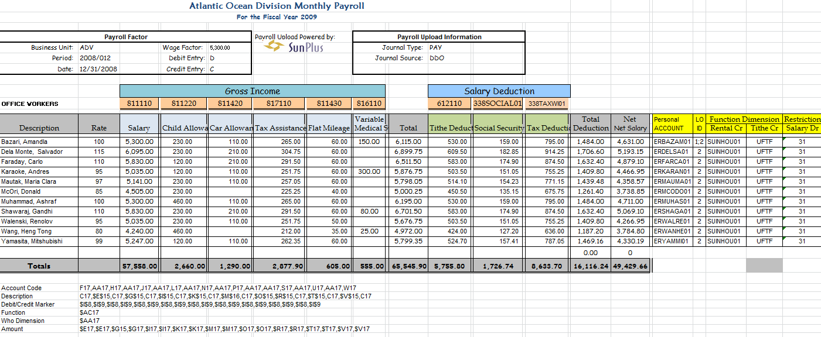

If the site chooses to use this Payroll upload, here is what you would do:

Open this spreadsheet and do the following:
- Change organization name at the top of the sheet to the correct name
- Change Fiscal Year in row 4
- Enter Business Unit Name in cell
- Enter Accounting Period in cell D8
- Enter Date for the upload in cell D9
- Double-check Wage Factor in cell I7
- Change Journal Source in cell R8 to the operator’s login code
- Change Account Codes in the orange cells (row 12) to correct values for the site
- Change values in light blue cells (row 13) to reflect appropriate accounts for the site
- DO NOT ADD OR SUBTRACT ANY COLUMNS (important formulas are present even in very small columns that seem unnecessary)
- Add as many rows as necessary to include all of the site’s employees.
- Enter the correct Rates for each employee
- Enter necessary amounts into the amount cells
There is a very confusing looking list of alphanumeric values in rows 31 - 36. These values are important for the upload mapping. Copy and paste them from the worksheet directly into the mapping dialogue box.

Trial Balance

Ask for the Trial Balance for last year’s transactions. Use this to prepare the Beginning Balance upload.

Beginning Balances

Options for uploading Beginning Balances:

The following scenarios are based upon this case:

SunPlus is to be implemented in the Central Atlantic Union in October 2009. The site’s Fiscal Year matches the calendar year. They are using the Old Sun Account system. They will enter actual transactions into SunPlus starting in period 10/2009.

Migrate individual detailed transactions from previous year (2008)
- Enter post-closing Trial Balance of Period 13/2007 from the old Sun Account in Period 12/2007 in SunPlus, excluding P&L accounts.
- Enter individual entries/transactions from January 2008 – September 2009, including P&L Accounts.
  - Tag P&L transactions with the correct Dimensions, especially FNCT;
  - Do NOT tag everything with In-House Operations or Miscellaneous dimensions.
- Enter Funding Entries to close the Functions in Period 12/2008.
- Actual entries will begin being posted into Period 10/2009.
Comparative statement figures in the Financial Statement for 2009 and 2010 (not detailed transactions)
- Enter post-closing Trial Balance for Period 13/2007 from the old Sun Account in Period 12/2007 in SunPlus, excluding P&L accounts.
- Enter monthly net activity by Function every month from January 2008 to September 2009, including P&L accounts.
  - Tag P&L transactions with the correct Dimensions;
  - Do NOT tag everything with Miscellaneous Dimensions.
- Enter Funding Entries to close the Functions in Period 12/2008.
- Actual entries will begin being posted into Period 10/2009.
Comparative statement figures only for 2010 and not for 2009:
- Enter post-closing Trial Balance of Period 13/2008 from old Sun Account in Period 12/2008 in SunPlus, excluding P&L accounts.
- Enter monthly net activity by Function every month from January 2009 to September 2009, including P&L Accounts.
  - Tag P&L transactions with the correct Dimensions;
  - Do NOT tag everything with Miscellaneous Dimensions.
- Actual entries will begin being posted into Period 10/2009.
Comparative statement figures that will start in October 2010 (this is usually what we have recommended in the past as it is less work and less complicated):
- Enter post-closing Trial Balance of Period 13/2008 from old Sun Account in Period 12/2008 in SunPlus, excluding P&L accounts.
- Enter net activity of transactions from January 2009 – September 2009 in Period 09/2009.
  - Tag P&L transactions with the correct Dimensions;
  - Do NOT tag everything with Miscellaneous Dimensions.
- Actual entries will begin being posted into Period 10/2009.
To modify the Trial Balance data into upload readiness:
- Check the Accounting Period represented by the balances:
  - Is it the ending balance of the month before the go-live date for the system?
- Ensure that the sum of all Trial Balance amounts equals 0.
  - Balances must be in balance
- If the site implements separate funds for Fixed Assets, the Fixed Asset (FUND 20) balance must equal the amount that will go to the Operating Fund (FUND 10)
- Ensure every amount has a corresponding existing account code (former system code)
- Add LIDs to LID column.
  - In the first row’s LID cell, populate the value 1;2
  - Populate the value 2 in all subsequent rows of data to be part of the import
- Merge balances into a single column with credits shown in the negative
  - Alternatively, to list balances in individual Debit and Credit columns, populate a Dr/Cr Indicator for each amount
    - D is the Indicator for Debit
    - C is the Indicator for Credit
- In the GDCoA Section of the sheet, starting with Second Reference, filter by Dimension column to show only the M’s (Mandatory), leaving all O’s or blanks (optional) hidden.
  - While the filter is on, populate the Beginning Balance section with real values according to the prepared dimensions
- The import is ready for mapping
When the Chart of Accounts and the Beginning Balances are in different spreadsheets:
- Check the Accounting Period represented by the balances:
  - Is it the ending balance of the month before the go-live date for the system?
- Ensure the sum of all the Trial Balance amounts equals 0.
  - The upload must be in balance
- If the site implements separate funds for Fixed Assets, the Fixed Asset (FUND 20) balance must equal the amount that will go to the Operating Fund (FUND 10)
- Ensure every amount has a corresponding existing account code (former system code)

The following assumes the GDCoA is already prepared:

- Add the LIDs to LID column
- Merge balances into a single column with credits shown in the negative
  - Alternatively, to list balances in individual Debit and Credit columns, populate a Dr/Cr Indicator for each amount
    - D is the Indicator for Debit
    - C is the Indicator for Credit
- Insert a column for Account Codes
  - Use a VLookup in the GDCoA section to determine appropriate new account codes based on the balances’ existing (old) codes
  - Review the list to discover accounts that do not have new codes
    - Figure out why codes are missing
  - Assign new codes to accounts missing codes
    - You can assign new codes in the GDCoA sheet
      - VLookup will detect it new codes in the GDCoA sheet.
    - You can, alternatively, hardcode it in the balances worksheet.
      - This happens when the CoA is submitted months prior and the site adds new accounts before the ending balances are submitted.
- In the Dimension columns:
  - Create a VLookup to the GDCoA sheet for M and O settings
  - Start with RSCE and work through DTLS
  - Re-format the M’s into values
  - Replace all O’s with blanks
- Starting with RSCE, filter by Dimension column to show only M’s, hide blanks (O’s)
- Map for import

Fixed Assets

Success and speed in Capital Assets Upload begin in the preparation stage.

The Fixed Asset process begins with the following steps:
- Collect Fixed Asset Data from site
- Ensure data is correctly formatted for Sun
- Add
  - Layout Identifier - LID
  - New Asset Code
  - Lookup Code
  - Short Heading
- Populate the Fixed Asset Register columns of the Key Concept Instrument:
- Start Period of Depreciation
- Estimated Life of Asset
- Gross Value
- Accumulated Depreciation
- Reconcile Start Period with the amount in Accumulated Depreciation
Example:
Building Gross Value $150,000
Accumulated Depreciation 55,000
Estimated Life 30 years
Start Period of Depreciation 02/1997
Implementation Period 01/2007

To establish if Accumulated Depreciation is reconciled with Start Period of depreciation:
  - Determine monthly depreciation

Monthly Depreciation = Gross Value / Estimated Life (150,000 / 30 = $5,000)

  - Determine number of years and months accumulated depreciation represents

Accumulated Depreciation in yrs/mths = Accumulated Depreciation / Monthly Depreciation (55,000 / 5,000 = 10 years)

  - Determine Asset Existence

Asset Existence = Prior period before implementation – Start period of depreciation (10/2006 – 02/1997 = 9 years & 11 months)

  - Compare number of years asset has been depreciated and existence of the asset

10 years – 9 years and 11 months

(In our example, the asset has been over depreciated for one month based on the start period of depreciation.)

  - Adjust Start Period in the Start Period column of the Asset Register Form to reflect the new start period (from 02/1997 to 01/1997)

Upload Procedure

There are two approaches to upload the Asset Gross Value and Accumulated Depreciation balances:
- Pre-audit Approach and
- Post Audit Approach

Pre-Audit Approach

There are two upload situations in the Pre-Audit Upload:
- Start of the Fiscal Year Implementation Upload and
- Interim Period of the Fiscal Year Implementation Upload.

Start of the Fiscal Year Implementation Upload

SunPlus implementations should be scheduled, if possible, for go-live at the first period of a Fiscal Year.

Example: SunPlus implementation scheduled for go-live to begin at start of Fiscal Year (01/2007)
- Close last Fiscal Year - 2006
- Reconcile the Start Period of Depreciation for each asset using the last Fiscal Year’s -- 12/2006 – Accumulated Depreciation figure and the Start Period for Depreciation.
- Upload Fixed Asset Register details; upload ONLY the Gross Value of the asset in the last Period of the last Fiscal Year – 12/2006 –

Dr 20x20x

Cr 138BEGIN01 – Beginning Balance Control

NOTE: Credit the Beginning Balance Control instead of 501110 (Fund Balance) to allow definition of the Asset Register and the Upload of the Asset Balances to be done as a standalone job; however, when the actual beginning balances of the trial balance are uploaded, the entry should be a debit to the Beginning Balance Control and a credit to the Fund Balance.

- Run Depreciation Calculation for the last Period of the last Fiscal Year -- 12/2006.

NOTE: When Depreciation Calculation is run, Accumulated Depreciation Expense is debited and Accumulated Depreciation is credited because of Asset Posting Presets.

- Determine the total Accumulated Depreciation generated by Depreciation Calculation run.
- Reconcile it with the Beginning Balance figure for Accumulated Depreciation.

NOTE: Because the Start Period was reconciled, there should be an insignificant difference in the overall total between the two. If the last Period of the last Fiscal Year -- 12/2006 -- was not audited, make the adjustment for the difference in the old system in the last Period of the last Fiscal Year -- 12/2006. After the adjustment is done in the old system, the figure in the old system in the last Period of the last Fiscal Year -- 12/2006 -- for the Gross Asset Value and the Accumulated Depreciation should be the same as the figure in the upload to SunPlus. The SunPlus Asset Listing and reports can be used to support the old system Asset Records during the audit for the prior Fiscal Year -- 2006.

- Reverse Depreciation Expense from expense account and debit it to the 138BEGIN01 - Beginning Balance Control - for the full amount. Credit various depreciation expenses, being sure to tag them appropriately (FUND, FNCT, RSTR).

NOTE: A significant amount is generated during Depreciation Calculation Run and then posted by the system – due to Asset Posting Presets -- into the expense accounts. This figure should not remain posted to expenses as it should be posted to the Fund Balance (it is equivalent to the Accumulated Depreciation expense for all assets since the establishment of the organization).

- The net credit of 138BEGIN01 - Beginning Balance Control - should be the same as the net value of the asset in the 20x20x section (Gross Value less Accumulated Depreciation). When the actual Beginning Balances of the assets (taken from the Trial Balance) are entered in 138BEGIN01 - Beginning Balance Control - the Beginning Balance Control account will be zeroed.

Interim Period of the Fiscal Year Implementation Upload

In this scenario, SunPlus implementation takes place at an interim period of the organization’s Fiscal Year. For our example, we will assume that implementation is taking place in July 2007. The first Period in which detail transactions will be posted to SunPlus will be Period 07/2007.

- Upload assets balances for 2006 to Period 12/2006.
- For Fixed Assets Balance migration, follow the steps in “Start of the Fiscal Year Implementation Upload” from 1 – 8.
- Upload the Gross Value of the Assets (new purchases) from January to June 2007 into Period 06/2007. The other side of the entries will be to 138BEGIN01 - Beginning Balance Control.
- Run Depreciation Calculation from January to June 2007.
- Enter any difference between the January – June Depreciation Expense and the figure in the old system into Period 06/2007 to balance the net activity entry.

The Post Audit Approach

There are two upload scenarios in the Post Audit Upload approach:
  - Start of the Fiscal Year Implementation Upload and
  - Interim Period of the Fiscal Year Implementation Upload.

Start of the Fiscal Year Implementation Upload

This is a perfect scenario for an asset upload; SunPlus implementations should be scheduled, if possible, for go-live to begin at the first Period of a Fiscal Year.

Example: SunPlus implementation scheduled for go-live to begin at start of Fiscal Year (01/2007)
- The prior Fiscal Year should be closed and audited.
- Reconcile the Start Period of Depreciation for each asset using the last Fiscal Year’s (12/2006) Accumulated Depreciation figure and the Start Period of Depreciation.
- Upload Fixed Asset Register details.
- Upload BOTH the Gross Value of the asset and the Accumulated Depreciation figure for the last Period of the last Fiscal Year (12/2006) into SunPlus debiting 20X20X and crediting 138BEGIN01 – Beginning Balance Control.

NOTE: Credit 138BEGIN01 - Beginning Balance Control (instead of 501110 - Fund Balance) so the definition of the Asset Register and the Upload of the Asset Balances can be done as a standalone job; however, when the actual Beginning Balances of the Trial Balance is uploaded, the entry should be a debit to 138BEGIN01 - Beginning Balance Control - and a credit to 501110 - Fund Balance.

- Run Depreciation Calculation for the first Period of the new Fiscal Year - 01/2007.

NOTE: Since the previous Fiscal Year has been audited, the figure for Accumulated Depreciation represents an audited amount; any adjustments generated for Depreciation Calculation in the first Period of the new Fiscal Year should be absorbed in that Period - 01/2007.

Interim Period of the Fiscal Year Implementation Upload

In this scenario, SunPlus implementation takes place at some interim period of the organization’s fiscal year. We will assume that implementation is taking place in July 2007. The first period in which detail transactions will be posted to SunPlus will be period 07/2007.

- Upload prior Fiscal Year Upload assets balances (2006) to last Period of prior Fiscal Year (12/2006).
- For Fixed Assets balances migration, follow steps in “Start of the Fiscal Year Implementation Upload”.
- Upload Gross Value of Assets (new purchases) from January to June 2007.
  - The other side of the entries will be to 138BEGIN01 – Beginning Balance Control.
- Run monthly Depreciation Calculation from January to June 2007.
- Post differences between Depreciation Expense at the end of the prior Fiscal Year and the January – June Depreciation Expense generated by Depreciation Calculation into the interim Period (06/2007) to balance net activity entry.

Actual Data Collection Process

Regardless of the approach, certain data must be accumulated in preparation for implementation.
For upload into SunSystems, create and populate a worksheet that will look something like this:

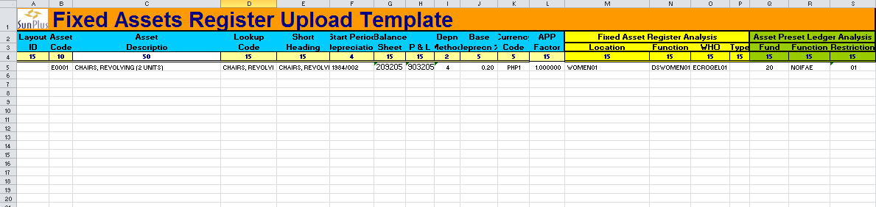

Compile the following:

FIXED ASSET UPLOAD DETAILS
LID | Layout Identifier
Asset Code | X00001 – See description below
Asset Types | See choices below
Asset Description | Name of the Asset; i.e., Apple Laptop
Lookup Code | Alternate way to find data; 15 characters long
Short Heading | Short description of asset used in reports with limited space
Start Period Depreciation | Period in which asset should begin to depreciate
Balance Sheet Account | See choices below
P&L Account | See choices below
Depreciation Method | Enter “4” for each asset besides Land
Base Depreciation Percentage | See below
Currency Code | Enter site’s Currency Code
APP Factor | Enter “1” for each asset
Gross Value | Enter the purchase price of each asset
Location Analysis | Enter code, if necessary
Function Analysis | Enter code, if necessary
Who Analysis | Enter code, if necessary
Resource | Enter code, if necessary
Fund | “20”
Function | Enter code, if necessary
Restriction | Enter code, if necessary
Options and Descriptions

ASSET CODE CODING CONVENTIONS
Asset Code | X00001 | X
 |  |  | E | Equipment & Furnishings
 |  |  | L | Land
 |  |  | I | Improvements
 |  |  | V | Vehicles
 |  |  | R | Residences
 |  |  | B | Buildings & Fixtures
 |  | 00001 | Sequential number to avoid duplicates

BALANCE SHEET ASSET ACCOUNTS
209202 | Land Improvement
209203 | Buildings & Fixtures
209204 | Residences
209205 | Furnishings & Equipment
209206 | Vehicles
209208 | Books
P&L ASSET ACCOUNTS
903202 | Land Improvements
903203 | Buildings & Fixtures
903204 | Residences
903205 | Furnishings & Equipment
903206 | Vehicles
903208 | Books

BASE DEPRECIATION PERCENTAGE
Buildings Life Rate
Well-constructed brick, stone, or reinforced cement buildings | 75 years | 1 1/3%
Brick veneer or thin-wall cement | 50 years | 2%
Frame stucco buildings – good foundation | 40 years | 2 ½%
All other buildings | 20 – 30 years | 3 – 5%
Furnishings & Equipment Life Rate
Durable office furnishings | 10 - 20 years | 5 – 10%
Light office furnishings | 10 – 15 years | 7 – 10%
Durable heavy institutional furnishings | 15 – 20 years | 5 – 7 %
Carpets, whole-room rugs | 8 – 12 years | 8 – 12%
Light school & institutional furnishings | 5 – 10 years | 10 – 20%
Office equipment | 5 – 10 years | 10 - 20%
Dormitory furnishings | 5 – 10 years | 10 – 20%
Engines & boilers | 5 – 20 years | 5 – 20%
Desktop/laptop/notebook computer | 3 – 5 years | 20 - 33%
Large central computer system / File server | 5 – 7 years | 14 – 20%
Audio-visual equipment | 3 – 5 years | 20 – 33%

Fixed Asset Values Preparation

Prepare Fixed Asset Values for upload.

- Add five columns to the far-right side of the upload:

- Asset Account
  - Check Chart of Accounts for asset account for each asset type (Building = 203203)
  - Populate with a Chart of Accounts code for each asset to be uploaded
- “I” Column
  - Enter an I for each asset (Asset Indicator)
- Debit/Credit Column
  - Enter a D for each asset
- Depreciation Marker Column
  - Enter a D for each Debit in the Debit/Credit column
- Accumulated Depreciation Debit/Credit Column
  - Enter a C for credit for each Debit in the Debit/Credit Column
- Accumulated Depreciation Account Column
  - Enter the Accumulated Depreciation Account for each type of asset
    - These accounts begin with “209”
- Sort the data by Asset Account
- Insert a blank row at the end of each string of asset accounts
  - In the Gross Value column cell of the blank row, total the amounts for the Asset Account which the row follows.
    - Do this for each individual Asset Account.
  - In the Asset Account column cell, enter the Asset Account (should match the Asset Account value immediately preceding that row).
    - Do this for each individual Asset Account.
  - In the “I” Column, leave the cells in the total row blank
  - In the Debit/Credit column, enter a C for the total cells
  - Leave the Depreciation Marker cell blank for the total rows
  - In the Accumulated Depreciation Debit/Credit Column, enter a D for the total rows
- In the Accumulated Depreciation Account column, enter the appropriate Accumulated Depreciation Account Code for each type of Asset Account

Sun 6.3 Application Implementation Steps

Create New Business Unit

- Business Unit Administration <BUA>

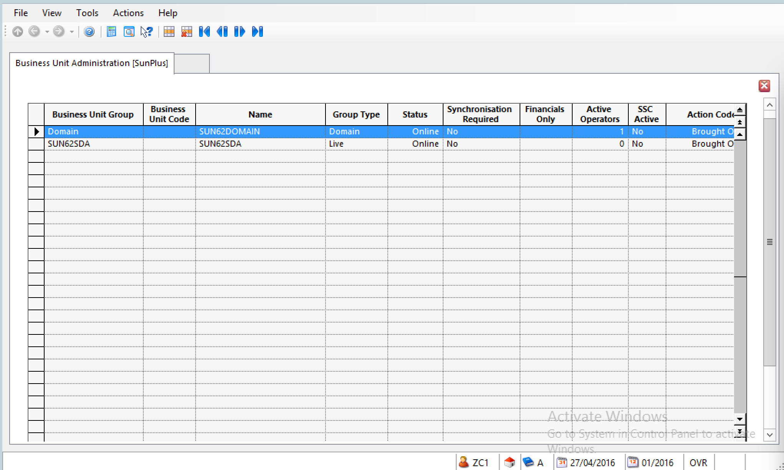
- Select SUN62SDA

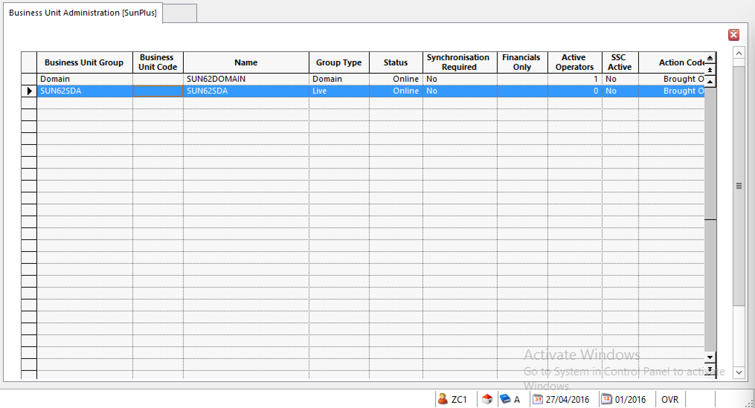’
- Click 

- Enter the Business Unit Code for the new business unit

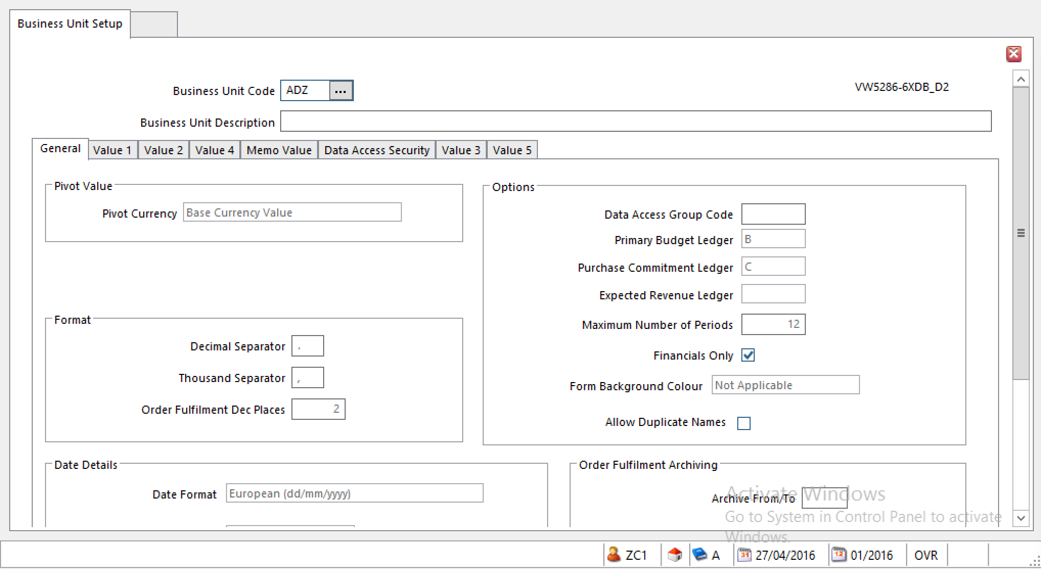
- Click OK

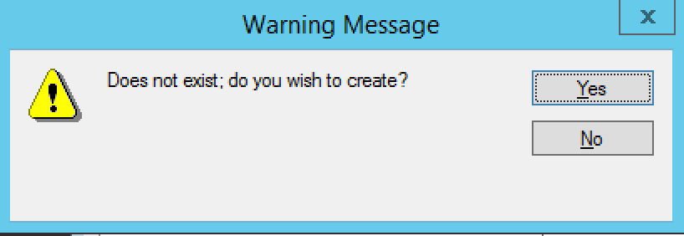

- Click Yes
- Enter the details of the new business unit
    - Business Unit Description – enter the name of the organization
    - General Tab
  - Pivot Currency – Base Currency Value
  - Date Details – adjust as necessary
    - Accept other defaults

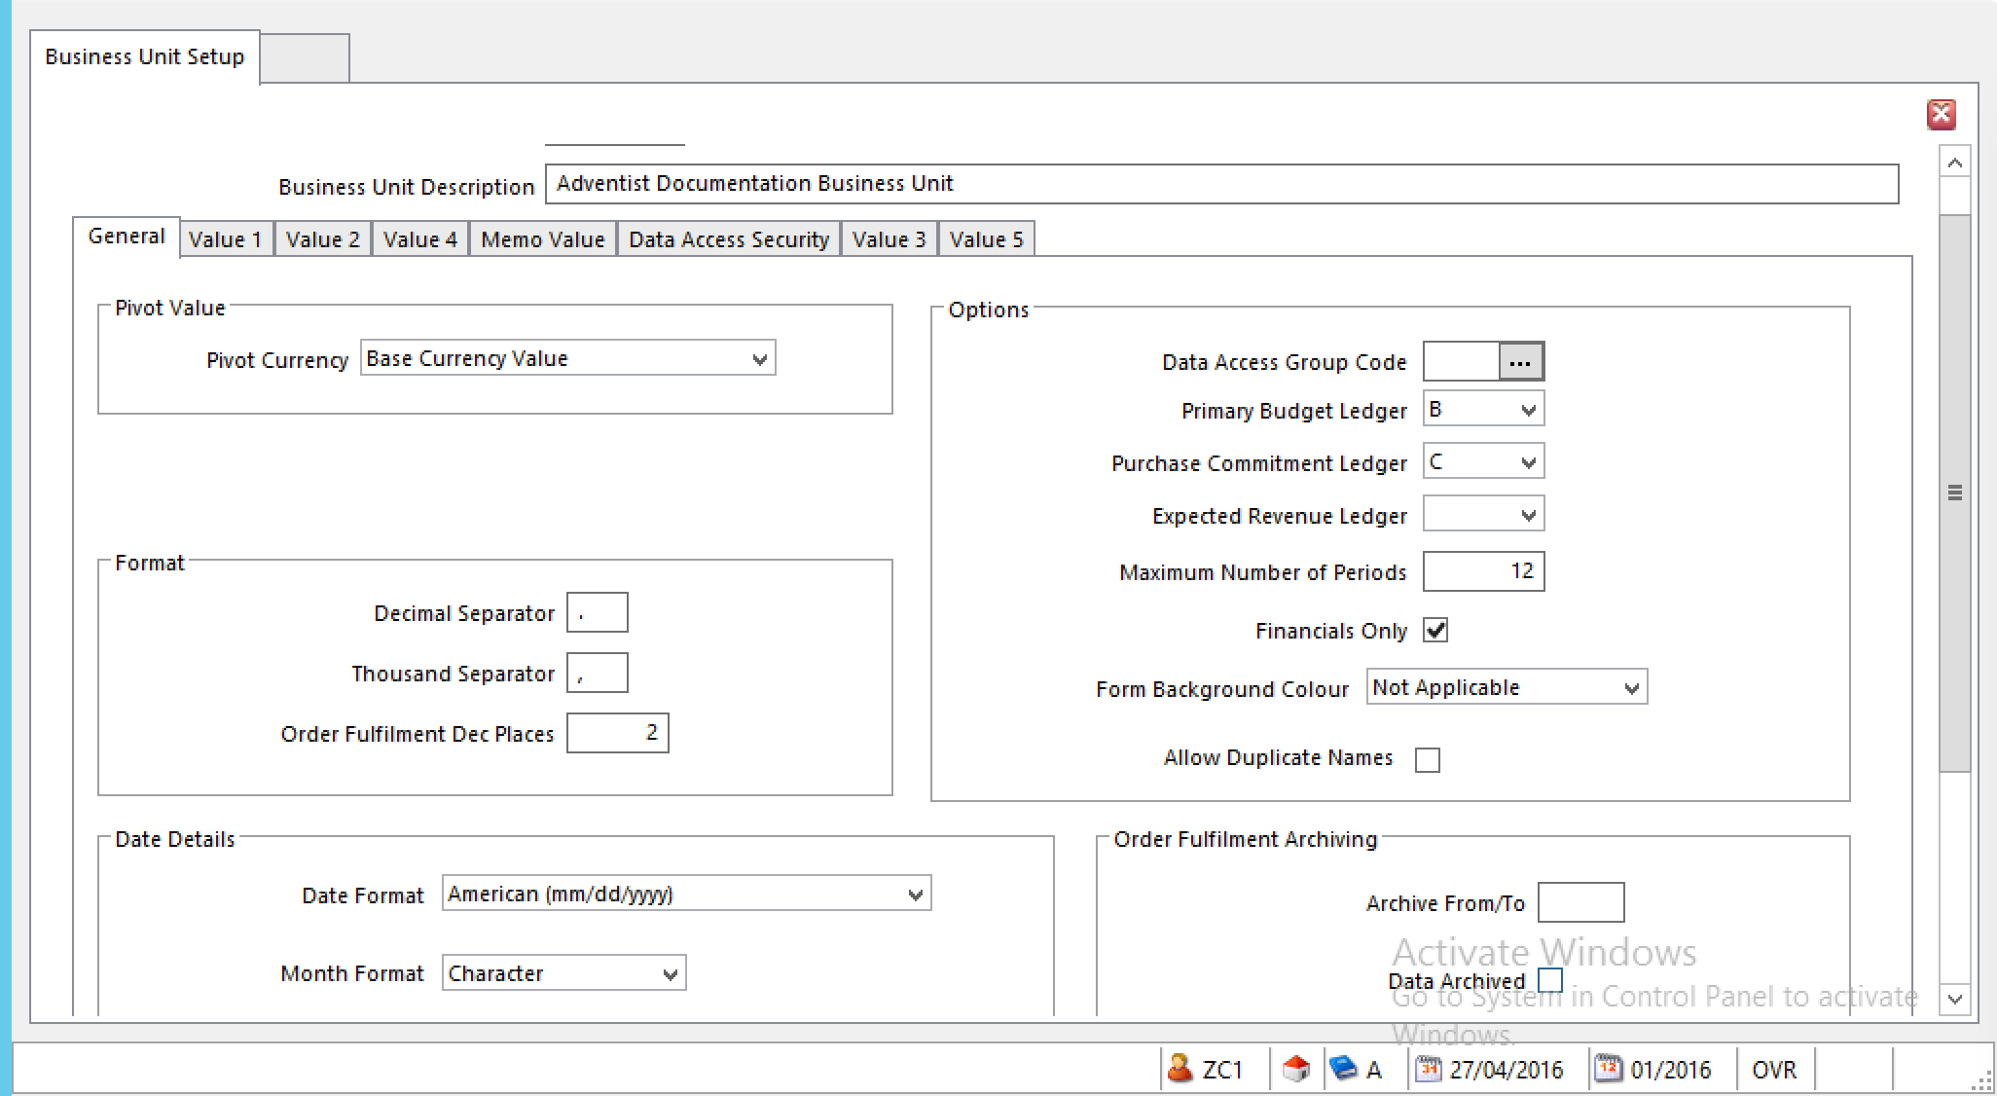
- Go to the Value 1 Tab
- Base Currency Name – enter organization’s base currency
- Base Currency – enter currency code XXX1
    - Accept other defaults

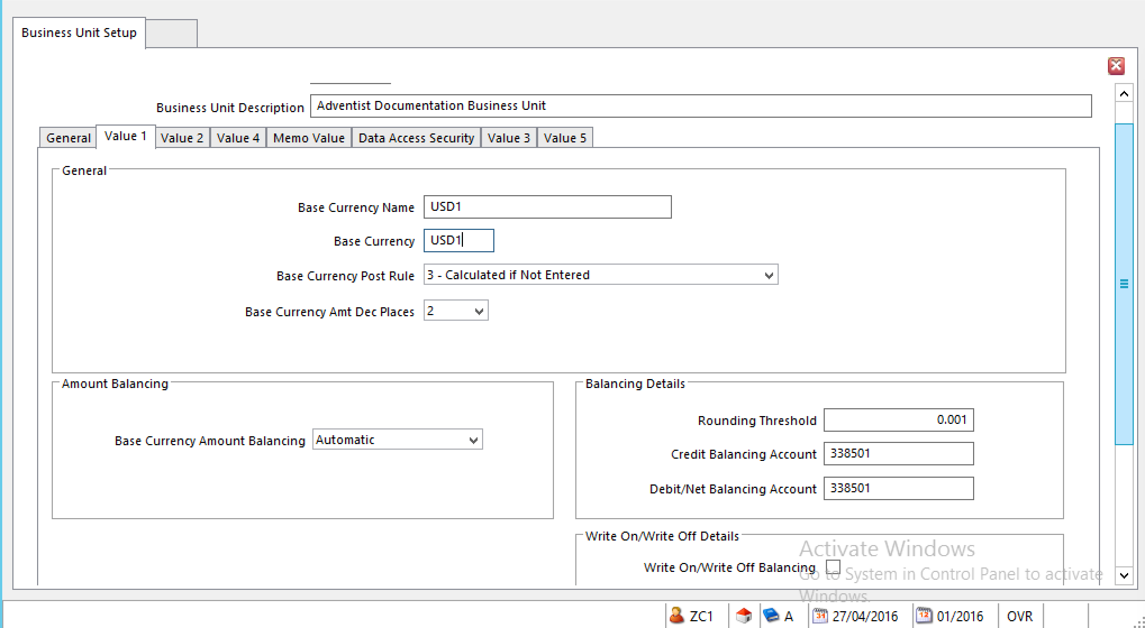
- Go to the Value 4 Tab
- 4th Currency Code
    - For a single currency site, enter Base Currency Code;
    - For a multi-currency site, leave blank
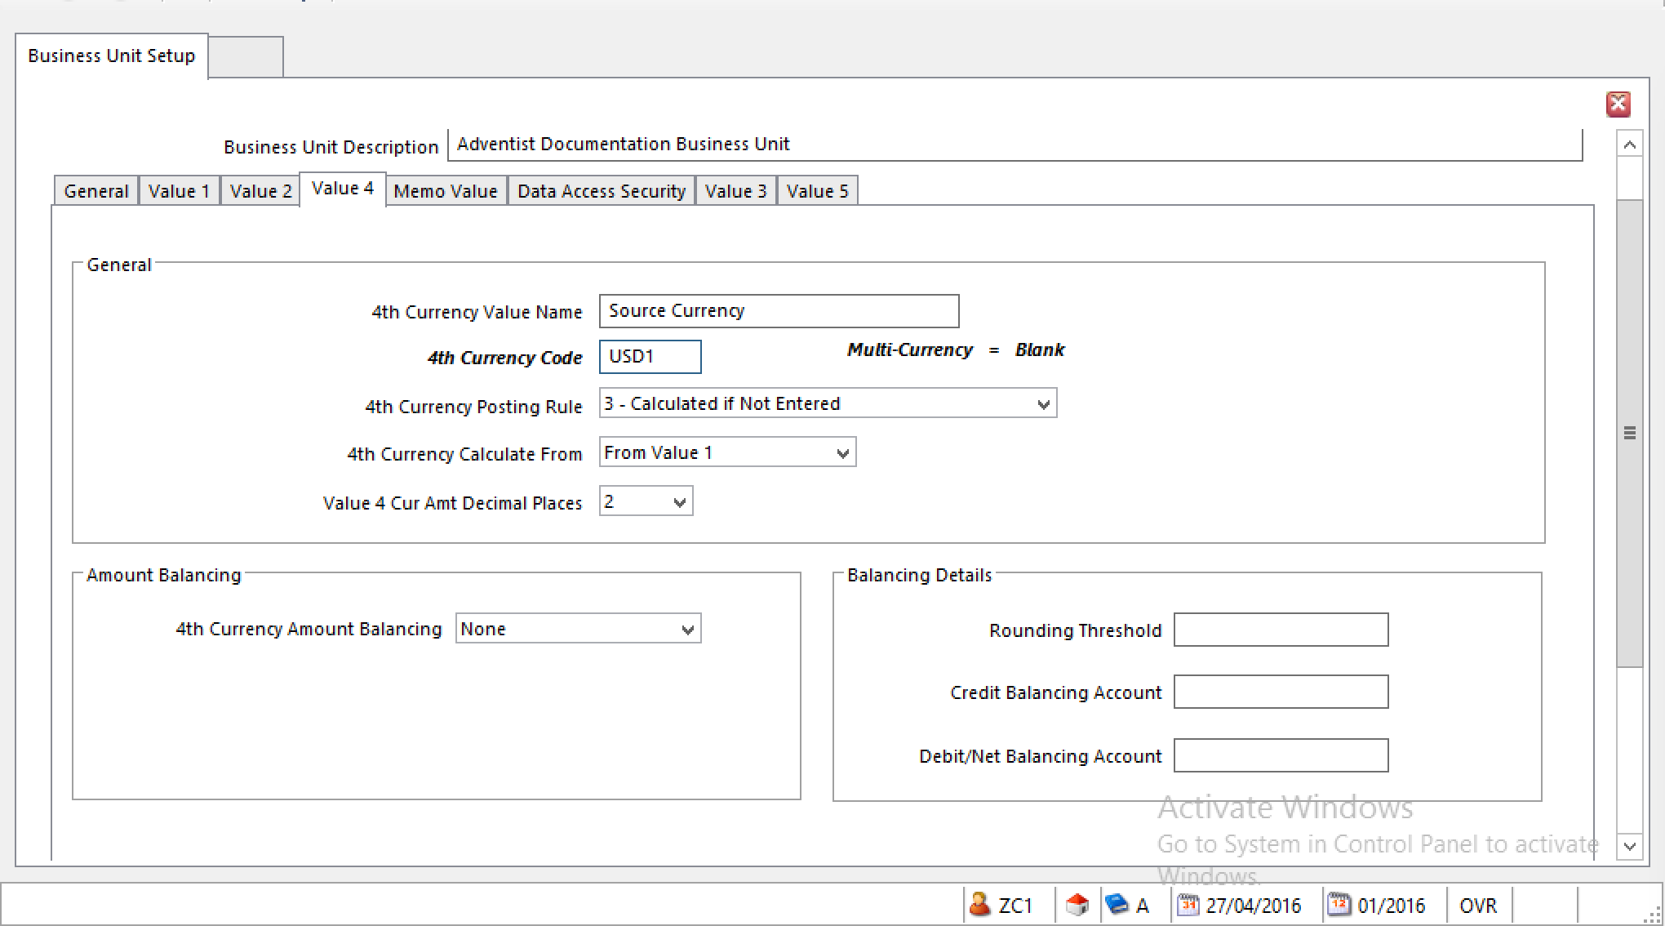
- Click OK
- The Business Rules Message is just a reminder

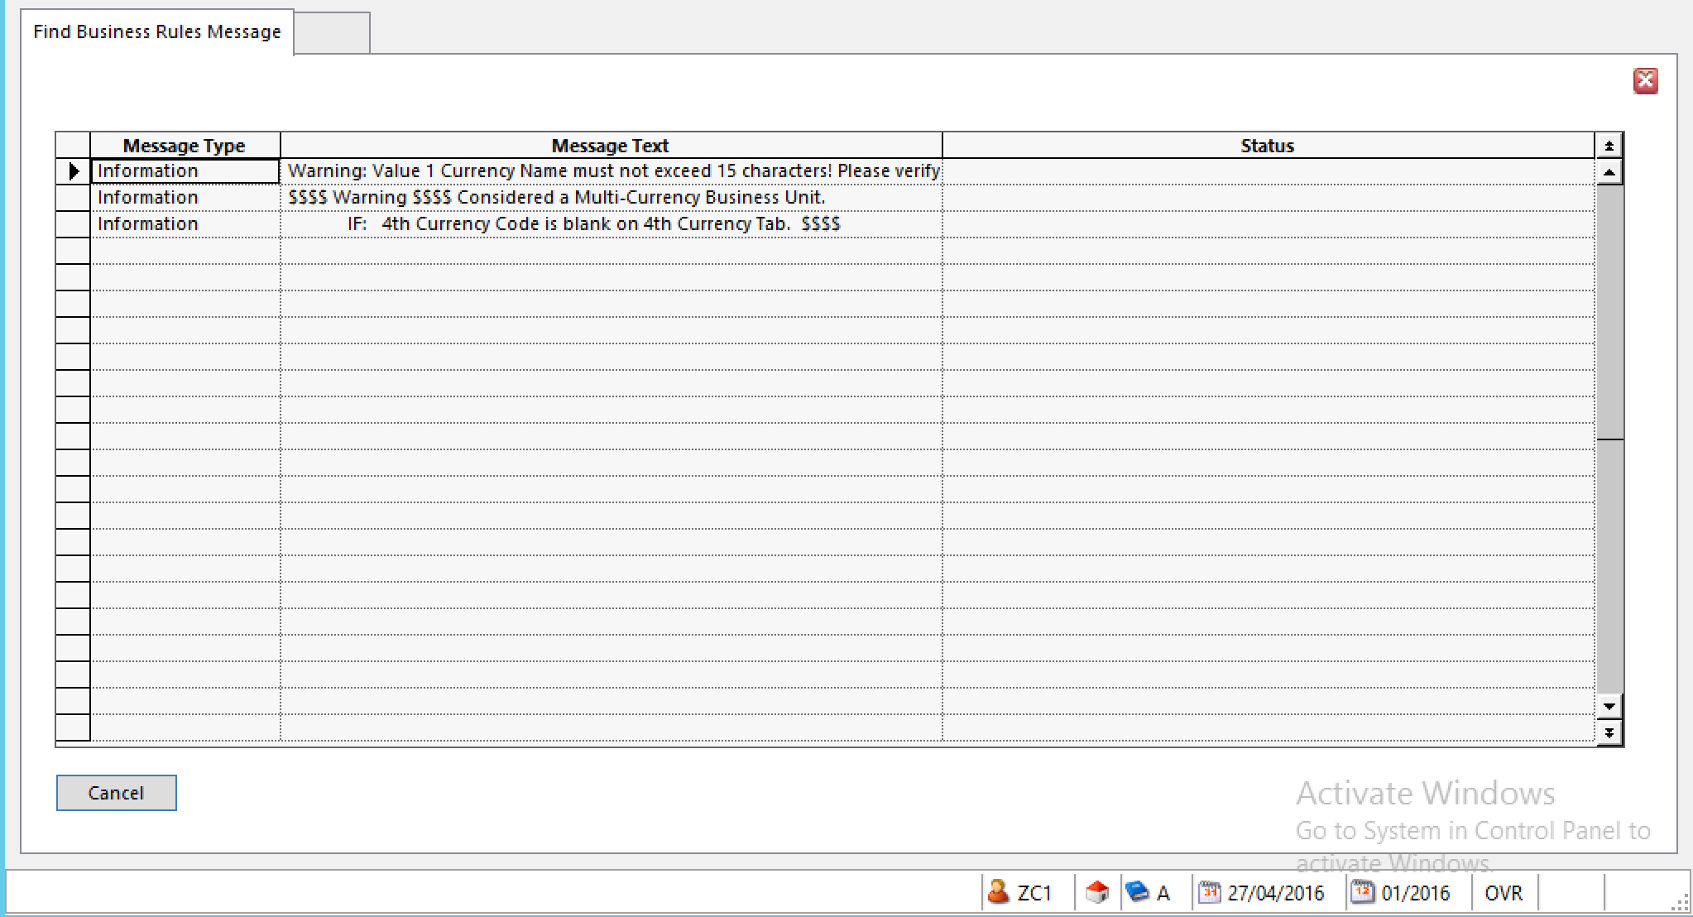
- Click Cancel

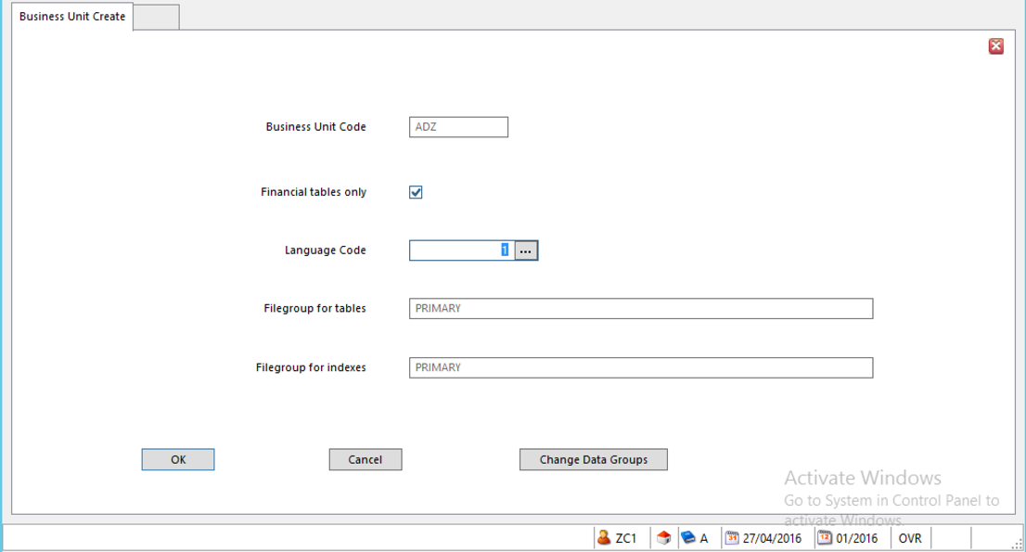
- Click OK

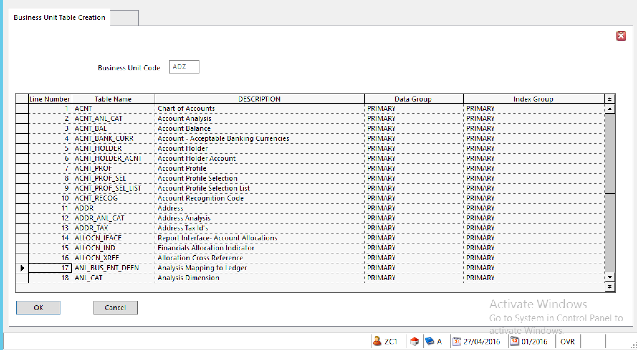
- Click OK
- The following screen will be displayed while the system works through the process

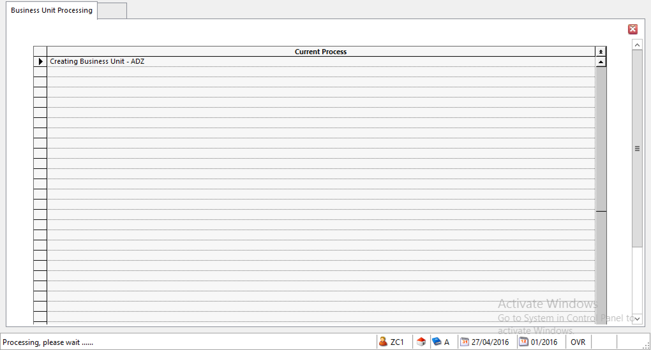
- When the Business Unit has been created, the following Information Message will be displayed

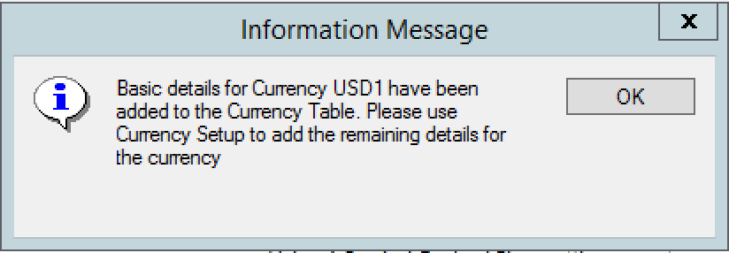
- Click OK

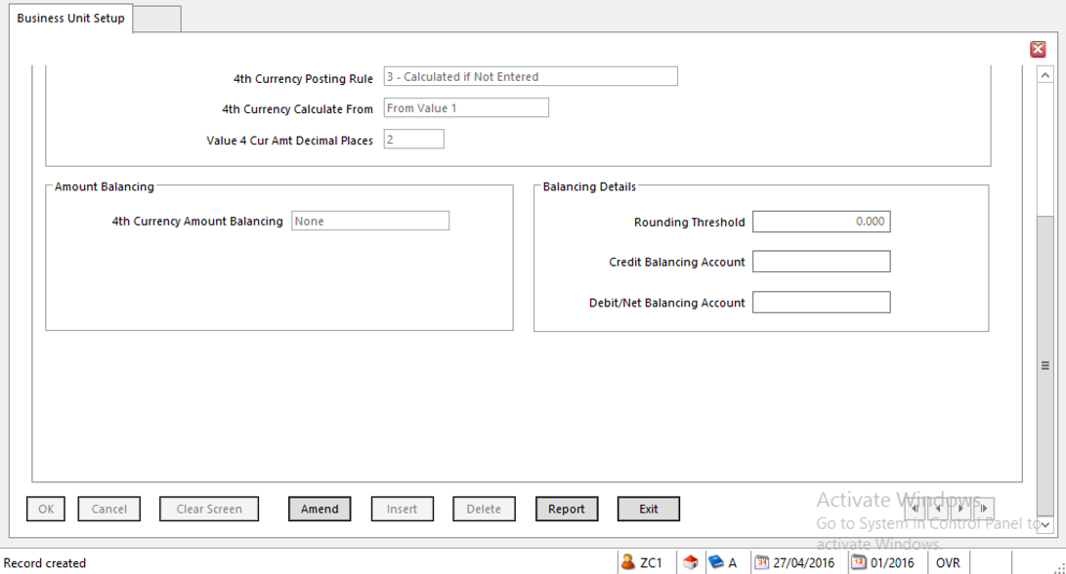
- The Business Unit has been created
- Click Exit
- You will be taken back to Business Unit Administration

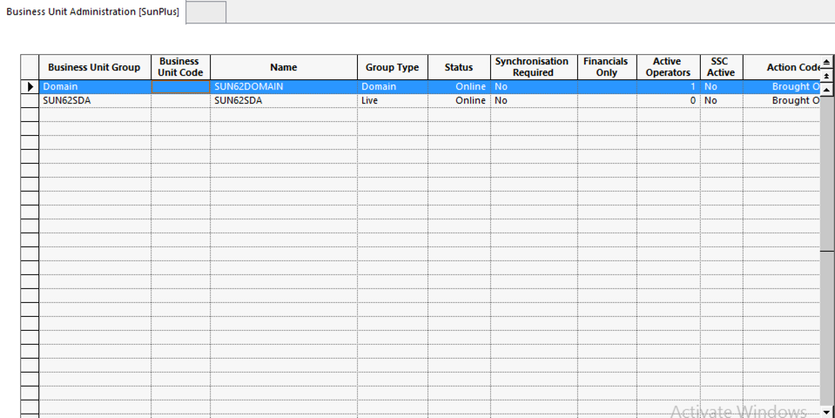

Copy A0A to New Business Unit

- In Business Unit Administration <BUA>, select SUN62SDA Business Unit Group
- Click

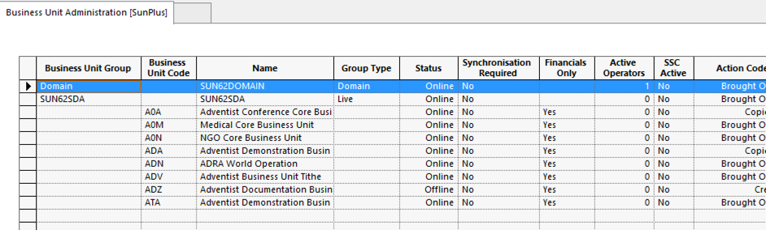
- A list of available business units is displayed
- Select A0A (the business unit to copy)

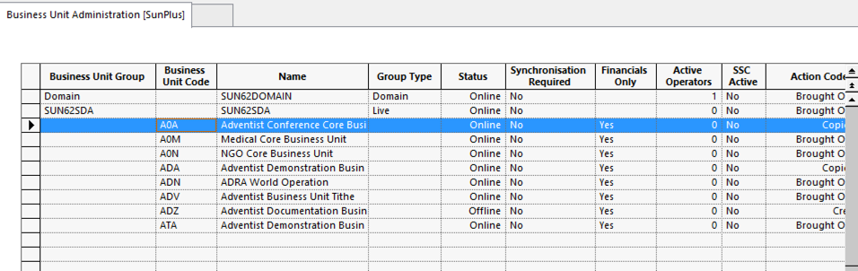
- Click

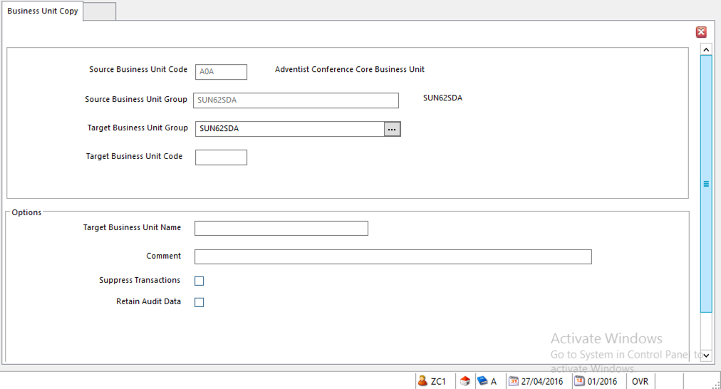
- In the Business Unit Copy screen, select SUN62SDA as the Target Business Unit Group
- Click OK

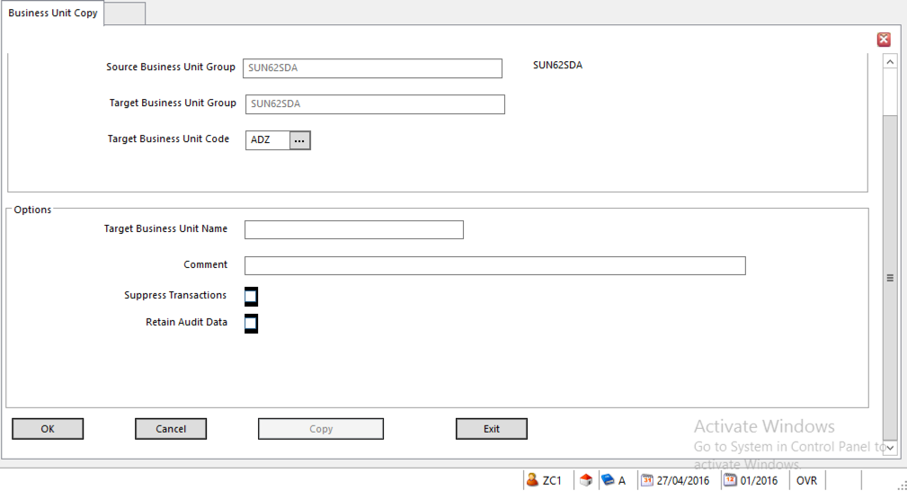
- Enter the new Business Unit Code in the Target Business Unit Code field
- Click OK
- The name of the Core Business Unit will be automatically displayed in the Target Business Unit Name Field; this value can be changed if necessary

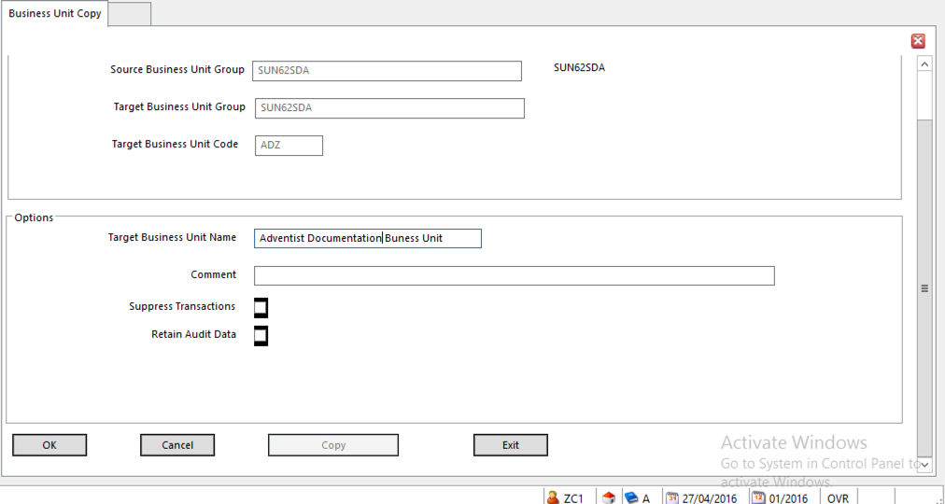
- Click OK
- Copy button will be activated

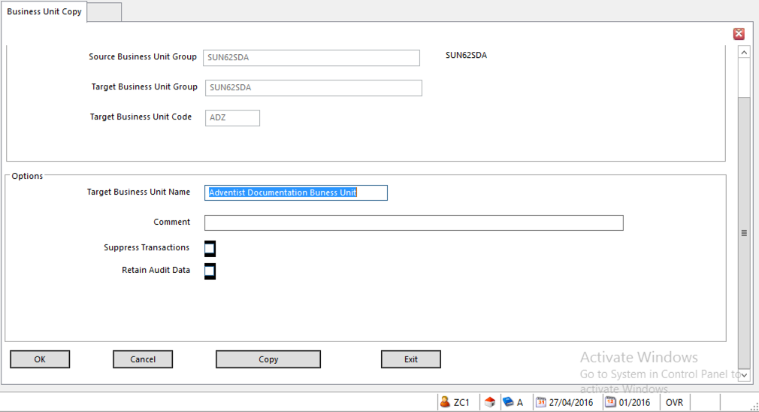
- Click Copy
- The Information Message will be displayed

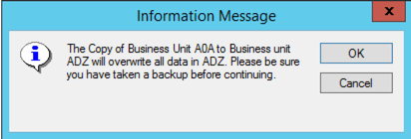
- Click OK
- A Synchronization Summary will be displayed

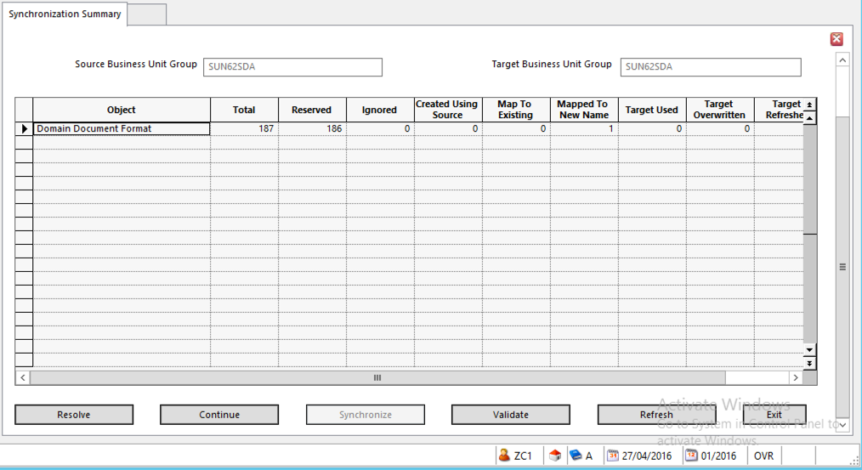
- Click Continue
- The Business Unit Processing screen will show processes as they are completed
- When all processes are finished, the last process listed will be Copying completed

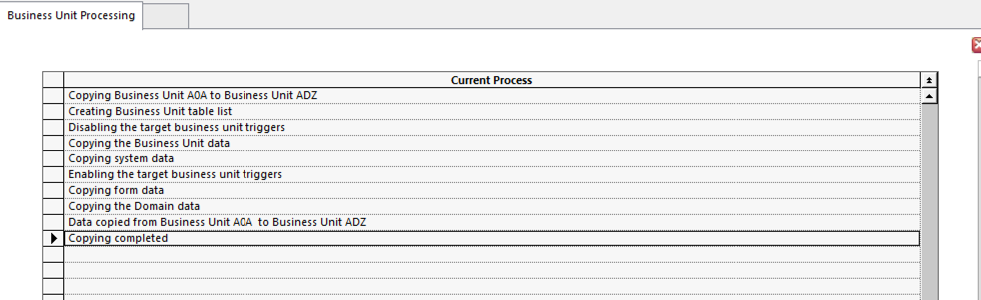
- Click Exit
- You will be taken back to the Business Unit Copy screen

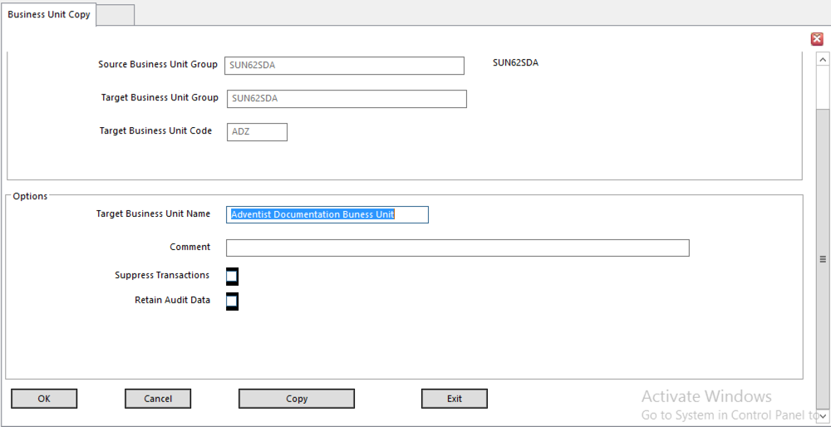
- Click Exit
- You will be returned to Business Unit Administration

Put Business Unit Online

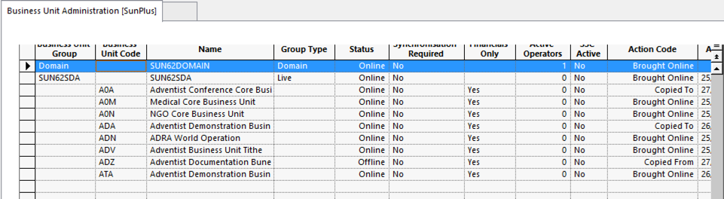
- Select the new business unit

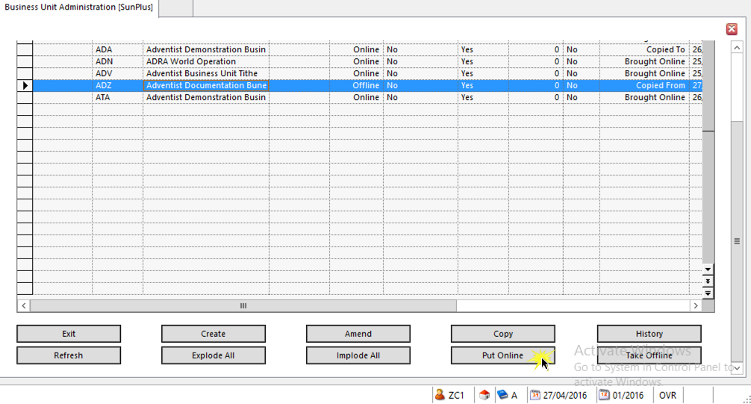
- Click Put Online
- The following Information Message will be displayed

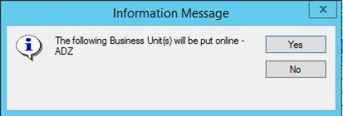
- Click Yes
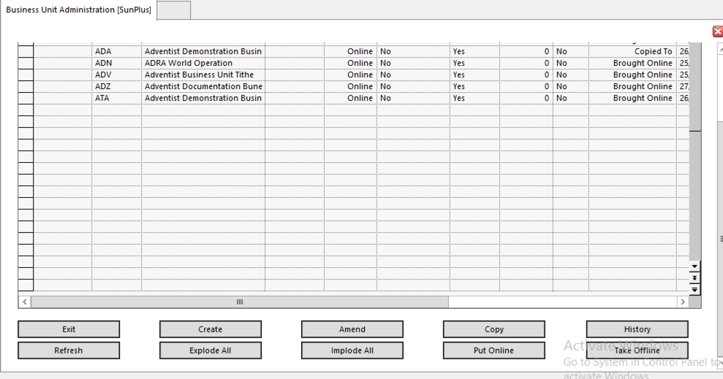
- Click Exit

Localize Business Unit Settings

- Go to Business Unit Administration <BUA>
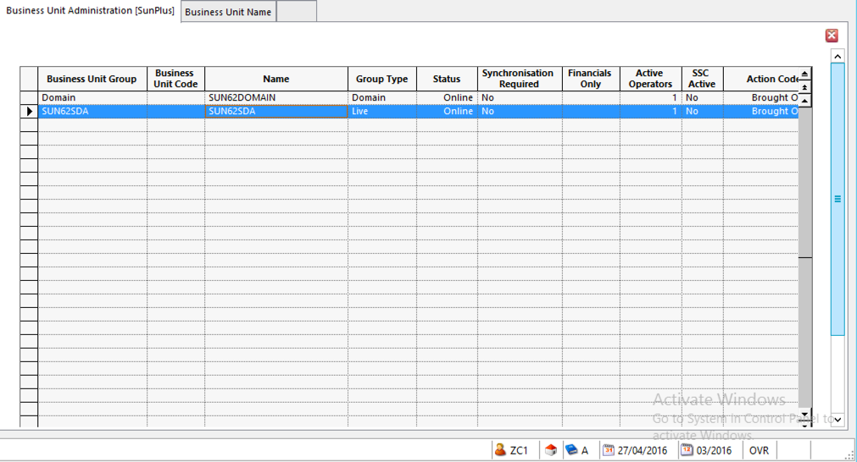
- Select SUN62SDA
- Click

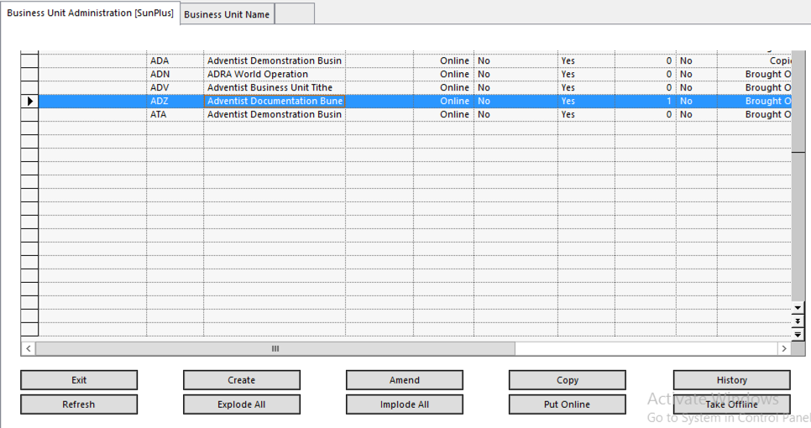
- Select the new business unit
- Click

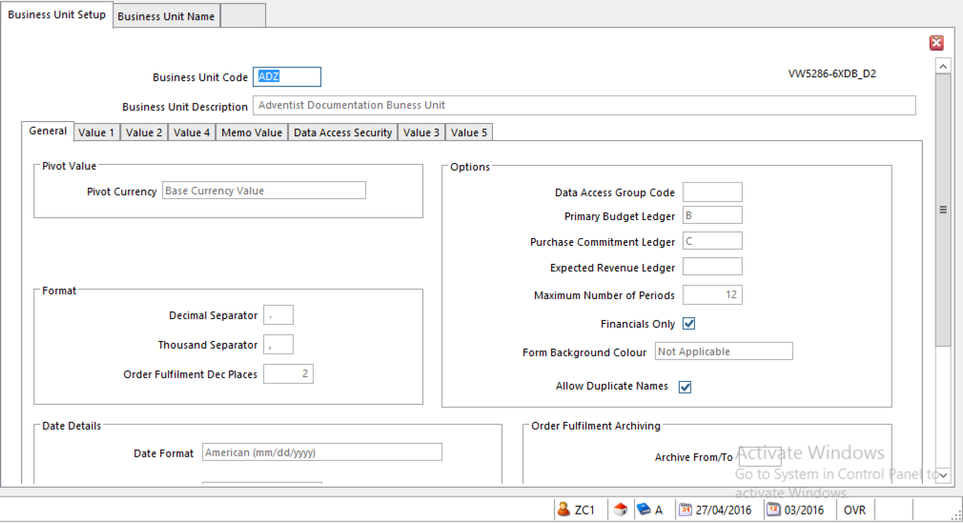
- Click
- Make any changes necessary to ensure the settings are correct for the organization

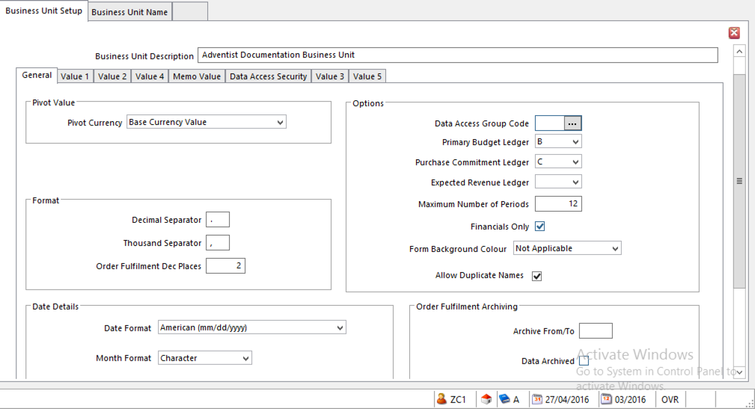
- Go to the Value 1 tab

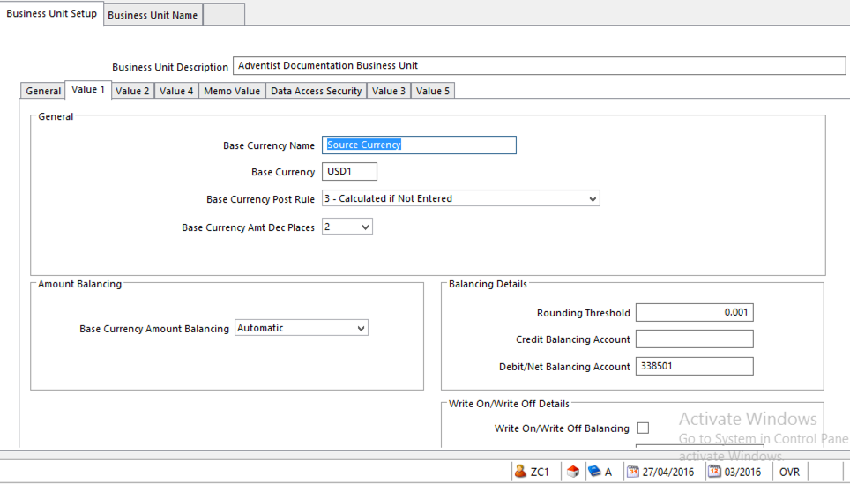
- Change Base Currency Name

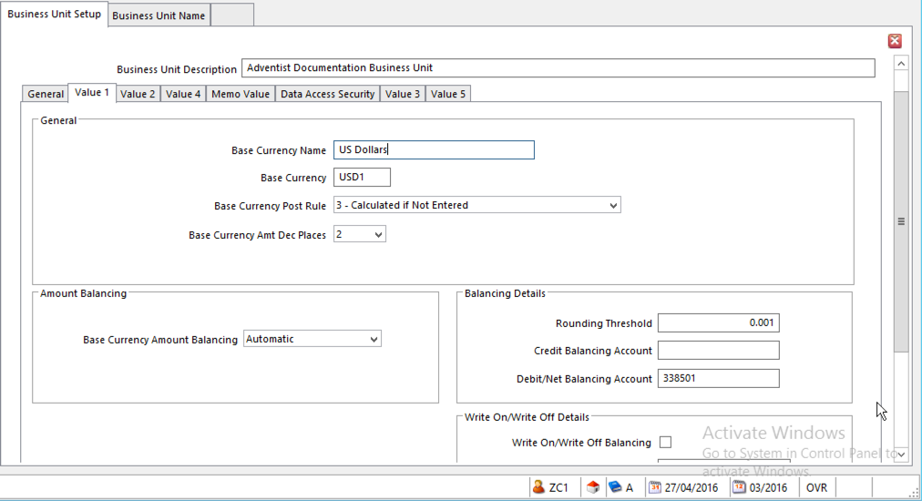
- Go to the Value 4 Tab

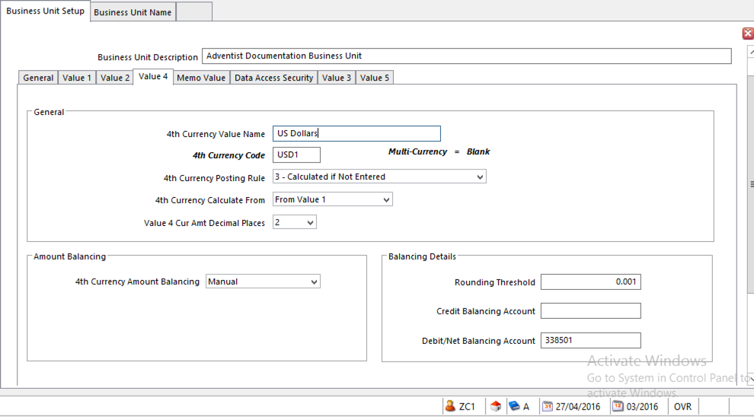
- Click OK
- The Business Rules Message will be displayed again

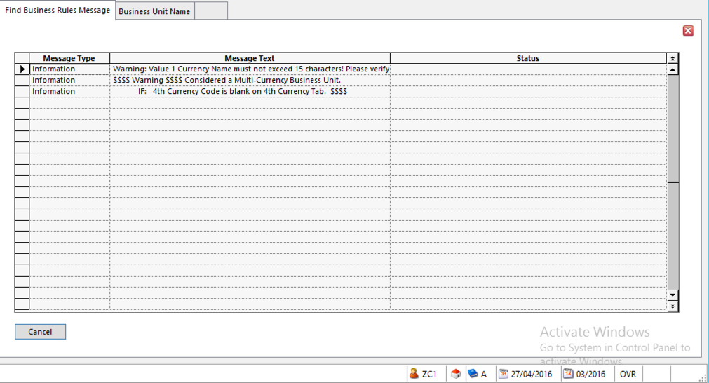
- Click Cancel

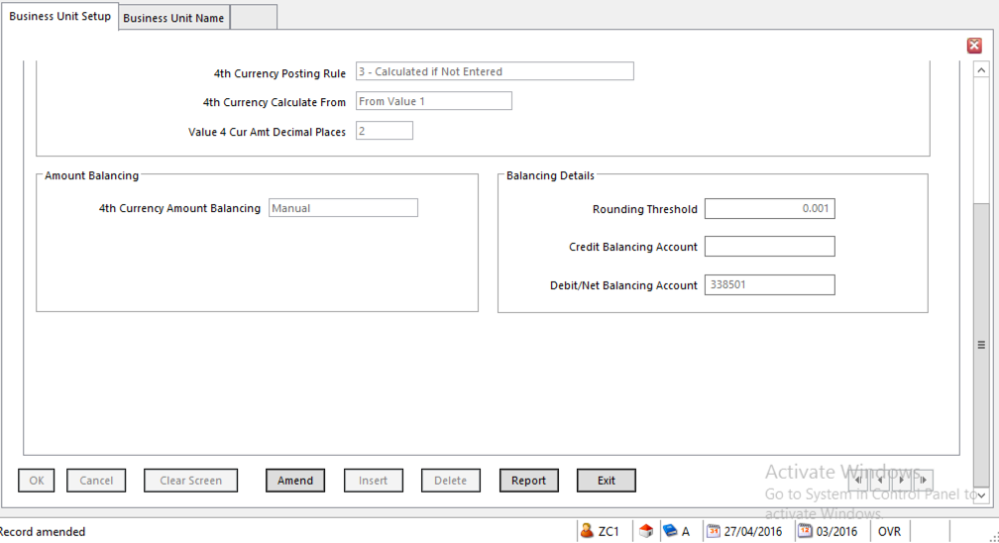
- Click Exit

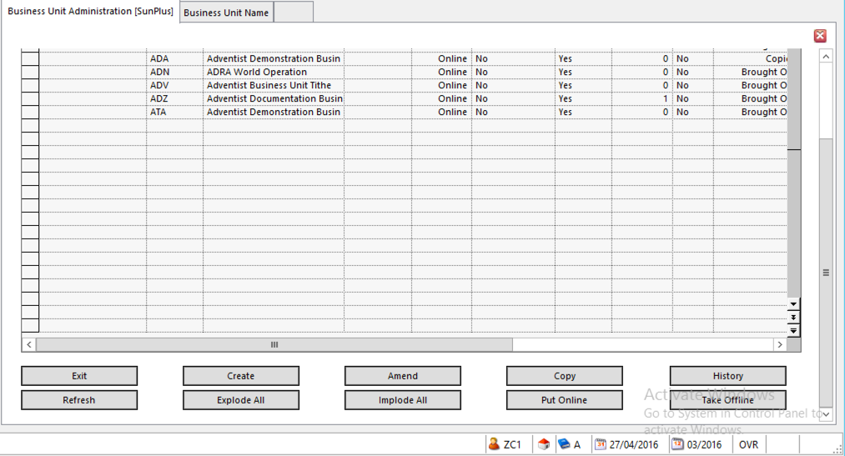
- Click Exit

Change Business Unit

- Go to Change Business Unit

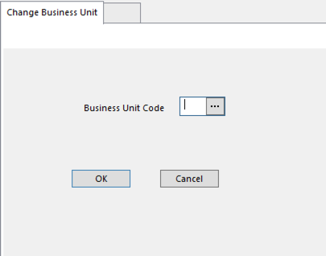
- Enter Business Unit Code for the new business unit
- Click OK

Run Report Model – RMD

- Type in RMD

Name Business Unit

- Go to Business Unit Name Setup <BUN>

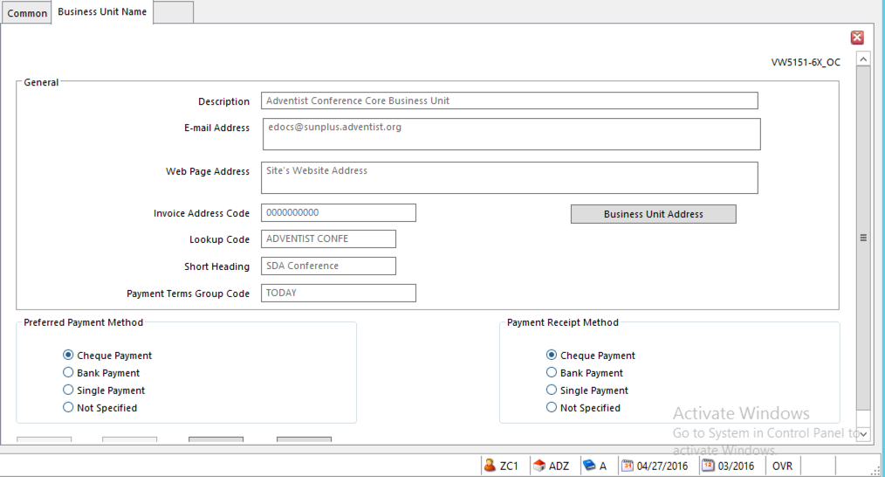
- Click Amend
- Change the Description to the name of the organization
- Enter the Email Address and Web Page Address (optional)
- Invoice Address Code should be 00000000
- Lookup Code - the name of the organization
- Short Heading - the name of the organization
- Payment Terms Group Code - TODAY

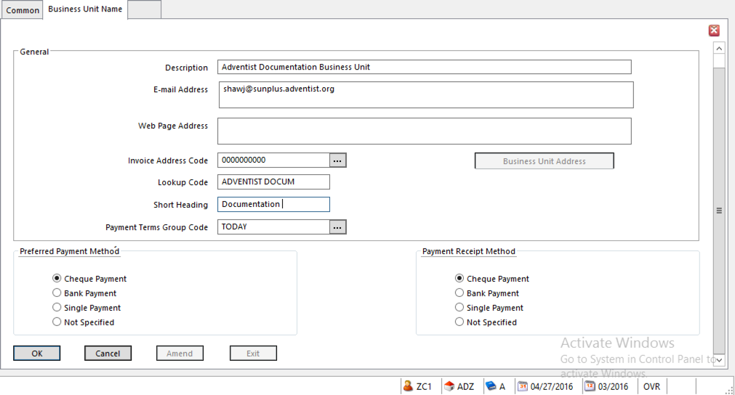
- Click OK
- Click Exit

Amend Ledger Setup

- Go to Ledger Setup <LES>

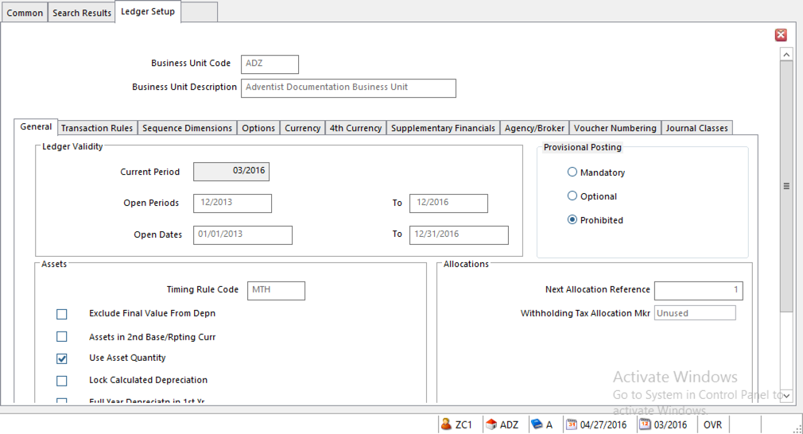
- Click Amend
- Enter Current Period

- Open Periods – the range should be large enough to allow upload of end of year balances
- Open Dates - the range should be large enough to include end of year

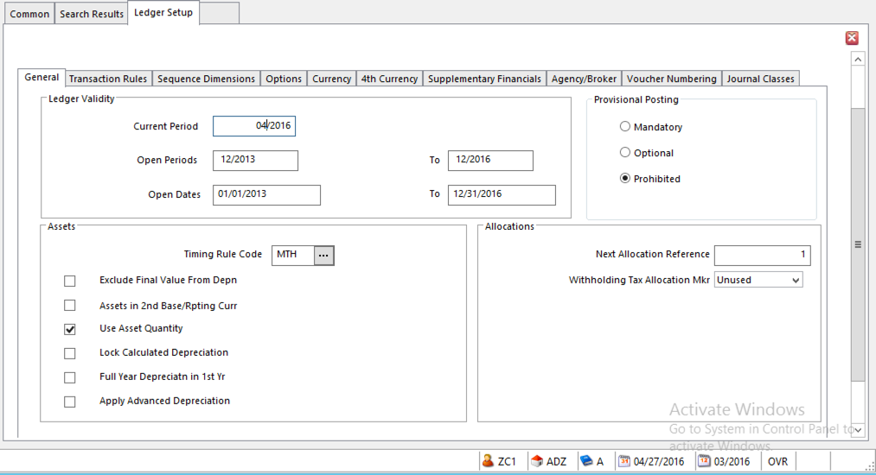
- Go to Voucher Numbering Tab
- The details on this tab should be as follows:

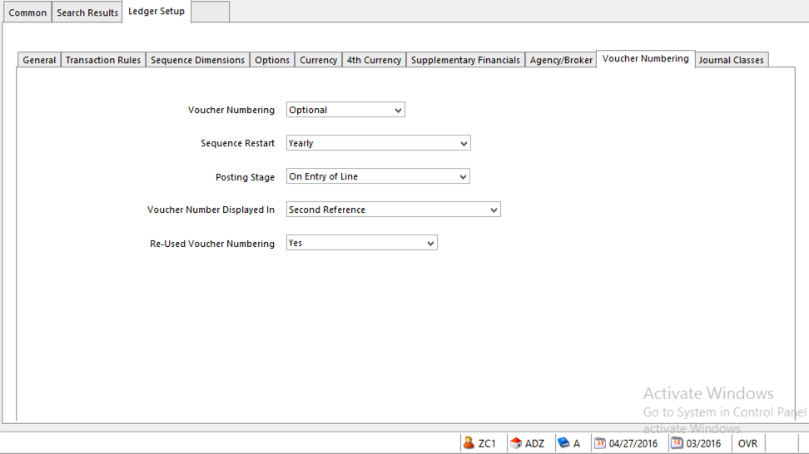
  - Voucher Numbering – will Voucher Numbering be used
    - Optional – SunPlus default - voucher # can post with journal transactions
    - Mandatory – journals must be posted with voucher numbering
    - Prohibited – journals cannot be posted with voucher numbers
  - Sequence Restart – when voucher numbering is automatically restarted (reset to 1).
    - Not Used – business unit is not using voucher numbering
    - By Period – restarts voucher numbering sequence at Current Period change
    - Yearly – restarts voucher numbering sequence when Current Year is changed in the Period (SunPlus default)
    - Daily – restarts voucher numbering sequence for each new date
    - Transaction Reference – reserved for future use
    - Never – voucher numbering sequence never restarts at 1

NOTE: When voucher numbering is restarted, separate sequences are simultaneously maintained for each new period, year, or date. For example, if Period is selected, and the period is changed from 01/2017 to 02/2017, a new sequence starts for period 02/2017; but any transactions posted back into period 01/2017 continue to use the numbering sequence for period 01/2017.

NOTE: Set sequence restart interval to correspond to the value set for date or period in Transaction References <TRS>.

NOTE: Each Voucher Number Stream can have a different Sequence Restart interval. The Sequence Restart interval set in Voucher Number Stream Setup for the Voucher Number Stream overrides the setting in Ledger Setup. The setting in Ledger Setup is used for Voucher Numbers Streams defined with a Restart option set to Use Ledger Setup Default.

    - Posting Stage – determines point where a voucher number is assigned during journal creation. This option applies only to Ledger Entry
      - In Ledger Import and other journal generation processes, voucher numbering is always assigned when the generated journal is either being Held or being posted to the ledger (either provisional or hard posting).
      - Off – no voucher numbering used
      - On Entry of Line – voucher number assigned when all details of the journal are complete (SunPlus default)
      - On Entry of Period – voucher number assigned when period is entered on journal line
      - On Posting – voucher number is assigned either when the journal is Held or when it is posted (either provisional or hard posting)
    - Voucher Number Displayed in – determines how the voucher number is displayed in journal transactions, in Ledger Entry, any other journal process, query, report
      - Transaction Reference – displayed in Transaction Reference field
      - Second Reference - displayed in Second Reference field
      - Not Applicable
    - Re-Used Voucher Numbering – decides how a gap in journal numbering is treated.
      - Gaps might occur if a voucher number is used for a provisional transaction that is subsequently deleted
      - Not Used
      - Yes – gaps are reused. For example, if voucher numbers 1, 2, 4, 5 have been used, the next voucher number to be assigned is 3, after which the sequence continues with 6
      - No – gaps are ignored

- Click OK
- Click Exit

Create Site’s Basic Address Codes

- Go to Addresses (Address Setup) <ADD>

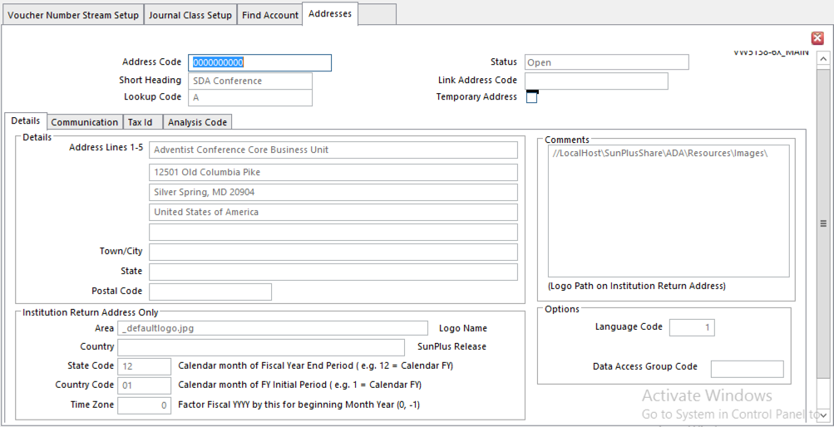
- Click Amend
- Set up organization’s Return Address Code (for invoices)
  - For Return Address Code 0000000000
    - Short Heading – organization’s acronym – i.e., GC, or SID
    - Lookup Code – organization’s SDA ORGID
    - Address Line 1 – organization’s name
    - Address Lines 2 – 5 – organization’s address
    - State Code – check to ensure the month of the organization’s end of fiscal year is correct
    - Country Code – check to ensure the month of the organization’s start of fiscal year is correct
    - Time Zone – factor fiscal year by this for beginning month year
    - Comments – follow this path to replace the SDA logo with the organization’s logo

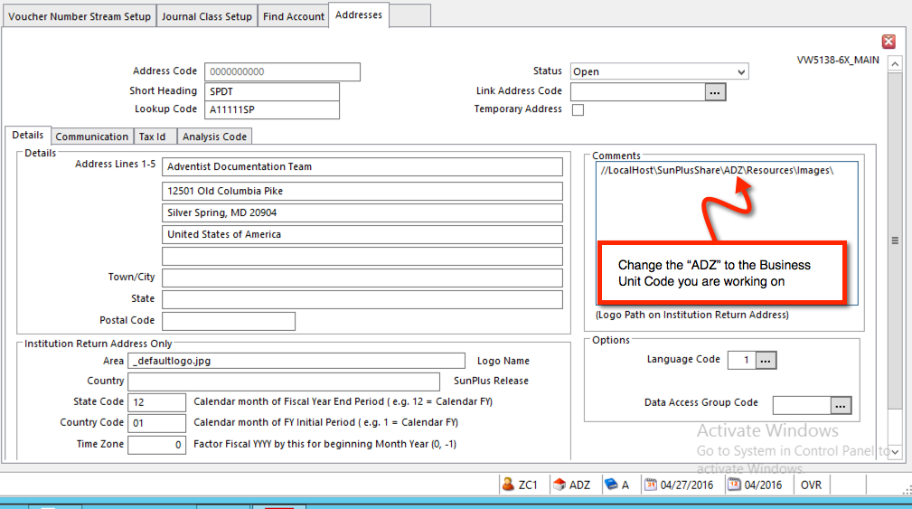
- Click OK
- The Business Rules Message will pop up

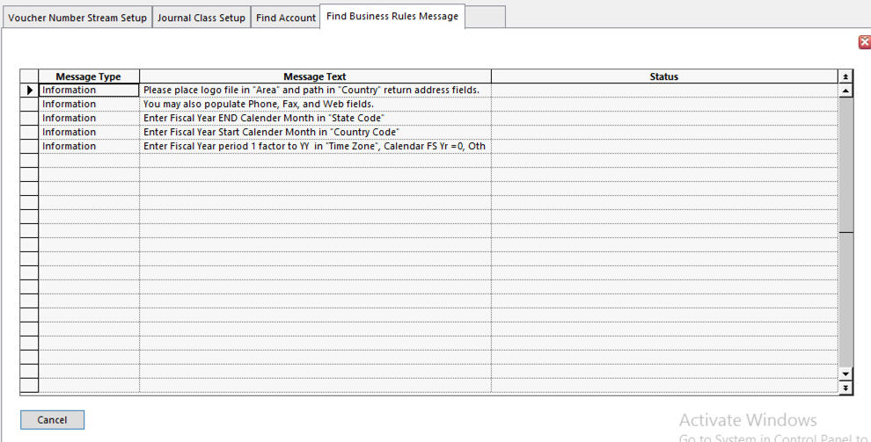
- Click Cancel
- Click Clear Screen
- Set up SDA Organization Address Code for the organization:
- For Address Code AXXXXX
    - Short Heading – organization’s acronym – i.e., GC, or SID
    - Lookup Code – organization’s SDA ORGID
    - Address Line 1 – organization’s name
    - Address Lines 2 – 5 – organization’s address
    - State Code – check to ensure fiscal year end month is correct
    - Country Code – check to ensure fiscal year start month is correct
    - Time Zone – factor fiscal year by this for beginning month year
    - Comments – follow this path to replace SDA logo with the organization’s logo

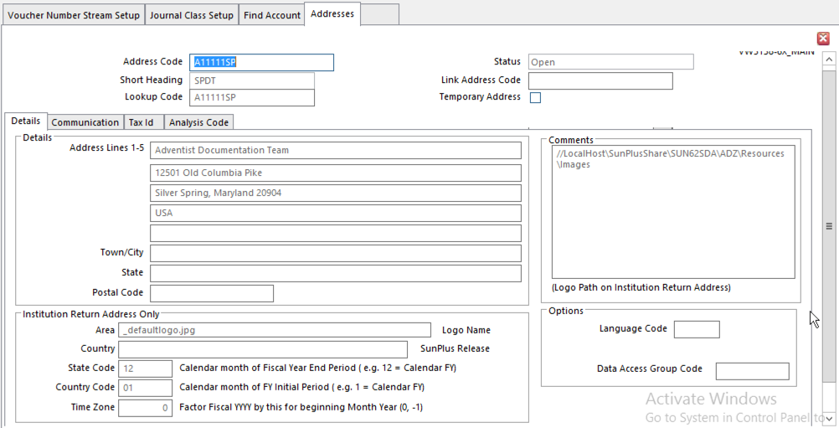
- Click OK
- Click Clear Screen
- Set up SDA ORGID Code for the organization’s parent organization
- For SDA ORGID for Parent Organization Code - AXXXXX
    - Short Heading – organization’s acronym – i.e., GC, or SID
    - Lookup Code – organization’s SDA ORGID
    - Address Line 1 – organization’s name
    - Address Lines 2 – 5 – organization’s address
    - State Code – check to ensure fiscal year end month is correct
    - Country Code – check to ensure fiscal year start month is correct
    - Time Zone – factor fiscal year by this for beginning month year

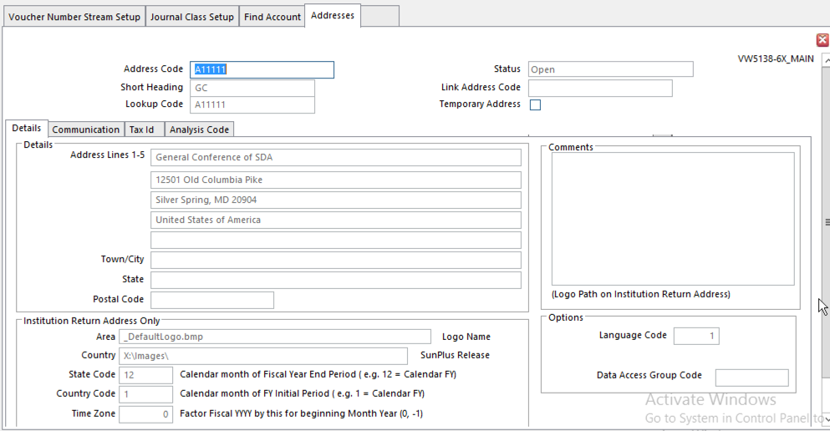
- Click OK
- Click Clear Screen
- Set up Operating Fund Address Code for the organization:
- For Operating Fund Address Code - 10
    - Short Heading – organization’s acronym – i.e., GC, or SID
    - Lookup Code – organization’s SDA ORGID
    - Address Line 1 – organization’s name
    - Address Lines 2 – 5 – organization’s address
    - State Code – check to ensure fiscal year end month is correct
    - Country Code – check to ensure fiscal year start month is correct
    - Time Zone – factor fiscal year by this for beginning month year
    - Comments – follow this path to replace SDA logo with organization’s logo

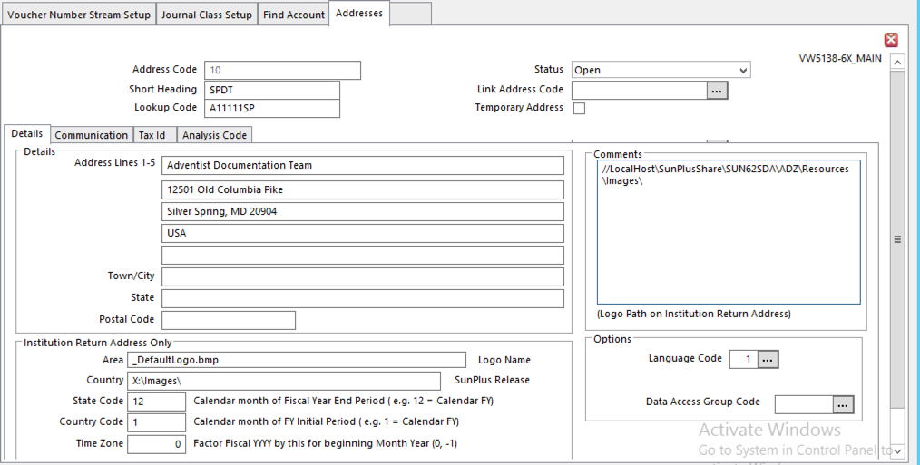

- Click OK
- Click Clear Screen
- Set up organization’s Plant Fund Address Code

  - For Plant Fund Address Code - 20
    - Short Heading – organization’s acronym – i.e., GC, or SID
    - Lookup Code – organization’s SDA ORGID
    - Address Line 1 – organization’s name
    - Address Lines 2 – 5 – organization’s address
    - State Code – check to ensure fiscal year end month is correct
    - Country Code – check to ensure fiscal year start month is correct
    - Time Zone – factor fiscal year by this for beginning month year
    - Comments – follow this path to replace SDA logo with the organization’s logo

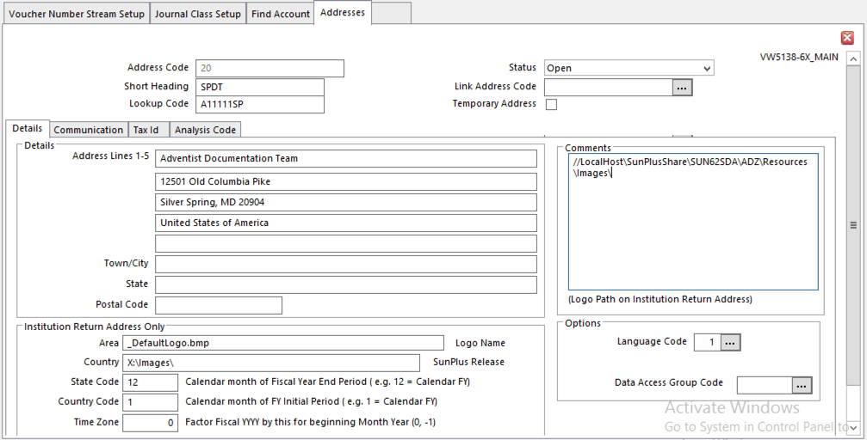
- Click OK
- Click Exit

Create Currency Codes

- Go to Currency Codes <CNC>
- Core comes with USD Currency Codes; create a new currency code for a Currency other than USD

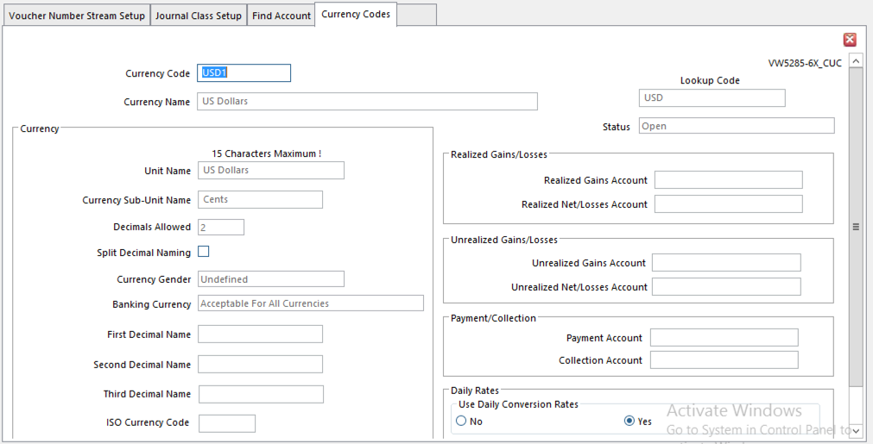
  - Single Currency Sites only need one Currency Code
    - Use the International Currency Code for the country’s currency
    - Add a “1” to the end of the 3-digit code – USD1
    - Even though the organization only uses one currency code, check Use Daily Conversion Rates
    - Multi-Currency Sites need currency codes for every currency they interact with
    - Each currency must have three codes:
      - USD1
      - USD2
      - USD3

Period Currency Rates Setup <CNP>

  - Go to Currency Period Rates
  - Period Currency Rates provide the conversion rate to convert one currency value to another in:
    - Ledger Entry
    - Ledger Import
    - Ledger Revaluation
    - Financial Analysis
    - Financial Statements, and
    - Payment Run
  - At least one Period Rate must exist for each Currency Code combination to be used as the default for all financial reporting functions
    - Including Base Currency to Base Currency (i.e., USD1 to USD1)
    - Single Currency Sites need a Period Currency Rate conversion for Base Currency to Base Currency
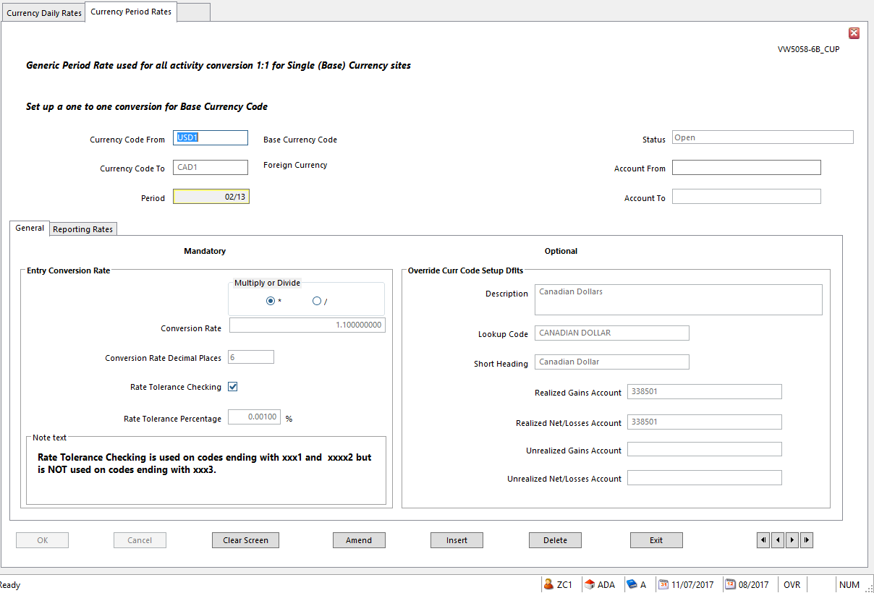

  - Currency Code From – always enter the Base Currency Code here
  - Currency Code To – enter the code of the currency the amount will be converted to
  - Accounting Period –
    - Blank to apply to all Accounting Periods
    - Enter appropriate period for the conversion rate to apply to one period only
  - Multiply/Divide
  - Conversion Rate
  - Rate Tolerance Checking – set as appropriate
    - In SunPlus world, Rate Tolerance is used on codes ending with xxx1 and xxx2 but is NOT used on codes ending with xxx3
    - This option, when set, performs a tolerance check on any rates entered or rates calculated by the system
  - Rate Tolerance Percentage – if Tolerance Checking is required, enter the maximum tolerance allowed for the Period Rate.
    - The percentage difference between the rate entered or calculated and the rate in the Conversion Rate field must be within this percentage
  - Override Currency Code Setup Defaults
    - Only populate these fields if you need to override values set up in Currency Code Setup
    - Realized Gains Account – account to which realized gains calculated using the Currency Period Rate will be posted
    - Realized Net/Losses Account – account to which any net realized amounts, or realized losses, calculated using this period rate are posted
    - Unrealized Gains Account – account to which any unrealized gains calculated using this period currency rate are posted. These unrealized gains are calculated and posted by Ledger Revaluation
    - Unrealized Net/Losses Account – account to which any net unrealized gains or unrealized losses, calculated using this period currency rate are posted. These unrealized gains are calculated and posted by Ledger Revaluation

Daily Currency Rates Setup

- Create any number of Daily Rates for each Currency Code. Different days and account ranges can be created, as needed.
- Daily Currency Rates are only used for a currency if the Use Daily Conversion Rates option is set to Yes for the currency in Currency Codes Setup
- Daily Currency Rates are NOT used in place of Period Rates. Period Currency Rates are needed as well as Daily Currency Rates (Daily Currency Rates are not needed for single currency systems)
- Go to Daily Currency Rates Set <CND>
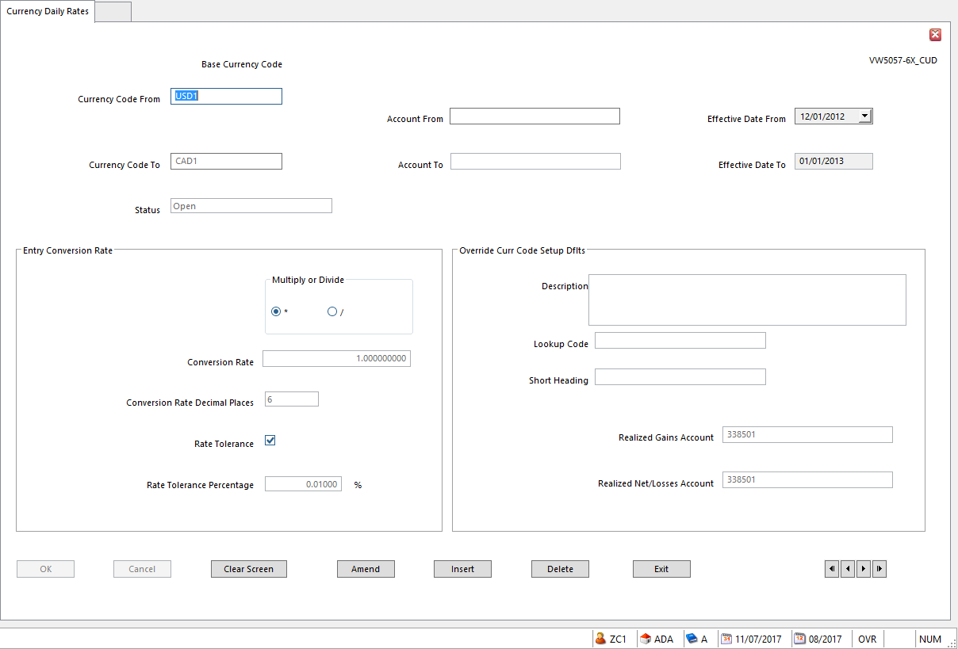
- Currency From – always enter Base Currency Code
- Currency To – enter the foreign currency Code (currency for which the exchange will be made)
- Effective Date – MANDATORY. Enter the date from which the rate applies
- Multiply/Divide
- Conversion Rate – rate entered here will apply for the number of days after the Effective Date according to the Number of Days Valid value entered for the currency in Currency Codes Setup
- Conversion Rate Decimal Places – the number of decimal places used in the currency conversion calculation
- Override Currency Code Setup Defaults – these fields are optional. Use to override values set in Currency Code Setup for this currency

Define Asset Depreciation Timing Rule (as needed)

- The MTH Depreciation Timing Rule is defaulted in Core. Create a different Depreciation Timing Rule, (if needed) in Asset Depreciation Timing Rule <FDR>
- Depreciation Timing Rules define how to spread the depreciation calculated by Depreciation Calculation over the periods in the year, using a predefined ratio.
  - Example: if there are 13 Accounting Periods in a financial year, the first 12 reflecting calendar months and the 13th holding year-end adjustments, only calculate depreciation for the 12 operational periods
  - The number of operational periods in the financial year can be specified and also it is possible to specify how the annual depreciation charge will be split across those periods. Use this feature to account for periods of, for example, four or five weeks.
  - If there is no timing rule, annual depreciation is divided evenly over the number of periods in the year.
  - The number of periods in the year is specified in the Maximum Number of Periods field in Business Unit Setup (Business Unit Administration)

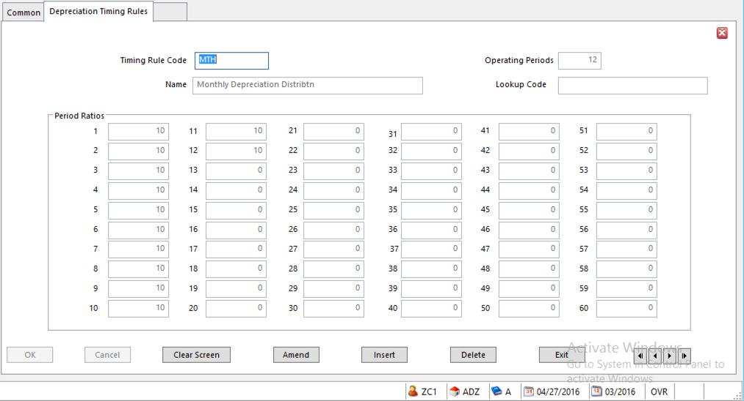
- Click Amend and set the ratios as needed
  - Operating Periods – number of periods for which depreciation is calculated during a financial year
    - Cannot exceed the maximum number specified in Business Unit Setup
        - Period Ratio 1-60 – proportion of the total depreciation to allocate to each period.
          - Defaults to zero – leave at zero if no amount will be apportioned to a period
- Click Exit

Create Payment Terms (as needed)

- For Payment Terms other than terms that come with Core, go to Payment Terms Setup <PYT>
  - If new Payment Terms are set up, the revised terms will apply immediately to any new transactions entered using the terms code.
  - Payment details on existing transactions entered under the ‘old” payment terms settings are not updated. Amend these payment details manually using Account Allocation.

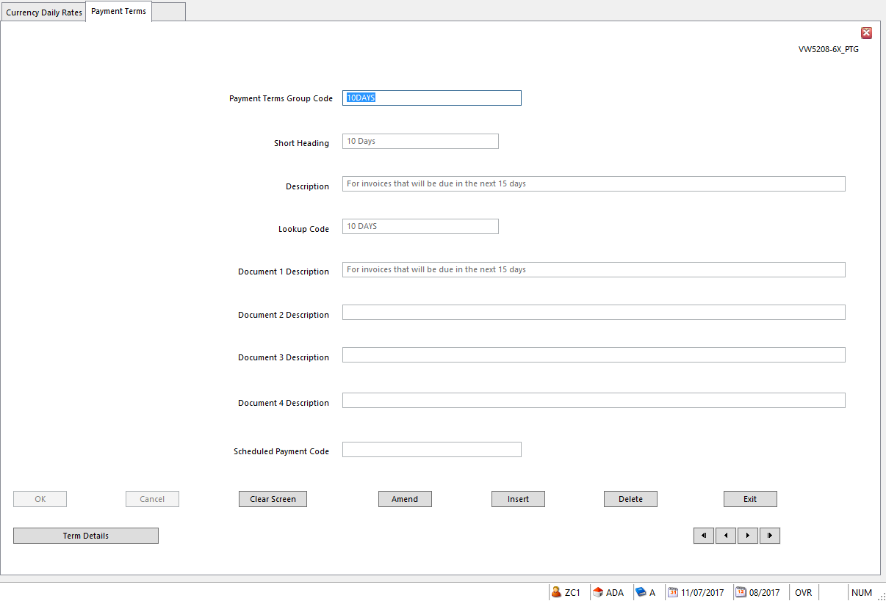
- The values on the first interface are mostly descriptive
  - Document Description fields 1 – 4 – use to note the document to produce on each of the four available document dates (if calculated as part of the payment terms)
    - Example: if you calculate as Document Date 1 the date the first debt chasing letter will be required for the transaction you might enter a Description of First Reminder Letter Due
  - Scheduled Payments Code – associate a Scheduled Payments record to be used with this set of payment terms. The code entered here must be pre-established.
    - Leave blank for no Scheduled Payments
- To set the Payment Term details, click Term Details button at the lower left

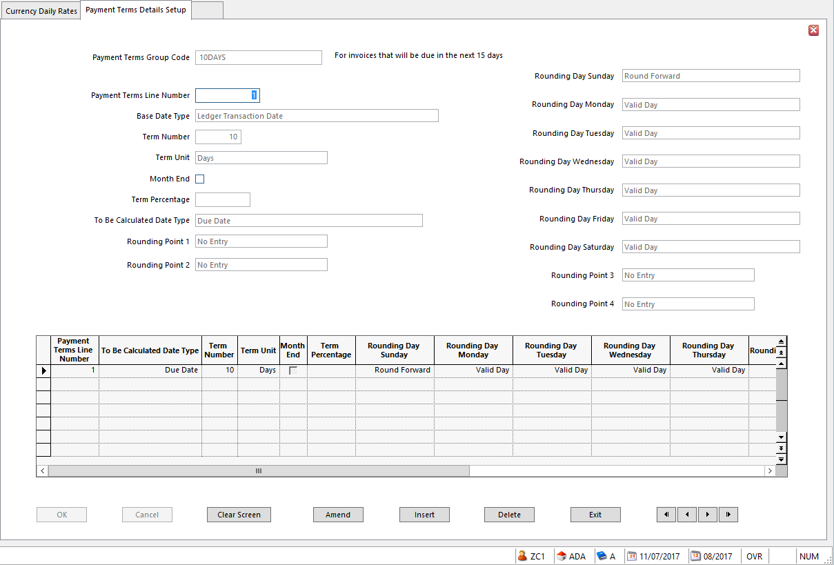
- Use the Details interface to set up rules for calculating a selected date and identifying related information, such as a percentage charge rate. For each payment terms detail line, set the following:
  - Payment Terms Group Code
  - Payment Terms Line Number – line number within the set of Payment Terms
  - Base Date Type – date to use as basis for calculating chosen terms date.
    - This date has to precede the terms date being defining
  - Term Number – number of days or months to add to the base date to calculate the required terms date
    - Term Unit value determines the meaning of this number
  - Term Unit – determines if days or months are added to the base date
  - Month End – if selected, the day number in the transaction date is replaced by the last day of the month and payment terms days are added to this month end date. This groups the month’s transactions together and treats them as if they were all dated on the last day of the month
  - Term Percentage –set up a percentage here to use with Discount Date 1, Discount Date 2, Interest Start Date, and Late Payment Date
    - This will be the percentage of the transaction amount used to calculate the discount or interest amounts

NOTE Interest and Late Payment Charge Percentages are information only – they are NOT used to calculate and apply interest charges

  - To Be Calculated Date Type – the terms date to calculate or define
    - To calculate Payment Due Date, select Due Date
  - Rounding Point 1 – 4 - number of days, between 1 and 31, used to round the calculated date
    - Up to 4 can be set
    - Example: set two rounding points, one of the 10th and one of the 20th. A Due Date calculated as 12th of March is automatically rounded to the 20th of March. A Due Date calculated as the 5th of April is rounded to the 10th of April, and a Due Date calculated as the 22nd of June is rounded to the 10th of July.
  - Rounding Day Sunday-Saturday – define each day of the week as either
    - Valid – days acceptable for the given action – i.e., valid payment dates
    - Round Backward – if the calculated day falls on this day of the week, it should be set back to the nearest Valid day
    - Round Forward – if the calculated day falls on this day of the week, it should be set forward to the nearest Valid day

NOTE Round Backward must never follow Round Forward.
If only one Valid day is set, default is that all preceding days will Round Backward and all following days will Round Forward. If a single Valid day is set, the Due Date can match weekly collective invoices.
- Click OK
- Click Exit

Create/Amend Budget Labels

- If the organization requires a budget ledger in addition to the standard A – Actuals and B – Budget Ledgers that come with Core, go to Budget Labels <BLB>

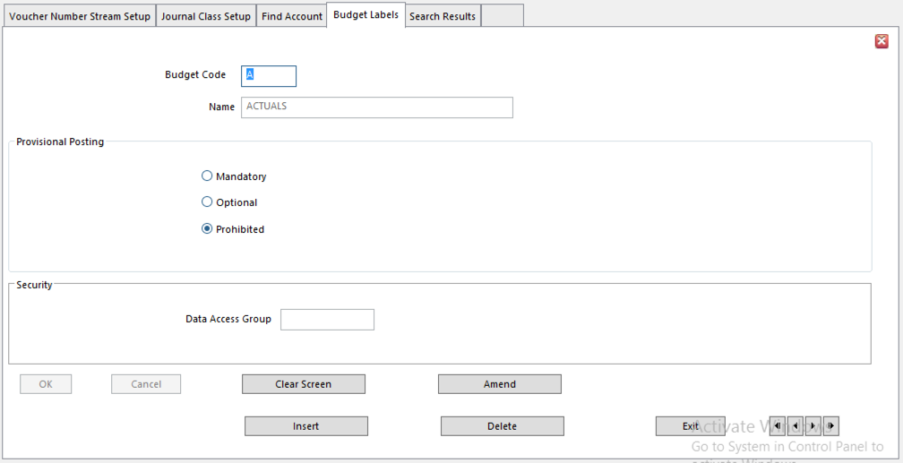
- Budget Code – assign one of the unassigned letters
- Click OK
- Enter Name for the new ledger
- Provisional Posting – must be checked
- Click OK
- Click Exit

Setup/Amend Analysis Dimensions (as needed)

- The following Analysis Dimensions come with Core

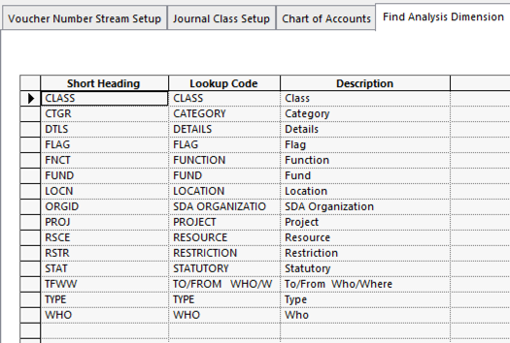

- For additional Analysis Dimension(s), go to Analysis Dimension Setup <AND>
- Enter the Analysis Dimension
- Click OK

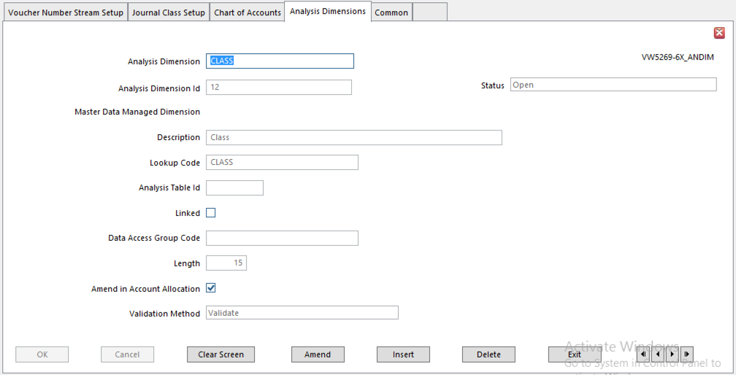

- Analysis Dimension Id – automatically supplied by system
- Description – name of the Dimension
- Lookup Code – name of the Dimension
- Length – enter the length the Analysis Code should be – 15 is the longest
- Amend in Account Allocation – only check if the system should allow the user to change the Analysis Code associated with this Dimension in Account Allocation
- Validation Method – For the system to validate the accuracy of the Analysis Code associated with this Dimension in Ledger Import or Static Data Import, select Validate
- Click OK
- Click Exit

Amend Analysis Structure Setup (as needed)

- Core comes with the following Analysis Structure – only amend if needed

  - Chart of Accounts Analysis

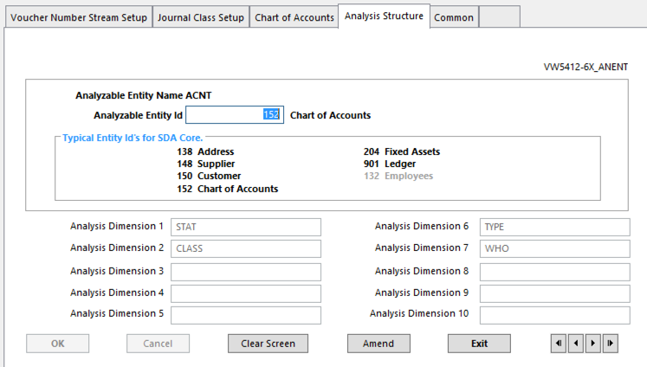
  - Fixed Assets

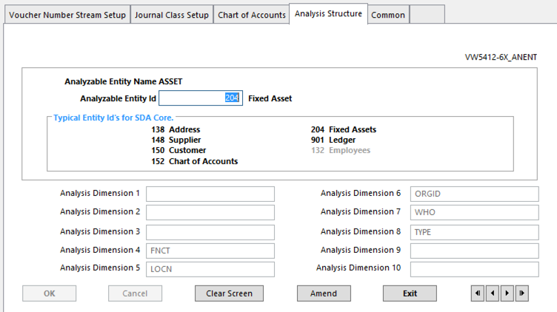
  - Ledger

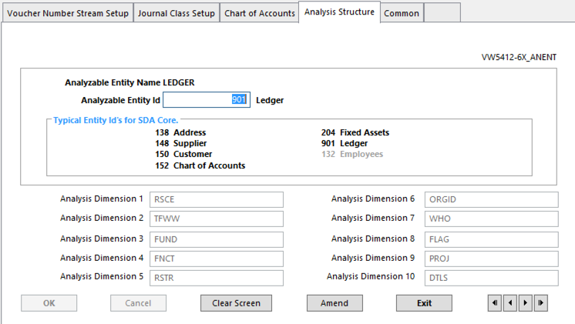
- To attach or amend the Analysis Structure for a table, go to Analysis Structure Setup <ANS>
- Enter the table Analyzable Entity Id number (see the list of Typical Entity Id’s for SDA Core to determine the table number)
- Click OK
- Enter the Analysis Dimension Code to be assigned in the Analysis Dimension field
- Click OK

- To attach Analysis Dimensions to a table not represented in the list of Typical Entity Id’s for SDA Core, click the Assist button at the right of the Analyzable Entity Id field. The complete list of Analyzable Entity tables is available there.

Voucher Number Stream Setup <VNS>

- SunSystems 6.2 uses Voucher Numbering.
- The basic Voucher Numbering Streams come pre-established in Core. Amend details as needed.

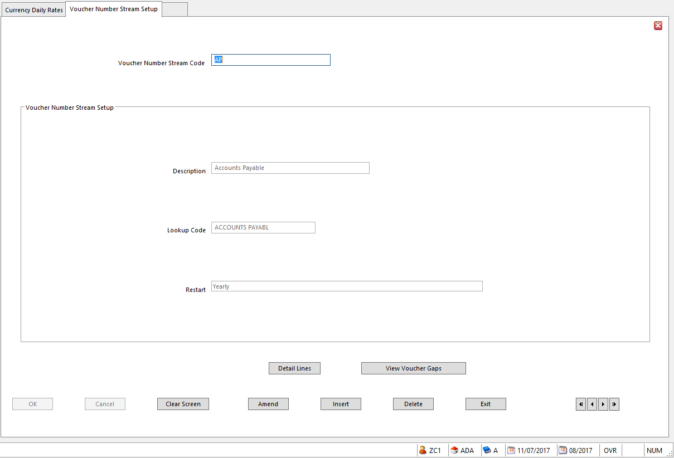

- A voucher number is a unique reference for a balancing business transaction. Some accounting environments use it as the main reference for financial transactions.
- Voucher numbering is mandatory for all transactions as the SunPlus default
- Voucher numbering can be displayed in Transaction Reference field or Second Ledger Reference.
- Voucher Number can be used as a selection criterion for queries, batch processes, and reports.
- On the first interface, set up the Code, Description, and Lookup Code.
- Restart – determines when the voucher number stream will be restarted – reset to 1 automatically
  - Use Ledger Setup Default – restarted according to Sequence Restart option set on the Voucher Numbering tab in Ledger Setup
  - Period – restart voucher number stream when current Period is changed
  - Year – restart voucher number stream when current Year is changed in the Period
  - Daily – restart voucher number stream when a new date is used on ledger transactions
  - Never
- Click OK
- Click Exit

Transaction Reference Format <TRS>

- Transaction Reference Formats are used in Voucher Numbering.
- The basic Transaction References come pre-established in Core. Amend details as needed.

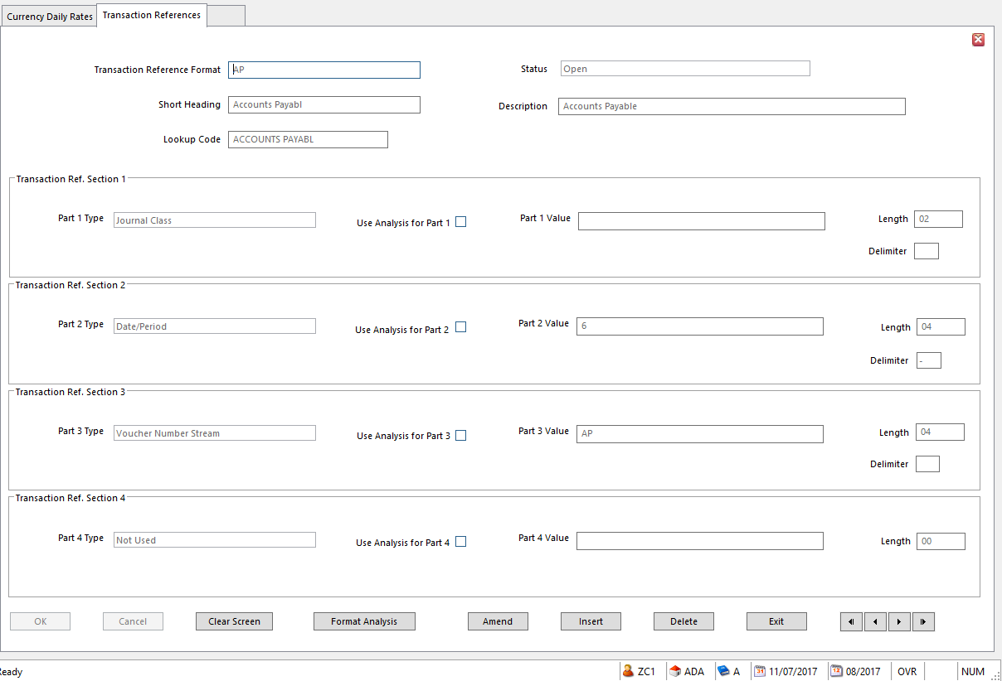
- A Transaction Reference can be broken down into four parts.
- Each potential part has a special section on the interface. Each part can be defined individually.
  - It is not mandatory to use all four parts in a Transaction Reference.
- Each section contains the following:
  - Type – define the type of data in the part
    - Number Stream
    - Constant Value
    - Operator Id
    - Date/Period
    - Input by Operator at Run Time
    - Journal Class
    - Voucher Number Stream

NOTE At least one of the part types must be either Number Stream of Voucher Number Stream

If either Journal Class or Voucher Number Stream is selected for one of the Transaction Reference parts, the other must also be selected as another part; the two work together.

  - Use Analysis – check if this part of the Transaction Reference is to be varied by referring to analysis held on the transaction
  - Value – value for the part, depending on the type of data defined in the Type field
    - Number Stream – enter a valid Number Stream
    - Constant Value - enter the value
    - Operator Id – leave blank
    - Date/Period
    - User Input – leave blank
    - Journal Class – value is deactivated
    - Voucher Number Stream – enter valid voucher number stream
  - Length – the number of characters for the length of that part
  - Delimiter – character to be used between this part and the next part of the Transaction Reference (optional)

NOTE If Delimiter is left blank, a space will be inserted when this Transaction Reference is used. Set the Delimiter to 0 for no delimiter to be inserted.

NOTE To set a Date or Period in a Transaction Reference:

To set up part of the reference as a date, enter the following in the Value field:

1 – century
2 – year
3 – month
4 – day
5 – period
6 – year of accounting period
Example: Part 1 – Type = Date (year is 2010)
Value = 2
Delimiter = -
Length = 2
Part 2 - Type = Number Stream
Value = SEQ (next sequence number is 123456)
Delimiter =
Length = 6
The next Transaction Reference would be 10-123456

Journal Class Setup

- Journal Class is part of the Voucher Numbering Stream
- Journal Classes classify journals at a basic accounting level
- Use them to associate logical groupings of journal types more formally than by using Journal Type codes. Use them to group journals according to their business function.
- Use Journal Classes if you are using Voucher Numbering

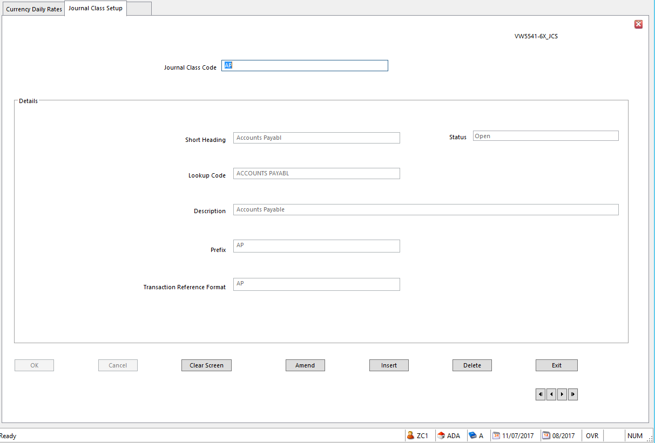
- Prefix – a unique code to identify the Journal Class
- Transaction Reference Format – enter Transaction Reference Format for this Journal Class

Journal Types

- The SunPlus Core comes with pre-established Journal Types.
- More Journal Types can be created, depending upon the site’s needs.
- With the addition of Voucher Numbering, the Journal Class set up in the last implementation step must be added to the relevant Journal Type.
- Go to Journal Types

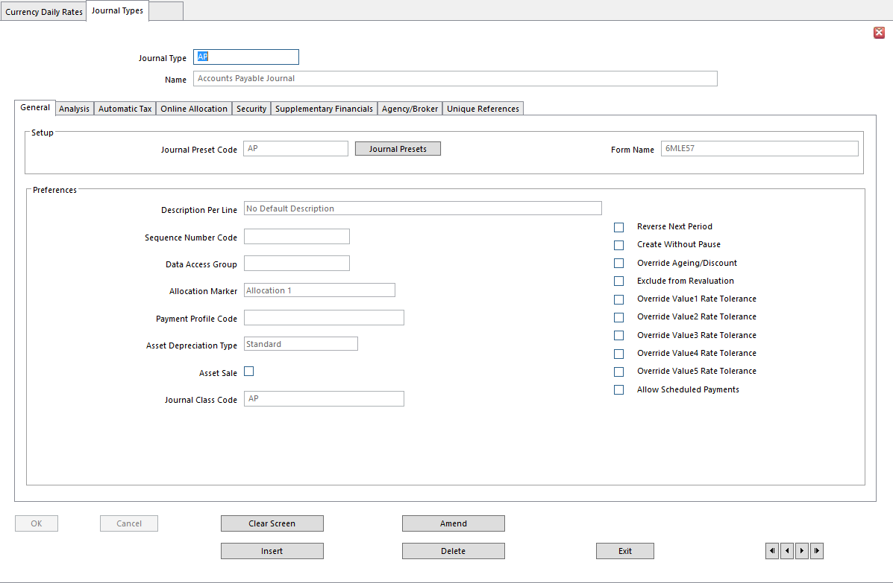

- Journal Class Code – enter the unique Journal Class Code set up for this Journal Type

Check Journal Classes in Ledger Setup

- Ledger Setup comes with pre-established Journal Classes in SunPlus Core. Check to make sure they are correct for the site
- Go to Ledger Setup
- Go to the Journal Classes tab

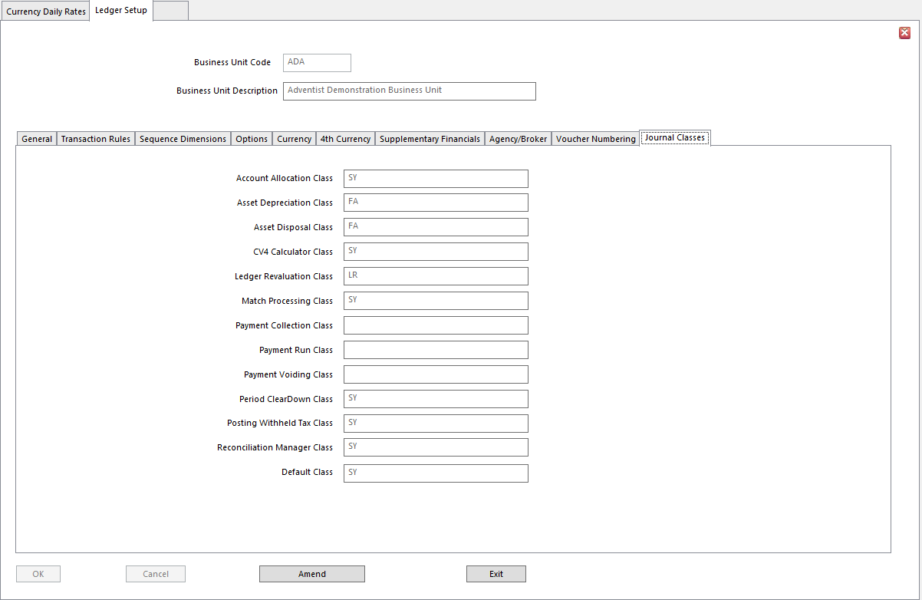

Create Users

- Go to User Manager

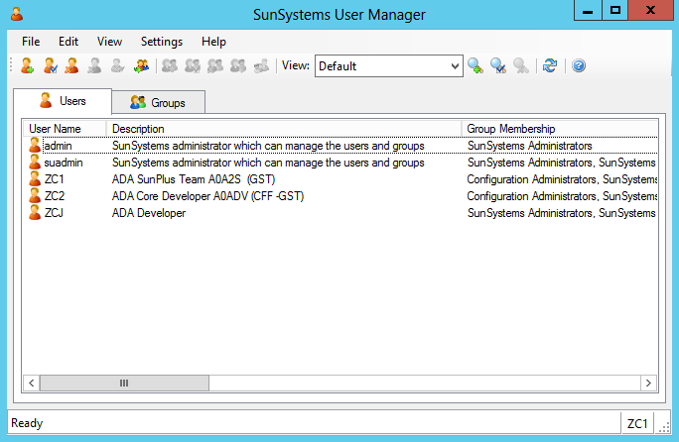

- Add User – click the Add User icon or select Add User from Edit menu
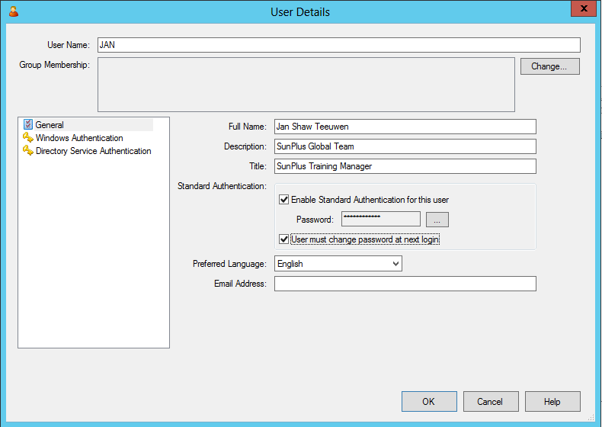
- Click Change button to access User Group list

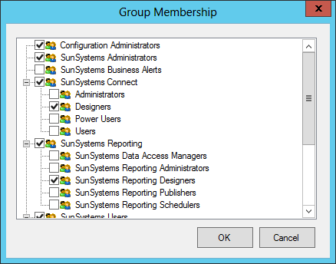
- Tick groups to which the user should belong
  - To prevent the user from having access to User Manager, don’t tick SunSystems Administrator group

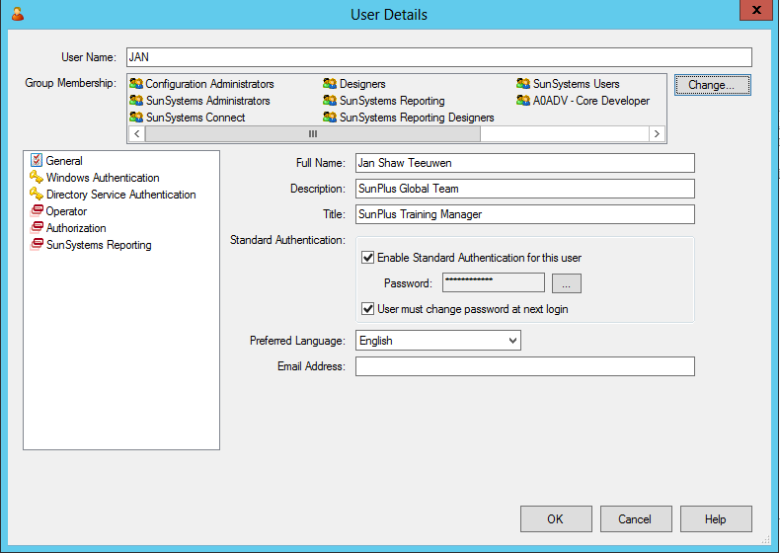
- The Groups selected will be displayed in the Group Membership field
- Click Operator in the pane displayed in the lower left part of the interface

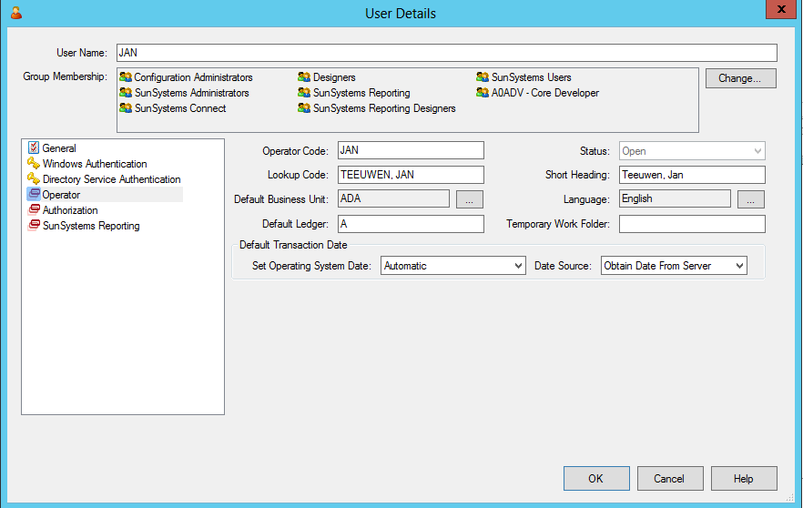

- Enter the Operator Code – this will be the login code
- Lookup Code
- Short Heading
- Default Business Unit – if this isn’t set, the user will have to choose the Business Unit every time
- Default Ledger – if this isn’t set, the user will have to choose the ledger over and over again
- Language
- Set Operating System Date – SunPlus default is Automatic
- Date Source – SunPlus default is Obtain Date From Server

Assign User Groups

- In User Manager, go to the Group tab

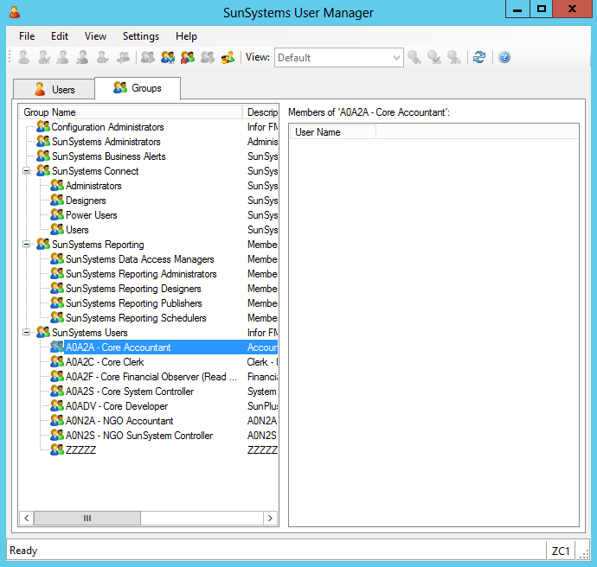

- Select each of the groups (one at a time) that will be using the Business Unit
- Double click on the group

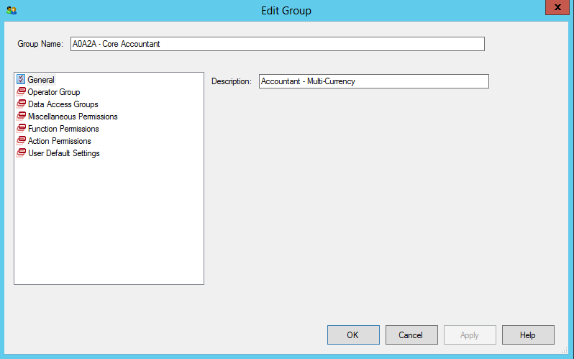

- Click on Miscellaneous Permissions

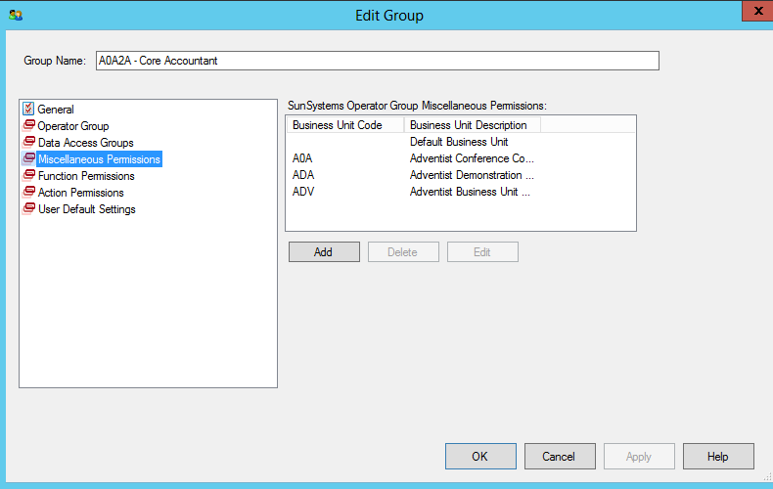

- Click the Add button below the pane on the right

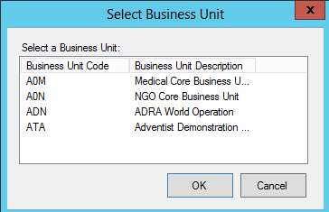

- Select the new Business Unit
- Click OK
- Use this interface to assign or withhold permissions to various processes for users of this group while logged into this Business Unit

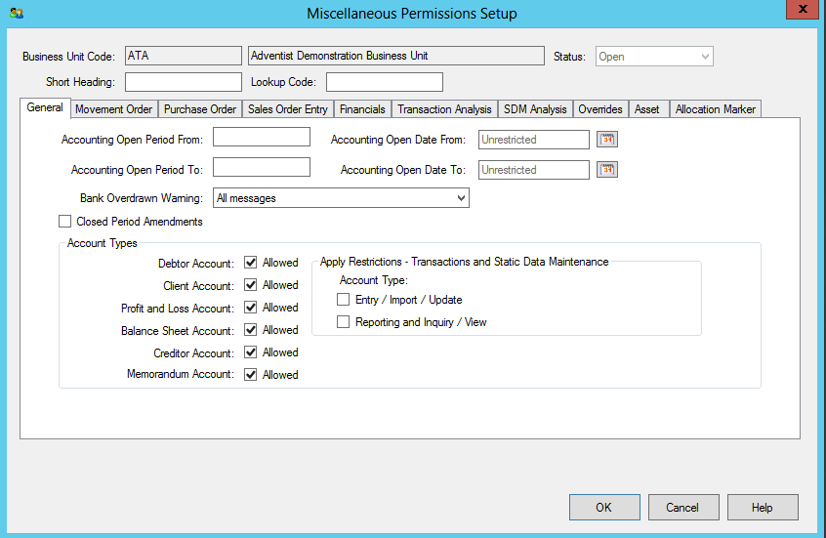

- SunPlus Standard is to accept all defaults here and click OK
- On the Edit Group interface, click Action Permissions

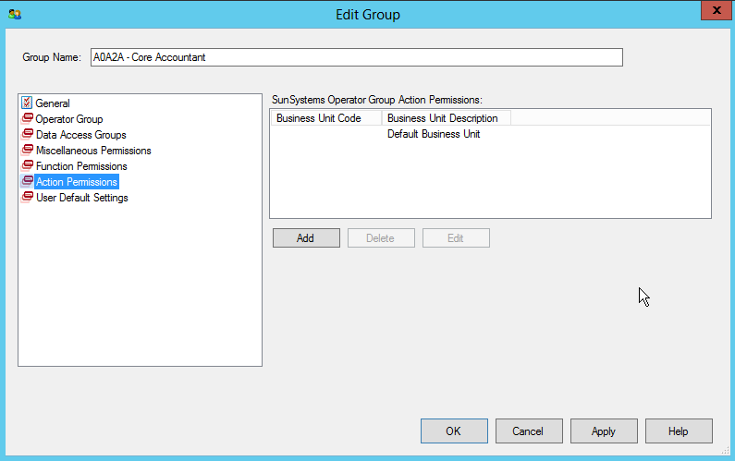

- Click the Add button
- Select the new Business Unit

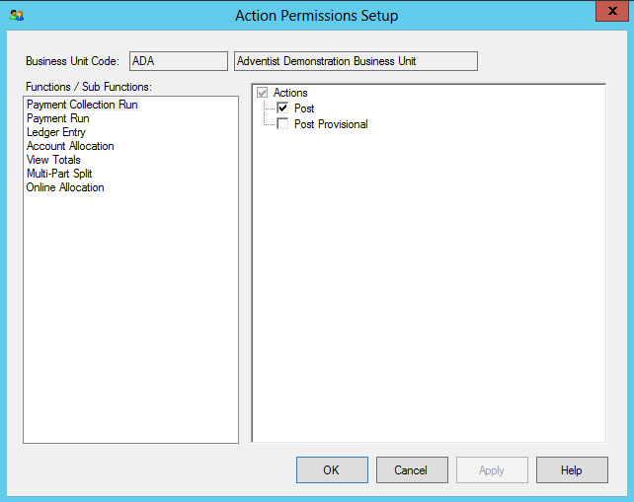

- Click on each of the items in the left-hand pane
- In the right-hand pane for each item, uncheck Post Provisional
- Do this for each of the User Groups for use in the new Business Unit

Upload Chart of Accounts

- Go to Microsoft Excel
- Prepare Chart of Accounts for upload

- Any Excel spreadsheet can work as long as there a column for:

Layout Identifier
Account Type
Account Name
Short Heading
Lookup Code
Balance Type
Status
Currency Code
T1
T2
T3
T4
T5
T6
T7
T8
T9
T10
A2

- To double check MOP settings for the organization’s accounts, refer to this list:
 | L1 | L2 | L3 | L4 | L5 | L6 | L7 | L8 | L9 | L10
1xxxxx | O | O | M | O | O | O | O | O | O | O
162 | O | O | M | M | O | O | O | O | O | M
163 | O | O | M | M | O | O | O | O | O | M
164 | O | O | M | M | O | O | O | O | O | M
165 | O | O | M | M | O | O | O | O | O | M
167 | O | O | M | M | O | O | O | O | O | M
168 | O | O | M | M | O | O | O | O | O | M
191 | O | M | M | O | O | O | O | O | O | O
2xxxxx | O | O | M | O | O | O | O | O | O | O
252 | O | O | M | O | O | M | O | O | O | O
253 | O | O | M | O | O | O | M | O | O | O
258 | O | O | M | O | O | O | O | O | O | M
3xxxxx | O | O | M | O | O | O | O | O | O | O
361 | O | O | M | O | O | O | O | M | O | O
362 | O | O | M | O | O | O | O | M | O | O
364 | O | O | M | O | O | O | O | M | O | O
368 | O | O | M | O | O | O | O | M | O | O
4xxxxx | O | O | M | O | O | O | O | O | O | O
452 | O | O | M | O | O | M | O | O | O | O
453 | O | O | M | O | O | O | M | O | O | O
458 | O | O | M | O | O | O | O | O | O | M
5xxxxx | O | O | M | O | O | O | O | O | O | O
6xxxxx | M | O | M | M | M | O | O | O | O | O
7xxxxx | M | O | M | M | M | O | O | O | O | O
8xxxxx | M | O | M | M | M | O | O | O | O | O
811 | M | O | M | M | M | O | M | O | O | O
822 | M | O | M | M | M | O | M | O | O | O
9xxxxx | M | O | M | M | M | O | O | O | O | O
992 | M | M | M | M | M | O | M | O | O | O
995 | M | M | M | M | M | O | M | O | O | O
997 | M | M | M | M | M | O | M | O | O | O
Axxxxx-Zxxxxx | O | O | M | O | O | O | O | O | O | O
Axxxxx | O | O | M | O | O | M | O | M | O | O
Cxxxxx – Clearing | O | O | M | O | O | O | O | O | O | O
Dxxxxx - Clearing | O | O | M | O | O | O | O | O | O | O
Txxxxx | O | O | M | O | O | M | O | M | O | O
Uxxxxx | O | O | M | O | O | M | O | M | O | O

- When the Chart of Accounts is ready for upload, click on the Infor Q&A tab on the Excel spreadsheet
- Click Accounts

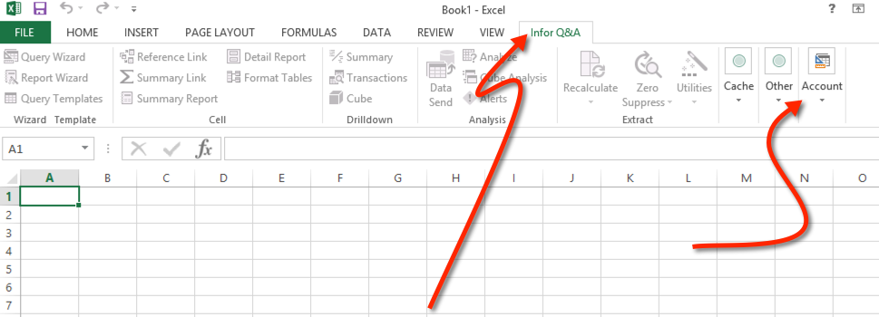

- Click on Data Send

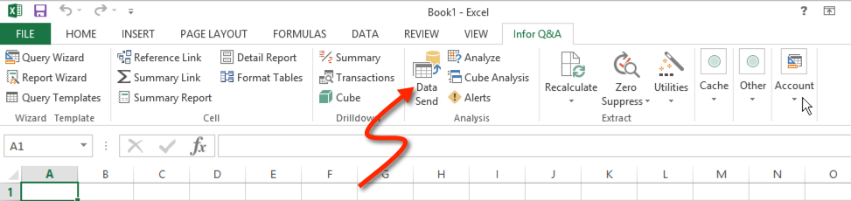

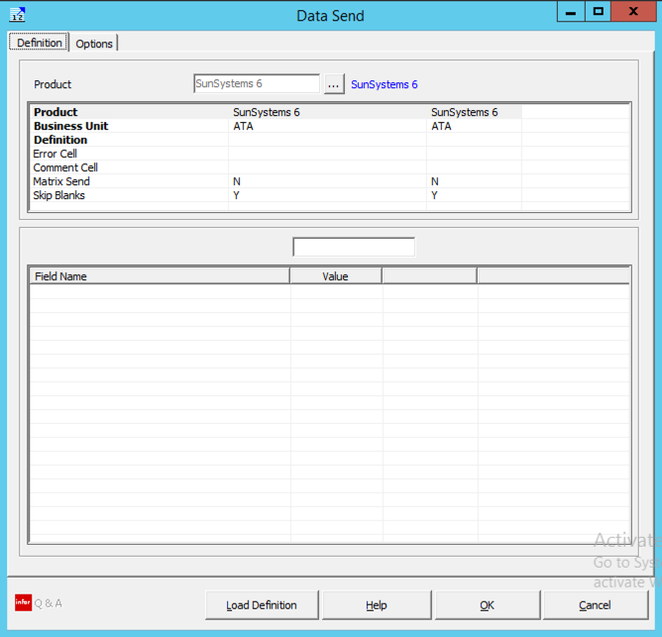
- Map the upload
  - Upper Pane
Product | SunSystems 6
Business Unit | XXX
Definition | Account Code
Layout Identifier | A3
Error Cell | Click in any cell, populated or not

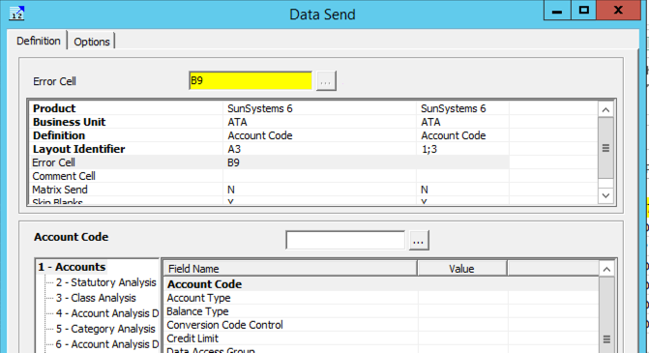

  - Lower Pane
Account Code | C3
Account Type | B3
Balance Type | G3
Currency Code | I3
Description | D3
Enter Analysis Codes 1 | J3
Enter Analysis Codes 2 | K3
Enter Analysis Codes 3 | L3
Enter Analysis Codes 4 | M3
Enter Analysis Codes 5 | N3
Enter Analysis Codes 6 | O3
Enter Analysis Codes 7 | P3
Enter Analysis Codes 8 | Q3
Enter Analysis Codes 9 | R3
Enter Analysis Codes 10 | S3

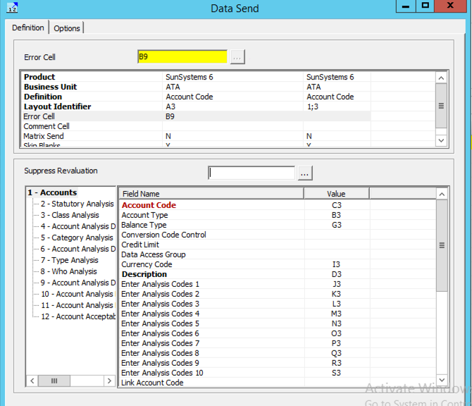
- Scroll down in the lower right hand side pane
    - Lookup Code – F3
    - Short Heading – E3
    - Status – H3
    - 4th Currency Default Currency Code – I3
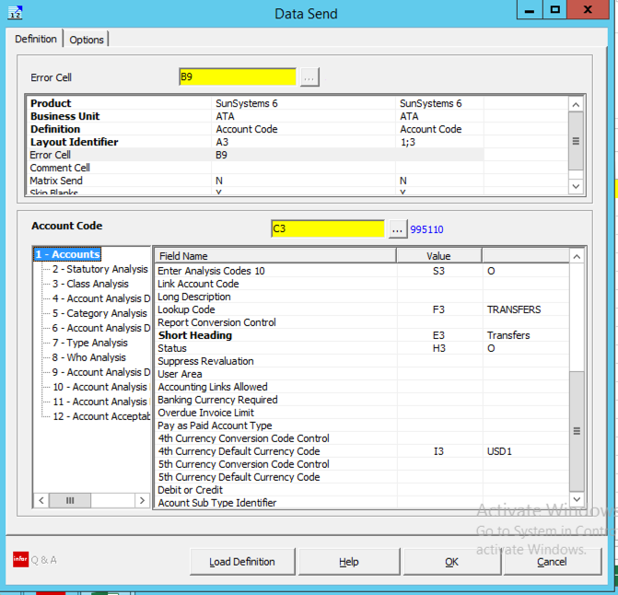
- Click on 3 – Class Analysis in the lower left hand pane of the Data Send interface

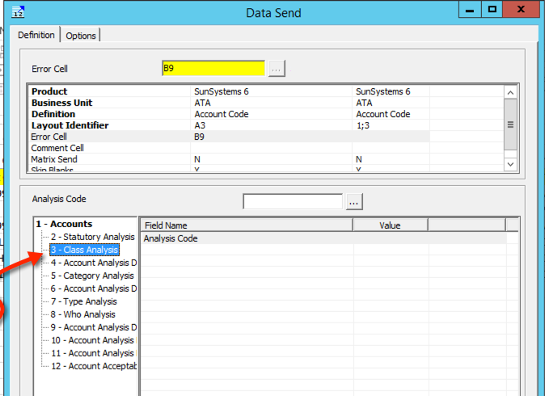

- Click on Analysis Code – T3

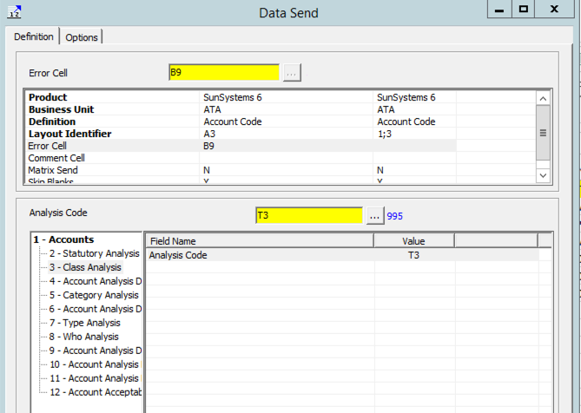

- Click on the Options tab on the Data Send interface

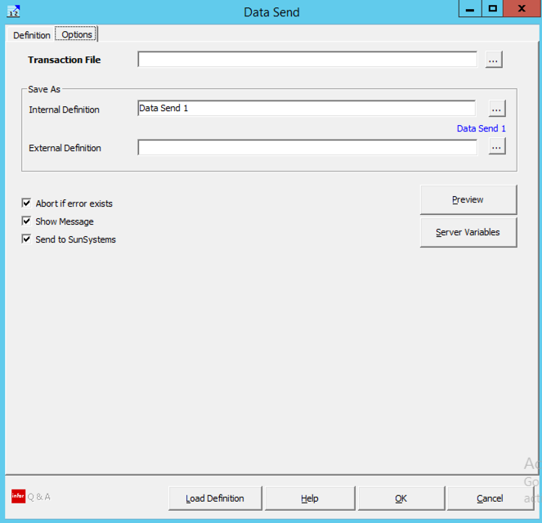

- Use the Assist button at the right of the Transaction File field to browse to the place on your computer where you want to save .xml files associated with the implementation

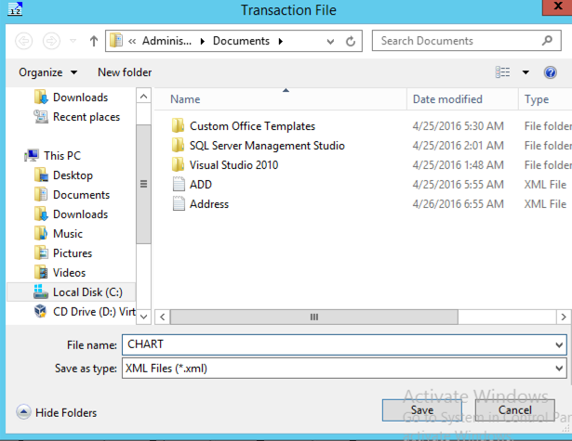
- Click Save
- Give the Internal Definition a name such as Accounts

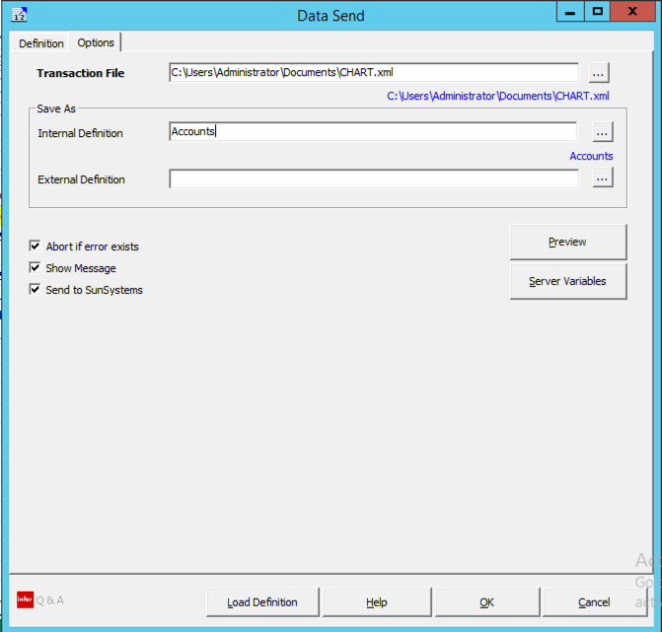
- Click OK to run the Data Send
- You may get this message

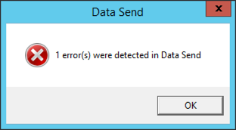
- Click OK
- Go to your error cell and right click to read the comment

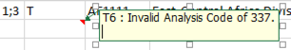

- My error is a missing Analysis Code. I can go into Analysis Codes and add it.
- Correct the error and redo the Data Send
- If you get the “Soap Error”, you can just ignore it – the .xml file will have been created anyway

- Go into SunSystems
- Open Transfer Desk
- Select the Import Addresses Profile

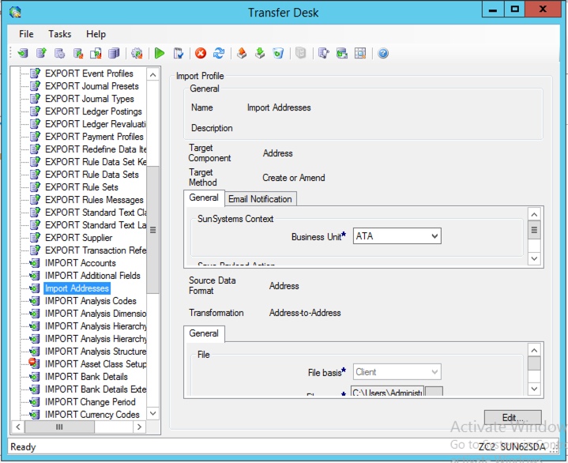
- Click Edit

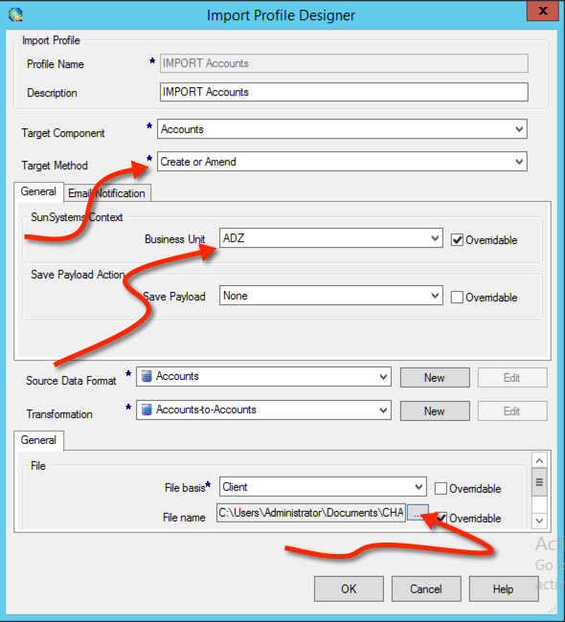
- Change the Business Unit name to the relevant code
- Change the File Name path to the path for the .xml file you created in the last step
- Click OK
- Click
- When the transfer is finished, you will get this message

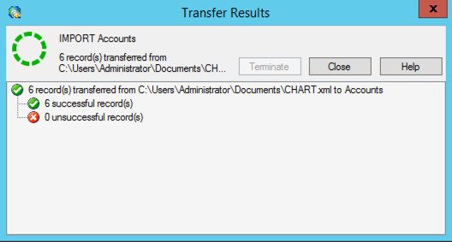
- Click Close
- Close Transfer Desk

Upload Analysis Codes
- Prepare your Analysis Codes
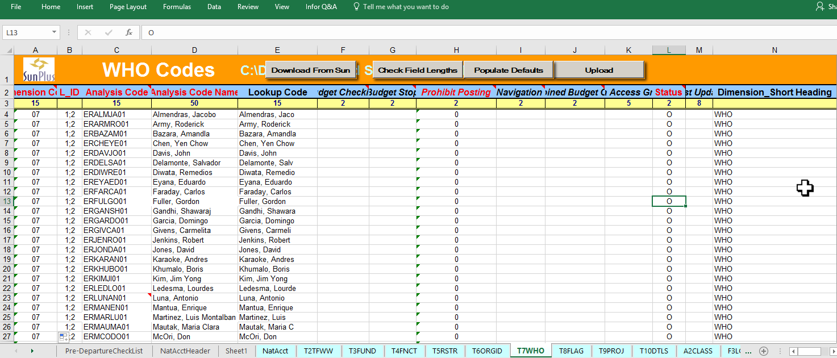
- Required fields:
  - Dimension Code – enter the numeric code for the Dimension – i.e., WHO is 07
  - LID – for Analysis Codes, the LID is 1;2
  - Analysis Code
  - Analysis Code Name
  - Lookup Code
  - Prohibit Posting – 0 for NO, 1 for YES (prohibit posting on headers)
  - Status – O = Open; C = Closed; S = Suspended; H = Hide
  - Dimension Short Heading – WHO (TFWW, RSCE, FUND, FNCT, ORGID, RSTR, FLAG, PROJ, DTLS)
- Log into Q&A XL
- Data Send

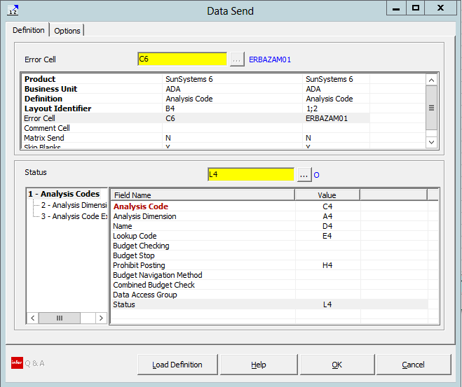
- 2 - Select Analysis Dimension Short Heading

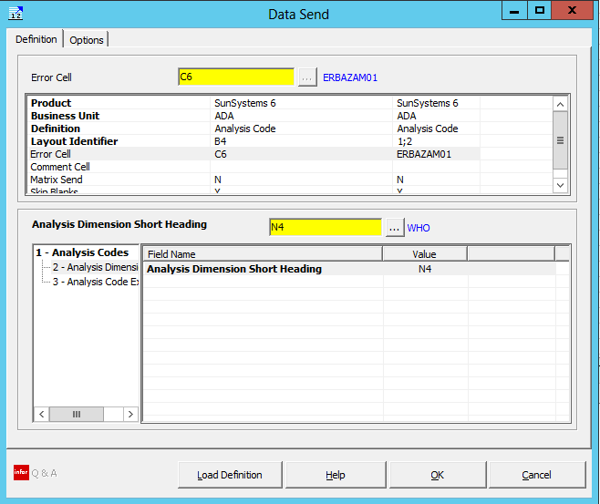
- Go to the Options tab

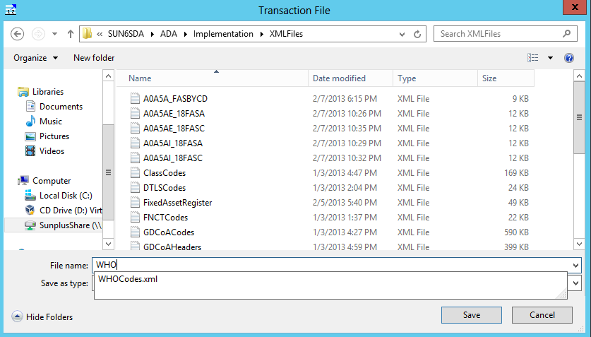
- Map Transaction File to location where you store the xml files for the implementation

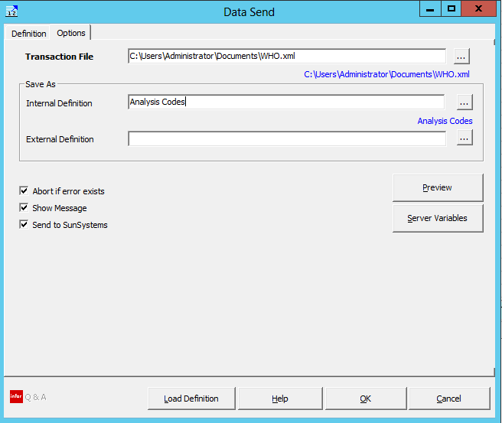
- If you enter an Internal Definition, you can re-use this mapping. To reuse the mapping, click Load Definition and choose the definition you saved here
- Click OK to start the Data Send
- When the xml file has been successfully created, go into SunSystems and open Transfer Desk

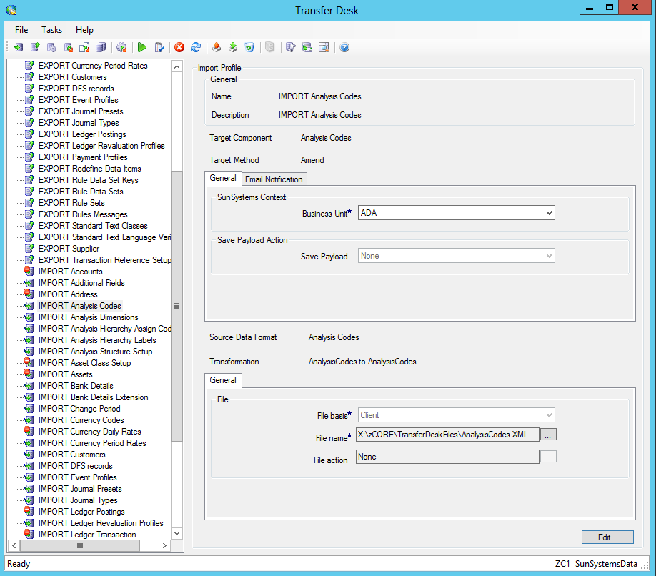
- Select Import Analysis
- Click Edit to make changes to the profile

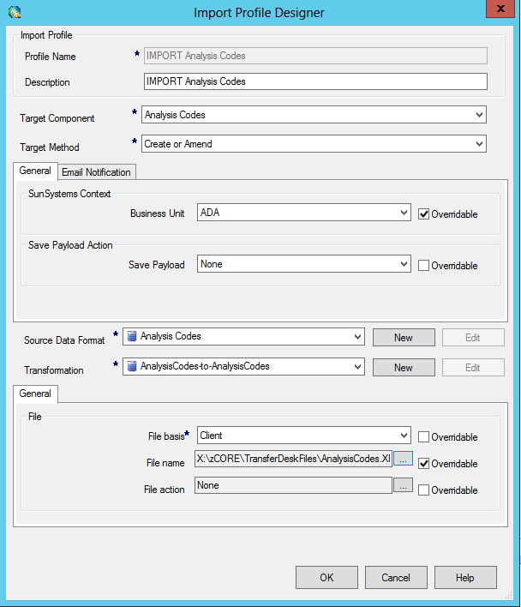
- Target Component – Analysis Codes
- Target Method – Create or Amend
- Business Unit
- File Name – choose the xml file you saved
- Click OK
- Click green Run arrow on toolbar to start the import
- You will get a success message when the import has finished.

The upload process for all Analysis Codes is basically the same. In fact, they can all be uploaded in the same upload. If you choose to do so, BE CAREFUL with the Dimension Code and Short Heading.

Upload Addresses

- You have already set up the basic addresses for the organization; now you need to upload the addresses for the organizations, employees, creditors, etc.
- Prepare your data

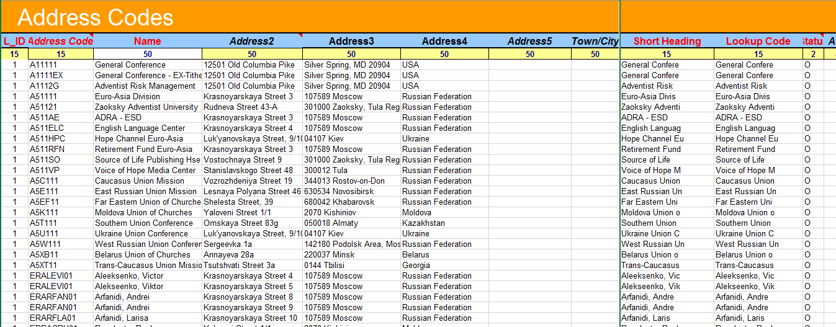

- The basic data needed for Addresses in SunPlus is:
  - Address Code
  - Name
  - Address2
  - Address3
  - Address4
  - Address5
  - Short Heading
  - Lookup Code
  - Status
- Of course, if the organization wants to populate any of the other available fields in the Address Setup function, you would do so and map accordingly
- The Layout Identifier (LID) for Addresses is ‘1’
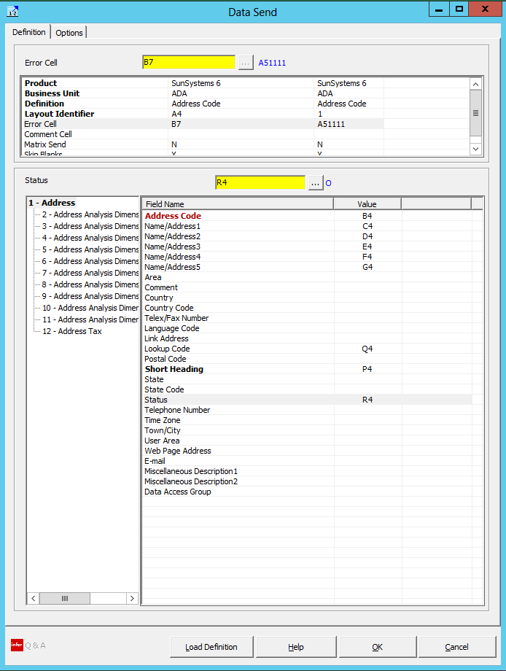
- Go to Options tab
- Select the location where you will store your xml file

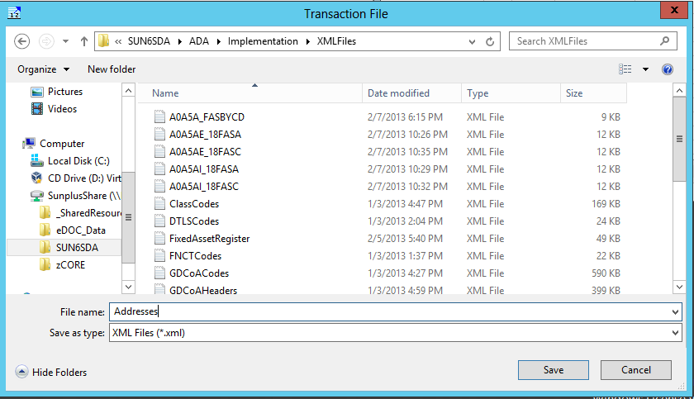
- You can also save the mapping as an Internal Definition, and reuse it in the future
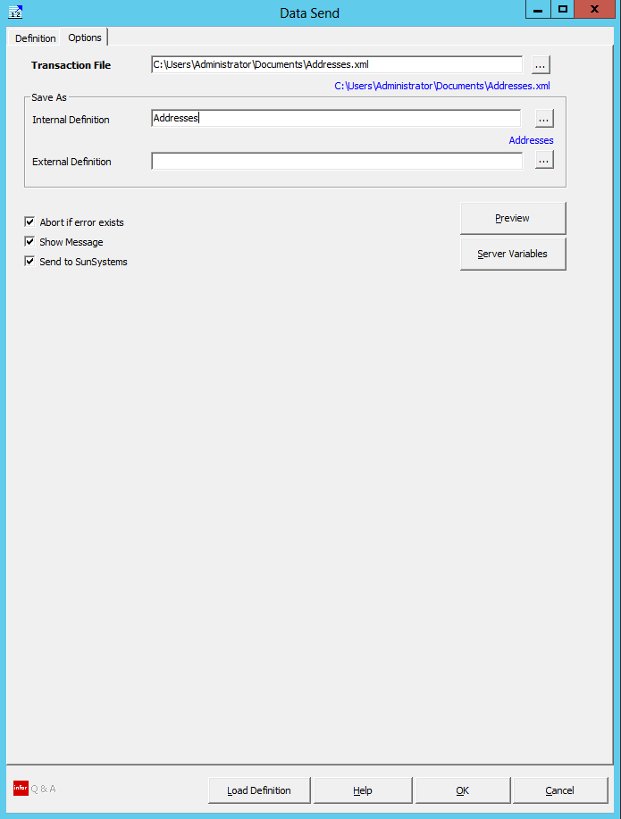
- Click OK to run the Data Send
- Go into SunSystems and select Transfer Desk

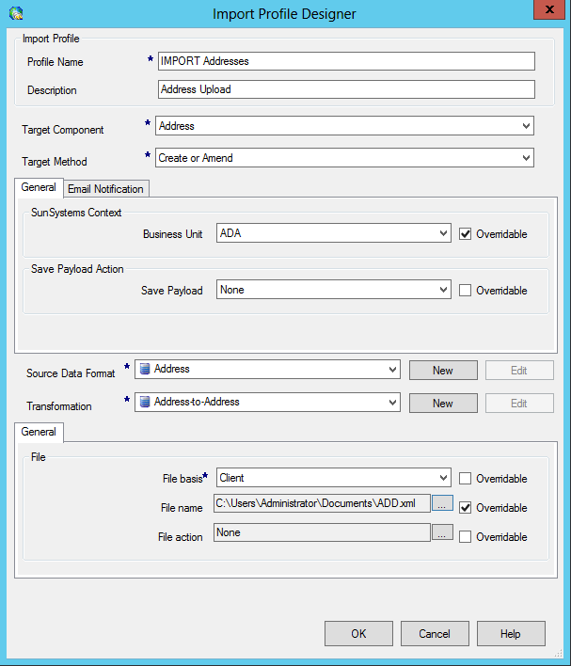
- Open the Import Address profile and make sure that the Business Unit and the File Name are correct for your import
- Click OK
- Click the green Run arrow to run the import

Upload Fixed Assets

- Prepare your Fixed Asset Register data
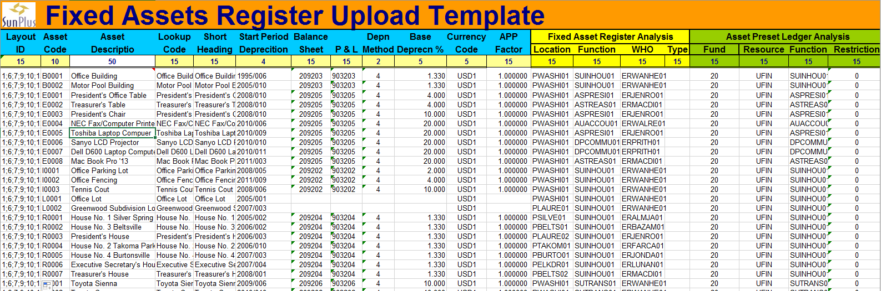
- Required data items:
  - Asset Code
  - Asset Description
  - Lookup Code
  - Short Heading
  - Start Period Depreciation
  - Balance Sheet Account
  - P&L Account
  - Depreciation Method
  - Base Depreciation %
  - Currency Code
  - APP Factor
  - Location Analysis
  - Function Analysis
  - WHO Analysis
  - Type Analysis (if needed)
  - Asset Presets
    - Fund
    - Resource
    - Function
    - Restriction
- Go to Infor Q&A
- Select Data Send

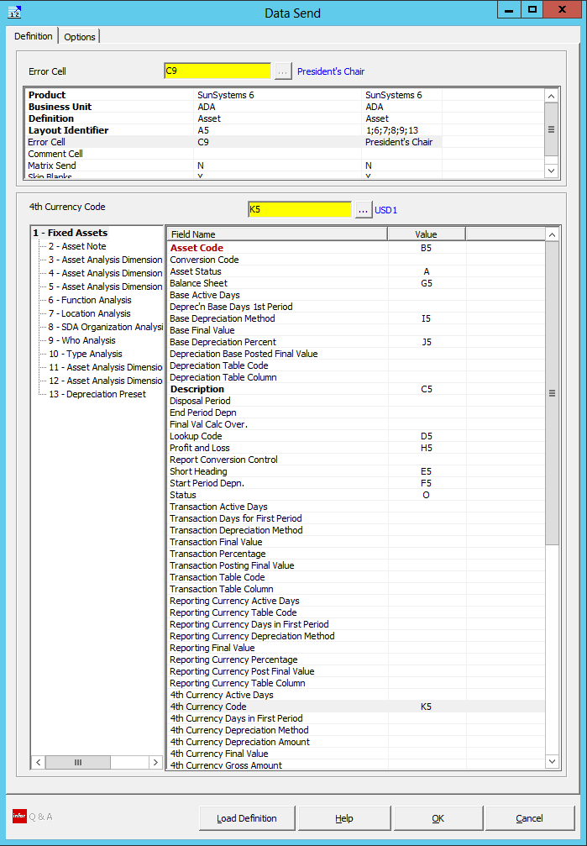
- Map 1 – Fixed Assets
- Map 6- Function Analysis

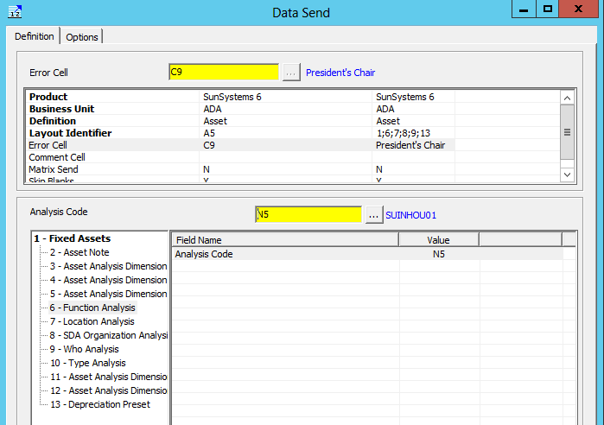
- Map 7 – Location Analysis

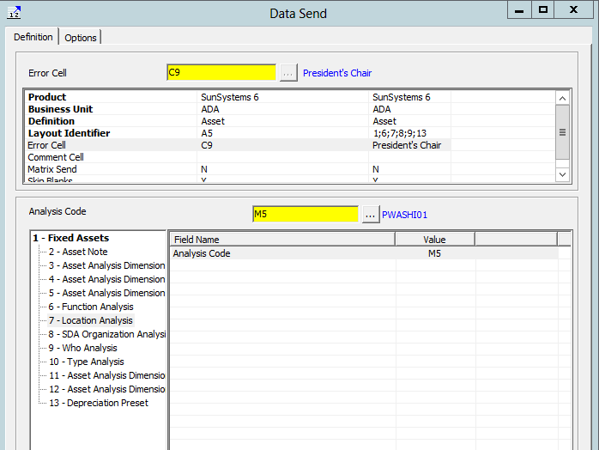
- Map 9 – Who Analysis

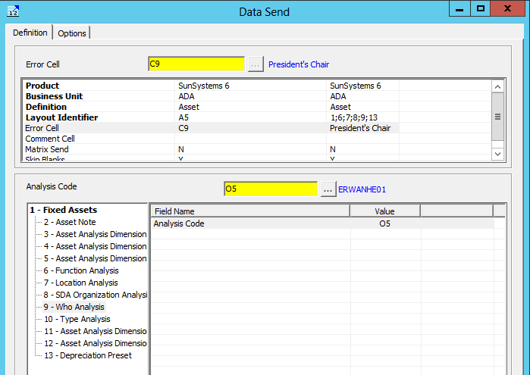
- If the organization will be using ORGID Analysis with their Fixed Assets, map 8 – SDA Organization Analysis
- Map 10 – Type Analysis (if needed)
- Map 13 – Depreciation Preset

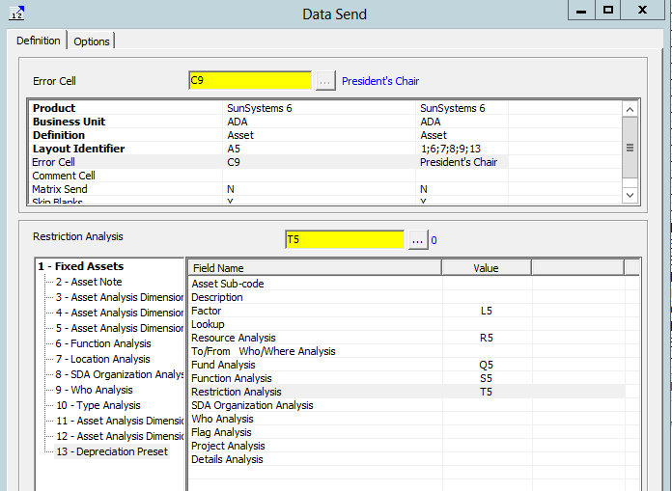
- Go to Options tab
- Name the file and place it in the xml directory you use for your uploads

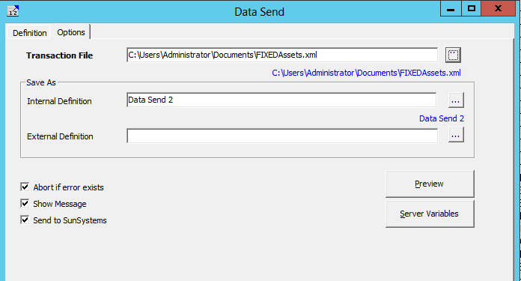
- Click OK
- Go to SunSystems
- Open Transfer Desk

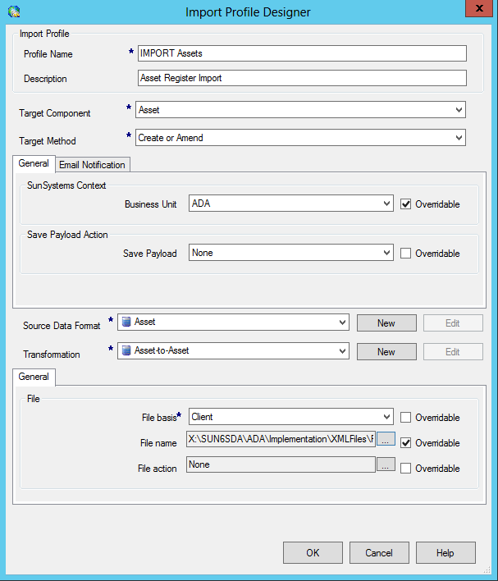
- Click OK
- Click green Run arrow icon

Upload Beginning Balances

- Prepare the data in Excel

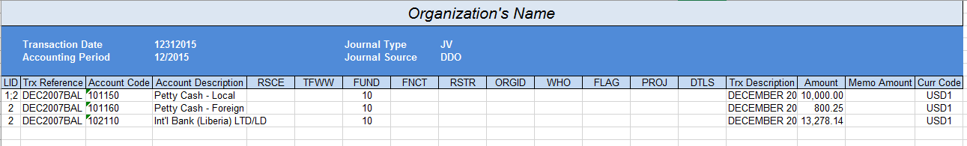
- Go to Infor Q&A
- Select Data Send
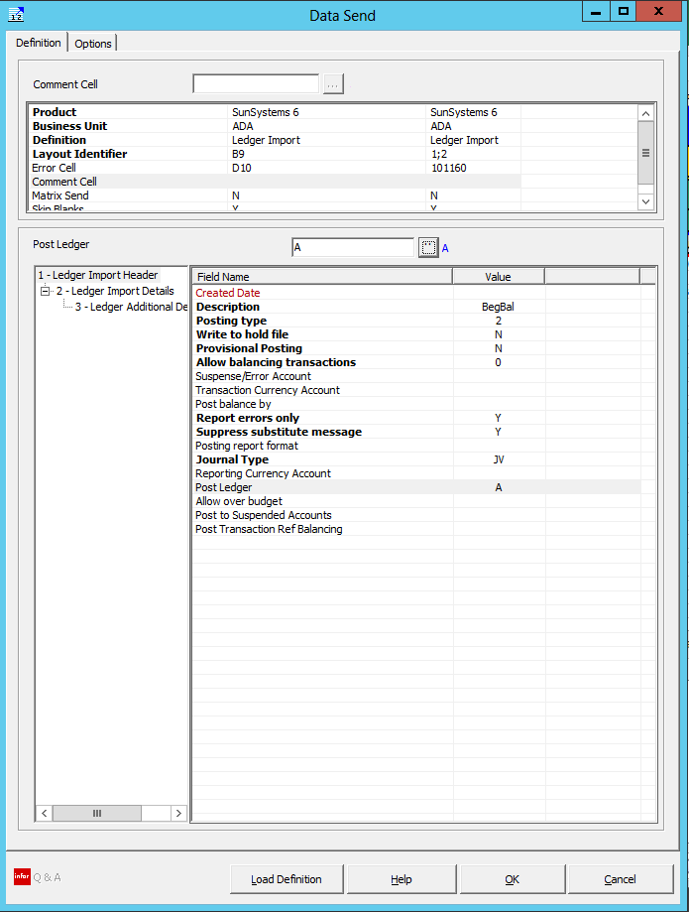
- Definition – Ledger Import
- Layout Identifier – 1;2 (1;2 on the first line of the data, 2 on all subsequent lines)
- Error Cell
- 1 – Ledger Import Header –
  - Description – any description – use to identify the file in the Ledger Import Control Desk
  - Posting Type – 2 – Post if no errors
  - Write to hold file – N – No
  - Provisional Posting – N – No
  - Allow balancing transactions – 0 – Never
  - Report errors only – Y – Yes
  - Suppress substitute message – Y – Yes
  - Journal Type – JV
  - Post Ledger – A
- Go to 2 – Ledger Import Detail
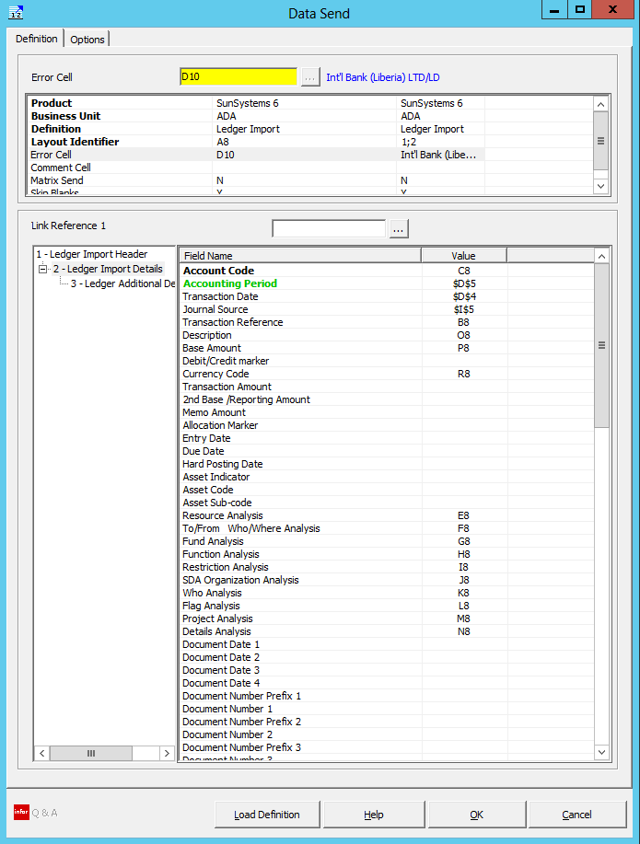
  - Account Code
  - Accounting Period – make the link absolute $D$5
  - Transaction Date – make the link absolute $D$4
  - Journal Source – make absolute $I$5
  - Transaction Reference
  - Description
  - Base Amount
  - Currency Code
  - Resource Analysis
  - To/From Who/Where Analysis
  - Fund Analysis
  - Function Analysis
  - Restriction Analysis
  - SDA Organization Analysis
  - Who Analysis
  - Flag Analysis
  - Project Analysis
  - Details Analysis
  - 4th Currency Code – for single currency sites
  - 4th Amount
- Go to Options tab
- Name the file and Save As Internal Definition BeginningBalances
- Click OK to run the import

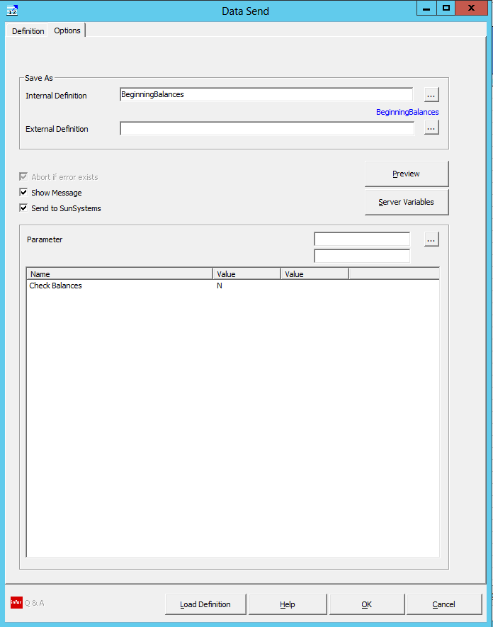

- Go to SunSystems
- Open Ledger Import
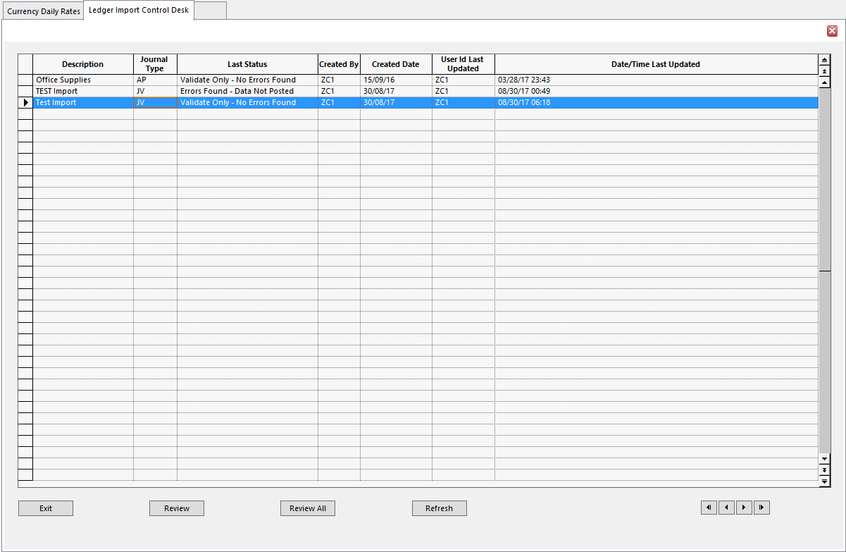
- Select your file from the list – it will be named whatever you named your file in the Ledger Import Header Description
- Click Review

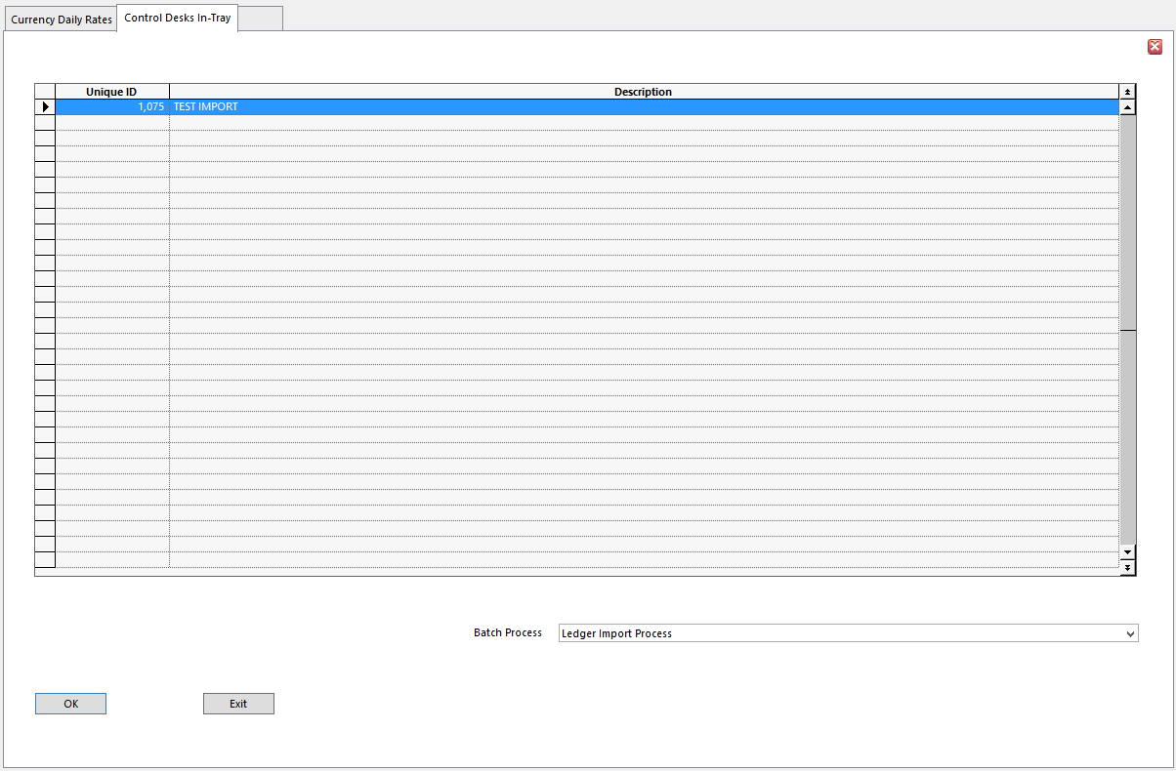
- Select Ledger Import Process as the Batch Process
- Click OK

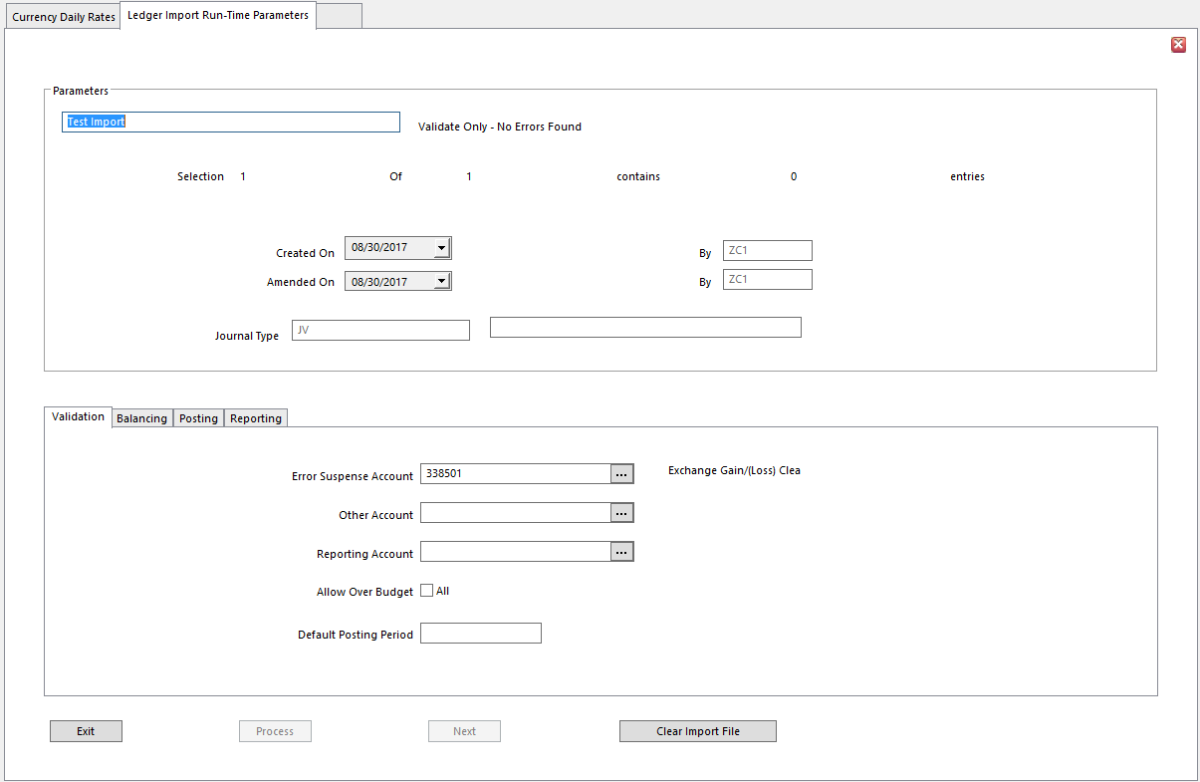
- Click Process
- If there are errors in your data, you will be told the import has failed
- Check the report to see what the errors are
- Make necessary changes
- Redo Data Send
- Redo Ledger Import

Upload Budget

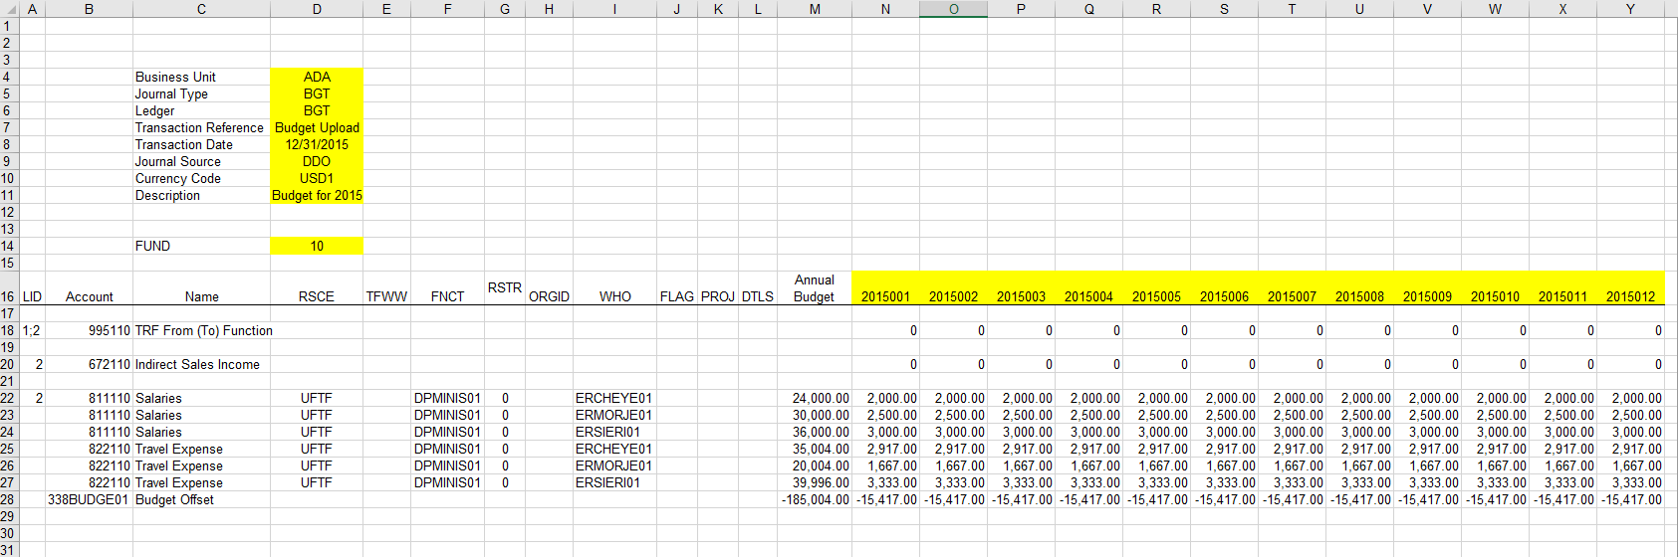
- You can import your Budget using a regular Ledger Import template. You also have the option of using a special, complex import template, such as the one above.
- Populate the Budget Upload spreadsheet
- Items in cells highlighted yellow are entered once, only in that cell, and apply to all the entry lines
- For each natural account which should be included in the Budget upload, enter the Account Code in column B and the Account Name in column C
- If the account requires an Analysis Code, you must enter that Analysis Code in the appropriate column: D – I
  - If you need to enter a budget for 7 employees under Salary, add 6 rows under the Salary Account
  - Each row will have the same Account Code – the code for Salaries – and Account Name – Salaries
  - Each Salary entry row will have a unique WHO code
- Enter 1/12th of the budget for each natural account into each of the month columns. If the amount does not divide evenly, place any excess into the first month of the year.
- Open Q&A XL and map the Data Send

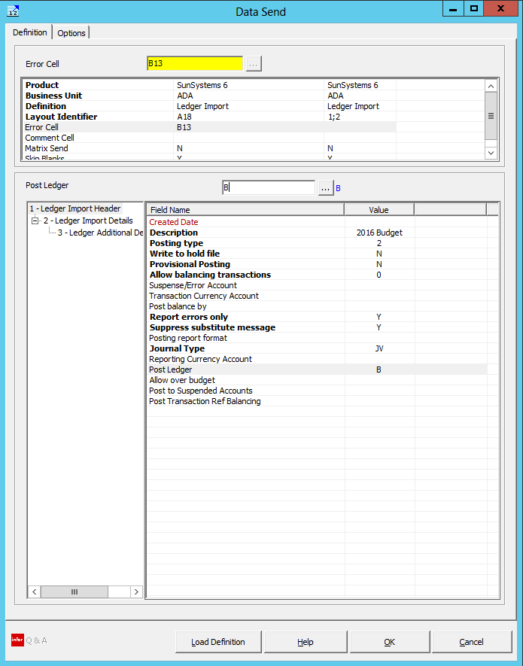
- Go to 2 – Ledger Import Details

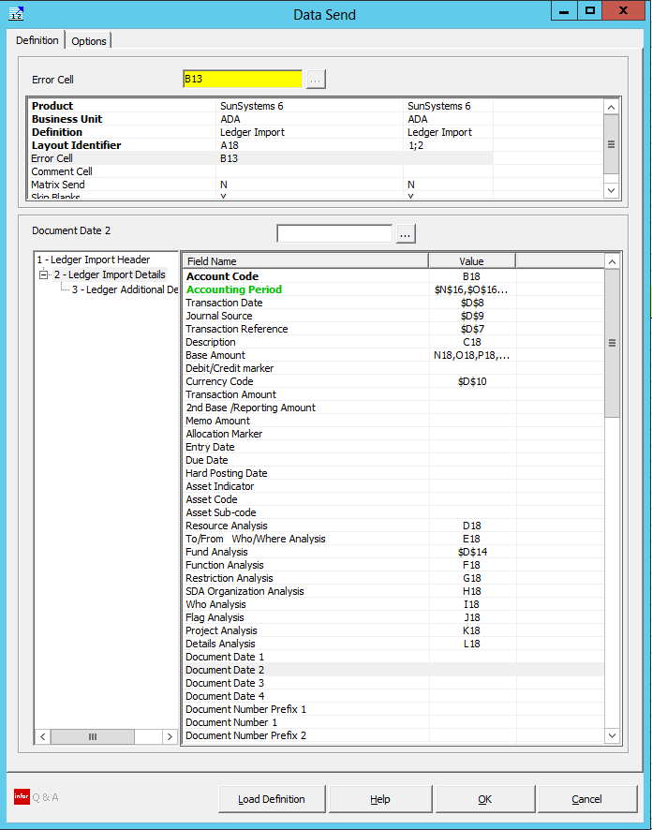
- NOTE unique mappings:
  - Accounting Period – enter a range of cells – format as below $N$16,$O$16,$P$16,$Q$16,$R$16,$S$16,$T$16,$U$16,$V$16,$W$16,$X$16,$Y$16
  - Transaction Date – lock the focus on a single cell - $D$8
  - Journal Source – lock the focus on a single cell - $D$9
  - Transaction Reference – lock the focus on a single cell - $D$7
  - Description
  - Base Amount – N18,O18,P18,Q18,R18,S18,T18,Q18,R18,S18,T18,U18,V18,W18,X18,Y18
  - Currency Code – lock the focus on a single cell - $D$10
  - Recourse Analysis
  - To/From Who/Where Analysis
  - Fund Analysis – lock the focus on a single cell - $D$14
  - Function Analysis
  - Restriction Analysis
  - SDA Organization Analysis
  - Who Analysis
  - Flag Analysis
  - Project Analysis
  - Details Analysis
- Click OK
- Go to SunSystems Open Transfer Desk
- Follow import process

Upload Asset Values

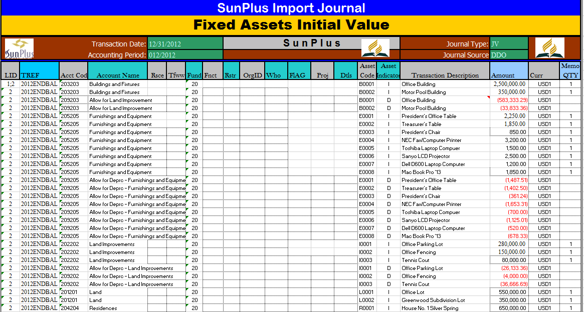

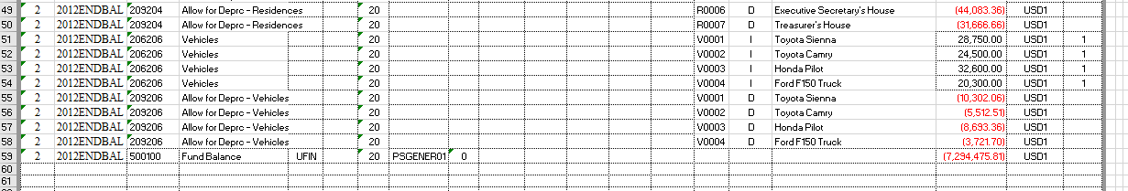

- Prepare your data for import
- You can upload Asset Values in a regular Journal Import template, but you need to add three columns:
  - Asset Code
  - Asset Indicator –
    - For each asset, enter an ‘I’ if the value is the initial asset value
    - Enter a ‘D’ if the value is the depreciation value
  - Memo QTY

End User Training

The following topics must be covered during End Users’ Training:
- Basics
  - Log in/out of SunSystems
  - Navigation Manager (menus)
  - Open/Close Periods and Dates
  - Change Password
  - Change Business Unit
  - Change Ledger
  - Operator
  - Filing Reference
- Data Entry
  - Ledger Entry
    - Accounts Payable
    - Accounts Receivable
    - Bank Deposit
    - Invoice
    - Journal Voucher with Debit/Credit Memos
    - Manually Generated Checks
    - Petty Cash
      - Disbursement
      - Replenishment
  - Other Journal Processes
    - Copy Journal
    - Reverse Journal
    - Hold Journal
- Static Data Creation
  - Natural Accounts Setup
    - Numeric Accounts
    - Alpha Accounts
  - Analysis Code Setup
  - Address Setup
  - Currency Codes Setup (MC sites)
    - Period Conversion Rates
    - Daily Conversion Rates
- Inquiries
  - Account Inquiry
  - Account Balance Inquiry
  - Fixed Asset Inquiry
  - Journal Inquiry
- Account Allocation
  - Online Allocation (Deposit Journal)
  - Correction Allocation Markers
  - Amending Posted Data in Account Allocation
  - Reconciliations in Account Allocation
- System Setup
  - Journal Types
  - Journal Presets
- Fixed Assets
  - Asset-related Ledger Entries
    - Purchase
    - Disposal
  - New Asset Setup
  - Depreciation
- Processes
  - Accounts Payable
  - Accounts Receivable
- Reports
  - Run Report from Function Screen
  - Run Report from Menu
  - Run Report from Report Manager
  - Run Report from Query & Analysis
  - Print Report
- Query & Analysis
  - Executive
  - Exports (XL)
  - Recurring Journal (XL)
  - Reports (XL)
- Month / Year End Processes
  - Closing / Funding Process
- Security
  - New User Setup
  - Unlock Locked Out Users
- Accounting Theory
  - Unallocated Function Accounting
    - Tithe Function Accounting
    - Non-tithe Function Accounting
    - Transfer In / Out Accounting
  - Allocated Function Accounting
    - Donation / Income Recording
    - Expense / Disbursement Recording
    - Transfer In / Out Accounting
  - Short-Term / Long-term Loan Receivable / Payable Accounting
  - Trust Fund Accounting
  - Tithe and Offering Accounting

Post-Implementation Checklist

Prior to finalizing the implementation, please check to ensure the following have been completed:

System Design

- Site’s staff approves GDCOA and Dimensions prior to upload.
- All Natural Accounts have been uploaded.
- All Natural Account “Header” Accounts have been Closed and MOP Settings and Account Types are correct.
- All Analysis Codes have been created and uploaded.
- Addresses for the site have been created:
  - 0000000000
  - 10
  - 20
  - AXXXXX for higher organization
  - AXXXXX for subsidiary organizations
- Addresses for all Organizations, Workers, and Creditors have been created and uploaded.
- Beginning Balances have been uploaded and reconciled with pre-implementation Financial Statements.
- All user ID’s have been created.
- Financial Statement has been amended to list the site’s:
  - President
  - Secretary
  - Treasurer
  - Currency
- All Financial Statements have been run and tested (including Drill Paths and Printing)
- At least one month’s transactions have been posted and various reports generated so users know what to do for the following months.
- All reports have been run and shown to users.
- All of the site’s users understand the use of the filing reference.

System Setup

- Business Unit Setup specifies whether the system is Single or Multi-Currency.
- The current Date / Period settings have been set in Ledger Setup.
- At least one of the site’s users knows how to use Ledger Setup and understands how and when to open and close Periods and Dates.
- At least one user understands the implications of the “Report Corrections” setting in both Ledger Setup and Q&A Setup.
- All necessary Journal Types have been created or amended.
- End users know how to use the various Journal Types.
- At least one user knows how to “Unlock” locked users and possibly other detailed components of SunSystems Security (User Manager).
- At least one user knows how to handle common system issues (e.g., restart the server / services, etc.)

Fixed Assets

- Asset Register has been completely uploaded.
- Asset Codes comply with the Asset Coding Nomenclature.
- Asset Posting Presets have been populated.
- Accumulated Depreciation has been tested against the Start Period of Depreciation.
- Gross Value and Accumulated Depreciation balances have been uploaded for each asset.
- Asset Net Value has been reconciled with ledger balances.
- Asset Gross and Accumulated Depreciation figures in the ledger reconcile with the Asset Register.
- At least one Depreciation Calculation has been run.
- Fixed Asset Reports (Executive) file has been run and all reconciliation items are correct.

End-users’ Training

- At least one of the site’s users is able to open Natural Accounts and Analysis Codes.
- At least one of the site’s users understands the full use of Account Allocation.
- All users are able to do Ledger Import via Q&A.
- All end users have been trained on Dimension and Fund Accounting.
- All end users have been trained on Unallocated and Allocated Fund Accounting.
- All end users have been trained on Short/Long Term Loan Payable / Receivable Accounting.
- All end users have been trained on Fixed Assets Accounting.
- All end users have been trained on Trust Fund Accounting.
- All end users have been trained on Tithe and Offering Accounting.
- All end users know how to print an Account Statement.
- At least one site user knows how to print the monthly Financial Statement and Trial Balance.
- All end users know where to find SunPlus Documentation.
- At least one site user knows what to do at the end of each month as well as at the end of each year.
- End users understand the Restriction and Resource Dimension Codes.
- All end users have been trained on the Year-end Closing or Funding Process.
- All users know how to contact SunPlus Support and the protocol for contacting Support.

Payroll

- All Employee accounts have been created and uploaded.
- Local Payroll or Excel file has been mapped; the template has been uploaded and tested.
- Salary and Allowances Expenses Summary has been designed and tested in a template for monthly upload.
- Payroll accountant clearly understands the Payroll process from Excel data population to Q&A upload.
- The Payroll accountant knows what Payroll reports to run every month.

Routine SunPlus Tasks

Starting and Ending SunSystems Session

Logging In To SunSystems

There are two ways to start a SunSystems session:
- SunSystems Desktop icon
- Start Menu

SunSystems Desktop Icon
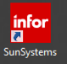

Click the Infor icon.

Start Menu
Start Menu > All Programs > Infor FMS SunSystems > SunSystems 6

Authentication Methods

There are two Authentication methods in SunSystems. Authentication methods control how a user logs into the system:
- Windows Authentication
- Standard Authentication

Windows Authentication The user is logged into SunSystems when he/she logs onto the operating system. Simply click the SunSystems icon after logging into the Windows operating system. No password is required.

Standard Authentication When the Login dialogue box is displayed:
Key in:
- User Name (usually 3 characters long, often the user’s initials)
- Password

Logging Out of SunSystems

To log out of SunSystems:
- Close Active sessions
  - Click Exit button on open form, or
  - Click X in the red box located on right of open session, just above ] session screen
- Close SunSystems
  - Click X in top right-hand corner of SunSystems window by Minimize / Maximize buttons, or
  - Click on the SunSystems icon in the top left-hand corner of the SunSystems window, or
  - Use the Menu Bar by going to File > Exit, or
  - Press Alt+F4

Main SunSystems Menu Screen

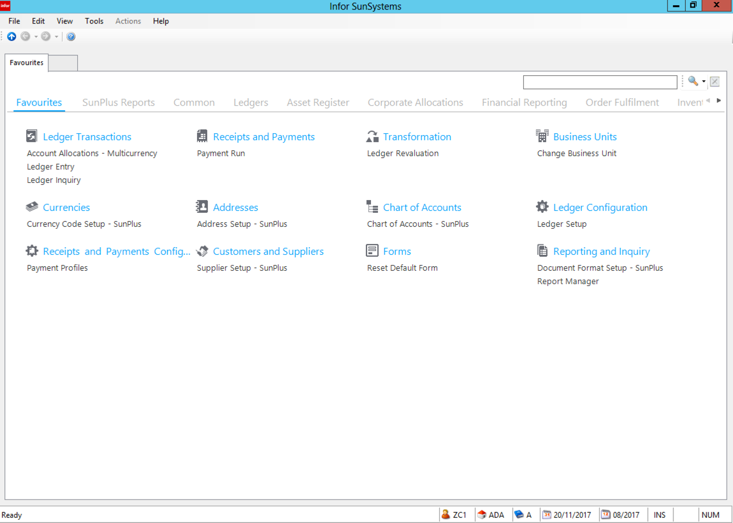

The SunSystems version 6 Navigation Manager (menu) is in browser format. It works on the same principles as a web browser.

- The currently open Navigation Manager tab is displayed on top.
- There are multiple tabs across the top of the screen:
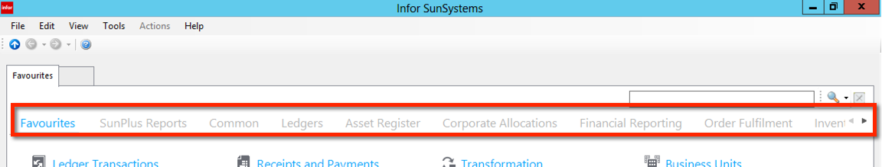
- Each tab represents a sub-portion of the menu. Clicking on a tab will change the focus to that portion of the menu. The highlighted menu is identified by a highlighted tab and by the tab’s name displayed on the tab at the left side of the screen.
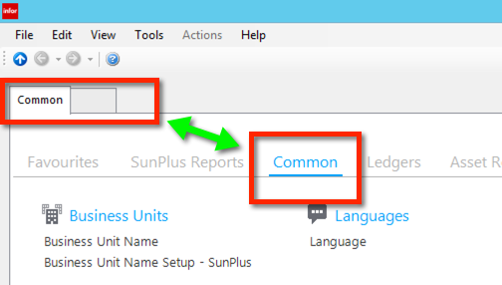

- In the following screenshot, the series of open menu tabs and menu functions are represented by labeled tabs at the left side of the screen.
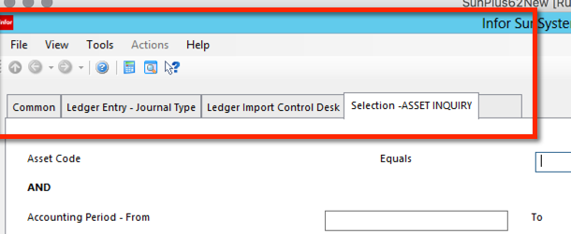

- Up to 9 menu function screens can be open at the same time. You can easily move back and forth between open screens by clicking on the function’s tab.
- To open a new function, click on the unlabeled gray tab at the right of the line of tabs.
- Some important information is always displayed in the lower right-hand corner of the Navigation Manager screen, to help ensure the user is working in the correct environment

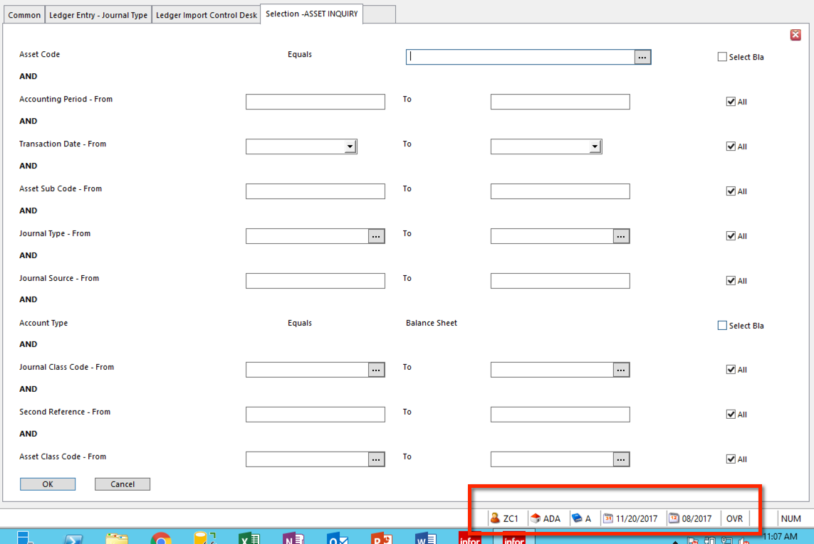
  - Starting from the left, we have:
    - Logged in user’s ID ZC1 in our example
    - Business Unit Code ADA
    - Ledger A
    - Today’s Date
    - Current Accounting Period
- To close a menu function screen, click X in red box on right-hand side of function or click Exit at the bottom of the screen
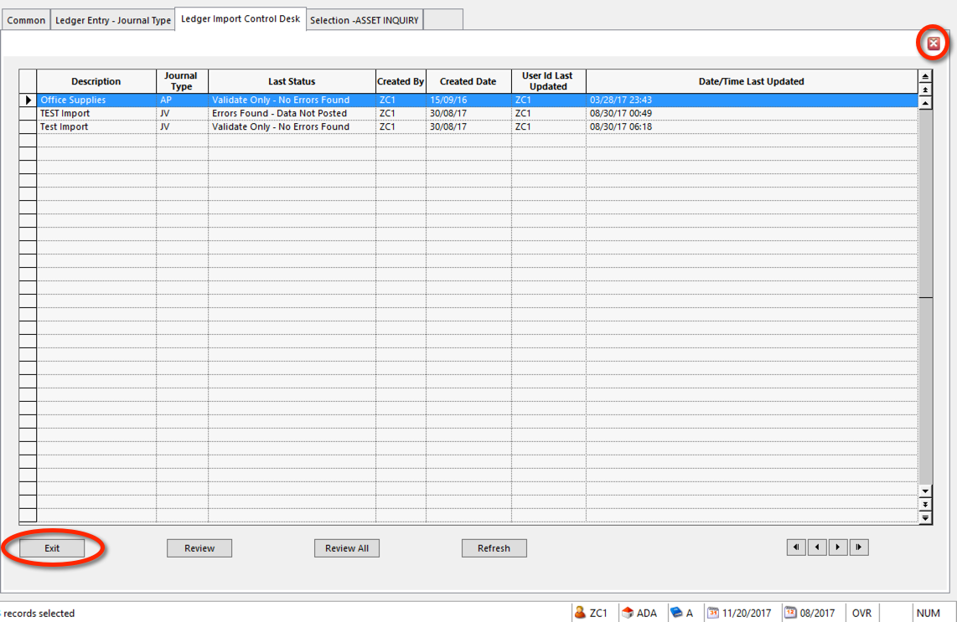

- To rapidly close a series of function screens, repeatedly click X until all screens are closed.
- To find Function you need, there is a Search field located at the right upper side of the screen

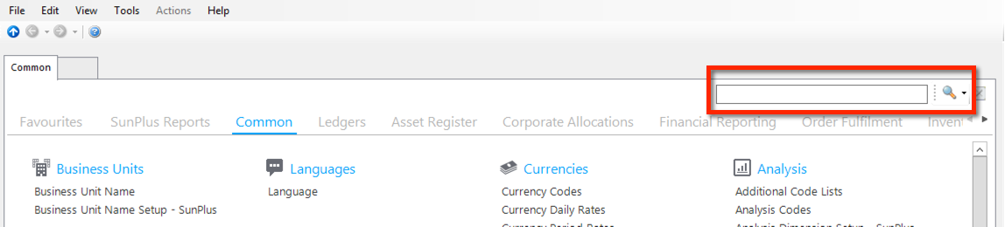
  - The icon you see at the right side of the Search field controls which Search Mode is used:
    - Search
      - The magnifying glass icon is the Search Mode
      - In this Search Mode, you can search for a function by entering any portion of the function’s title as your Search value. The system creates a special Search Results menu displaying every function in the system whose title contains the string of characters you used for your search.
    - Lookup
      - The green arrow icon is the Lookup Mode
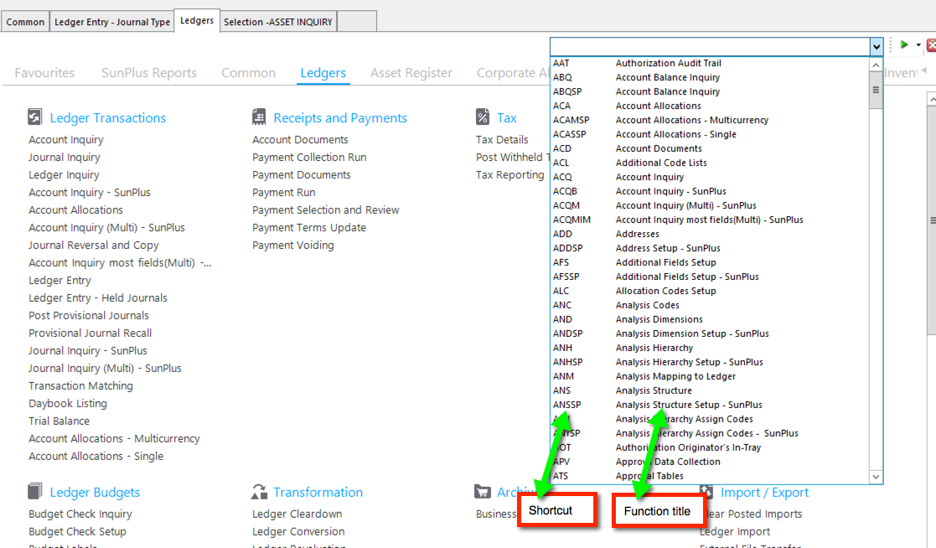

      - Either click on the item in the list to select, or enter the Shortcut
  - The Favorites menu allows each user to create a personalized listing of only those functions he or she routinely uses.

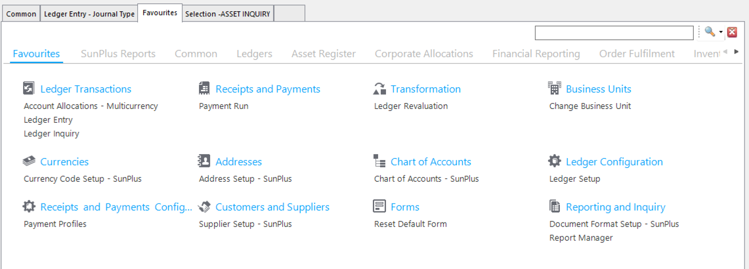
    - To add a function to the Favorites menu, right-click anywhere on the Favorites menu screen.
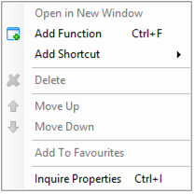

    - Select Add Function

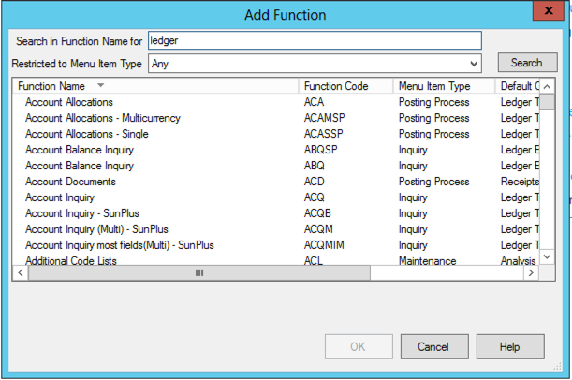
    - Either scroll through items in Function Name list in lower pane, or enter any portion of the item’s name in the Search in /function Name for field and click Search

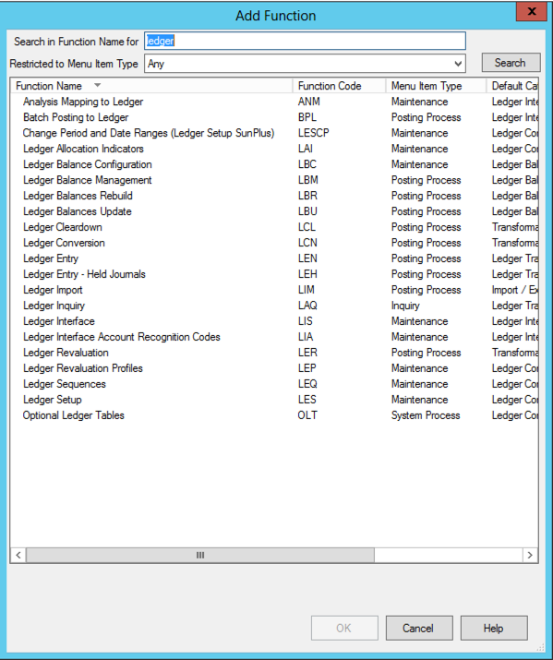
    - The system will create a list of all menu functions that include the portion of the name that you searched for
    - Click on the item you want and click OK to select
  - You can also add a function to your Favorites menu from another menu. Simply right-click on the function title and select Add Function from the dropdown list.
  - To remove a function item from your Favorites menu, right-click on the name of the item on the Favorites screen
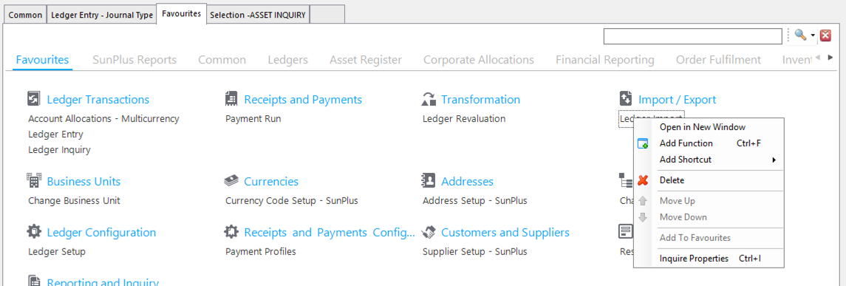

  - Select Delete
    - The function item you have deleted from the Favorites menu will continue to be available on the menu tab where it was originally located
      - Adding the function to the Favorites menu does not remove that item from whichever menu tab that function was originally located on
  - Menu icons are not links. They are representative of the directory file in which the menu function was stored. They are also visual reminders of function classifications.

Change / Open Period

There are two ways to change the current Accounting Period:
- Change Period
- Ledger Setup

Preparing to Change the Period

Be very careful when changing an Accounting Period in a multi-user environment. Users who are logged into the system when you change the period may have their work affected by the change.

- If they have a Ledger Entry form open when you change the period, their work within that particular posting session will not be affected as long as they use the form they had open when the period was changed. They will still be posting in the original period.
- If they open another Ledger Entry session form after you change the period, the new Ledger Entry session will use the new period. The user will get a message indicating the period has been changed since they last used Ledger Entry.

It is standard practice to print audit trail reports, such as Account Listing, Journal Listing, and Trial Balance, before moving to a new period.

Change Period

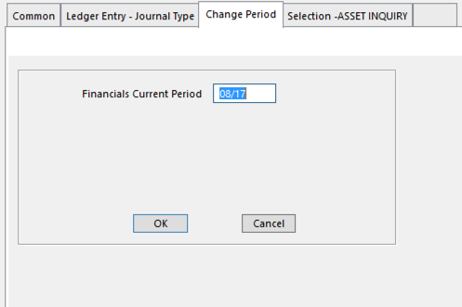
- Enter the new period in the Accounting Period field.

Ledger Setup

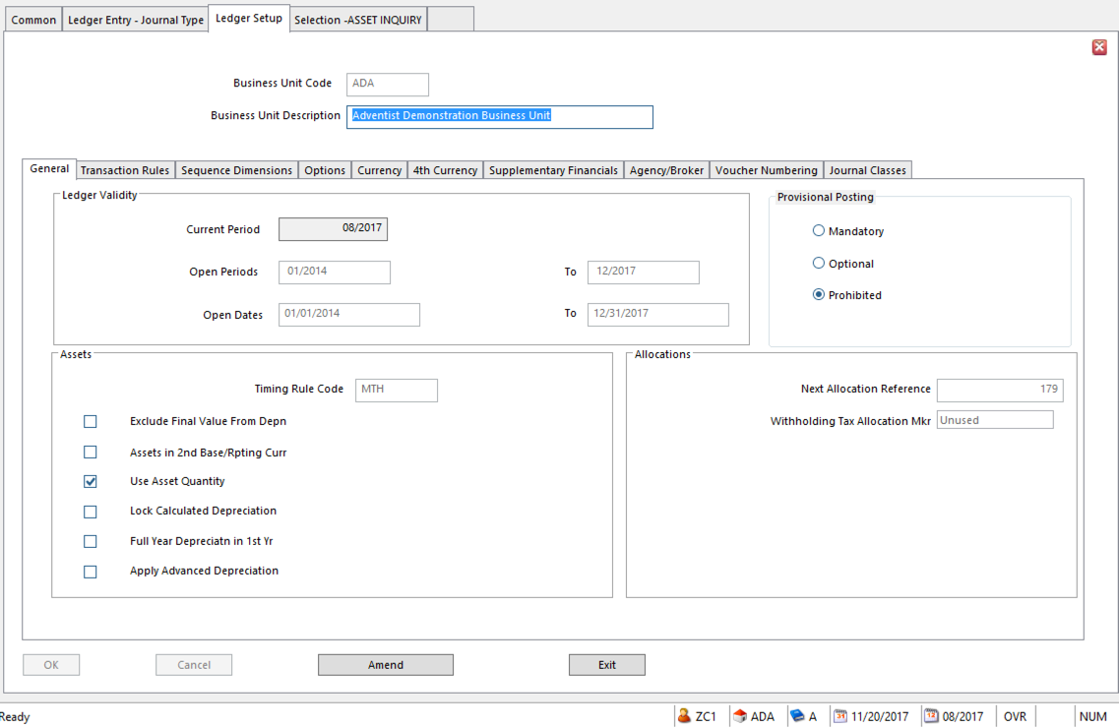

- Current Period enter the new Accounting Period to be opened
- Open Periods From / To a range of periods can be open at the same time. A user can post journals to any period within this range.
  - Leave both From and To fields blank to set up no restriction on posting to any period
  - You can enter actual period values, or
  - Use relative period numbers
    - C Current Period (postings only to Current Period)
    - +nnn nnn = the number of periods after the Current Period
    - -nnn nnn = the number of periods before the Current Period
- Open Dates From / To a range of transaction dates during which users can post journals.
  - Leave both fields blank for no posting restrictions.
  - Enter actual Dates, or
  - Enter relative Dates
    - T Today
    - +nnn nnn = the number of days after the Current Date
    - -nnn nnn = the number of days after the Current Date

Change Business Unit

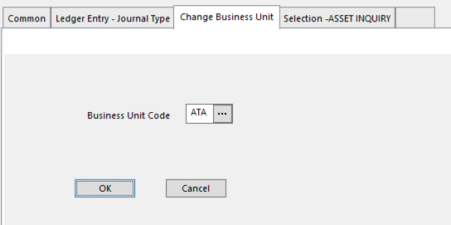

- To change the Business Unit, go to Change Business Unit.
- Enter the code for the Business Unit to be opened.
- Click OK.

Change Password

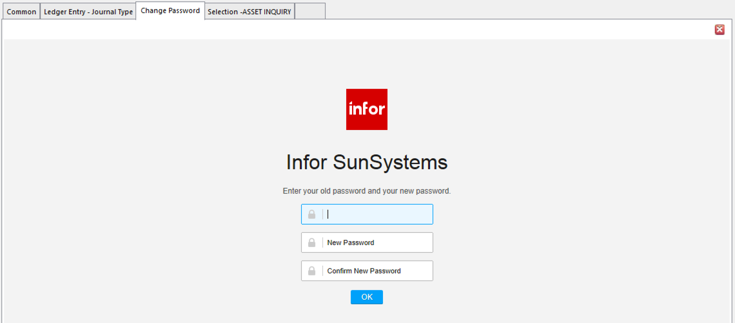
- To change the user password, go to Change Password.
- Enter old password in the first field.
- Enter new password in the second field.
- Reenter the new password in the third field.
- Click OK

Change Ledger

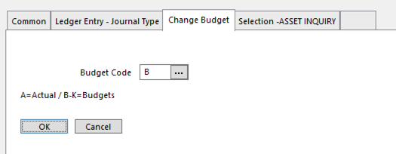
- To change the ledger in which you are working, go to Change Budget.
- Enter the code for the new budget.
- Click OK.

Operator

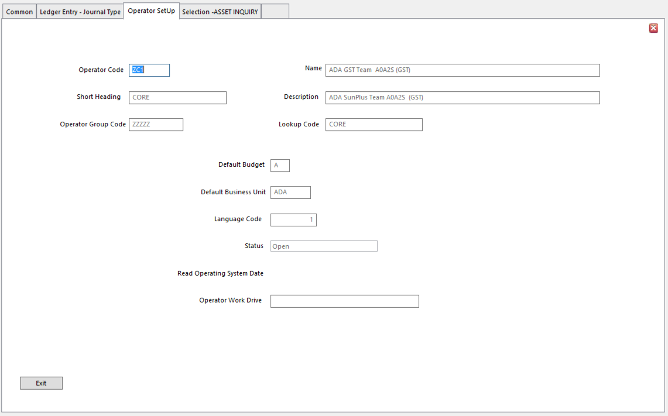

- Although the end user cannot set up a new user, or change the majority of a user’s details, he or she can access his or her own user setup information.
- Go to Operator View

Filing Reference

A unique Journal Number is automatically assigned by the system when a journal is posted in Ledger Entry or Ledger Import. If a transaction sequence number is also assigned to a Journal Type, this number is displayed next to the Journal Number in the lower left-hand corner of the Ledger Entry screen.

The SunPlus standard is to use this Journal Number as the Filing Reference for the transaction. That means journal listing and originating documents are filed in numeric sequence by Filing Reference rather than by the Journal Type.

It is easy to retrieve a Journal Listing using the Filing Reference. If you are unsure of the Filing Reference for a journal, use one of the Inquiry functions to look up the journal.

Filing In SunSystems Forms

Move Between Fields

Use 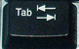 key or the mouse to place the cursor in the field

Move Between Groups of Fields

Press 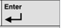 or click OK

This validates the data you have entered already

The File, Exit or Exit buttons also trigger validation of the entries.

Click Cancel if you don’t want to save changes.

Entering Data in Grids

You can type into text fields or select from drop-down lists, calendars or query windows. But it may be easiest to use the grid to find the record you need, then switch to the form view to make changes.

Scrolling Through Auto-complete Data

Use 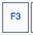 key to scroll through a list of auto-complete data for the current field type.

This can speed up data entry if you are entering several lines of the same type.

NOTE You can only scroll through values entered since you opened the form for the current session. After you close the form, the entries are no longer available for scrolling.

Auto-complete to End of Record

Use 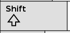 + 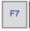 to copy the values in the fields from the current cursor position to the end of the record or screen.

Then, use to paste the copied values from the current cursor position.

NOTE Errors can occur if you press when the cursor is not in the same position as the +.

You would likely use this combination when creating similar records within a static data maintenance function.

Data Entry

Financial data can be entered into the system in two ways:
- Ledger Entry
- Ledger Import

Ledger Entry

- Go to Ledger Entry

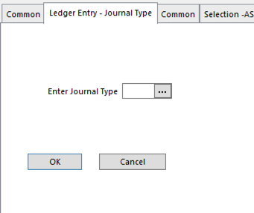
- Enter the Journal Type
- Click OK

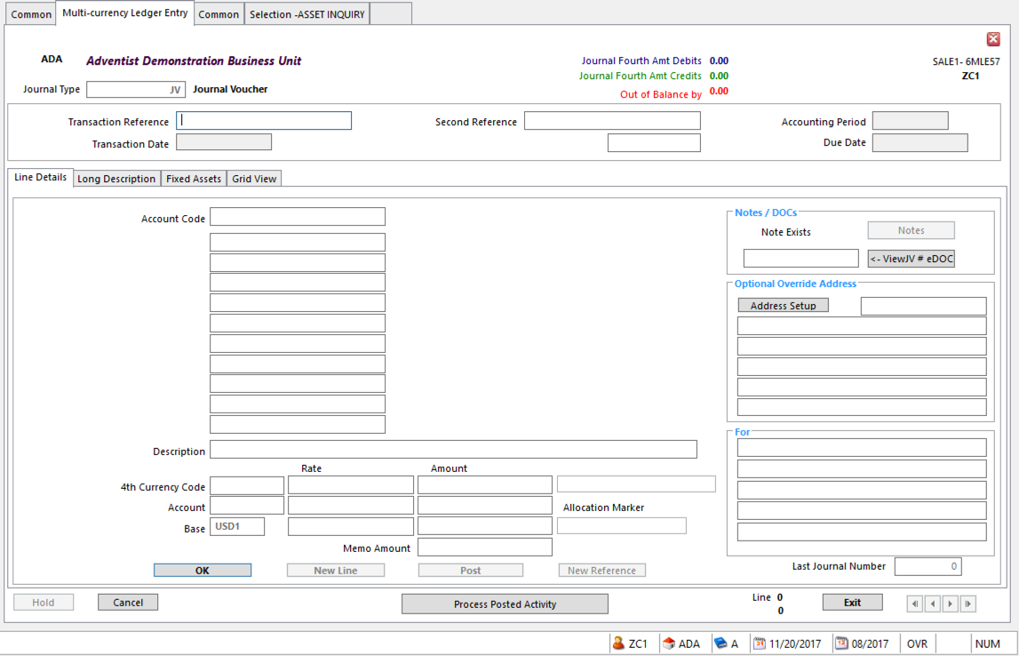

- Transaction Reference a value that will tie this transaction to the originating document
- Click OK
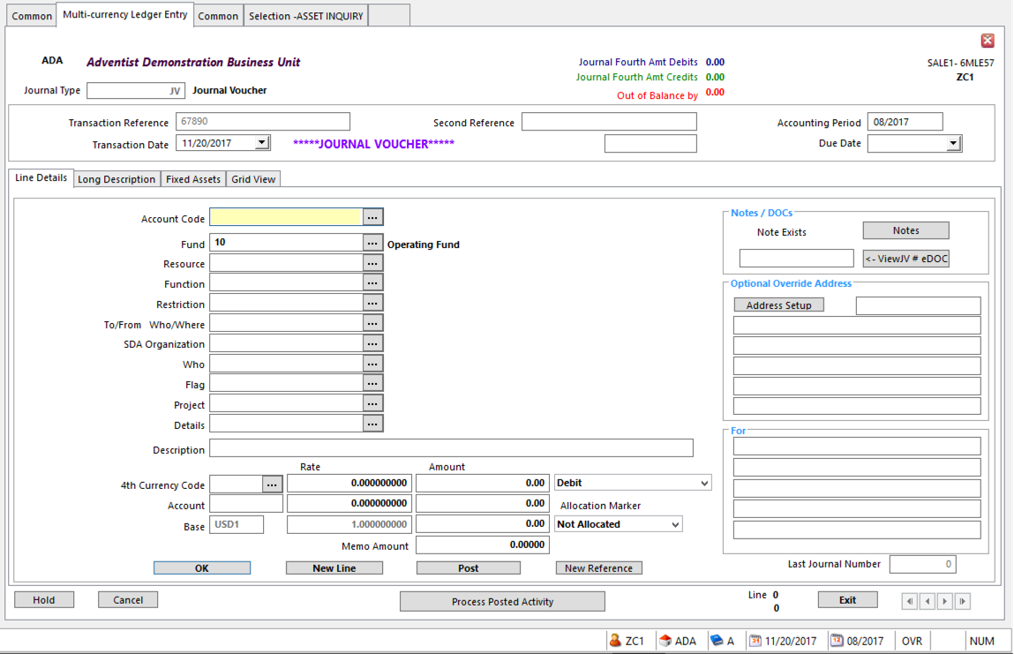

- When you click OK, the fields necessary for the chosen Journal Type will be opened. Their backgrounds will be white.
  - If a field is not opened (the background is gray), it is unnecessary for that Journal Type).
- Mandatory fields for Ledger Entry
  - Accounting Period
  - Transaction Date
    - Use dropdown calendar to choose
    - Type in date
    - Use + for Today’s Date
  - Account Code
  - Fund
  - Description
  - Amount
  - Debit/Credit Marker
  - Analysis Dimension Analysis Dimension requirements depend upon MOP settings in Chart of Accounts

Details for Specific Journal Types

Accounts Payable

For a full explanation of the Accounts Payable process, please see page 247.

This is only a summary of the Accounts Payable transaction entry.

- Enter bill
Journal Type AP
Debit Expense
Credit Creditor

- Pay bill
Journal Type AP
Debit Creditor
Credit Bank
Online Allocation is part of this process

- Payment Run
- Payment Documents

Accounts Receivable
For a full explanation of the Accounts Receivable process, please see page 253.
- Enter transaction
Journal Type JV
Transaction Reference invoice number, check number, etc.
Debit Cash on hand
Credit appropriate account
- Print Receipt

Bank Deposit
- Journal Type DP
Credit Cash on Hand
Debit Bank
Online Allocation is part of this process

- Print Deposit Summary

Invoice
- Check if Supplier Account exists
  - If not, set up the Supplier’s Natural Account in
    - Chart of Accounts Setup
    - Address Setup
    - Supplier Setup
    - If the supplier will be paid electronically, also set up Bank Details
- Ledger Entry
Journal Type AP
Credit Supplier’s Alpha Account
Debit Expense
- Select transactions for Payment Run
- Run Checks in Payment Documents
- Run Electronic Payments Process in Payment Documents
- File

Journal Voucher with Debit/Credit Memos
- Journal Type JV
- Enter transaction details
      - For transactions involving an SDA Organization, enter
        - ORGID Code
        - FLAG = Y
- The Debit/Credit memo will be automatically printed immediately after the Journal Listing.

Manual Checks
- Write Check
- Ledger Entry
Journal Type MGXXX
Description include vendor’s name or organization title
Credit Bank
Debit Expense
Debit Expense
Debit Expense
- Journal Listing will be automatically printed
- Print Check Vouchers
- Select by range of Journal Numbers
- File by Journal Number

Petty Cash Disbursement
- Journal Type PC
Transaction Reference Invoice number or other unique tie to originating document
Credit Petty Cash Account
Description Payee’s name only
Debit Expense
- Print Cash Voucher

Petty Cash Replenishment
- Journal Type MGXXX
Credit Bank Account
Ref2 Check Number
Description Organization’s Name
Debit Petty Cash Account
Description Replenish Petty Cash Account

- Print MC Check Voucher

Other Data Entry Processes

Copy a Journal

Use Journal Reversal and Copy to select one or more journals and repost them as duplicate copies, without having to re-enter details in Leger Entry.

- More than one journal can be copied at once, but all of the journals must be the same Journal Type.
- Original transaction data can be copied, except for fields required for an audit trail, such as:
  - Date
  - Period
  - Operator Id.
- When posted in the ledger, the generated journal is given a Journal Copy marker.

Conditions for a Journal to be Eligible for Copying

To be eligible for copying, a journal or group of journals must:
- Be in balance
- Be the same Journal Type (for groups of journals)
- Not have a SYSTM Journal Type (system generated journal)
- Have an Open or Hidden Journal Type
- Not be part of a Saved Set or an Authorization batch

NOTE To copy a journal posted to a Journal Type that has the Unique References option set in the Journal Type Setup, first uncheck Unique References check box for Journal Type.

- Go to Journal Reversal and Copy.

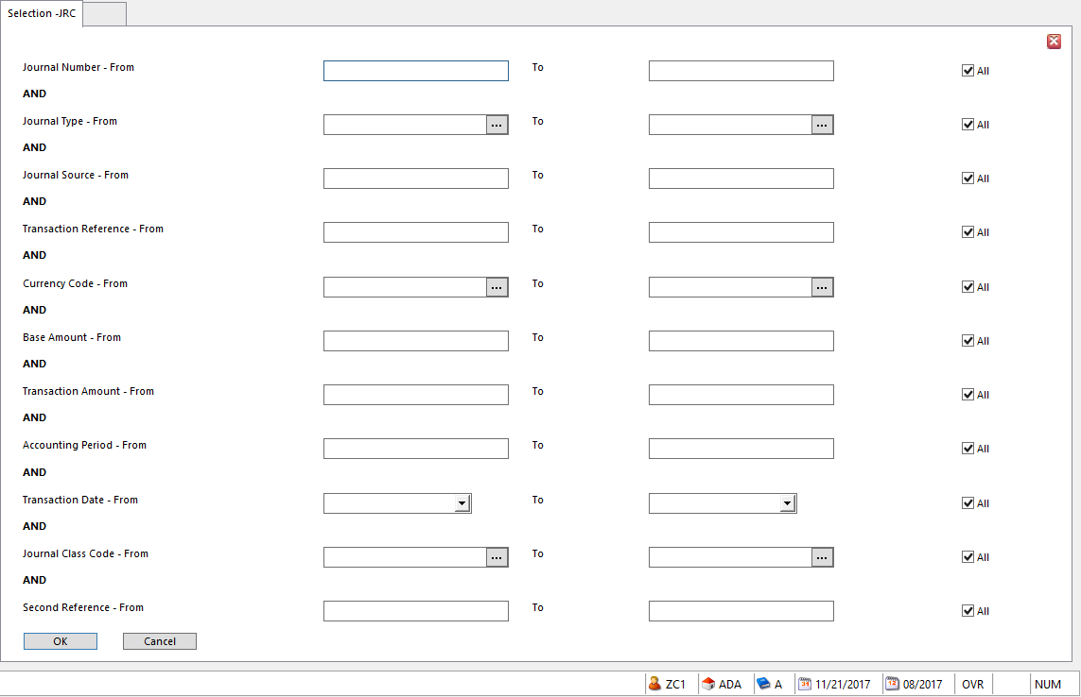
- Enter filter to select the journal to be copied
  - Usually the Journal Number
  - If necessary, use Journal Inquiry to identify the Journal Number
- A second screen will show the journals that fall into the requested range

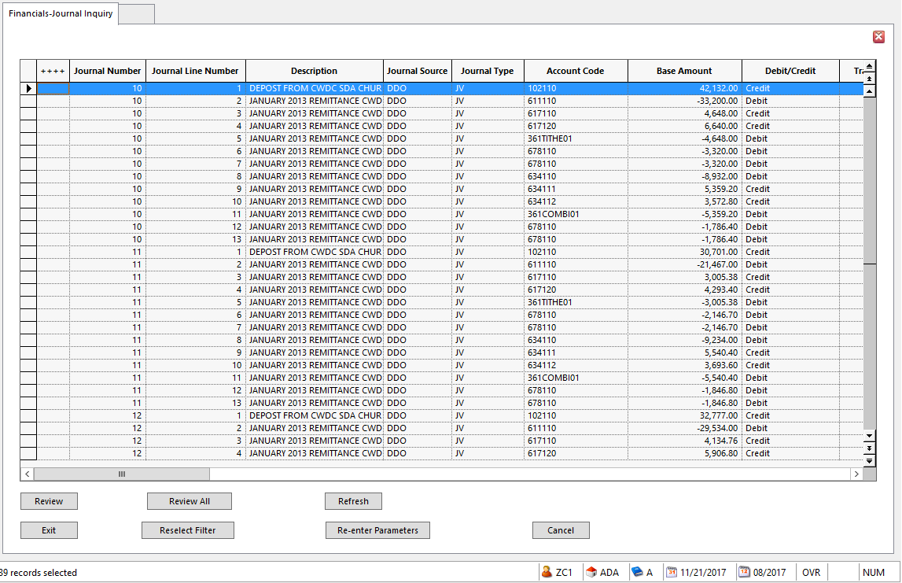
- Select the Journal or range of Journals to Copy
  - To select multiple journals, hold down the CTRL key while clicking each required journal line
  - To select a contiguous range of journal lines, click and drag the mouse down the left side of all the required lines.
    - If all the lines of a journal have not been selected, the system will select them so the entire journal will be copied.
- To select the entire range of journal lines, click Review All
  - To select one line, click on that line and then click Review

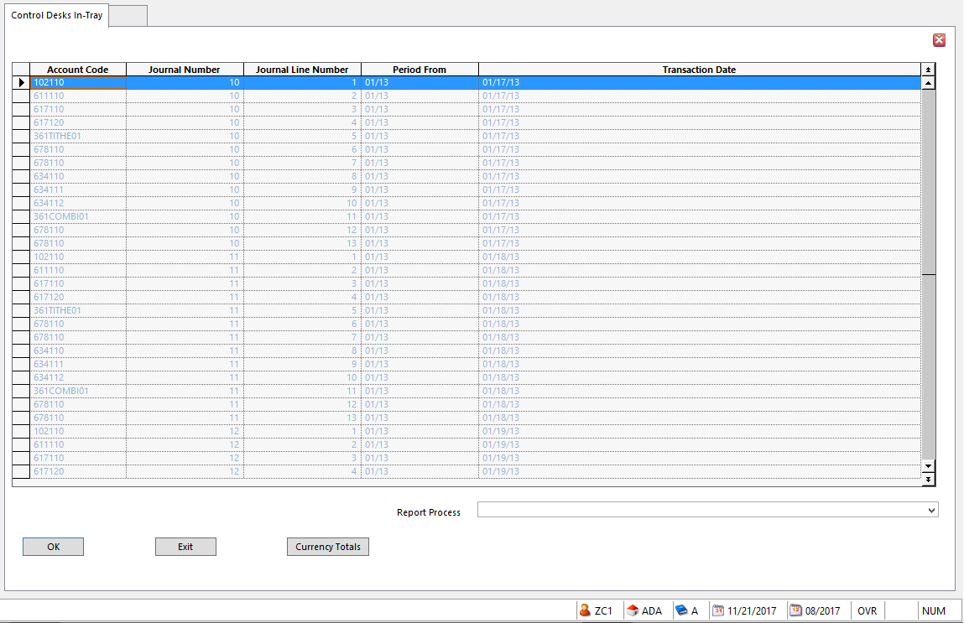
- Selected Journal lines will be displayed in a second Control Desk In-Tray
  - The text will be very light on this screen
- Select Journal Copy as the Report Process

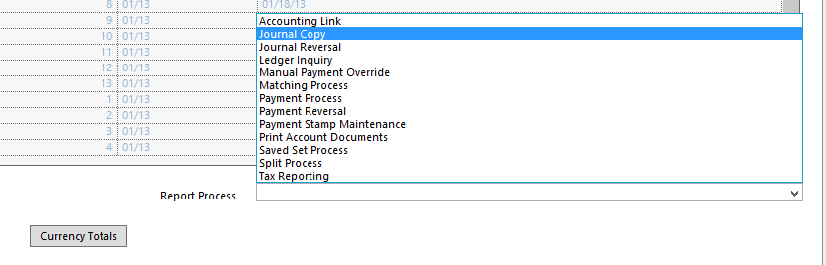
- Click OK

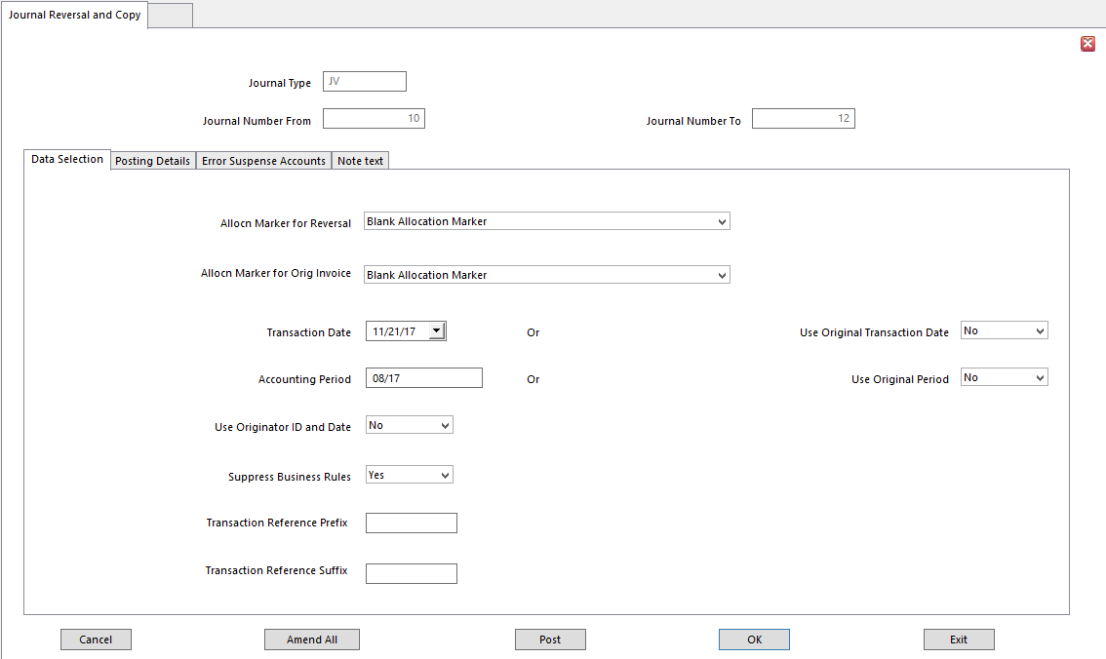

The Header details on the Journal Reversal and Copy screen are for display only.

      - Allocation Marker Choose the Allocation Indicator to apply to journal lines for copy
- Applies to source journal lines AND generated journal lines
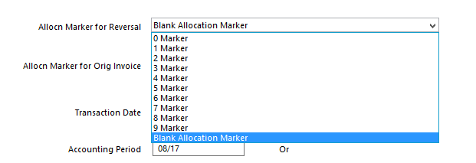

- Allocation Marker for Orig Invoice Only for Payment Reversals
- Transaction Date Date registered on generated journal as the transaction date
- Use Original Transaction Date Yes - copy Transaction Date from originating journal to generated journal.
  - Ignores Transaction Date field
- Accounting Period Enter Accounting Period for posting generated journal
- Use Original Period Yes - copy Accounting Period from originating journal
  - If Yes, leave Accounting Period blank
- Use Originator Id and Date Yes - copy both Originator Id and Date from originating journal
No – use Operator ID and current System Date for generated journal
- Ignore Reversal in Next Period Used only for Reversals
  - Ignores Reverse Next Period setting in Journal Types
- Suppress Business Rules Yes - generated journal is posted despite all Business Rule checks
No – generated journal follows Business Rules
- Event Profile must include call point, ‘End of Journal Line’ and Posting Type must be ‘Post if No Errors Found’

Why suppress Business Rules? For instance, for transactions involving account codes that have subsequently been restricted using Business Rules.

- Transaction Reference Prefix Up to 5 characters, alpha, numeric, or alphanumeric
- Transaction Reference Suffix Up to 5 characters, alpha, numeric, or alphanumeric

Posting Details Tab

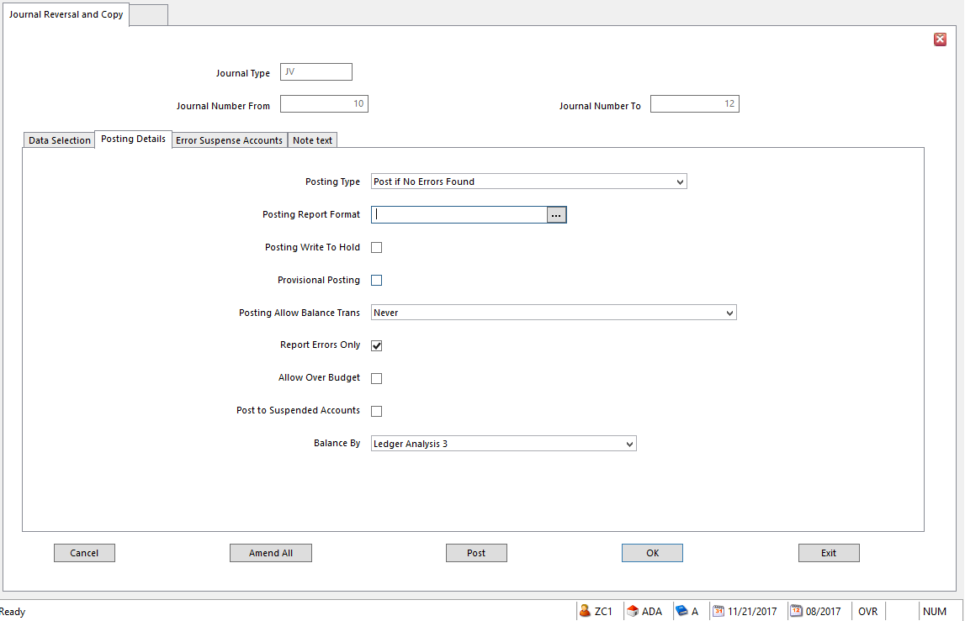

The Posting Details Tab relates to Ledger Import parameters.
- Posting Type Determines if generated transactions are posted, and if errors are ok
Options are:
- Validate Only Transactions are validated but not posted
- Post Transactions are validated
Balancing transactions are generated if necessary; journal is posted
- Post if No Errors Found Transactions are validated and, if no errors, posted.
Can be overridden for an imbalance using Posting Allow Balance Trans settings
- Posting Report Format Report format for reporting validation details or posting copy
- Posting Write to Hold Validates generated journals; stores them in the Journal Hold file
  - Provides additional level of posting control
  - Journals must be released from Hold and posted
  - Left unchecked: journals are validated; posted
- Provisional Posting Provisional Posting is not typically used in SunPlus organizations
- Allow Over Budget Overrides budget controls
  - Allows postings exceeding available budget
- Post to Suspended Accounts If set, transactions can post to Suspended natural accounts
  - If not set, posting to Suspended account is treated as error

Error Suspense Accounts Tab

- Base Suspense Account Natural Account for balancing adjustment if Base Currency journal values do not balance and imbalance exceeds Value 1
Currency Rounding Threshold
- If Posting Type option on Posting Details is set to Post, rejected journal transaction lines will be posted to this account
    - For example, if Account on journal transaction is invalid or analysis code is prohibited, this account is substituted.

- Transaction Suspense Account Natural Account for balancing adjustment if Transaction Currency journal values do not balance and imbalance is not a currency conversion rounding difference

NOTE To generate and post balancing adjustments in the Transaction Currency, the Amount Balancing option must be set to Manual on the Value 2 tab of Business Unit Setup.

- Reporting Suspense Account Natural Account for balancing adjustment if Second Base or
Reporting Currency journal values do not balance, and imbalance exceeds Currency Rounding Threshold for Value 3.

NOTE To generate and post balancing adjustments in Reporting Currency, Amount Balancing option must be set to Automatic on Value 3 tab of Business Unit Setup.

Note Text Tab

Enter optional text relating to the Journal Copy.

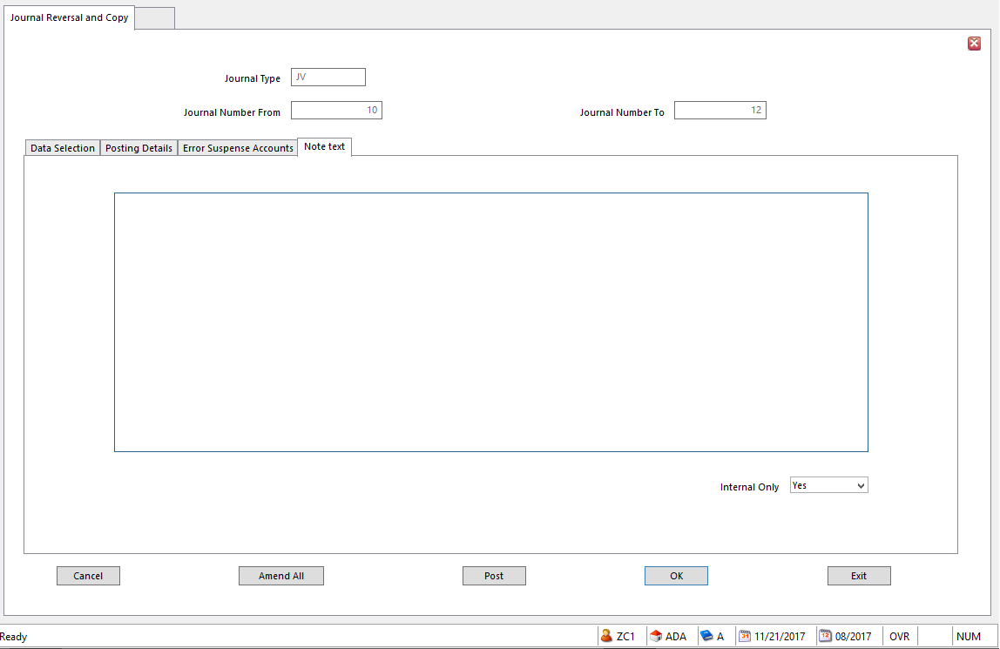
- Internal Only Yes - prevent text from appearing on documents intended for public
distribution

Reverse a Journal

Use Journal Reversal and Copy to reverse one or more journals, without having to re-enter details in Ledger Entry.
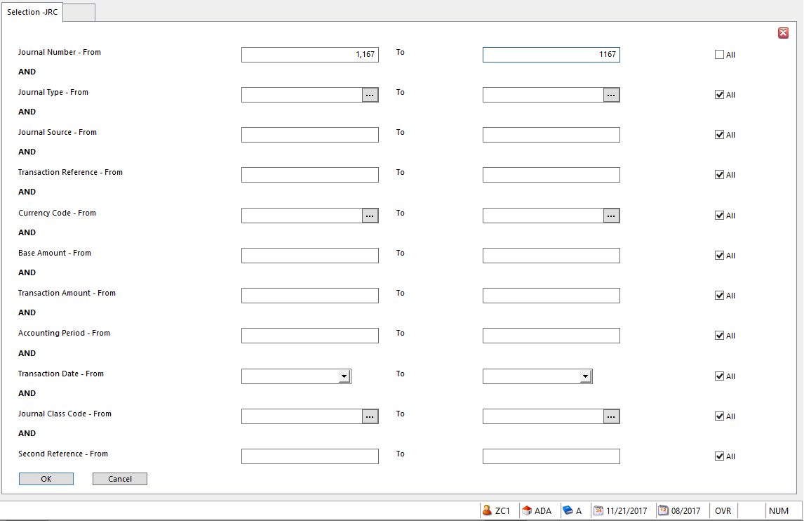

- Enter selection filter to select one or more journals to Reverse
  - Journal Number(s) is typically used
- Click OK
- Header Fields Display only

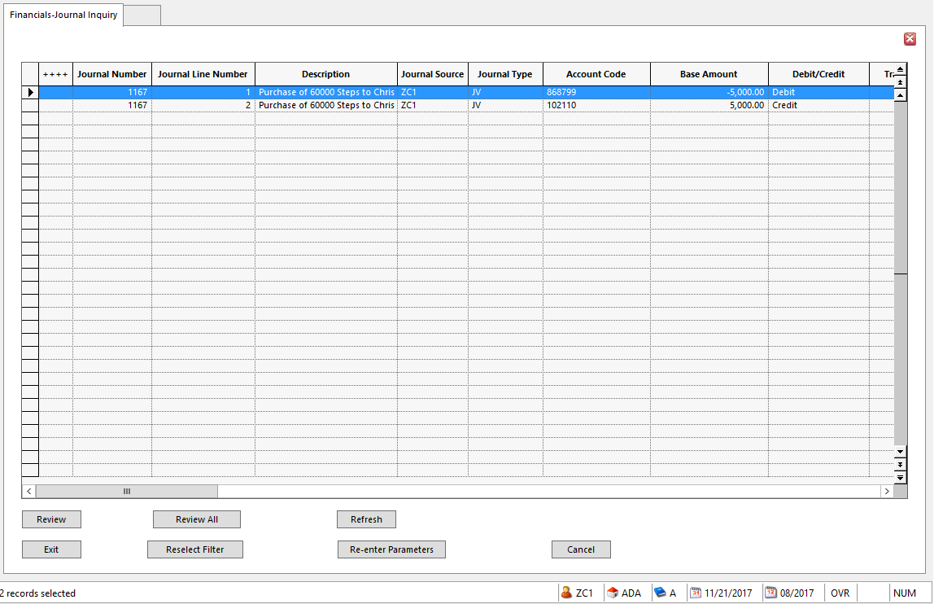
- Selected journal lines are displayed in the Financials-Journal Inquiry screen
- Click the Review or Review All button to select lines to Reverse

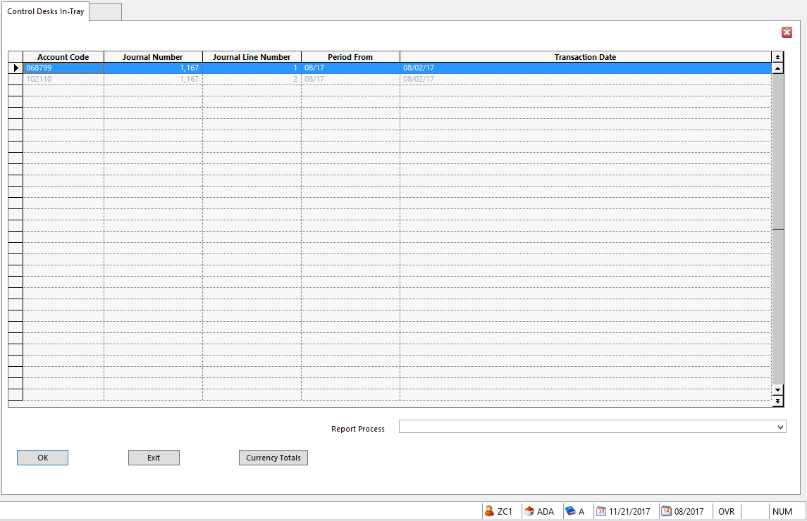
- Selected lines are displayed in the Controls Desks In-Tray screen
- Select Journal Reversal Report Process

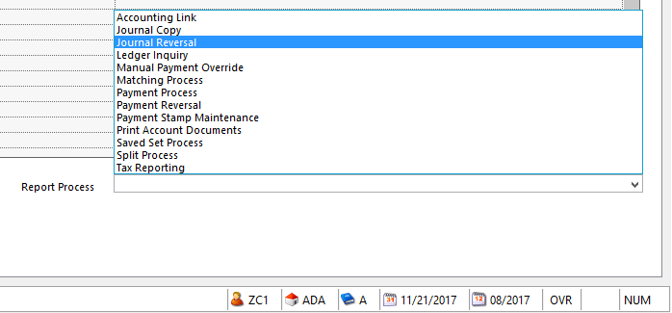
- Click OK

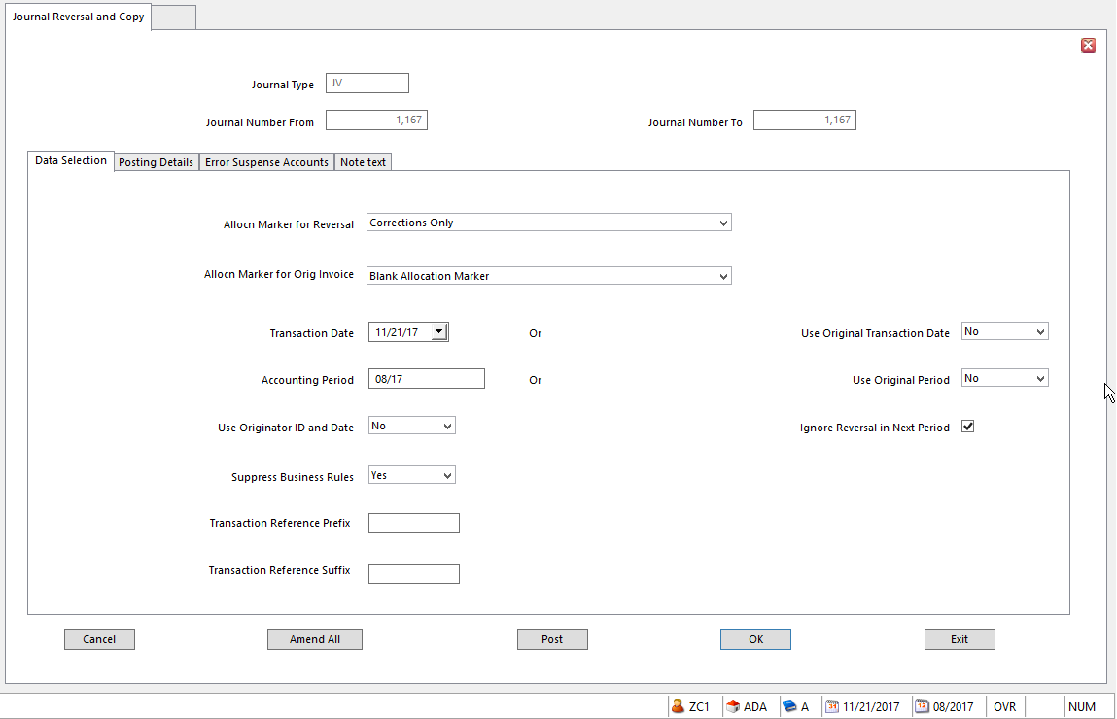

*** See the explanations for Journal Copy above. The process is the same.

NOTE IMPORTANT – always reverse a journal in same period in which original journal was posted, otherwise your financial statements will be incorrect.

Held Journals

Journals that are not yet ready for posting can be Held in a Held Journal file for each Business Unit. Held Journals can be recalled using Ledger Entry.

- Held Journals are never included in general financial reports

Hold Journal in Ledger Entry

In Ledger Entry, a journal can be Held if:
- It is not yet in balance
- Ledger Entry will be exited before the journal is posted
- Transaction details need to be investigated
- A supervisor must review the journal before posting

To Hold a journal in Ledger Entry:

Actions Menu

- Go to the Actions menu in the menu bar

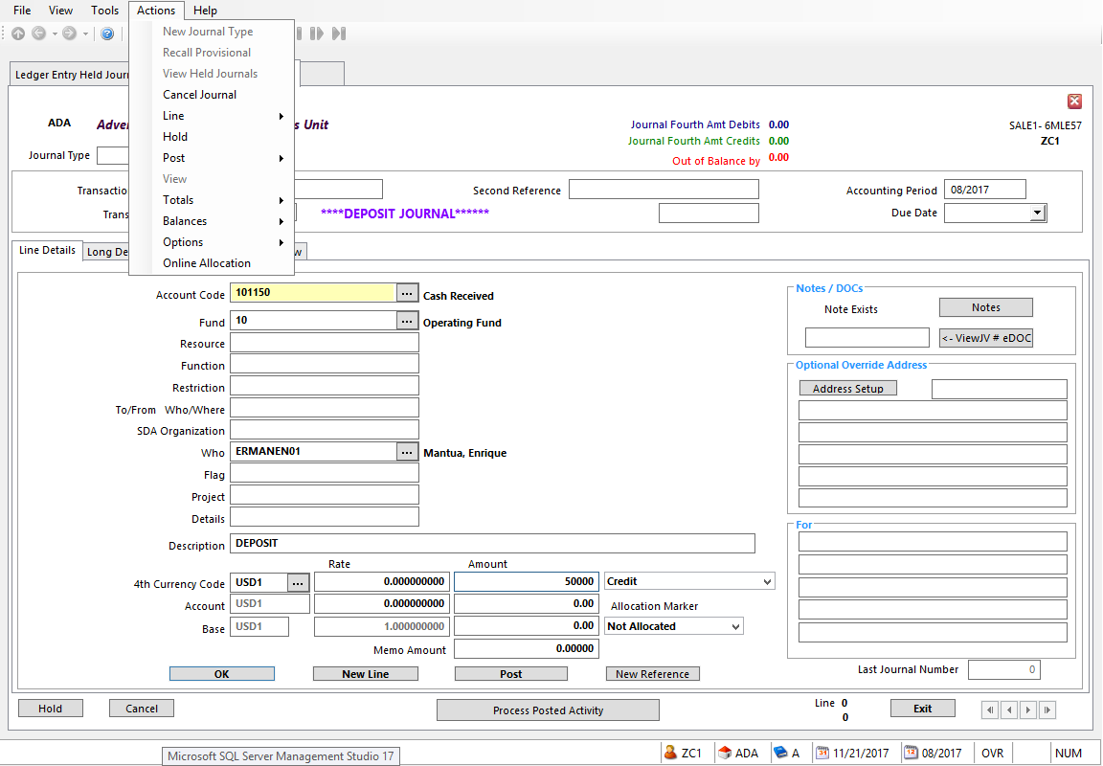
- Select Hold

Or Click Hold Button on Entry Screen

- Click the Hold button on the bottom left of the Ledger Entry screen

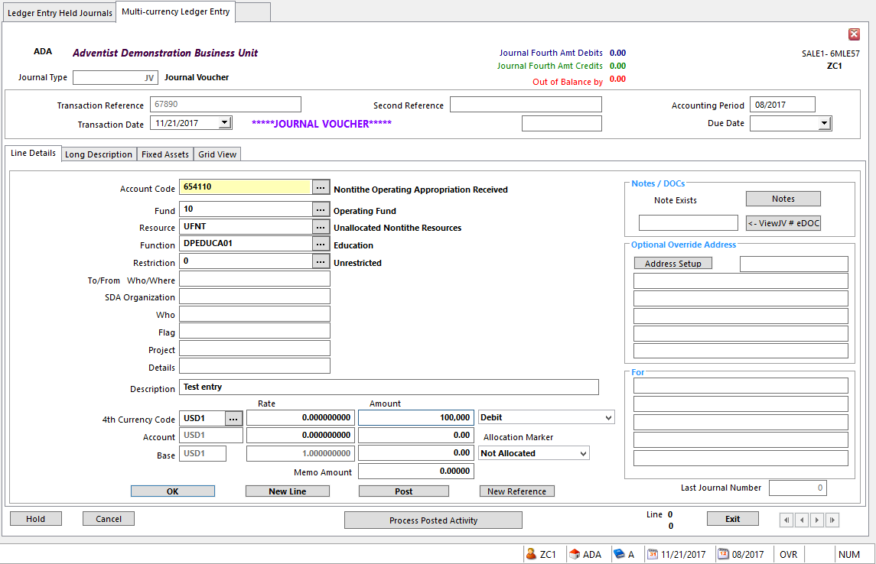

- The Held Status of the journal is displayed in the lower left corner of the screen:

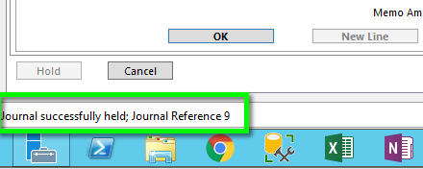

Journal Fails Validation

If the journal does not pass the validation process, the system will produce a warning message:

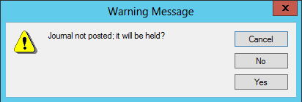

There are three choices:
- Cancel Return to Ledger Entry and correct the problem
- No Discard the journal details completely
        - Confirmation message is displayed
- Yes Hold the journal

Hold Journal in Ledger Import

The Post to Hold setting in Ledger Import validates the journals and stores them as Held Journals
- An additional level of posting control because journals must be released from Hold and posted
- If blank, journals are validated and posted

Hold Journal in Account Allocation

Account Allocations can be used to split a transaction into multiple transactions as long as the total equals the original transaction value. Split transactions can include a mix of debit and credit transactions.
- Split details can be Held by clicking Hold button if the Split can’t be completed
  - The Hold Multi-Part Split dialog pops up; reasons for Holding the Split can be entered
  - The Split can be completed later
- Holding the Split Transaction generates a journal, assigns a unique Journal Reference Number and a SPLIT Journal Type
- Original Transaction gets status of Allocation in Progress until the Split Transaction in the Held Journal is completed or deleted

The following details are added to the Original Transaction:
- Split in Progress flag is set
- Split By User Id is set to the operator id of the user who processed the Split
- Held Journal Number that contains the Split transactions

- To complete the Split, select the Held Journal using Ledger Entry Held Journals to return to the multipart split form
- Enter additional Split Transactions or Amend the existing Split Transactions to complete the Split
  - Search Results – Account Allocation form is displayed showing Original and Split Transactions
  - Allocated in Progress Status is removed from the Original Transaction
- Click Post – generated Split Transactions are posted; Held Journal details are removed

Retrieve Held Journals

Use Ledger Entry Held Journals to list and recall Held Journals and recall a selected journal or select View Held Journals action in Ledger Entry.

A journal will remain in the Held Journal until:
- It has been recalled and posted, or
- It has been recalled and deleted

NOTE Transactions held as part of a multipart Split have a Journal Type of SPLIT.

- Go to Ledger Entry – Held Journals or select View Held Journals from the Ledger Entry Action menu

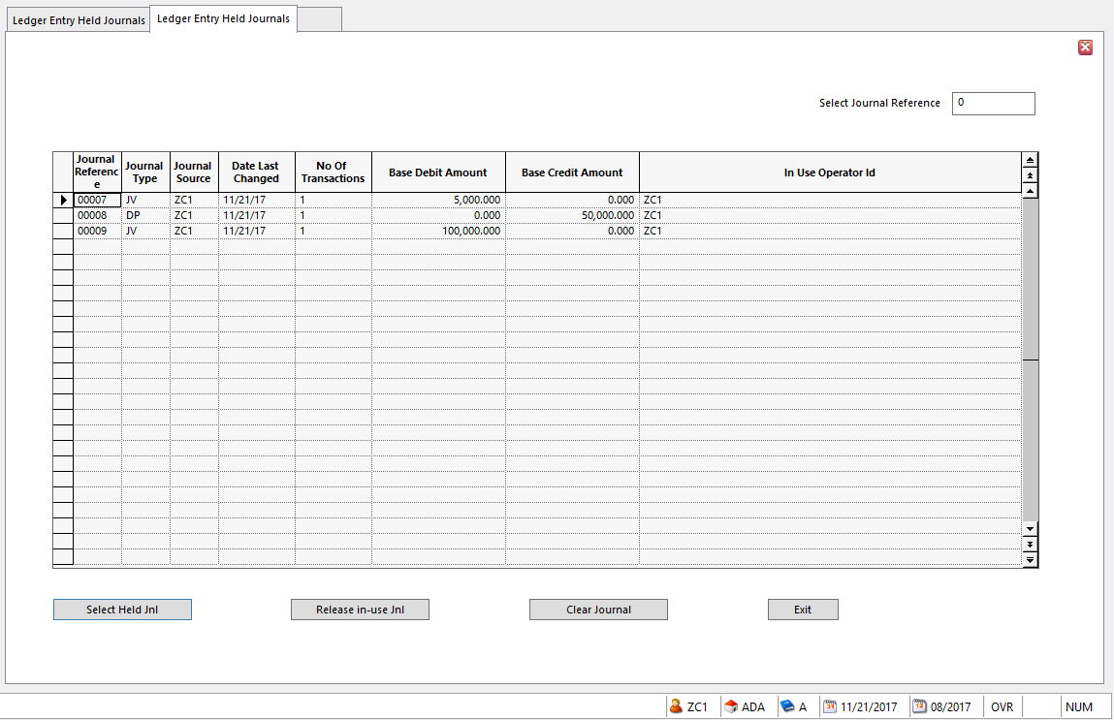
- A list of Held Journals is displayed
  - Each journal has a Journal Reference Number
  - No of Transactions field identifies the size of the journal
  - Journal Source identifies the system user who Held the journal
- Click the journal to reselect
- Choose Select Held Jnl option from the Action menu to reselect the journals for processing
- Or click Select Held Jnl button at the bottom of the form
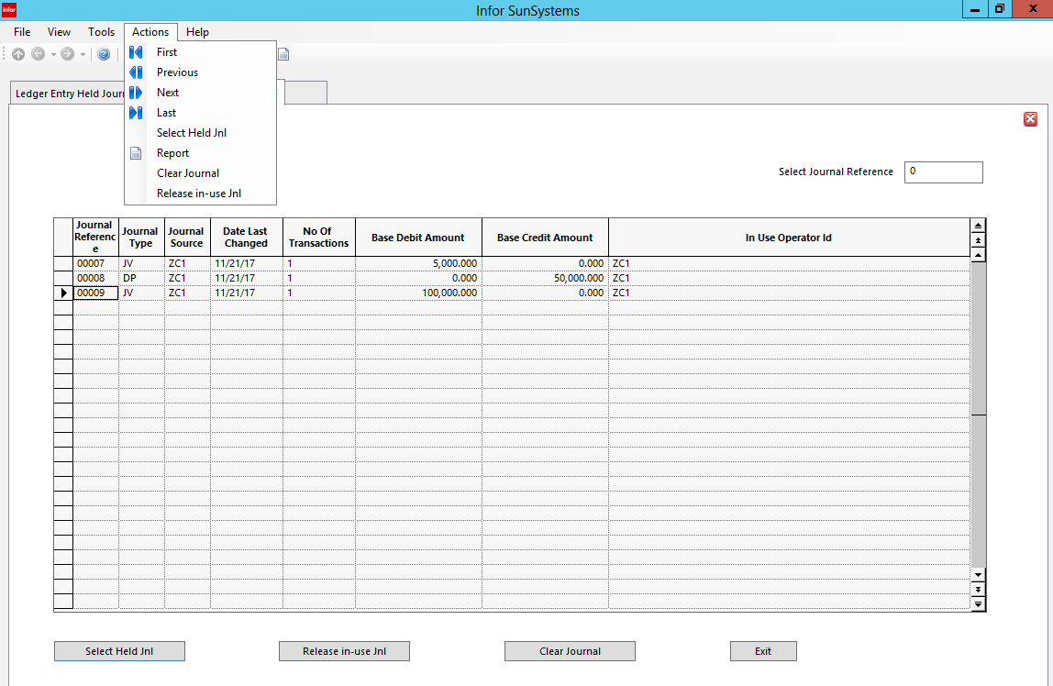
- If the journal was held in Ledger Entry, journal details reappear in Ledger Entry they can be Amended and Posted or Cancelled

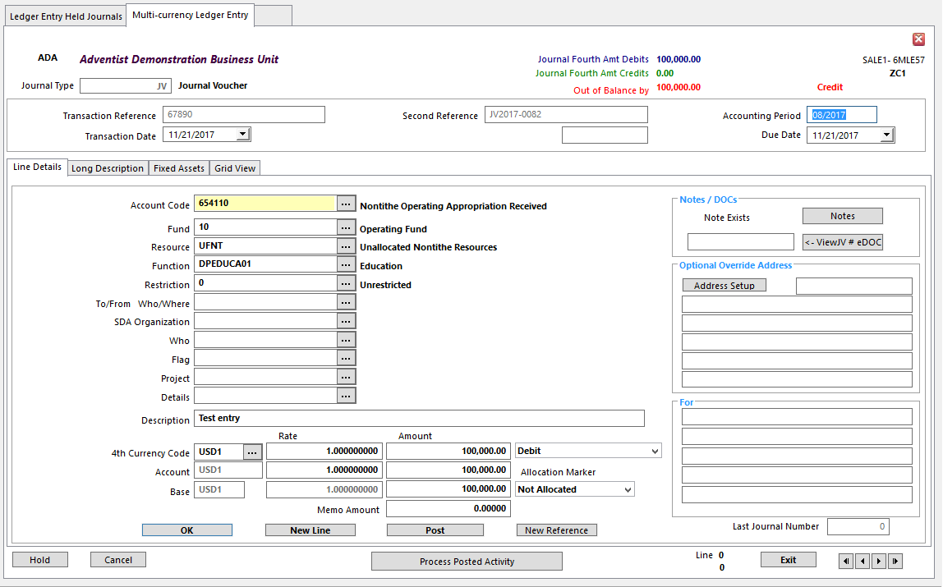
- For Split Held Journals, choose Select Held Jnl to display Split transaction details on the Manual Ledger Allocation Multipart Split form
- The transaction Split can be completed
- To remove the journal, select Clear Journal from the Action menu or click the Clear Journal button

Releasing In-Use Journals

When a transaction is Held, the Allocation Status is set to Allocation in Progress. When the Held Journal is posted, the Status is reset.

Use Release In-Use Action or button to reset the journal Status.

Printing Held Journals

Held Journals are not included in general Financial reports, as they have been entered but not posted. For a Held Journals Listing, go to the Actions menu in Ledger Entry Held Journals.

To print the Journal Held Listing:

- Select Report from the Action menu

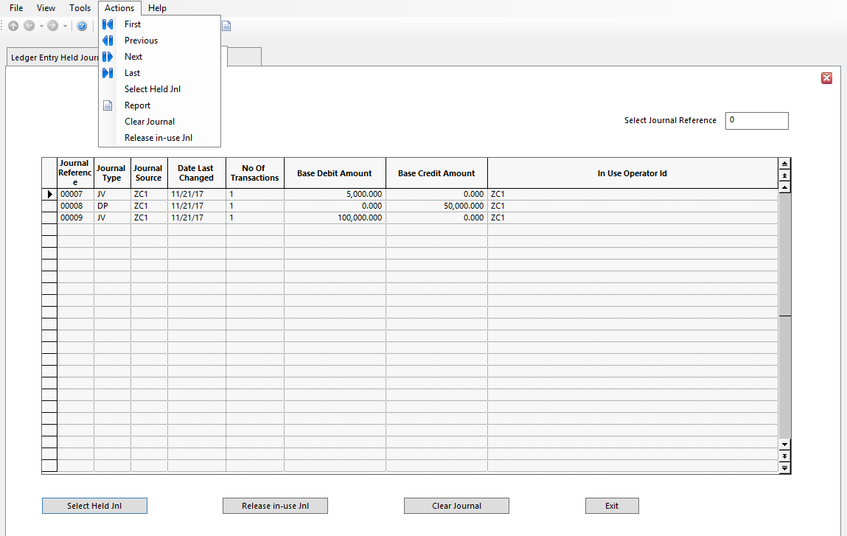

- Change settings, if necessary, in the Document Format Runtime Parameters

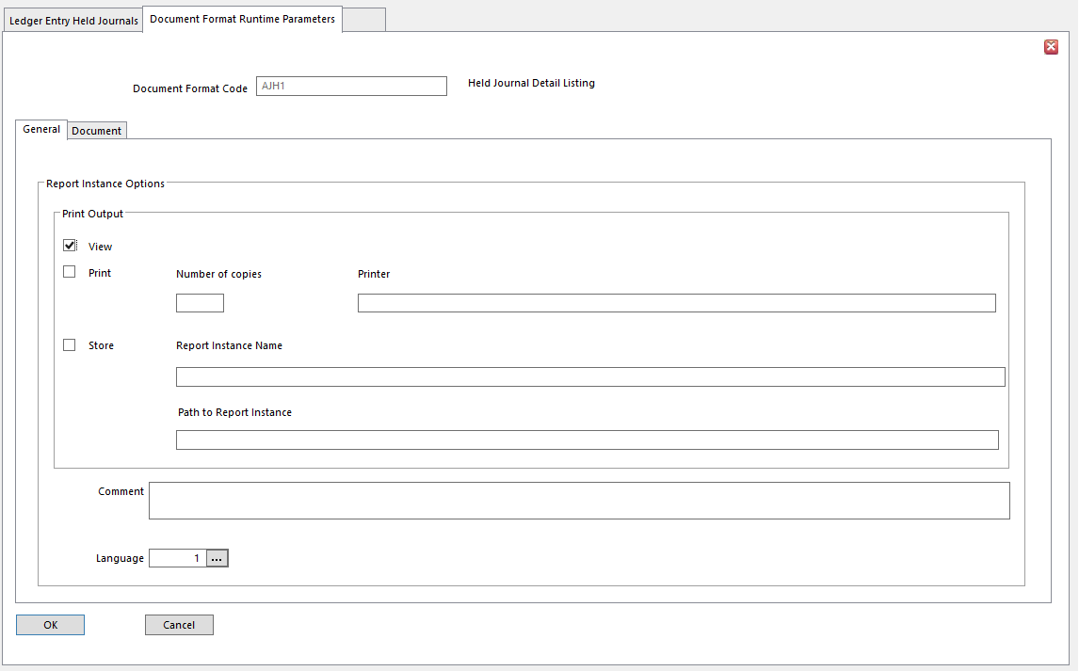
- Click OK

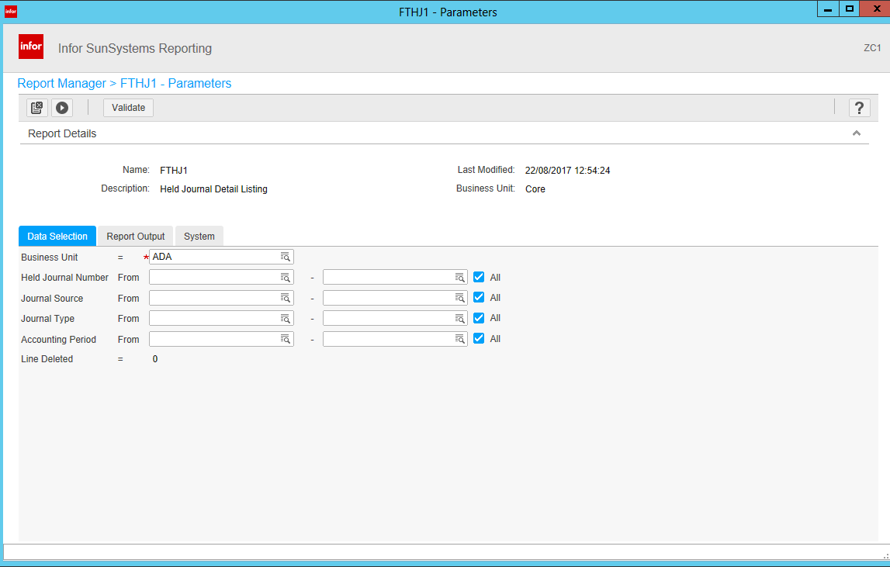
- Enter any required Data Selection values
- Click the arrow icon to run the report

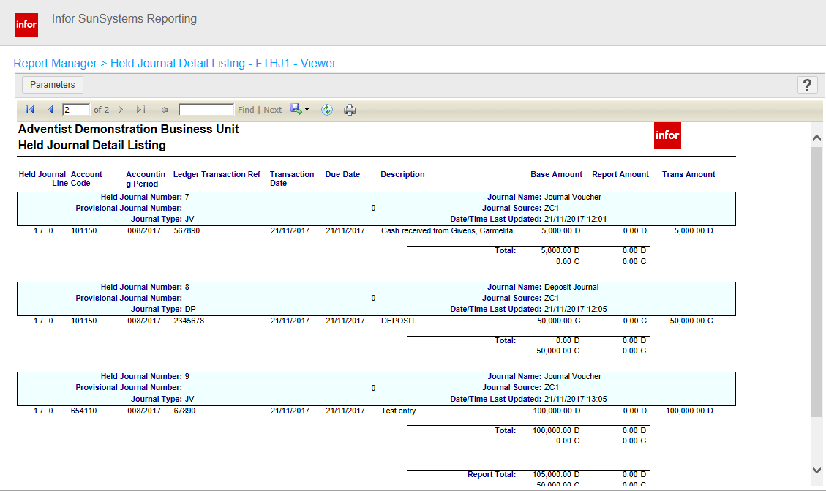

The Journal Held Listing includes:
- Business Unit Code
- Suppress Transactions No or leave Blank – for report to show transaction details
Yes - to show only Date, Description, and total values of each Held Journals
- If transactions are suppressed, the Description of each Held Journal is printed by the journal total line
- Page Break After For each Held Journal to start on a new page, enter 1
  - Leave Blank for the journals to print continuously

Void Journal

There are several ways to correct posting mistakes without destroying the audit trail.

Supervisor Authorization

All transaction details can be changed before a journal has been posted.

To authorize a journal before posting:
- In Ledger Entry, enter journal details
- Click Hold button
- Have a supervisor review the journals
- Go to Held Journals
- Retrieve the approved journal
- Post

Making Corrections After Posting

Some simple changes can be made in Account Allocation after a journal has been posted.
- To preserve Audit Trail, some Journal Transaction details cannot be changed
- The following details CAN be changed after posting:
  - Description
  - Due Date
  - Transaction Analysis Codes
  - Allocation Markers

- Go to Account Allocation
- Make the necessary changes
- Click Post button in Account Allocation

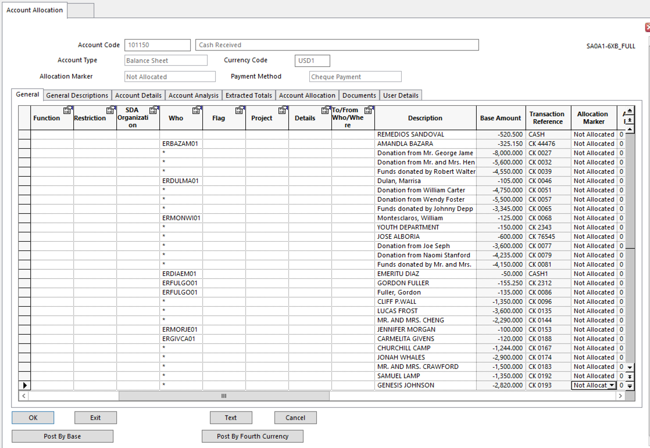

Amending Critical Transaction Information

Correction transactions must be made to correct critical transaction information, such as:
- Transaction Date
- Transaction Reference
- Debit/Credit Marker
- Transaction Amount

To enter a correction transaction, use Ledger Entry, Journal Reversal and Copy, or Ledger Import.

In Ledger Import
- Use the Export/Reverse option in External File Transfer to transfer the erroneous journal transactions to a file with the debit/credit marker reversed
- Use the Import option in External File Transfer to reimport the Ledger Entry
  - This is helpful for correcting a number of transactions at once

Concealing Correction Transactions

Assign a Correction Allocation Marker in Account Allocation to keep Correction Transactions off external documents, while retaining the audit trail.

NOTE The Correction Allocation Marker must be set on at least two transactions with values netting to zero.

Payment Voiding

Payment Run can be used to cancel or remove payments. These transactions can be cancelled or reversed in Payment Voiding.

Payment Voiding
- Changes Transaction Status to Unpaid
- Generates Reversal Journals for all selected payment transactions
- Sets Allocation Marker on the transactions to Correction
- Reinstates the transactions that were paid
  - Sets Allocation Markers on paid transaction to either Unallocated or Withheld

If the Payment Method is not for Single Payments, when posting Voiding Transactions, there is an option for including transactions with analysis separately in a Reversal. If the Reversal includes transactions with different analysis codes, each can be reversed in a separate transaction.
- Each Voiding Transaction line copies the analysis codes from the payment transaction being reversed
- Any ledger analysis is therefore reversed as well
- Click No to create one voiding transaction line with no ledger analysis.

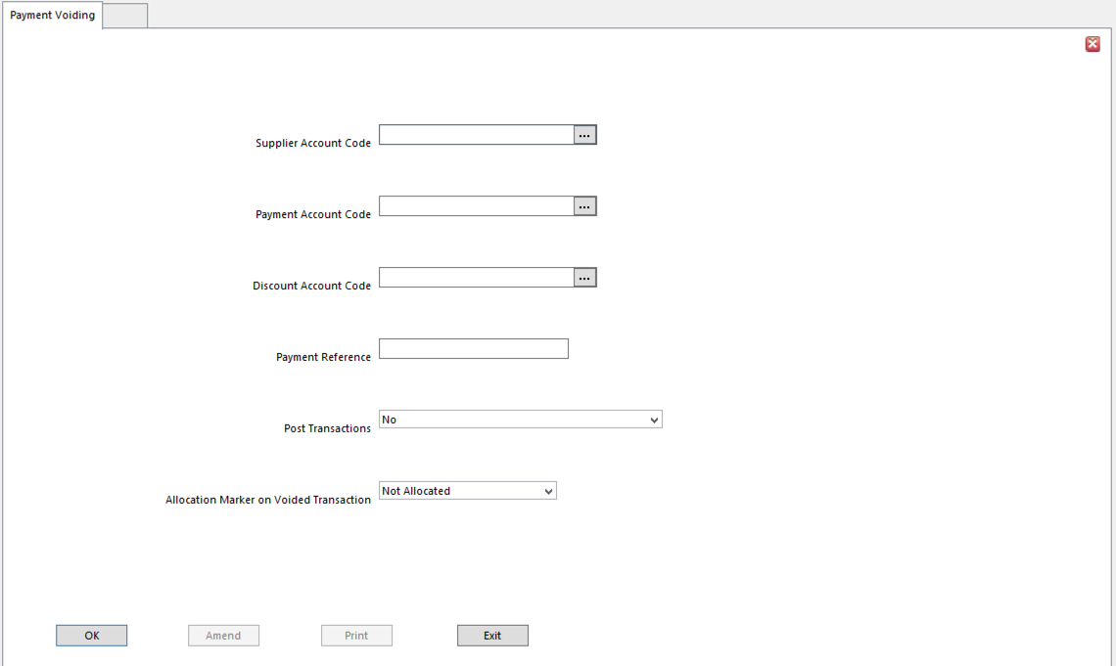

- Go to Payment Voiding
- Enter details of the system generated payment to void
  - A message will ask if the Payment Method was Single Payment
  - If unsure, check the Payment Profile in Payment Profiles Setup Payments tab
- If the Payment Profile is for checks or bank payments, click No

- Supplier Account Code Enter Creditor/Payables/Client account for payment to be voided
- Payment Account Code Enter account to which balancing transaction was posted for the
voided payment
- This account is specified in Payment Account field in Payment Run (normally bank account)
- Discount Account Code Account for any settlement discount for payment to be voided.
- This account is specified in Input Discount Account field in Payment Run
- Leave blank if discount was not taken for this payment
- Payment Reference Transaction Reference of the payment to be voided
      - This will be the Reference on the Supplier account
      - Payment Reference is only assigned to payment transactions when payment documents are produced for the Payment Run using the Final Print setting of Final in the Document Format Report Parameters
      - If a Final Print Run hasn’t been performed for the payments, the Payment Reference will be blank even though the payment transactions have been posted
      - Before voiding one of these payments, use Payment Documents using the Final Print option and Store option to produce a ‘dummy’ payment document and assign a reference to the payment
- Post Transactions This option determines if Void Payment transactions are posted to
the ledger
- No - a report is produced identifying the void transactions that would be posted
  - Allows review to ensure the correct transactions have been selected

NOTE If original payment transactions were Provisionally Posted, the Void Payment transactions must also be posted as Provisional.
  - Allocation Marker on Voided Transaction Select Allocation Marker to replace the Paid Allocation
Marker of the original transaction. Select:
- Pay As Paid – if Financials is being used as a broker ledger, to reset the Paid Allocation Marker to Unallocated
    - Sets the Allocation Code to the code associated with Releasing Payable Allocation action, followed by the code associated with the Payment Voiding Allocation action.
    - If the payment being voided was marked as a Funding payment, this Funding marker is removed
- Withhold - prevents selection for payment until Allocation Marker is reset
- Not Allocated – replaces Paid Allocation Marker with the Unallocated Marker making the transaction eligible for payment again
- Force – replaces the Paid Allocation Marker with the Force Allocation Marker, to ensure transaction is paid on next Payment Run, as long as all relevant criteria are met
- 0-9 Marker – replaces the Paid Allocation Marker with 0 to 9, as appropriate for the Payments procedure

Static Data Creation / Maintenance

Natural Accounts Setup

A Natural Account can be created at any time.

  - To create a Debtor/Receivables, Creditor/Payables, or Client account, use Customers or Supplier to create the related Chart of Accounts Code and define all other details
    - Payment Terms
    - Tax Requirements
    - Etc.
  - If the Natural Account is created in Customers or Supplier, the link to the Customer or Supplier account is set up
  - If the Debtor/Receivables, Creditor/Payables, or Client account is not linked to the related Customer or Supplier account, the Payment and Discount Terms will not be available to the Transaction Matching function, which could create discrepancies

Chart of Accounts Interface General Tab

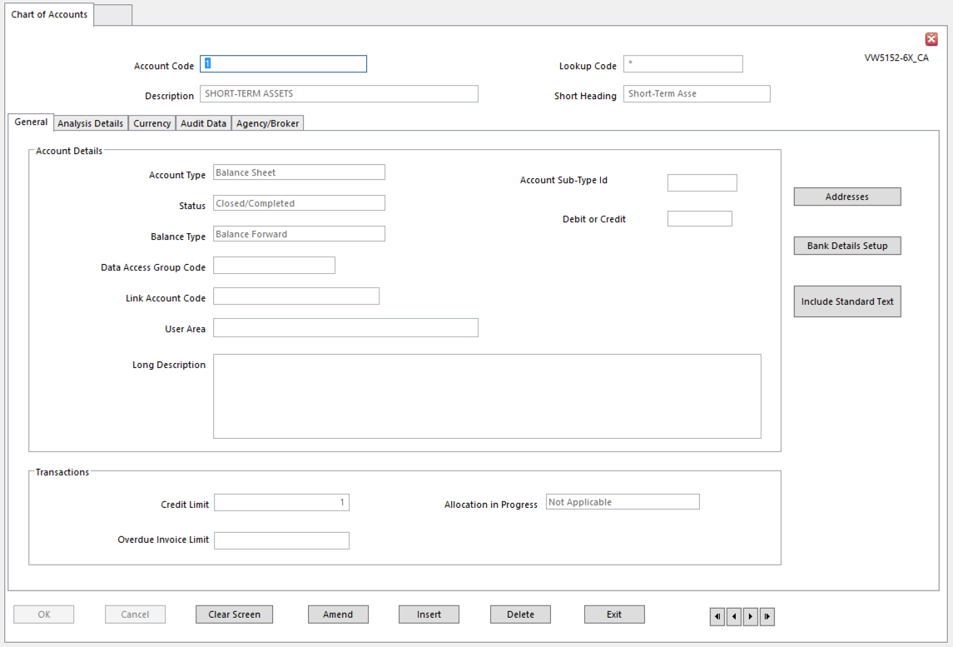
- Account Type Debtor/Creditor/Client/P&L/Balance Sheet, or Memo
- Client accounts can have either a Debit or Credit balance
- Client accounts always link to Supplier accounts, not to Customer accounts
- Memo accounts contain non-financial data
- Status
- Balance Type Balance Forward (P&L and Balance Sheet other than bank accounts)
Open Item (Debtor, Creditor, Client, Bank Accounts)
- Account Sub-Type ID If integrating, enter the Account Sub-Type ID
- Data Access Group Use carefully to restrict operator access to this account
- Debit or Credit Use only if you are integrating
- Link Account Code For linked accounts in Journal Presets, enter the code of the account
to link to this account
- Otherwise, leave blank
In Journal Presets, specify that the account code for a journal line is set to the Link account of the account entered on another line
- User Area Available field – can be used to store any static account information
      - This data is usually hidden, but the values can be pulled into a QA Executive report
- Long Description Available field for any static account data
  - This data can be pulled into a QA Executive report
- Addresses Setup Click to access Addresses Setup record for this account
- Bank Details Setup Click to access Bank Details record for the current account
- Credit Limit Enter amount in Base Currency of credit available on this account
  - Leave blank for no credit limit
- Overdue Invoice Limit Enter amount of Overdue Invoices allowed for the account
- Allocation in Progress Display-only
  - Yes - transactions on the account are being Allocated

Analysis Details Tab

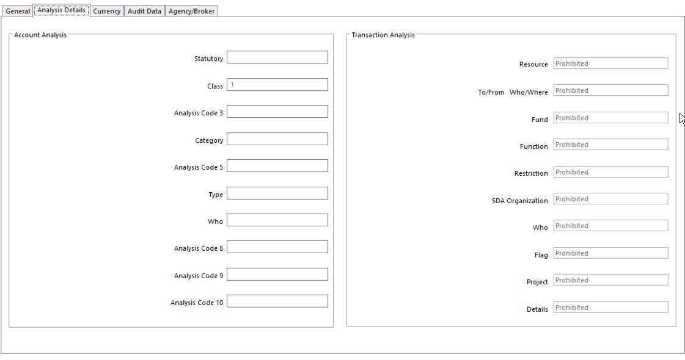

- Analysis Code Up to 10 Analysis Dimensions can be assigned to an account

Currency Tab

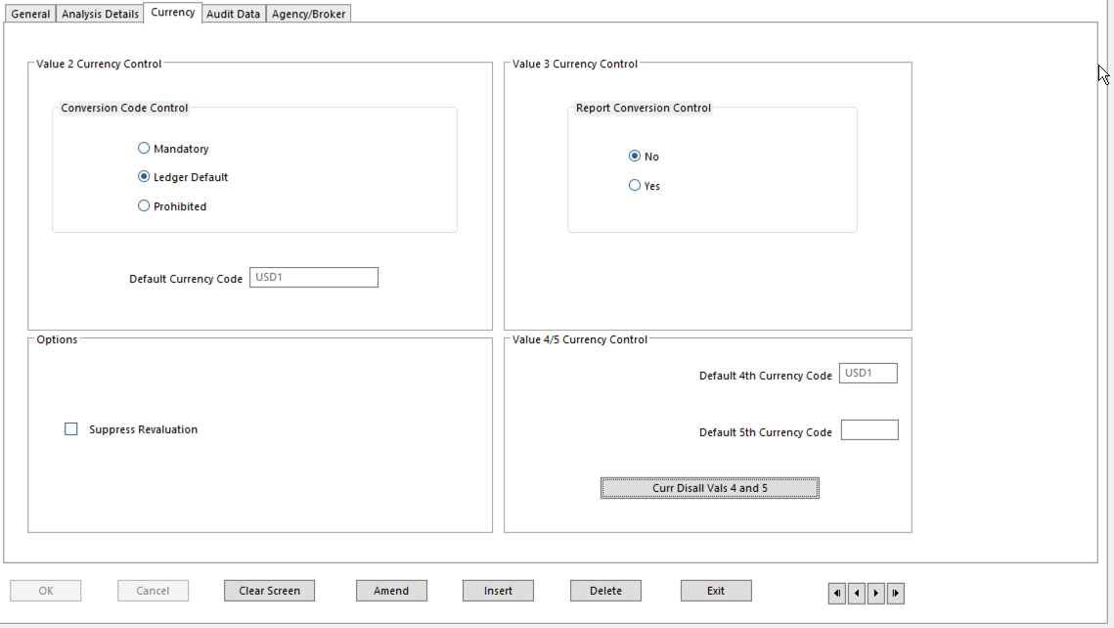

- Conversion Currency Control Select Currency Posting Control to use as default for this account in
Ledger Entry and Ledger Import
  - Overrides corresponding Business Unit option
  - Entry can’t be Forced – the value is undefined
          - Mandatory – forces Transaction Currency to be entered on transactions for this account, regardless of Business Unit Rules
    - Prohibited – prevents Transaction Currency from being entered on transactions for this account, regardless of Business Unit Rules
    - Ledger Default – uses the Business Unit Rule for Transaction Currency
- Default Currency Code Default Currency Code for account postings
- Will be the default Transaction Currency Code on Ledger Entry
- Useful if the majority of foreign currency postings in a particular currency
- Report Conversion Control Not typically used in SunPlus
- Suppress Revaluation Account will be excluded from Ledger Revaluation even if it falls
within selected range of accounts for the Ledger Revaluation
  - Typically used on Fixed Asset accounts or on monetary assets in a high inflation country
- Default 4th Currency Code 4th Currency is defined as variable on Business Unit Setup
  - Set Default Currency Code for 4th Currency in the same way as for the Transaction Currency
  - SunPlus convention is to populate this field
- Default 5th Currency Code Not typically used by SunPlus
- Currency Disallowed for Values 4 and 5 Identify currencies that are not acceptable for Values 4 and
5 on a given account
          - Not typically used by SunPlus

Audit Data Tab

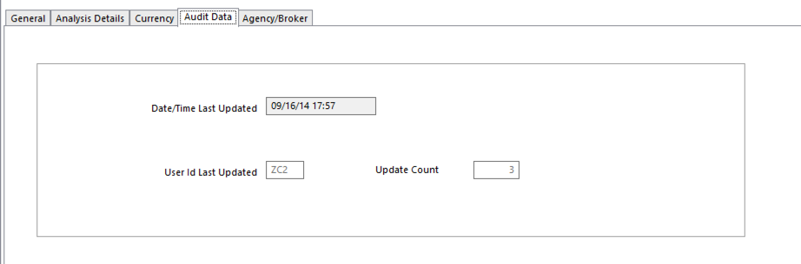
          - Date/Time Last Updated When the account record was most recently created or updated
          - User Id Last Updated

Agency/Broker Tab

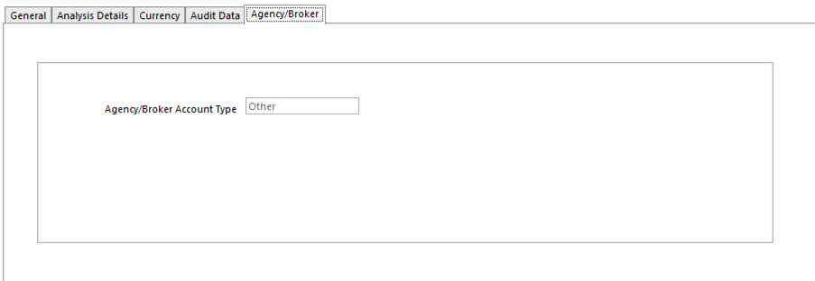
- Agency/Broker Account Type If Business Unit is used as a Broker Ledger operating in a Pay As Paid
environment, the system has to distinguish between the parties involved in a business transaction. The options are:
  - Client – customer accounts – identify insured party
  - Carrier – underwriter accounts – identify insurer
  - Other – other parties in transaction who need to be updated when payment is received – third party brokers
  - Nominal – all other accounts – commission income to business, or bank charges

Printing Chart of Accounts

Chart of Accounts Report lists all of the ledger Chart of Accounts details.

To run:
- Chart of Accounts Setup
- Action menu
- Report

Change Account Status

Suspend, Close, Delete Account

Use to add a level of control to postings to the account.
- If a Suspended account is selected for Ledger Entry, a warning message is displayed.
  - This warning can be overridden, and the posting can be made
- Suspended accounts cannot be used as posting accounts in
    - Payment Run
    - Depreciation Calculation
    - Ledger Revaluation
    - Etc.
- Closed provides stronger limits on the account.
    - Prohibits further posting
    - If an account can’t be deleted because transactions have been posted to it, it can be Closed to prevent further postings.

To change Account Status:
- Go to Chart of Accounts
- Enter the required account
- Go to Action menu
- Select Close, Hide, Suspend, or Reopen
  - Status will change to reflect your choice
- Click OK

To Delete an account
- A ledger account cannot be deleted if:
    - Financial transactions exist in the Actuals ledger
    - Budget transactions have been entered for it
    - Transactions exist in the archive tables for it
  - To Delete the account, ensure account balance is zero, run Ledger Cleardown for the account
  - Use Delete button or delete a range of accounts using Action menu Range Delete option

Supplier Setup

Supplier Setup maintains static information for organizations from which goods or services are purchased.

Each Supplier is linked to a Natural Creditor/Payables account in the Chart of Accounts. When a new Supplier account is set up, the related Chart of Accounts account can be set up at the same time by entering all Chart of Accounts details.

Each Supplier can reference many static data details – Address Codes, Bank Details, and Contacts. When you set up a new Supplier, check to be sure the necessary Addresses, Payment Terms, Bank Details, and Currency Codes exist in the system.

Communication Tab

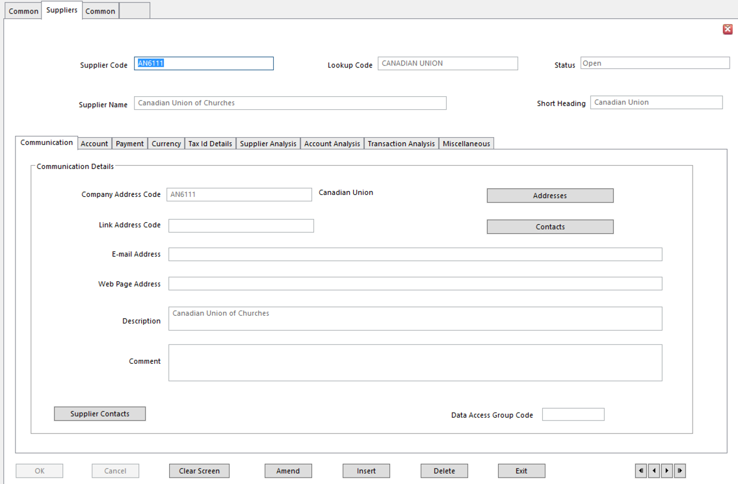
  - Company Address Code Organization’s main address
  - Link Address Code Alternate address for the organization – i.e., a head office
  - Email Address
  - Web Page Address
  - Description Description of the organization
- Use this text field to store any kind of text information
    - For instance, describe the products acquired from this Supplier
- All text fields can be pulled into a QA Executive report
- Comment Use this text field to store any kind of text information
- Data Access Group Limit operator access to this Supplier, if necessary
- Supplier Contacts Click this button to identify people at this organization
- Contacts linked to the organization will be listed
- Use to open Contacts screen and add or remove Contacts
- Contact can be added and linked to Supplier at any time
Addresses Click this button to go to the Addresses interface, to link one or more addresses to this Supplier

Account Tab

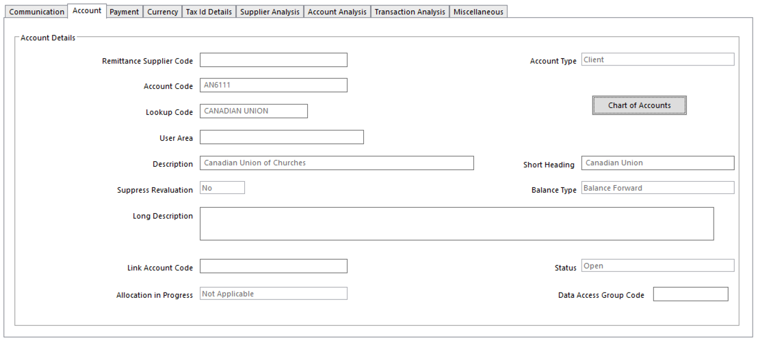
- Remittance Supplier Code Supplier holding account on behalf of a multi-site organization
- Some multi-site organizations have one central site to which remittances should be sent, and one consolidated creditor/payables account
- The address here is for that site

NOTE Choose either Remittance Supplier Code or Account Code for an organization. You cannot have both.

- Account Code Chart of Account’s Creditor/Payables/Client account for Supplier
- All transactions for this Supplier are posted to this account
- If a code for an account that has not yet been set up is entered, all necessary account details and account is created
- Account Type Defaults to Creditor; changed to Client if Supplier is also a Customer
  - Lookup Code For Natural Account
- User Area Use this text field to store any kind of text information
  - Text fields are available for use in QA Executive reports
- Description Use this text field to store any kind of text information
        - Text fields are available for use in QA Executive reports
  - Short Heading For Natural Account
  - Suppress Revaluation Excludes Supplier from Ledger Revaluation, even if it falls within a
range of accounts on which Revaluation is being run
  - Balance Type Balance Forward or Open Item
- Balance Forward – summarized during Ledger Cleardown regardless of Allocation Markers on individual transactions
          - Single balance transaction per Accounting Period
          - Transactions are archived and no longer available for reports or inquiries
          - P&L accounts are usually Balance Forward (except for bank account)
        - Open Item – only Allocated transactions summarized in Ledger Cleardown
          - Debtor, Creditor, and Client accounts are usually Open Item
          - Bank account may also be Open Item, for Reconciliation purposes
- Long Description Use this text field to store any kind of text information
- Text fields are available for use in QA Executive reports
- Link Account Code Account to be linked with this account via Journal Presets
- Leave blank if not required
- Allocation in Progress Shows if transactions are in the process of Allocation
- Data Access Group Controls access to this account
- Chart of Accounts Click for access to Chart of Accounts record for Supplier

Payment Tab

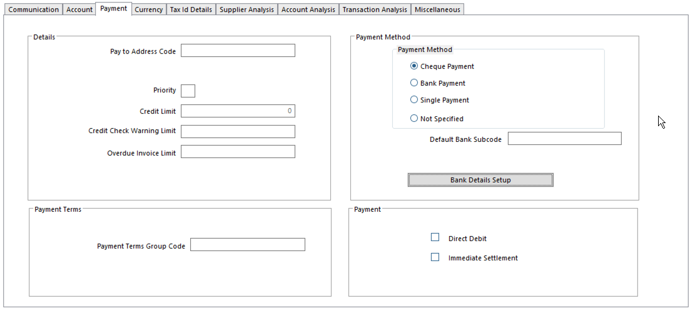

To use Payment Run to produce automatic payments or bank transfer payments, payment details must be set up on this tab.

- Pay to Address Code Address Code to which payments should be sent for the Supplier
- Priority Codes used to group Suppliers and Clients together for any reason
- Enter any number or character to represent the group to which this Supplier belongs
- Priority Groups can be used in a number of system functions, such as Payment Run
  - Credit Limit Information only field. Not used in calculations.
  - Credit Check Warning Limit Information only field. Not used in calculations.
  - Overdue Invoice Limit Information only field. Not used in calculations.
  - Payment Method Method for paying Supplier
          - Must match Payment Method specified in Payment Run Rules
- Cheque Payment
- Bank Payment Automatic Bank Payment Method
  - Direct Debit or BACS
          - Supplier’s Bank Details must be defined in Bank Details Setup
    - This can only be used if Automatic Bank Payments facility has been selected in Ledger Setup
  - Single Payment – One-Off Supplier
  - Undefined – alternate payment method is used for the Supplier – i.e., manual check
- Default Bank Subcode Supplier’s default bank account details
  - Defined in Bank Details Setup
- Required if account will be settled by bank transfer and Supplier has more than one defined bank account
- Bank Details Setup Click Bank Details to set up or amend Supplier’s Bank Details using
- Payment Terms Group Code Payment Terms agreed with the Supplier
- Define in Payment Terms
- Terms determine
    - When transaction is due for payment
    - Whether Settlement Discounts apply, and
    - Payment Dates and Charges calculated based on Due Date and Discounts
    - Whether a transaction must be split into installments using Scheduled Payments
- Direct Debit Select to generate payments using Payment Run
- Applies to Debtors/Receivables and Client accounts only
- Immediate Settlement Select if account will always be settled in the next Payment Run
- Due Date is ignored
- Leave blank to include a transaction in a Payment Run when the transaction is due for settlement, according to the terms identified in the Payment Terms

Currency Tab

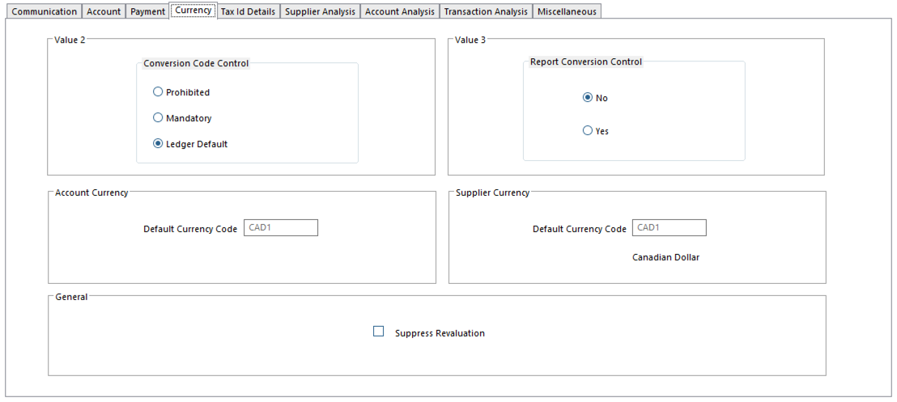

- Conversion Code Control Determines if a Transaction Currency value (Value 2) is entered on
postings to this account in Ledger Entry and Ledger Import
- Overrides Business Unit Setup setting
- Options:
    - Prohibited – prevents foreign currency values for
    - Mandatory – the transaction value has to be entered in any currency
    - Ledger Default – uses the Currency Control option defined in Business Unit Setup
- Report Conversion Control Determines if Reporting or Second Base Currency value (Value 3) can
be entered on postings to this account.
- Overrides Business Unit Setup setting
- Options:
    - No – prevents entry of Reporting Currency Value
    - Yes – allows Reporting Currency Value to be entered in any currency
- Default Account Currency Code Default currency for Transaction Currency postings to this account
- Used as default Transaction Currency Code on Ledger Entry
- Useful if majority of foreign currency postings are made in a particular currency
- Default Supplier Currency Code Default currency for Supplier
- Default currency for other Supplier processes
    - For instance, if documents are always required in a particular Currency/Language for Supplier
- Suppress Revaluation Excludes Supplier from Ledger Revaluation even if it falls within a
range of accounts for which Ledger Revaluation is being run

Tax ID Details Tab

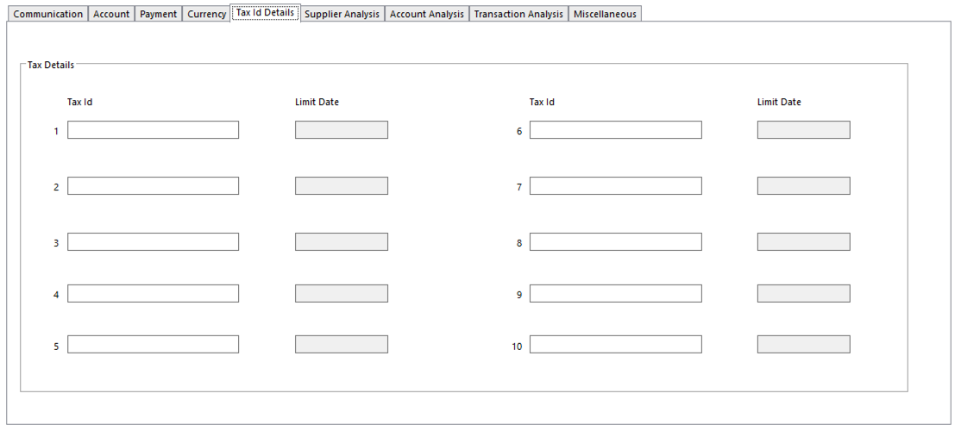
- Tax Id (1 to 10) VAT Registration Code or other Tax Registration Number for Supplier
- SunSystems can be configured to validate that the Tax Ids entered on Supplier records are unique
- Limit Date (1 to 10) Date to which each Tax Id applies

Supplier Analysis Tab

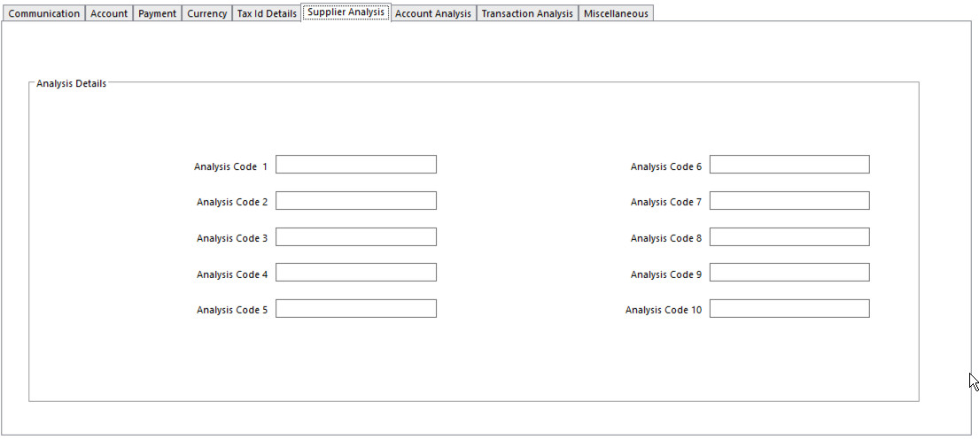
- Analysis Code Up to 10 Analysis Dimensions can be assigned to a Supplier

Account Analysis Tab

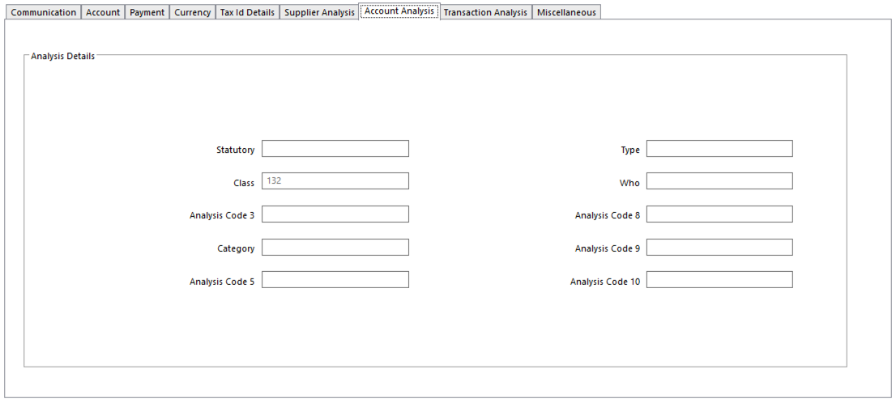
- Analysis Code Up to 10 Analysis Dimensions can be assigned to an account

Transaction Analysis Tab

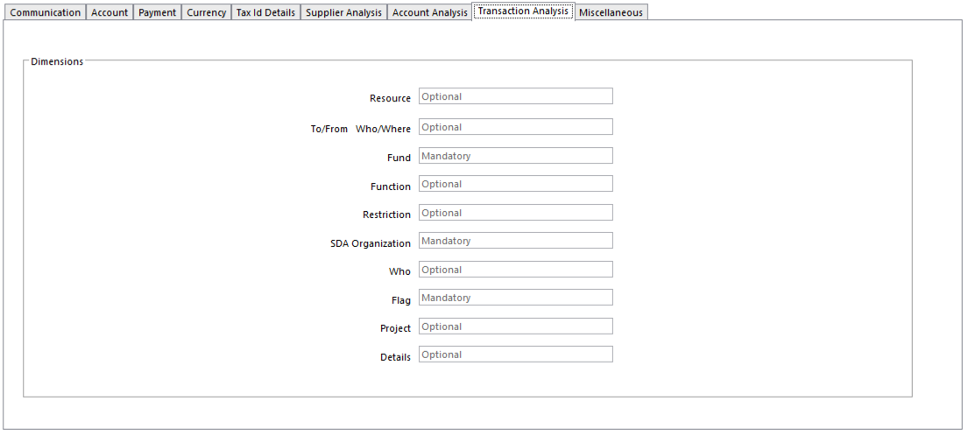
- Enter Analysis 1 – 10 Up to 10 Analysis Dimension codes can be entered on a transaction
- Transaction Input Rules for each Dimension can be determined
- Options:
    - Optional – uses the Transaction Analysis requirements defined for Journal Type when transactions are being entered for this Supplier
    - Mandatory – forces a valid Analysis Code to be entered for the Dimension on transactions for this Supplier, regardless of settings in Journal Type
    - Prohibited – prevents Analysis Code for Dimension being entered on transactions for Supplier

Miscellaneous Tab

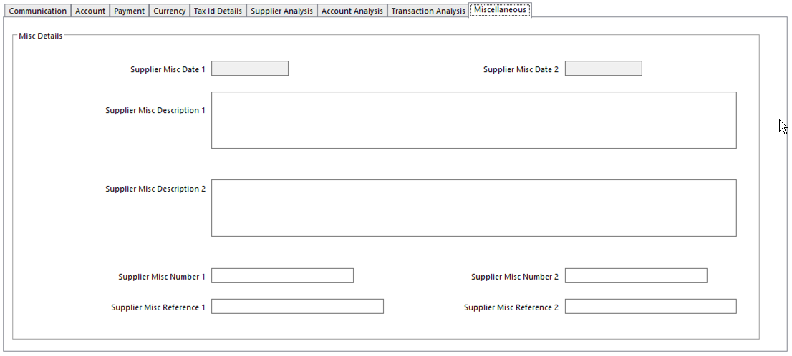

- These fields are available for any information that is not provided for elsewhere
  - These fields can be pulled into any QA Executive report

Contact Setup

One or more people at a particular Customer/Supplier organization can be set up as a Contact using Contacts.
A link is then made with the organization using Supplier.
- Any number of Contacts can be set up for a Supplier
- A Contact can also be linked to more than one Supplier
- A Contact that has been linked to a Supplier cannot be deleted

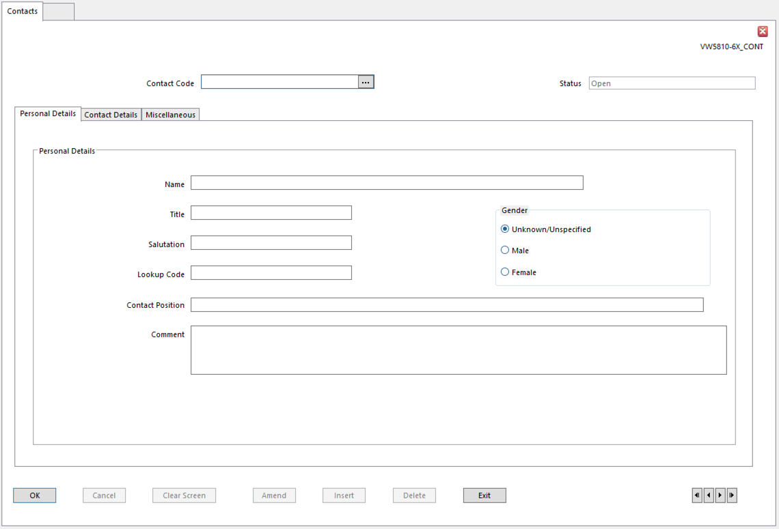

Contact Details

  - Contact Code Identifies the Contact
  - Name Contact’s full Name
  - Title Contact’s title – Mr., Ms., Sir, Doctor
  - Salutation Greeting for letters or documents to the Contact
          - Will follow “Dear” in a letter
  - Position Contact’s role in the company or job title
  - Comment
  - Base Address Code Contact’s main address
        - Defined in Addresses
        - Address code must exist before Contact
  - Telephone Number Contact’s telephone number if different from the number defined for
Base Address
- Might be the Contact’s extension number
  - Misc Fields Use as required

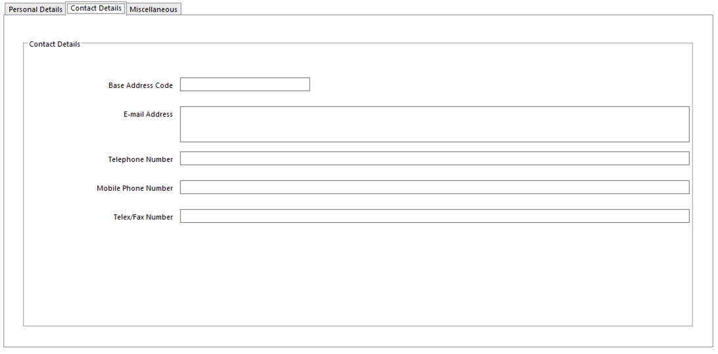

Miscellaneous

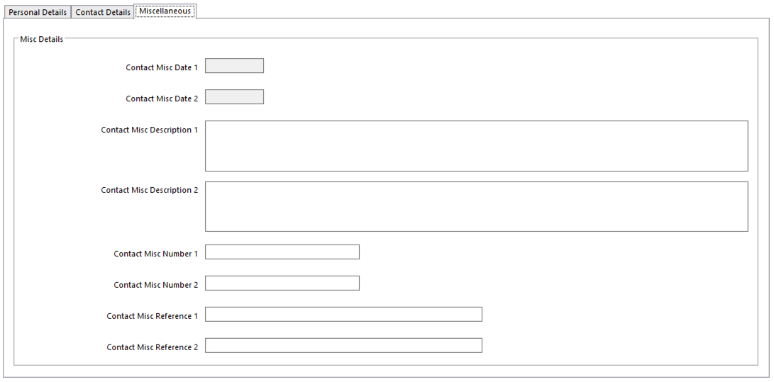

Linking a Contact to a Customer/Supplier Account

- Set up the Contact in Contact Setup
- Use Customers/Supplier to retrieve details
- To link Contact to a Customer/Supplier, click the Assign Contacts (Supplier Contacts) button
  - Contacts already assigned to this account will be listed on this form
- Click Insert to display a blank line on the dialog
- In the Contact Identifier field, enter the Contact Code or use Query to select the Contact
- In Address Code field, enter Contact’s address code or use Query to select
  - Contact’s address may differ from the Customer/Supplier address
- In Priority field, enter priority for this Contact
- Click OK to Save

Removing a Contact for a Customer/Supplier

When a Contact is removed for a Customer/Supplier, the link is the only thing removed; Contact details remain until deleted in Contacts.

To remove the link with the Customer/Supplier account:
- Use Customer/Supplier to retrieve the Customer/Supplier account
- Click the Contact button to display the Assign Contacts dialog listing the account’s Contacts
- Highlight the Contact to delete and click Delete
- Confirm

Analysis Code Setup

To set up new Analysis Codes:
- Go to Analysis Code Setup

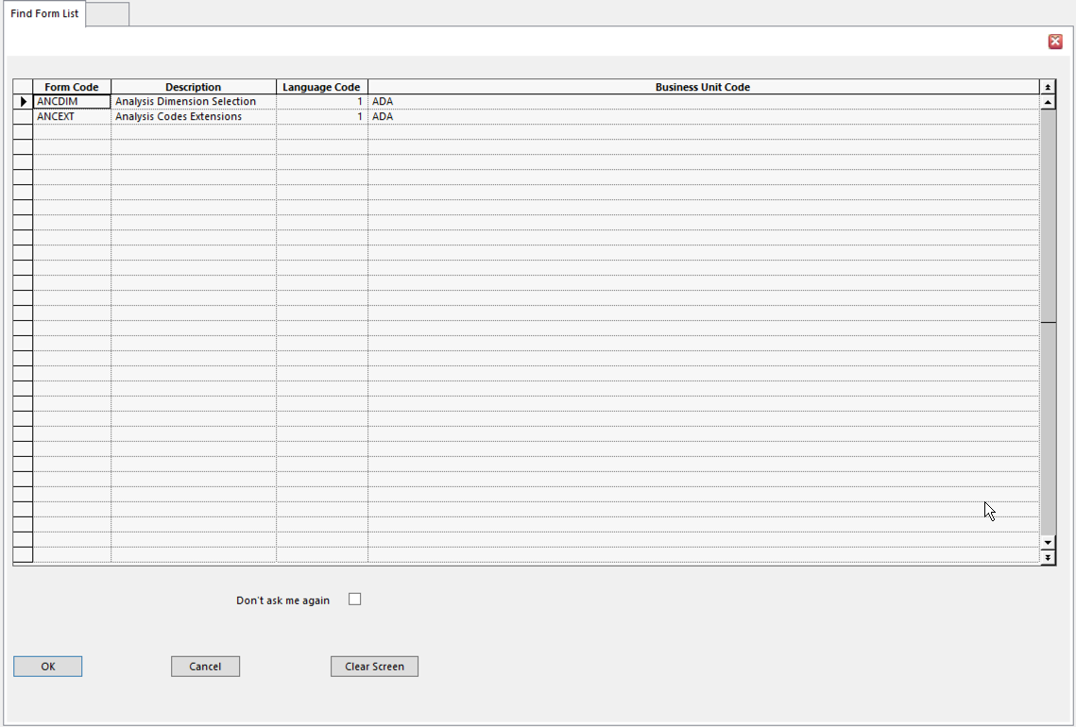
- Select Analysis Codes Extensions

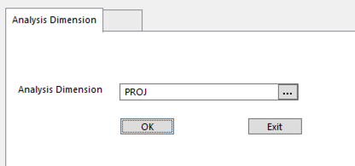
- Enter or select the relevant Analysis Dimension
- Click OK
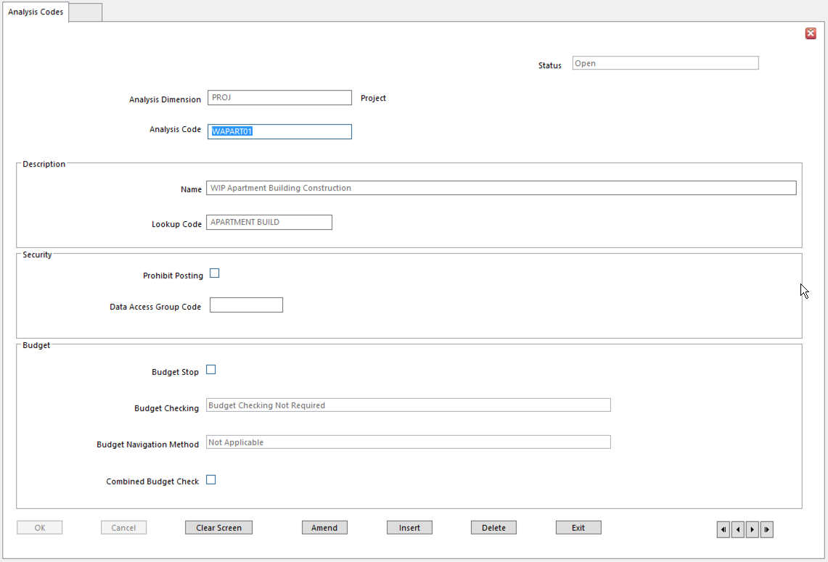
- Enter:
  - Analysis Code
  - Name
  - Lookup Code
  - Prohibit Posting Tick if Analysis Code should not be used in Ledger Entry
      - Use Prohibit Posting only on Heading codes
- The following fields are available, but rarely used in standard SunPlus organizations
  - Budget Stop Use to prevent any new transactions being entered against this code.
      - For example, if a Ledger Transaction, Purchase Invoice or Purchase Order is raised, this Analysis Code is used and there is a budget stop; user is warned and stopped from entering the transaction
      - If budgets for all postings using this Analysis Code should be Open, leave field blank.
  - Budget Checking Use to determine the type of Budget Checking to be carried out for
the Analysis Code. Options are:
    - Budget Checking Not Required - select for no budget checking for transactions with this Analysis Code
    - Allow Budget Checking - select for this Analysis Code, when it is used on a transaction, to be used for budget checking
    - Allow Budget Checking at Account Level Only - select for budget to be checked at the account level for transactions with this Analysis Code
  - Budget Navigation Method If Budget Checking is carried out, select Period to be checked
for available budget.
- Choices:
  - Current Period Budget only
  - Previous Periods
  - Future Periods or
  - A combination of these.
- Alternatively, choose Not Applicable if budgets should not be checked
    - This overrides Budget Check Setup settings
    - Available budget is checked against a Period and is calculated as:

Available budget = budget – committed expenditure – actual expenditure

    - Budget Checking uses current Period Budget first. If there is insufficient available budget in this Period, it then checks other Periods; Budget is consumed in order. If there is still insufficient available budget, the transaction fails Budget Checking.
          - Period Budget Only – only checks available budget for defined Period
          - Previous Periods - if insufficient Budget in current Period, start checking the previous period. If there is insufficient budget, check previous period, etc.
      - Future Periods – start checking in the current Period if there is insufficient Budget, check the next Period, if there is insufficient Budget, check the next Period, etc.
      - Previous and Future, Previous First – start checking in current Period, if there is insufficient Budget, move backward one Period at a time, consuming available Budget. Then move forward from the current Period one Period at a time, consuming available Budget.
      - Previous and Future, Future First – start checking in the current Period, if there is insufficient Budget, move forward one Period at a time, consuming available Budget. Then move backward from the current Period one Period at a time, consuming available Budget.
      - Not Applicable – select to use the navigation method specified on the Budget Check Setup records.
          - If navigation method on Budget Check record is set to Not Applicable, that Budget Check is not performed for this Analysis Code.
  - Combined Budget Check Checks against a combination of Analysis Code and account
budgets.
- If Budget for Analysis Code has been used, Budget Checking checks the Account Budget and uses any available budget

Address Setup

A Customer/Supplier may have more than one business location. Several different addresses can be set up for a Customer/Supplier. They can be identified as Delivery, Acknowledgement, or Invoicing Addresses.

Delivery Addresses

Delivery addresses can be linked to individual sales order lines on a sales order.
- Create new address in Addresses
- Use Customers to retrieve the customer details
- From the Action menu, select Delivery Addresses to display Customer Delivery Addresses Setup
- Click Insert to display a blank line on the form
- In Delivery Address Code field, enter Address Code or use Query to select the code
- Click OK to assign the new Address to the Customer as a Delivery Address
- Enter the following details for the address, if required:
  - Description
  - Lookup Code
  - Short Heading
  - Minimum Order Value Minimum value of good/services that must be ordered by the
Customer for Delivery Address
- If entered, this value overrides the value setting on the Customer record
- Default Lead Time Time it takes to deliver to the Customer at this Address
  - Expressed in the Lead Time Unit selected
  - Used when calculating Agreed Due Date on Sales Order Line
- Default Lead Time Unit Unit of Time in which Lead Time is expressed: Days or Weeks
  - Used when calculating Agreed Due Date on Sales Order Line
- Default Dispatch Warehouse Warehouse from which goods are dispatched to this
Customer for this Delivery Address
- Whole Sales Order Line Only Overrides Whole Sales Order Line Only settings on Customer
record and the Sales Business Setup
  - Yes Whole Sales Order Line must be delivered
  - No Part of the Sales Order Line can be delivered
- Customer Override Carrier Defines carrier used to transport goods from warehouse to
Delivery Address
  - A carrier is a Supplier defined as being a carrier on the Supplier record
- Click OK to save

Acknowledgement Addresses

Acknowledgement Address is the address to which acknowledgement of receipt of Customer’s order is sent.
- Acknowledgement address can be selected on Sales Order Header
- If only one Acknowledgement Address is defined for a Customer, this is used as the default on the Sales Order Header
- If more than one is defined, address with the same code as the Customer Address will default
- Set up the new address in Addresses
- Use Customers to retrieve the customer details
- From the Action menu, select Acknowledgement Addresses
- Click Insert to display a blank line on the form
- In the Acknowledgement Address field, enter the address code or use query to select
- Click OK

Invoicing Addresses

The address to which sales invoices are sent.
- Set up the new address in Addresses
- Use Customers to retrieve the customer details
- From the Action menu, select Invoice Addresses
- Click Insert to insert a blank line
- In the Invoice Address Code field, enter the address code or use Query to select
- Click OK
- Enter the following details, if required:
  - Description
  - Lookup Code
  - Short Heading
- Click OK

Linking Ordering Address to a Supplier

Several Ordering Addresses can be linked to a Supplier account.
- All addresses are defined in Addresses
- Suppliers establishes the link to an Ordering Addresses

The Primary Order Address Code must be set up as a Supplier Order Address Code.
- Set up the new address in Addresses
- Use Supplier to retrieve supplier details
- To link an Ordering Address to a supplier, select Supplier Ordering Addresses from the Action menu on the Supplier form, to display the Suppliers Ordering Addresses Setup form.
- Click Insert to add a line
- In the Address Code field, enter the address code or use Query to select the code
- Click OK
- Enter the following:
  - Default Lead Time Time it takes Supplier to deliver from this address
      - Expressed in the Lead Time Unit selected
  - Default Lead Time Unit Unit of time in which Lead Time is expressed: Days or Weeks
  - Minimum Order Value Minimum value of goods or services that must be ordered from the
Supplier for Ordering Address
      - Uses Base Currency
      - When exiting a Purchase Order, the order lines are totaled using the field defined on Purchase Type Setup as the Holds Purchase Value field
      - If total is below minimum Order Value a warning message is displayed and the lines must be held
      - The lines cannot be released until the value of the order is above the minimum order value
- Click OK

Currency Maintenance

SunSystems is a true multi-currency system. Transactions can take place in one currency, accounts can be maintained in other currencies, bank transactions and payments can use different currencies, and reports to the parent organization can be started in the currency of choice. Dual Base Currency lets organizations fully comply with both GAAP and Euro accounting and reporting requirements.

- Base Currency (Value 1) fixed currency of the ledger
- Transaction Currency (Value 2) currency that can vary with each transaction
- Second Base/Reporting (Value 3) a second fixed currency for the ledger (not typically used by SunPlus)
- 4th Currency (Value 4) fixed or variable transaction currency

At Ledger Entry/Ledger Import time, if 4th Currency is Fixed, which is the SunPlus standard, only one currency value is entered. The remaining currency values can be calculated based on Period or Daily Currency Conversion Rates.

Currency Code Setup

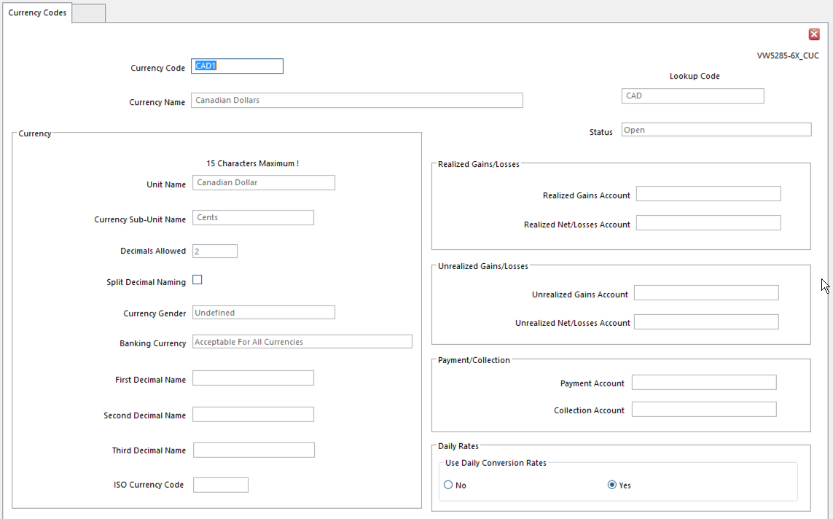
- Currency Code
- Currency Name
- Lookup Code
- Status
- Unit Name Currency name used when writing amount in sentence format
- Used on account documents and payment documents
- Use plural form of name
- Currency Sub-Unit Name Currency sub-unit name to be used in sentence format
- Use plural form of name
- Decimals Allowed Number of decimal places to entered for transaction amounts
- 0 to 3 decimals
- Split Decimal Naming Set if currency requires more than one decimal subunit name
- Some currencies have different names for subunit decimal places
- Most currencies don’t require this – leave blank
- Currency Gender Determines words used in sentences when an amount is written out
- SunPlus convention – No Gender
- Banking Currency Used with Values 4 and 5, if they are used as banking currencies
- SunPlus convention – Available for All Currencies
- First, Second, Third Decimal Name SunPlus convention – leave blank
- Realized Gains Account Leave blank if Realized Gains are posted to account entered at run
time or if Net Gains/Losses are posted to a single account
- Realized Net/Losses Account Leave blank if difference amounts are posted to an account code
entered at run time
- Unrealized Gains Account Leave blank if Unrealized Gains are posted to account code entered at
run time, or if Net Gains/Losses are posted, or only Losses are posted
- Unrealized Net/Losses Account Leave blank if difference amounts are posted to account code
entered in Ledger Revaluation, or only Gains are posted
- Payment Account Account from which funds are taken during Payment Run for
payments in this currency
- Normally a bank account
- Leave blank for payment account specified in Payment Run
- Collection Account Account to which funds are added during Payment Collection Run
- Use Daily Conversion Rates Type of Currency Exchange Rates used for this currency on Ledger
Entry and Ledger Import:
- Yes – Daily Conversion rates
    - Need to define Period Rates too
  - No – Period Conversion Rates

Daily Conversion Rates

Daily Conversion Rates are defined for a from/to currency combination, for a specific calendar date, or range of effective dates, rather than an Accounting Period. Daily Rates are particularly useful for highly volatile currencies where the rate fluctuates widely on a daily basis. Daily Rates are only used if Use Daily Conversion Rates option is set for the currency in Currency Codes.

Daily Rates are used to convert discount values calculated by Payment Run, Transaction Matching, and Reconciliation Manager. If Daily Rates are used for a currency, Period Rates cannot be used for the currency in any of the functions mentioned above. Daily Rates are not used for financial reporting or Ledger Revaluation.

Any number of Daily Rates can be created for each currency code. A currency can have different rates for different days and account ranges.

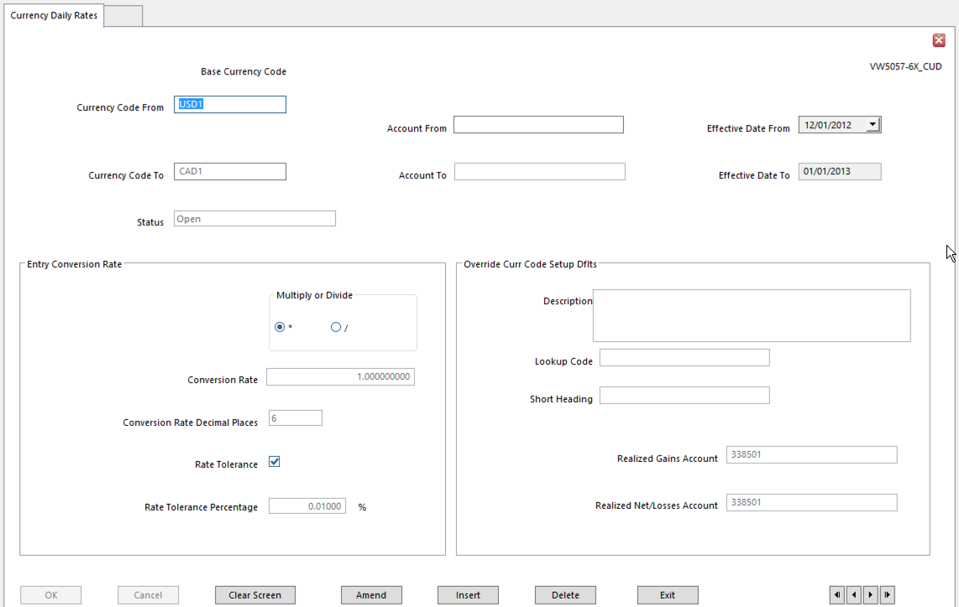
- Currency Code From Currency to convert from – must be a pivot currency
- Currency Code To Currency to convert to
- Account From/To Only account code or range of account codes to which this rate applies
- Leave blank if rate applies to all accounts
- If specified rate exists for account, specified rate is used
- Effective Date From
- Effective Date To
- Multiply/Divide
- Conversion Rate Currency rate that applies for the range of dates
- Conversion Rate Dec Places Decimal places in currency conversion calculation
- Rate Tolerance Choose for a tolerance check on rates entered or calculated by system
- Allows a check on unrealistic rates entered in error
- Rate Tolerance Percentage If tolerance checking is used, this is maximum tolerance allowed

Use the following settings to override details specified in Currency Codes for the Daily Rate. Leave these fields blank to use the Currency Codes definition.

- Description Currency name associated with Currency Daily Rate – i.e, spot rate
- Lookup Code
- Short Heading
- Realized Gains Account Account where Realized Gains calculated with Daily Rate are posted
- Realized Net/Losses Account Account where Net Realized amounts or Realized Losses are posted

Period Conversion Rates

Period Rates are defined for a from/to currency combination for an Accounting Period or for an account code range. Several Currency Period Rates can be defined for a currency combination, relating to various Accounting Periods and account ranges.

Ledger Entry and Ledger Import use Period Rates to convert currency values as part of the journal input process. Period Rates are always used by Ledger Revaluation and financial reporting.

A global rate can be defined for the currency combination by leaving the Accounting Period and Account Code range blank. This global rate is used as a default rate to apply to all periods and accounts. It is not necessary to define a rate to convert a currency to itself.

Period Rates are used in
- Ledger Entry
- Ledger Import
- Ledger Revaluation
Period Rates can be used by:
- Financial Analysis
- Financial Statements
- Financial Tables
Period Rates are used in the following functions to convert discount values, if discount is taken or allowed:
- Payment Run
- Payment Collection Run
- Transaction Matching
Period Rates are not used if the currency requires Daily Rates. If Daily Rates are used for journal input, a Period Rate must be defined for other functions, such as Ledger Revaluation and financial reporting.

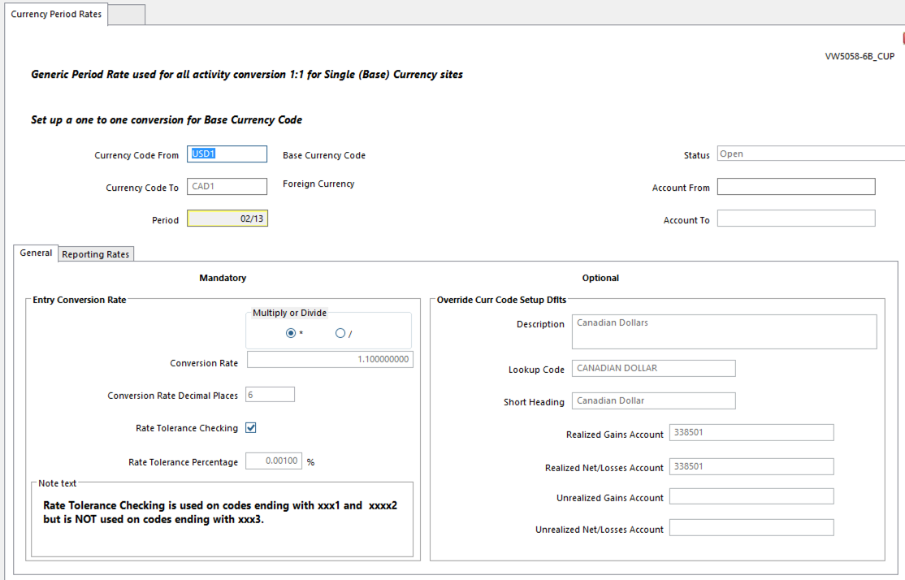
- Currency Code From Currency to convert from – always Base
- Currency Code To Currency to convert to
- Account From/To Only account code or range of accounts to which Period Rates apply
- Leave blank if the rate applies to all codes
- If specified rate exists for an account code, specified rate used
- Period Leave blank to define a single rate applying to all accounting periods
- Multiply or Divide
- Conversion Rate
- Conversion Rate Dec Places Decimal places used in Currency Conversion calculation
  - Rate is rounded to this number of decimal places before being used in calculation
- Rate Tolerance Checking A tolerance check on entered or system calculated rates
- Stops unrealistic rates being entered
- Rate Tolerance Percentage Maximum tolerance allowed for the Period Rate
- Percentage difference between entered or calculated rate and the Conversion Rate must be within this percentage.
- If Override Rate Tolerance field in Journal Type is selected, the level identified here is invalid

Use the following settings to override details specified in Currency Codes for this Period Rate. Leave blank to use Currency Codes definition.

- Description Currency name associated with this currency Period Rate
- Lookup Code
- Short Heading
- Realized Gains Account Account where Realized Gains are posted
- Realized Net/Losses Account Account where Net Realized amounts, or Realized Losses are posted
- Unrealized Gains Account Account where Unrealized Gains are posted
- Unrealized Net/Losses Acc Account where Unrealized amounts, or Unrealized Losses are posted

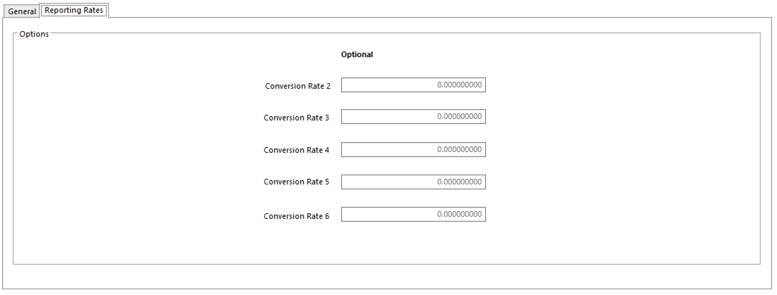
- Conversion Rates 2-6 Alternate currency rates used to revalue or consolidate accounts in
financial reports

Inquiries

Account Inquiry

Account Inquiry displays selected current transactions posted to a particular account.

Selected transactions displayed in Account Inquiry by Account report.

Perform an Account Inquiry

- Select Account Inquiry option
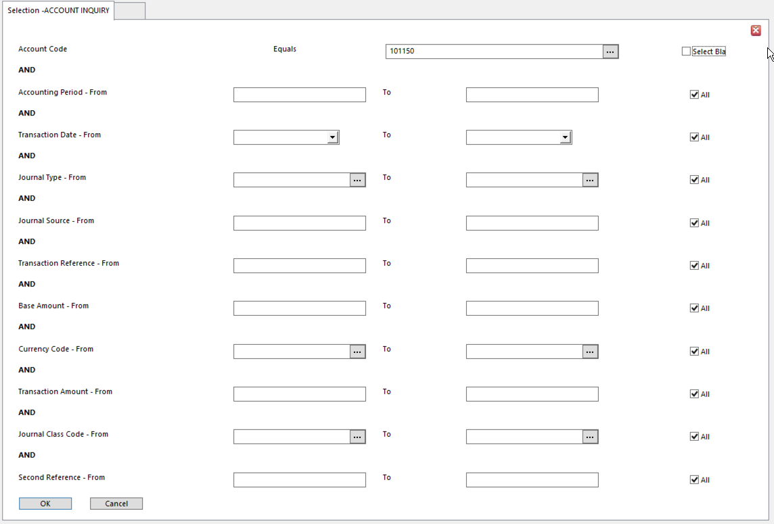
- Enter selection details
  - A transaction has to meet all selection criteria to be displayed
- Click OK to extract account details
- Account transactions will be displayed in the Financials – Account Inquiry window

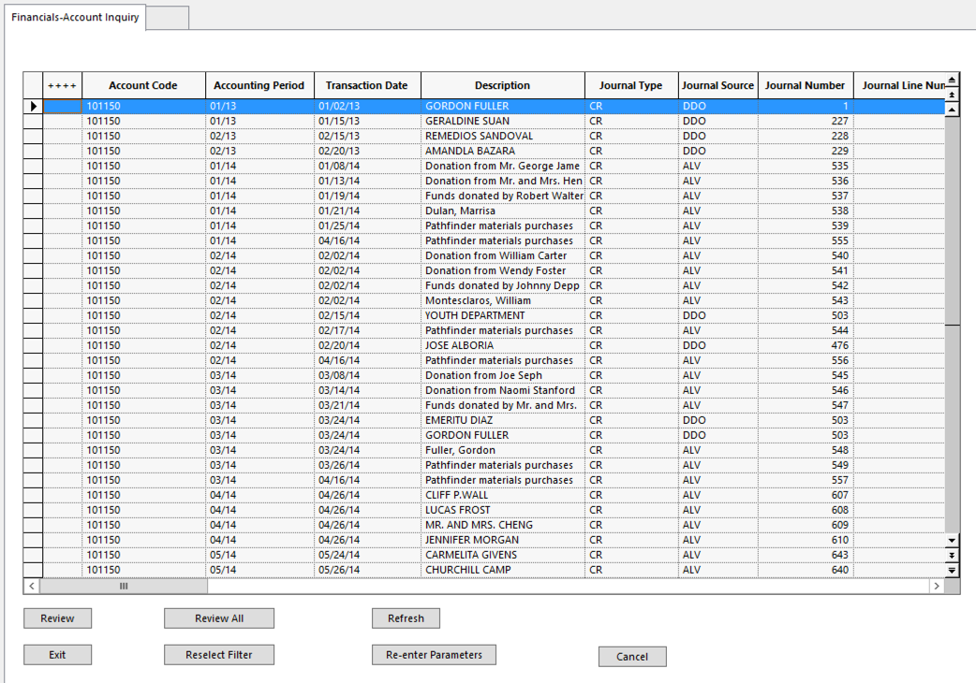
- Double click any of the following fields to drill down to related details:
  - Account Code
  - Journal Number
  - Analysis Codes
  - Saved Set Reference

Running the Ledger Inquiry by Account Report

This report prints the main transaction details for selected transactions, including Transaction Analysis Codes.

- In the inquiry window, highlight the transactions to print

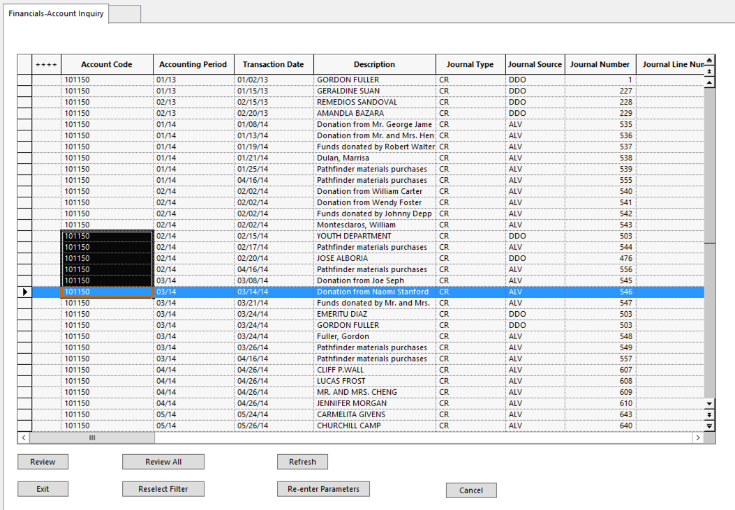
- Click Review to list the transactions on the Control Desk In-tray
  - Click Review All to automatically select all of the transactions in the inquiry

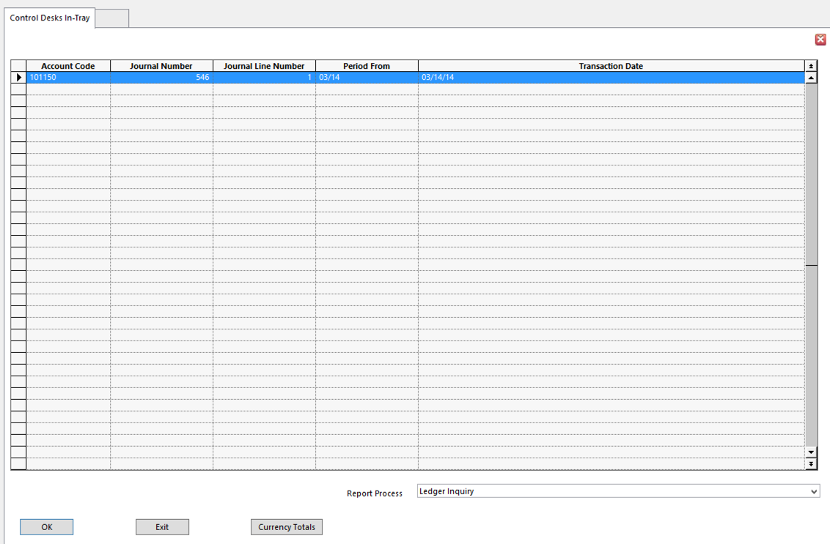
- In the Report Process field, select Ledger Inquiry
- Click Ok to produce the report
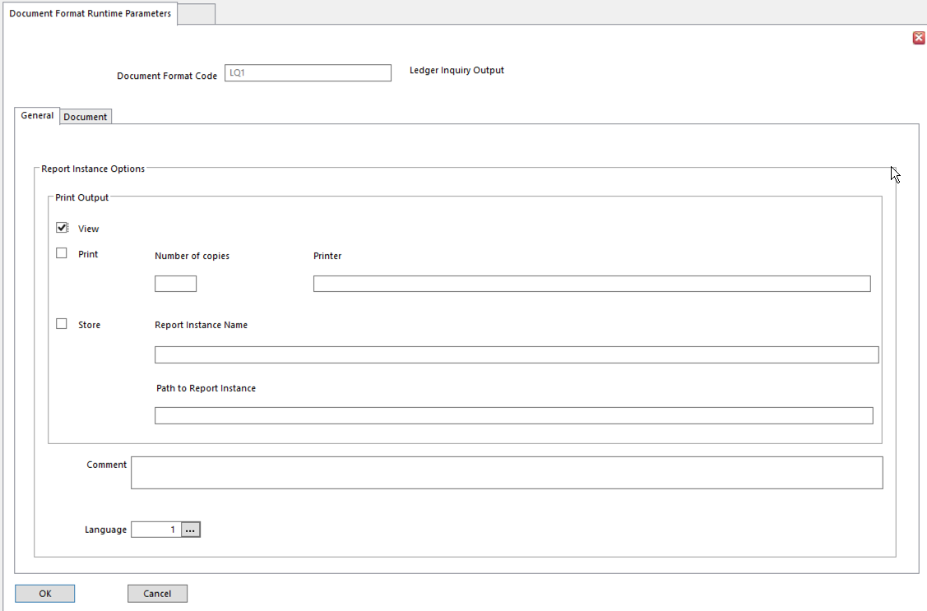

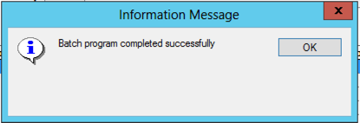

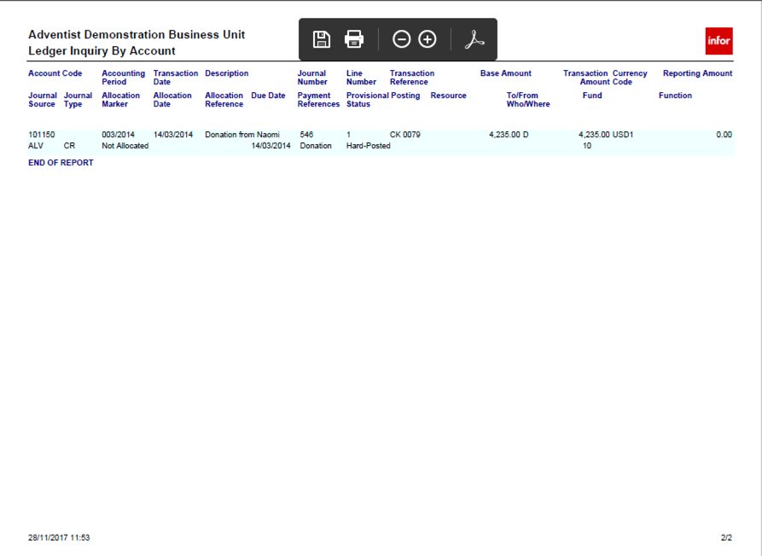

Account Balance Inquiry

Account Balance Inquiry displays the balance for an account or range of accounts for a selected Period. Each account’s balanced is calculated from the transactions selected for the inquiry. All transactions for a range of Periods can be selected, or any subset of transactions for a range of Periods.

- For P&L accounts, enter a range of Accounting Periods.
- For Balance Sheet accounts, select the To Accounting Period.

Account Balance Inquiry displays summarized, consolidated account values.

- Use the Explode control desk facility to break down a total.

Perform an Account Balance Inquiry

- Select Account Balance Inquiry

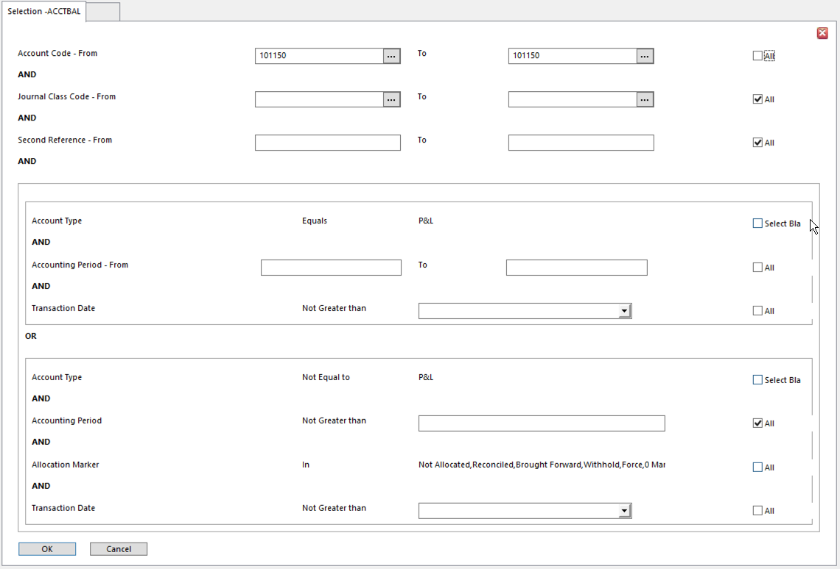
- Enter selection details
  - A transaction must meet all of selection criteria to be included
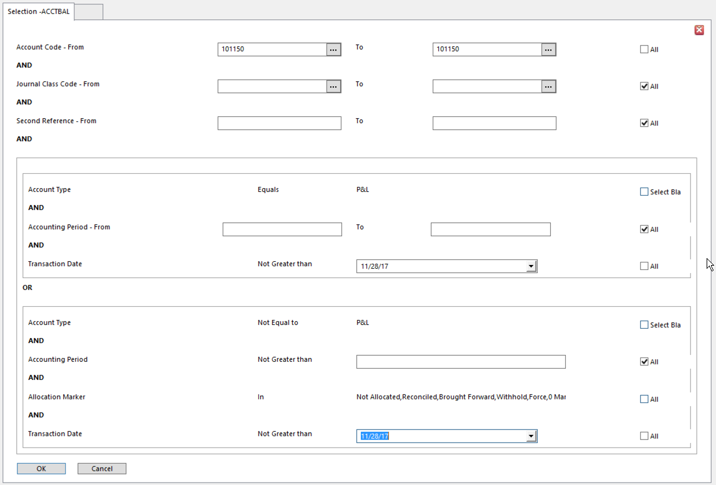
- Click OK to extract
- The account balance details appear on the Financials Inquiry window

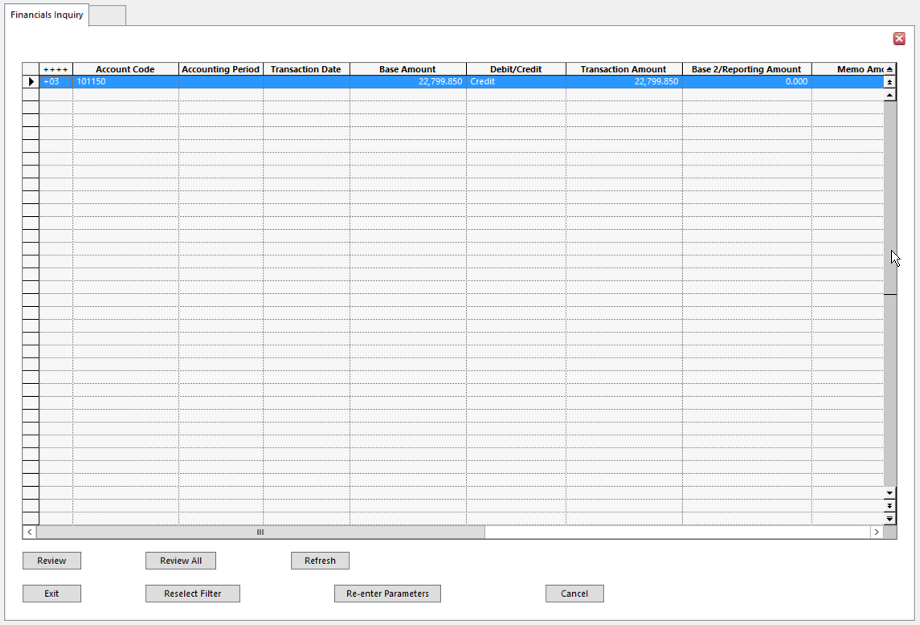
- I only inquired on a single account, so I got the above results. When I clicked Review, I got the details for this account. See below
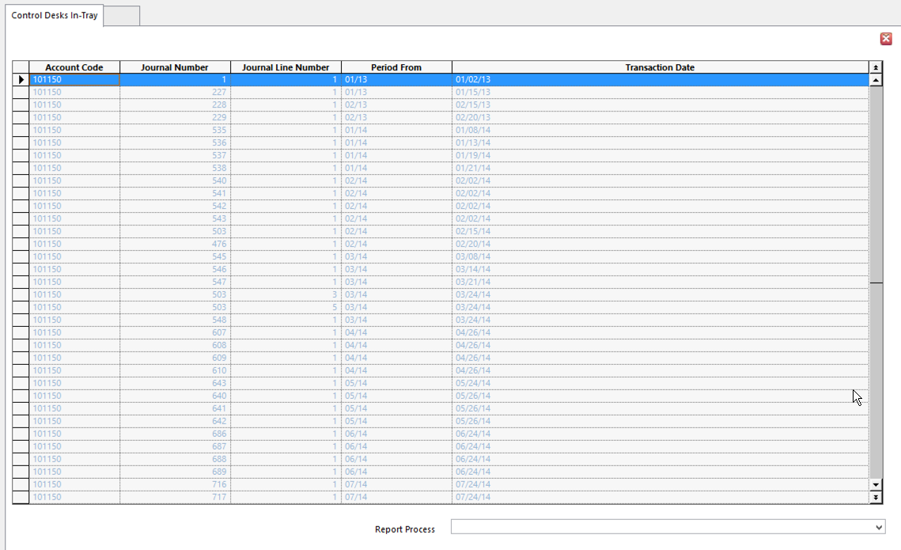
- Notice the Report Process field at the bottom of the screen. A listing of transaction details – or a selected portion of them – can be printed by selecting Ledger Inquiry Report Process.

Budget Check Inquiry

A Budget Check contains the budget checking rules for an account or range of accounts, by identifying the budget for the accounts. This is used with Order Fulfillment. If your organization does not use Order Fulfillment, you will not need Budget Check Inquiry.

Ledger Inquiry – Archive

Use to view archived and current transactions posted to an account. Archived and current transactions on the account can be printed out.

- Go to Ledger Inquiry
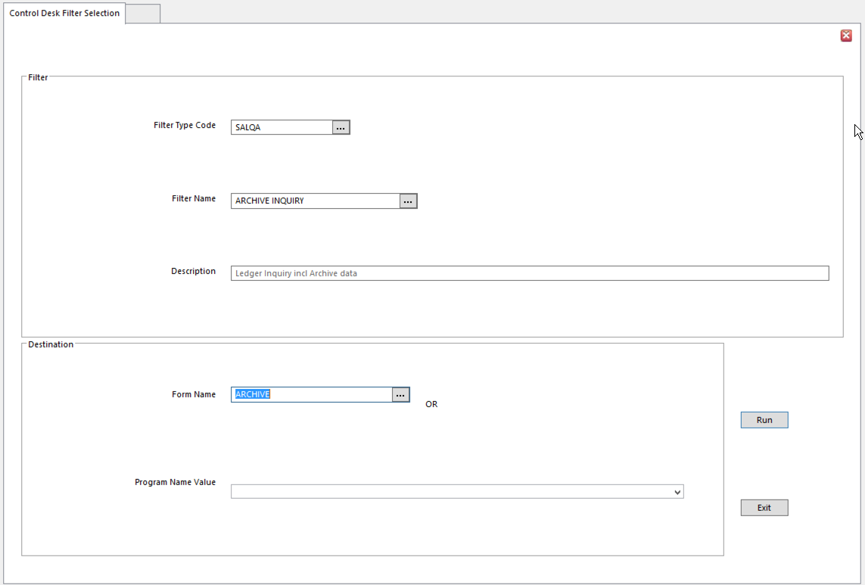
- Filter Type Code SALQA – Ledger Inquiry Archive
- Filter Name ARCHIVE INQUIRY
- Form Name ARCHIVE
- Click Run

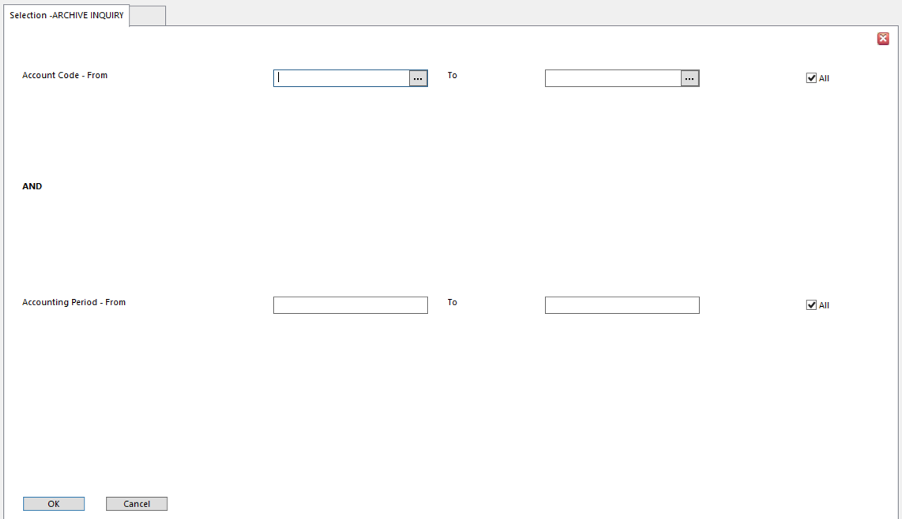
- Enter Account Code(s) for inquiry
  - By default, all account codes are selected
- Enter Accounting Period(s)
  - By default, all Accounting Periods are selected
- Click OK
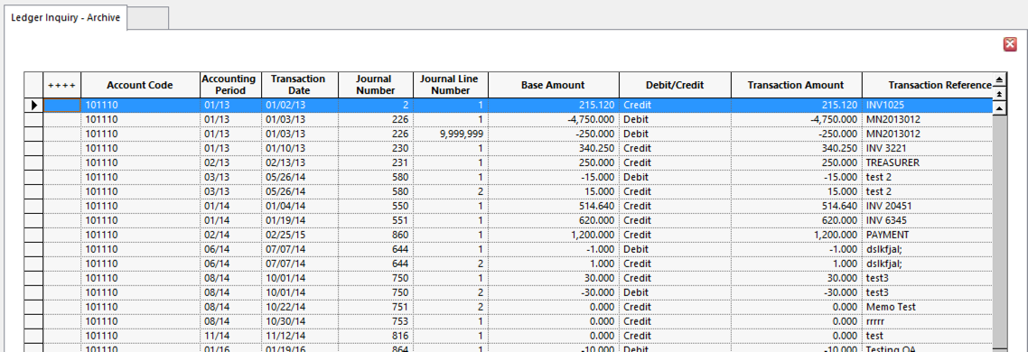

Ledger Inquiry

Ledger Inquiry provides the functionality for a large number of inquiries. Please see the Filter Name list below.

The basic process applies to each.

- Select Filter Type Code from the list
- Select Filter Name
  - Each choice focuses the next set of options
- Select best options for the type of inquiry
- Click OK

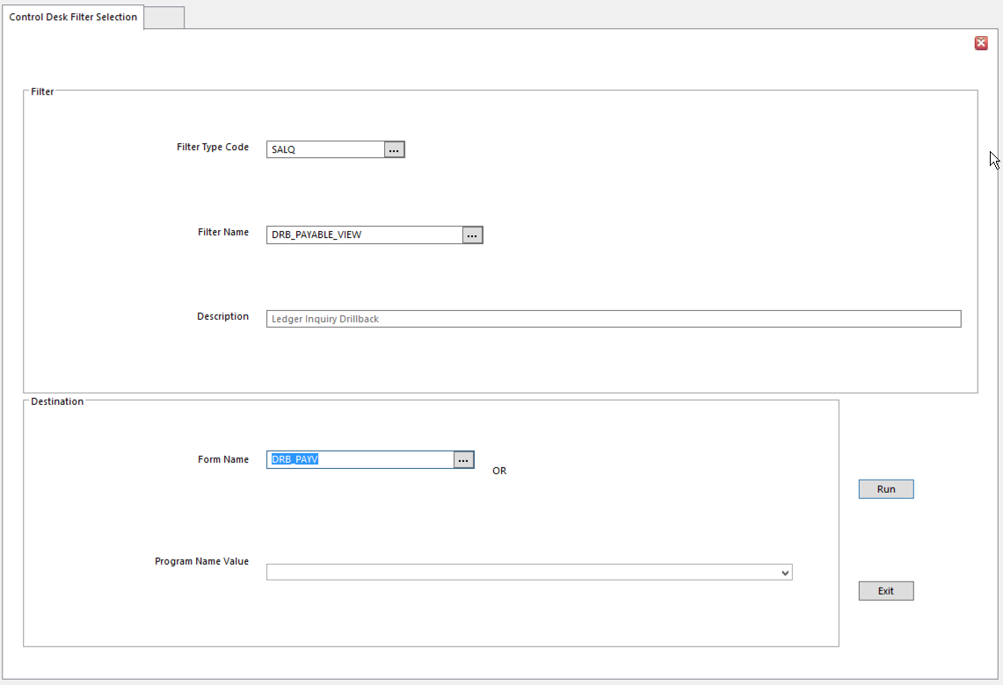
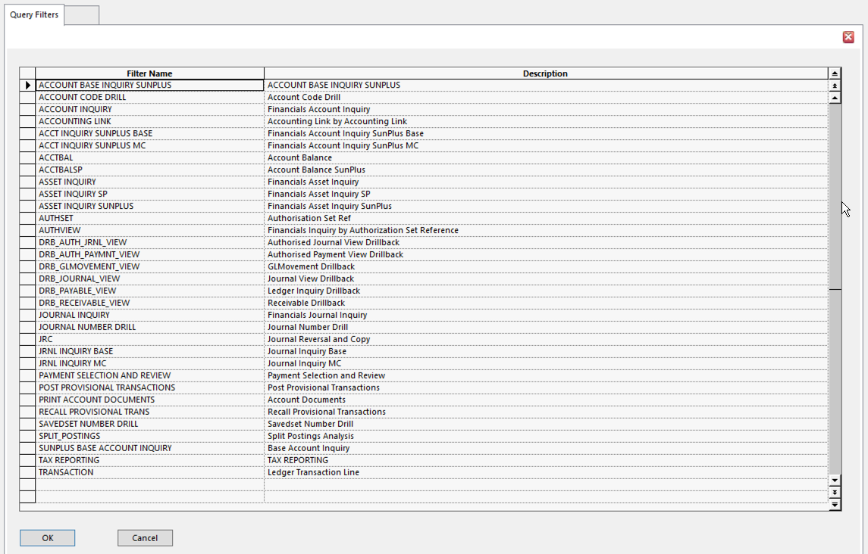

Journal Inquiry

Journal Inquiry can display a range of posted journal transactions. Selected transactions can be printed out.

Performing a Journal Inquiry

- Select Journal Inquiry
- Enter the selection details
  - A transaction has to meet all of the selection criteria
- Click OK
- The transactions appear on the Financials – Journal Inquiry window

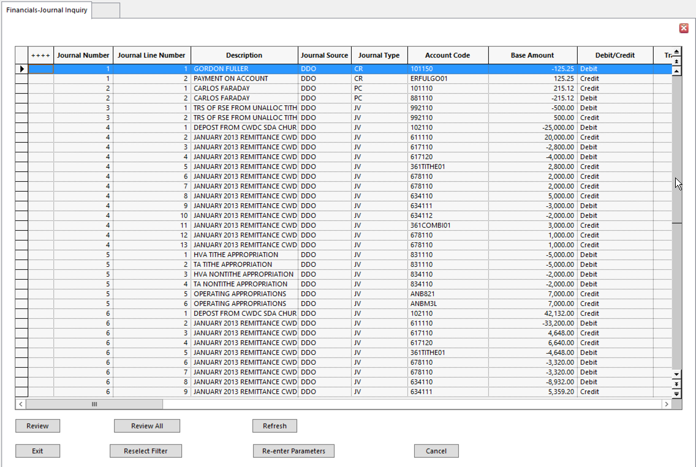
- Double click on a field to drill down to the related details, if they are available

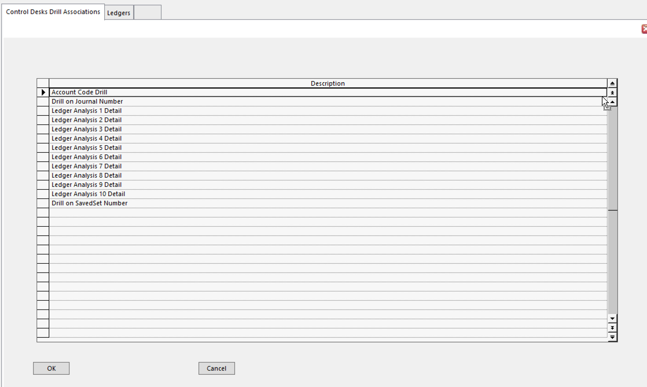
- Select the item to drill down on
- Click OK

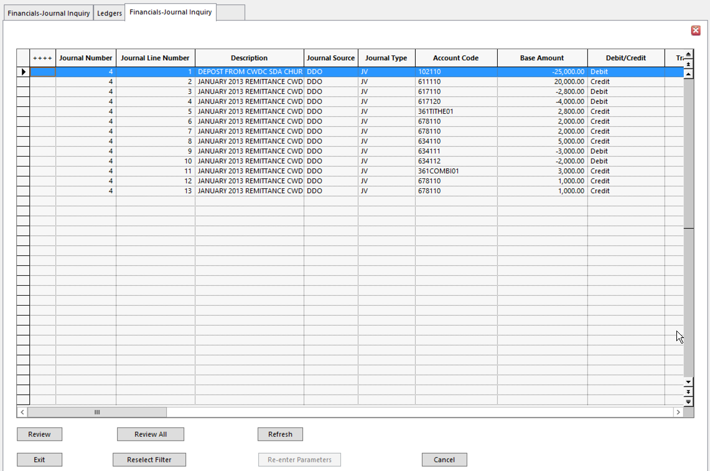
- I drilled on the Journal Number
- If necessary, select one or more lines and click Review or Review All
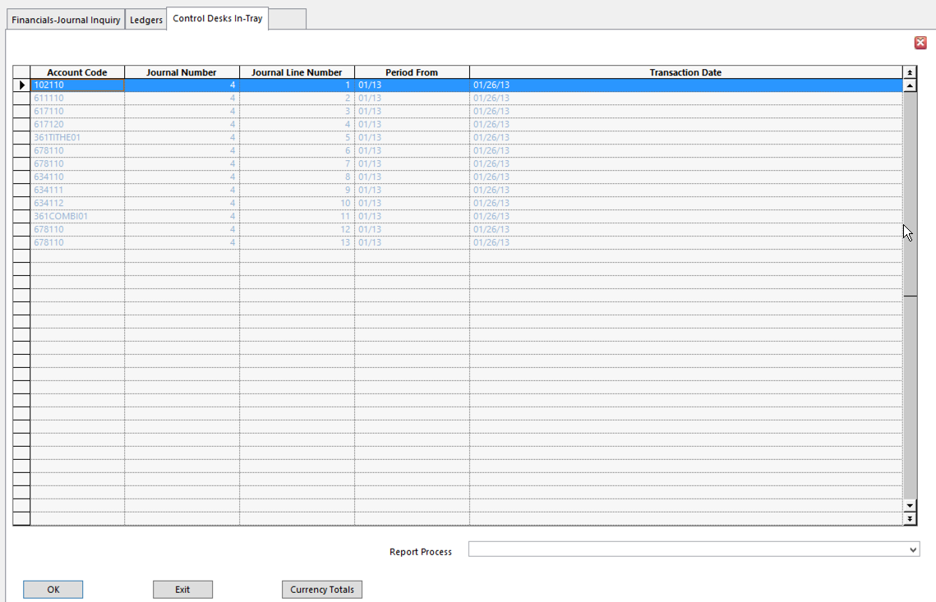
- Select the Report Process Ledger Inquiry Report to print this drill

Account Allocation

Account Allocation is used primarily to match transactions on an account. For example, a Payment transaction can be matched (Allocated) to the relevant Invoice. Fully match a group of transactions or split a transaction to only match part of the transaction value.

Account Allocation can determine if settlement discount has been taken and automatically post the discount and any tax on the discount. Also, it can generate and post any currency exchange differences caused by fluctuating exchange rates.

Account Allocation lets you:
- Change the Allocation Marker on a transaction, for example, to reconcile the transaction, indicate the processing status of the transaction, mark it for immediate payment or withhold it from payment.
- Alter the Transaction Analysis codes, Description, Entry Date, Payment Terms Code, Due Date, and other payment-related details.

Performing Account Allocation

- Extract Account Transactions for Allocation
- Select the transactions to Allocate or Amend on an account.

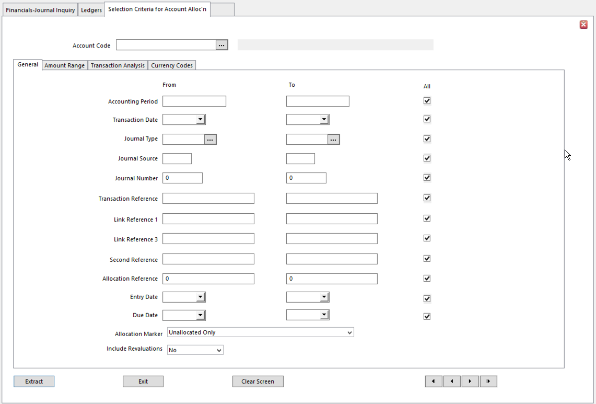
- Notice the Allocation Marker selection field toward the bottom of the screen. Selections can be filtered by Allocation Marker, making it easier to retrieve only the types of transactions you are interested in.

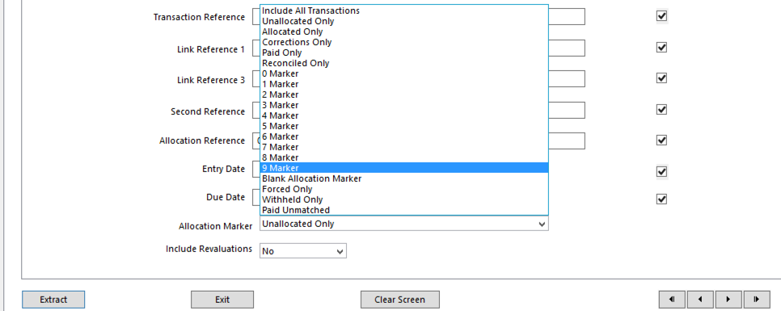
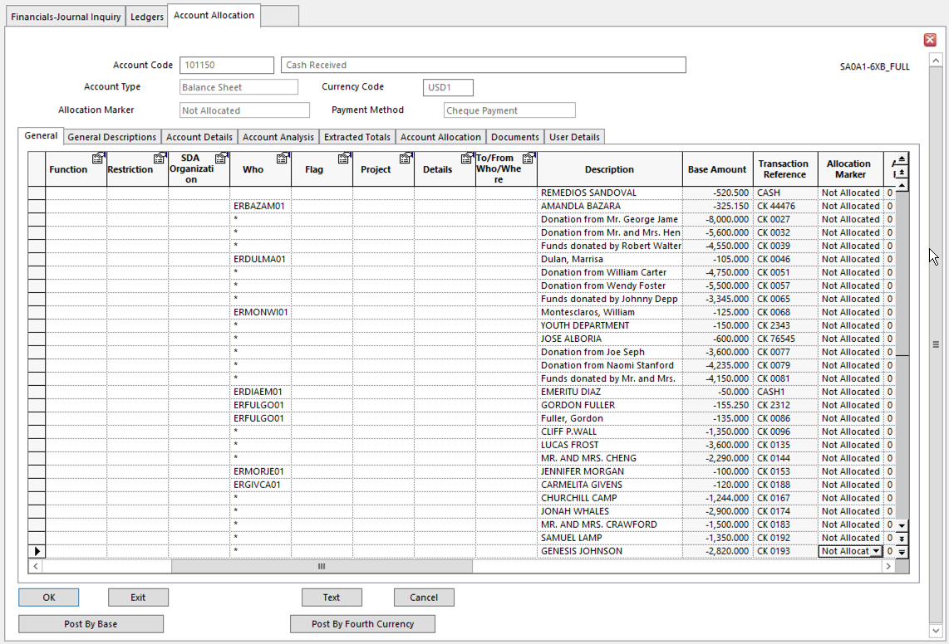
- The transactions are displayed on the Account Allocation form
- The sequence in which Unallocated Transactions are displayed can be controlled
  - Click in the header of the column by which to sort
  - Click the Sort icon on the toolbar

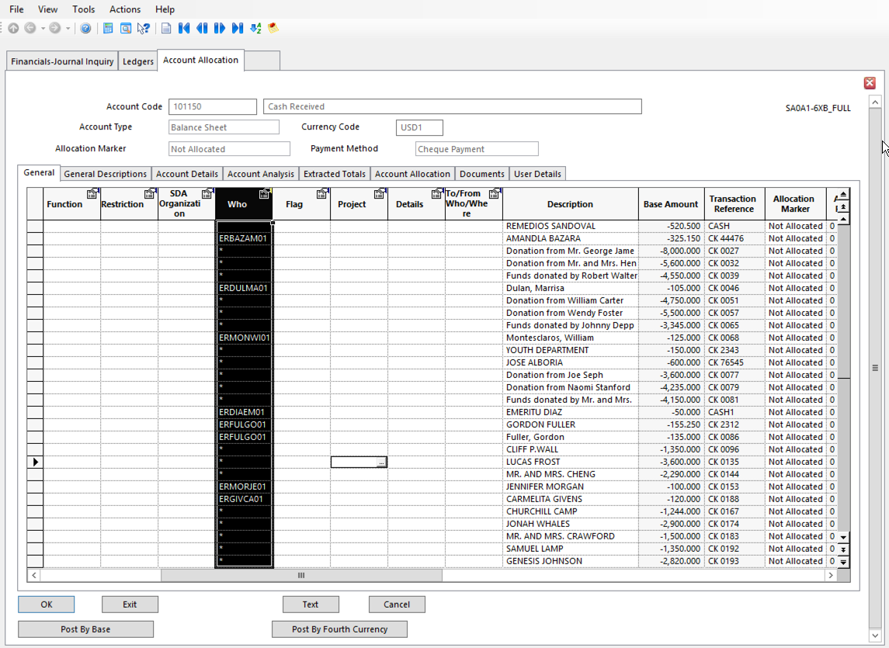
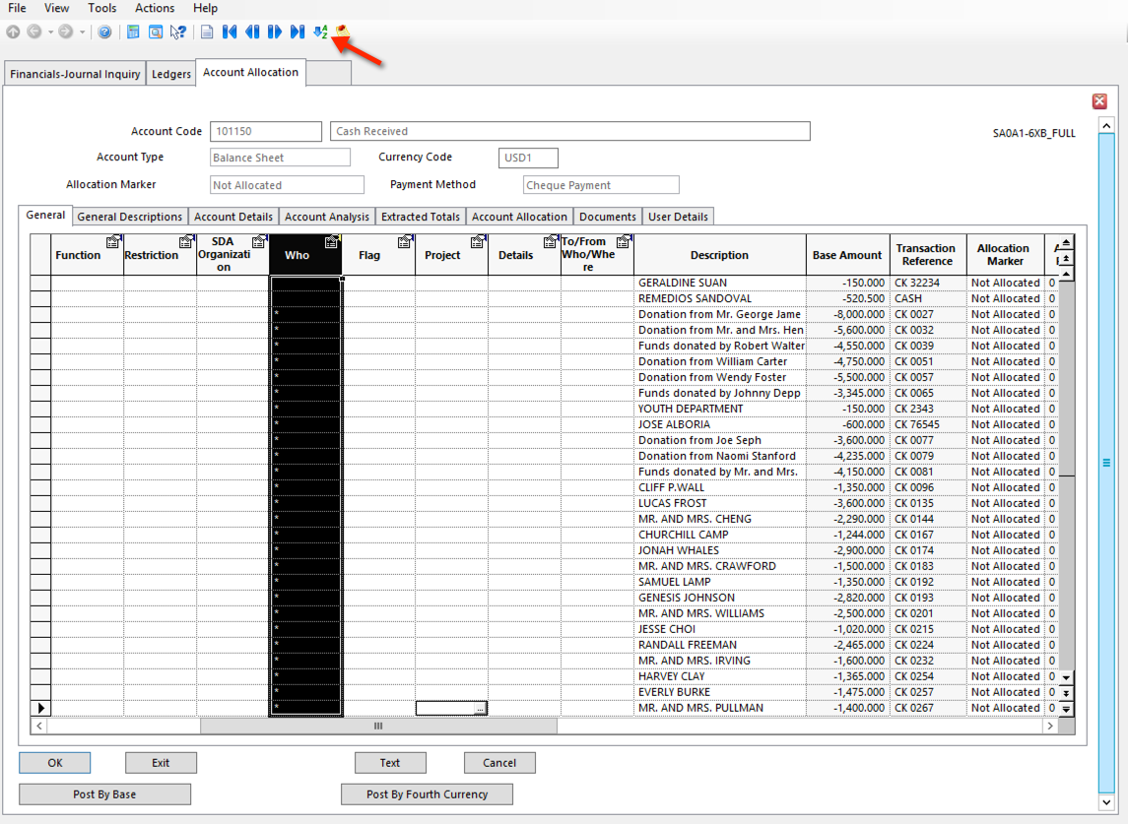
- Amend Transaction details
  - If an Account Allocation column has a white background, values in that column can be amended
  - The following can be amended:
    - Transaction Description
    - Allocation Marker
    - Ledger Transaction Analysis Codes
    - Payment Terms Code
    - Due Date
    - Discount 1 Date and Percentage
    - Discount 2 Date and Percentage
    - Interest Date and Percentage
    - Late Payment Date and Percentage
    - First Document details – Date, Prefix number and Document number
    - Second Document details – Date, Prefix number and Document number
    - Payment Reference
    - Bank Code
  - Financial data cannot be amended
    - Errors must be corrected in reversal entries.
  - Allocated Marker can be changed to change the Status of the transaction or to request certain processing.
    - Force Include transaction in next Payment Run
    - Withhold Exclude transaction from next Payment Run
    - Allocated Identify a matched transaction
    - Reconciled Marks bank account transactions that have been Reconciled with the
bank statement
    - Correction Identifies transactions as internal corrections and eliminates them
from financial reports
    - Markers 0 – 9 Record processing stages
  - Allocation Marker can be reset in some circumstances
  - For Allocation Markers set on transactions that have to balance, each Marker must be set on a group of balancing transactions.
    - Use the Allocation Totals option to view balancing details for each marker individually
      - Action menu
      - Allocation Totals

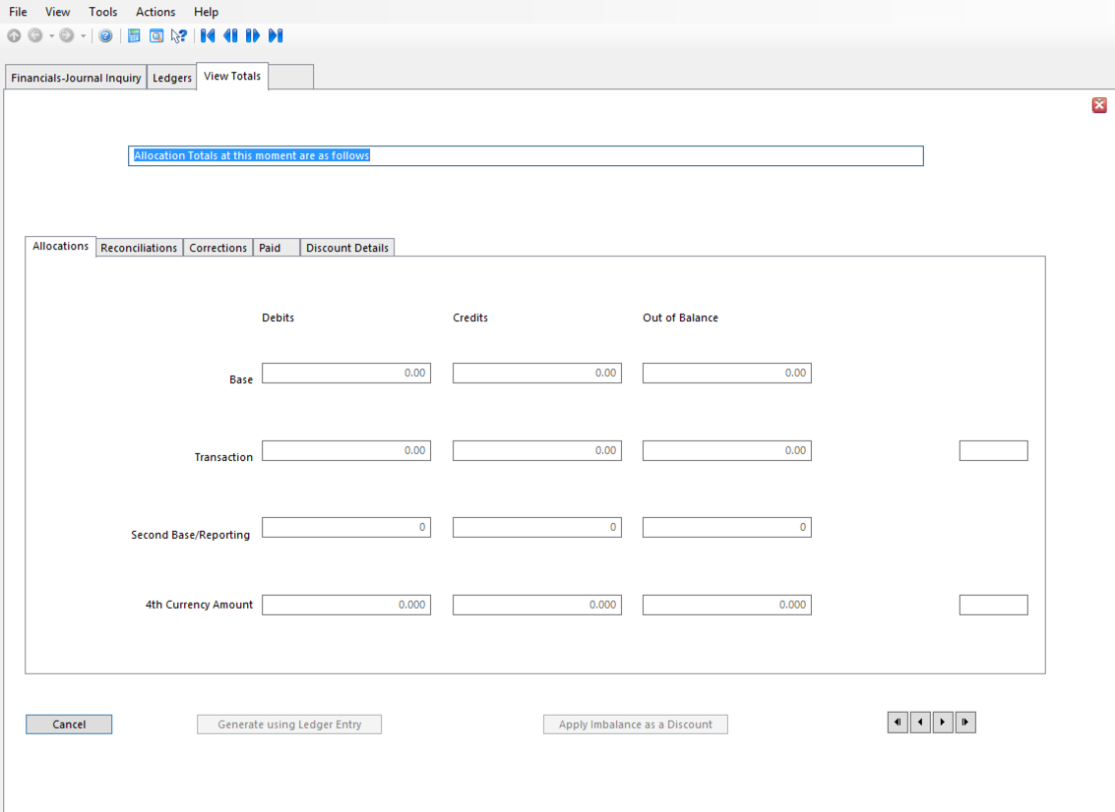
  - Use the Action All option to change the Allocation Marker from one code to another on all appropriate transactions. The system looks for all extracted transactions that reference the From Marker and changes the marker to the To Marker you have chosen.
- Match (Allocate) the Transactions
  - Allocating transactions links related transaction to Close them and let them be removed from the system during Ledger Cleardown
  - Matched (Allocated) transactions must balance. Total Allocated Debit transactions must equal the Total Allocated Credit transactions
  - Fully Match transaction (To Be Allocated) or partially Match a transaction by choosing Split and entering amount to be allocated
- View the Allocation Balancing
  - Allocated transactions must balance.
  - Action menu > Currency Totals > Base Currency (or the currency you need)
- Post the Allocations, Discount, and Exchange Differences
  - Click Post

Reconciliations in Account Allocation

To manually Reconcile a bank account, use Account Allocation to extract the Unallocated transactions.

For each item in the bank account statement, change the Allocation Marker on the matching line in Account Allocation to Reconciled.

Exclude previously Reconciled items from the next reconciliation extraction.

Journal Types

Every journal must belong to a Journal Type which defines the input and validation rules applying to the journal transactions.

The basic Journal Types come pre-established in the SunPlus Core. If additional Journal Types are needed, or if changes should be made to the existing Journal Types, it is fine to do so. If you are unsure about the process, look at the existing Journal Types to see what is required.

NOTE Make changes to existing Journal Types VERY CAREFULLY. Once a Journal Type is in use, making changes to it will cause the same Journal Type to exhibit different behavior, creating issues in your ledger.

- To set up or amend a Journal Type, go to Journal Types

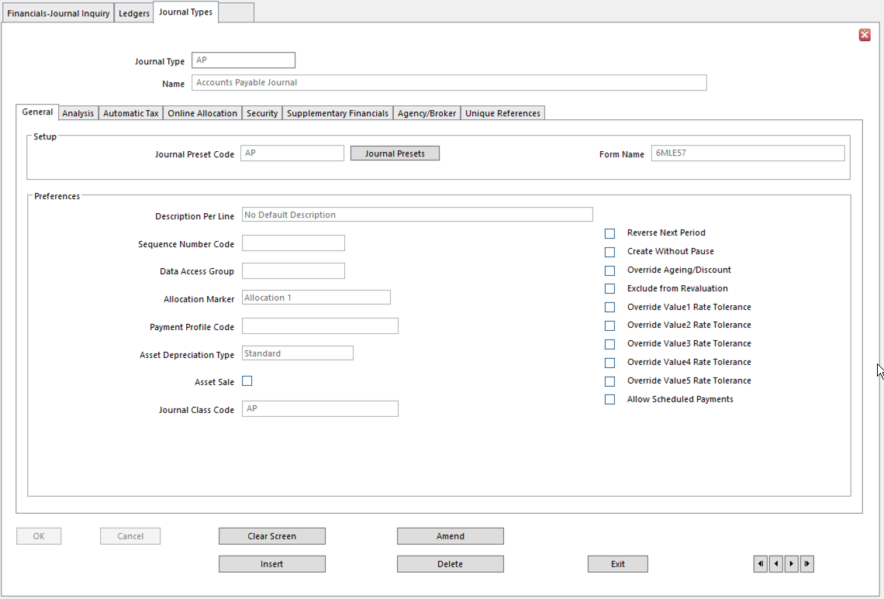

General Tab

  - Journal Preset Code SunPlus convention is to set up Journal Presets using the same code as
their related Journal Type
- This makes it easy to determine which Preset goes with which Journal Type
- Journal Presets provide preset details for the journal line to which they are attached
  - Form Name Ledger Entry form used to enter this Journal Type
- Leave blank for the operator to select Ledger Entry form at entry time
  - Description Per Line This value controls the entry of Journal Line Description
- Default Description – Override per Reference – new description must be entered every time the Transaction Reference changes
- No Default Description – a new description must be entered on every line of the journal
- Default Description – Override per Line – gives the option to enter a different description on each line
    - Journal Name is used as the default
  - Sequence Number Code Identifies numbering sequence used to sequence the transactions
    - In Ledger Sequencing, the sequence number is automatically assigned to each transaction.
    - The sequence number is entered through an analysis dimension specified on Ledger Setup as the Transaction Sequence Dimension

NOTE In SunSystems version 6.2 and above, the SunPlus convention is to use Vouchering Numbering instead of Ledger Sequencing.

  - Data Access Group Use to restrict access on this Journal Type
- Data Access Groups are linked to selected Operator Group(s)
  - Allocation Marker Use to automatically set Allocation Marker on ledger transactions
upon posting to this Journal Type
- Leave blank or choose No Allocation to leave Allocation Marker blank if predefined allocations are not required
- Allocation Marker options:
    - Allocation Markers 0 – 9 – Select one to automatically set as Allocation Marker on each journal line posted to Creditor, Debtor, or Client account
      - Lines which are entered to other accounts (P&L, for example) are posted without an Allocation Marker
      - Allocation Markers 0 – 9 are part of Creditor or Debtor management only
    - Force – each transaction line of this Journal Type posted to a Creditor, Debtor, or Client account is assigned this Allocation Marker to identify it as requiring a Forced Payment or Collection
      - Lines entered to other accounts are posted without an Allocation Marker
      - Force Allocation Marker is only used as part of Payment or Collection process in Creditors, Debtors, or Clients
    - Withhold – each transaction line posted to any Account Type is assigned this Allocation Marker to identify it as being withheld from the Payment Run and Payment Collection Run
    - Reconciled – automatically sets Allocation Marker to Reconciled on all transaction lines when journal is posted
- Payment Profile Code Enter if transactions in this Journal Type will be allocated and paid
immediately after the journal is posted
- When the journal is posted, Payment Run is automatically initiated and this Payment Profile is used
- Depreciation Type If Journal Type will be used for manually posting Depreciation on Fixed
Assets, use this option to select the Type of Depreciation
- Standard
- Advanced or
- Reduction
- If not used for manual posting, leave it as Standard
- Asset Sale Check if Journal Type will be used for registering Fixed Asset sales
- Journal Class Code SunPlus uses Voucher Numbering in versions 6 and above
  - This field must be populated
- Journal transactions are posted with a Voucher Number that includes Journal Class
- Journal Class establishes a sequence of Voucher Numbering
- Reverse Next Period Used on Accrual and Prepayment journals
- Each transaction line is posted twice:
    - in the Period identified in Ledger Entry and
    - a reversal in the following Period
- Create Without Pause If set, Ledger Entry prompts you to enter the next journal line
- No need to click New Line
- If Journal Presets are attached to Journal Type, the procedure stops once the final Preset line has been entered
- Override Ageing/Discount Used on Cash Payments or Cash Receipts immediately due
- Due Date is automatically set to Transaction Date and Discount Dates are ignored
- Affects Payment Run and Payment Collection Run
- Prevents settlement discount being calculated in Payment Run on these transactions
- Exclude from Revaluation Excludes postings to this Journal Type from Ledger Revaluation
- To only exclude from the Ledger Revaluation Balancing Run, don’t select this option. Select Suspend Post Rules in the Journal Types – Posting Overrides form.
- Override Value Rate Tolerances Currency rate tolerances can be set for each currency rate to
ensure realistic conversion rates are used.
- If this option is selected, any rate tolerance settings for the currency rate entered on the journal are overridden by the global rate tolerance settings in Ledger Setup.
- Allow Scheduled Payments Allows transaction lines to be automatically Split according to a
schedule or percentages and dates can be configured and assigned to a customer or supplier
- Set this option to enable transactions in this Journal Type to be Split using Scheduled Payments.

Analysis Tab

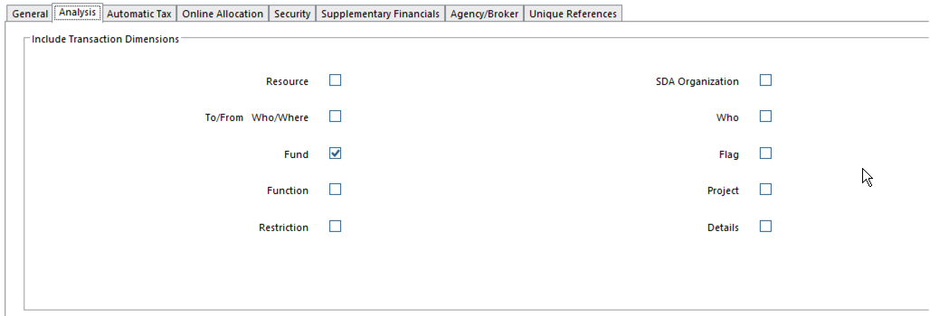

- Analysis Select Analysis Dimensions required to analyze this Journal Type
- Entry operator will only be prompted to enter Dimensions selected here
- Overridden for an account by Transaction Analysis Codes entered in Chart of Accounts, Customers, or Supplier

Automatic Tax Tab

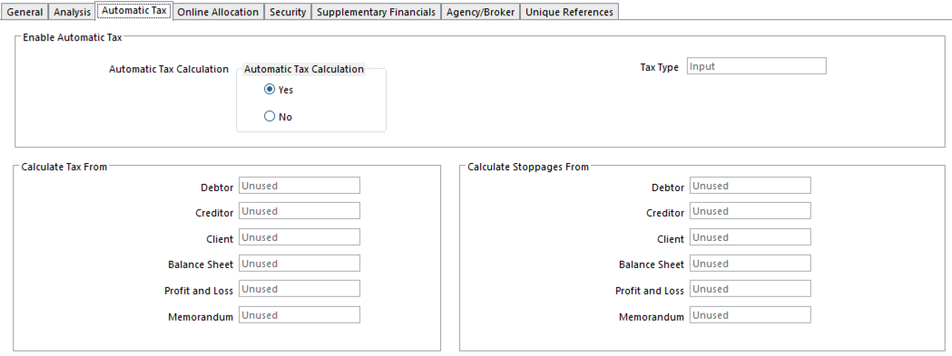
Details on this tab are used by the Automatic Tax Calculation feature.

- Enable Automatic Tax Defaults to No
- Tax Type Determines if Input or Output Tax Account codes are used for tax
postings
- Calculate Tax From Select type of Tax Calculation for each of these Account Types:
- Gross
- Net
- Unused
- Calculate Stoppages From Select Stoppage Calculation for various Account Types

Online Allocation Tab

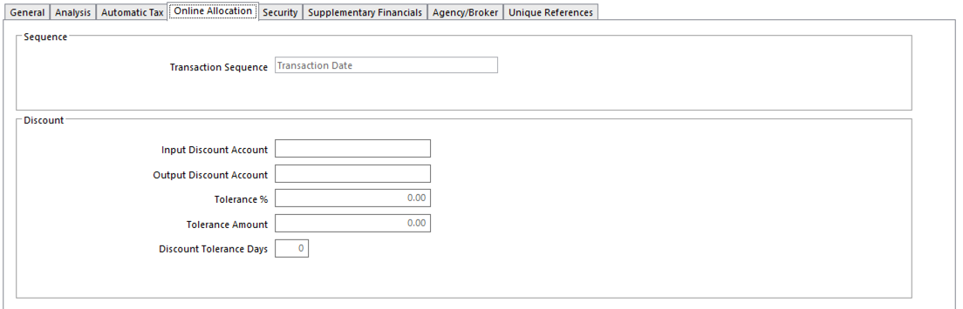
These settings define Allocation processing for Ledger Entry.

- Transaction Sequence Default order transactions are displayed in Account Allocation and
during Online Allocation
- Order increases speed of matching transactions
- SunPlus convention is Transaction Date
- Input Discount Account Account used for discounts generated on Creditor accounts and for
discounts generated on debit transactions on Client accounts
- Cannot select Closed or Memo accounts
- Output Discount Account Account used for discounts generated on Debtor accounts and for
discounts generated on credit transactions on Client accounts
- Cannot select Closed or Memo accounts
- Tolerance % Tolerance percentage used when calculating discounts
- Leave blank for no tolerance allowed
- Determines acceptable difference between allowed discount percentage and the percentage discount that has been taken
    - If difference falls within this tolerance percent, it is written off as additional settlement discount
- Tolerance Amount Acceptable difference between allowed discount amount and the
amount of discount taken
- If difference is below this tolerance amount, it is written off as additional settlement discount
- Discount Tolerance Days Number of days tolerance allowed when applying discount.
- The number of tolerance days entered here will be added to the Discount Due Date to extend the Period

Security Tab

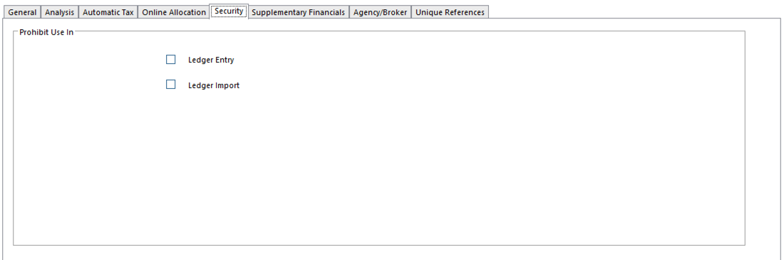
A Journal Type can be prohibited in specific circumstances.

- Prohibit Use in Ledger Entry
  - Prohibit Use in Ledger Import
  - Posting Rules Additional set of options allowing Override of Posting Rules for each of
the transaction values in use in the business unit

Supplementary Financials Tab

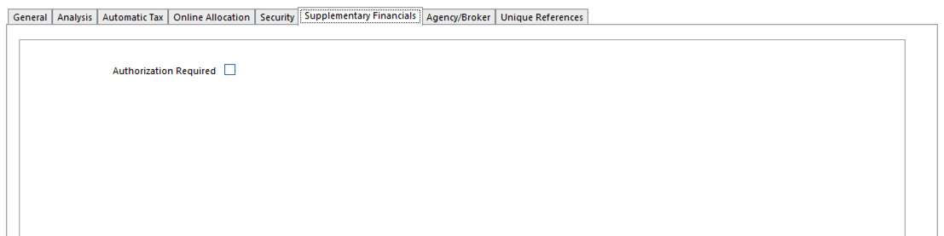
Only use if configuring the system to use Authorization.

Agency/Broker Tab

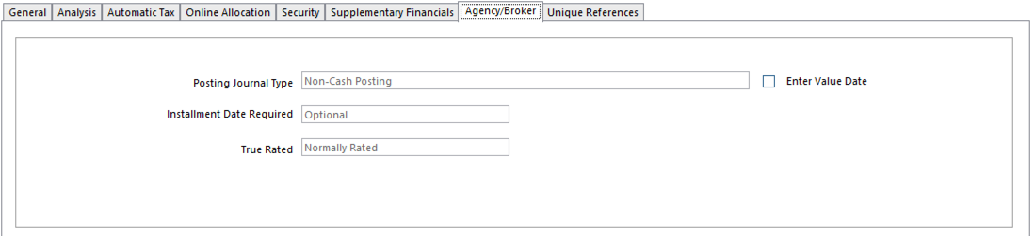
This option must be set to the default of Non-Cash Posting, even for Cash Receipts and Cash Payments, unless SunSystems is used as a broker ledger with Pay As Paid capability.

- Posting Journal Type Indicates if the journal is posting cash or non-cash related transactions
- If Cash Posting is selected:
    - Value Date must be supplied
            - date from which cash transaction is available for matching
    - When Write-on/Write-off Balancing is enabled and cash is being matched in the 4th currency, matching imbalance is converted into the currency values using exchange rates on the cash transaction
    - System sets True Rated Flag for that transaction
- Enter Value Date Used along with Posting Journal Type for Cash Posting
- If set, a Value Date must be entered on the journal
- Date from which cash transaction will be available for matching in Account Allocation
    - Consider waiting for cash to be Allocated until it clears the bank
- Instalment Date Required For Instalment Checking, indicate if Instalment Date is required
- Optional – Instalment Date can be entered
- Mandatory – Instalment Date must be entered
- Prohibited – Instalment Date cannot be entered
- True Rated Identifies the True Rated Flag set on transactions
- Flag determines how transactions are treated by Financials processes such as Matching and Ledger Revaluation
    - Flag is used by Ledger Revaluation if the Revalue Until True Rated option is set in Ledger Setup
  - Options:
    - Normally Rated – transactions reference currency rates can be revalued using Ledger Revaluation
    - Advance Rated – transactions reference fixed future exchange rates
      - Transactions with this flag are withheld
    - True Rates – transactions reference fixed exchange ranges are not revalued by Ledger Revaluation

Unique Reference Tab

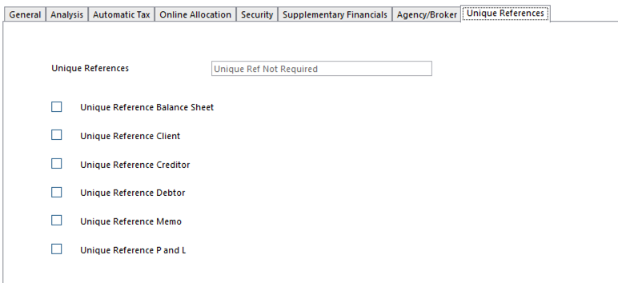
- Unique References Determines Transaction Reference validation for this Journal Type
- Unique Ref Not Required – duplicate Transaction References are allowed for transactions posted in this Journal Type
- Unique Ref is Required – Every transaction line must have a unique reference from any other transaction posted to the same account; however, this setting can be overridden
    - Validation is performed for each account type selected below
  - Unique Ref Is Mandatory – every transaction line for this Journal Type must have a reference that has not been used on any other transactions posted to the same account
    - Validation is performed for each Account Type selected below on this tab
If Unique References option is set to Unique Ref Is Required or Unique Ref is Mandatory, one or more Account Types must be selected for which Transaction References are validated to ensure they are unique for each account. Any combination of the following may be selected:
- Unique Reference Balance Sheet
- Unique Reference Client
- Unique Reference Creditor
- Unique Reference Debtor
- Unique Reference Memo
- Unique Reference P&L

Printing Journal Type Report

To print a report on Journal Types, go to the Action menu, select Report.

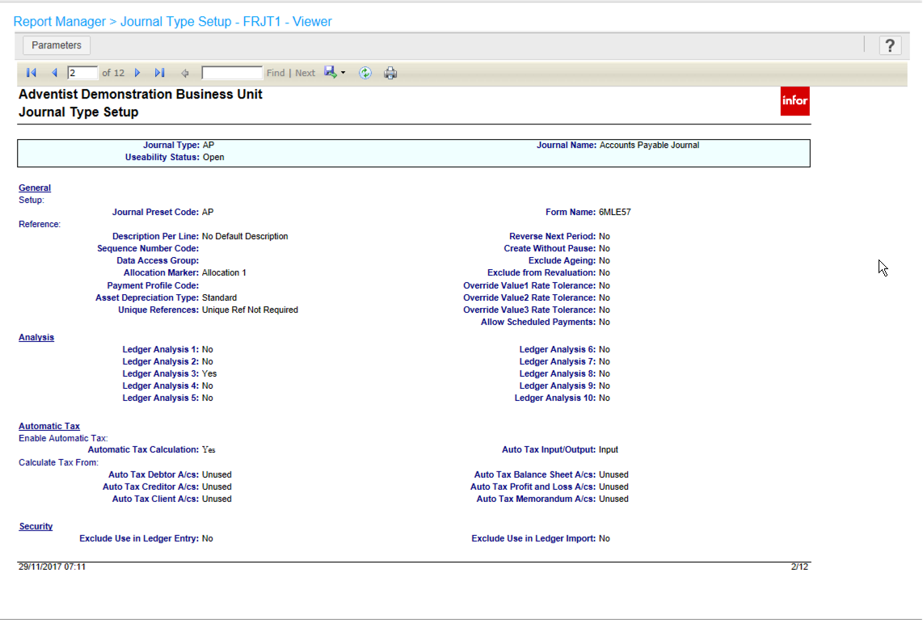

Journal Presets Setup

Journal Presets predefine or enforce some or all of the entries for a journal. This depends on the Force Presets option.

NOTE Any Preset field can have an entry of ‘-‘ (hyphen) to indicate a preset of blank, or ‘..’ (two dots) to indicate that an entry should be duplicated from the equivalent field on the previous line of the journal.

Presets Tab

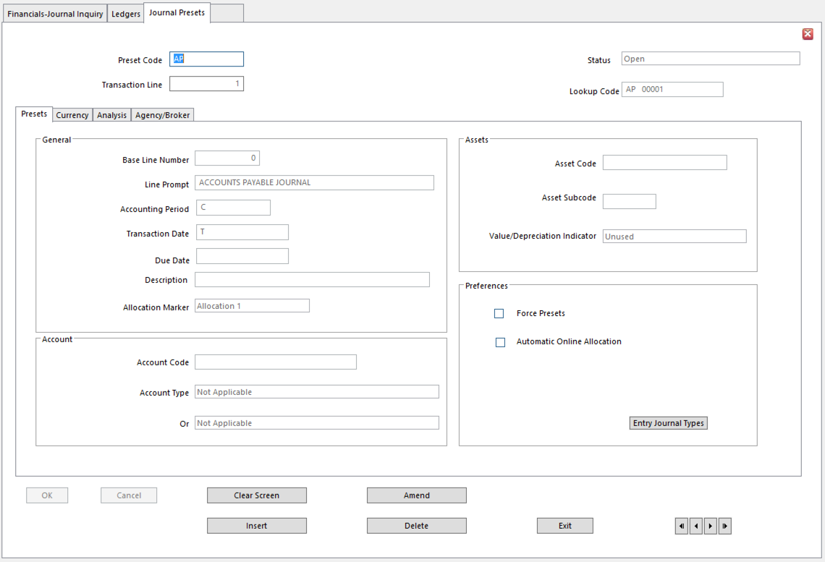
- Transaction Line Transaction Line Number to which Preset will be applied
- Base Line Number Journal Line Number on which calculations are based and from which
defaults are taken for this line.
- Number can’t be higher than Line Number entered in header
- Line Prompt Displayed as prompt in Ledger Entry header; ensures required data is
entered
- Can be anything
- SunPlus convention: Name of Journal Type as a reminder
    - An option: ‘Enter Creditor or Client account here’
- Accounting Period Presets Accounting Period to an absolute value or a relative value
- Special values can be used:
    - C preset to Current Period
    - C+nnn preset to period nnn periods after the
Current Period
          - C-nnn preset to period nnn periods before the Current Period
    - +nnn preset to period nnn periods after the
period on the base line
    - -nnn preset to period nnn periods before the
period on the base line
- Transaction Date Presets the Transaction Date to an absolute value or a relative value
- Special values can be used:
    - T preset to Today’s date
    - T+nnn preset to date nnn days after today’s date
    - T-nnn preset to date nnn days before today’s date
    - M-Months to add or subtract months
    - N-Net to add and subtract months and adjust to
the last day of the month

- Due Date Presets Due Date to an absolute value or a relative value
- Special values can be used:
    - T preset to today’s date
    - T+nnn preset to nnn days after Transaction Date
    - T-nnn preset to nnn days before Transaction Date
          - +nnn preset to nnn days after Due Date on base
line
    - -nnn preset to nnn days before Due Date on base
line
    - A suffix of M-Months to add or subtract months
    - A suffix of N-Net to add and subtract months and adjust to the last day of the month
- Description If Description Per Line is required for Journal Type, Preset
Description automatically using any of the following codes:
- @nnn (where nnn is a number 1-999) to copy the account name associated with the account code on line nnn
- @nnnA to copy the account code on line nnn
    - For instance, copying the Customer account name or code as part of the Description on the bank posting line of a Cash Receipts journal
    - The number (nnn) must be lower than the Preset line
  - Can also be text

- Allocation Marker Automatically set Allocation Marker on transactions in this Journal
Type
- Select No Allocation to leave the Allocation Marker blank if predefined allocations are not required
- Options:
    - Default use the corresponding Allocation Marker option set on Journal Type for this Preset line
    - Allocation Markers 0 – 9 select one to automatically set as Allocation Marker on journal line for this Preset, if posted to a Creditor, Debtor, or Client account
      - If another Account Type is associated with this line, such as P&L, no Allocation Marker is used
      - Only Creditor, Debtor, or Client Account Types can use 0-9 markers
    - Force if line is for Creditor, Debtor, or Client account, journal line is assigned Force Allocation Marker to identify it as requiring a forced payment or collection
      - If line is for another Account Type, no Allocation Marker is used
      - Only Creditor, Debtor, or Client accounts can use this Allocation Marker
    - Withheld account will be withheld from Payment Run
    - Reconciled automatically sets Allocation Marker to Reconciled on transaction line
- Account Code Preset Account Code for this line
- Use ‘*’ (asterisks) as mask to Preset range of valid Account Codes for this line
- Use @nnn to Preset a Linked Account
    - Nnn number of Preset line where the first account (account from which link comes) appears
- Account Type Preset Account Type
  - This ensures line is posted to a specified Account Type
- For another Account Type, use second Account Type field
- If Preset line forms basis for a calculation and should remain unposted, select Calculation Line (unposted)
- Asset Code Applies to Fixed Assets Register
- Presets Asset Code
- Asset Subcode Applies to Fixed Assets Register
- Presets Asset Subcode
- Value/Depreciation Indicator Identifies the type of asset value to be updated by the journal
- Options:
    - Asset Value
    - Depreciation
    - Initial
    - Preset Blank value must be entered manually
- Force Presets Operator cannot alter Preset value for this Journal line
- Automatic Online Allocation Online Allocation window automatically appears upon completion
of journal line entry
- Journal Types Accesses Journal Type form

Currency Tab

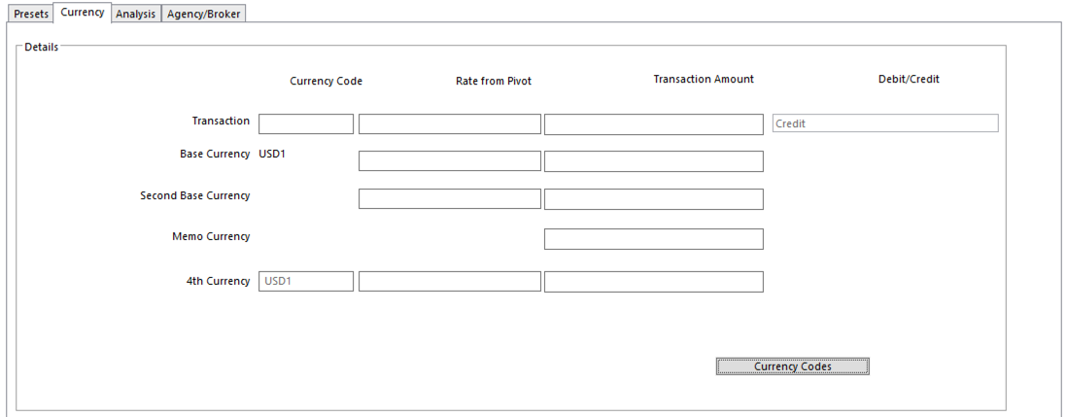

In multi-currency environments, currency details can be preset for up to 5 values for a journal line.

- Transaction Currency Code Default Currency Code for this journal line
- ‘-‘ (hyphen) presets blank Currency Code restricting this line to base amounts only
    - Only available if Posting Rule for the value is set to Only Present if Entered
- Rate from Pivot Conversion Rate to use for the line
- Rate used to convert Pivot Currency amount into the Transaction Currency
- Not required if Transaction Currency is the Pivot
- Leave blank to look up the appropriate rate for the Currency Code at entry time
- Transaction Amount Preset transaction amount for the line, expressed in Currency Code
identified above
- Can be entered with zero, one, two, or three decimal places, depending on Currency definition
- Debit/Credit marker field includes options that preset the amount to the value needed to balance the current Journal, Transaction, or Period
- Other options:
    - Percentage - for example 5%. Amount is calculated as this percentage of the amount entered on the base line referenced
    - Ratio - for example 5R or 6.3R. Works like the percentage, but only one base line may be referred to for each Journal Type
- Debit/Credit Preset Debit/Credit Marker for the line
  - Applies to all currency values
- Options:
    - Reverse of Base Line reverses Base Line marker
    - Same as Base Line copies Base Line marker
  - Out-of-Balance options (automatically calculate balancing amount and insert it in the Amount field):
    - Journal Balance calculates out-of-balance amount for the journal
    - Transaction Balance calculates out-of-balance amount for transaction lines (lines with same transaction reference)
    - Period Balance calculates out-of-balance amount for period (journal lines that have same period)
    - Txn Balance plus Unposted calculates transaction out-of-balance amount plus the net out-of-balance amount of all calculation lines

Analysis Tab

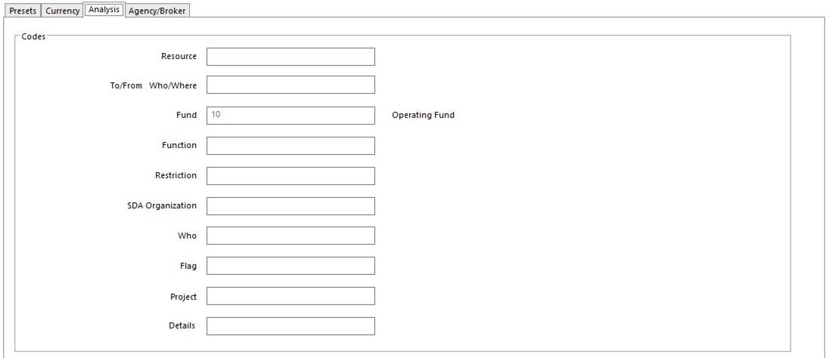
- Ledger Analysis 1-10 Preset values for a particular Dimension by entering the code
- SunPlus convention is to populate Fund – 10
- Enter ‘..’ (two dots) to copy entry from previous journal line

Agency/Broker Tab

Not commonly used in SunPlus. Only relevant for organizations using SunSystems as Broker Ledger.

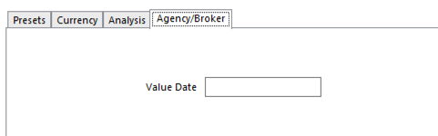

Printing Journal Presets

A Journal Presets Report listing the Journal Preset definitions can be printed.

Go to Action Menu > Report > Report> select document format from list.

Fixed Assets

In SunSystems version 6 and above, SunPlus uses Asset Classes to group assets that share a logical category, such as Depreciation Method or Percentage. Asset Classes hold defining information about the type of assets in the class. This gives them more power than simply associating the assets by Asset Code conventions. For example, a Furniture Asset Class could group asset records for types of furniture that all depreciate at 20% per year with the Straight Line Method and whose depreciation amounts will be posted to the same depreciation account.

When Asset Class is assigned to an asset in the Fixed Asset Register, the Depreciation Method, Percentage, and Accounts are automatically entered on the Asset Record. Any fields that have been manually populated will not be overwritten unless there is a confirmation that they should be overwritten.

Asset Class

The following Asset Classes are pre-established in SunPlus Core:
- 00OTHERS Church & School Properties
- 05EQUIP Equipment & Furniture with 5 Years of Estimated Life
- 10EQUIP Equipment & Furniture with 10 Years of Estimated Life
- 10IMPRO Improvement of Land with 10 Years of Life
- 10VEHIC Vehicle with 10 Years of Estimated Life
- 25EQUIP Equipment & Furniture with 25 Years of Estimated Life
- 25IMPRO Improvement of Land with 25 Years of Life
- 50IMPRO Improvement of Land with 50 Years of Estimated Life
- 75BUILD Building with 75 Years of Estimated Life
- 75RESID Residence Building with 75 Years of Estimated Life

To set up new Asset Classes, go to Asset Class

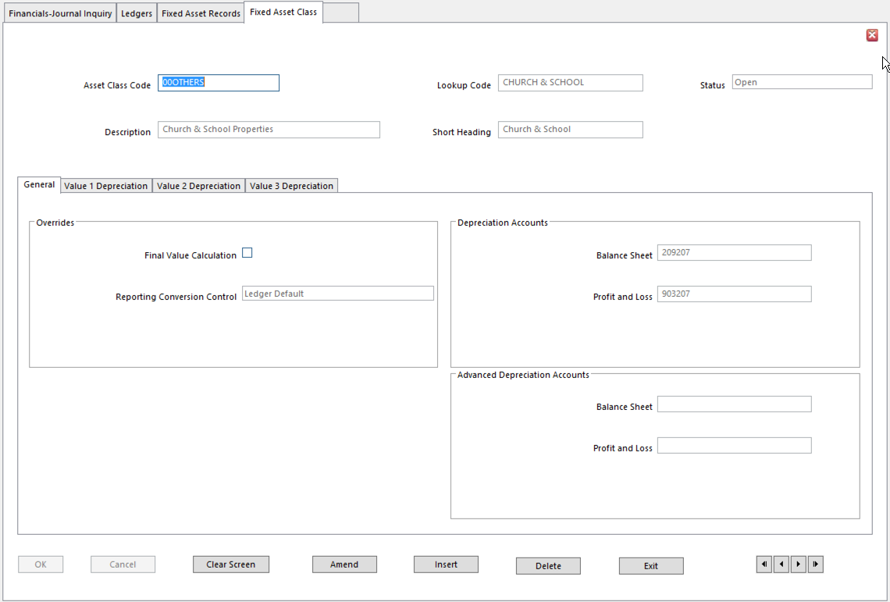
- Final Value Calculation Overrides Ledger Setup’s Exclude Final Value from Calculation setting
- Reporting Conversion Control Currency control option used for postings to assets in this Class in
Reporting Currency
- Options:
    - Ledger Default – use Value 3 Currency Post Rule option in Business Unit Setup to determine if Reporting Currency values are required on transactions posted to assets of this Class
    - Mandatory – Reporting Currency value is mandatory
    - Prohibited – Reporting Currency value cannot be entered
- Balance Sheet Account for Depreciation postings for this Class of assets
- Leave blank to use account entered in Depreciation Calculation
- Profit and Loss Account for Depreciation postings for assets of this Class
- Leave blank to use account entered in Depreciation Calculation
- Advanced Depreciation Accounts SunPlus usually doesn’t use Advanced Depreciation

Value 1 Depreciation Tab

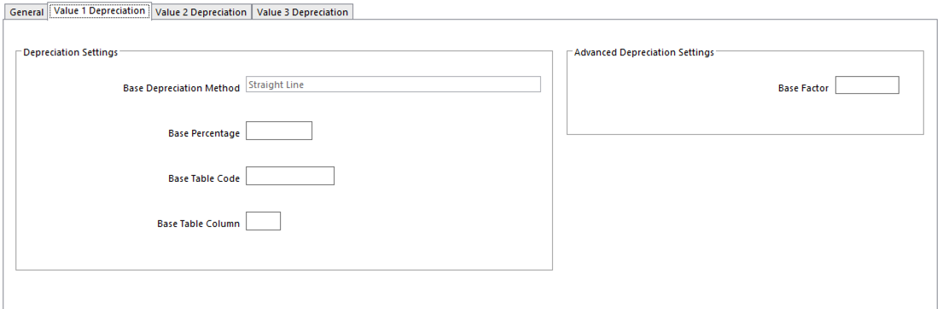

- Base Depreciation Method If No Depreciation, there will be no automatic depreciation for
Asset Class
- Base Percentage Percentage rate used to calculate amount of Depreciation deducted
- Base Table Code Depreciation table for Table Depreciation (if used)
- Base Table Column Column of the Table of Rates to be used in Depreciation
- Base Factor Amount used to multiply Standard Depreciation amount to calculate
Advanced Depreciation

Value 2 Depreciation Tab

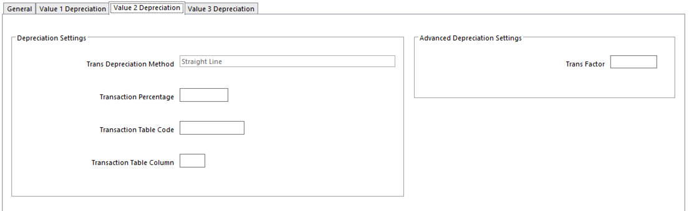
Same as for Value 1 Depreciation fields, but for Transaction Currency.

Value 3 Depreciation Tab

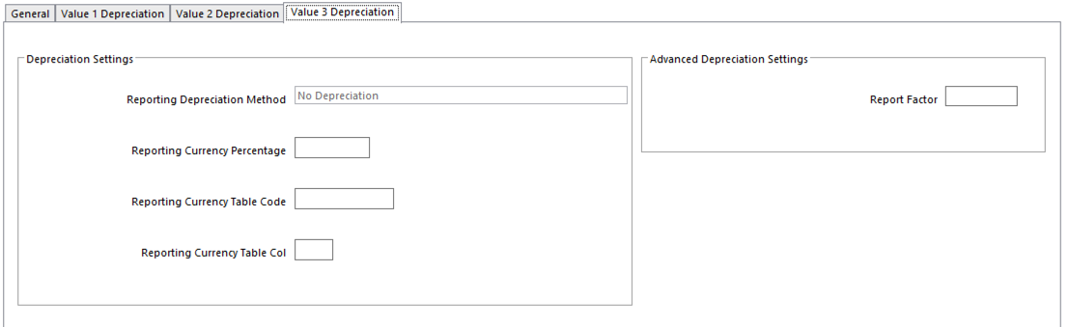

Same as for Value 1 Depreciation fields, but for Reporting Currency.

Asset Records

The Fixed Asset Register holds the static information, asset values, and depreciation details for each asset.

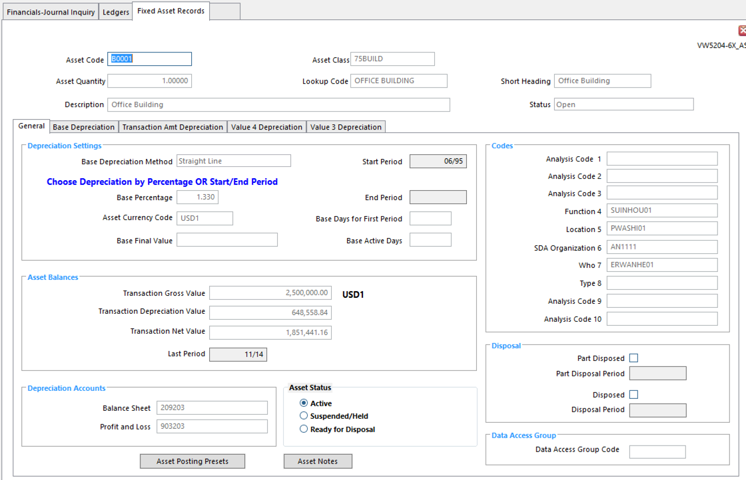
- Status Note: this Status code is different from Asset Status in General tab
- This Status is for the Asset Record, rather than for asset itself
- Asset Quantity Multiple units can be entered as a single asset
- I.e., purchase of 100 chairs, can be recorded as a single asset
- Use Memo Amount field in Ledger Entry to record Quantity
- Asset Class Enter Asset Class and relevant fields will be automatically populated
- Leave blank if no Asset Class applies to this asset
- Base Depreciation Method SunPlus standard is usually Straight Line
  - Other options are available if needed
- Base Percentage Percentage Rate for calculating amount of Depreciation deducted
- Note: a Percentage Rate can be entered or left blank and the End of the Depreciation period in the End Period field entered – NOT BOTH!
- Start Period Period in which Depreciation begins
- End Period Period in which Depreciation stops – see note on Base Percentage
- Base Days for First Period Depreciation can begin part way through first period
- Enter number of days in first period in the life of the asset
- Leave blank if Full Year Depreciation in 1st Year checkbox in Ledger Setup is ticked
- Base Active Days Number of days asset is active in the Start Period
- Required for Depreciation to only be charged for a certain number of days in the first period in the life of the asset
- Leave blank to calculate Depreciation for entire first period
- Leave blank if Full Year Depreciation in 1st Year checkbox in Ledger Setup is ticked
- Asset Currency Code Currency Code for this asset – used as Transaction Currency
- Base Final Value Final value of this asset in Base Currency
- Could be Scrap or Residual value
- Transaction Gross Value Original asset value, including additions, revaluations, or disposals
- Sum of all transactions with Initial or Value Asset Indicators
- Reflects changes made in Ledger Entry, Ledger Import, or Asset Disposal
- System-populated field after Ledger Entry, Ledger Import, Asset Disposal postings
- Transaction Depreciation Value Standard Accumulated Depreciation for the asset
- Displays sum of all Depreciation calculated and posted by Depreciation Calculation, Ledger Entry, and Ledger Import against the asset
- Transaction Net Value Gross Value of the asset less Accumulated Depreciation
- Last Period Last period in which the asset was Depreciated
- Depreciation Accounts Balance Sheet Account for Depreciation postings for this asset
- Leave blank for account entered in Depreciation Calculation
- Depreciation Accounts Profit & Loss Account for Depreciation postings for this asset
- Leave blank for account entered in Depreciation Calculation
- Asset Status Current Status of the asset itself
- Active – in use
- Suspended/Held – no longer in use
    - Suspended/Held assets trigger Ledger Entry warning
    - Asset Disposal ignores these assets
    - Depreciation Calculation ignores these assets
  - Ready for Disposal – tagged for disposal
    - No transactions can be posted to this asset
- Part Disposed Set If a portion of Asset Quantity disposed of in Asset Part Disposal
- Part Disposal Period System enters period in which part of asset has been disposed
- Disposed Set if the asset has been Disposed of in Asset Disposal
- Disposal Period The Period for Disposal of the asset
- Leave blank for the system to populate when the asset has been disposed of using Asset Disposal

Asset Analysis Posting Presets

Use to predefine Analysis Codes entered on transactions generated by Depreciation Calculation and Asset Disposal posting to an asset. Analysis Code combinations can be preset for an asset.

Asset Posting Presets interface is accessed by a button on the Asset Records interface.
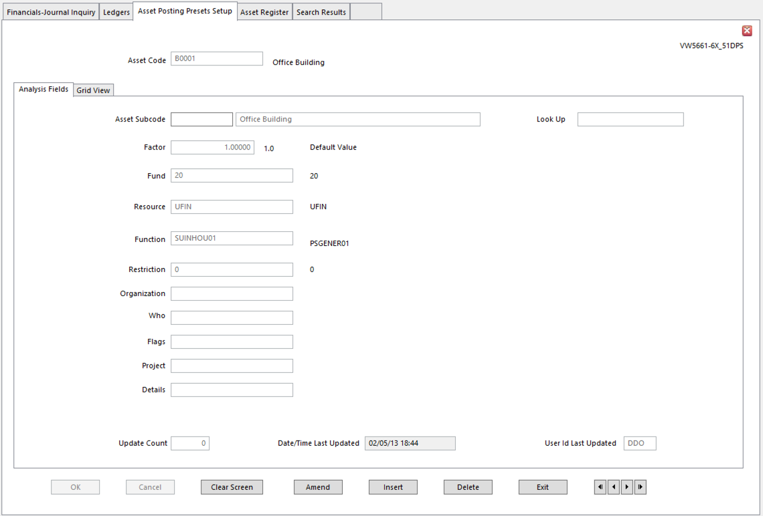

- Asset Subcode Uniquely identifies Posting Presets and Analysis Code combination
- Factor Proportion of Total Asset Depreciation apportioned to this subcode
- Left blank, factor is assumed to be zero and Depreciation is not analyzed to this subcode
- Analysis Dimensions Enter appropriate Analysis Code for the asset
- These Analysis Codes will be assigned to transactions

Asset Notes

A lot of information about an asset can be stored in Asset Notes. An Asset Record can be linked to any number of Asset Notes. The link between Asset Record and Asset Notes is the Asset Code. Asset Notes are for information only. They are optional, but they can be displayed in reports.

Asset Notes are accessed through a button on the Asset Records interface.
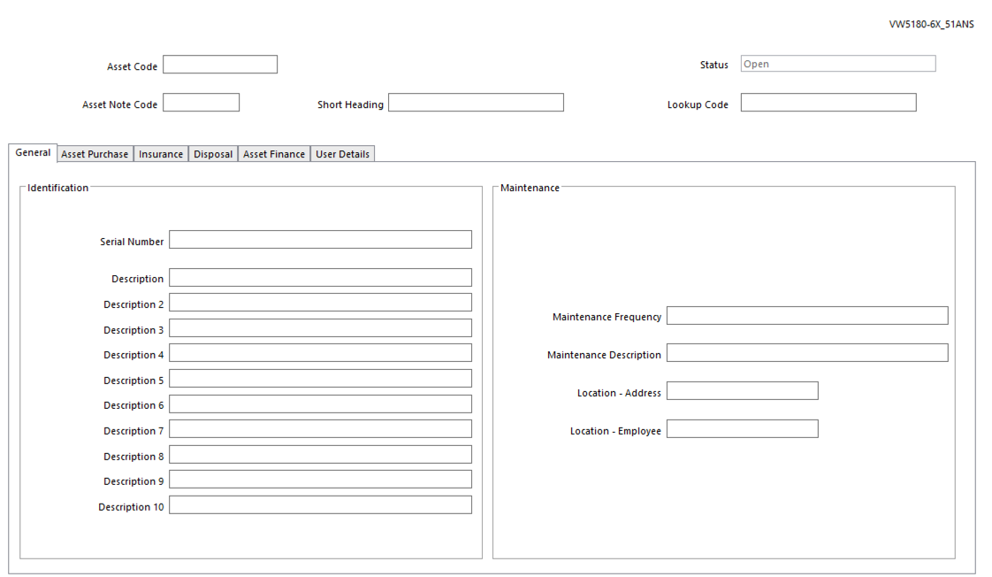
- Asset Note Code Unique code to identify this Asset Note
- Serial Number
- Description 1 – 10 Text fields available for descriptive information
- Maintenance Frequency
- Maintenance Description Type of maintenance required
- Location – Address Physical location of the asset
- Location – Employee Person responsible for the asset

Asset Purchase Tab

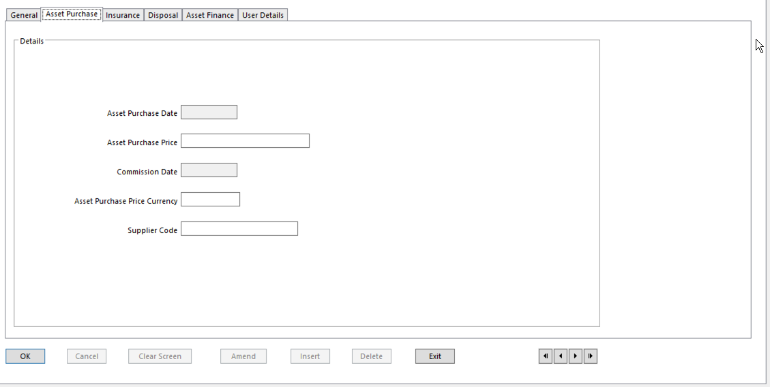
- Supplier Code Supplier from which asset was purchased

Insurance Tab

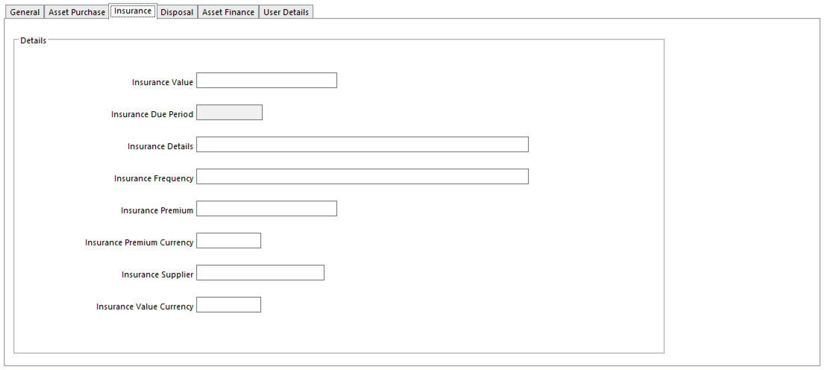
- Insurance Frequency Frequency with which insurance is renewed
- Insurance Supplier Insurance Broker or company

Disposal Tab

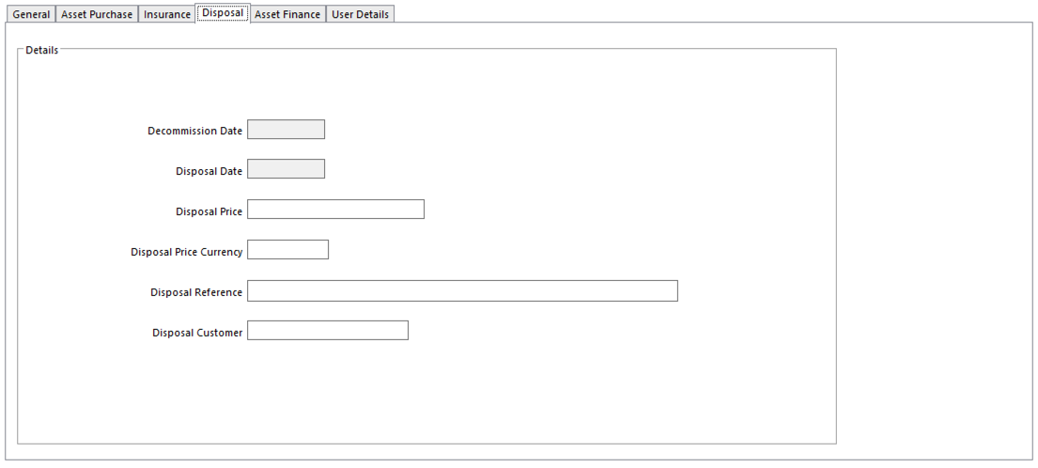
- Disposal Customer Customer to whom the asset will be disposed

Asset Finance Tab

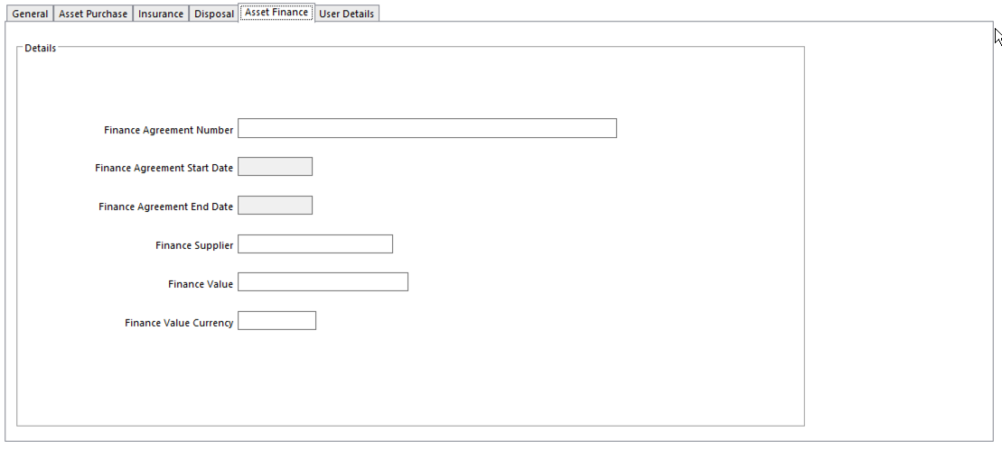
- Finance Supplier Finance Company

User Details Tab

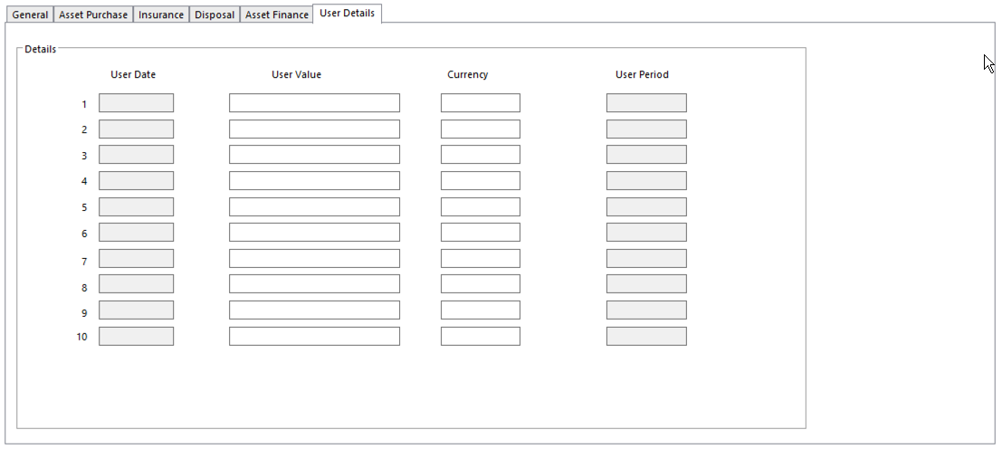

- User Dates Up to 10 additional user defined dates for the asset
- User Value Up to 10 additional user defined values for the asset
- Currency Currency of each user defined value
- User Periods Up to 10 additional user defined periods for the asset

Asset Budgets

Up to ten Budget valuations can be kept for each asset in addition to the ‘Actual’ Ledger valuation. Asset Budgets Details provides for up to ten alternate asset valuations and Depreciation Methods on valuations. This allows analysis of the effect of changing Depreciation Method on life of an asset, or current cost valuation. Budget Asset Details can be used for forecasting and can be printed alongside Actual Asset information.

Open Asset Budget Details

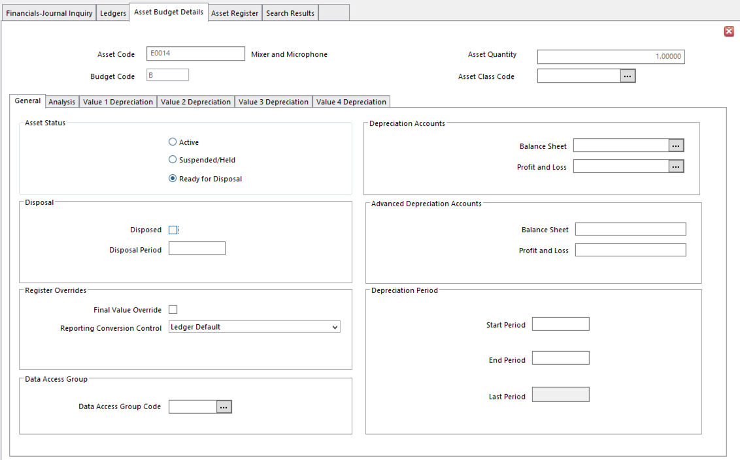

Asset Budget Details setup is exactly the same as regular Asset Setup. The screen looks a little different because the interface has not been customized by SunPlus.

Asset Inquiry

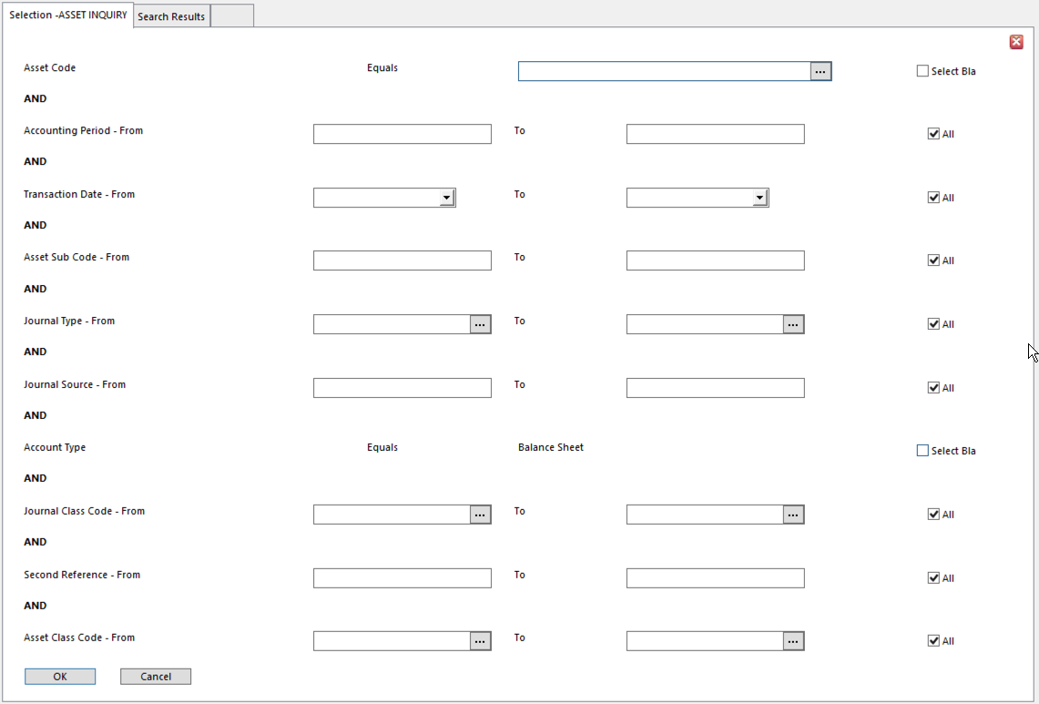
- Enter selection details
- A transaction must meet all selection criteria in order to be included in the display of results
- Click OK to extract transaction details

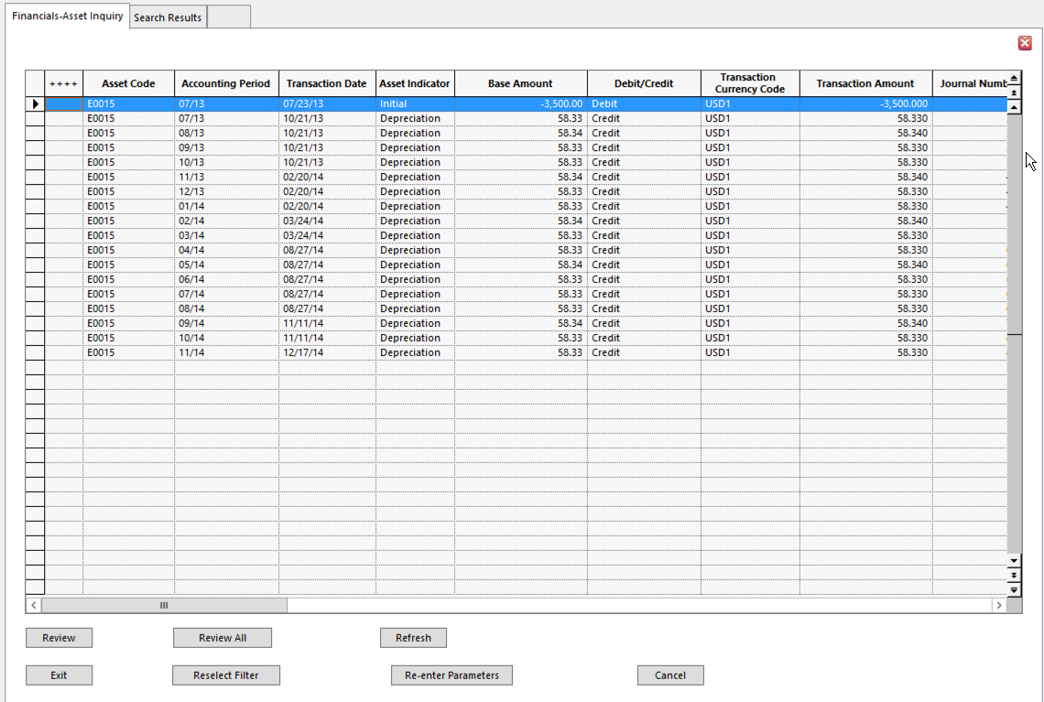
- I selected a line and then selected Implode All from the Action menu.
- I got this:
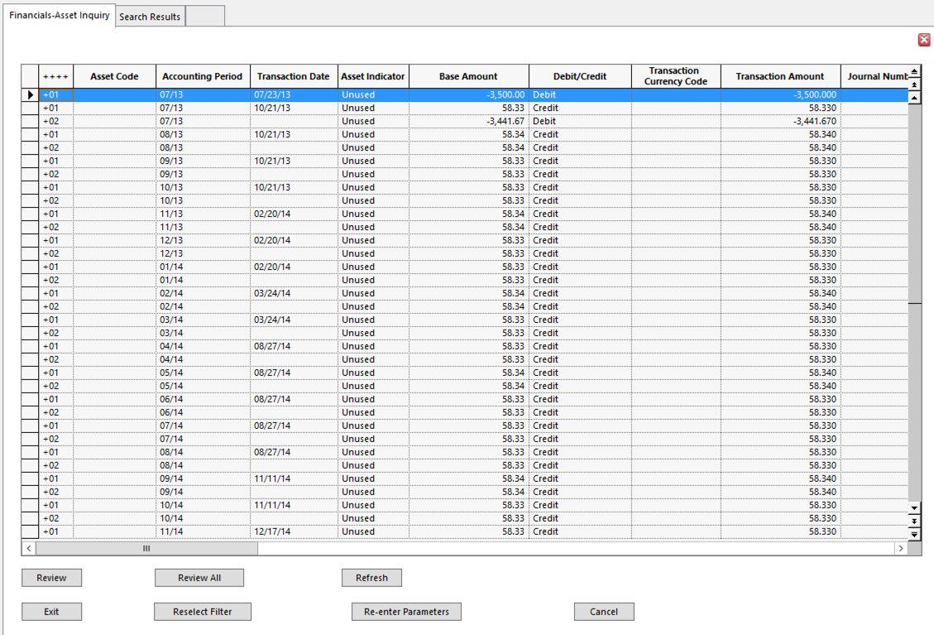

Fixed Asset Entries

Fixed Asset Purchase Entry

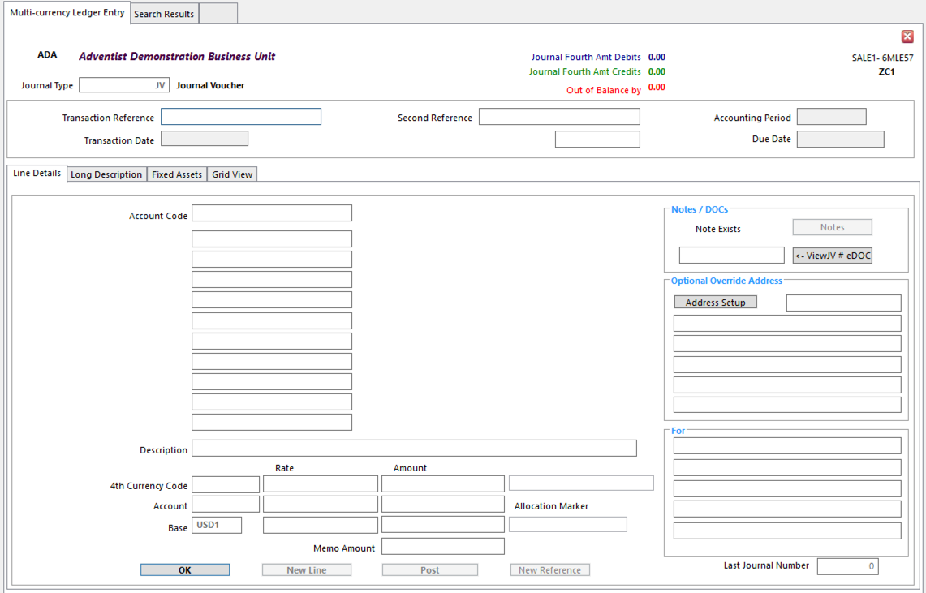
- Journal Type JV
- Ext/Trans Ref Value tying transaction entry to originating documents
- Line 1
Debit 962224 – Payment for Assets
RSCE UFUN – Uninvested in Plant Resources
Fund 10
RSTR 0 – Unrestricted
- Line 2
Credit 102XXX – Bank Account
Fund 10

To record Bank Payment and the use of Unexpended Function and Nontithe Restriction

- Line 3
Debit 20X20X Assets
RSCE UFUN
Fund 10
RSTR 0
Fixed Asset Tab set up Asset Code
Asset Indicator Initial
Quantity must be entered

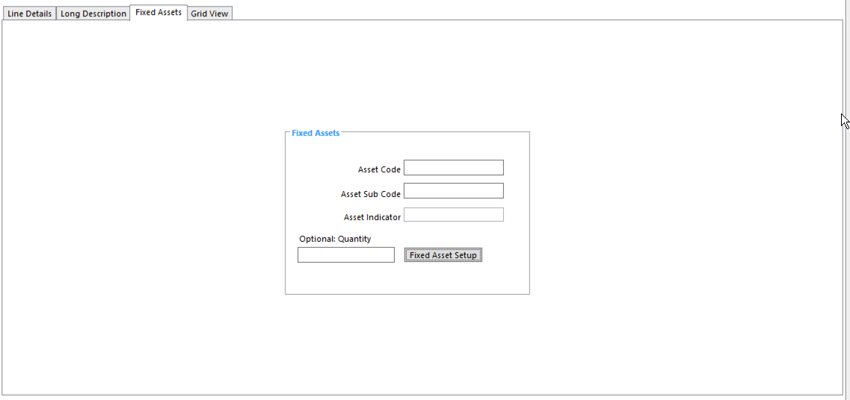
- Line 4
Credit 773225 – Asset Acquired
RSCE UFIN – Invested in Plant Resources
FUND 10
RSTR 0

To record actual purchase of Fixed Asset, and the addition in Invested Resources and non-tithe Restriction

Fixed Asset Appreciation Entry

Entry of an appraised increase in Gross Value will increase monthly depreciation for the asset from the entry period up to the last period of the asset’s estimated life.

- Run Asset’s Depreciation Calculation up to the period before the period in which the asset’s appreciation is to be recorded.
- This Ledger Entry will increase the value of the Invested Resources Balance / Net Asset

- Ledger Entry
Journal Type JV
- Line 1
Debit Asset Control 20X20X
RSCE UFIN
FUND 20
RSTR 0
Fixed Asset Tab Attach Asset Code
Set Asset Indicator to Asset Value
- Line 2
Credit 778110 – Plant Asset Appraisal Value Additions
RSCE UFIN
FUND 20
RSTR 0
- Enter an explanation for the increase in the Asset Notes
- Disclose the appraisal in the Financial Statement’s Asset Report

Fixed Asset Depreciation Entry

Entry of an appraised decrease in Gross Value will decrease monthly depreciation for the asset from the entry period up to the last period of the asset’s estimated life. This is rarely done in Ledger Entry. It is usually taken care of by Depreciation Calculation.

- Run Asset’s Depreciation Calculation up to the period before the period in which the asset’s depreciation / reduction will be recorded.
- This Ledger Entry will decrease the value of the Invested Resources Balance/Net Asset

- Ledger Entry
Journal Type JV
- Line 1
Debit 978110 – Plant Asset Appraisal Value Deductions
RSCE UFIN
Fund 20
RSTR 0
Fixed Asset Tab attach asset code
Set Asset Indicator to Asset Value
- Enter explanation for the decrease in the Asset Notes
- Disclose the decrease in the Financial Statement’s Asset Report

Fixed Asset Disposal Entry

When payment is received for the sale of an asset, use Cash Receipt Journal to record the payment.

- Ledger Entry
Journal Type Cash Receipt
- Line 1
Debit Cash
- Line 2
Credit 762110 Proceeds from Sale of Asset
RSCE UFUN
FUND 20
RSTR 0

The system creates this entry when Asset Disposal is run for the item:

- Line 1
Debit 977110 Asset Disposal & Retirement
RSCE UFIN
FUND 20
RSTR 0
- Line 2
Credit 205205 Equipment & Furnishings

These automatic entries close out the gross value of this piece of equipment.

- Line 3
Debit 209205 Allowance for Depreciation Equipment
- Line 4
Credit 977110 Asset Disposal & Retirement
RSCE UFIN
FUND 20
RSTR 0

These automatic entries close out the Accumulated Depreciation for this piece of equipment.

Depreciation Calculation

Depreciation Calculation calculates and posts Depreciation for a range of assets for all of the periods between the last time Depreciation was calculated and the selected period.

For the system to accurately reflect the up-to-the-minute financial situation, Depreciation Calculation should be run monthly.

Closed or Suspended Accounts in Depreciation

Specify a Suspense account to be used in Depreciation Calculation. If any Depreciation is due to be charged to an account with a Closed or Suspended Status, the posting is made to the Suspense account and a warning is given on Depreciation Calculation report.

Depreciation Exceptions

If an asset already has Depreciation posted to it within a Period, it is excluded from the Depreciation Calculation run for that Period, and Depreciation is not posted for that account.

Depreciation cannot be posted to an asset with the status of Ready for Disposal or Suspended.

The Final Value is a value below which Depreciation is not calculated. It can either be deducted before Depreciation is calculated, so that it is always excluded from Depreciation Calculation, or Depreciation can be calculated on the Gross Amount until the Net Value reaches the Final Value. In final Depreciation Calculation, only the difference between the Net Value and the Final Value is generated.

It is important to note that the Net Value may be less than the Final Value if Depreciation is posted manually or if the Gross Value is reduced by posting a Disposal. Such exception conditions are shown on the Asset Status Listing.

Running Depreciation Calculation

Before running Depreciation Calculation, the following must be in place:

- Fixed Asset Setup Depreciation Method and Percentage values must match on Base and
Transaction Currency tabs
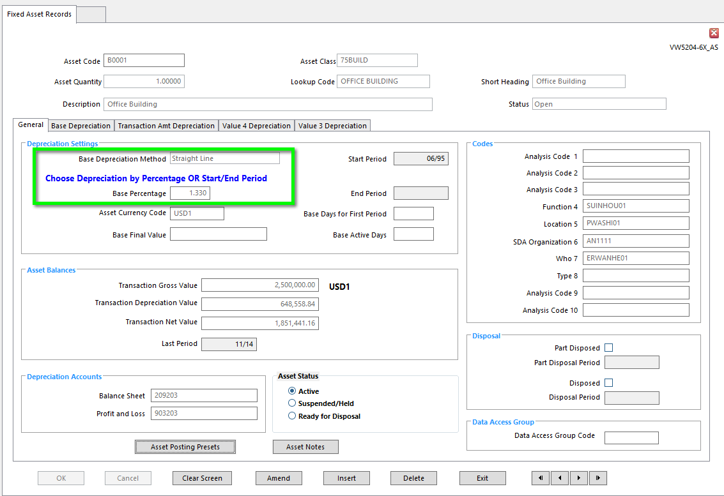

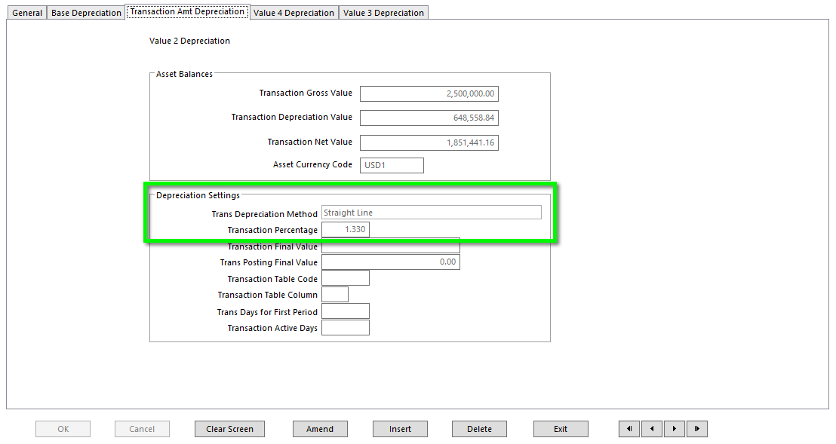

  - All Asset Codes included in Depreciation Calculation must have Currency Codes
  - All Asset Codes included in Depreciation Calculation must have Asset Posting Presets
- Event Profiles (In Business Rules)
  - All Fixed Asset-related Events must have a Status of Open
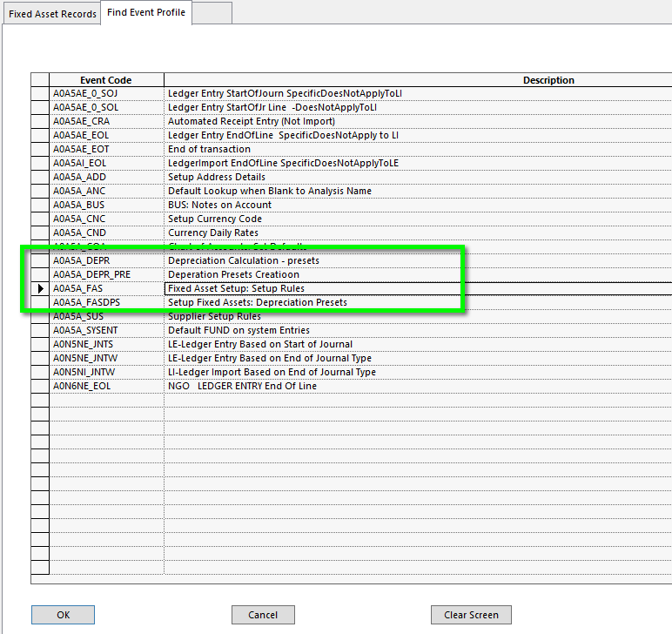

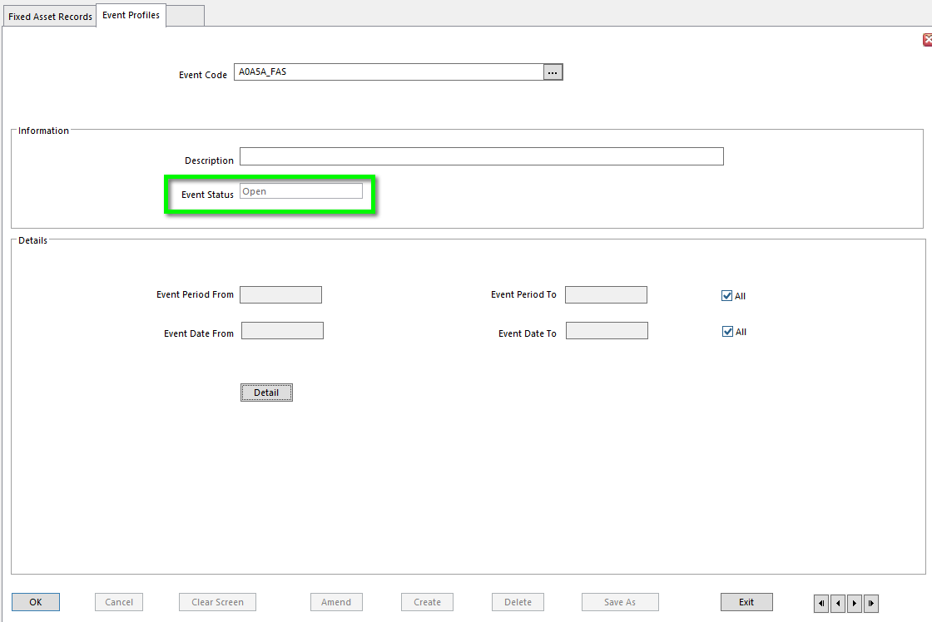
- Depreciation Calculation
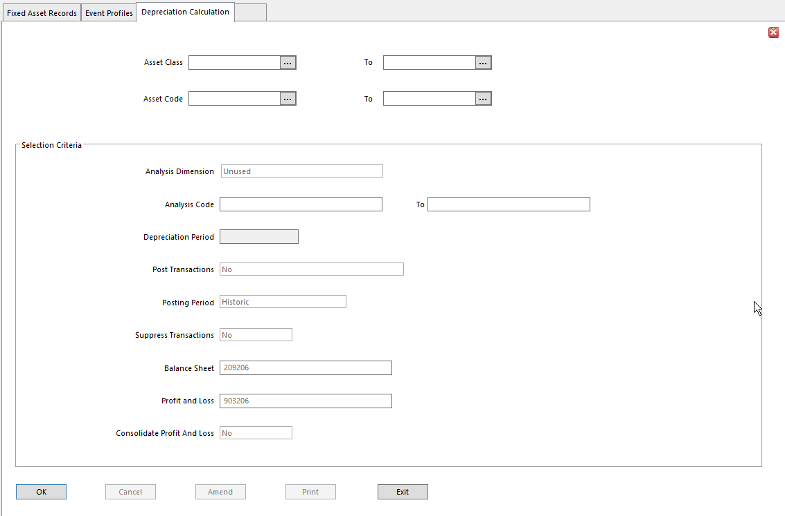
- Asset Class From To Single Asset Class or range of Asset Classes to be processed
  - Leave blank for all, or select specific Asset Codes below
- Asset Code From To Asset Code or range of Asset Codes to be depreciated
  - Leave blank for all Asset Codes
- Analysis Dimension Enter Asset Analysis Dimension to be used to select assets
  - Leave blank to select all assets regardless of Analysis Dimension
- Analysis Code From To If you choose Analysis Dimension above, enter Analysis Code or range
of Analysis Codes used to select assets for Depreciation
  - Only assets referencing Analysis Code or Codes are included
- Depreciation Period Depreciation is calculated for all periods between the last
Depreciation period and period entered here
- Default is Depreciation to be calculated up to Current Period
- Enter Period up to which Depreciation is to be calculated if the default isn’t accurate
- Post Transactions No - to report on Depreciation Calculation by posting Depreciation
  - Yes - to calculate and post Depreciation
  - Post Provisional - If provisional postings are Mandatory or Optional, select Post Provisional to post transactions provisionally
  - A Depreciation report is always produced
- Posting Period Single = post all calculated Depreciation to the period in the
Depreciation Period field
Historic = Post calculated Depreciation to related period

NOTE If Depreciation has not been run every month, be aware that if Depreciation Calculation is run for a Single Posting Period, Depreciation will be calculated for all periods in which Depreciation was not run, but entire amount – including Depreciation for all previously missed periods – will be posted into the same period. This makes comparative analysis impossible. SunPlus recommends using Historic as the Posting Period.

- Suppress Transactions Yes - To only print asset transactions generated during current run
        - No - To print all asset transactions, including previous Depreciation, Asset, and Disposal transactions
- Balance Sheet Balance Sheet Depreciation account where Depreciation is posted
        - Depreciation is normally posted to Balance Sheet account on Asset Record in Asset Register
        - If this account is blank in Asset Records, this account is used
- Profit & Loss Profit & Loss account where Depreciation is posted
  - Depreciation is normally posted to Profit & Loss account on Asset Record in Asset Register
  - If this account is blank in Asset Records, this account is used
- Consolidate Profit & Loss Normally two postings are generated for each asset’s Depreciation
Calculation:
- One to Balance Sheet Accumulated Depreciation account and
- One to Profit & Loss Depreciation Expense account
- Yes – specify how to consolidate Profit & Loss postings

When all Depreciation Calculation parameters have been set, click Print to initiate Depreciation Calculation.

Depreciation Calculation Consolidation

If YES is selected for Consolidate Profit & Loss, the Depreciation Calculation Consolidation interface is displayed, where the consolidation posting can be defined.

- Asset Code From To Check Asset Code checkbox to consolidate Profit & Loss posting by
Asset Code into one transaction line.
- Range of Account Codes to be consolidated can be specified
- Leave From and To fields blank with checkbox checked for all Asset Codes to be consolidated
- Analysis Dimension For each Analysis Dimension, check the checkbox to consolidate
Profit & Loss posting by Analysis Dimension into one transaction line
- Range of Analysis Codes to be consolidated can be specified
- Leave From and To fields blank with checkbox checked for all Analysis Codes for that Dimension to be consolidated
- Additionally, Analysis Codes are removed if the analysis is not allowed for the relevant Depreciation account

Fixed Asset Disposal

Asset Disposal is a three-step process:
- Identify Asset(s) to be Disposed
- Enter sale proceeds, if any
- Run Asset Disposal

- Identify Asset(s) to be Disposed

There are two methods of identifying asset(s) for Disposal:

- Asset Records

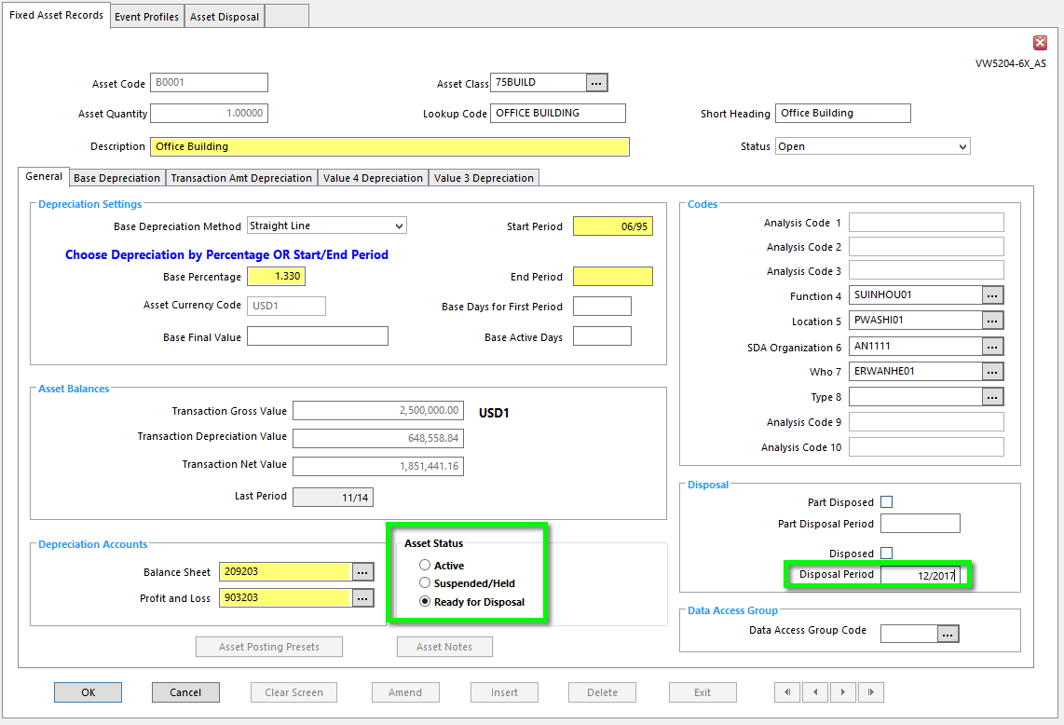

  - Open Asset Record for the asset to Dispose
  - On the General tab, change Asset Status to Ready for Disposal
  - In the Disposal section, enter the Disposal Period in which the asset should be disposed

- Asset Disposal Selection

Asset Disposal Selection is the best choice for flagging multiple assets, especially if they exist in groups.
- For each of the following groups, enter range to be selected. Leave blank to include all.

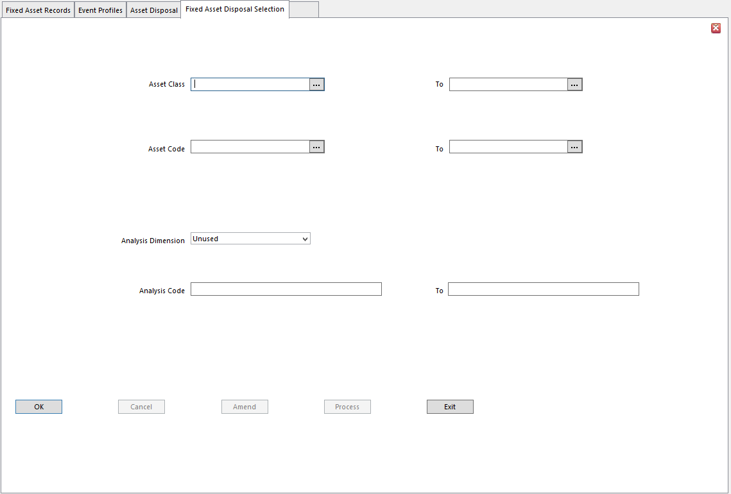
        - Asset Class From To
        - Asset Code From To
        - Analysis Dimension
- Analysis Code From To

- In Ledger Entry, enter sale proceeds, if any (if the asset has been sold)

NOTE This step must take place before running Asset Disposal.

- Run Asset Disposal

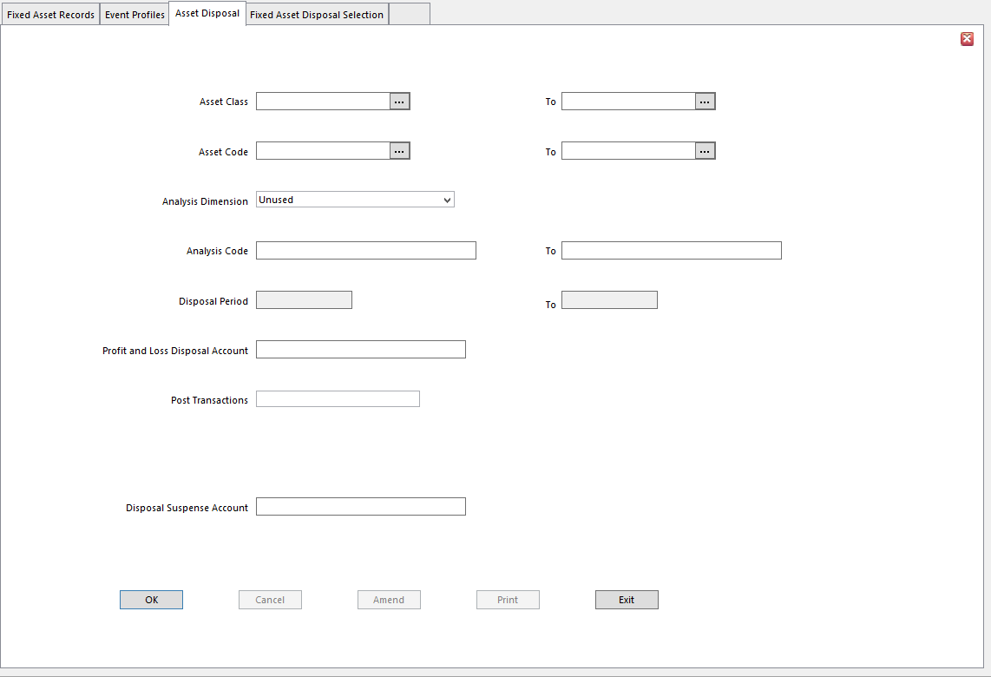
- Asset Class From To Enter Asset Class or range of Asset Classes to include
  - Leave blank to select all Asset Classes or
  - Leave blank to specify Asset Codes
- Asset Code From To Enter Asset Code or range of Asset Codes to include
  - Leave blank for all
- Analysis Dimension Leave blank to select all Dimensions
- Analysis Code From To If Analysis Dimension is populated, use these fields to restrict the
assets to be disposed according to related Analysis Codes
- Leave blank to select all Analysis Codes within the chosen Analysis Dimension
- Disposal Period From To Period or range of Periods in which to Dispose assets
  - Transactions are posted to Disposal Period specified on Asset Record, as long as it falls within this selected range of Periods
  - If Disposal Period on Asset Record is blank, transactions generated during the Disposal are posted to the Last Period in Disposal Period range
  - Disposal Period on Asset Record is updated with the posting
- Profit & Loss Disposal Account Profit & Loss account to which Disposal transactions are posted
- Post Transactions No - To report on Disposal transactions without posting
Yes - To post the transactions
- Provisional Postings – Not used by SunPlus
- Remove Asset Details If Yes for Post Transactions is chosen, this field will be displayed.
- Options:
        - No - select if asset details should NOT be removed
        - Remove Transactions - select to remove transaction details for the Disposed asset from the Register
              - Details will remain in Financials for Account Inquiries and reports
        - Remove Transactions and Assets - select to remove transaction and asset details from the Register
- Disposal Suspense Account Account to be used if transactions generated by Disposal have
Memo Type accounts
  - To ensure Disposal journal balances, Memo accounts are replaced by this Disposal Suspense account

Disposing of Multiple Assets Using XL

- In XL, create upload file with a Ready for Disposal Status for the assets
- Include Disposal Period

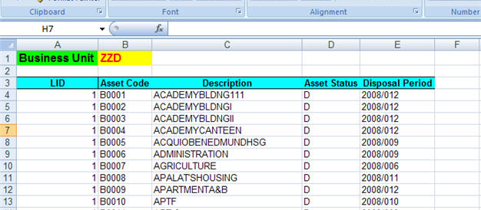
- Use Data Send to upload the file

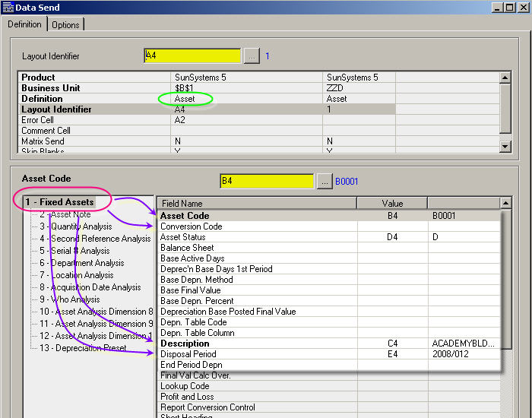

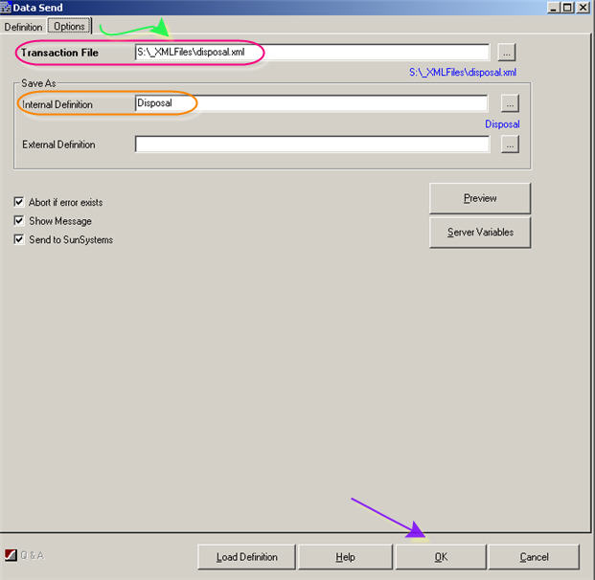
- Run Transfer Desk’s Assets Profile to AMEND the assets

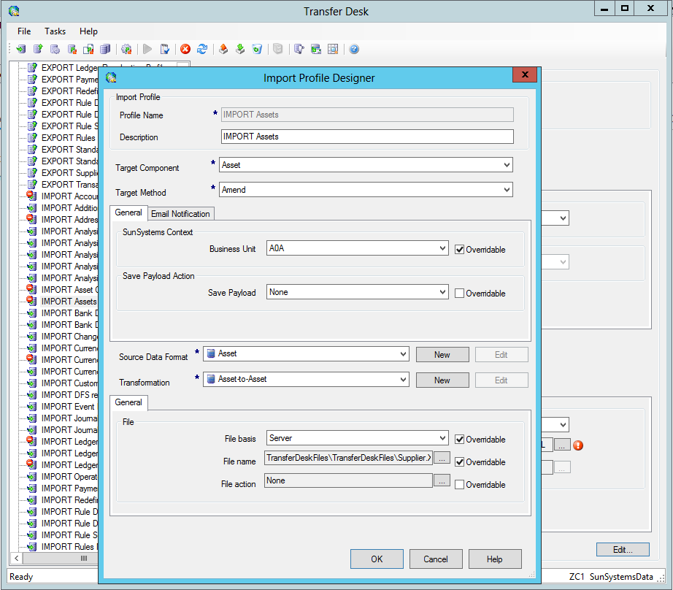
- Run Asset Disposal

Processes

Accounts Payable Process

There are 7 steps in the Payment process. (Underlying assumption: the system has been set up to process Payments)

Produce and Review List of Invoices Due for Payment
Process Manual Checks
Withhold/Force Payments
Payment Run
Print Remittances/Checks
Void/Cancel Checks
Print Payment Listing

Produce and Review List of Invoices Due for Payment

- To decide which Invoices are due for Payment, go to Payment Run

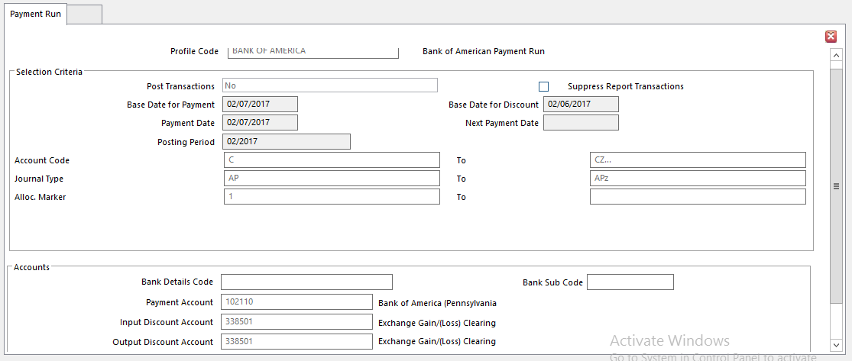
- Post Transactions Select NO
- Fill in the rest of the fields
- Click OK between certain fields to activate the next field
- Click Print to run the report
- Print will bring up Document Format Runtime Parameters interface

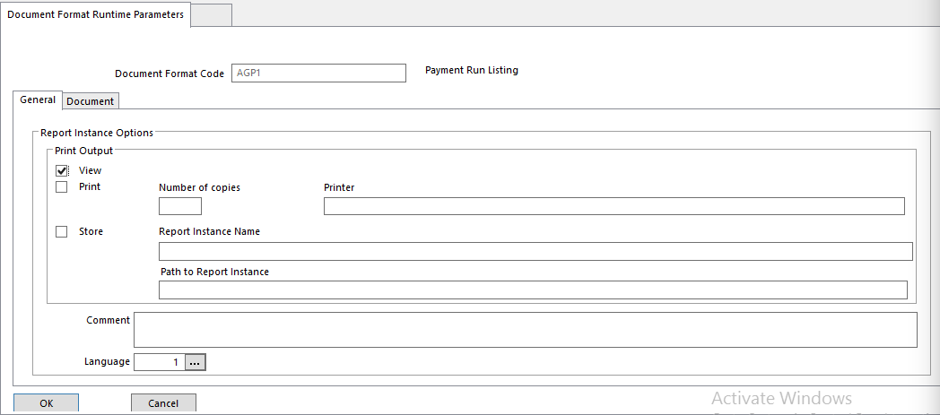

- Choose either View or Print
- Click OK

Process Manual Checks

- Post any manually written checks that have not been posted since the last Payment Run
  - Accounts Payable Journal Type triggers Online Allocation in Ledger Entry, allowing the match of a manual check transaction to the relevant Invoice transaction as part of the Ledger Entry process.
- When the Online Allocation interface appears, change Allocation Marker on the matching transactions to To Be Allocated

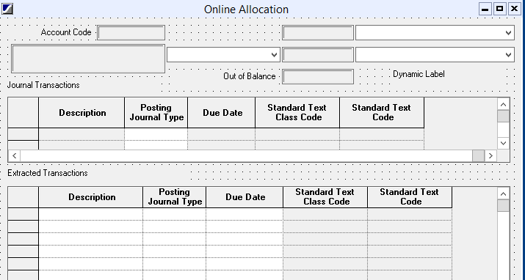

Withhold and/or Force Payments

- To prevent one or more transactions from being included in Payment Run, or require one or more transactions to be included in Payment Run, go to Account Allocation.

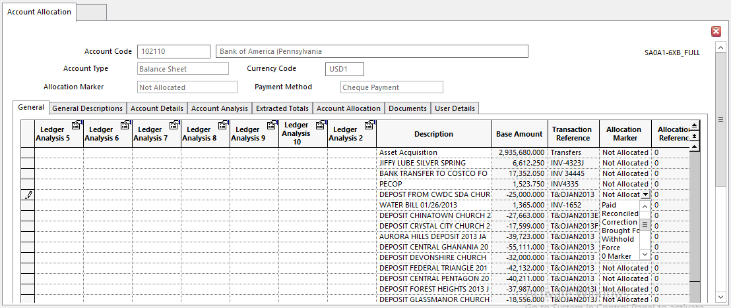
- Find the transaction(s) to exclude from Payment Run and change Allocation Marker to Withhold
- Find the transaction(s) to include in Payment Run and change Allocation Marker to Force

- When Post by Base is clicked, the changes will be recorded against the transactions in the ledger.

Payment Run

- When transactions have been marked for Inclusion or Exclusion, process Payment Run a second time
- Choose applicable Payment Profile
- Set Post Transactions to YES

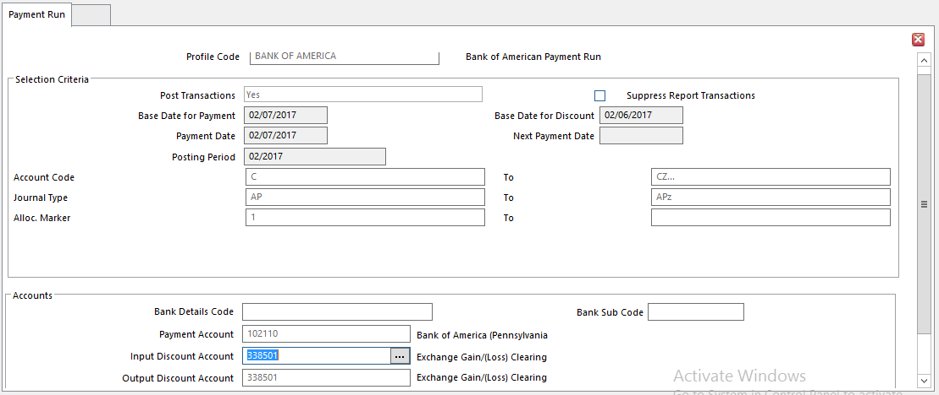
- Fill in other fields as required
- Click Print
- Payment Run is initiated
- Details will be stored
- The system will automatically produce a Payment Listing for the Run
- Select where to store the listing in the directory
- The Listing’s Name can be changed

Print Remittances/Checks

- Payment Documents will be displayed
- Payment Documents prints all documents pertinent to the Payment Run

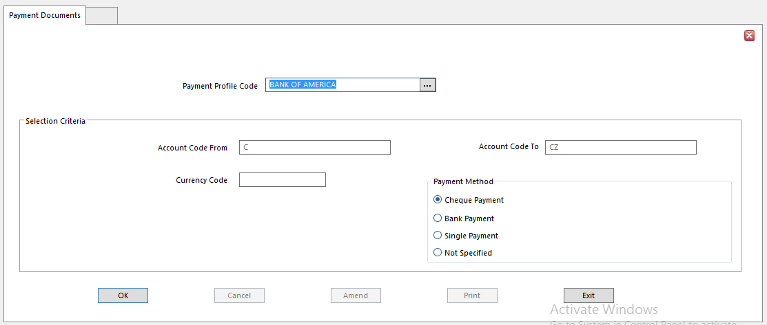
- Single Payment is one of the Payment Method options
- If selected, system generates and assigns a unique Transaction Reference, such as a check number, to each payment document
- Transaction Reference is updated onto the payment transaction for audit control. This is helpful when printing onto pre-numbered stationery.
- Be aware that Payment Reference is assigned to payment transactions when payment documents are produced for Payment Run using Final Print setting in Document Format Parameters Interface
- Until Final Print has been performed, Payment Reference will be left blank even though payment transactions have been posted
- Re-run Payment Documents and select Final Print option to assign a reference to the payment.

Void/Cancel Checks After Payment Run

- Go to Payment Voiding

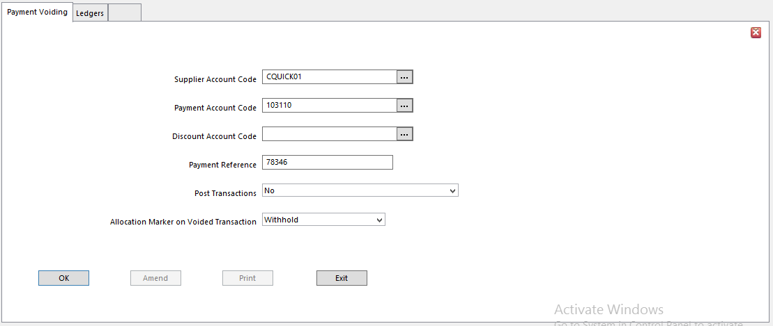
- Enter Supplier Account for payment to be voided
- Enter Payment Account where the balancing transaction was posted
  - This is typically the bank account
- Enter Discount Account if a settlement discount was posted
  - Leave blank otherwise
- Enter Payment Reference, which is Transaction Reference of the payment to be voided, such as a check number
  - No – To print report identifying transactions that would be posted (to validate selections)
  - Yes – To Post Transactions
        - If Payment is voided, all transactions for the selected payment will be reversed, including any discount or tax transactions generated by Payment Run

Print Payment Listing

- When Payment Run has been completed, print the Payment Listing, which is a list of checks in numeric order
- Run after each Generate Payments Run
- Print Aged Reports at the end of every month to track outstanding payments

Payments to One-Off Suppliers

To process a payment for a Supplier with whom you will only do business once, use the One-Off Supplier process.

- Set up a Supplier record and a natural account in the Chart of Accounts for One-Off Suppliers
- Set Payment Method to Single Payment

- Include Payee’s Name in the Description field when entering transactions into this account in Ledger Import or Ledger Entry
- At Payment Run, transactions to accounts with a Payment Method of Single Payment will produce a separate payment for each selected transaction

Prevent Payments Being Made

- To prevent Supplier’s transactions being included in Payment Run, Suspend Creditor/Payable account. Transactions can be entered on the account, but they cannot be selected for Payment.
- Suspend Supplier account to prevent transactions from being paid for that specific Supplier, not Chart of Accounts account.
- To prevent a transaction from being paid, set Allocation Marker on transaction to Withhold or alter Due Date.

Prevent a Payment Account From Being Overdrawn

A Payment Limit can be assigned to Payment Run by setting Total Payment Limit field in Payment Profiles. Once a total payment amount has been reached, the limit will stop any other payments.

Accounts Receivable Process

SunSystems provides a number of tools to manage Receivables accounts.

Customer Setup – static customer details
Chart of Accounts – Receivable accounts
Analyzing Customers, Accounts, and Transactions
Managing Disputes with Clients
Recording Transactions
Matching Transactions
Inquiring on Receivables
Receivables Reports
Payment Collection Run

Customer Setup

Customer Setup is used to maintain all of the information needed for an individual or an organization to which the organization sells goods or services. Records set up in Customer Setup are linked to Natural Accounts in the Chart of Accounts. Create both Customer and Chart of Account records at the same time by filling in all Account details in the Customer Setup screen.

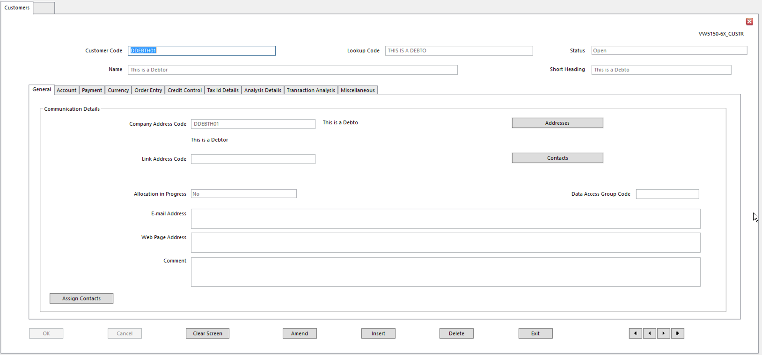
- Company Address Code Code for organization’s (individual’s) main address
- Link Address Code Alternate address – for instance, a Head Office
- Allocation in Progress Indicates if Allocation is in progress, or if Allocation is not applicable
to this account
- Assign Contacts Click Assign Contacts button to associate individuals you work with at
the organization with this record
- Data Access Group To limit system users who can interact with this organization, enter
the applicable Data Access Group Code

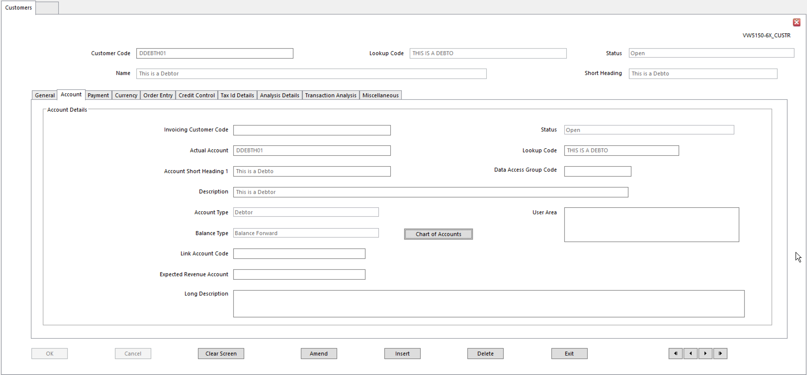
- Invoicing Customer Code Code for Customer who holds account for a multi-site organization
- Enter code where Invoice should be sent, if different from Customer’s location
- Actual Account Mandatory - Chart of Accounts code where financial postings for
Customer will be posted
        - Both Invoicing Customer Code and Actual Account Code cannot both be used together
      - Description Description for the Actual Account in GDCOA
    - Account Type Can be Debtor or Client (if the customer is also a supplier at times)
    - Balance Type Customer accounts are usually Open Item
    - Link Account Code Code for account to be linked to this account via Journal Presets
- Leave blank if unnecessary
- Expected Revenue Account Default Revenue Account for the Customer
  - Used mostly by Order Fulfillment
- Long Description Use to store any additional information
- User Area Use to store any additional information
- Data Access Group Enter if Data Access Group code should be attached to this account

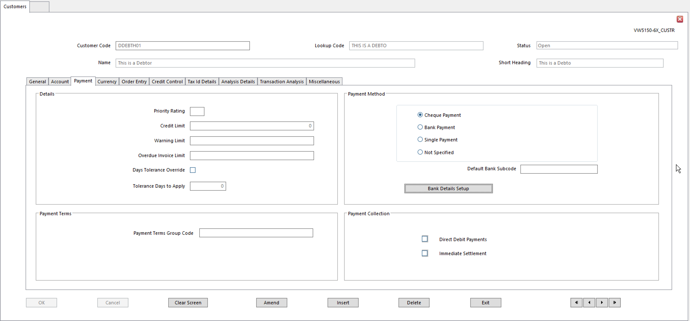
To use Collection Run via Bank Transfer for Accounts Receivable, certain payment details have to be set up for Customer.
- Priority Rating Use Priority Ratings to group Customers, Suppliers, Clients for any
reason
- Enter any number or character as Priority Rating Group Code
- Certain system functions use this to select accounts for processing
    - Payment Collection Run
    - Payment Run
    - Account Statements
- Credit Limit Amount of credit available to this Customer
- In Base Currency
- Leave blank for unlimited credit
- Limit is reported in Aged Analysis reports
- Used when Credit Limit Checking is carried out in Sales Order processing
- Credit Limit can be amended here, but is actually held in the Chart of Accounts record
- Warning Limit Credit amount that should produce a warning.
- If Customer’s account balance exceeds this amount, a warning appears in Sales Entry when additional transactions are entered for the Customer
- Leave blank if no warning is required
- Overdue Invoice Limit Amount of Overdue Invoices this Customer can have before Sales Orders are credit held
- Leave blank if Customer can have unlimited amount of Overdue Invoices
- Days Tolerance Override Overrides number of days tolerance defined in Payment Terms linked
to Customer
- To use this, enter the alternative number of Days Tolerance
- Tolerance Days to Apply The number of days tolerance applying to this customer for payment
- This number is added to Discount Days defined in Payment Terms to calculate the Discount Date for the transaction
- Payment Method How Customer will settle the account
Method selected here must match Method set for Payment Collection Run Profile
- Cheque
- Bank Payment – Customer uses Automatic Bank Payment Method (Direct Debit or BACS)
    - If this is the Method, set up Bank Details for the Customer’s account
    - This Method can only be used if Automatic Bank Payments is set in Ledger Setup
- Single Payment – one-off customers
- Not Specified – alternate method of payment
- Default Bank Subcode Used for Customers who have multiple bank accounts recorded
- Choice of Bank Account must be made
- May be necessary for Customers will accounts in multiple Currencies
- Payment Terms Group Payment Terms applying to Customer (defined in Payment Terms)
- Direct Debit Payments Select to generate debits using Payment Collection Run
- Only applies to Debtors and Client accounts
- Immediate Settlement Select account to always be settled in next Payment Collection Run
- Ignores Due Date
- Leave blank to include transaction in Payment Collection Run when transaction is due for settlement according to Payment Terms (this requires a Payment Method of Bank Payment)

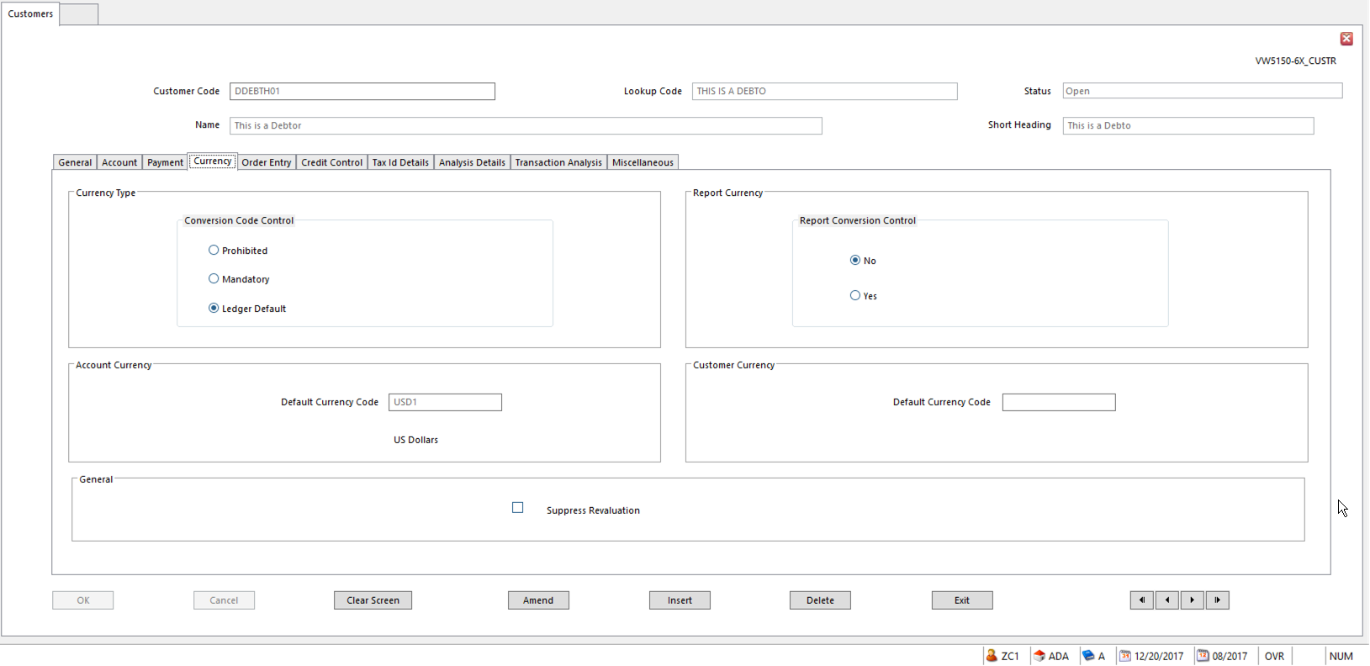
- Conversion Code Control Determines if Transaction Currency Value (Value 2) is entered on
postings to this account
- Overrides the setting in Business Unit Setup
- Report Currency Conversion Control Most SunPlus sites do not use Value 3
- Account Currency Default Currency Code for postings to this Customer
- Customer Currency Default Default Currency for this Customer
- Suppress Revaluation Tick to exclude Customer from Ledger Revaluation, even if it falls
within a range of accounts on which Ledger Revaluation is being run

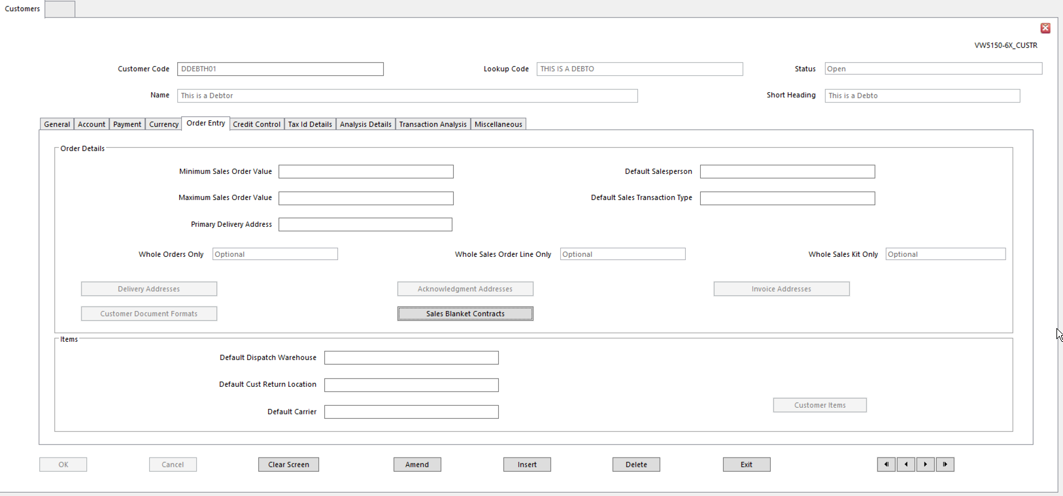
The fields on the Order Entry tab are only used in Order Fulfillment.

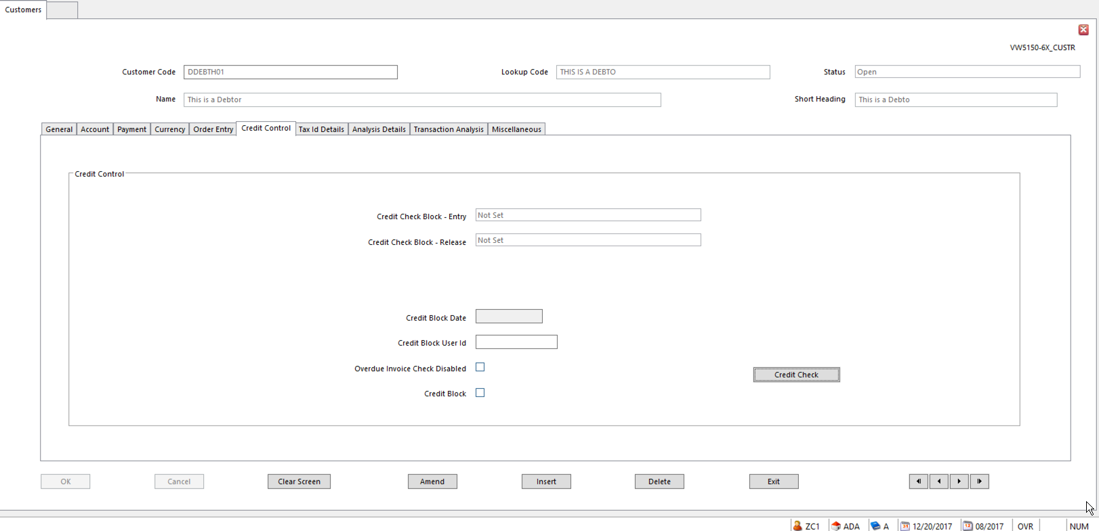
- Credit Control Controls level of warning or restriction applying to Order Entry and
Release Stages in Sales Order processing lifecycle
- Apply to both Credit Limit Checking and Overdue Invoice Checking
- Warn Only – warning displayed, processing can continue
- Warn and Block – warning is displayed
    - Line is put onto Credit Hold and Order Hold
- No Credit Checking – no Credit Limit Checking on Overdue Invoice Checking is performed
- Block Only - line is put onto Credit Hold and Order Hold
- Not Set – system looks at the equivalent flag on the Sales Type to find appropriate action
- Credit Check Block – Entry Set what happens when a Sales Order line fails
- Credit Check Block – Release Set what happens when a Sales Order line fails at the Order
Acknowledgement stage
- Credit Block Date Date the Credit Block was applied
- Credit Block User Id Id of Operator who set Credit Block
- Overdue Invoice Check Disabled Overdue Invoice Checking can be disabled for this Customer
- Credit Block Set if Customer no longer has any credit
  - Credit Block Date and Credit Block User Id are automatically updated on Customer record
  - Warning is displayed if a Sales Order is entered
  - Sales Order line is put on Credit Hold and Order Hold
- Credit Check Click Credit Check button to display Credit Check Inquiry form

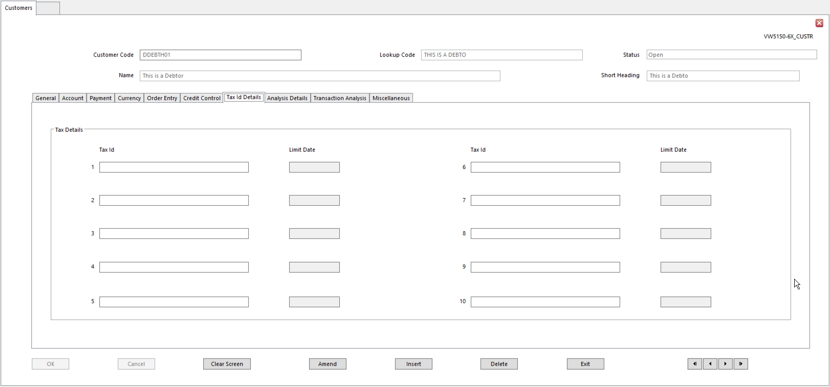
Use to register VAT Registration Codes or other Tax Registration Numbers for Customer, as well as Dates to which each Tax Id applies

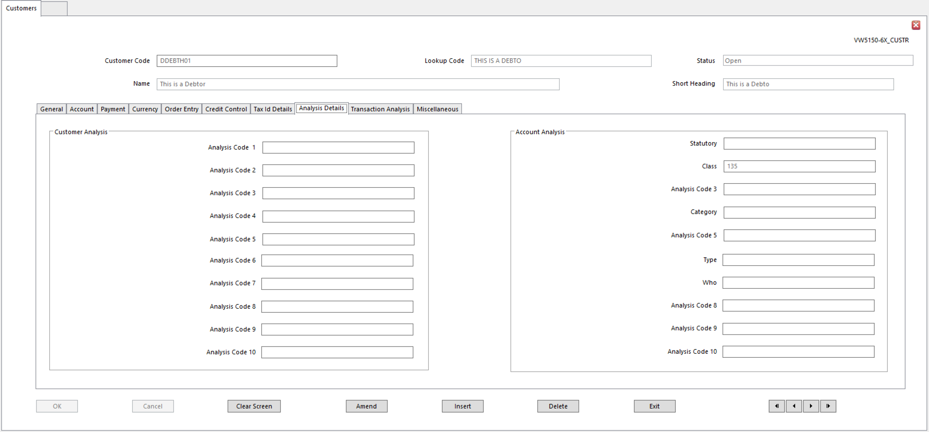
Assign up to 10 Customer specific Analysis Codes, as well as up to 10 Natural Account Analysis Codes.

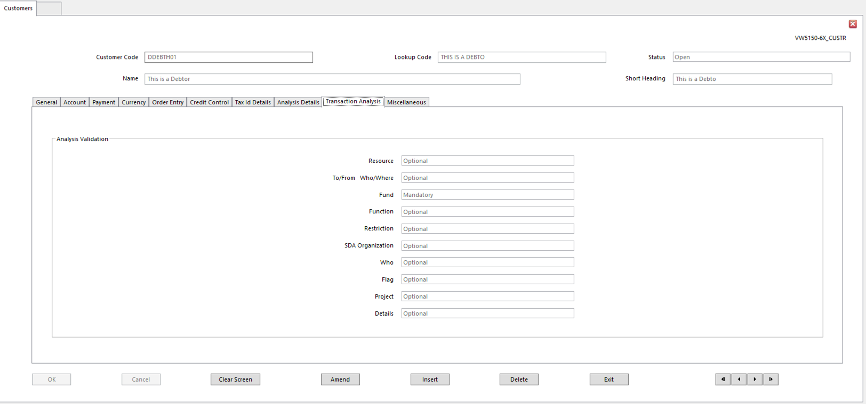
Use Transaction Analysis tab to set MOP settings for the associated Natural Code.

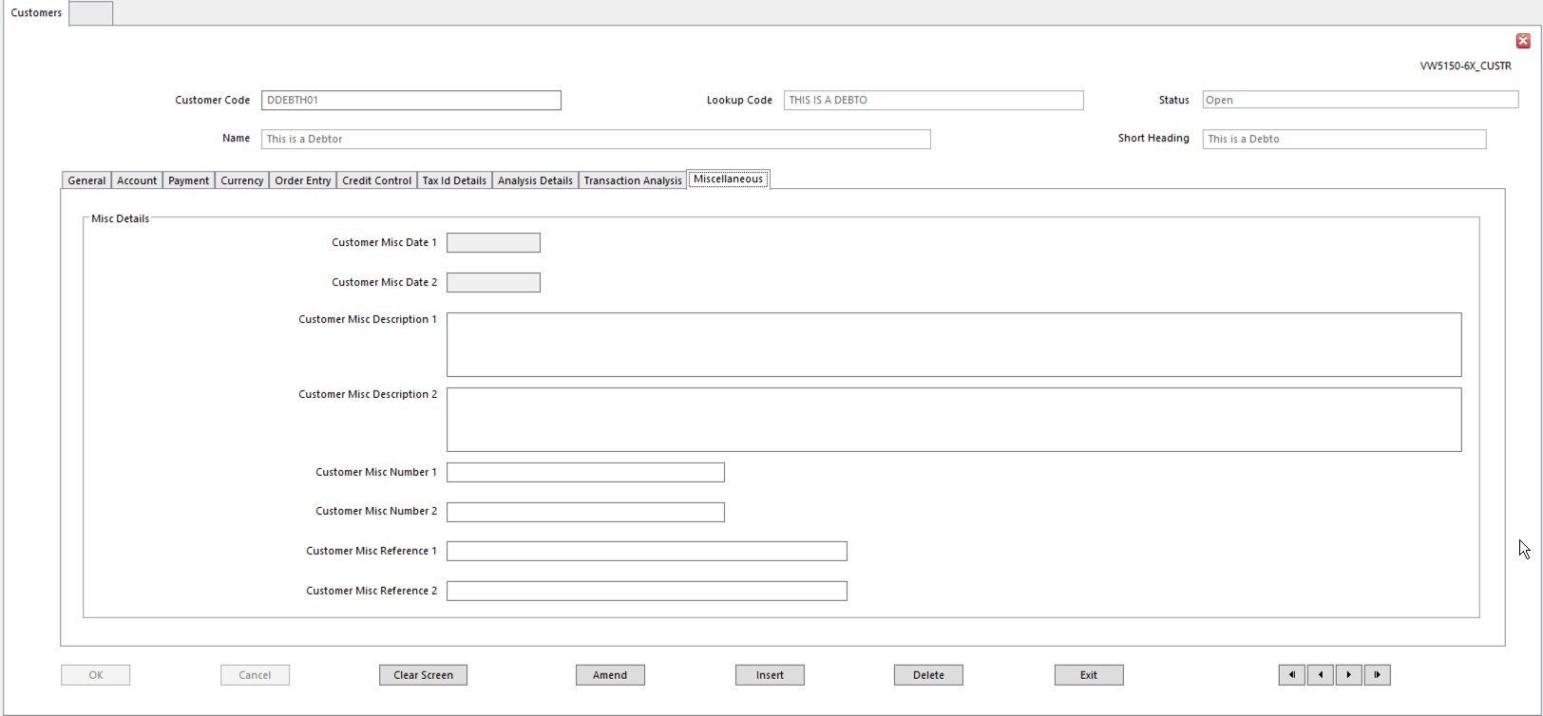
Use these fields to store Additional Data for the Customer.

Chart of Accounts – Receivable Accounts

In SunPlus, Natural Accounts are set up at the same time as Customer record.
Fill in Account fields in Customer Setup, and the Natural Account will be created.

Analyzing Customers, Accounts, and Transactions

Receivables can be analyzed in myriad ways with SunSystems. There can be:
- Up to 10 Customer Analysis Codes
- Up to 10 Natural Receivables Accounts Analysis Codes
- Up to 10 Transaction Analysis Codes

Managing Disputes with Clients

Customer accounts can be Closed or Suspended.

- Go to the Action menu on the Customer Setup screen

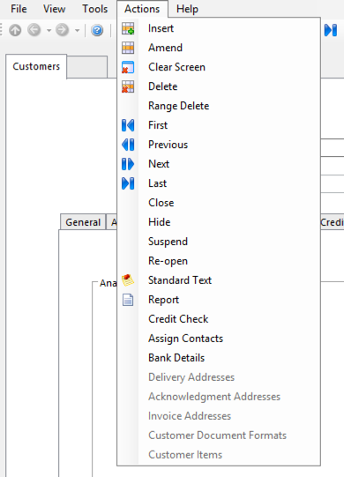
- Close Closed accounts cannot be posted to
- Suspended Suspended accounts can be posted to, but warnings will be displayed
- Hide Hidden accounts will not appear on Inquiries, but are available for
Input, Processing, or Reporting

Recording Transactions

Transactions can be posted to Receivables accounts using Ledger Entry, Ledger Import, or Order Fulfilment.

Receipt transactions can be created automatically by Payment Collection Run. Receipt transactions are generated, posted, and matched automatically.

Uncleared Transactions

Open Item transactions remain on an account until they have been completely paid and matched. This means Uncleared transactions remain on the Receivables statements for as long as necessary.

Matching Transactions

All transactions on Open Item Receivable accounts are held until they are cleared by a payment or a credit note.

A Receipt can be matched to an Invoice when the receipt is posted, using Online Allocation associated with Ledger Entry. Or use Account Allocation to match the Receipt to the transaction.

Using Account Allocation, mark transactions that have been paid for by Receipt. See Account Allocation for details.

Inquiring on Receivables

Use the Account Inquiry function to view details of a Receivables account.
All of account transactions can be displayed, or the search can be narrowed using selection criteria:
- Exclude or Include Allocated Transactions
- Select particular Allocation Markers
- Select range of Periods
- Display range of Journal Types
- Display range of Journal Sources (Operator Codes)
- Select transactions by Analysis Codes
- Display range of Currency Codes

Receivables Reports

SunPlus offers a full range of Receivables Reports.

Payment Collection Run

SunSystems can generate a bank payment file of debits to claim from Customers. This file has to be processed by a third-party software package before it can be sent to a bank clearing system.

Payment Collection Run uses Payment Profiles to determine currencies and transactions to be included in the run and any selection criteria applied to them. It assembles transactions that have reached or passed Due Dates.

Discounts can be given, specifically if payment is made by Direct Debit. Discount Percentages to be given to the Customer can be specified; also, whether the Payment must be immediately processed or when it will fall Due.

Payment Collection Run can also be used without producing a bank file. For instance, this might be used for claiming bills or exchange, or settling inter-company accounts.

Payment Profiles Setup

Use Payment Profiles Setup to define any number of Profiles. Each Profile can contain different selection criteria, including Account selection, Currency Codes, Due Dates, etc. Set up the Profile before running Payment Collection Run.

A different Profile will be used for each type of run. At least two Payment Profiles must be defined: one for Payment Runs and one for Payment Collection Runs.

Different profiles can be defined: for instance, to select transactions by currency or bank, or select groups of accounts.

A transaction has to meet all selection criteria in a Profile to be included in the Payment Collection Run.

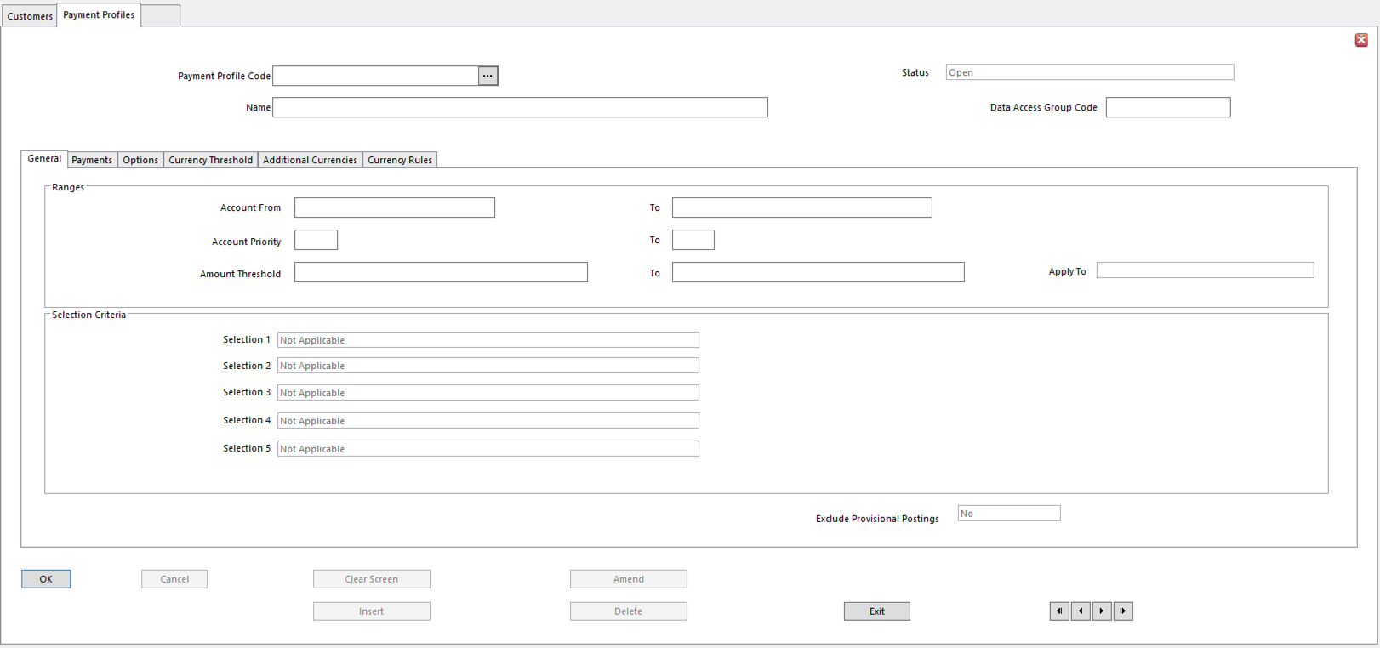
- Account Code From/To Range of accounts for which transactions are considered for Payment
Collection (Receivables or Client accounts)
- Account Priority From/To Range of Priority Rating Codes to include in Payment Collection
- Leave blank to ignore Priority Rating Codes
- Amount Threshold From/To Range of values to Include or Exclude transactions for Payment
Collection
- Can apply to an Account Balance or Transaction Amount, depending on choice set in Apply To field
- Ignore – Amount Threshold range not required (default)
- Balances –Amount Threshold applies to the account balance
- Transactions –Amount Threshold applies to individual account transactions
  - Only transactions falling within the range will be selected. All others will be ignored.
- Selection Criteria Run time selection criteria – can have up to 5
- Account Code
- Transaction Reference
- Journal Type
- Journal Source
- Payment Limit
- Allocation Marker
- Account Analysis Codes
- Ledger Transaction Analysis Codes
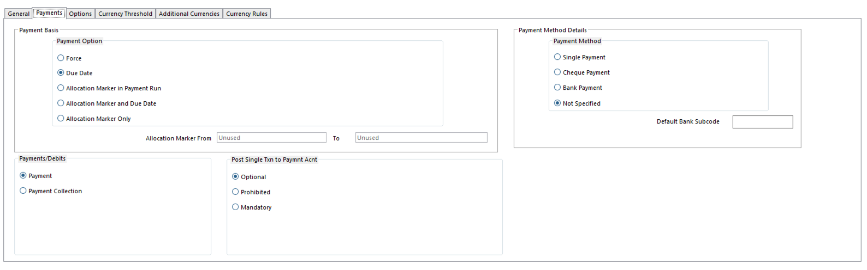
- Payment Option Determines basis on which transactions are selected for payment
- Force – selects transactions with Allocation Marker of Force
- Due Date – Due Date on or before Base Date for Payment entered at run time
    - Includes Allocation Marker of Force
    - Excludes Allocation Marker of Withhold
- Allocation Marker –choose Allocation Markers to include at run time
- Allocation Marker and Due Date – selects transactions according to range of Allocation Markers and Due Dates
- Allocation Marker Only –ignore Due Date
- Allocation Marker From/To If either Allocation Markers Only or Allocation Marker and Due
Date are chosen above, enter the range of Allocation Markers to use as selection criteria
- Use this to preset Allocation Markers if same range is required for every run
- Payments/Debits Determines if Payment Profile will be used for Payments or Payment
Collections
- Post Single Transaction to Payment Account Determines if a single, summarized ledger
transaction is posted to Payment or Collection account for Payment or Collection Run
- Mandatory – forces single transaction only to each payment account
- Prohibited – posts individual payment transactions to the payment accounts
- Optional – lets choice be made at run time
- Payment Method Determines the Payment Method for the Payment Profile
- Accounts can only be selected for payment with this Profile if they have this Payment Method selected
- Default Bank Subcode Bank Subcode for use with this Profile
- If blank and Payment Method is Bank, all Customers or Suppliers are selected
- To print Bank Details on Payment Remittances using Payment Documents, create all Bank Details with Subcodes
  - Bank Details without Subcodes are not printed

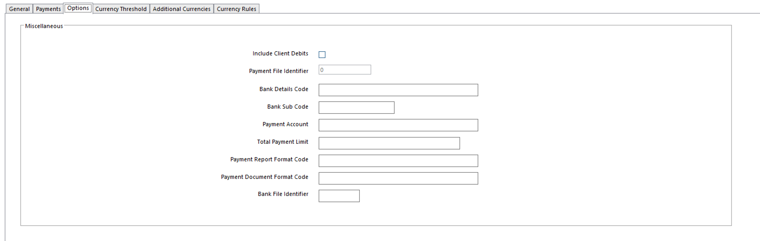
- Include Client Debits Relates only to Payment Run
- Client transactions with Debit balance are included
- Payment File Identifier Letter (A-Z) or number (0-9) identifying Payment file for Profile
- Each Payment file is overwritten when Payment Run or Payment Collection Run are run for the Profile
- Bank Details Code Bank Details Record.
  - When a Bank Details Code linked to one of the organization’s bank accounts is entered, the Payment Account field below displays relevant Chart of Accounts record for bank account
  - A Bank Details record is necessary for Bank Payment Method
- Bank Sub Code Subcode, if used, on Bank Details record identified above
- Leave blank if not needed
- Payment Account Bank Account to be used in Payment Run or Payment Collection Run
- Total Payment Limit Total payment amount for the Payment Run
- If this amount is exceeded, Payment Run is terminated and none of the accounts are paid
- Payment Report Format Code Document Format Code to use for Payment Run Details Report
  - This code is Mandatory
- Payment Document Format Code Document Format Code to use for Payment documents
- Bank File Identifier (Optional) Enter code to be used as default file extension to the bank
payment file that is created by Payment Run with this Profile
- Default set here is displayed the first time a user runs a payment with this Profile
- During Payment Run, user can accept or change the bank file identifier, and subsequent runs with this Profile use the bank file identifier specified in the previous run

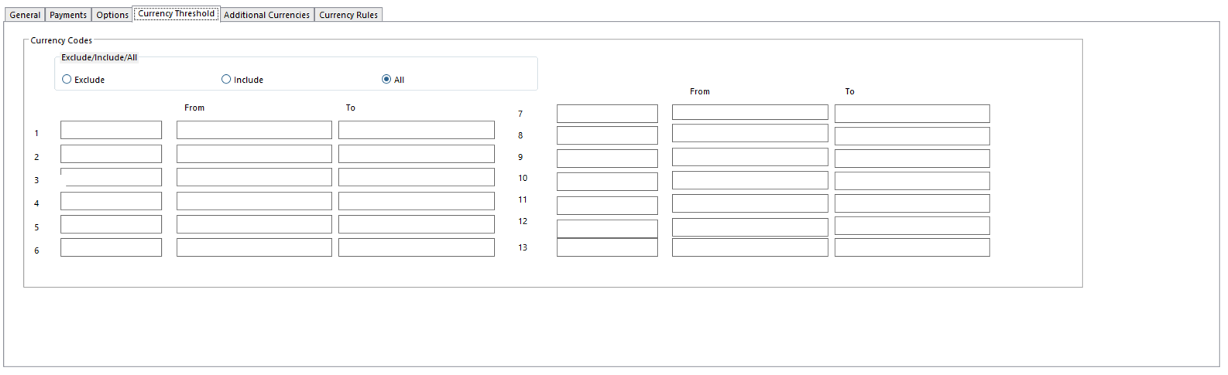
Currency for Payments option in Ledger Setup decides whether payments can be made in Transaction Currency or 4th Currency values. Selected currencies can be Included or Excluded from a Payment Run or Payment Collection Run. Even if payments can be produced only in Base Currency, selected transactions can be Included or Excluded from a Payment Run or a Payment Collection Run.
- Exclude/Include/All Indicates if selected Currency Codes will be included or excluded
- Exclude – excludes transactions using selected currencies
- Include – includes transactions using selected currencies
- All – all transaction currencies are considered for payment
    - Currencies Codes 1 – 13 Up to 13 currencies can be included or excluded
    - Currency From/To Enter range of amounts to be selected by the Profile for the Currency
- Limits amount range for currency as calculated from Base Currency
- Amount fields are ignored with Exclude setting

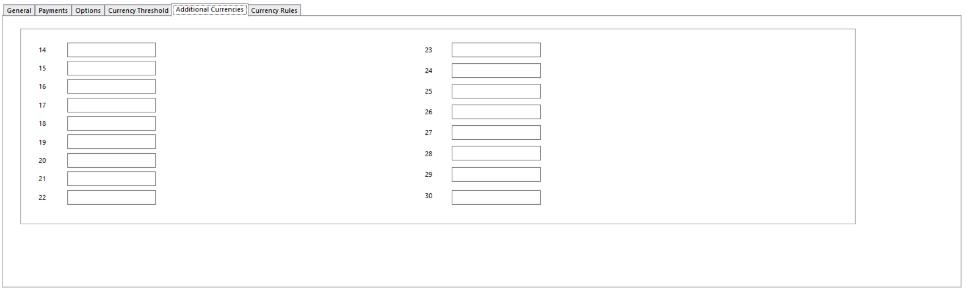
- Additional Currencies 14 – 30 Use this tab to Include or Exclude more than 13 currencies

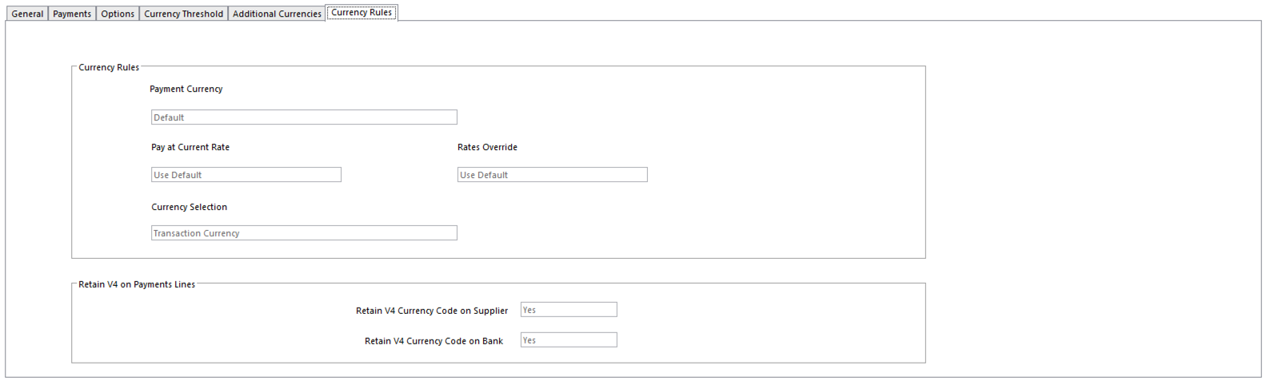
- Currency for Payments In a multi-currency organization, this setting indicates payment or
collection settlement by currencies other than Base Currency
- Options:
  - Base
  - Transaction
  - 4th
- Set to default to the default setting in Ledger Setup
- Whichever currency option is selected here, amounts for other currency values are calculated according to Pivot Currency option in Business Unit Setup; for Value 4, if necessary, from 4th Currency Calculate From option in Business Unit Setup
- Pay at Current Rate In multi-currency organizations, this determines basis for exchange
rates to be used for payments and collections.
- Yes - calculate different currency values during payments and collections using Current Exchange Rates
- No - use original exchange rates posted on the source transactions being paid or collected
- Default - use ledger’s default setting
- If Ledger Setup option – Pay at Current Rates – is No, Yes cannot be set here
- Rates Override Can derived currency exchange rates be overridden during Payment
Run and Payment Collection Run?
- Yes - display Currency Rates Override form during Payments and Collections
- No - If Rates Override option in Ledger Setup is set to No, Yes cannot be set on any Payment Profiles
- Currency Selection Determines if Profile currency selections refer to Transaction
Currency or 4th Currency
- Does not refer to Payment Currency
- Retain V4 Currency Code on Supplier Determines if Value 4 Currency Code is included on
payment transaction lines posted to Supplier account
- Retain V4 Currency Code on Bank Determines if Value 4 Currency Code is included on payment
transaction lines posted to the bank account

Payment Collection Run

Preparing for Payment Collection Run

      - Identify type of transactions to be selected for Payment or Collection
- For example,
  - All outstanding Invoices due for payment today
  - Only most critical Suppliers
  - Only Payments Due in a particular currency
      - Assign Payment Stamps if using payment stamps to group transactions
      - Identify Payment Profile
      - Preview Payments or Payment Collections to be sure the correct transactions will be paid or collected
- Preview: set Post Transactions to No on Payment Run or Payment Collection Run
  - Produces Payment Run Details Report listing transactions selected for inclusion
      - Include or Exclude transactions for Payment or Collection by altering selection criteria
        - Payment Run or Payment Collection Run will:
- Use selection criteria to assemble transactions due for Payment or Collection
- Produce Payment Collection Run Details Report listing or summarizing account transactions selected for Collection and showing total number and amount of Collections being generated
- Create Payment file containing all Payment Collection Details
    - Produces required Payment Documents supporting Payment Collections
- Generates/posts ledger transactions to record each Payment collected on Receivables or Client accounts, Settlement Discounts taken, and Tax Adjustments on the Discount
- Allocates Payments against the transactions collected using Allocation Marker Paid
    - Prevents reselection for collection and allows archiving
    - Allocation Reference, Period, Date are entered on both sets of transactions
- Optionally, produces Bank Transfer file, if Payment Method is Bank

Initiating a Payment Collection Run

- Select Payment Collection Run
- Select Payment Profile and click Enter
- Enter the following Payment Collection Run form details
  - Profile Run Time Selection Criteria
  - Ledger posting account details
- If Payment Method is Bank, Payment Collection Run Bank Transfer dialog will appear
  - Enter Bank Transfer File details
- From Action menu, select Amend Consolidation if payment should not be consolidated
  - Or if Analysis Codes should be entered against Payment transaction
- From Action menu, select Amend to alter Payment Collection Run selection details
- From Action menu, select Print to initiate Payment Collection process
  - Document Format Runtime Parameters form will be displayed, to allow control of the production of Payment Collection Run Details Report
- Enter required options and click OK
  - Payment Profile is checked for Currency Rules settings: the Collection may require conversion for one or more currency values
    - Depending on Override Rates option, Currency Rates Override form may be displayed, verify Exchange Rates for each currency; modify as required
    - Enter Realized Gains/Losses Account(s)
    - Click Print
- Payment Collection process will begin
  - Payment Collection Run Details Report is produced;
  - Postings are generated if Post Transactions option is Yes
  - Payment files are produced as appropriate
  - If Post Transactions is Yes and Payment Documents are required, Payment Documents form will be displayed
    - Use to produce physical payment documents, such as Remittances
Payment Collection Run Form

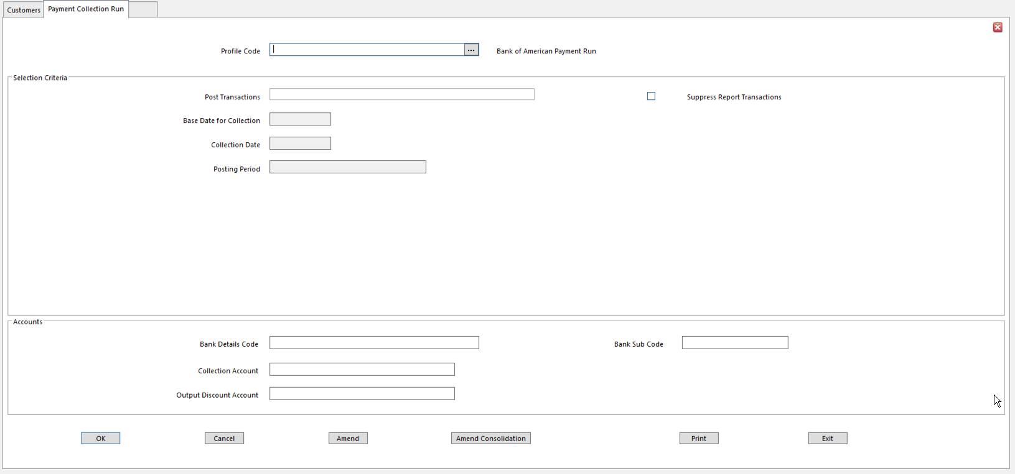
    - Profile Code
    - Post Transactions Yes – generate/post Payment Collection transactions, produce
Payments file, set Allocation Marker to Paid on selected transactions, produce Payment Run Details Report, and (optionally) produce Bank Transfer file
- No - produce Payment Run Details Report showing items selected for Collection
- Suppress Report Transactions Select to summarize transactions on Payment Run Details
Report
- If blank, Payment Run Details Report shows payment and discount allowed on individual transactions
- If chosen, Summary Report is produced showing total amount for collection from each account
- Base Date for Collection Transactions with Due Dates on or before this Date are included
- Collection Date Transaction Date for debit transactions generated during this Run
- Default is Today
- Posting Period Posting Period for transactions generated during this Run
- Default is Current Period
- Selections 1 – 5 From/To Up to 5 Run Time Selection Criteria may be displayed
- These are determined by Payment Profile
- Bank Details Code Bank Details code for organization’s own bank account
- Mandatory for collections with Bank Payment Method
    - Bank Subcode
    - Collection Account Chart of Accounts code for posting balancing bank transactions
- Normally this is a Bank Account
- Memo accounts cannot be selected
- Account can be set up on the Profile
- If collecting payments in more than one transaction currency, Collection Account identified for each currency is used
- If a collection account has not been defined for a currency, the account entered here is used
- Output Discount Account Chart of Accounts code for posting balancing transactions for
generated discount for credits
- Cannot be a Memo account

Reconciliations

Reconciliation Manager is used to automatically or manually Match and Reconcile transactions in the Ledger. Use Reconciliation Manager for:
- Bank Reconciliations
- Inter-company Reconciliations
- Debtor/Creditor Payment Matching

Reconciliation Manager uses predefined criteria to match and reconcile two sets of transactions. Transaction Sets are defined as separate reconciliation accounts. Selection and matching criteria are defined in a Reconciliation Profile.

Reconciliation Steps

- Define a Reconciliation Profile to identify a reconciliation requirement and determine the transaction selection criteria (1-time step)
- Define two Reconciliation Accounts to identify two sets of transactions to be Reconciled (1-time step)
- Run Reconciliation Manager using Reconciliation Profile to match and reconcile the transactions

Reconciliation Profiles

Reconciliation Profile identifies a reconciliation or matching requirement.

One scenario: to use Reconciliation Manager to Reconcile bank statements and also to match debtor receipts to invoices, define separate Reconciliation Profiles for each. The Reconciliation Profile determines the transaction selection criteria and the matching criteria for the reconciliation process.

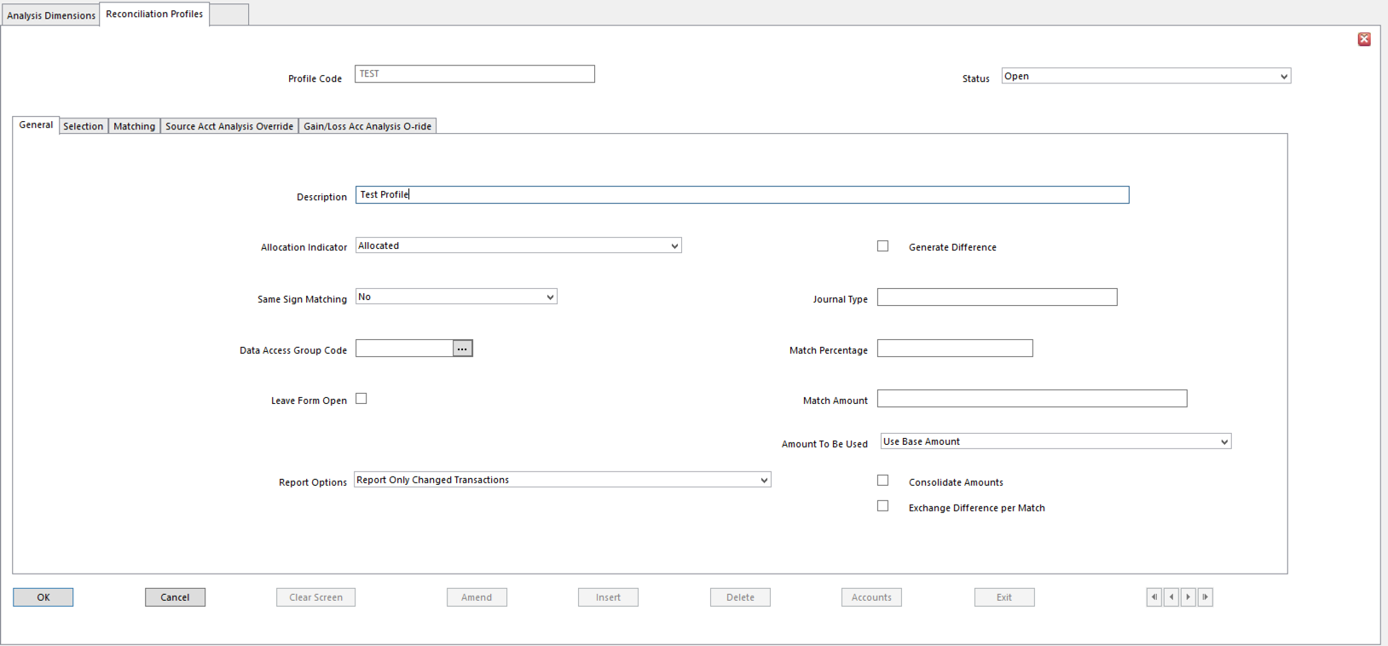
  - Profile Code
  - Status
  - Description
  - Allocation Indicator Choose Allocation Indicator to assign to reconciled transactions
- Options:
  - Allocated
  - Correction
  - Withheld
  - Forced
  - Reconciled
  - Not Allocated
  - Any numeric Marker 0 to 9
- For example, if Profile matches payment transactions against invoices on a debtor account, assign Allocated Marker
  - Profile matches bank account transactions to the bank statement details, assign Reconciled, etc.
- Allocated and Correction Markers can only be assigned when reconciling transactions on the same account with opposite signs
- Transactions marked Allocated, Reconciled, or Correction have to balance before the details can be posted
- Generate Difference Determines if Exchange Gain/Loss differences are calculated and
posted to Exchange Gain/Loss accounts
- Exchange Gain/Loss accounts are identified in Reconciliation Account details
- Same Sign Matching Determines how transaction sign is used to determine if transactions
reconcile
- Yes - match transactions with same sign
  - For instance, on Bank Reconciliations
- No - match transactions with opposite signs
  - For instance, to match payment and invoice on a debtor or creditor account
- Not Applicable - if transaction amount sign is irrelevant to the matching process
  - For instance, if transaction amount is not a matching criterion
- Journal Type Determines Journal Type assigned to journal transactions generated
when manually Reconciling transactions using this Reconciliation Profile

  - Data Access Group Code
  - Match Percentage Percentage Tolerance allowed between matching transaction values
- Transactions are matched if difference in transaction amounts is within the percentage
- If a percentage is entered, an amount field must be selected as one of the Matching Criteria
  - Leave Form Open Tick for Reconciliation Manager form to stay open when
Reconciliation process for Profile has been completed
  - Match Amount Tolerance amount allowed between matching transaction values
- Transactions are matched if difference in transaction amounts is equal to, or less than, this amount
- If an amount is entered here, an amount field must be selected as a Matching Criteria
- Match Percentage and Match Amount are ignored if Consolidate Amounts option is set
- Amount to be Used Determines currency in which Reconciliation Totals are displayed at
top of the Reconciliation Manager form
- This is currency in which reconciled values must balance before posting
- Whatever is entered here updates the Match Criteria, as detailed in the matching section below
- Regardless of Currency Value used for determining the match, Base Currency amounts are always balanced
- Value 4 amounts are balanced according to Currency Amount Balancing settings in Business Unit Setup
- Resulting differences are generated according to settings on Reconciliation Account records
- Currency differences are never generated into Transaction Currency
- Each transaction can hold a different Value 2 currency

NOTE Generation of balancing entries is only applicable to Allocations or Corrections, not to Reconciliations.

- Report Options Determines whether a report will be generated, and if so, what
transactional details are included in the report
- No Report
- Report Only Changed Transactions
- Report all Transactions
- Consolidate Amounts Determines if Auto Reconcile consolidates values of matching transactions, for example, to match several smaller value transactions against a single large value transaction. Amount field is automatically selected as a Matching Criteria
- Exchange Difference per Match Determines if Exchange Differences are calculated by
Reconciliation Manager for each match found within Matching Criteria
- If set, system calculates Exchange Difference for each set of matching transactions and copies analysis from the transaction with the lowest Base value in the matched pair of transactions
- Where duplicate transactions are found, they are omitted from the matching process.
- If not set, system consolidates all Gains/Losses and posts the balance to Gain/Loss and Source accounts
- This option can only be used if Generate Difference is selected, and it can only be used when matching credit transactions against debit (or vice versa) within the same account of the same Business Unit
- When selected, Exchange Differences are only generated when Auto-Reconcile is selected in Reconciliation Manager

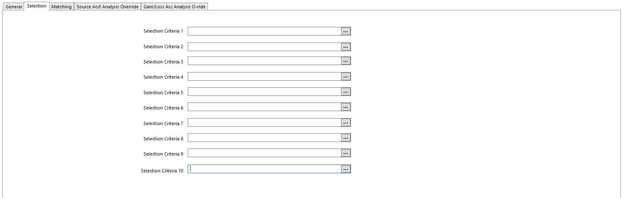
- Choose up to 10 Selection Criteria
  - Transactions must meet all selection criteria before being considered for Reconciliation
  - Select any of the following:
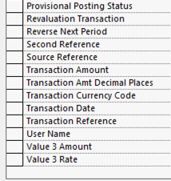
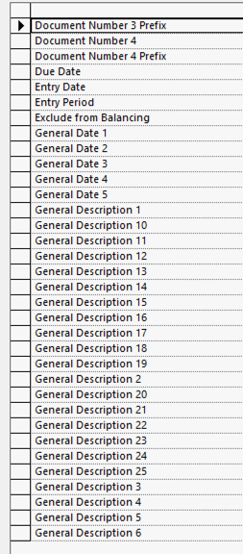
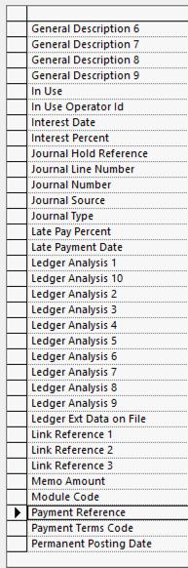
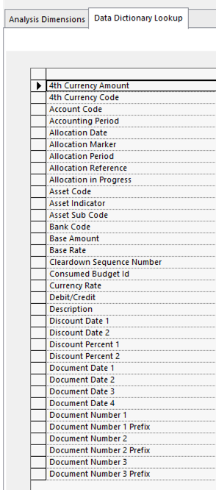

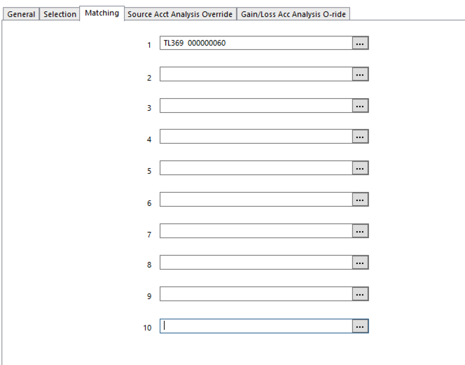
- Use fields on Matching Tab to identify data items that must match on selected transactions for them to be Reconciled by the automatic Reconciliation process.
  - For example, you might want to match transactions on Transaction Reference, Amount, and Ledger Transaction Analysis Code 1
  - During automatic Reconciliation, transactions extracted for Reconciliation Accounts are searched for transactions containing the same data in the Matching Criteria fields
  - These transactions are Matched and Reconciled

Source Account Analysis Override

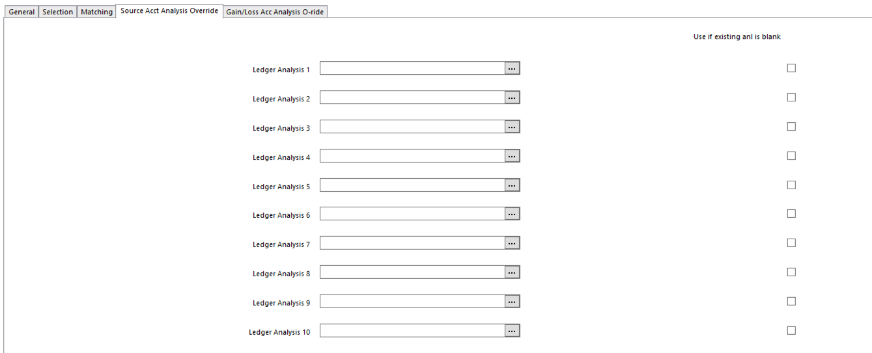
- Transaction Analysis Code Overrides only apply if Exchange Difference per Match option is
selected, and only apply to Auto-Reconcile processing.
        - Settings on this tab override default Transaction Analysis Codes that apply if Exchange Difference transactions (per match) are generated for Reconciliation Profile
- Analysis Code Overrides defined here apply to Exchange Difference transactions that post to
Source account
- Default Analysis Codes for Exchange Difference Source Transaction are taken from transaction
in the matched set containing the lowest Base Currency Value
- Ledger Analysis 1 to 10 Select Analysis Code to be used if default Analysis Code is not
provided on Source transaction
        - Leave blank to use default code
        - Enter “-“ (hyphen) to remove any default code and leave the Analysis Code blank on Exchange Difference transactions
- Use if existing anl is blank Check if Analysis Code is only to be used when Analysis Dimension is
blank on Source transaction

Gain/Loss Account Analysis Override

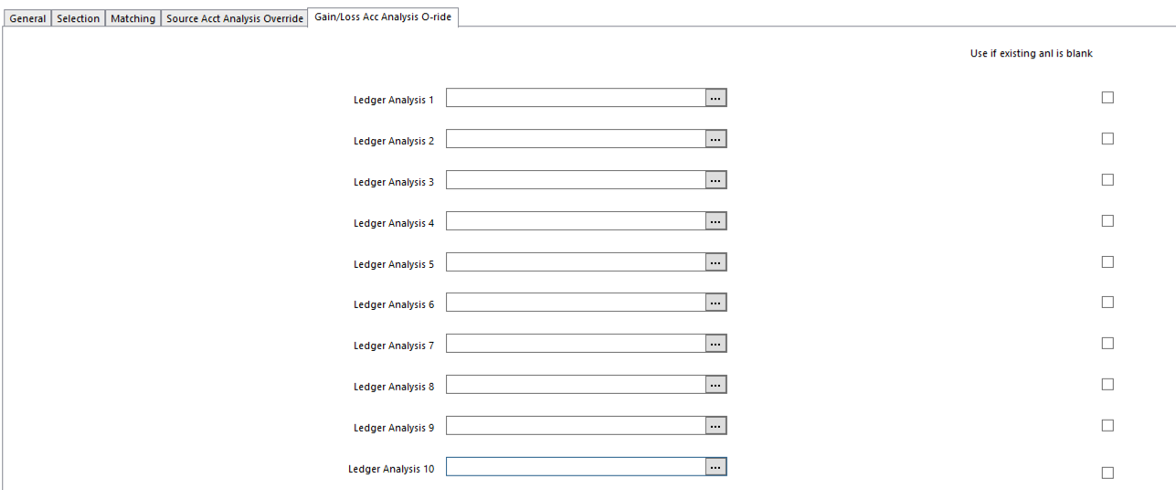
These Transaction Analysis Code Overrides only apply when Exchange Difference per Match option is selected, and only apply to Auto-Reconcile processing.

Values on this tab are used to override default Transaction Analysis Codes applying if Exchange Difference Transactions (per match) are generated for Reconciliation Profile. Analysis Code Overrides defined here apply to Exchange Difference Transactions that post to Gain/Loss account.

Default Analysis Codes for Exchange Difference Gain/Loss transaction are taken from the transaction in the matched set that contains the lowest Base Currency value.
- Ledger Analysis 1 to 10 Select Analysis Code to use if default Analysis Code is not provided on
Source transaction
- Leave blank to use the default code
- Enter “-“ (hyphen) to remove any default code and leave the Analysis Code blank on Exchange Difference transactions
- Use if existing anl is blank Check if Analysis Code will be used when Analysis Dimension is blank
Source transaction

Reconciliation Accounts

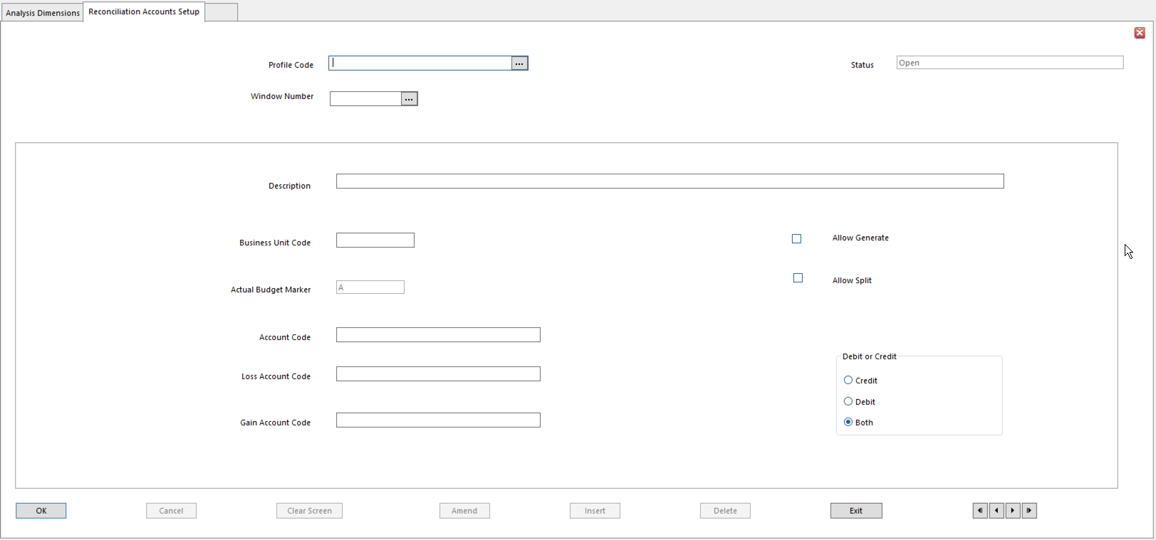
Reconciliation Accounts function is used to identify a set of transactions to be reconciled in Reconciliation Manager. Two Reconciliation Accounts must be defined for a Reconciliation Profile. For example, if the Reconciliation Profile will be used to reconcile bank account transactions against the bank statement, two reconciliation accounts would be required as follows:

- One to retrieve the transactions posted to the bank account
- Another to retrieve bank statement transactions (must be loaded into SunSystems)

TIP Bank statement transactions are typically posted to Budget Ledger as budget transactions to the bank account.

The two sets of transactions are displayed in the top and bottom sections of the Reconciliation Manager window. For each Reconciliation Account, you must determine whether the transactions appear in the top r bottom part of the window.

- Profile Code
- Window Number Section of Reconciliation Manager where transactions are displayed
- Window Number 1 - Top part of the form
- Window Number 2 - Bottom part of the form
- Description
- Business Unit Code Business Unit for the transactions
  - Useful for inter-company Reconciliation
- Allow Generate Setting decides if journal transactions are generated as part of
Reconciliation process
- For example, can Exchange Gain/Loss postings be generated automatically?
- Actual Budget Marker Ledger from which account transactions are extracted
- Allow Split Determines if a transaction can be split
  - For instance, to Allocate only part of a transaction’s value, Split the transaction
- Account Code Account Code from which transactions are extracted
  - Leave blank to select Account at run time
- Loss Account Code Account where Exchange Losses, or Net Gains/Losses, are posted
  - Only required if Generate Difference option is set in the Reconciliation Profile
  - If Use Transaction Amount option is set in Reconciliation Profile, the Transaction Currency Amount is used as the matching amount and the system generates Gain/Loss transactions to balance Base Currency Amounts, if necessary
- Gain Account Code Account where Exchange Gains are posted
- Only required if Generate Difference option is set in Reconciliation Profile
- If Use Transaction Amount option is set in Reconciliation Profile, the Transaction Currency Amount is used as the matching amount and the system generates Gain/Loss transactions to balance Base Currency Amounts, if necessary.
- Exchange Gain/Loss Post Rule setting in Ledger Setup determines the use of this account
- If Exchange Gain/Loss Post Rule is set to Gains only, or Separate Gains and Losses, any Gains are posted to this account
- Debit or Credit or Both Use to restrict, if necessary, transactions selected to either debit or
credit transactions only, or both
- For example, if matching transactions for a debtor account, you might want to display the debit transactions in the top window and the credit transactions in the bottom window

Reports

Reports in SunSystems can be run in several ways:
- Report Shortcut menu item or favorite menu
- Action menu of a system form
- SunSystems process, for example, Payment Run
- Report Manager by selecting a report in the Store

Regardless of how the report is run, the type of output can be chosen:
- View
- Print
- Store
- Or any combination of the three

View
- If the View option is chosen, the report is immediately displayed online
  - In a separate browser window
  - Can be Printed

Print
- If Print is chosen, the report is immediately printed and then deleted from the system

Store
- If Store is chosen, the report can be viewed or printed at any time, using Report Manager
- Stored report is saved as an output file set in the report parameters
- Reports can be Stored instead of, or in addition to, Viewed or Printed

Report Parameters

Report parameters may need to be entered in the Parameter Editor or the Document Format form, or both. This depends on settings built into the specific report.

Entering Document Format Run Time Report Parameters

Document Format Runtime Parameters is used to enter parameters for a report to be produced when it is requested by another SunSystems form. This happens in two cases:
- When the report is automatically produced by a function
- When the report is requested from within a SunSystems function by selecting Report on the Action menu

NOTE A Document Format must have been defined using Document Formats Setup for the report to be produced.

Action Menu

Many SunSystems functions include a Report action. Use this to produce a report from inside the function, without having to select it from a menu.

This is particularly good for static data functions. Immediately after data has been updated, the static data report can be printed.

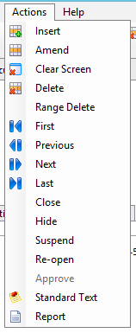
- Go to Action menu on the toolbar
- Select Report
- Enter general report parameters

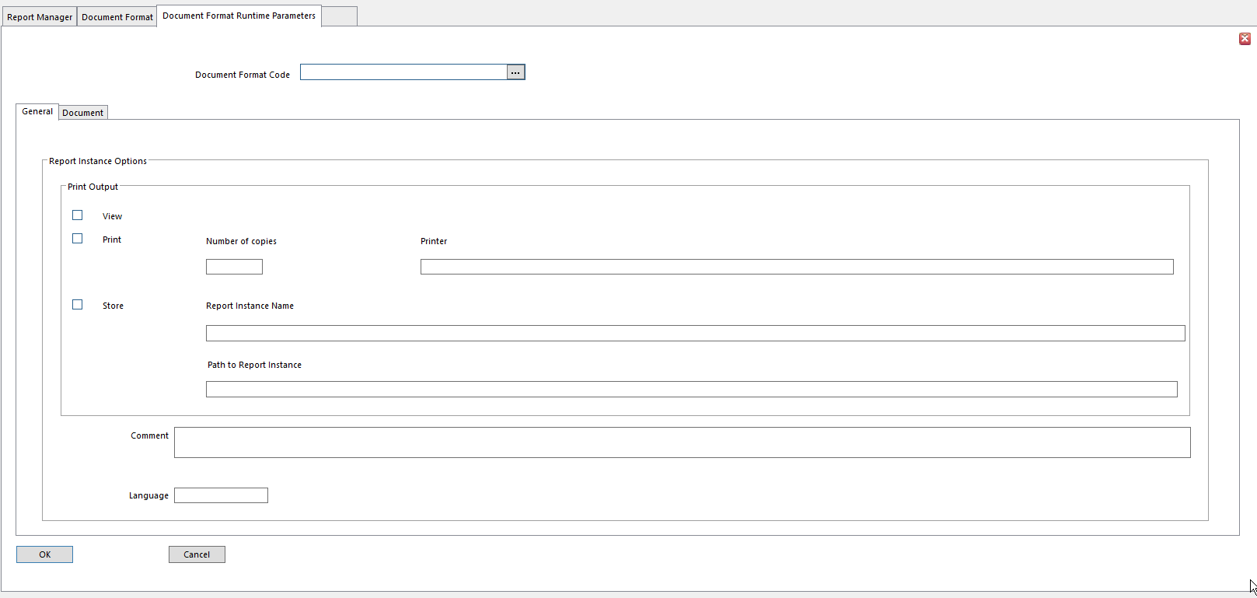
- Click Assist button at the right of Document Format Code field

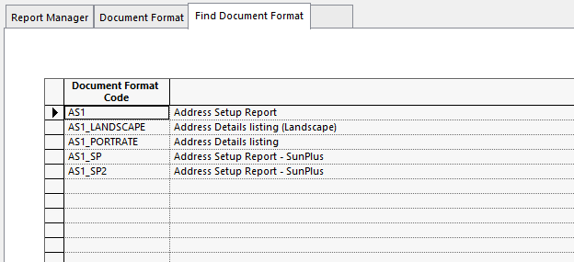
- Select the report from the list

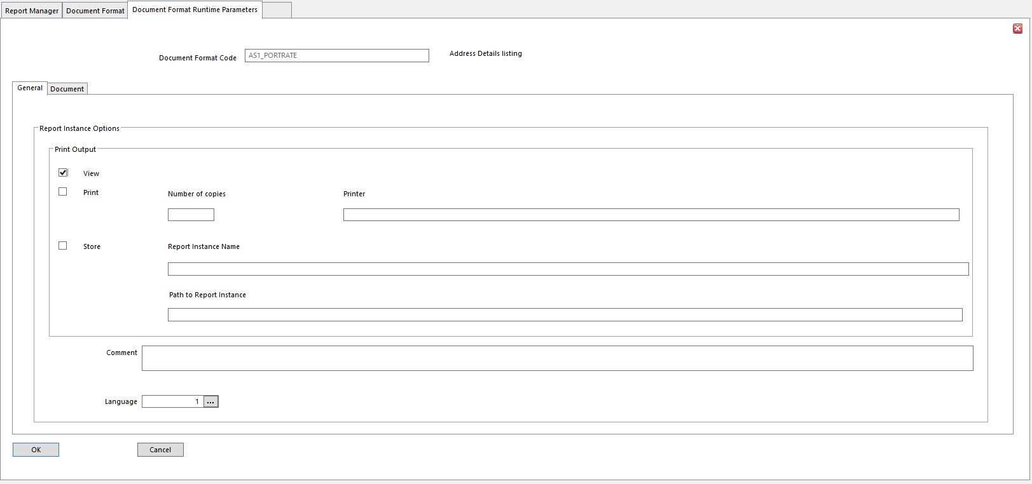
- Document Format Code Document Format for chosen report
  - Id’s report and defines many of the report’s parameters
- General Tab Default settings can be overridden
- View Display the report online
- Print Print the report
- Number of Copies Number of copies to be printed
- Printer Enter path and name of printer for this report
- Store Save the report in a file
- Report Instance Name Name of file to be produced for storage
- Path of Report Instance Path to report instance entered in Report Instance Name above
  - Default is My Reports/Output folder in Report Manager
- Comment Comment relating to report
        - For example, printing instructions
        - Printed on front page of report
- Language Language in which document or report will be produced
- Document Tab Information only applies if Document Format is being used for
documents that require special stationery, draft, final prints or copies
- Print Type Type of report to be produced
  - Initial Print
  - Supplementary Print
  - Reprint
- Print Options
  - Final Print [Initial or Supplementary Print]
    - Determines if this is the final printing of the report
  - Previously printed lines [Supplementary only]
    - Supplementary Print Type determines if lines printed on previous versions of report should be included in this report
    - If not set, only additional print lines that were not included on previous versions are printed
    - Only used for Order Fulfilment.
    - For ledger-based documents, all previously printed lines for selection criteria are reprinted, regardless of the setting of the Previously Printed Lines Print Option
  - Mark as copy [Reprint only]
    - If Print Type is Reprint, this option indicates that this report is a reprint of a previous print
    - This is particularly important when reprinting documents such as invoices
- Print Test Page Set to print a test page prior to the actual print
        - A test page contains all report headings and prints ‘XXX’ in place of report values
        - It allows review of the format of the report that would be produced, without actually running the report
        - Useful if printing onto preprinted stationery and need to ensure the paper is aligned correctly, or are unsure of the information that appears on the report
- Document Date Date to appear on printed documents
- Click OK

Enter Parameters Using Parameter Editor

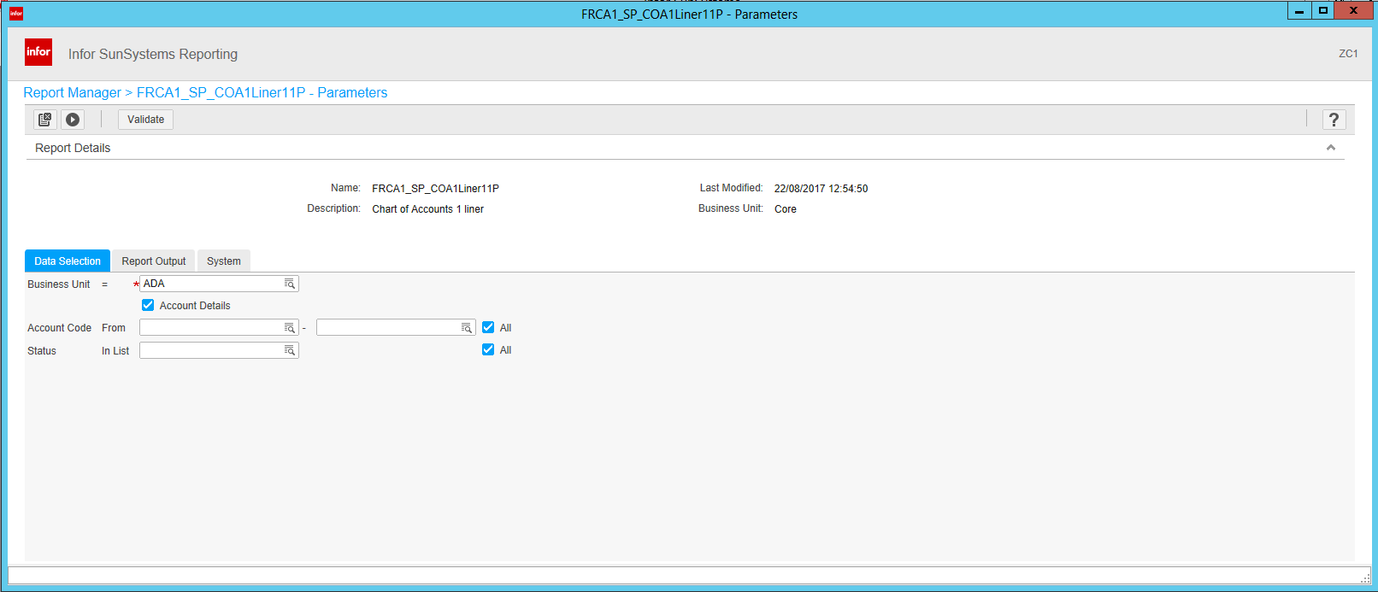
- Use Parameter Editor to establish parameters required for the report

Report Manager

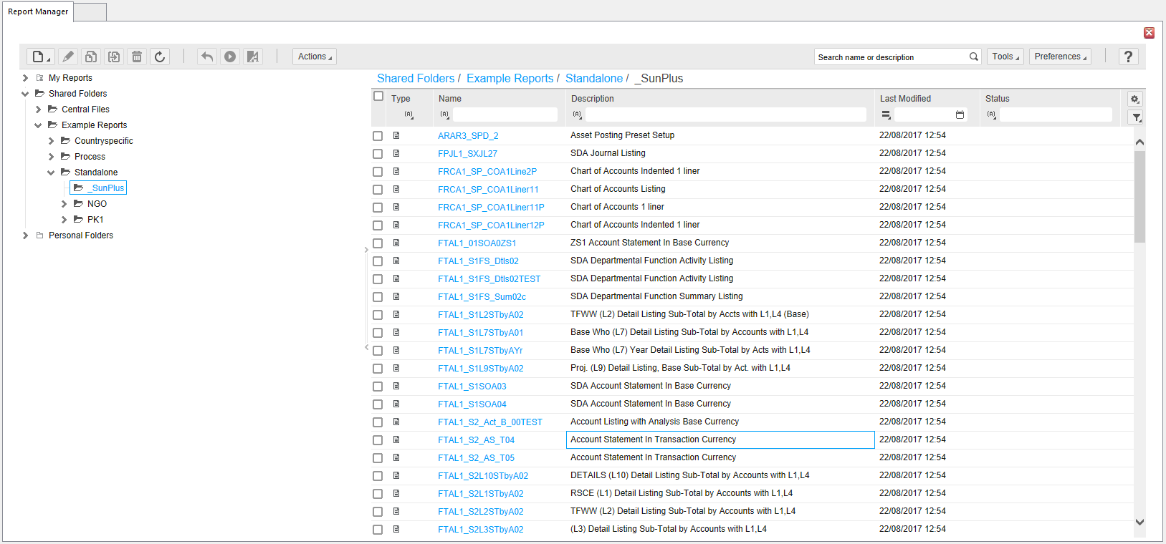
- Report Manager window is split into three parts:
- Report Folders Pane at the left of the screen
  - Contains folders and folder structure of report store
- My Report Pane at the right of the screen
  - Shows list of reports and details of currently selected folder
- Toolbar

Using Report Manager to View a Report
- Locate stored report to retrieve
- Click on link to open it
  - Default output location is My Reports/Output folder, but another output location may be set in Report Output parameters when the report is run
- Click on Report Output tab of Parameter Editor
- Change options as required
- Select required format for report from dropdown list
  - For example, report can be produced as a web page or as a spreadsheet
- Click Run to run report
  - A message is displayed informing you the report is being generated

Viewing Report Output
- After report has been generated, report results are displayed
- To produce the report as a web page, the Reporting page is displayed, containing:
  - Navigation arrows to move through the report pages
  - Percentage to zoom in and out of the report
  - Find and Next fields to search for a word or words
  - Export drop down box to export the data in the report to a file
  - Refresh to update the data in the report
  - Help to display the Help file
- To re-deploy report, simply refresh output window using Refresh button from toolbar

Using Report Manager to Retrieve a Stored Report

- Access Report Manager
- Locate the stored report
  - Eeport will be displayed in Report Manager

Report Manager Toolbar

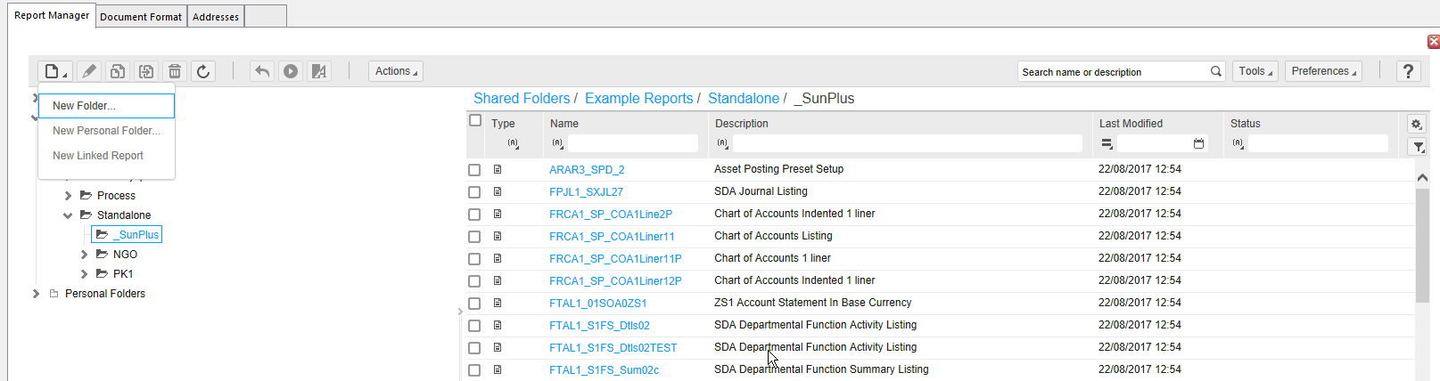

- use to set up a New Folder, New Personal Folder, or New Linked Report

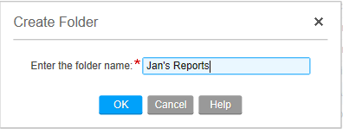
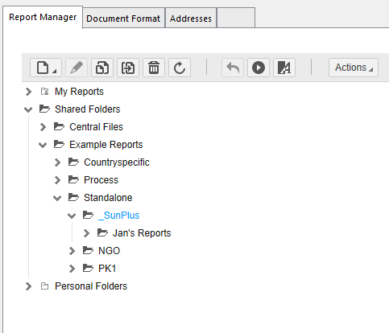

use to copy a report into a personal or group folder
- Select report to be copied by ticking check box at left of report title

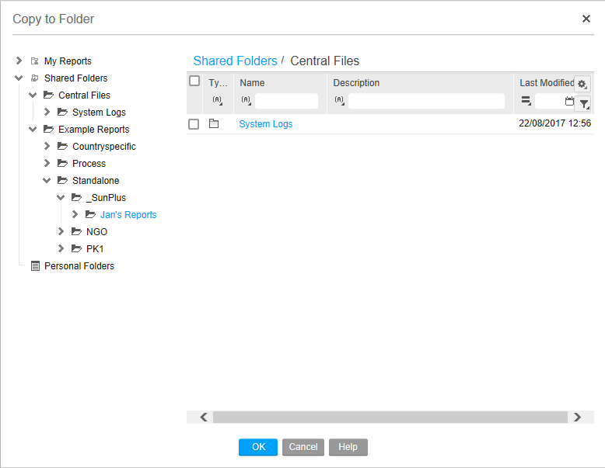
- Select folder to which report will be copied
- Click OK
use to move selected report into selected folder
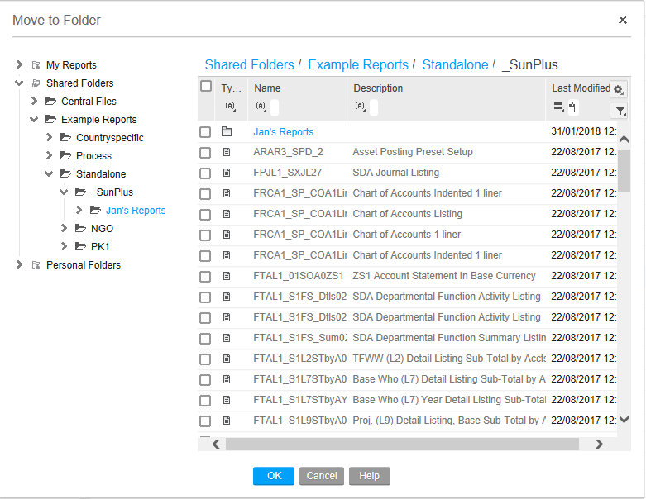

use to Delete a report

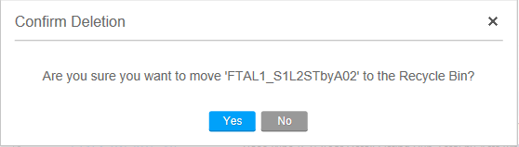

use to Refresh a report to redeploy
use to Run the selected report
rename link for a selected report

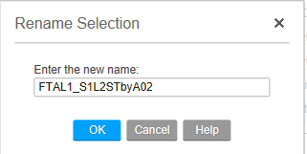

use to Import and Export reports from Report Manager
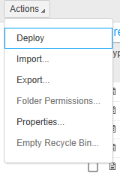
search for report by entering any string of characters from the report’s title
use to configure outputs
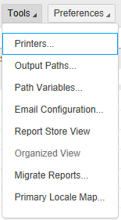

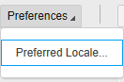

- use to customize – a little – the presentation of reports in the main report window

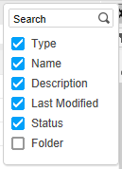

- filters

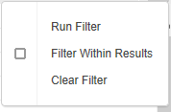

Monthly SunPlus Tasks

Change Period

Take care when using Change Period in a multi-user environment. Users who are logged in while period is changed may or may not be affected by the change as follows:
- Users that have a Ledger Entry session form open, that Ledger Entry session is not affected as long as the same opened Ledger Entry session form is used.
  - Those users are still posting to the Original Period
- If another Ledger Entry session form is opened after the period is changed, a transaction posted in this new Ledger Entry session will be in the New Period
  - A message will be displayed notifying the user that the period has changed since they last used Ledger Entry
Before changing to a new period, it is standard practice to print audit trail reports, such as Account Listing, Journal Listing, and Trial Balance.

There are two ways to change the current Accounting Period in SunSystems:
- Change Period
- Ledger Setup

Change Period

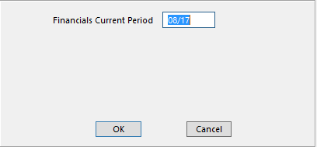

- Type in the new period
- Click OK

Ledger Setup

- Go to Ledger Setup
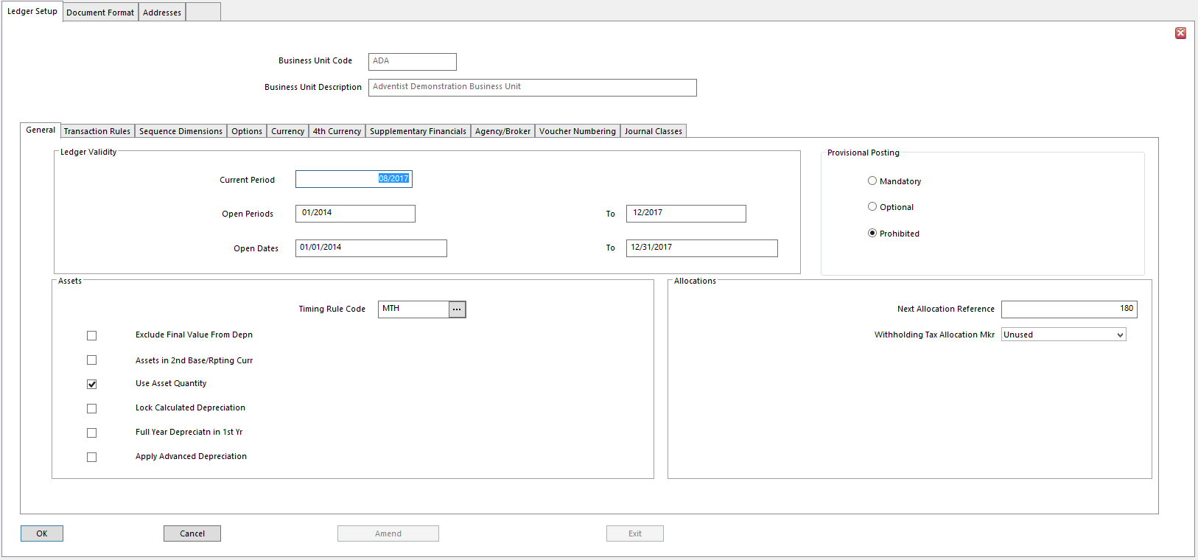

- Click Amend
- Enter the new Current Period
- Click OK

Open Dates

- To change Open Dates for Business Unit, go to Ledger Setup

- Click Amend
- Enter the new range of Open Dates
- Click OK

Post Exchange Rates
For multi-currency organizations, post current Exchange Rates once a month.

If the organization has only a couple of currencies, use Currency Period Rates to set up the new exchange rates. If the organization uses a number of currencies, set up a Ledger Import template and upload the rates in one upload.

Currency Period Rates

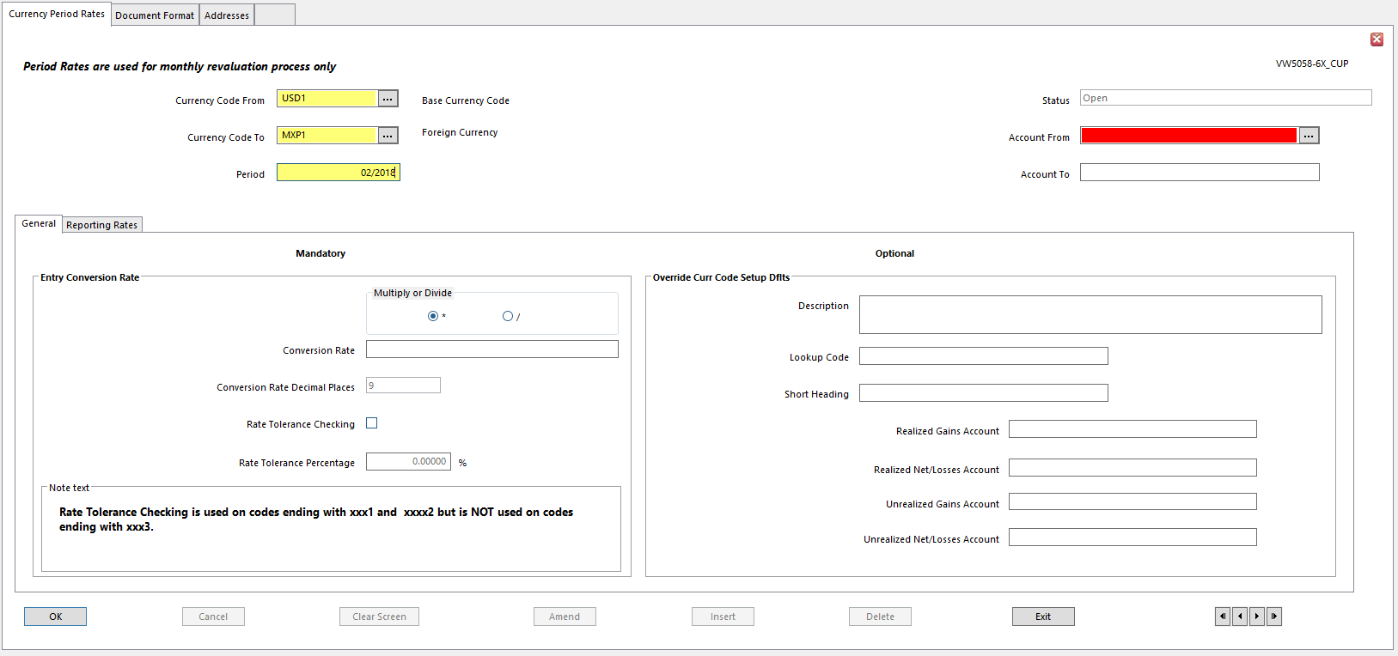

- Currency Code From Code of currency to convert from – always BASE
- Currency Code To Code of currency to convert to – the foreign currency
- Account From / To Enter Account Code or range of Account Codes where Period Rate
applies
- Leave blank for all
- Period Accounting Period to which rate applies
- Leave blank for all
- Multiply or Divide Choose to multiply or divide From Currency Amount by Period Rate
to determine To Currency Amount
- Conversion Rate Currency Conversion Rate for the Period
- Conversion Rate Decimal Places Number of decimal places used in currency conversion
Calculation
- Conversion Rate is rounded to this number of decimal places before it is used in calculation
- Rate Tolerance Checking If chosen, a tolerance check is performed on any rates entered or rates
calculated by system
- Stops unrealistic rates being entered and used by mistake
- Rate Tolerance Percentage If tolerance checking is required, this is the maximum tolerance
allowed for the Period Rate
- Description Currency Name associated with this Currency Period Rate
- Realized Gains Account Account where any Realized Gains calculated using this Currency
Period Rate are posted
- Realized Net/Losses Account Account to which Net Realized Amounts, or Realized Losses,
calculated using this Period Rate are posted
- Unrealized Gains Account Account to which any Unrealized Gains calculated using this Period
Currency Rate are posted
- Unrealized Net/Losses Account Account to which any Net Unrealized Amounts, or Unrealized
Losses, calculated using this Period Currency Rate is posted
- Conversion Rates 2 – 6 Alternative Currency Rates used to revalue or consolidate accounts in
financial reports

Ledger Revaluation (Multi-Currency sites only)

Ledger Revaluation revalues one currency against another currency on a group of transactions. For the revalued currency, it calculates the difference between the original and revalued amount on each transaction. This revaluation difference may be:
- An Unrealized Currency Gain/Loss resulting from a fluctuation in Exchange Rate, or
- A Balancing Adjustment reflecting a rounding difference

Ledger Revaluation can post revaluation transactions to the ledger to reflect the difference in accounts, or simply report on the differences.

Transactions to be included in a Revaluation can be identified precisely by specifying the selection criteria in Ledger Revaluation Profiles.

Ledger Revaluation Profiles

The Source and Target Currencies must be specified in a Revaluation Profile. The currencies chosen for a Revaluation Profile depend on Revaluation requirements, and on Pivot Currency. This in turn determines the content of any generated Revaluation Postings. The Pivot Currency must be either Source or Target of a Profile.
- Source Currency Revaluation Source Currency can be – Base, Transaction, or 4th
  - Currency value on each transaction that is used as basis of Revaluation
  - These values are not updated.
  - Revaluation postings never adjust the Source value
- Target Currency Target Currency can be Base or 4th
        - Transaction Currency cannot be selected as Target, as these currency values are assumed to be real rather than calculated values, and therefore should not be changed

Ledger Revaluation Profiles are used to define selection criteria for transactions that must be revalued. Any number of Profiles can be created for different types of currency transactions and different combinations of currency transactions.

Ledger Revaluation revalues selected currency transactions using Exchange Rates for the periods from the Revaluation Period to, and including, the Current Period.
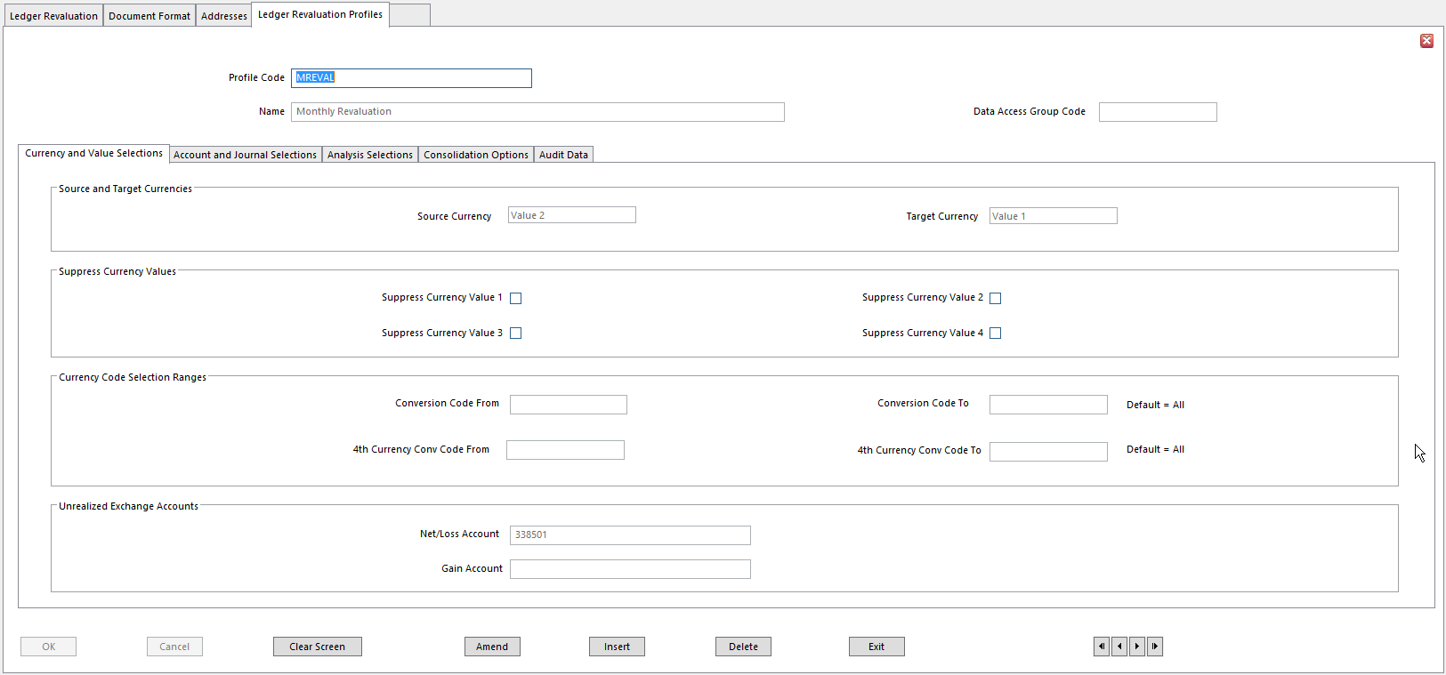
- Profile Code
- Name
- Source Currency Transaction value to be revalued
- This value will not be updated on revalued transactions
- Options:
  - Value 1 use Base values as the basis for Revaluation
  - Value 2 use Transaction values as basis for Revaluation
  - Value 4 use 4th currency values as the basis
- Target Currency Target value for Revaluation
- Value will be recalculated from Source transaction value
        - Options:
          - Value 1 – Base
          - Value 4 – 4th
        - Transaction Currency values cannot be recalculated
        - Target and Source Currencies must be different
- Suppress Currency Value 1 – 4 Check for a currency value to Exclude it from Revaluations using
this Profile
        - Suppressed value is written as zero in Revaluation transactions
        - Source Currency Code is retained for each transaction, unless it is consolidated for the currency value, using the relevant currency option on the Consolidation Options tab
- Conversion Code From / To Range of Value 2 Currency Codes required in Revaluations using
this Profile
        - Leave blank to include all Currency Codes
- 4th Currency Conversion Code From / To Range of Value 4 Currency Codes required in
revaluations using this Profile
        - Leave blank to include all Currency Codes
- Unrealized Exchange – Net/Loss Account Account to post Losses resulting from Revaluations
using this Profile, or Net Gains/Losses
- Unrealized Exchange – Gain Account Account for posting Unrealized Gains resulting from revaluations using this Profile
        - Only requirement is Gains/Losses must be posted separately

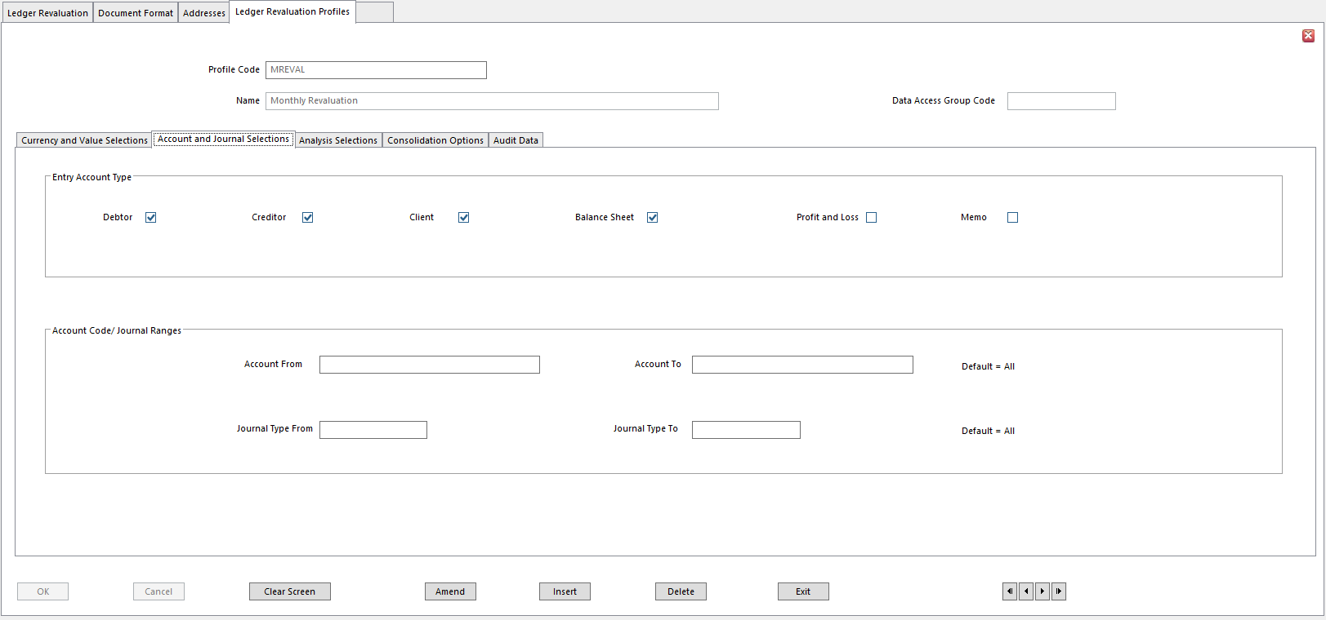
- Account Types Types of account for which transactions are revalued
        - If an account type is not chosen, accounts of this type are excluded from this Revaluation Run
        - P&L Accounts must be processed separately from other account types
        - Suppress Revaluation field in Chart of Accounts overrides selections made here
- Account Code From/To Range of Account Codes to be revalued
        - Leave blank for all
- Journal Type From/To Range of Journal Types to be revalued
        - Leave blank for all

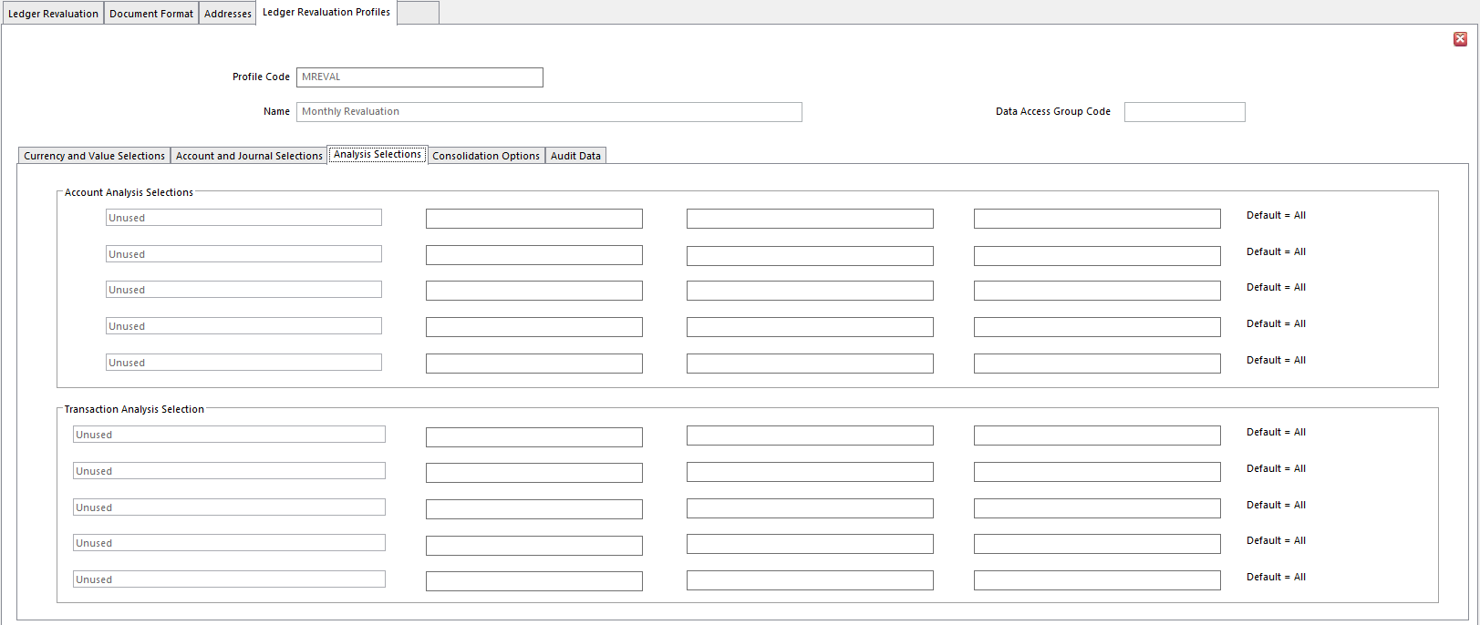
- Account Analysis Selections Select up to 5 Analysis Dimensions, then the range of Analysis
Codes for each, for which accounts defined with those Analysis Codes are to be included in Revaluations using this Profile
- Transaction Analysis Selection Select up to 5 Analysis Dimensions, then the range of Analysis
Codes for each, for which transactions posted with those Analysis Codes are to be included in Revaluations using this Profile

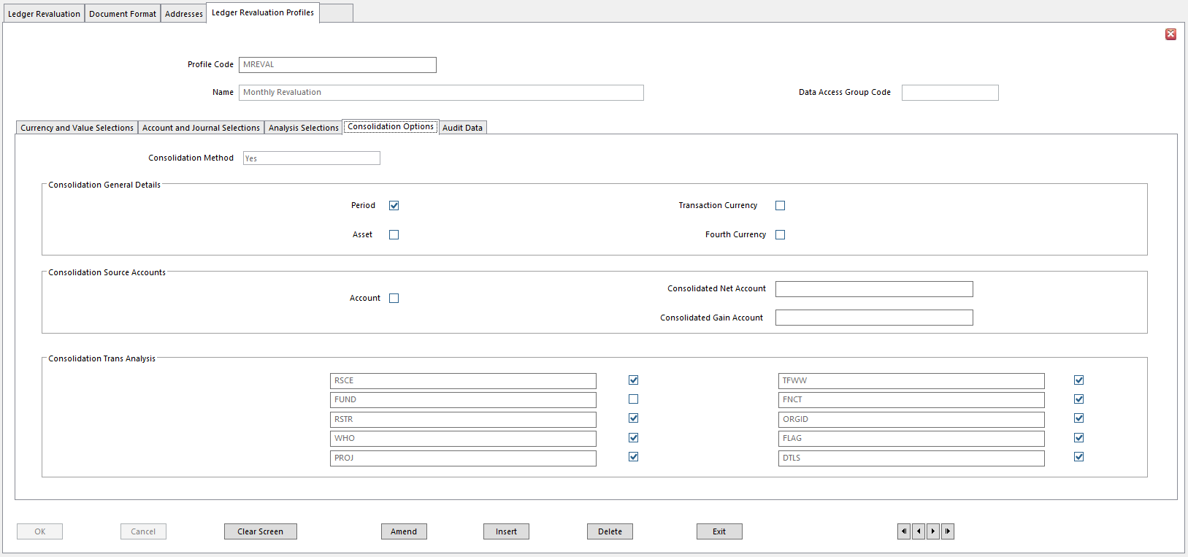
- Consolidation Method Determines level at which Revaluation posting is made
        - Options
          - Yes - consolidates Revaluation transactions according to options set on this tab
          - No – generates/posts transactions at lowest level of detail
          - One to One - generates separate Revaluation posting for each account and allocates the same Revaluation Link Reference to Source posting and the new Revaluation difference posting
NOTE It is strongly recommended that you always use the same Consolidate option for Revaluations on a ledger.

- Period Determines if transactions for each account selected for Revaluation
are consolidated by Accounting Period, prior to Revaluation
        - P&L Accounts cannot use this option
        - Check to Consolidate transactions by Period
        - Leave unchecked to revalue transactions for each Period individually
- Asset Determines if transactions selected for Revaluation are Consolidated
by Asset Code prior to Revaluation
        - Check to Consolidate transactions by Asset
        - Leave unchecked to revalue transactions individually for each Asset
- Transaction Currency Determines if transactions selected for Revaluation are Consolidated
by Value 2 prior to the Revaluation
        - Value 2 is written as zero in the Revaluation transactions
        - Check to Consolidate transactions by Transaction Currency
        - Leave unchecked to revalue the transactions individually for each Value 2 Currency
- 4th Currency Determines if transactions selected for Revaluation are Consolidated
by Value 4 Currency Code prior to Revaluation
        - Check to consolidate transactions by 4th currency
        - Leave unchecked to revalue transactions individually for each Value 4 Currency
- Account Determines if transactions selected for Revaluation are Consolidated \
by Account prior to Revaluation
        - Select Yes to consolidate transactions by account
        - Select No to revalue transactions for each account individually
- Consolidated Net Account This field is displayed depending on Exchange Gain/Loss Post Rule
set for the ledger in Ledger Setup
        - Enter account where Consolidated Net Gains/Losses are posted
          - Required if transactions are consolidated across several accounts, so Gain/Loss adjustments cannot be posted to original transaction accounts
- Consolidated Loss Account This field is displayed depending on Exchange Gain/Loss Post Rule
set for the ledger in Ledger Setup
        - Enter account to which consolidated losses are posted
          - Required if transactions are consolidated across several accounts, so Gain/Loss adjustments cannot be posted to original transaction accounts
- Consolidated Gain Account This field is displayed depending on Exchange Gain/Loss Post Rule
set for the ledger in Ledger Setup
        - Enter account to which consolidated Gains will be posted
          - Required if transactions are consolidated across accounts, so Gain/Loss adjustments cannot be posted to original transaction accounts
- Consolidation Transaction Analysis Dimensions 1 to 10 For each Analysis Dimension assigned
to ledger transactions, determine if transactions selected for revaluation are consolidated for the Analysis Dimension, within the account, prior to Revaluation
        - Check the check box to consolidate transactions that reference a selected dimension, within each account
        - Leave unchecked to generate separate revaluation postings for each Analysis Code, for dimension

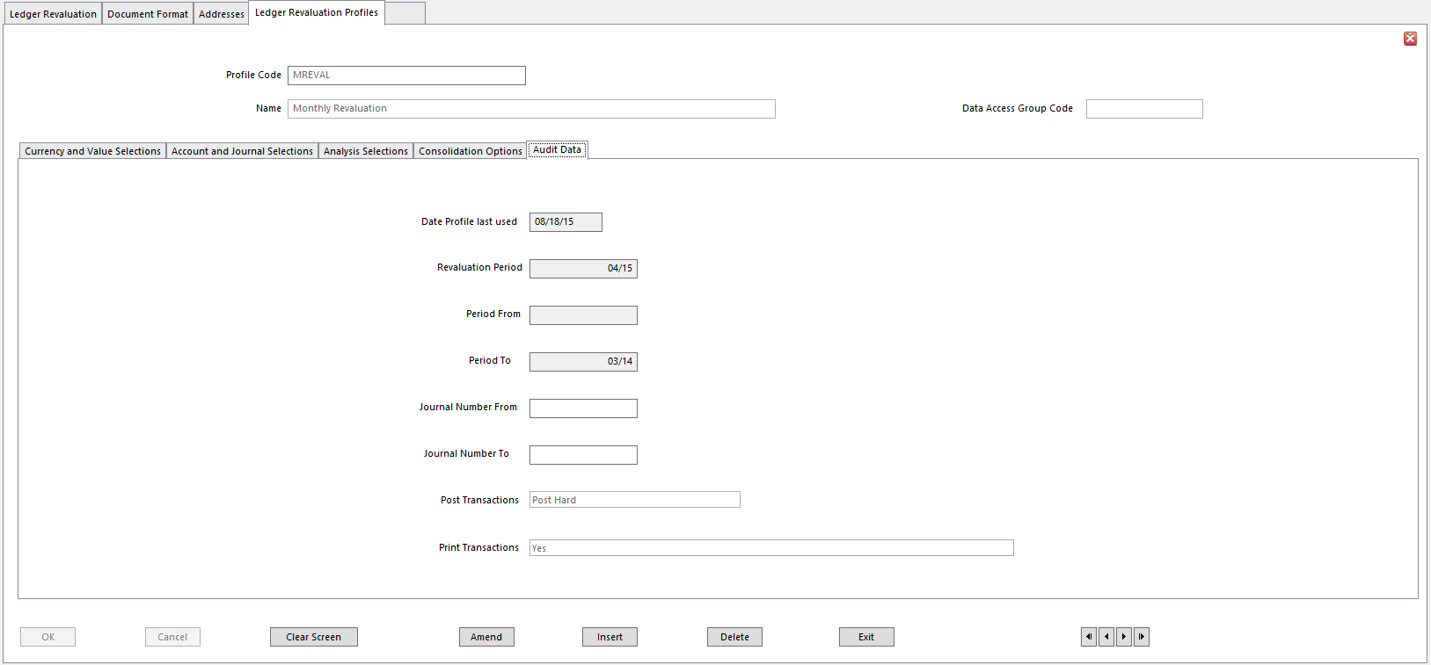

- The values displayed in the fields on this tab are for audit purposes and cannot be modified
- Date Profile last used date when a Ledger Revaluation using this profile was run last
- Revaluation Period the accounting period when this profile was last used for revaluation
- Period From / To the range of periods selected in Ledger Revaluation at last run with this profile
- Journal Number From / To range of journal numbers selected when this profile was last run
- Post Transactions refers to last run
- Print Transactions displays Yes if individual revaluation transactions were included in revaluation report when profile was last used

Ledger Revaluation

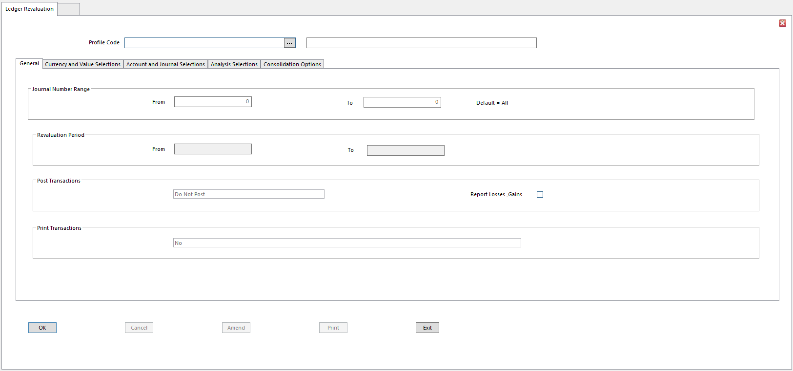
- Profile Code Select a Profile for current Revaluation
- When Profile has been selected, runtime options, such as Journal Number Range and Revaluation Period, are displayed on General tab of Ledger Revaluation form
- All other selection criteria defined in Profile are displayed in other tabs and cannot be modified within Ledger Revaluation
- Journal Number Range Range of Journal Numbers to be revalued
- Leave blank to select all
- Revaluation Period Range of Periods for which transactions are to be revalued
- To revalue Profit & Loss accounts, enter a range of Periods
- To revalue any other type of account, enter a single Period
- Post Transactions Determines if Revaluation transactions are posted to the ledger
        - Select Post Hard to post revaluations
        - Select Post Provisional if ledger is set for Provisional Posting
        - Select Do Not Post to only report Revaluations
- Report Losses and Gains This option is only displayed if Post Transactions is set to Do Not Post
and if Exchange Gain/Loss Post Rule is set to Gains Only, or Losses Only, on Options tab of Ledger Setup
- Select to allow consolidation to both Gains/Losses accounts, thus overriding the setting of Exchange Gain/Loss Post Rule set for the ledger
- Leave unchecked to follow Exchange Gain/Loss Post Rule for the ledger and use a Gains account only or a Losses account only for Consolidation
- Print Transactions Select Yes to print all transactions
- Select NO to print only transactions for which a Revaluation Gain/Loss was calculated
All other tabs contain Display Only values.

Ledger Cleardown

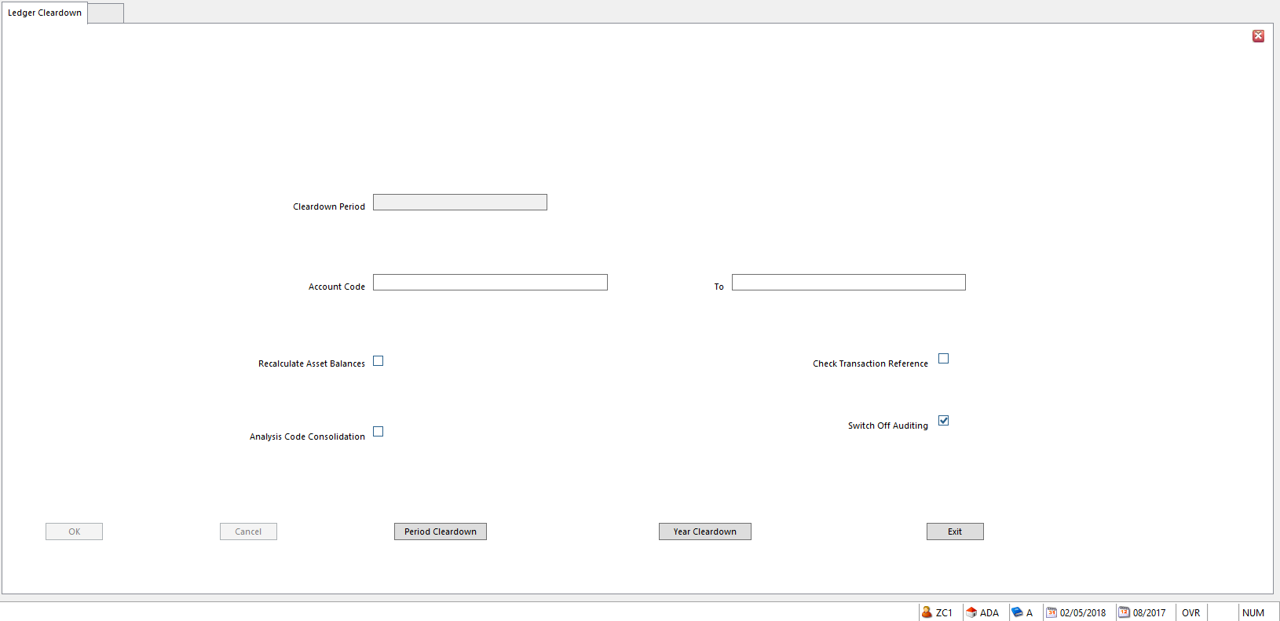
Ledger Cleardown removes historical or redundant transactions from Business Unit ledger and replaces them with summarized balance transactions. Ledger Cleardown is optional; however, it should be considered, as it leaves a more compact, easily managed system.

Ledger Cleardown compresses the ledger. Individual transactions are removed and summarized, or balance transactions are kept for reporting purposes. Transactions for an account code are summarized by Period, Analysis Code, Currency Code, and other details. There are two Cleardown options:
- Period Cleardown – accumulates transactions on Period by Period basis
- Year Cleardown – summarizes transactions for the financial year; posts balances to the final Period of the year

Ledger Cleardown can use transactions posted to Assets to recalculate Asset’s Gross, Net, and Depreciation values.

NOTE Year Cleardown clears all accounts, whether Open Item or Balance Forward.

Transactions are only summarized if they have been posted to an Accounting Period that is equal to or prior to the Period or Year chosen for cleardown.

NOTE When Ledger Cleardown is run on a Budget Ledger, budget transactions are always deleted rather than archived. In a Year Cleardown, all budget transactions up to, and including, the specified year are cleared. Summary balances are posted in the last period of the specified year for each account and analysis code combination.

Archiving Transactions

Ledger Setup gives you the option of removing cleared transactions to an archive file rather than deleting them during Ledger Cleardown.

Running Ledger Cleardown

Before running Ledger Cleardown:
- Post all audit trail reports
  - Including Journal Listings and Account Listings
- Log all operators out of the system
- Back up Business Unit

To Run Ledger Cleardown

- Go to Action menu
- Select Period, or click Period Cleardown button
Or
  - Select Year, or click Year Cleardown button
- Enter Ledger Cleardown Period or Year and Account range
- Click OK
  - If Analysis Code Consolidation option has been set, Analysis Code Consolidation window will be displayed
- Identify each Analysis Dimension to be consolidated
- Enter range of Analysis Codes for each Dimension
- Click OK
  - A Cleardown? Warning message will be displayed
- Click Yes to initiate Ledger Cleardown
  - Click NO to cancel Ledger Cleardown
  - The process identifies each account as it is cleared down

Fields on Ledger Cleardown Screen

- Cleardown Period Period or Year to be cleared down
- Period Cleardown - enter the last period to be cleared down in the format ppp/yyyy
    - Current Period cannot be Cleared Down
  - Year-end Cleardown - enter the year to be cleared down in format yyyy
    - You will be warned if you select the prior year, since you might need those figures to be shown on reports
- Account Code From/To Default is all Account Codes
- If you don’t want to select all, enter Account Code or range of Accounts Codes
- Recalculate Asset Balances To Recalculate Asset Register, select this option to recalculate the
Gross, Accumulated Depreciation and Net Values for assets in the Fixed Asset Register, from the asset related ledger transactions.
- Analysis Code Consolidation Select to Consolidate some, or all, Analysis Codes on cleared
transactions
- Check Transaction Reference Select to Cleardown all transactions with the same Transaction
Reference at the same time.
- This means transactions referencing a particular Transaction Reference will only be cleared down when all of these transactions are able to be cleared down.
- Switch Off Auditing If Data Audit is used, the Ledger Cleardown process may be
significantly slower depending on tables for which Data Audit is switched on.
- To temporarily switch off Data Audit in order to speed Cleardown, select this option so that no audit details are recorded during the Cleardown
- After Cleardown, auditing is automatically switched on again for the tables as configured in Data Audit Configuration
- Analysis Code Consolidation If the Analysis Code Consolidation option is chosen, the Analysis
Code Consolidation dialog appears
- Select Analysis Dimensions to consolidate into balance transactions, and the range of codes to be consolidated for each Dimension
- If Consolidation is NOT applied, Analysis Codes referenced on transactions are left intact and summary balance transactions are produced for each combination of Analysis Codes, for each account and period and other factors.
- Analysis Dimensions Analysis Dimensions assigned to ledger transactions are listed.
      - Choose the Type of analysis that is to be consolidated
- Consolidate Select an Analysis Dimension to consolidate transactions
- From/To Range of Analysis Codes to be consolidated for Analysis Dimension
- Leave blank to consolidate all Analysis Codes for the Dimension

Difference Between Period and Year End Cleardown

In a Year End Cleardown, rather than creating summary transactions per period, summary transactions are produced for the last period of the Cleardown year. All balance transactions for each period of the year are rolled forward into a single set of balances. This includes balance transactions for previous years, not just for the year being cleared. These balances are the closing balances for the year being cleared down and become the opening balances for the following year.

Although it might seem like a good idea to run a Year Cleardown at the end of the last period of the year, consider retaining detailed transactions of certain accounts to run comparative reports with during the following year. In this case, Year Cleardown should be run one year behind.

Function Funding

If Functions need to be funded, run a preliminary Function Statement.

Find the amount spent.

Transfer monies to fund it.

Works in Progress

In Fund Accounting, sometimes Resources that have been set aside for financing a project, such as a construction project, are recorded in Operating Fund (10), and sometimes they are recorded in the Plant Fund (20). Knowing where Allocated Resources are recorded will ease the complication and confusion of accounting for Works in Progress.

The Fund Dimension Code (Operating or Plant) in which the Allocated Resources are recorded is also the Fund Dimension Code where the actual cash/bank backup for Allocated Resources should be recorded.

Fund Accounting allows AFC Allocated Fund Capital to be recorded in the Operating Fund as long as the related fund backup is also recorded in the Operating Fund.

Work In Progress can also be recorded in the Operating Fund as long as the Allocated Fund financing the project as well as the Cash/Bank backup of the Allocated Fund are also in the Operating Fund.

If Work in Progress is accumulated in the Operating Fund, at the end of each fiscal year, it must be moved to Plant Fund.

Work in Progress transactions can be recorded either in the Operating or in the Plant Fund. The determining factor for recording Work in Progress transactions is the location of the cash/bank and the allocated fund set aside to finance the project.

Work in Progress transactions should always be recorded in the same Fund as the cash/bank and Allocated Fund to finance the project. It is illogical to record Work in Progress transactions in the Plant Fund when the cash/bank and the Allocated Fund that is set aside for the project is recorded in the Operating Fund.

Basic Principles
- Project’s Cash & Investments and related Net Assets’ Allocated Function must be in same Fund
- Funds can be either the Operating Fund or in Plant Fund
- During the year record the Work in Progress in the same Fund that has the underlying Cash & Investments. This eliminates the need for complicated inter-fund transfers during the year.
- If construction is completed at year end, the Work in Progress needs to be eliminated and the building recorded
- If construction is not completed by year end, the ongoing Work in Progress account must be in Plant Fund at end of the year.
  - If Work in Progress is recorded in Operating Fund, it must be transferred to Plant Fund
  - If during the year, the Cash, the Allocated Net Assets, and Work in Progress are kept in Plant Fund, nothing needs to be moved at year end.

Year-End Tasks

- Print all Audit Reports for each Period
- File Audit Reports for each Period
- Transfer the Year-end Profit to Balance Sheet
  - Print Trial Balance
  - Reconcile and confirm the Prior Year Net Profit/Loss
  - Use a profit and loss account: Prior Year Profit/Loss
  - Balance Sheet Account – Retained Earning
  - Print a Trial Balance for the first period in the new year and note the amount called Prior Year’s Net Profit/Loss
  - If Trial Balance shows profit, use Ledger Entry to debit the Profit and Loss account and credit the Balance Sheet account with the amount
    - For Loss, Reverse the signs
  - Post journal to the last period of the prior year

The SunPlus year-end close process does not require traditional closing entries where the income and expense accounts are to close the “net activity for the year” or income and expense summary to the Fund Balance.

Security

Menu Groups

Add Function to Menu

Adding or removing a function to/from a user’s menu is a two-step process:
- Attach the Function in User Manager
- Synchronize the changes in User Group Menu Designer

User Manager

- Go to User Manager

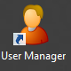

- Access the Group tab

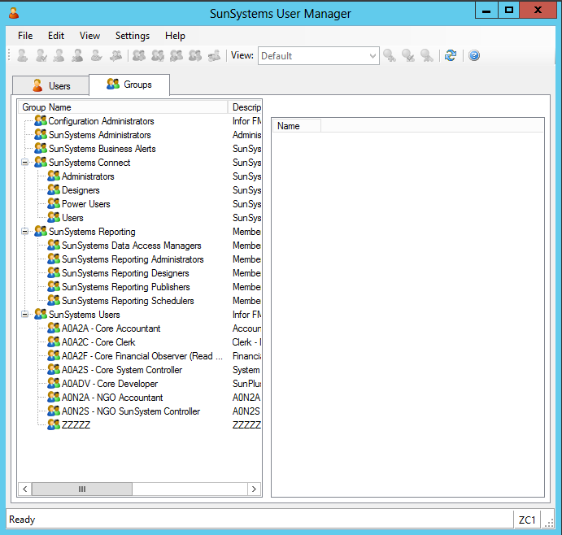
- Click on the Users Group to Amend

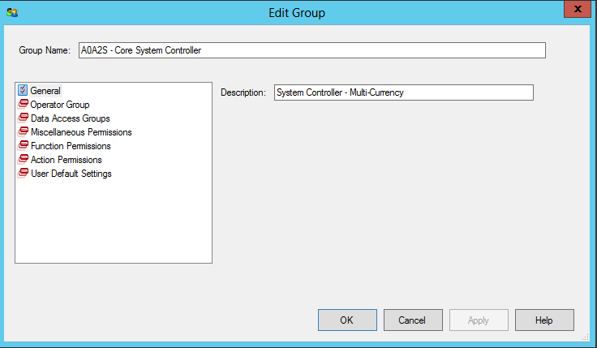
- Click on Function Permissions in the pane on the lower left of the interface
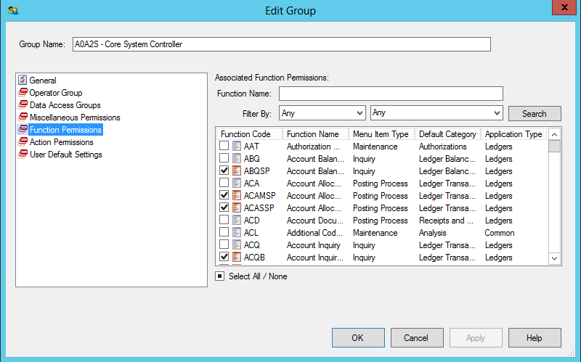
- Checked items in the list displayed in the right-hand pane are assigned to the Group
- Functions with red icons are SunPlus-specific functions
- Functions with blue icons are standard SunSystems functions
- To Add or Remove a Function from Group, find Function and check to Add or uncheck to Remove item
- Search using any string of characters from Function’s title using Function Name field and then clicking Search
- When items have been Added or Removed, click Apply, then click OK

User Group Menu Designer

- When all changes have been made in User Group, go back to SunSystems
- Open User Group Menu Designer

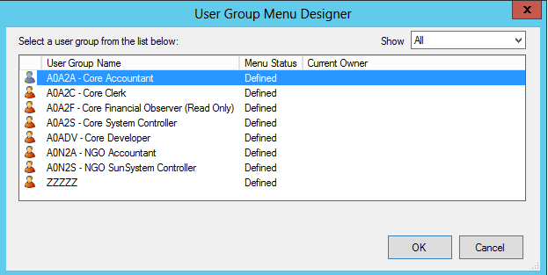
- Select modified User Group

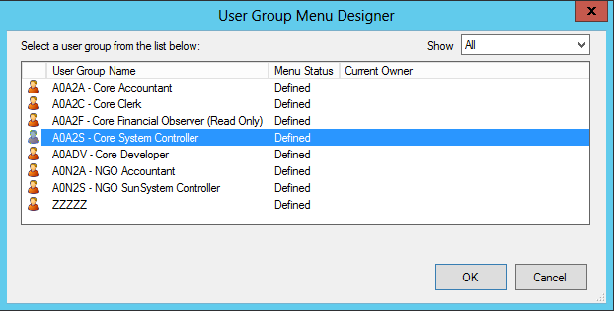
- Click OK

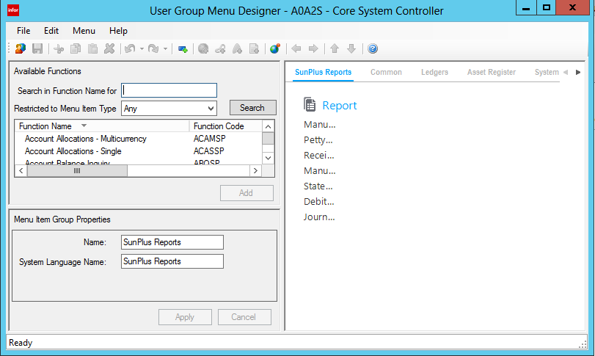
- On the Menu menu, select Synchronize to Permissions

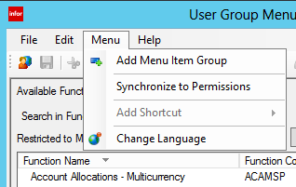

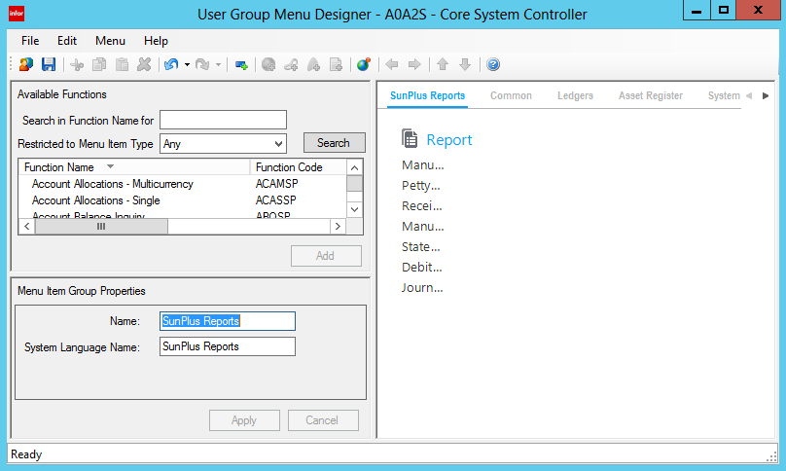
- Click Save icon
- Close User Group Menu Designer
- To Synchronize more than one User Group to Permissions, click first icon on left side of icon bar to select next User Group

New User

Set Up New System User

- To set up a new system Operator in SunSystems, go to User Manager
- On Users tab
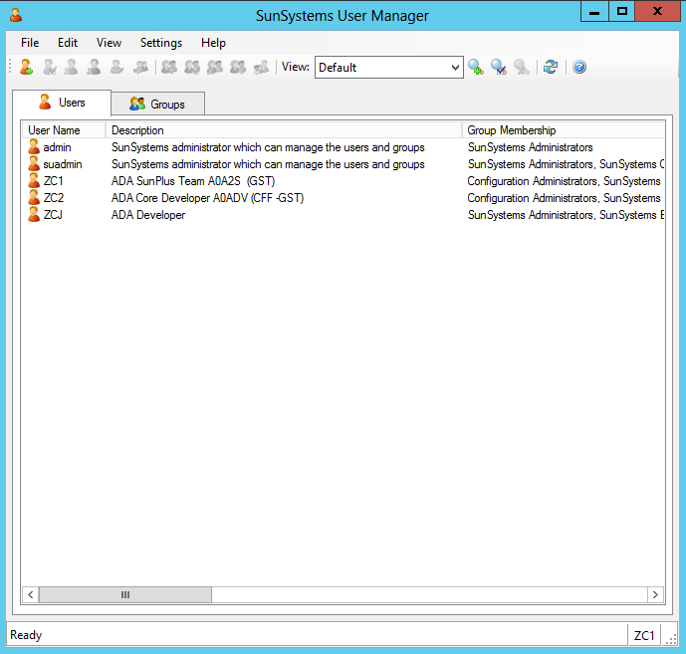
- Click Add User icon at the far left of the icon bar

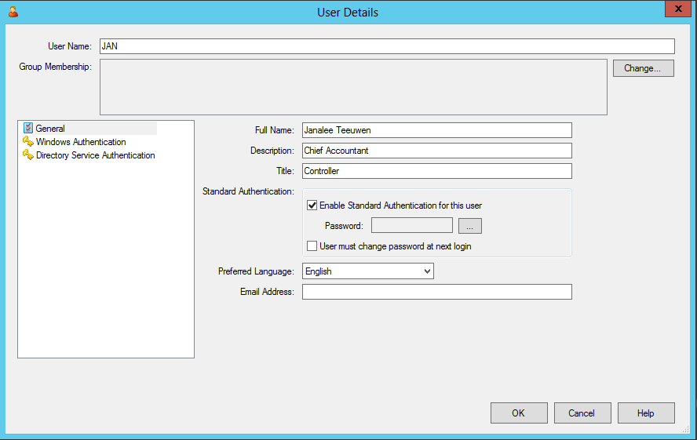
- User Name Enter Username for use as user’s Login
    - SunPlus standard is a 3-character code, usually user’s initials
- Full Name Enter the system user’s Full Name
- Description Enter any Description– usually relevant to business role
- Title Enter user’s Title
- Standard Authentication Check Enable Standard Authentication if user should log in every time
they work in the system
    - Other option is Windows Authentication (See below)
  - Check User must change password at next login unique password must be entered after first login
- Click Assist button to right of Password field
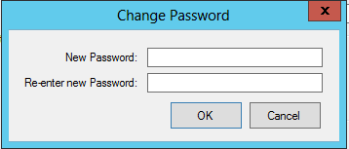
- Enter User’s Password
- Confirm User’s Password
- Click OK
- Preferred Language Select the user’s language
- Email Address Optional
- Click Change button to the right of Group Membership field toward the top of the interface

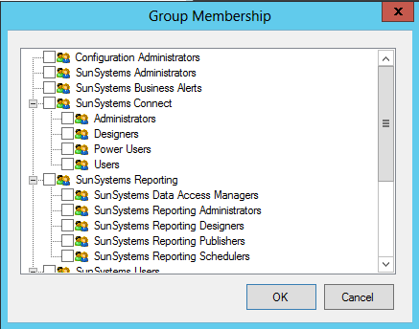
- Check checkbox to left of Groups to which this user will have access

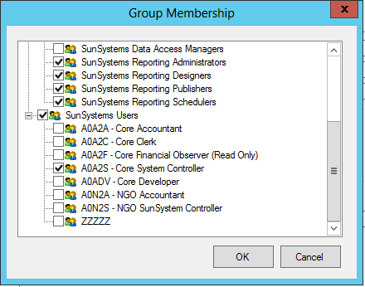
- Click OK

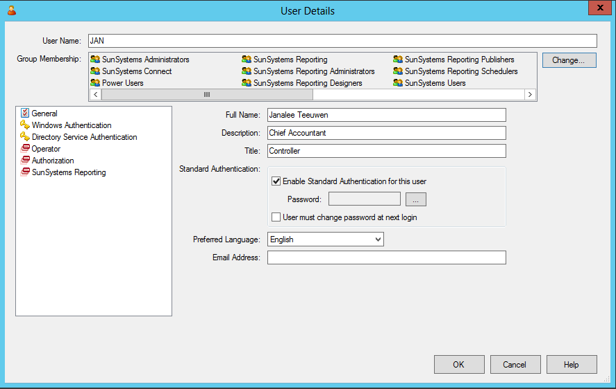
- Click on Operator in the pane on the left

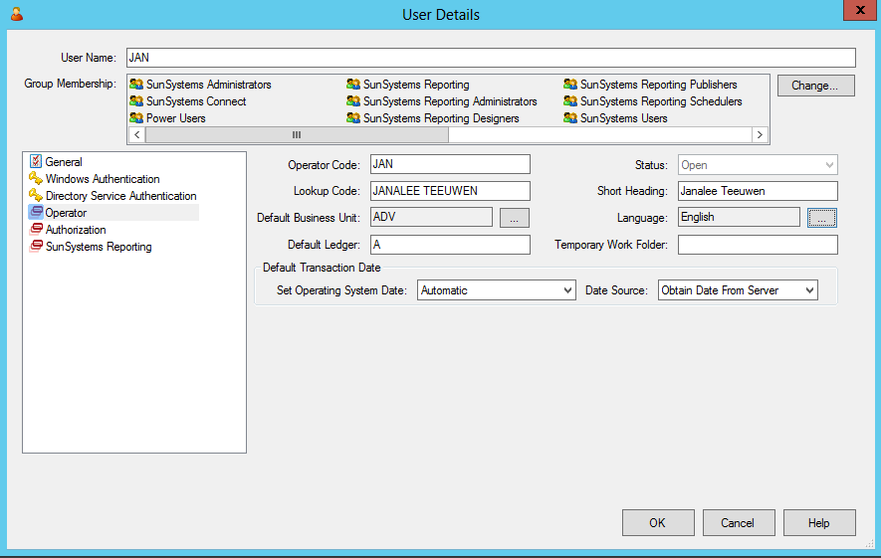
- Operator Code Enter the 3-character Login code
- Lookup Code Enter an alternate way to search for the user’s information
- Short Heading Enter the User’s Name as it should be printed in reports
- Default Business Unit Enter Business Unit the user will be working in most of the time
    - Leave blank if user should select Business Unit every time they open a new Function
- Default Ledger Enter Actuals Ledger code unless user should select the ledger every
time they open a new Function
- Language Select the user’s language
- Set Operating System Date Select Automatic (SunPlus standard)
- Date Source Select Obtain Date From Server
- Click OK

Remove User From System

- To remove a user from access to the system, go to User Manager
- Select the user by clicking on their name in the User tab
- Click Delete User icon in Icon Bar
- A warning message will be displayed

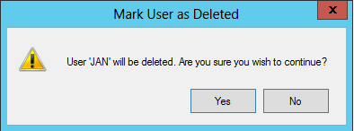
- Click OK to Delete the user

Unlock Locked Out User

- Go to User Manager
- Select the locked out user from the list on the Users tab
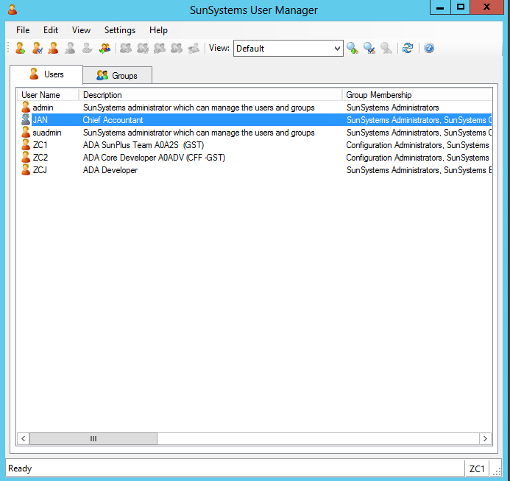
- At the bottom of User Details interface, go to the Lock Status field

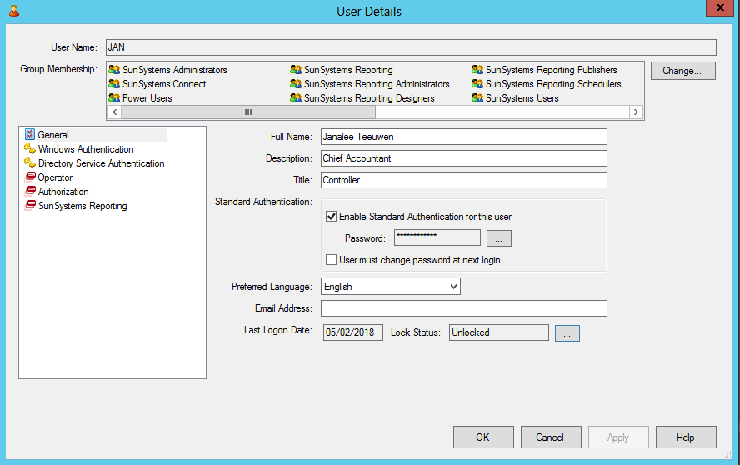
- Click Assist button at right of Lock Status field

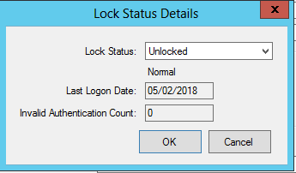
- Select Unlocked
- Click OK

Operator Activity

- To see which Operators are logged into the system at a given time, go to User Manager
- Go to Settings menu
- Select SunSystems

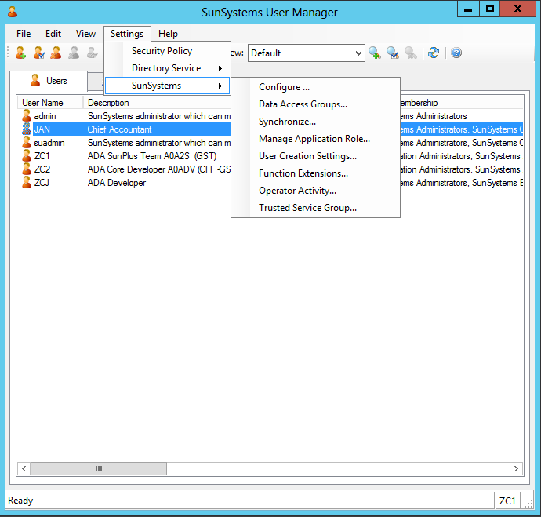
- Select Operator Activity

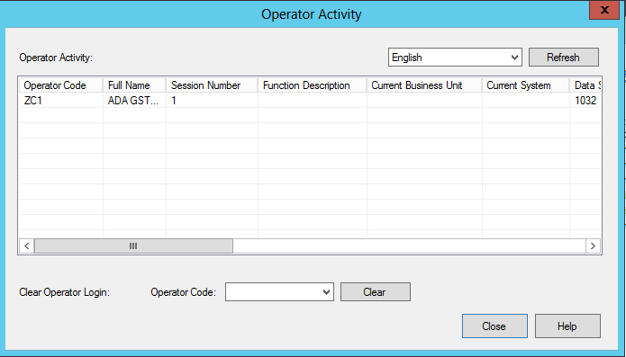
- To clear an Operator, select Operator’s Code from the dropdown list in Operator Code field

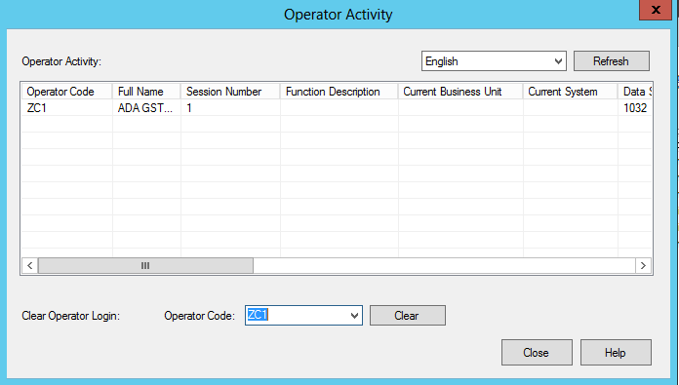
- Click Clear button

Setup for Report Corrections

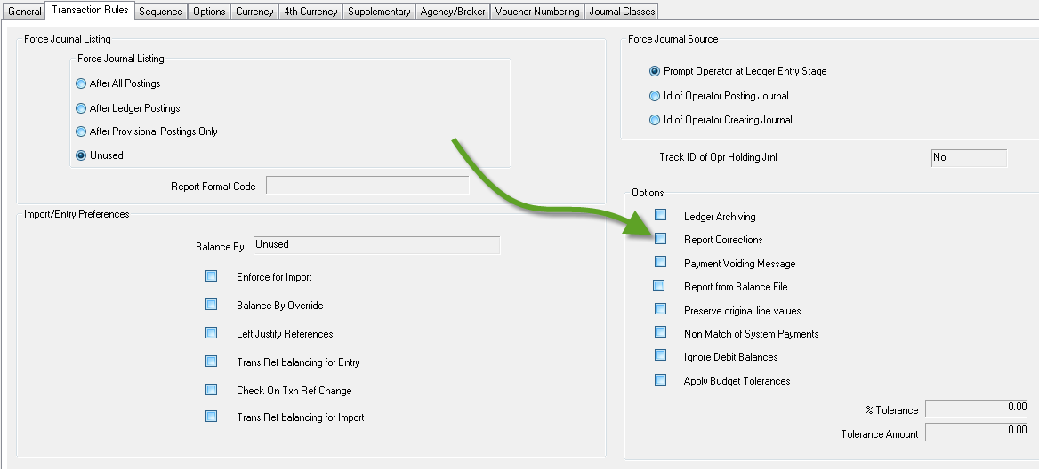
- If Correction transaction should be included in financial reports, tick Report Corrections checkbox on the Ledger Setup Transaction Rules tab
  - If this checkbox is unticked, Correction transactions will be left out of financial reports

Special Processes

Additional Fields Setup

Each ledger transaction can include up to 25 additional Description fields (of 30 characters each), and 5 additional Date fields. These additional fields can be used for recording supplementary references and other details which do not need to be validated against a pre-defined list.

Additional fields in ledger transactions can be populated in Ledger Import and Ledger Entry, providing the Ledger Entry form has been designed to include these fields. The fields can also be set to specific values using Business Rules. They can be defined to be changeable in Account Allocation, providing the Account Allocation form has been designed to include these fields. Additional fields can be included on forms, filters, and reports, in which the description entered in Additional Fields Setup is displayed.

NOTE SunPlus Core comes with Additional Fields added to the Ledger Entry forms.

- Go to Additional Field Setup
- Use Additional Fields Setup to define specific purposes for any of the additional fields by assigning them a Heading and a Description.

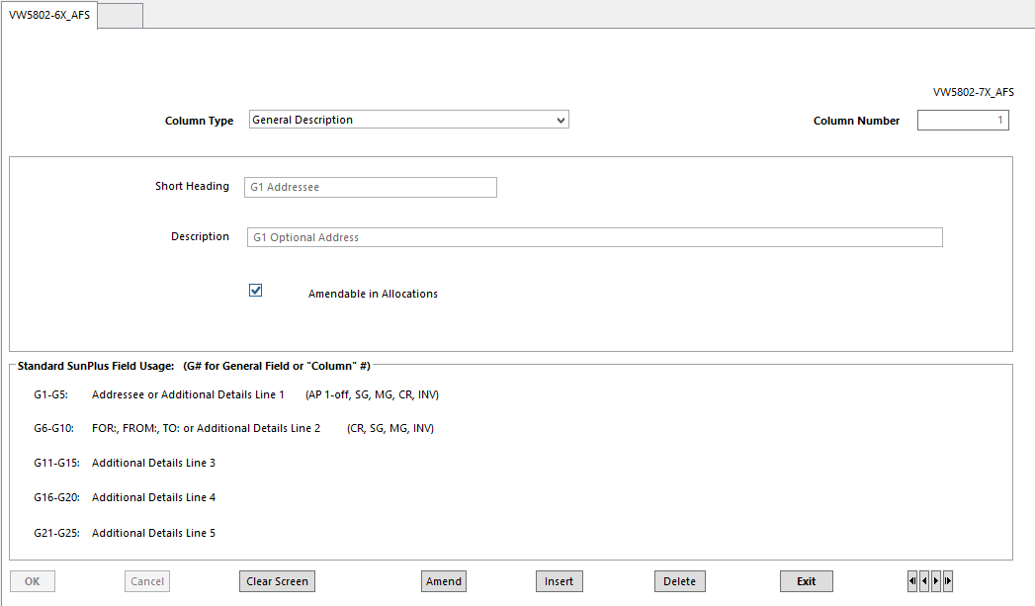
- Column Type Either Description or Date
- Column Number Number of the Additional Field
- 1 to 25 for General Description field and
- 1 to 5 for General Date fields
- Short Heading A shortened version of Description
- Description Name or Description for this field
  - Used to identify Additional Field on Reports, Inquiries, Forms
- Amendable in Allocations Specifies if data within this field should be changeable in Account
Allocations

Reset Default Forms

Reset Default Forms displays all SunSystems user specified default forms. In order to amend a user’s default form for a Function, the user must delete the unwanted form from the Reset Default Forms grid, and then run the Function to select a different form from the list available for that function.

Opening a Form

Depending on the system setup, the Find Form List form may be displayed, requiring selection of a specific form for the Function to be opened.

If the Don’t Ask Me Again checkbox is checked, the next time the shortcut for the Find Form List is bypassed and the form previously selected for that function is opened by default. To change this default setting, use the Reset Default Form Function.

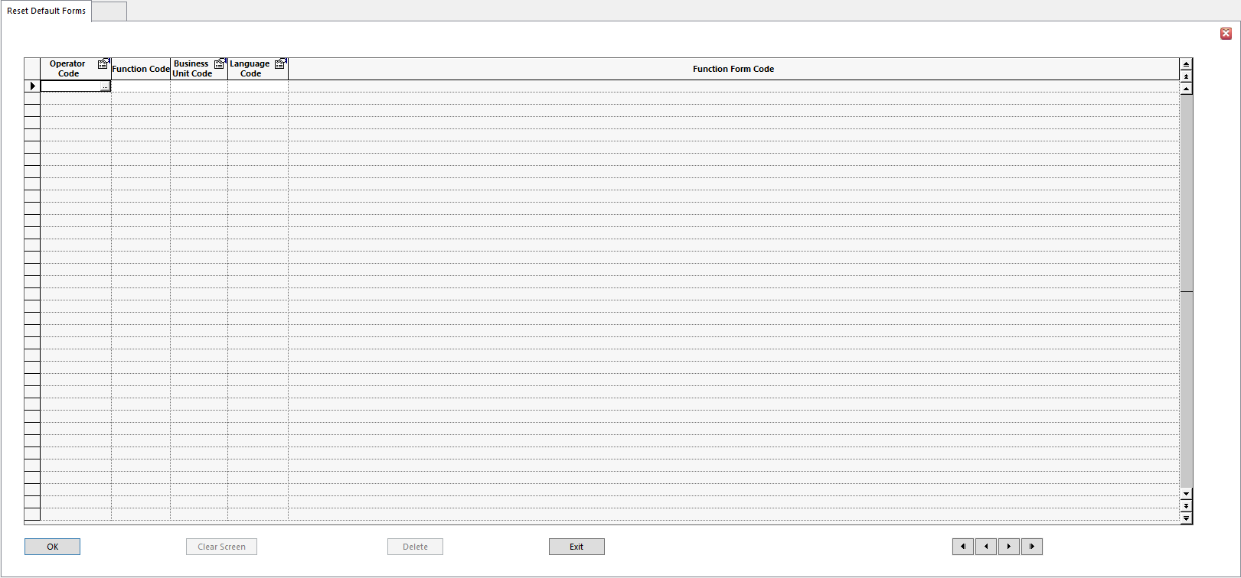
To Delete a default form:
- Select the required default form from the list
- Click Delete command button
- Click OK to confirm your deletion
- Click Exit when finished

To use the Reset Default Forms form:
- Click on Assist button at right of the Operator Code cell to access the dropdown list of Operators

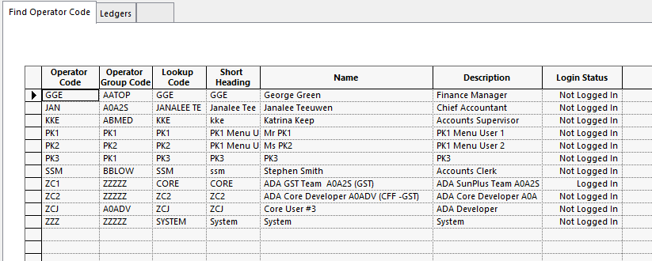
- Select Operator
- Enter Function Code
- Enter Business Unit Code
- Enter Language Code

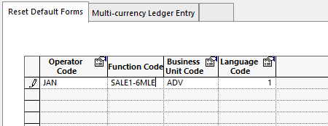
- Click OK
- Click Delete

Setup for Special, Rarely Used, Processes

Some SunSystems processes are rarely used by SunPlus; however, there are special instances when their use is highly appropriate. For that reason, they have been included in this manual. This section documents how to configure the system to effectively carry out these processes.

Configuring SunSystems to do Authorizations

Configuring SunPlus to do Authorizations is a 9-step process:
- Identify site’s Authorization requirements
- Identify General Categories of Reasons for Rejecting an Authorization
- Ledger Setup <LS>
- Operator Setup <OS>
- User Team Setup <UT>
- Financial Rejection Code Setup <FRC>
- Filter Designer <FLD>
- Authorization Stage Setup <ASS>
- Journal Types Setup <JT>

Step 1 – Site Requirements

Before beginning the configuration process, you need to clearly understand the types of authorization the site requires. Authorizations are tied to specific Journal Types. Identify the types of journals the site wishes to submit to the Authorization process, as well as the users who will be involved both as transaction Originators and as Authorizers.

Step 2 – General Categories of Reasons for Rejection

Because the Authorization process includes the assignment of codes for specific reasons for rejection, you should determine, before beginning the configuration process, the usual reasons for authorization being withheld. Each reason will be assigned a specific Rejection Code.

Step 3 – Ledger Setup

- Go to Ledger Setup <LESU>
- Supplementary Tab
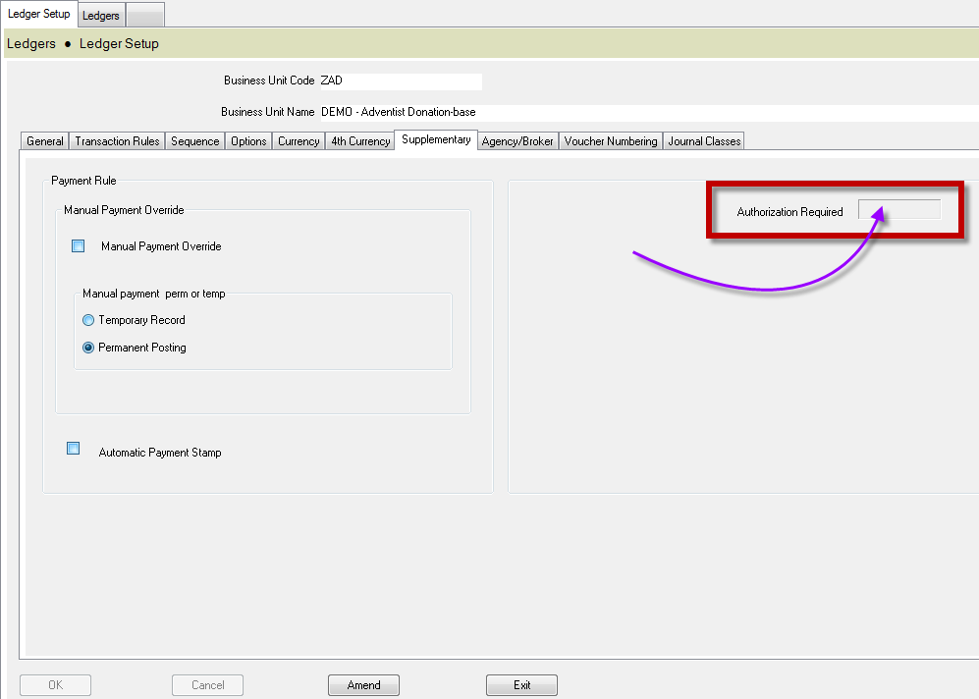
- Authorization Required = Select Yes
- Click Save

Step 4 – User Setup

Each system user who will fulfill an authorization role must be set up accordingly.

- Go to User Manager
- User tab – for the user
- Select SunSystems 5 Authorization
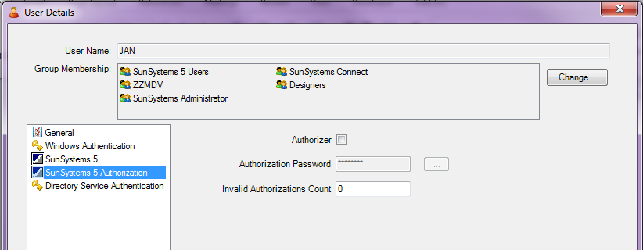
- Tick the Authorizer checkbox
- Assign an Authorization Password to be used by the user only filling Authorizer role
- Leave Invalid Authorizations Count at 0

Step 5 – User Team Setup

- Create the required Authorization Teams
- For each team, create a suitable Team Name
- Click Authorizer Operators to assign operators to the team
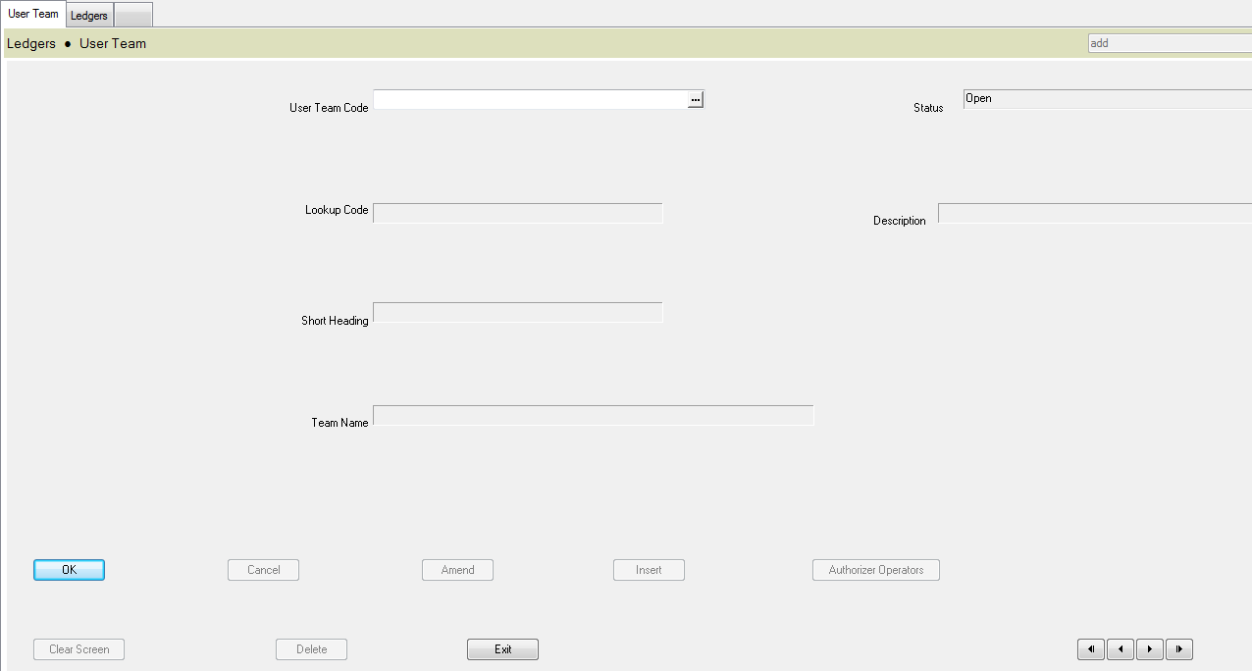
- Go to User Team Setup <UTS>
- Enter a unique User Team Code
- Lookup Code
- Short Heading
- Description
- Team Name
- Click Authorizer Operators button to select the members of this team
  - These are individuals who will serve as Authorizers

Step 6 – Financial Rejection Code Setup

- Create required Rejection Codes
- Go to Financial Rejection Code Setup <FJC>

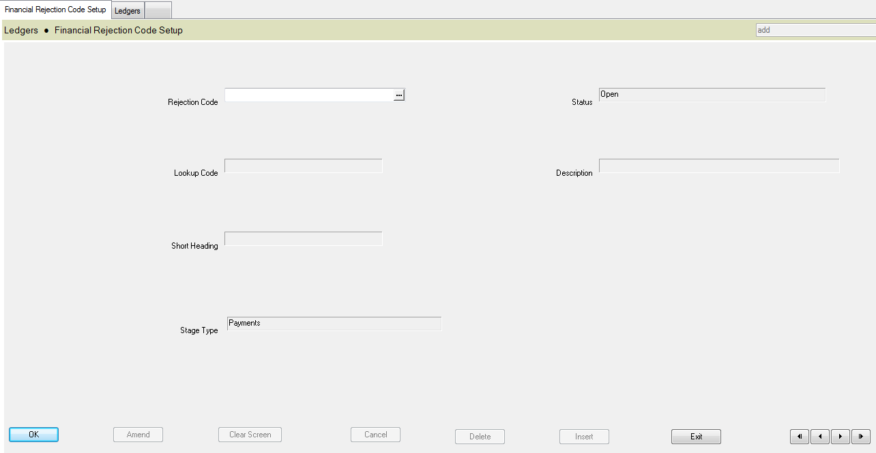
- Rejection Code Enter a unique code for the Rejection
- Lookup
- Short Heading
- Description Description will be displayed against transactions rejected with code
- Stage Type Specify Authorization Stage Type for this financial Rejection Code
  - There are four Stage Types:
    - Payments
    - Matching / Allocation
    - Ledger Entry / Import

Step 7 – Filter Designer

- Create necessary filters for different Authorization Stages and Stage Types
- Go to Filter Designer <FLD>

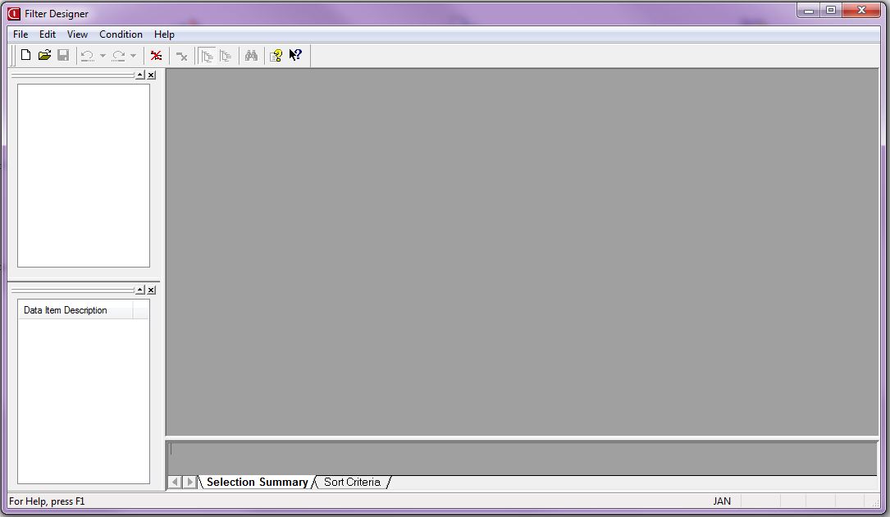
- Open a New Filter

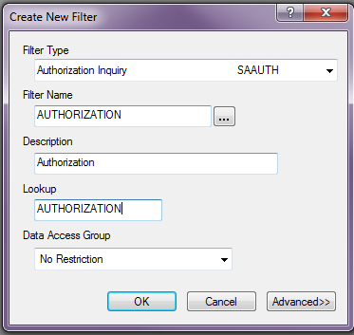
- As in the screenshot above, select a Filter Type of Authorization Inquiry – SAAUTH
- Drag required filter conditions into the filter Edit Area
- The first condition for an Authorization Filter must be Authorization Set Reference
- In Edit Condition dialog, check the Runtime Entry check box, and leave the Blanks check box unchecked
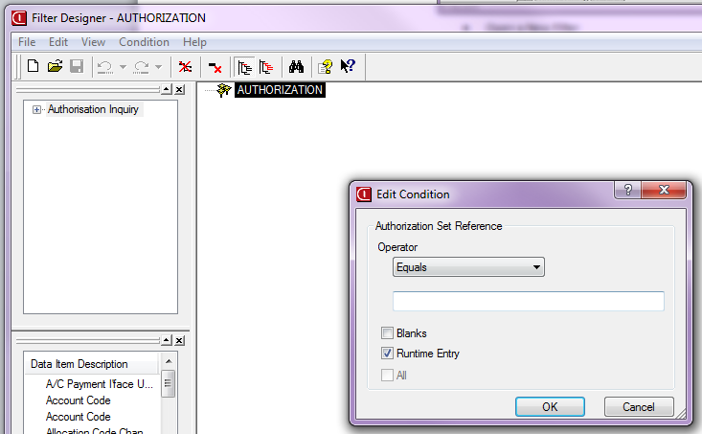
- Select any other Data Items the filter may require
  - None of the conditions other than Authorization Set Reference can have the Runtime Entry setting
- Select File
- Select Results Destination from the Filter Designer menu
- Click Form
- Select Authorization Detail as the output form for filter
- Save the filter

Step 8 – Authorization Stage Setup

- Create all Authorization Stages site will require in each Authorization process
  - For example, you might want a two-stage authorization process for Ledger Entry, in which the first Stage requires Authorization of all journals, and second Stage only requires the Authorization of those journals with a credit total greater than 1000.
  - For each stage, specify the appropriate Filter defined in the last step
  - Specify the User Team required to Authorize this Stage of the process, and specify the Authorizer, that is, the operator id of a user within that team to whom transactions are to be sent, by default, for Authorization
- Go to Authorization Stage Setup <AUS>
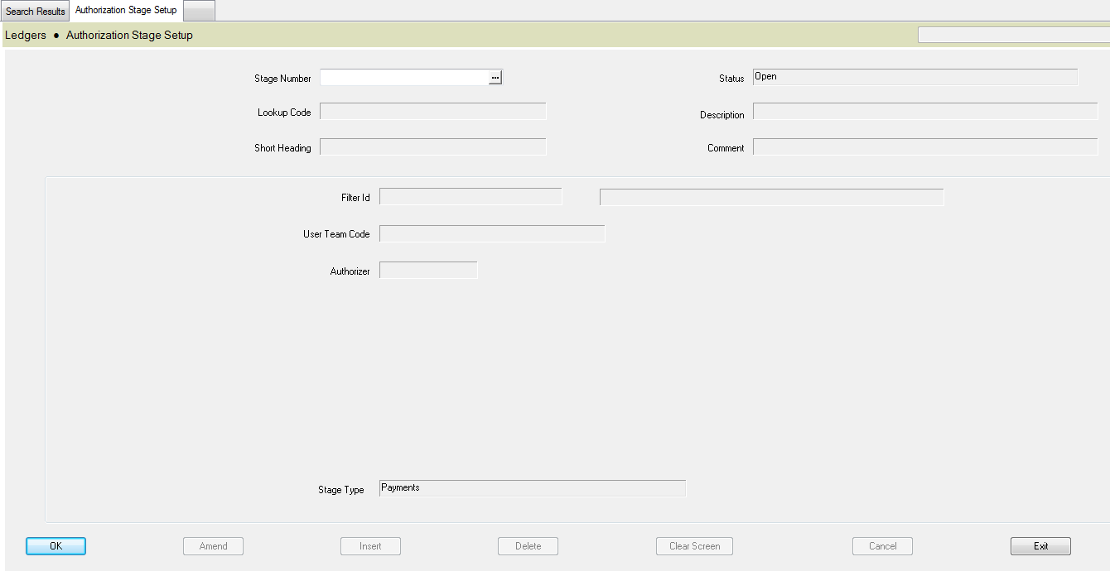
- Stage Number Number uniquely identifying an Authorization Stage
  - Authorization can be required for several different Financials processes
  - An Authorization Stage is linked to a Stage Type
  - Stage Number determines order in which Authorization Stages are requested if more than one Authorization Stage is required for a set of transactions
- Comment Any additional text describing this Stage in Authorization process
- Filter ID Enter Filter used to identify transactions for this Authorization Stage
  - For example, this Authorization Stage may only be required if the transactions reference a particular account code
  - Filter must have been defined using Filter Designer
- User Team Code Group of Operators able to Authorize transactions at this
Authorization Stage
- Authorizer Default Operator, within User Team, who Authorizes the transactions
- Stage Type Type of Financials processing for Authorization Stage
        - Authorization Stages are carried out in Stage Number order, within this Stage Type
        - The following Types are available:
    - Payments
    - Matching / Allocations
    - Ledger Entry / Import

Step 9 – Journal Types Setup

In Journal Type Setup, specify whether each Journal Type requires Authorization. For those that do:

- Go to Journal Types Setup <JNT>
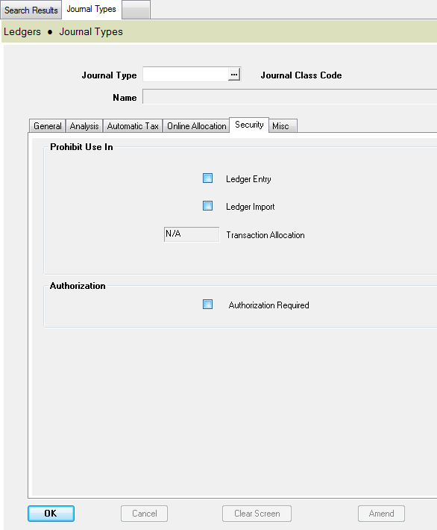
- Amend the Journal Type
- Go to Security tab
- Check Authorization Required check box
  - This must be done for each Journal Type for which authorization is required, one by one.

Accounts Payable Setup

Payment Profiles

Payment Profiles Setup is used to define criteria by which transactions are selected for payment in a Payment Run. When Payment Run is processed, you must select a Payment Profile.

Many different Payment Profiles to meet payment requirements. For example, you might define Payment Profiles to select transactions by currency or bank, or to select a particular group of accounts.

A transaction must meet all of selection criteria in Payment Profile to be selected for payment.

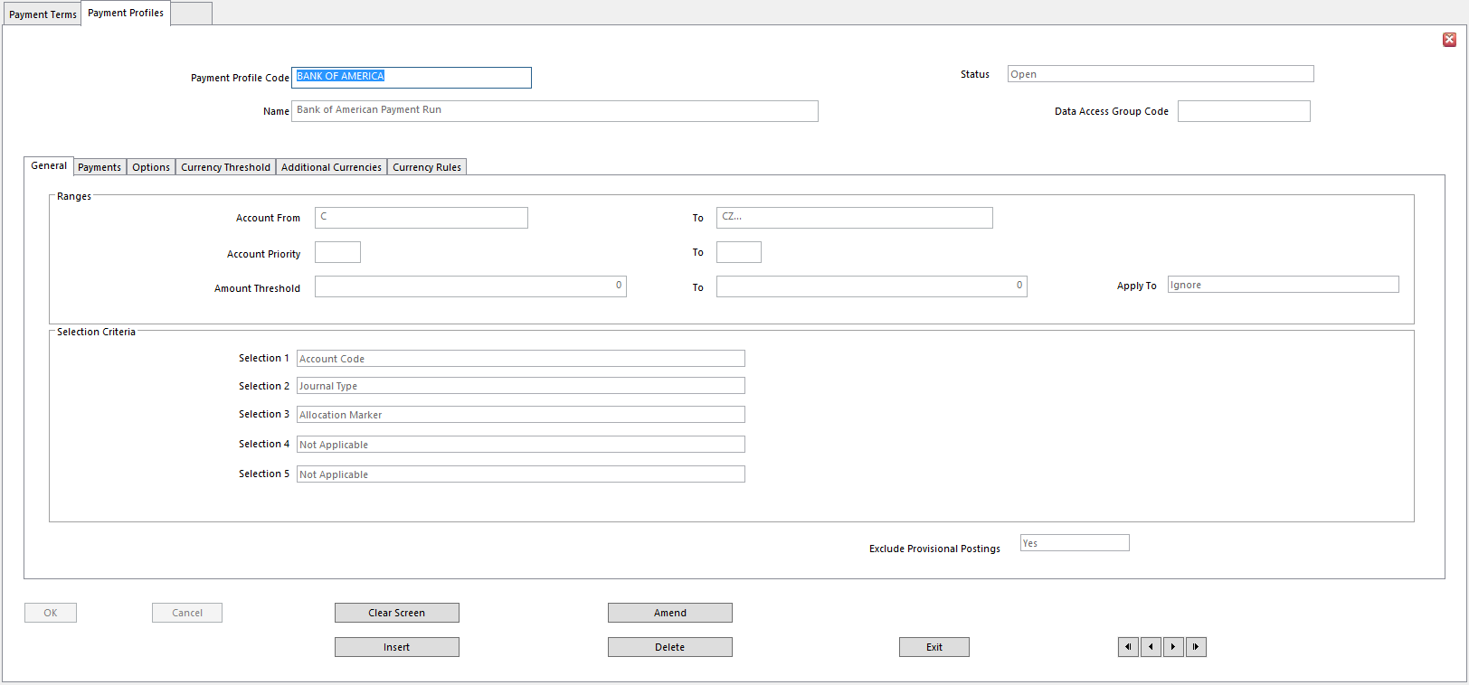
- Payment Profile Code
- Name Profile Name
- For instance, our example is named after the relevant bank
- Status
- Data Access Group Enter Data Access Group to restrict access to this group
- Account From/To Range of accounts for transactions considered for payment in profile
- Leave blank to select accounts at run time
- Accounts entered at run time override accounts entered here

- Account Priority From/To Range of Priority codes
- Use Priority numbers to group Customers and Suppliers for any reason
- Leave blank to ignore Priority Rating codes
- Amount Threshold From/To Range of values used to Include or Exclude accounts or
Transactions
- Threshold range can apply to an Account balance or Transaction amount
  - Depends on choice made in Apply To field below
- Apply To Amount to which threshold range applies
- Ignore – amount threshold range is not required (default)
- Balances – the amount threshold applies to account balance
- Transactions – the amount threshold applies to transactions
- Selection Criteria 1 – 5 Run Time Selection Criteria for Payment Profile
- Select up to 5
- Can be refined at Run Time
- Transactions must meet all selection criteria to be in the Payment Run
- Exclude Provisional Postings SunPlus does not use Provisional Postings

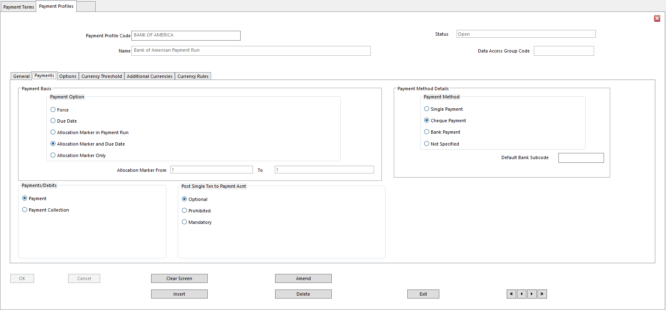
- Payment Option Basis on which transactions are selected for payment
- Available options:
          - Force – transactions with Allocation Marker Force
          - Due Date – transactions with Due Date on or before Base Date for Payment entered at run time
              - Excludes Force Allocation Markers
          - Allocation Marker in Payment Run – transactions with Allocation Markers selected at run time
              - Allocation Marker must be a Run Time selection criteria
          - Allocation Marker and Due Date – transactions selected according to range of Allocation Markers and Due Dates
          - Allocation Marker Only – ignores Due Date
          - Allocation Marker From/To If either Allocation Markers Only or Allocation Marker and
Due Date options is chosen above, this is the range of Allocation Markers used to select transactions
              - Allocation Markers can be preset if same range is required for every Run
          - Payment Method Determines Payment Method for the Profile
          - Single Payment
          - Cheque Payment
          - Bank Payment
          - Not Specified
          - Default Bank Subcode Bank subcode used for Profile, if Payment Method is set to Bank
          - Payments/Debits Determines if Payment Profile will be used for Payment Run or
Payment Collection
          - Payment
          - Payment Collection
          - Post Single Txn to Paymnt Acnt Determines if single, summarized ledger transaction is posted to
Payment or Collection account for Payment or Collection Run
          - Optional
          - Prohibited
          - Mandatory

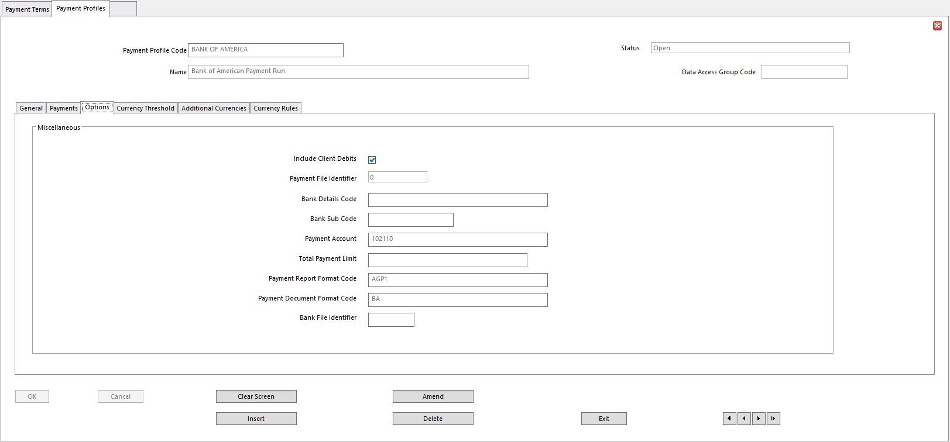
- Include Client Debits Client accounts with debit balance are considered for payment
- Payment File Identifier A letter in A-Z Range or Number in 0-9 Range
        - Uniquely identifies Payment file generated for Profile
        - Each Payment file is overwritten only when Payment Run or Payment Collection Run is run for this Payment Profile
- Bank Details Code Bank Details record
- When a Bank Details code linked to one of your own bank accounts is entered, Payment Account field below displays Chart of Accounts record for that bank account
- Bank Details Code is necessary for payments where Payment Method is set to Bank
- Bank Sub Code The subcode, if used, on Bank Details Record identified in field above
- Otherwise leave blank
- Payment Account Bank Account used in Payment Run or Payment Collection Run
- If Payments are made/collected in Transactions Currency, Payment Account or Collection Account defined in Currency Codes is used for payments generated in each currency
- Account entered here is used if a Payment Account or Collection Account has not been specified for the currency
- Total Payment Limit Total Payment Amount for Payment Run
- If limit is exceeded, Payment Run is terminated and none of accounts are paid
- Payment Report Format Code Document Format Code to use for Payment Run Details Report
- This code is mandatory
- Payment Document Format Code Document Format Code to use for payment documents, if
required for Payment Profile – such as Cheque and Remittance Advice
- Bank File Identifier (Optional) Enter code used as default file extension to Bank Payment
file created by Payment Run with this Profile

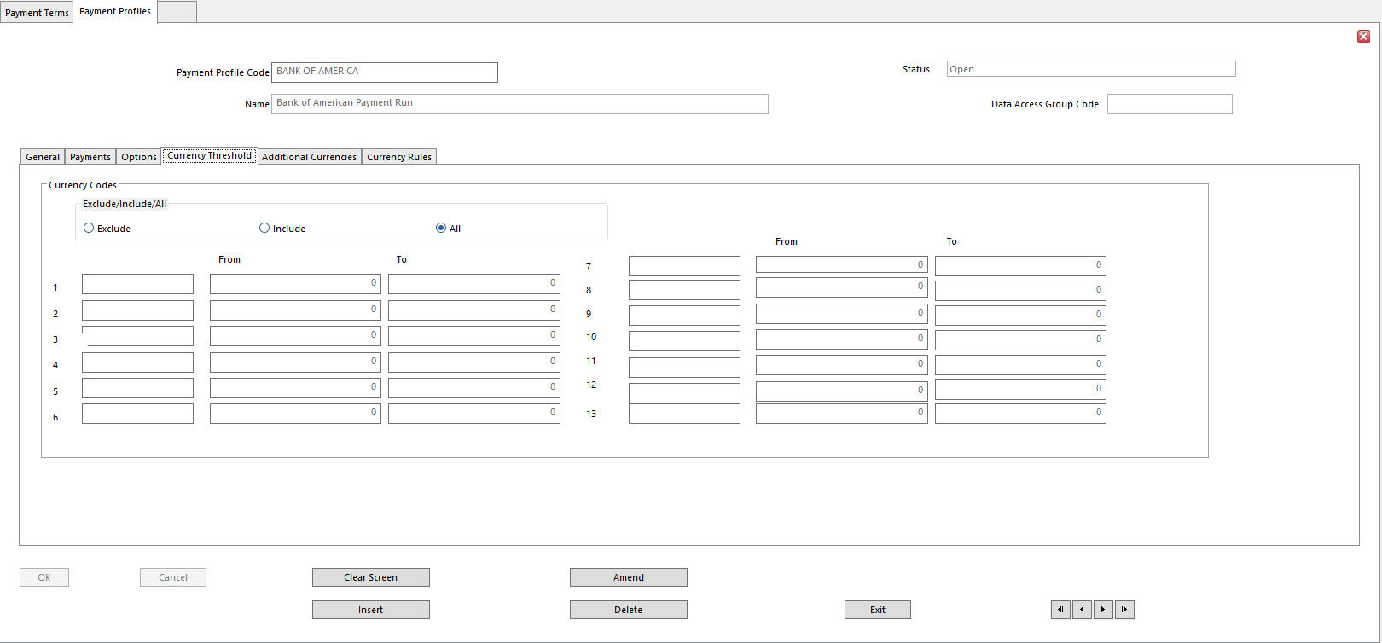
Currency for Payments option in Ledger Setup determines if payments can be made in Transaction Currency or 4th Currency values.

Transaction Currency Values can be Included or Excluded from a Payment Run or Payment Collection Run. If payments are set to be produced only in Base Currency, transactions referencing a Transaction Currency can be Included or Excluded from a Payment Run or Payment Collection Run.

- Currency Codes Exclude/Include/All Indicates if Currency Codes selected will be Included or
Excluded
- Currency Codes From/To Up to 13 currencies can be Included or Excluded on this tab

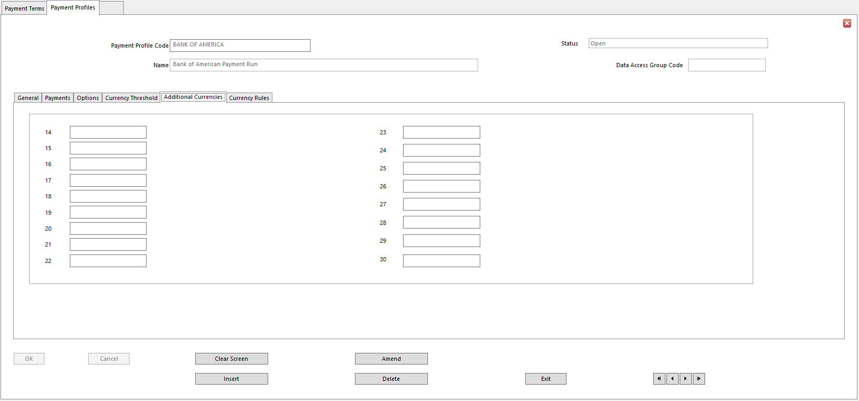
- Currency Codes From/To Select additional currencies to Include or Exclude

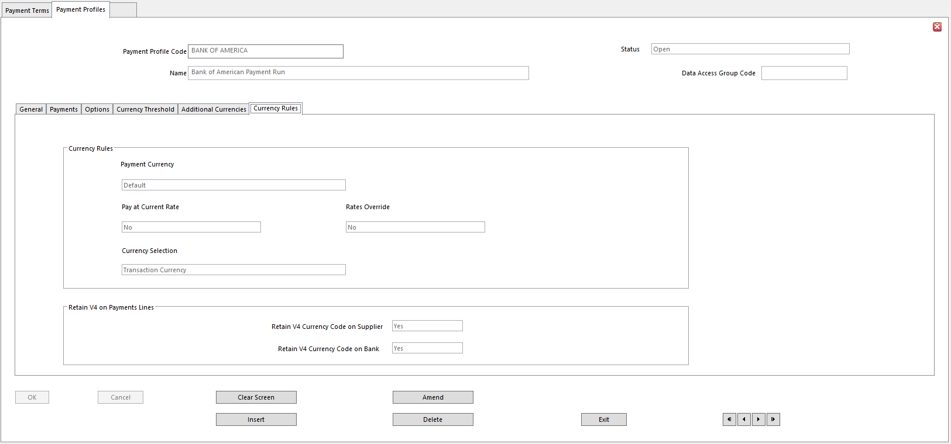
- Payment Currency Determines if settlement can be in currencies other than Base
- Select Default to use default setting defined in Ledger Setup
- Pay at Current Rate In multi-currency environments, this determines basis for which
Exchange Rates are derived for Payments and Collections
- Yes – calculate different currency values during Payments and Collections using current Exchange Rates
- No – use original Exchange Rates posted on Source transactions
- Default - use default setting for ledger
- Rates Override In a multi-currency environment, determines if derived currency
Exchange Rates can be overridden during Payment Run
- Yes – display Currency Rates Override form during Payments, letting currency Exchange Rates be amended
- Currency Selection In multi-currency environment, refers to currency selections on
Currency Threshold tabs
- Determines if currency selections in Payment Profile refer to Transaction Currency, or 4th Currency
- Does not refer to Payment Currency
- Retain V4 Currency Code on Supplier Indicates if V4 Currency Code, if defined as variable, is
included on Payment transaction lines posted to Supplier account
- Retain V4 Currency Code on Bank Indicates if V4 Currency Code, if defined as variable, is
included on Payment transaction lines posted to Bank account

Payment Terms Setup

Payment Terms control Dates, Discounts, Documents, and Charges that can apply when Payments are settled for an account.

A set of Payment Terms is linked to each Customer and Supplier and used to calculate these dates and related Payment details on the Customer’s or Supplier’s transactions.

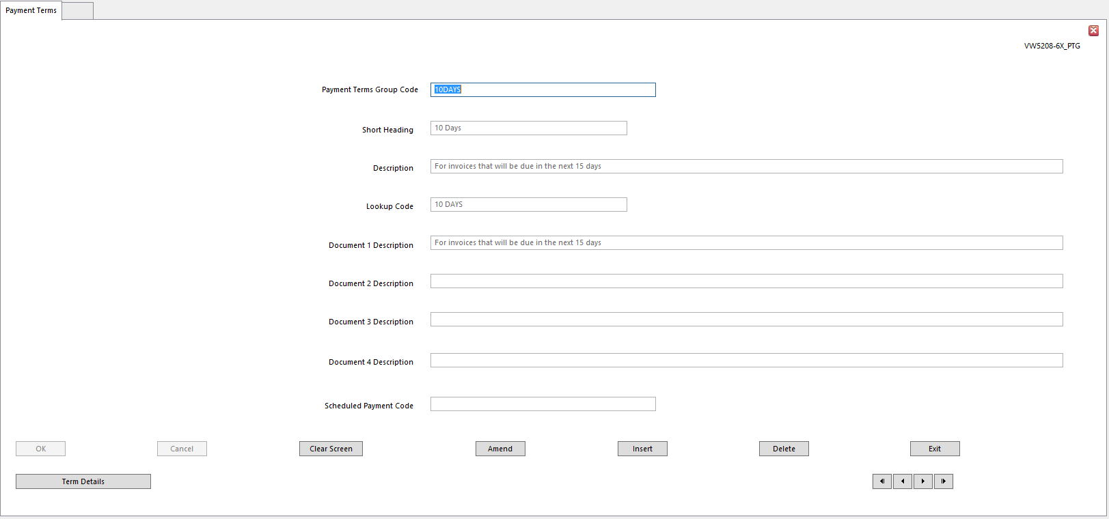
- Payment Terms Group Code
- Short Heading
- Description
- Lookup Code
- Document 1-4 Description These fields note the document to produce on each of four available
Document Dates, if these dates are calculated as part of Payment Terms
- For instance, enter a Description of First Reminder Letter Due if calculating Document Date 1 as date for first Debt Chasing Letter
- Scheduled Payment Code Code identifying Scheduled Payments record to be used with a set of
Payment Terms
- Scheduled Payments Code must already be set up
- Leave blank for no Scheduled Payments

Term Details

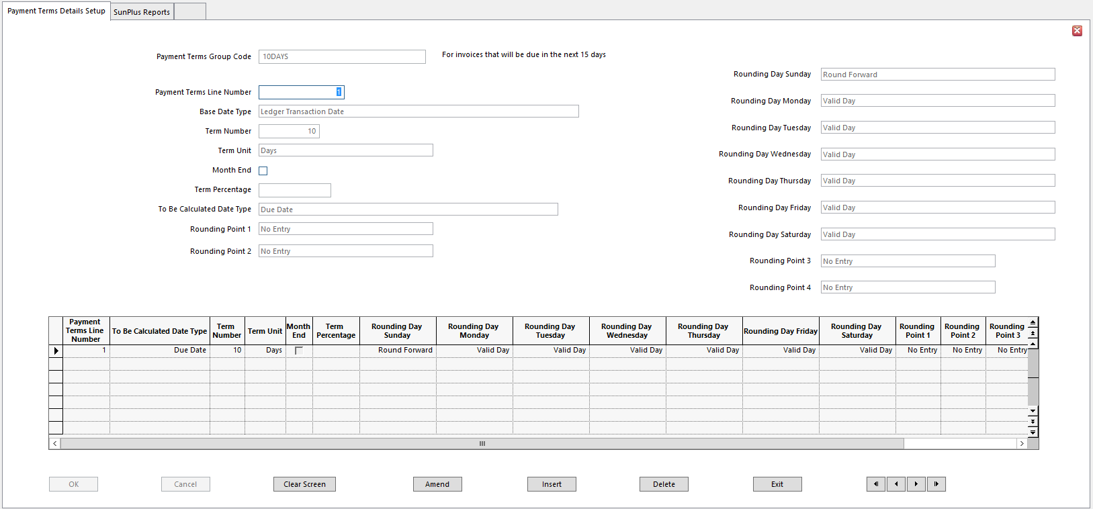
Payment Terms details set rules required to calculate a selected date and identify related information, such as a Percentage Charge Rate.
- Payment Terms Group Code
- Payment Terms Line Number Number of line identified within set of Payment Terms
- Base Date Type Date to use as basis for calculating chosen Terms Date
- Date must precede Terms Date being defined
- Term Number Number of Days or Months to add to Base Date to calculate required
Terms Date
- Meaning of Date is determined by Unit chosen below
- Term Unit Determines if Days or Months will be added to Base Date
- Month End If selected, Day Number in Transaction Date is replaced by last day of
the month, and Payment Terms Days are added to this month end date
- The effect is to group month’s transactions together and treat them as if they were all dated on the last day of the month
- Term Percentage Enter against Discount Date 1, Discount Date 2, Interest Start Date
and Late Payment Date
- This is Percentage of Transaction Amount used to calculate Discount, or Interest Amounts

NOTE Interest and Late Payment Charge Percentages are maintained for information purposes only – not for calculations

- To Be Calculated Date Type Terms Date to calculate or define
- Rounding Point 1-4 Number of days, between 1 and 31, used to round the calculated date
- Up to 4 Rounding Points can be set
- Rounding Day Sunday-Saturday Define each day as:
- Valid – days acceptable for given action
- Round Backward - if calculated day falls on this day of the week, it should be set back to the nearest Valid day
- Round Forward – if calculated day falls on this day of the week, it should be advanced to the nearest Valid day

NOTE Round Backward can never follow Round Forward

Link Payment Terms to Journal Transactions

Payment Terms are linked to individual Supplier/Customer accounts.

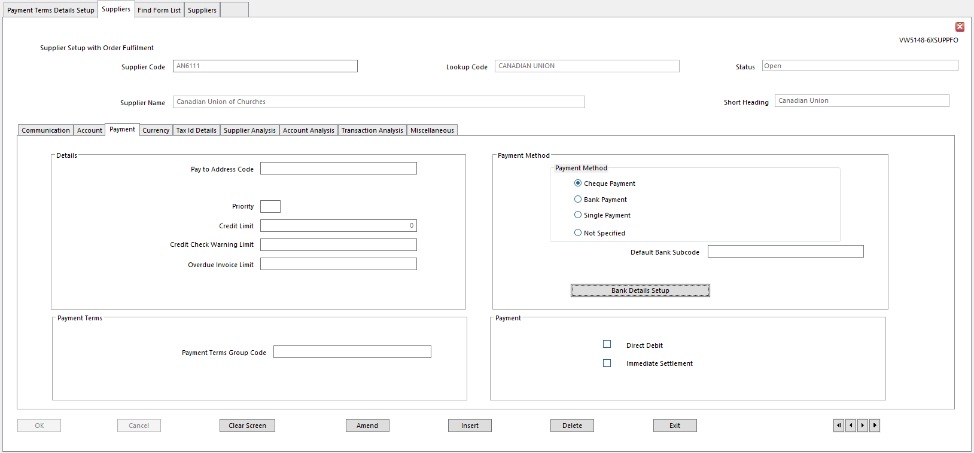
- Enter Payment Terms Group Code

Ignore Payment Terms on Journal Type

- To ignore Payment Terms on a particular Journal Type, go to Journal Type Setup and check Override Ageing/Discount check box on General Tab

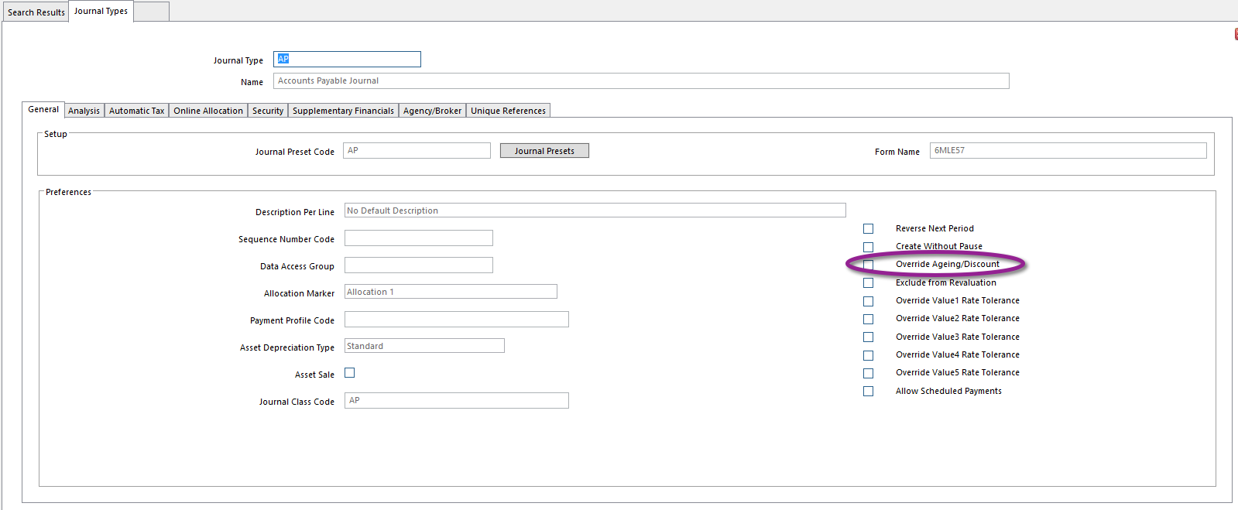

Bank Details Setup

If settlement will be by Bank Transfer, the details of Customer or Supplier bank accounts are required. A Customer or Supplier can have more than one bank account, and each account is identified by a Bank Subcode. The default bank for each Customer or Supplier is identified in Customers Setup or Supplier Setup. This default bank of the Customer or Supplier is used in Payment Run to determine bank details for the Bank Transfer file.

Bank Details Setup is used to link bank details to Customer and Supplier account codes, and to maintain details of the organization’s own bank accounts.

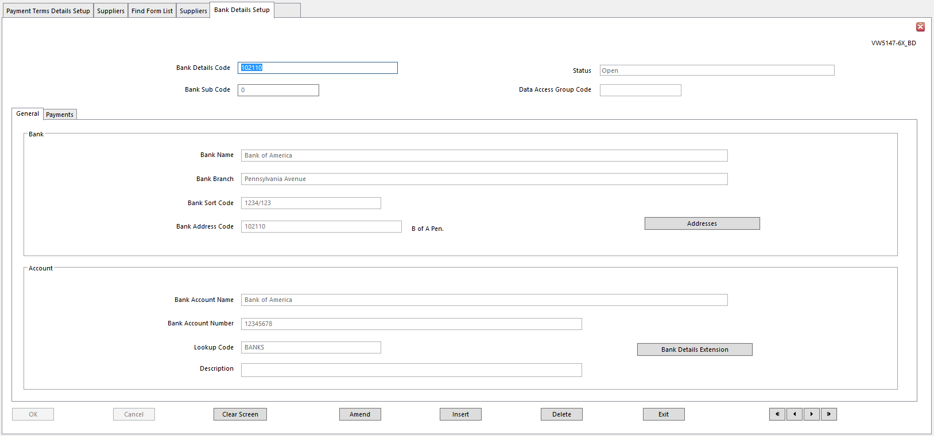
- Bank Details Code Code linking all bank details for Customer or Supplier, or for one of the
organization’s own bank accounts
- Bank Subcode Code identifying an individual bank account for Debtor, Creditor, or
Client account, if more than one bank account is required.
- Define any number of banks from which funds can be drawn, or into which funds can be deposited, when settlement is by Bank Transfer
- If Subcodes are not used, defaults to blank for a single bank
- Bank Name Bank Name
- Bank Branch Bank Branch where the bank account is held
- Bank Sort Code Sort Code identifying bank and branch
- Bank Address Code Address Code identifying the bank’s address
- Addresses If bank’s address has not been defined or should be updated, click
Addresses to access the address maintenance facility
- Bank Account Name Name as shown on Bank Account
- Enter Debtor, Creditor, or Client Name if you don’t know any other
- Bank Account Number Bank Account Number

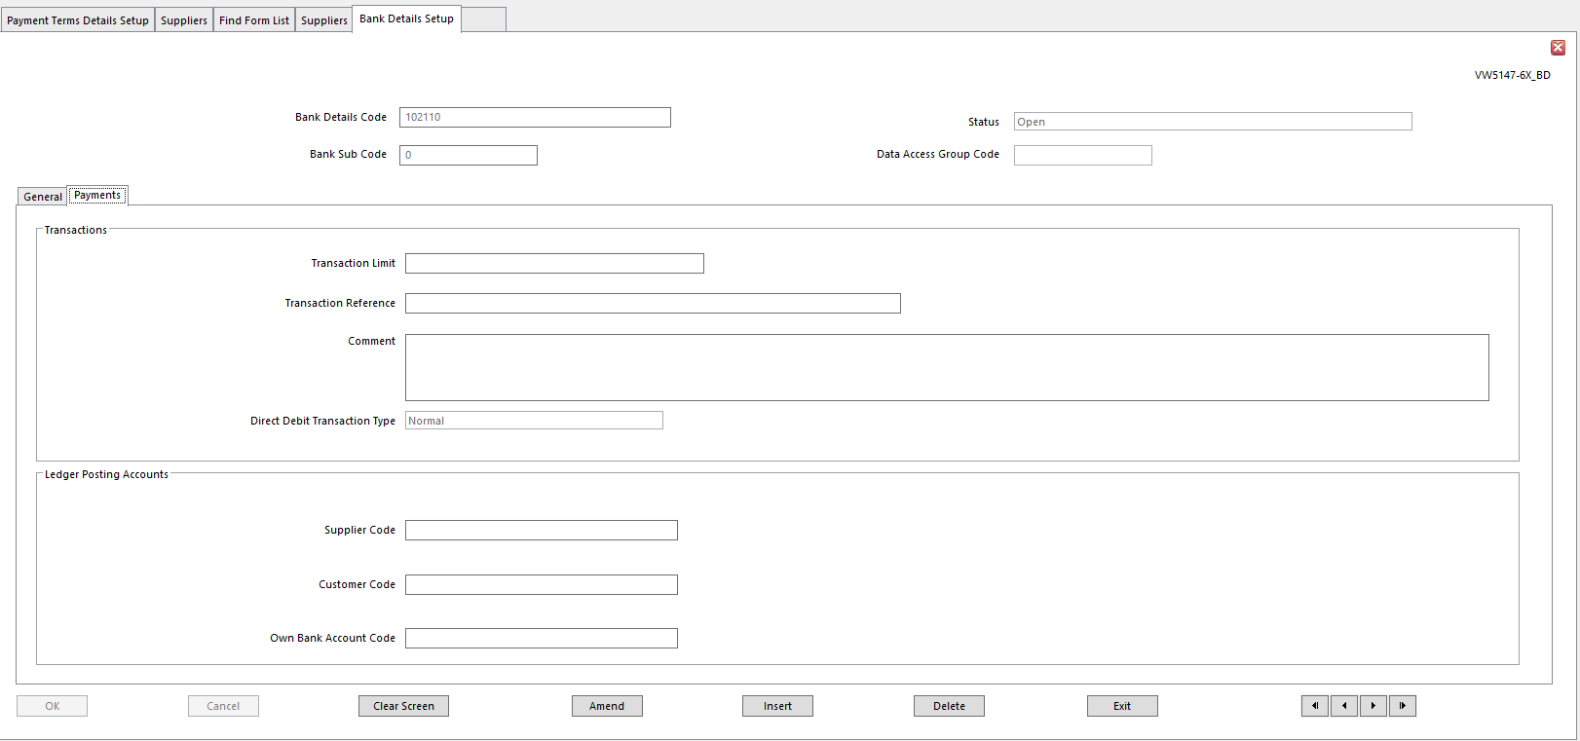
Details on Payment tab tailor Bank Transfer Records created for Customer or Supplier
- Transaction Limit Maximum Amount allowed for single transaction to this account holder
- This is meant to help limit extent of gross fraud or error
- If during Payment Run a sum is calculated that exceeds this limit, no entry is made on the Bank Transfer file
- Payment Run Report highlights any payments that have exceeded Transaction Limit
- Transaction Reference A specific reference for use on Payment Run transactions for
payments to identify payments for this account holder
- Leave blank to use Reference entered in Payment Run
- Comments Use for any text relevant to these Bank Details
- Direct Debit Transaction Type Each option, once it has been processed, reverts to Normal
- This can happen in the same Transaction Run if more than one currency payment is processed
- The first transaction will have one of the options below and the second will be set to Normal
- Bank Code Number is located at the end of Direct Debit Export file
- Options:
- First – tells bank this is first Direct Debit payment for the current contract
  - Bank Code 01
- Last – tells bank this is last Direct Debit payment for the current contract
  - Bank Code 19
- Normal – tells bank this transaction has happened before and will continue for current contract
  - Bank Code 17
- Represent – if a collection is rejected this means Direct Debit is presented again until it is paid
  - Bank Code 18
- Supplier Code Posting Account Supplier to which Bank Details relate
- Customer Code Posting Account Customer to which Bank Details relate
- Own Bank Account Code If Bank Details record is associated with one of the organization’s own
bank accounts, enter Chart of Accounts Code for relevant Bank Account
- Bank Account must be Balance Sheet

Document Format Setup

A Document Format links the report request and the reporting services functionality which generates the report. The Document Format identifies the report file used to produce the report and the report parameters and other details required.

Document Formats also hold Transaction References and provide an entry point for Consolidation Rules.

A Document Format has to be defined for every report executable that may be called by another SunSystems function. Reports run directly from Report Manager or from menu shortcuts do not require a Document Format.

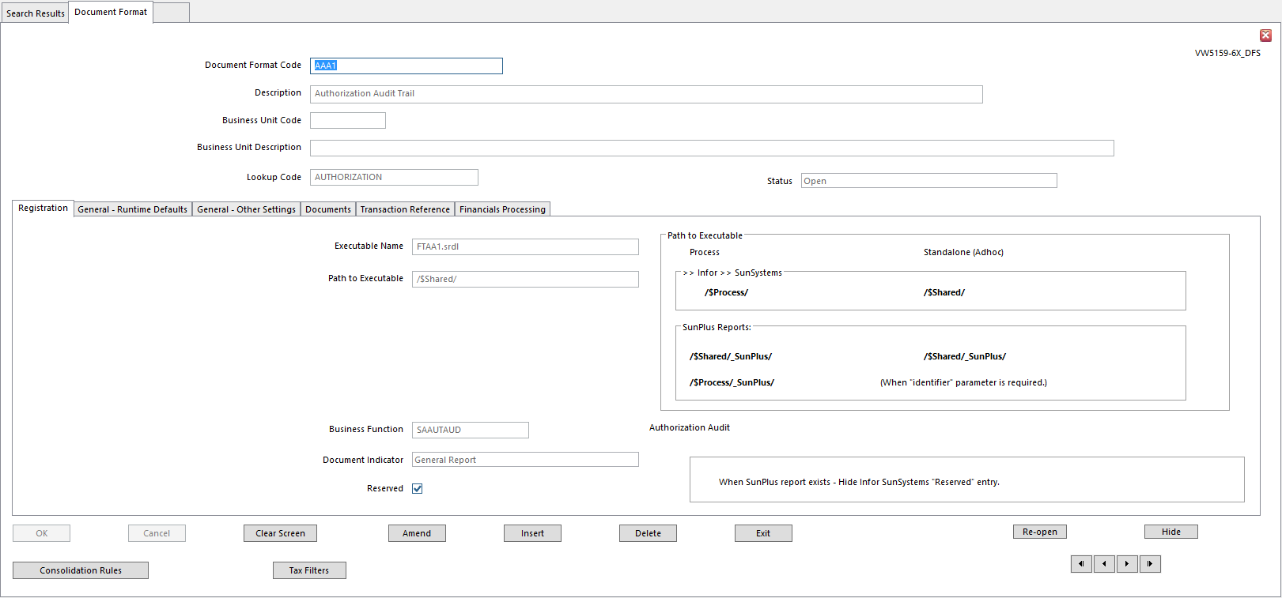
- Document Format Code
- Description Description of Document Format
- Displayed next to Format Code to identify report
- This field must be populated
- Business Unit Code Leave blank if Document Format can be used by any Business Unit
- Business Unit Description Automatically populated when Business Unit Code field is populated
- Lookup Code
- Executable Name Name of report file that will produce the report
- Path to Executable Path identifying location of report file
- Left blank, the default report execution folder is used
- Business Function SunSystems function for which report will be run
- Document Indicator Select Document for a report that requires the Document settings, for
example, if it requires special stationery, test print, or reprint options.
- Determines if Document tab parameters are required
- Otherwise, select General Report
- Reserved When set, Document Format cannot be amended or deleted

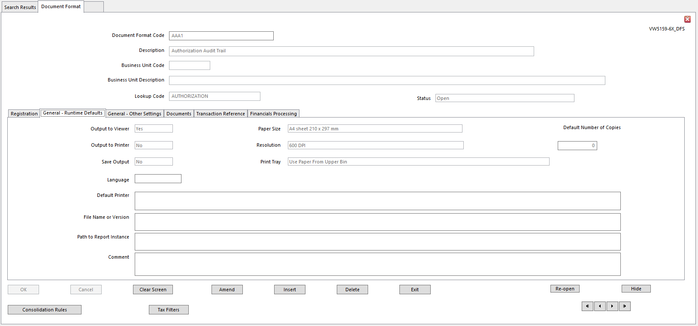
These options provide default settings for the General tab on the Document Format Run Time Report Parameters form displayed at report run time:
- Output to Viewer Yes – defaults to onscreen display of report rather than print
- User can override this on Run Time Parameters form
- Output to Printer Yes – defaults to sending report output to a printer
- Override available on Run Time Parameters form
- Save Output Yes defaults to saving the output in the report store
- Override able on Run Time Parameters form
- Paper Size Not used
- Resolution Not used
- Print Tray Not used
- Default Printer Not used
- Default Number of Copies Not used
- File Name or Version Default name of report file, if report is stored in a file
- File name is displayed in Report Instance Name field on Run Time Parameters form
Left blank, the name of the file becomes the default name
- Path to Report Instance Path of folder in which the report files are stored
- Comment Any comment to store about the report
        - Will be printed on front page of report
        - Could be printing instructions, for instance
- Language Language in which document or report will be produced

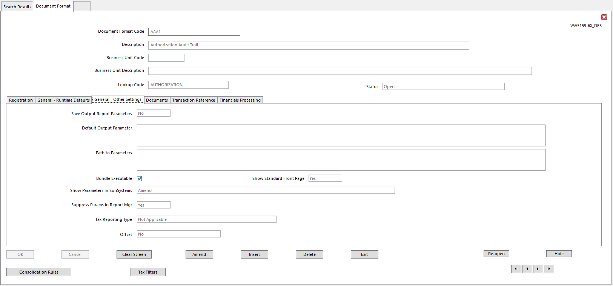
- Save Output Report Parameters Not used
- Default Output Parameter Not used
- Path to Parameters Not used
- Bundle Executable Not used
- Show Standard Front Page Sets option to print standard front page on report
- Show Parameters in SunSystems Determines if parameters are displayed and amendable at
run time
- Suppress Runtime Parameter Display in SunSystems – if set, Document Format Parameters form does not appear at run time
    - set if there are no user definable parameters
- View Only – allow user to view but not change parameters
- Amend – allow user to view and override default report parameters
- Suppress Params in Report Manager Determines if parameters will display on Report
Parameters form at run time
- Tax Reporting Type If Document Format produces Tax Report, this identifies SunSystems
module from which tax related transactions’ details are extracted
- Offset Set for Tax Reports
        - Offset transactions are automatically extracted for each tax related transaction
        - When a tax related transaction is selected for reporting, all balancing transactions posted in journal are also extracted

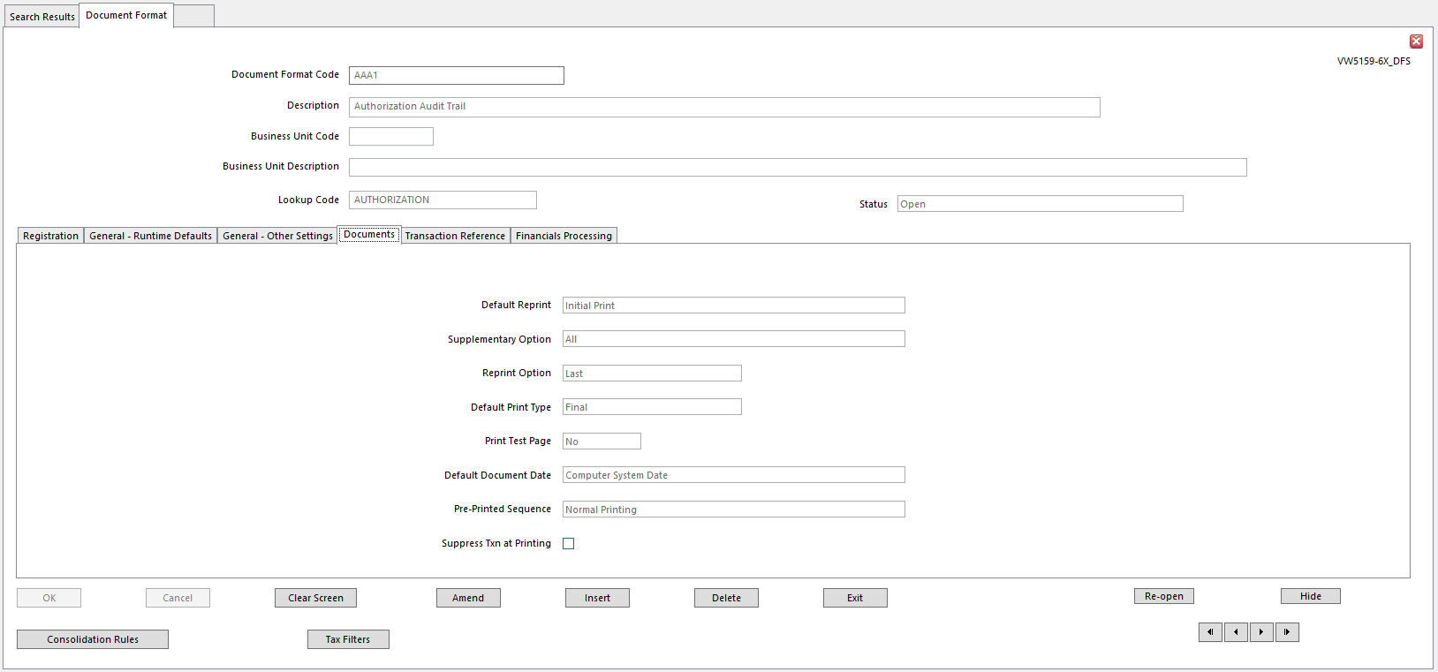
- Default Reprint Indicates default type of report
- Initial Print
- Supplementary Print
- Reprint
- Supplementary Option If supplementary report is requested, determines if report should
include:
- All items for report, including those printed on initial versions of the report (default)
- Only new and amended (supplementary) items
- Reprint Option Determines default settings for a reprint
- Last – select if this is last time report can be produced
- Copy – select to clearly mark reprinted report as a copy
- Default Print Type Determines if report is a Draft or Final Print
        - If Final Print is not set, draft version of document is produced
        - Draft documents include word DRAFT in large characters
- Print Test Page Set to print a test page before main body of report
- Default Document Date Options:
- Operator Login Date – current login date is used
- Computer System Date –system date on print server is used
- Suppress Txn at Printing Check only if Transaction Reference Format field is set on Transaction
Reference tab
- Check to suppress Transaction Reference generated on production of document

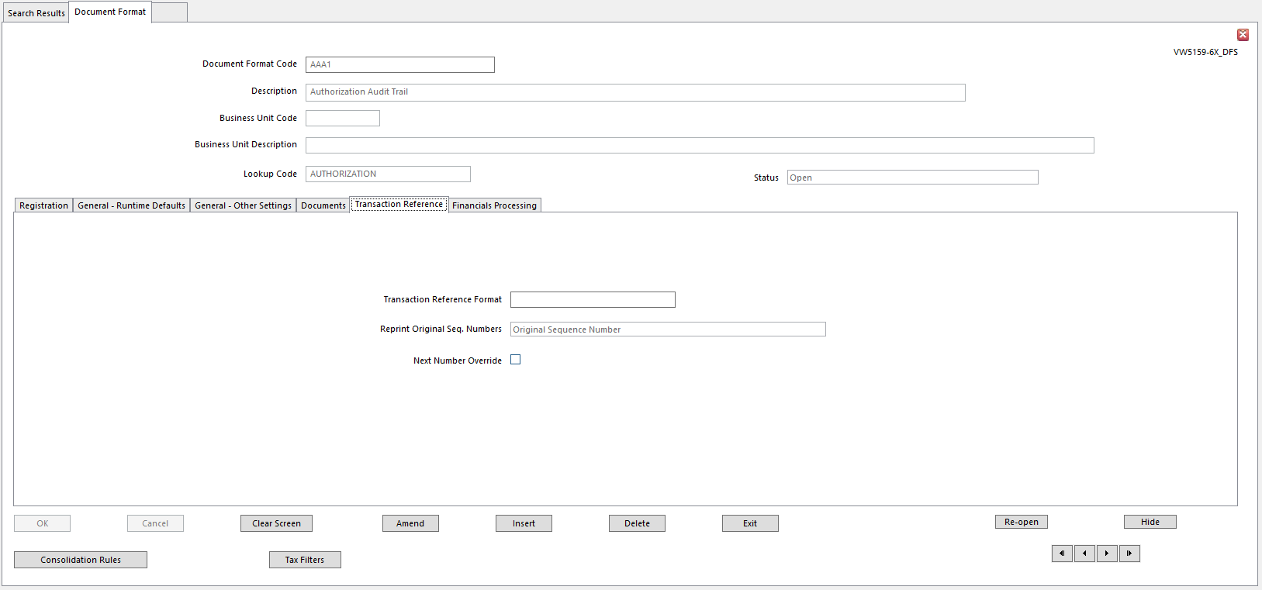
- Transaction Reference Format Name of Transaction Reference Format set up using
Transaction Reference
- Transaction Reference - used to number transactions
- Reprint Original Seq Numbers Determines if reprints will use Original Numbering Sequence or
a new one
- To reprint cheques with Original Cheque Numbers, field must be set to Original Sequence Number
- Next Number Override New Sequence Number can be entered at run time
- Normal Printing – no special sequencing is required
  - Sequence Number pre-calculated, based on each change of group
- Pre-Printed Stationery – Select if stationery includes pre-printed Reference Numbers and it is not possible to pre-determine how many rows will fit a page
- Page Level Sequencing – select to pre-calculate Sequence Number Sequence and page numbers used in document
  - Sequence Number increment may be based on Number of Lines per Page setting, and number written back to transactions depends on Sequence Number Position setting
  - Only use these settings if rows on report are set to a fixed height and cannot be expanded dynamically
- Number of Lines per Page Enter number of lines to be shown on each page of document
        - Remaining lines will be printed on an overflow page
- Sequence Number Position Options:
- Undefined
- First Page on Group
- Last Page on Group
- Every Page

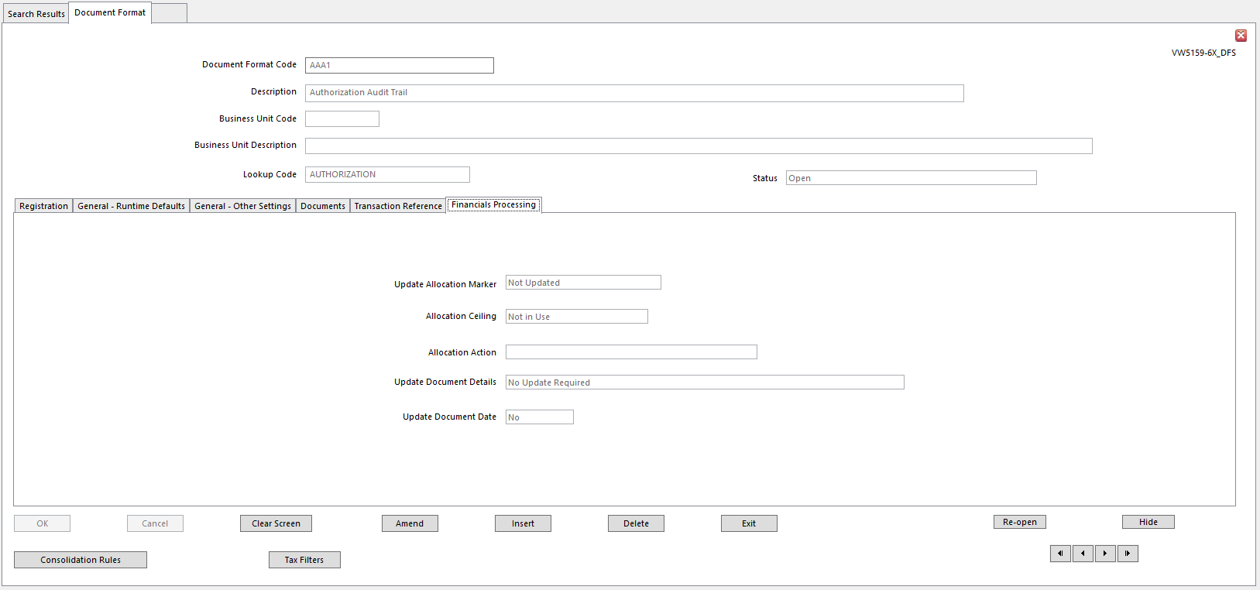
- Update Allocation Marker Allocation Marker can be automatically incremented when a
document is printed
- Identifies new marker to replace existing Allocation Marker
- Enter number in range 1-9 to be new Allocation Number applied after printing
- Enter ‘+n’ – plus sign and number between 1 - 9 to increase Allocation Marker of all transactions included on report by that number, or up to ceiling identified in Allocation Ceiling field, whichever is lower
- Enter a ‘-‘ – hyphen and a number between 1 -9 to decrease Allocation Marker by that number, or set to zero, whichever is higher
- Enter any other Allocation Marker to set Allocation Marker on all transactions included on report to this value. For example, enter F to set all Allocation Markers to Force
- Allocation Ceiling Maximum Allocation Number for transactions in documents with
format
- Enter number in range 1-9 as Allocation Ceiling, or NOT in Use
- If a ‘+’ sign is chosen as Update Allocation Marker, Allocation Marker is incremented up to ceiling identified here
- Allocation Action Allocation Code can be automatically amended when document is
printed
- This identifies Allocation Action Code to update Allocation Code
- Update Document Details Document Date or Reference updated for document when report is
printed
- Yes - select one of the following to update Document Date or Transaction Reference:
- First Document Details to be Updated
- Second Document Details to be Updated
- Third Document Details to be Updated
- Fourth Document Details to be Updated
- Transaction Reference will be Updated
- No Update Required
- Update Document Date Determines if document details will be updated after report is
produced
- Yes - update details identified above, otherwise No

- Consolidation Rules button Click Consolidation Rules button, this message will be displayed:

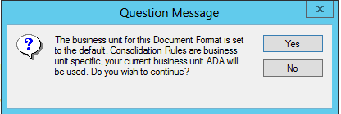

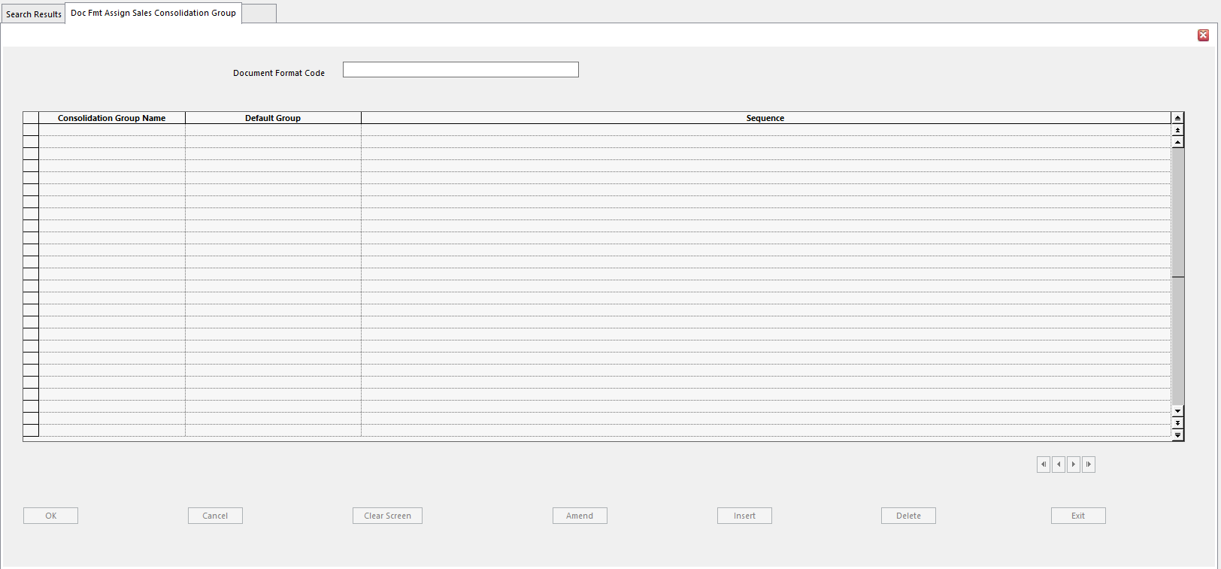
- This has to do with Sales Consolidation Rules. Typically SunPlus sites do not use these settings.
- Tax Filters Button If Tax Filters button is clicked, this message is displayed:

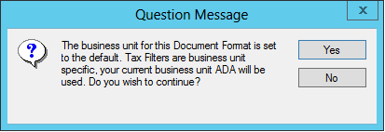
- If Document Format is used for Tax Reporting, one or more Tax Filters are required to select tax related transactions to include in the report
- Standard Filters can be used, or new ones created using Filter Designer
- Filters can be modified to assign additional selection criteria to tax reporting, for example, to use an Analysis Dimension as a selection criterion

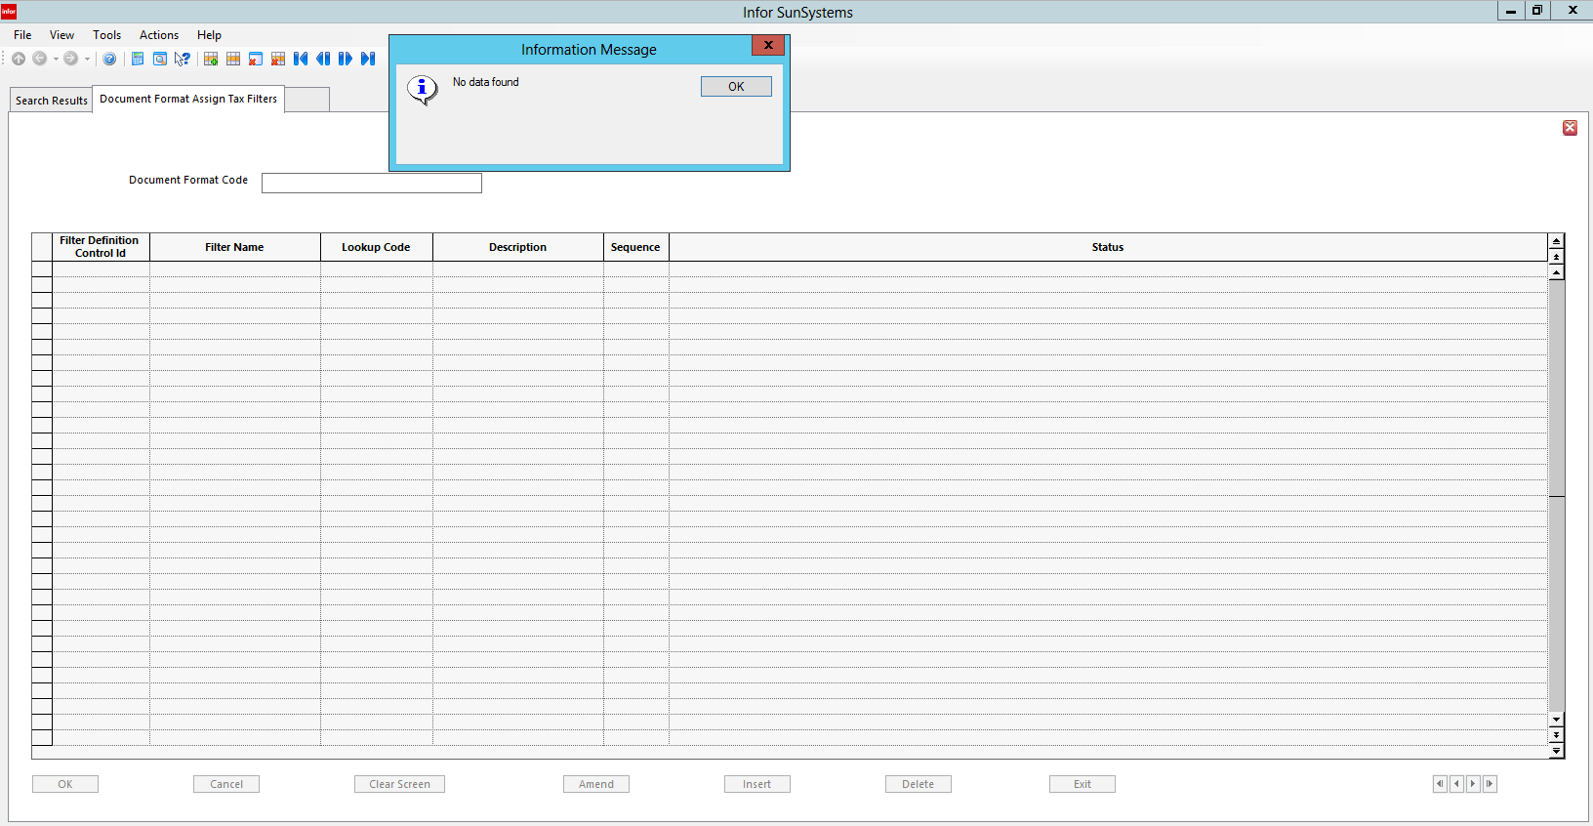
Attach one or more filters to Document Format. To attach a filter:
- Select Action menu
- Select Assign Tax Filters or click Tax Filters button to display Document Format Assign Tax Filters form
- In Document Format Assign Tax Filters grid, select required filter in Filter Definition Control Id
  - Optionally add a Lookup Code and Description for this filter
- Click OK to assign the filters to Document Format
- Click Exit to close Document Format Assign Tax Filters form and return to Document Format

Form Designer

Form Designer is one of a suite of tools that can be used to customize SunSystems. Use Form Designer to copy and modify existing SunSystems forms or create your own forms. You can add your selection of data items and controls to a form and specify your own help text to assist users.

When forms have been created or modified, permission levels for individual operators can be set using Form Permissions Editor and Security Console or User Manager. This means the system can be set up for individual users so they only have access to the functions and data that are pertinent to their specific role.

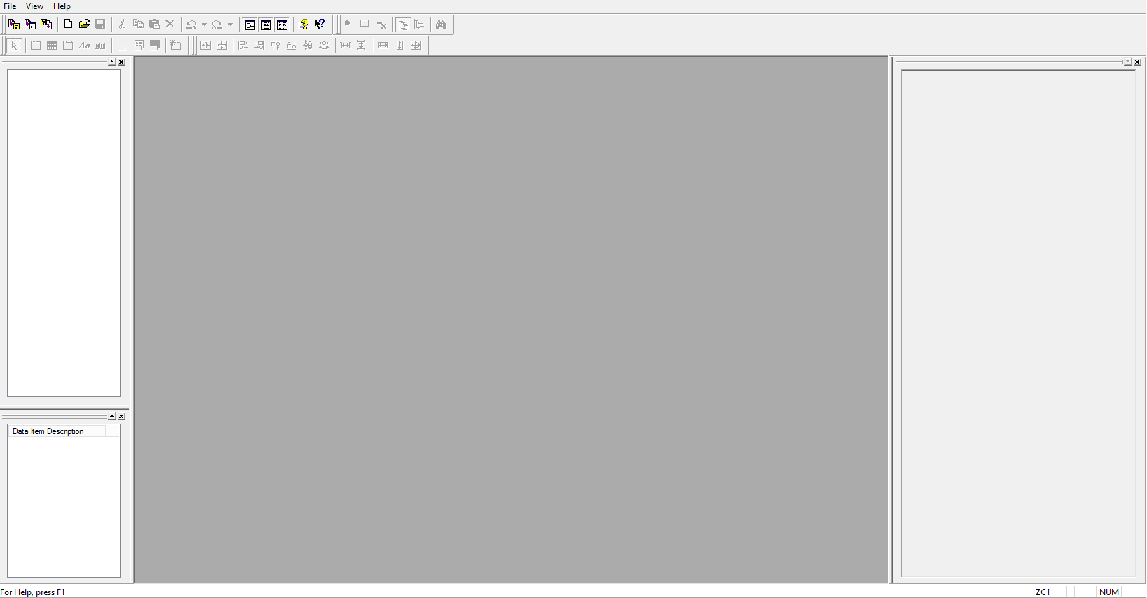

Window Layout

Form Designer has four areas:
- Data Item Hierarchy Top left of default Form Designer window
- Data Item List Bottom left of default window
  - When a form is opened or created, relevant Data Items for that function are displayed.
  - Mandatory Data Items are indicated by red bullet
- Form Center of default Form Designer window
  - Where forms are created or amended
  - Displays form and Data Items placed on it
- Properties Bar Right hand side of default window
  - Displays properties of the form and form controls

Toolbars

Toolbars provide access to = functionality associated with Standard, Data Item, Layout and Toolbox toolbars.

Status Bar displays current Operator Id and keyboard settings such as Caps and Num Lock.

When a form is open, Data Item Hierarchy, Data Item List, and Properties bar are populated with information about the current function and form and the Status Bar indicates the current language.

Data Item Hierarchy

The Data Item Hierarchy displays data items available to the selected form in manageable subsets. To view subsets, expand or collapse the hierarchy tree.
- Show the Current Node button on Data Item toolbar to populate Data Item List only with items from the current node of Data Item Hierarchy
- Show Current Sub-Tree button on Data Item toolbar to populate Data Item List with items from the current node and all sub-nodes of Data Item Hierarchy
- Data Item Toolbar
- Hide Non-Mandatory, Non-Entry, Used Data Items
- Use Hide Non-Mandatory Data Items to show only Mandatory Data Items in Data Item List
- Use Hide Non-Entry Data Items to hide non-entry Data Items in Data Item List
- Use Hide Used Data Items to hide items on Data Item List which are already added to form
- Show Current Node and Show Current Sub-Tree
- Use Show Current Node to populate Data Item List only with items from the current node of Data Item Hierarchy
- Use Show Current Sub-Tree to populate Data Item List with items from current node and all sub-nodes of Data Item Hierarchy
- Search Data Item List
- Use Search Data Item List to search Data Items List for specific data items
- Standard Toolbar
- Check Out, Local Compile, Check In
- New, Open, Save
- Cut, Copy and Paste, Delete
- Undo, Redo
- Window Layout
- Use Toggle Data Item Hierarchy to show or hide Data Item Hierarchy
- Use Toggle Data Item List to show or hide Data Item List
- Use Toggle Properties to show or hide Properties bar
- Help Topics, What’s This Help
- Use Help to open Contents and Index for Help file (F1)
- Use What’s This? to display explanations of controls and windows (Shift+F1)
  - When you click What’s This? The mouse pointer changes to a question mark and arrow
  - Click on the item you want to know more about
  - Click anywhere on the screen to close the popup window
- Layout Toolbar
- Center Horizontally and Vertically
- Use to center selected controls horizontally and vertically within the container they reside in
- Select more than one control at a time by holding down the Ctrl key and clicking or dragging mouse pointer over a selection of controls
- Aligning – Align Left and Right, Align Top and Bottom, Align Centrally
- Use to align selected controls in relation to each other based on a common edge
- Last control selected has blue handles instead of white
- Blue handles mean control has priority and it is that control which the others are aligned against
- Evenly Spaced Horizontally and Vertically
- Use to evenly space selected controls horizontally and vertically within container where they reside
- Each control is treated as an individual item
    - To evenly space controls with corresponding labels, to select labels and evenly space them separately
- Resizing, Make Same Width and Height
- Use Make Same Width and Make Same Height to change selected controls to same width or height as dominant control – the object with blue handles
- Use Make Same Size to change selected controls to the same size as dominant control
- Toolbox Toolbar 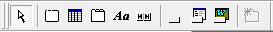
- Selection Mode
- Click button and then click controls to select them
- Select multiple controls by holding Ctrl key down
- Or drag your mouse around a group of controls
- Frame
- Use to add a frame to form
- Frames are effective ways to segment data within a form or tab
- Grid
- Use to add a grid to form
- Grids are useful if users should be able to view many records at the same time
- Tab Control
- Use to add a tab page control to form
- Further tabs can be added by using Add Tab Page also on the Toolbox toolbar
- Text Label
- Use this button to add labels or relevant comments to form
- Navigation Control
- Use Navigation Control to incorporate multi-record interaction into form
- Action, Function, Application
- Use Action to add an Action command button to form
- Use Function to add Function command button to form
- Use Application to add Application command button to form
- Add Tab Page
- Once a tab control has been added to a form, use Add Tab Page to add additional tabs

Customize Toolbars

- Go to View menu
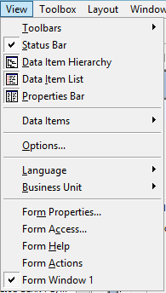

- Select Toolbars
- Select Customize

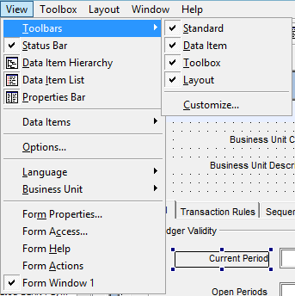

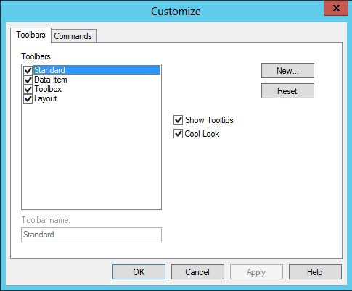

- If you untick the items in the Toolbars pane, notice the effect on the Form Designer toolbar

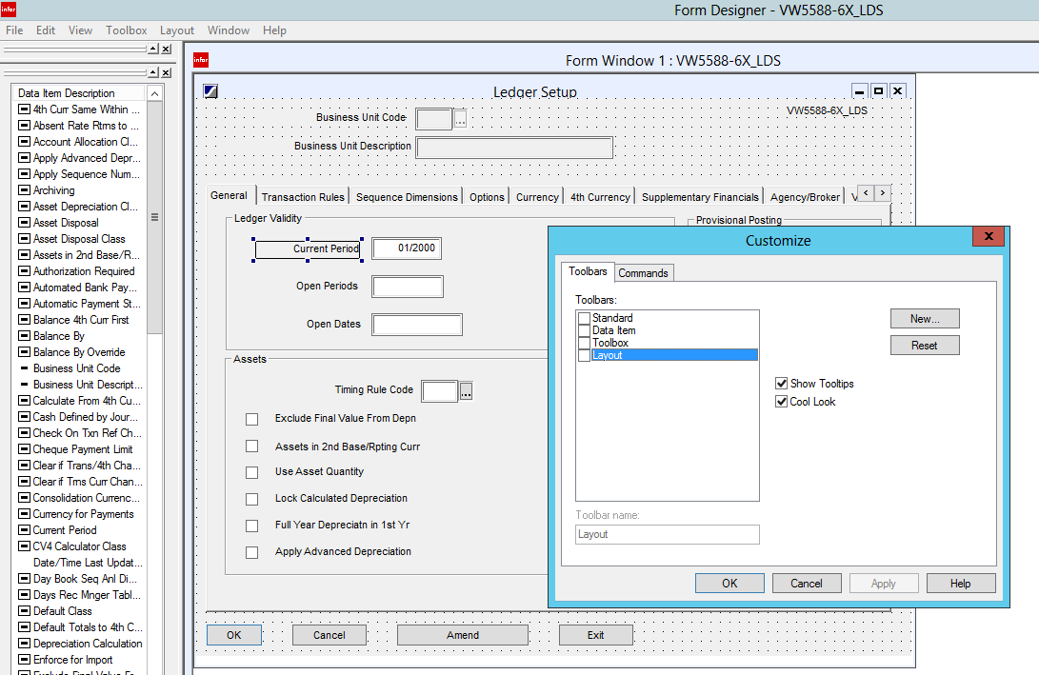
- If you tick items in the Toolbar pane, notice that those toolbars reappear in the window
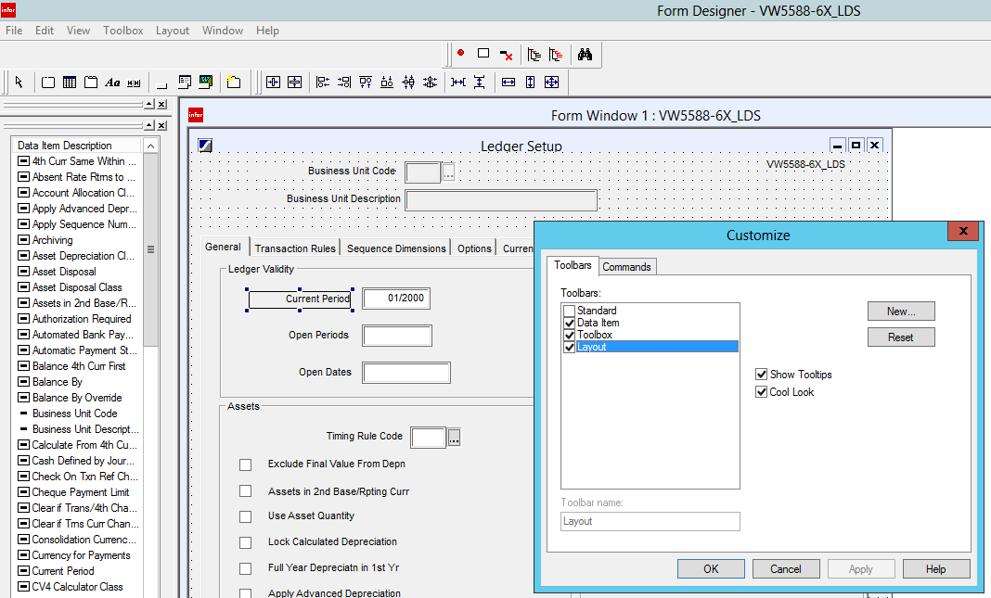
- The way the toolbars are displayed can be rearranged by clicking on the double vertical bars at the left side of each toolbar and pulling that toolbar to the location where it should be displayed

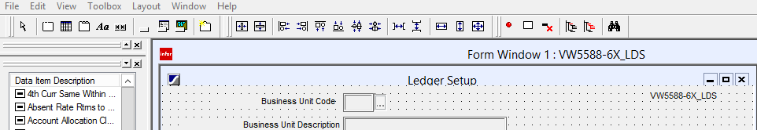
- If the Show Tooltips checkbox is left unchecked, when the cursor is hovered over a toolbar icon, the tooltip will not be displayed

Using Form Designer

When Form Designer is first open, it is a good idea to go to View menu and select Options.

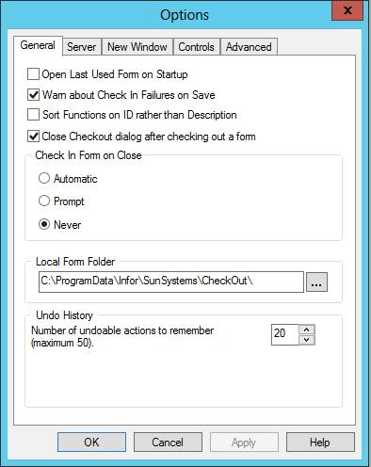
- On General tab, modify how Form Designer works
  - Two settings to modify according to preferences are:
- Sort Functions on ID rather than Description – helps when selecting a form to work on
- Check In Form on Close – Automatic
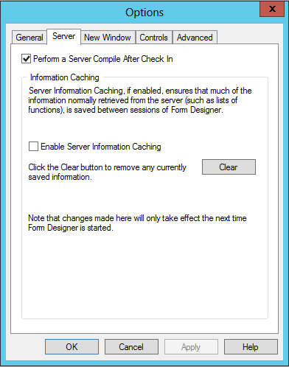
- On Server tab, be sure Perform a Server Compile After Check In is ticked

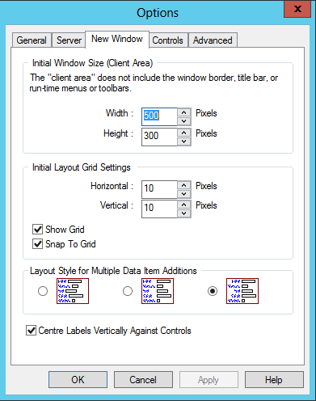
- On New Window tab set window parameters

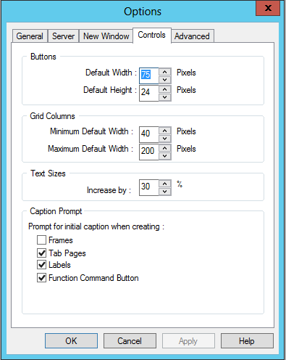
- Controls tab sets defaults for various form features

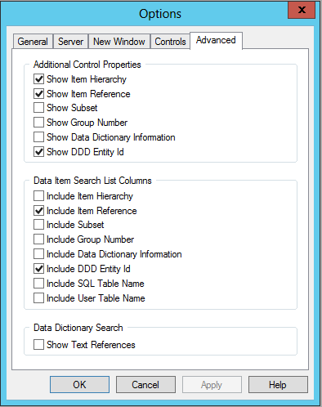

Work on Form
- Check Out Form Use first icon on left of icon bar to check out a form

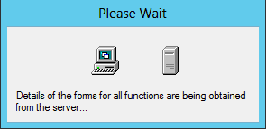

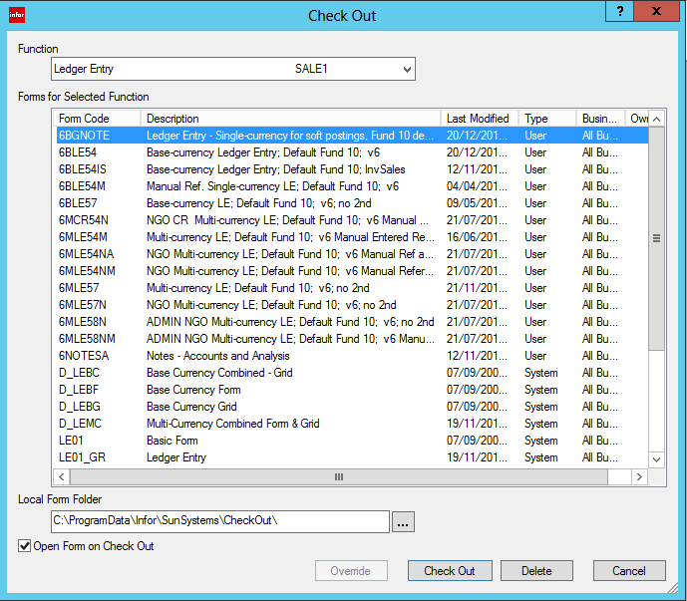
- Note Open Form on Check Out check box at bottom left of interface
  - It is very helpful to have that box checked
- Choose Function form to work on from this list

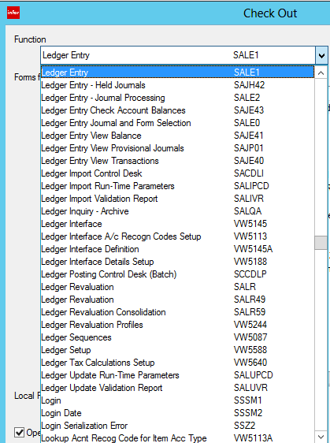
- Select form to check out

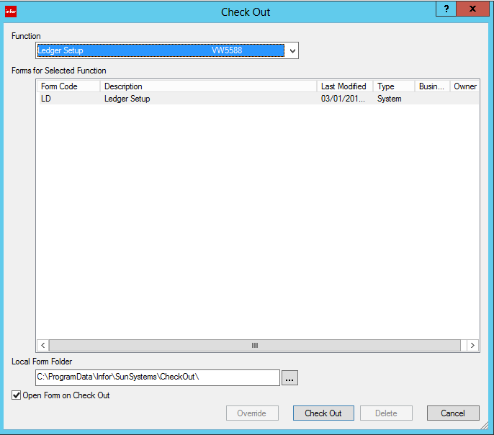
- Click Check Out

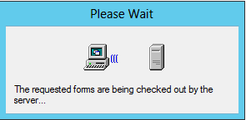

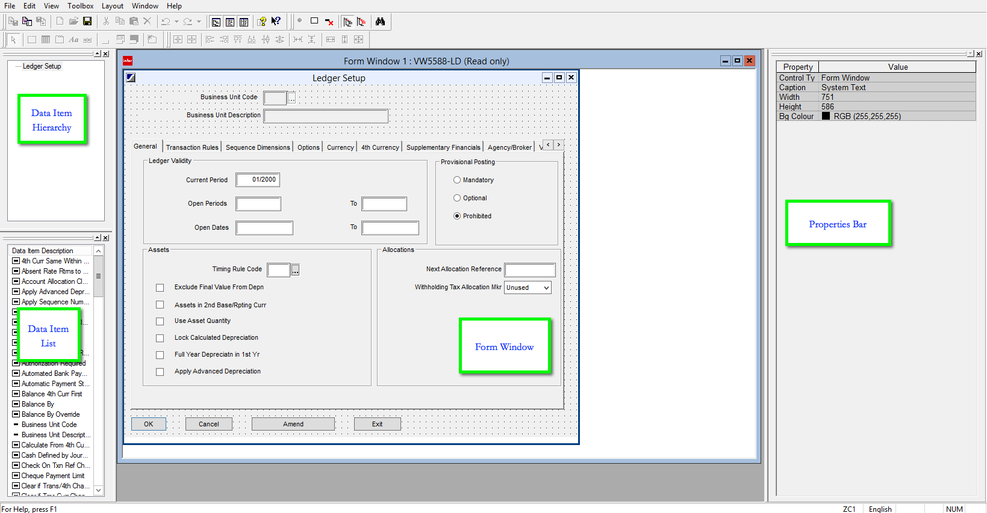
- Notice the checked-out form is “Read Only”
- Save a copy of this form

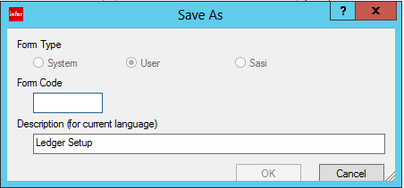
- Enter the code for the new SunPlus form
- SunPlus naming conventions stipulate that SunPlus form codes begin with a 6
- Change the Description text by typing in the Description field
- Click OK

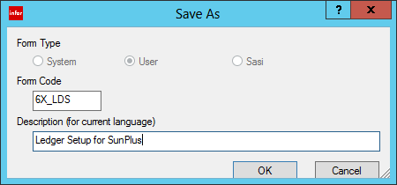
- SunPlus convention is to place Form Code for the new SunPlus form in the form header
- This makes choosing a form to modify much easier

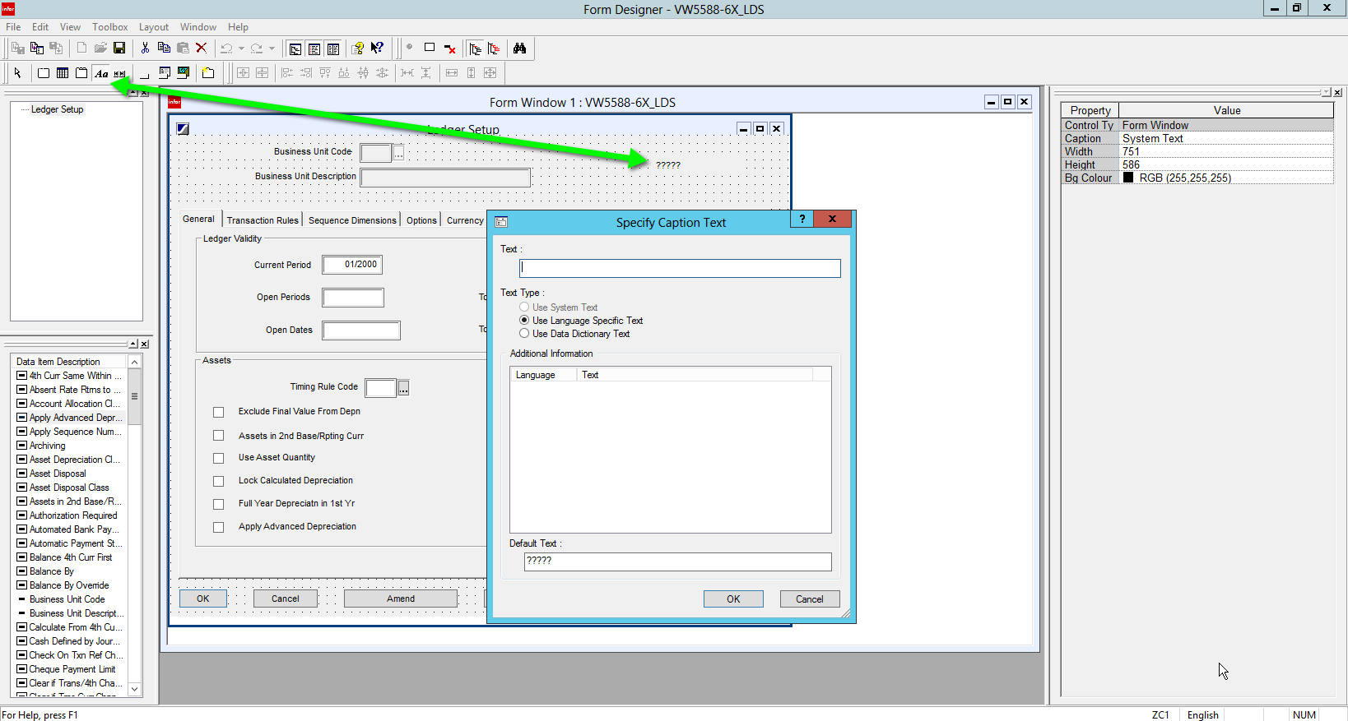
- Aa icon on the left side of the icon bar is the icon for a Caption
- Click the Aa icon and create a box in the area of the header where the Form Code should be displayed
- Specify Caption Text interface is displayed
- Enter text to be displayed in Caption box in the Default Text field of Specify Caption Text interface

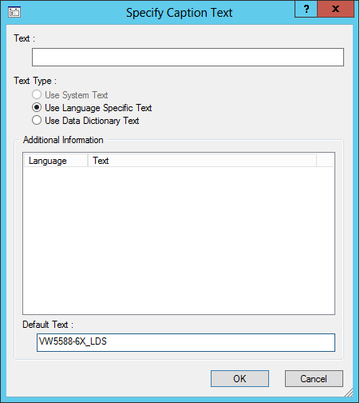
- When OK is clicked, the Caption will fill in

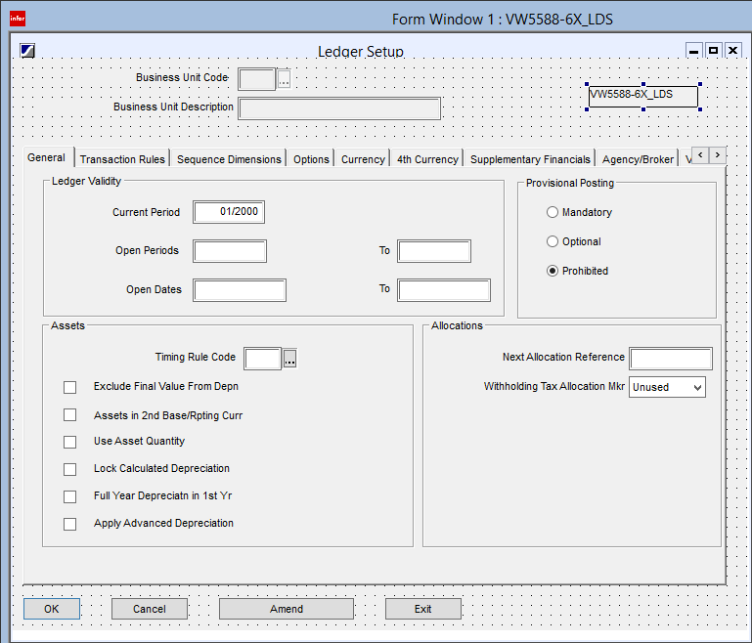
- To move Caption, click on it and drag the box where it should be displayed
- To modify size of Caption box pull box handles in the necessary direction

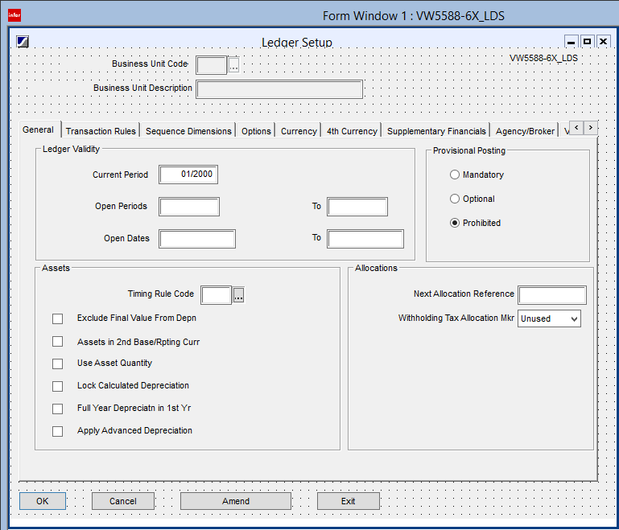
- When form needs to be modified in some way, easily identify the form to be modified by using the VW5588-6X_LDS code

Data Item Hierarchy

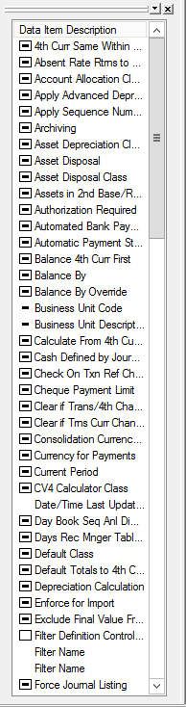

- In Data Item List, black dash enclosed in the box to the left of Data Item Name indicates that item is already located somewhere on existing form

Filter Designer

Create New Filter Process

- Go to Filter Designer

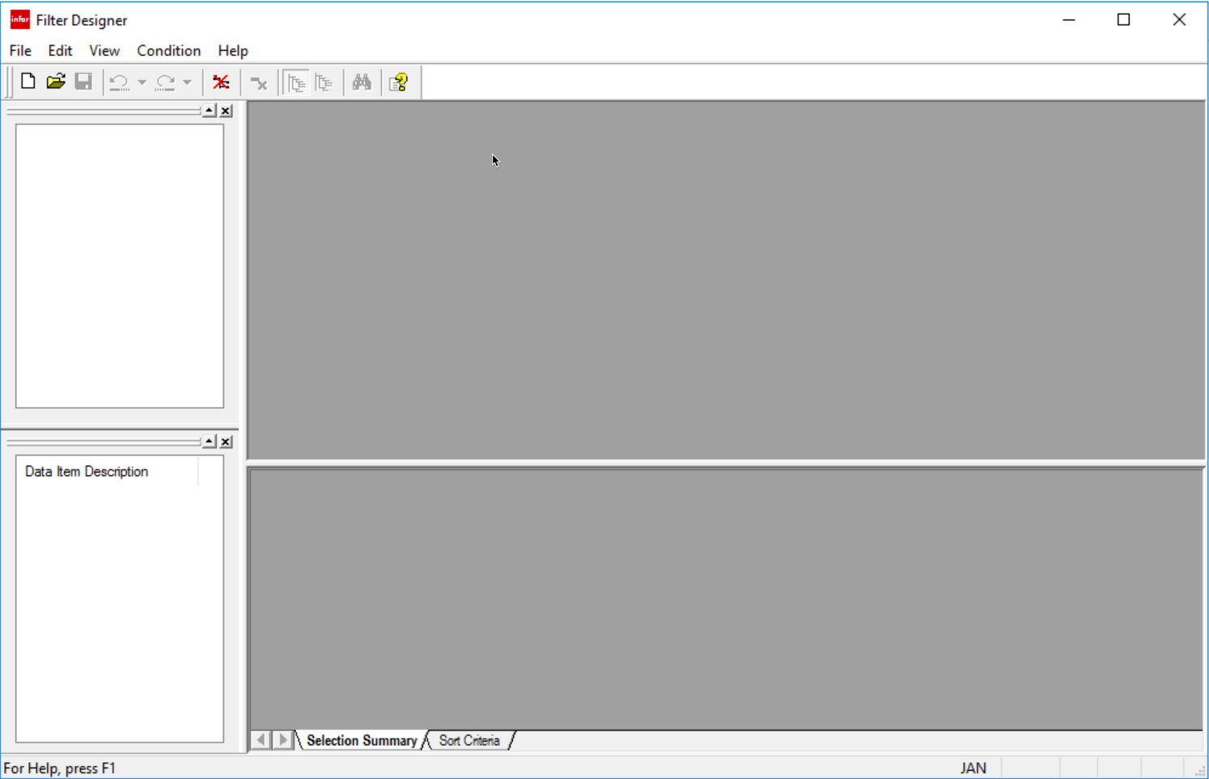

- Go to the File menu

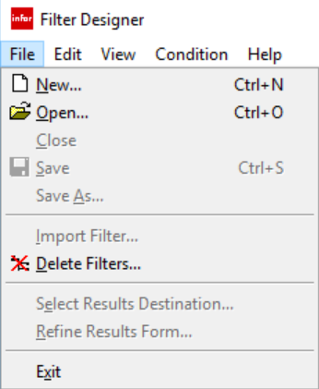
- Select New

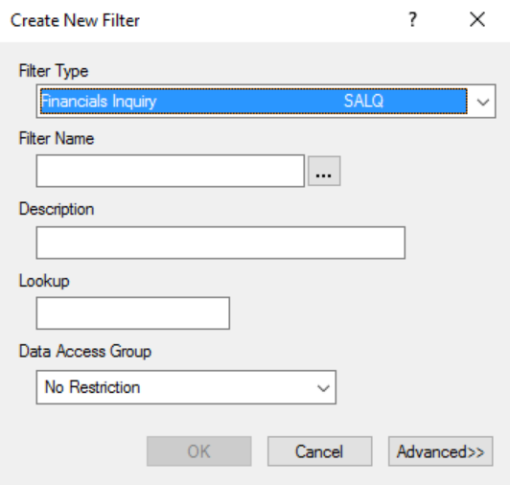

- Select Filter Type, assign Filter Name, Description, and Lookup

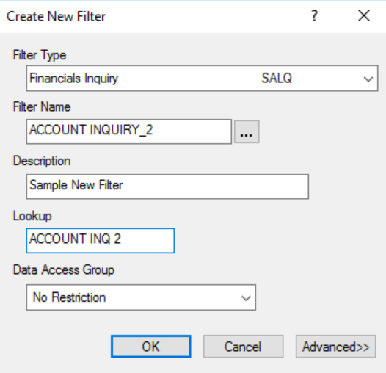

- Click OK

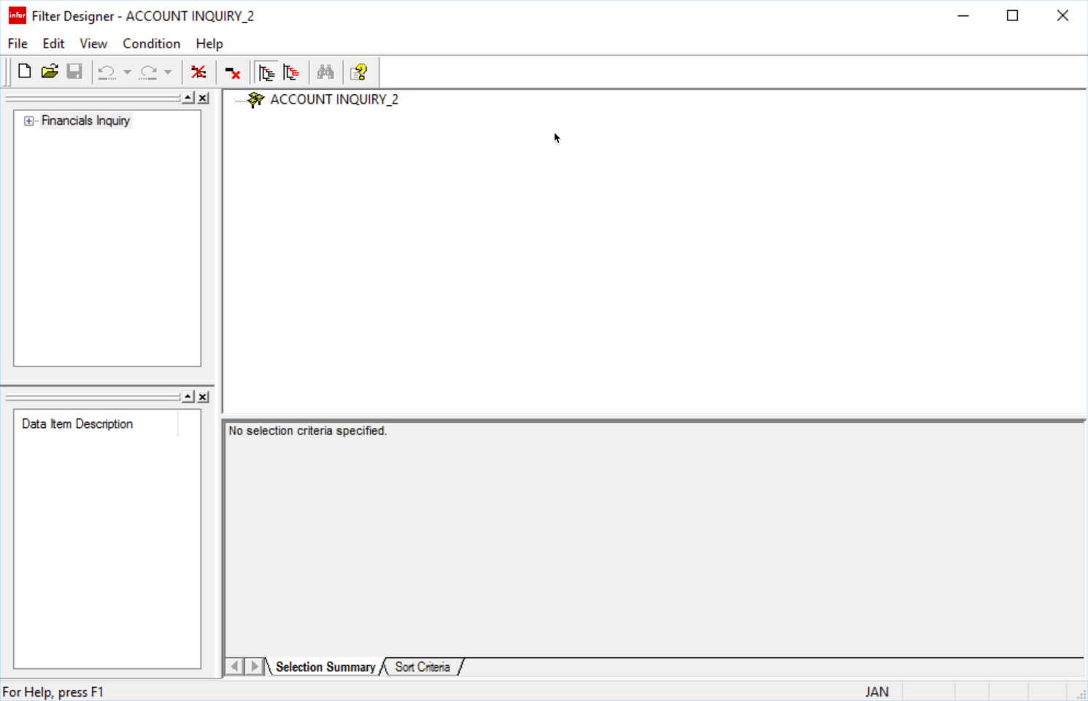
- Add Data Items

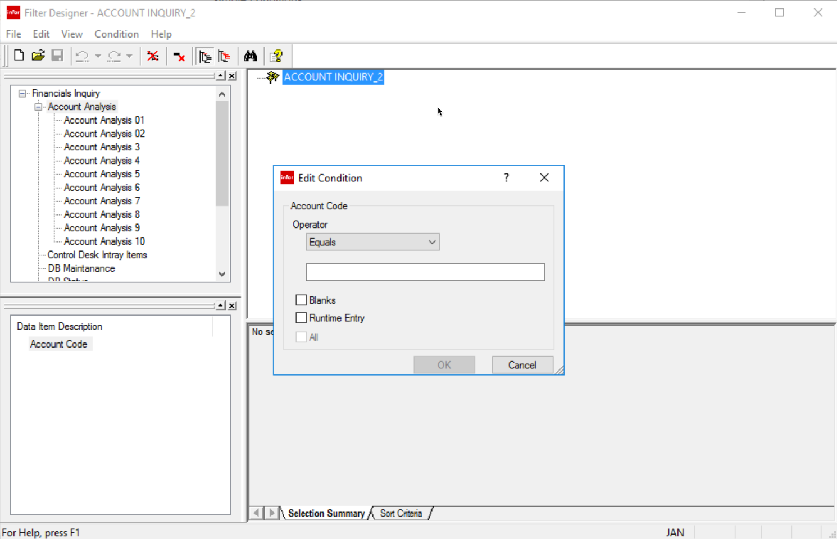
  - Simple Condition – consists of
    - A Data Item
    - An Operator
      - Operator Includes can contain wildcards

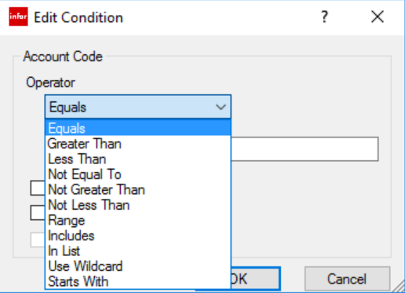
    - 1 or more values
      - Fixed Values are entered at Filter creation time
        - they cannot be modified at run time
      - Runtime Values are entered at runtime
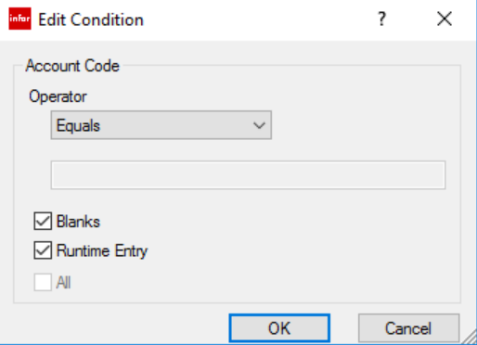
  - Compound Condition – a group of simple conditions joined by the same logical Operator
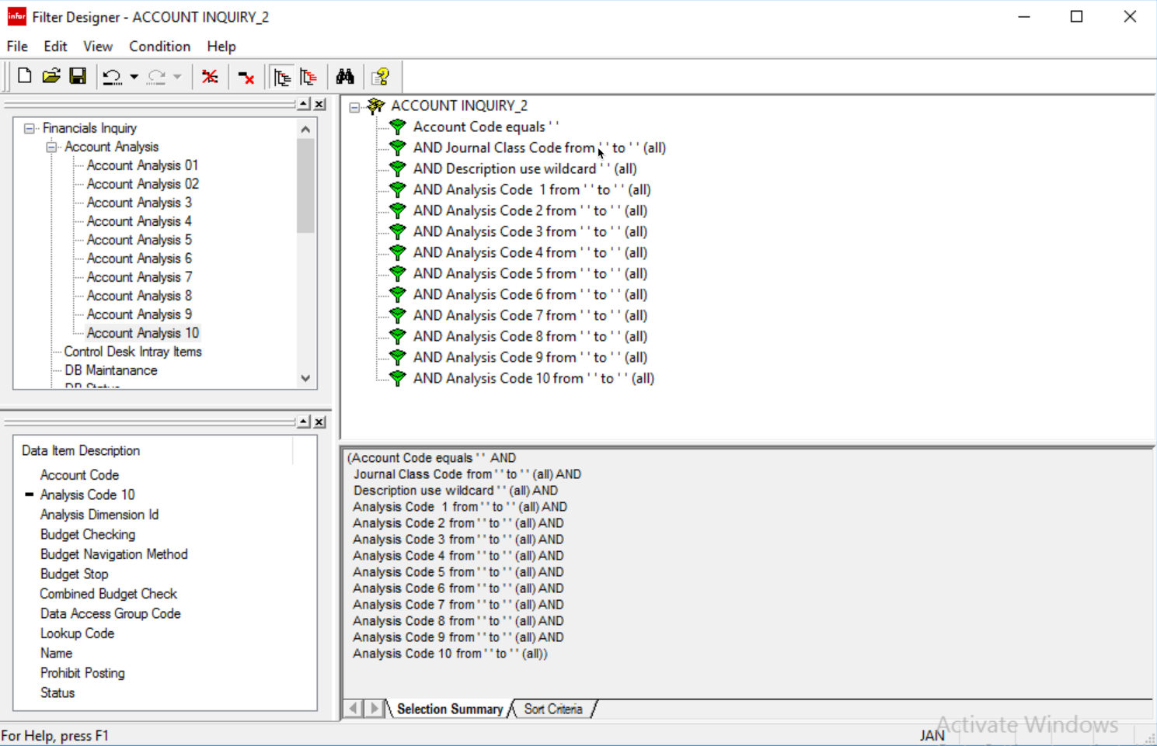
- Set Sort Criteria, if necessary
  - Open Sort Criteria tab in the lower portion of the Edit Area

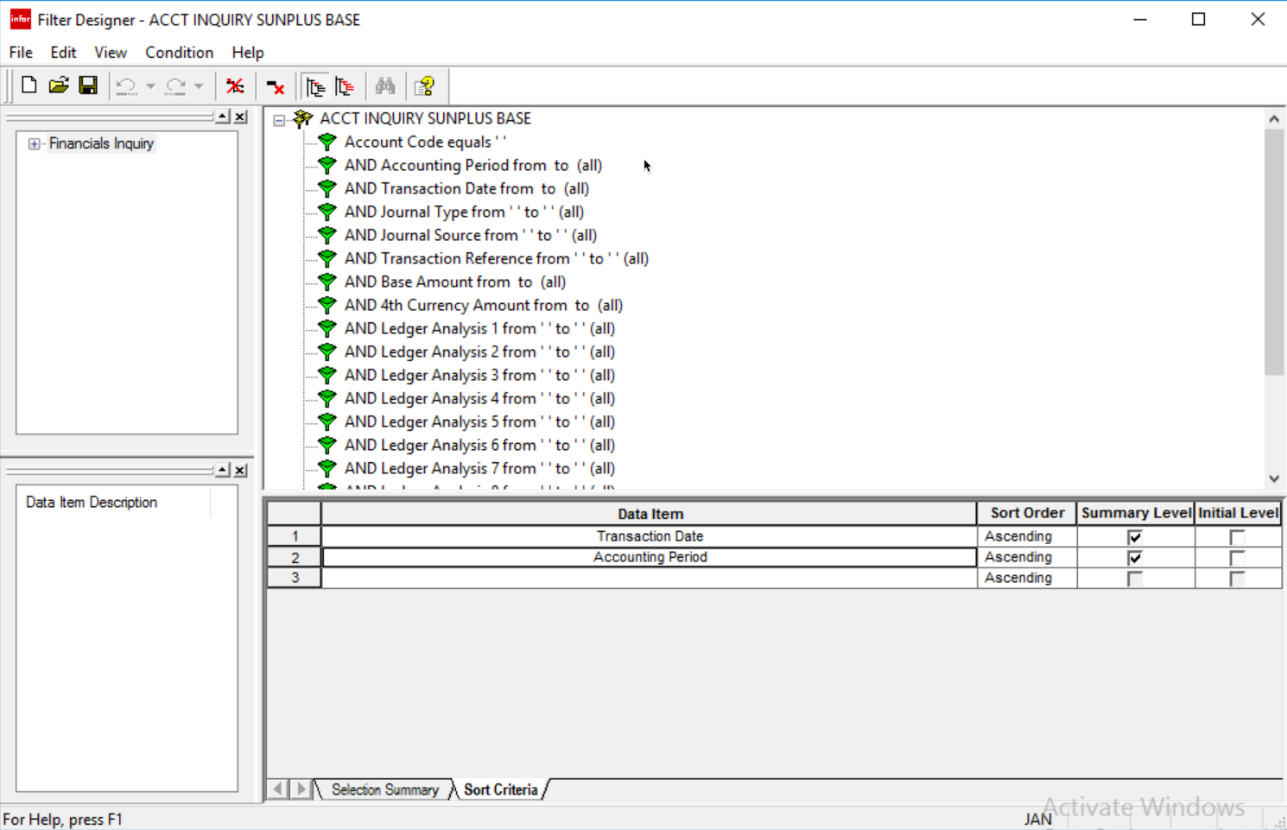
  - To add a Data Item as a Sort Criteria, drag the item from the upper portion of the Edit Area into the desired row of the Sort Criteria grid
    - Default sort order for Sort Criteria is Ascending, this can be changed to Descending by accessing the dropdown menu in the Sort Order column cell for that Data Item
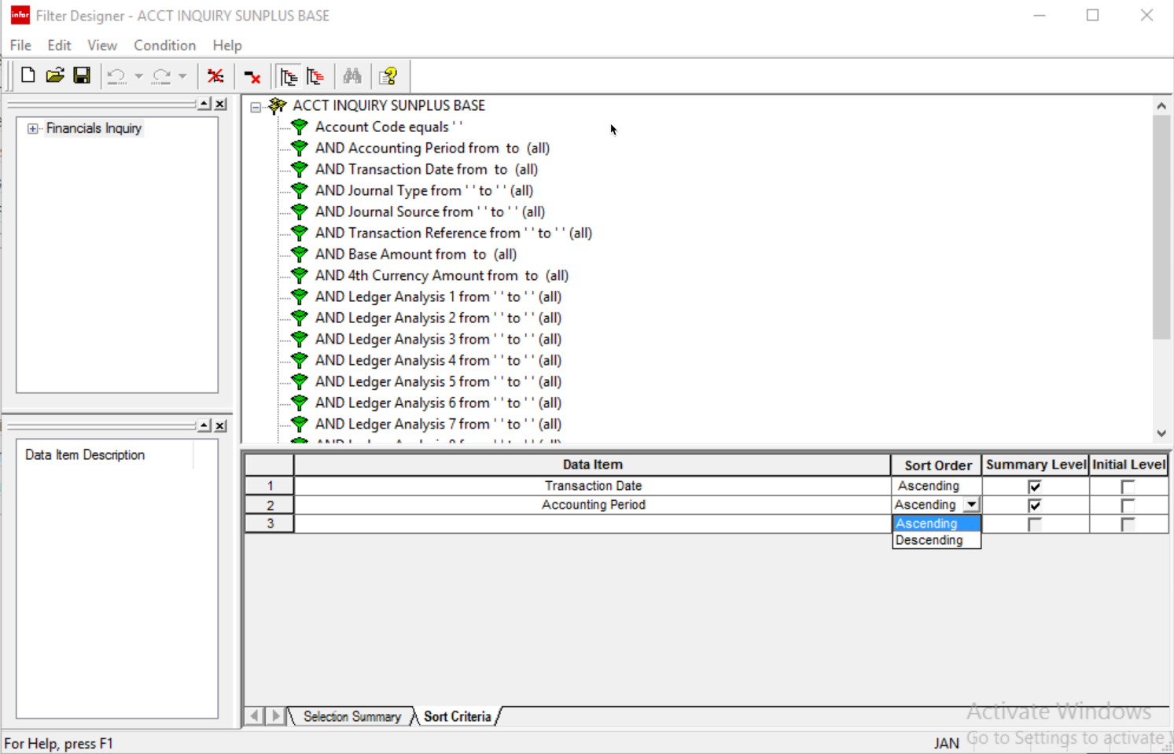
    - Summarization levels can also be set in the Sort Criteria grid

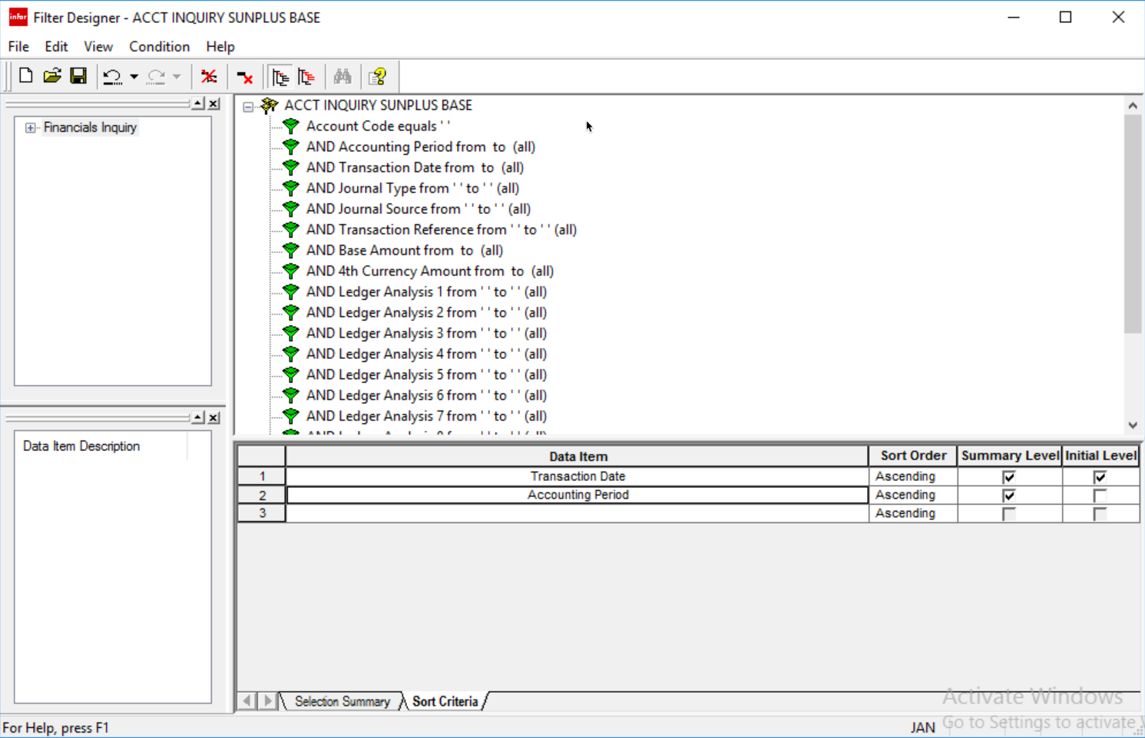
- Data Access Group(s) can be assigned to the Filter, if necessary
  - Go to the View menu on the Toolbar
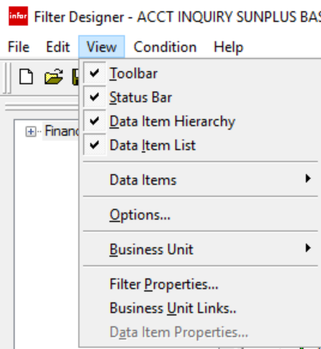
  - Select Filter Properties

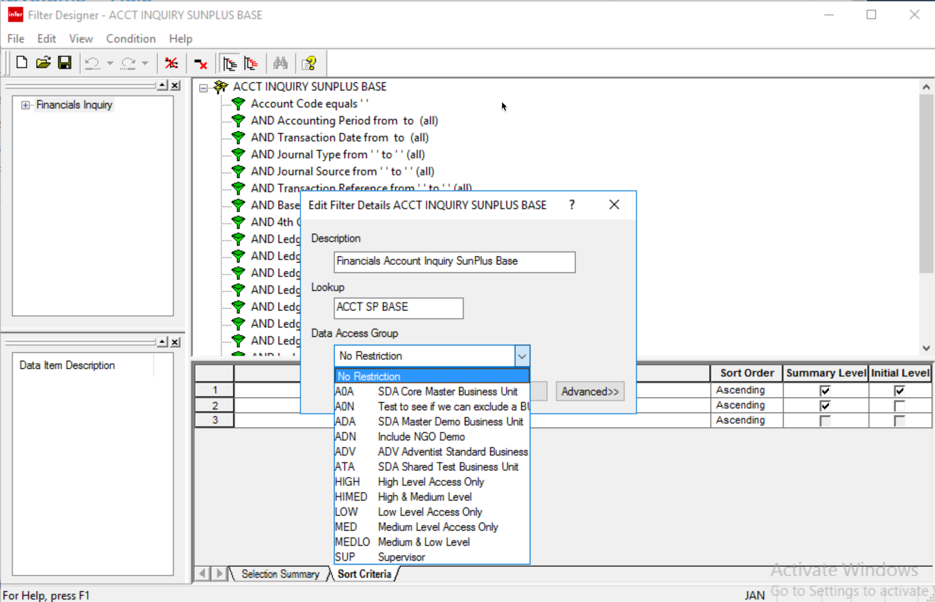
  - Access the dropdown menu for the Data Access Group field
  - Select the Data Item Group to be added to the Filter
- Other settings can be accessed by clicking the Advanced>> button on the Filter Properties interface

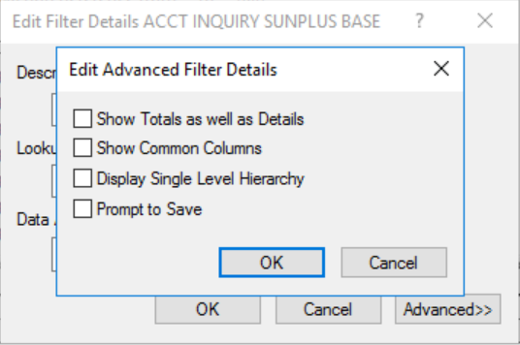
- A Filter can also be associated with a certain Business Unit
  - The default Business Unit setting for Filters is All Business Units, allowing the Filter to be used in all Business Units
  - Go to the View menu on the Toolbar
  - Select Business Unit
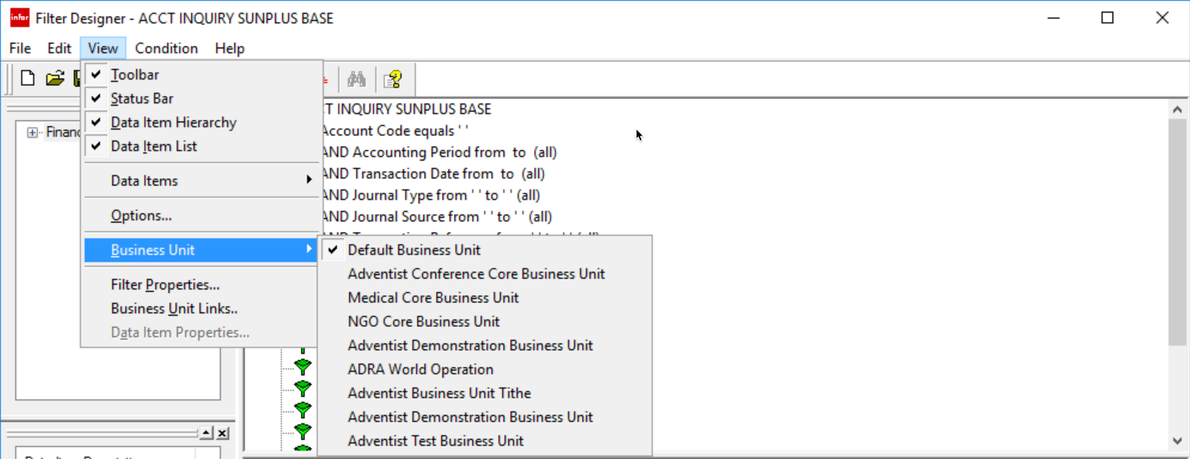
  - Select the Business Unit from the list
  - Click OK
- Once the Filter has been defined, the Results Destination must be set up
  - Go to the File menu on the Toolbar

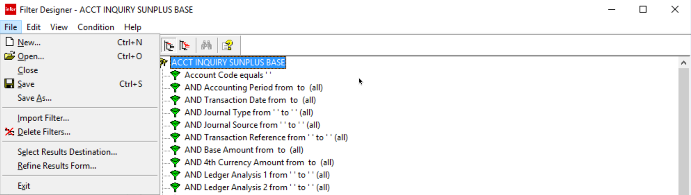
  - Choose Select Results Destination

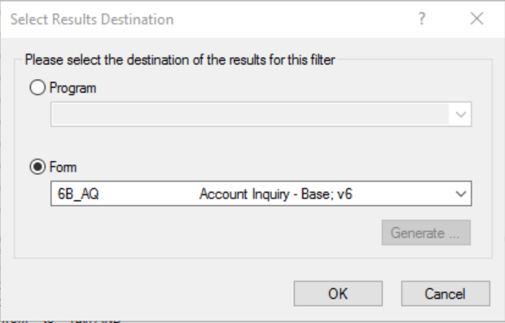
  - There are two choices for destination choice:
    - Program – results can be sent to a program
      - A results report can be printed directly from Document Format if necessary
      - To send results to a program, tick the Radio button for Program
      - Choose the desired destination from the dropdown list
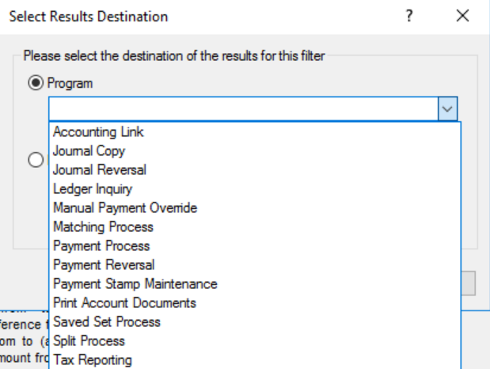
      - Click OK
    - Form – results can be sent to an inquiry results form, when they can be reviewed
      - From the results form, the results can be printed out, using the Control Desk
      - Tick the Radio button for Form
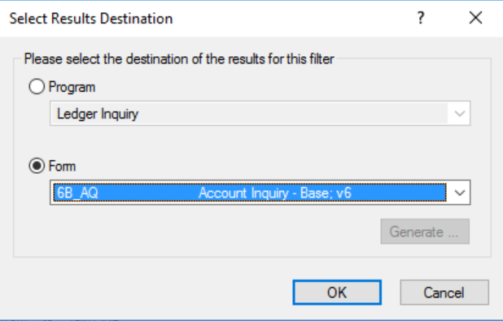

      - Use the dropdown list to select the results form
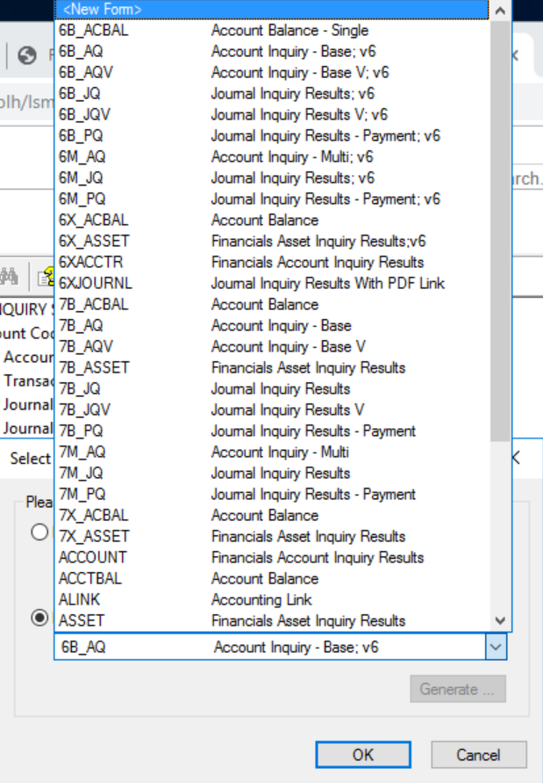
      - Click OK
- Go to the File menu
- Select Save to save the new Filter
- Click OK

Create Filter From Existing Filter

- The easiest way to create a new Filter is to Copy an existing Filter
- Click the Open Filter icon

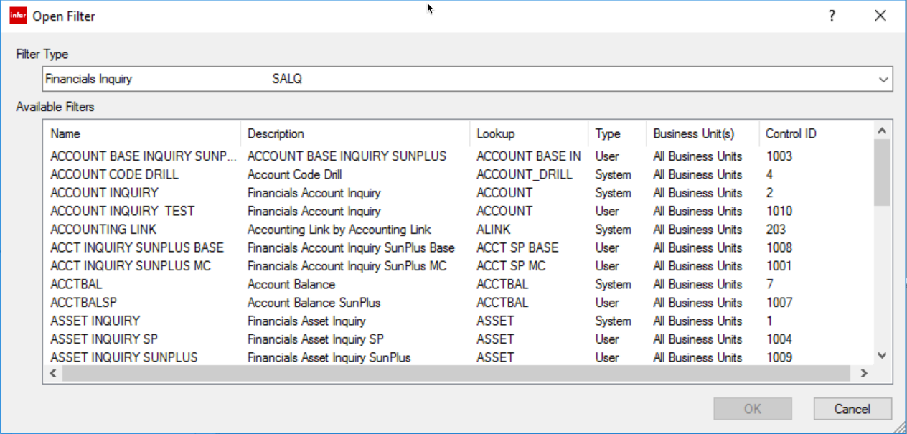
  - If asked to select a Filter Type, select Financials Inquiry
  - Available Filters lists all of the pre-established filters that come with SunPlus Core
    - This list is a combination of SunSystems standard and SunPlus standard filters
    - The way to distinguish between SunSystems standard and SunPlus standard filter is the Control ID, the column at the far right
    - 4-character ID’s indicate SunPlus filters
    - The system assigns 4-character filters in sequential order
    - To create a new filter, it is effective to Copy an existing filter and modify it as needed
- Select the existing filter of the type needed, i.e., Account Inquiry
- Click OK
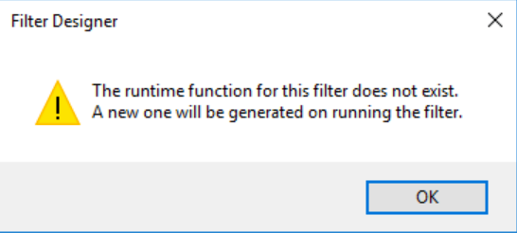
  - The runtime function warning will be displayed
- Click OK
  - The Filter’s details will be displayed as follows

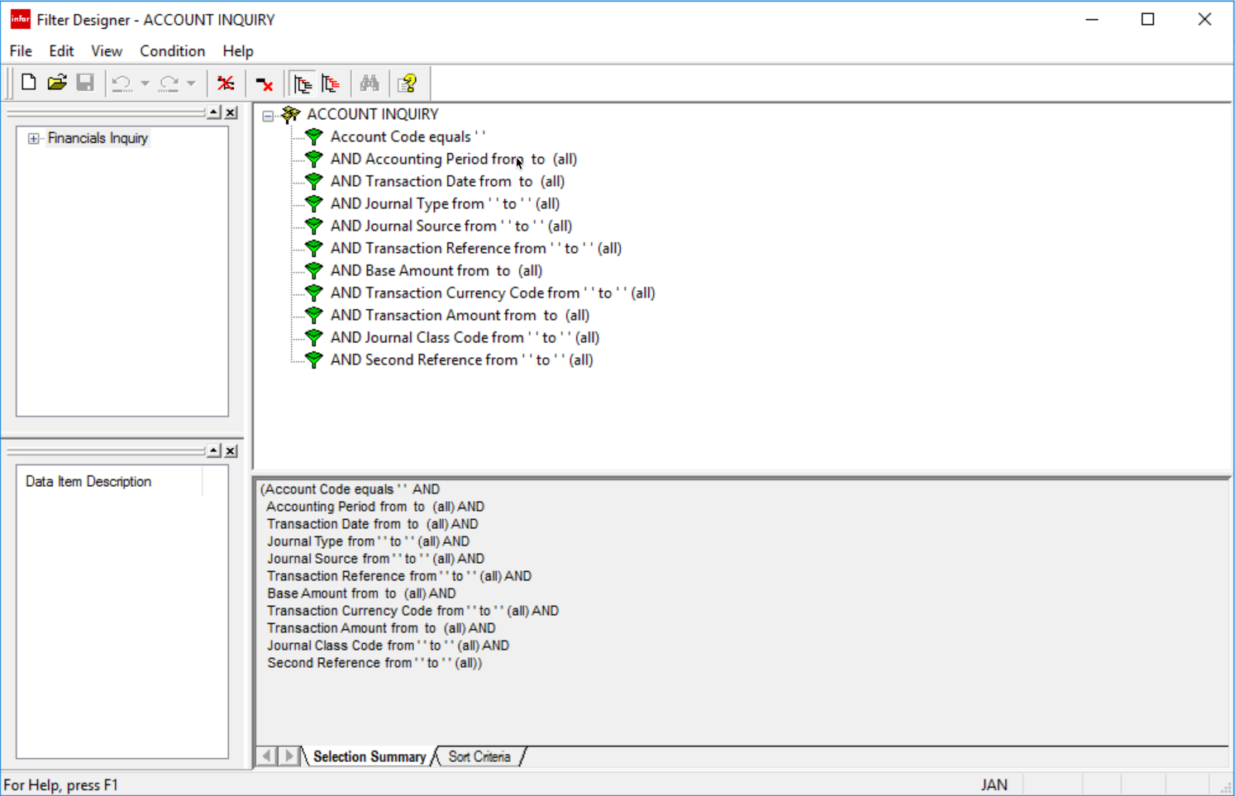
- Go to the File menu

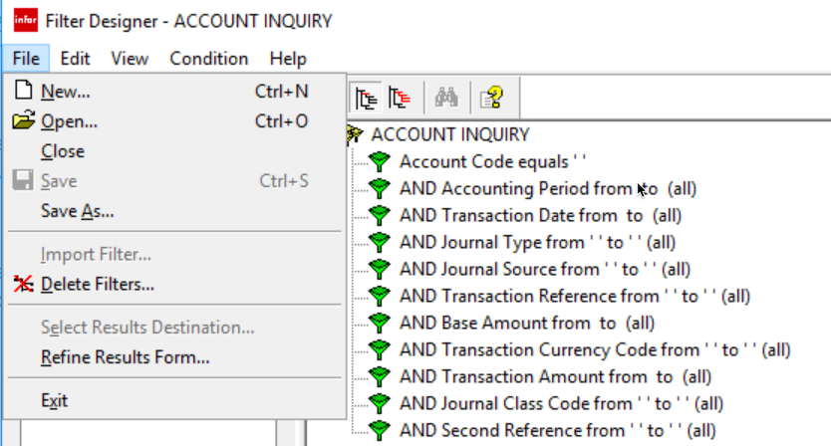
- Select Save As …
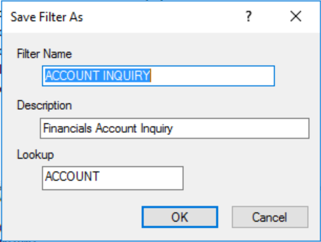
- Give the new Filter a Name
  - The name entered here will be displayed on the Filter Designer menu
  - The Description and Lookup values can also be changed

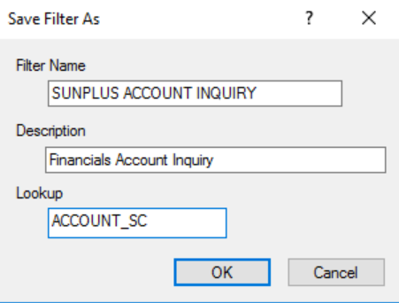
- Click OK

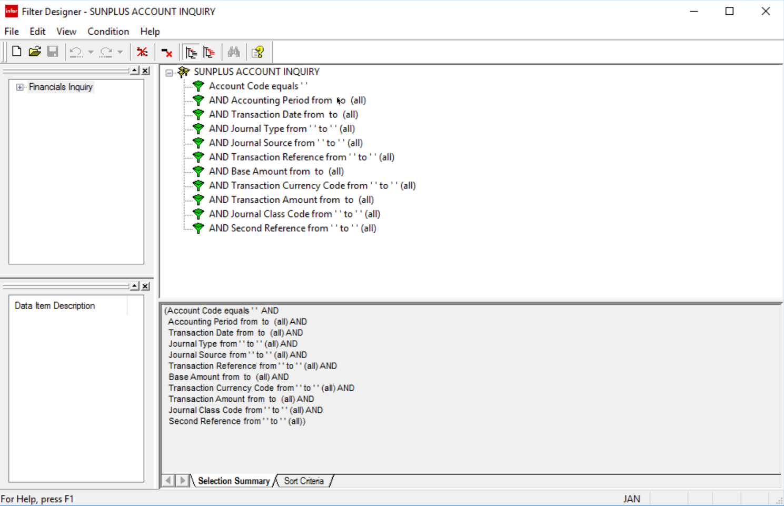
  - Notice that the new Filter is displayed
  - The larger area at the right is the Filter Edit Area
    - This is where filters are created or edited
    - It is split into two portions
      - Upper Portion displays filter conditions – this is where selection criteria are edited
        - A Yellow icon  indicates simple conditions with no run time entries
        - A Green icon  indicates simple conditions with run time entries
        - A three figure icon  indicates compound conditions
      - Lower Portion is split into two tabs
        - Selection Summary – displays filter conditions in textual form as an equation
          - Filter conditions cannot be edited in this area
        - Sort Criteria – displays sort criteria and allows editing
  - In the upper work pane the details of the existing filter (the filter from which the copy was made) are listed
  - These items can be Deleted, Added to, or the Operator can be changed

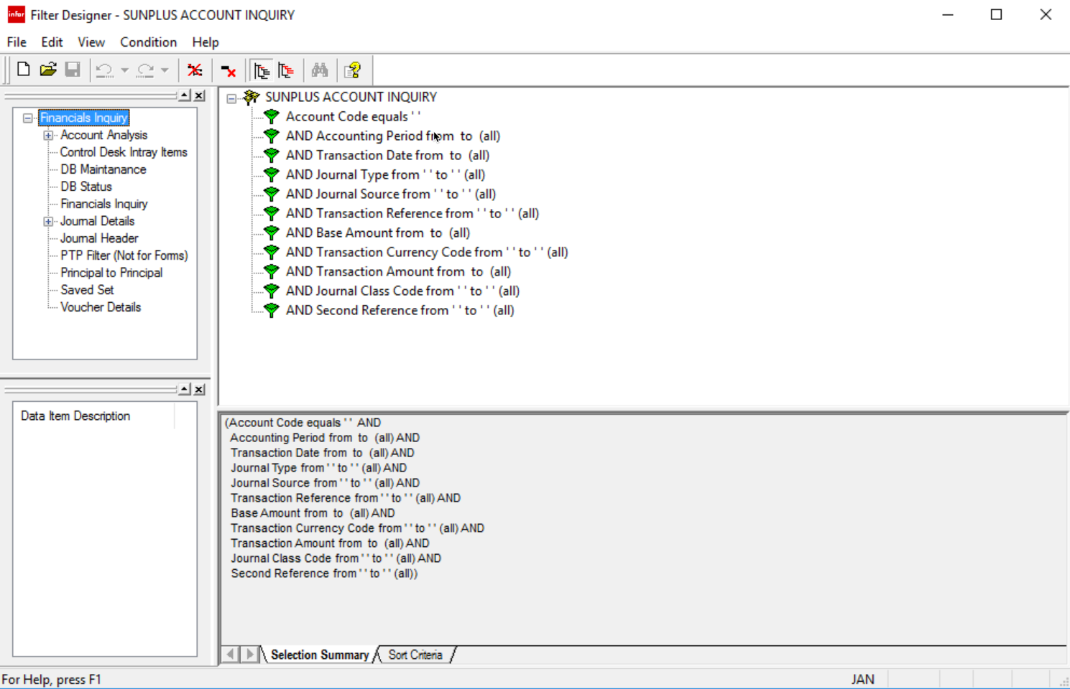

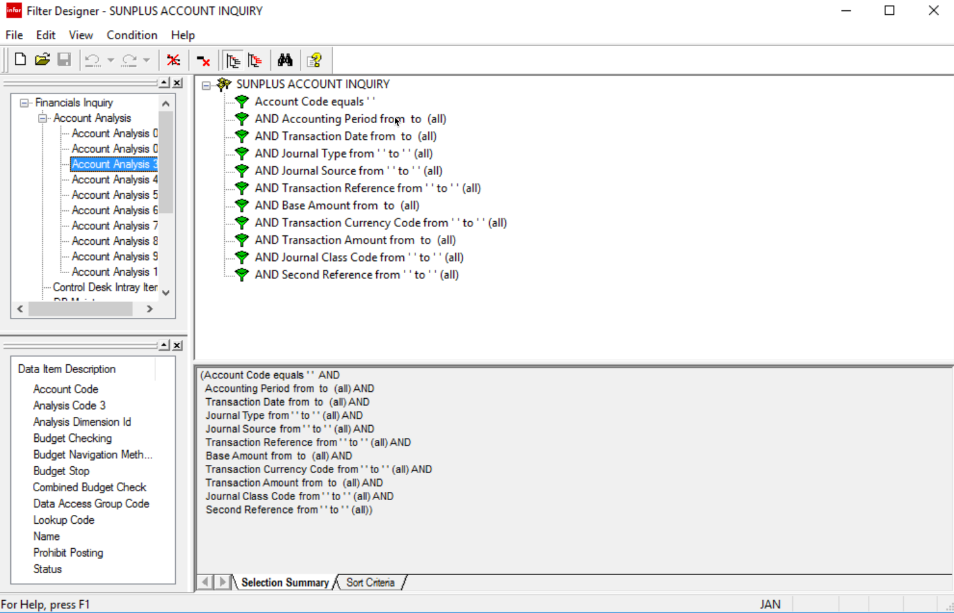
- To modify a Data Item, select the item
  - Go to the Condition menu on the Toolbar

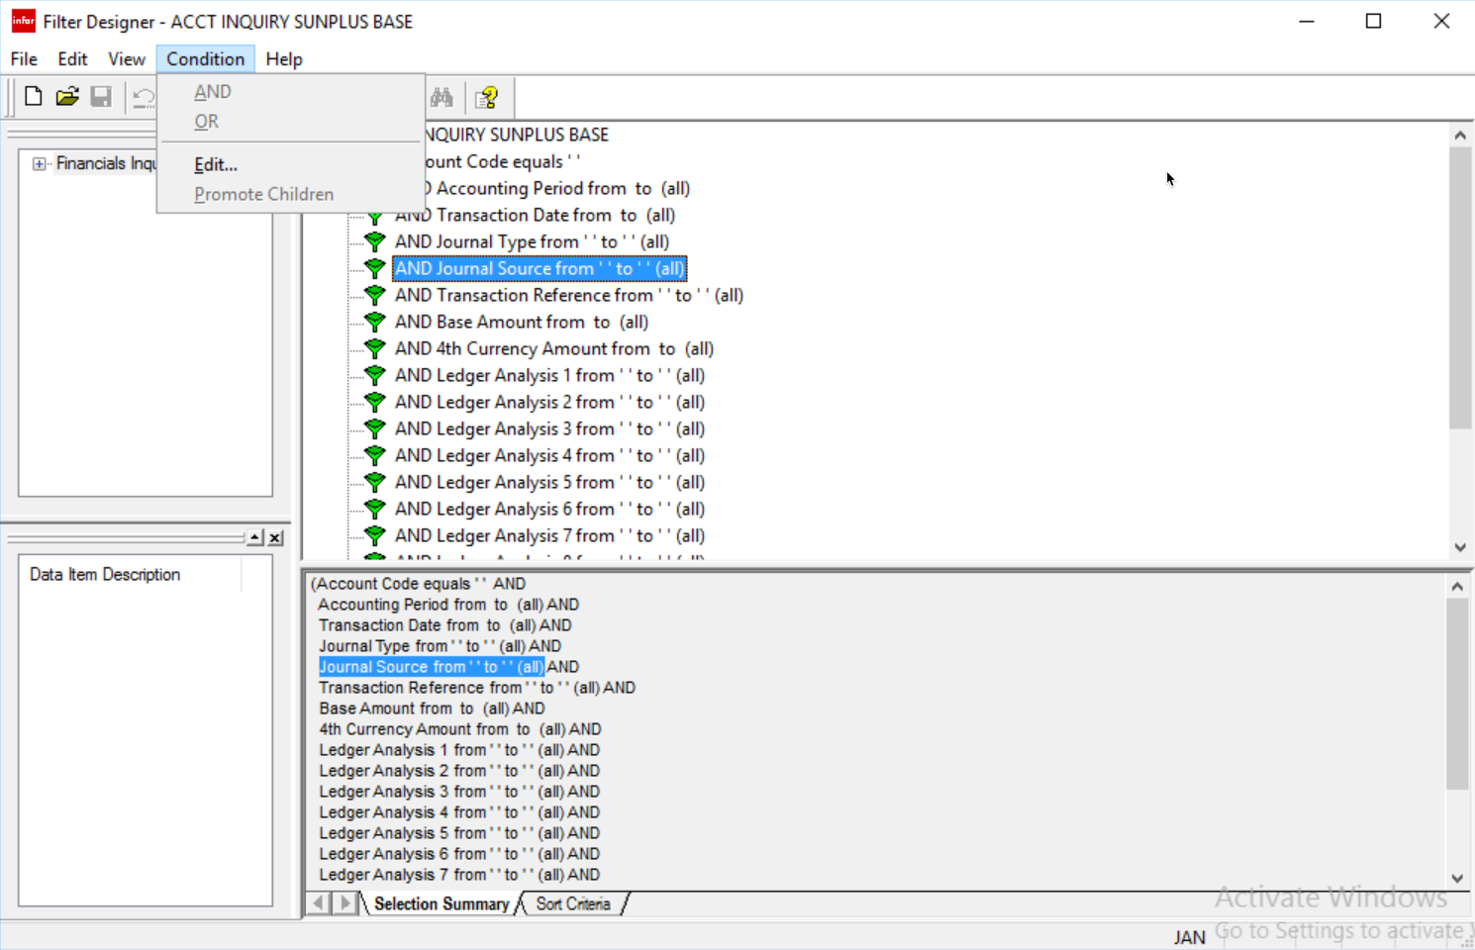
- Select Edit
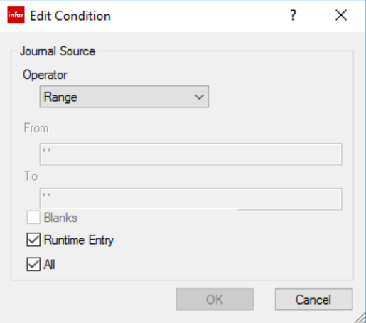
- Make the necessary changes
- Click OK
- To Add Data Item, select the item from the Data Item Description pane
  - Drag onto the upper Edit Area
  - Be careful not to accidentally create compound selection criteria
- To Delete Data Item, select the item
  - Go to the Edit menu on the Toolbar
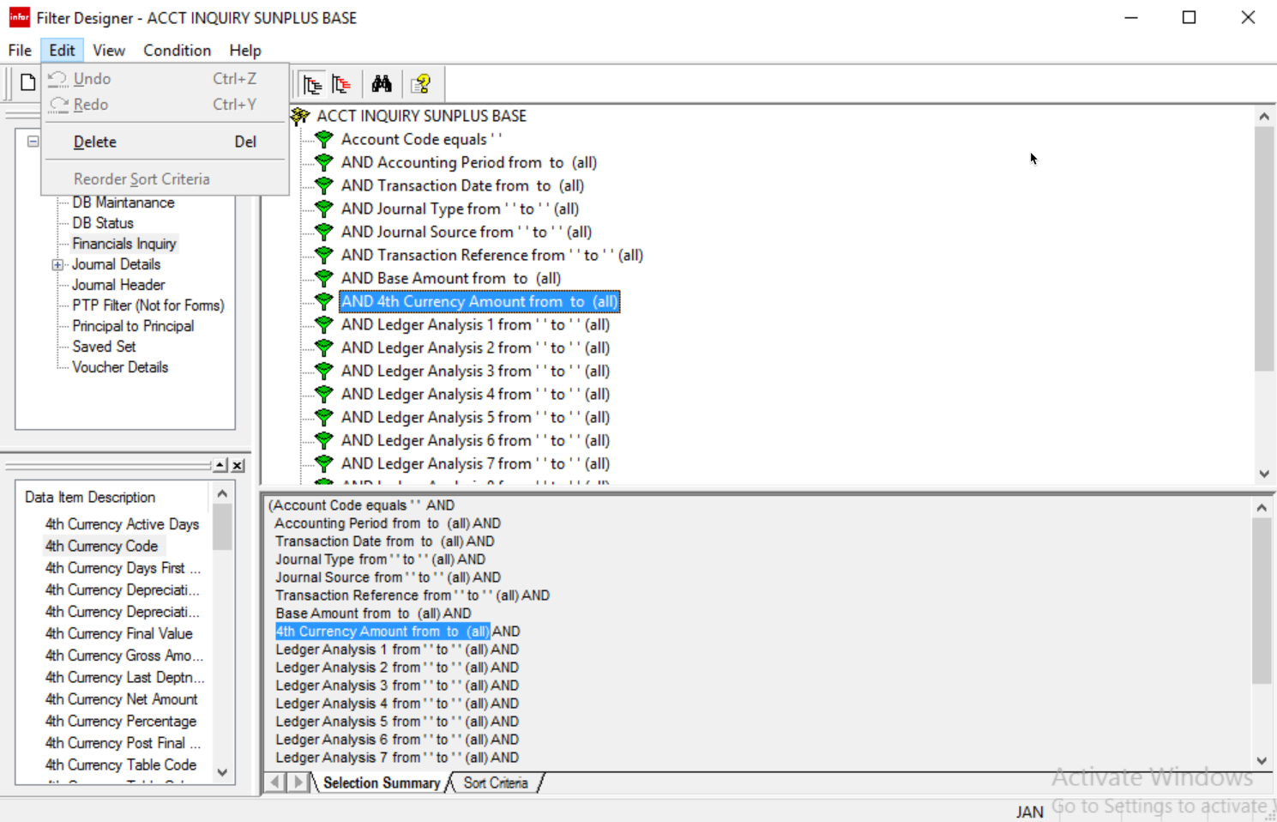
  - Select Delete
  - Click Save

Business Rules

Business Rules can be created for data input and static data functions. These rules are applied and actions carried out depending upon whether the rule criteria are met. Business Rules cannot be used to break any audit or validation controls built into the system.

Setup Business Rules
            - Event Profile
- An Event Profile contains a series of conditions that determine when and under what circumstances a set of Business Rules applies
- Conditions are defined using one or more IF statements.
- There are 3 types of conditions:
  - Function Condition
    - Identifies the SunSystems function to which the Event Profile will be linked
  - Call Point and Action Code Conditions
    - Call Point – identifies the function stage that will trigger the Business Rules
    - Action Code – identify the commands an operator can choose – Cancel, Hold, Post
  - Data Item Conditions
    - Other conditions that must be met before the profile is invoked
    - These conditions apply to a limited set of common data items
      - i.e., a particular Business Unit
      - a particular Operator Group
- The first condition always identifies the SunSystems function to which the Business Rules apply
  - Business Rules can apply to
    - Input functions
      - Ledger Entry
      - Ledger Import
      - Purchase Order Entry
    - Static Data functions
      - Chart of Accounts
      - Supplier
      - Address
      - Fixed Asset
      - Etc.
- An Event Profile can only be linked to one function; however, if the conditions and rules make sense for a different function, use Save As to copy the Event Profile and its rules to use for another function
- The choice of function determines the data items that are available for the Business Rules
  - The data items typically available for that function
  - Related static data items

Let’s take a look at the details of an existing Event Profile:

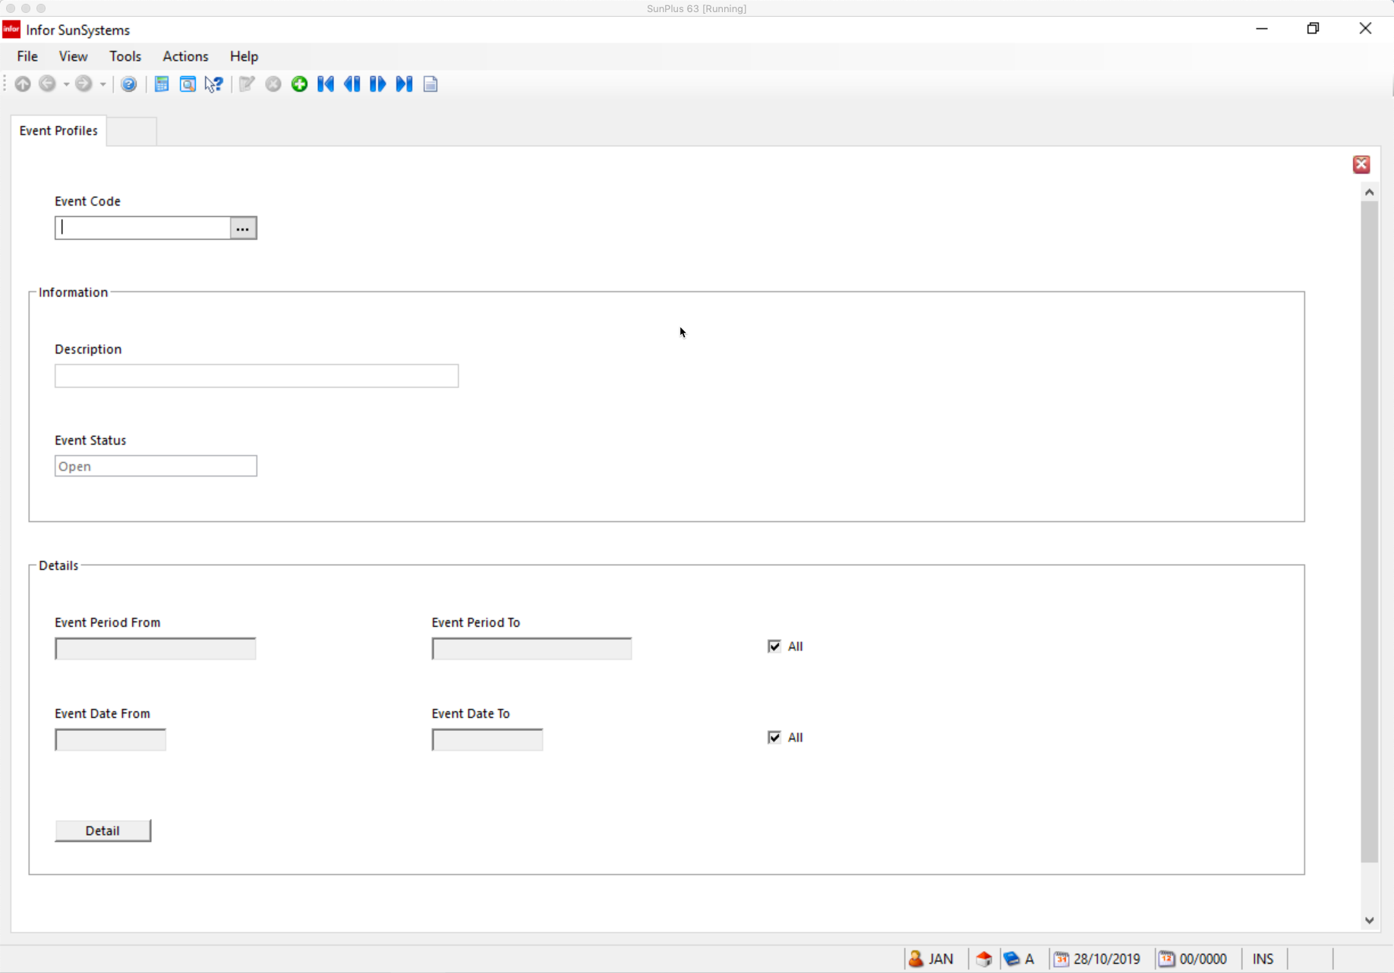
- This is the A0A5A_ADD Address Details Event Profile

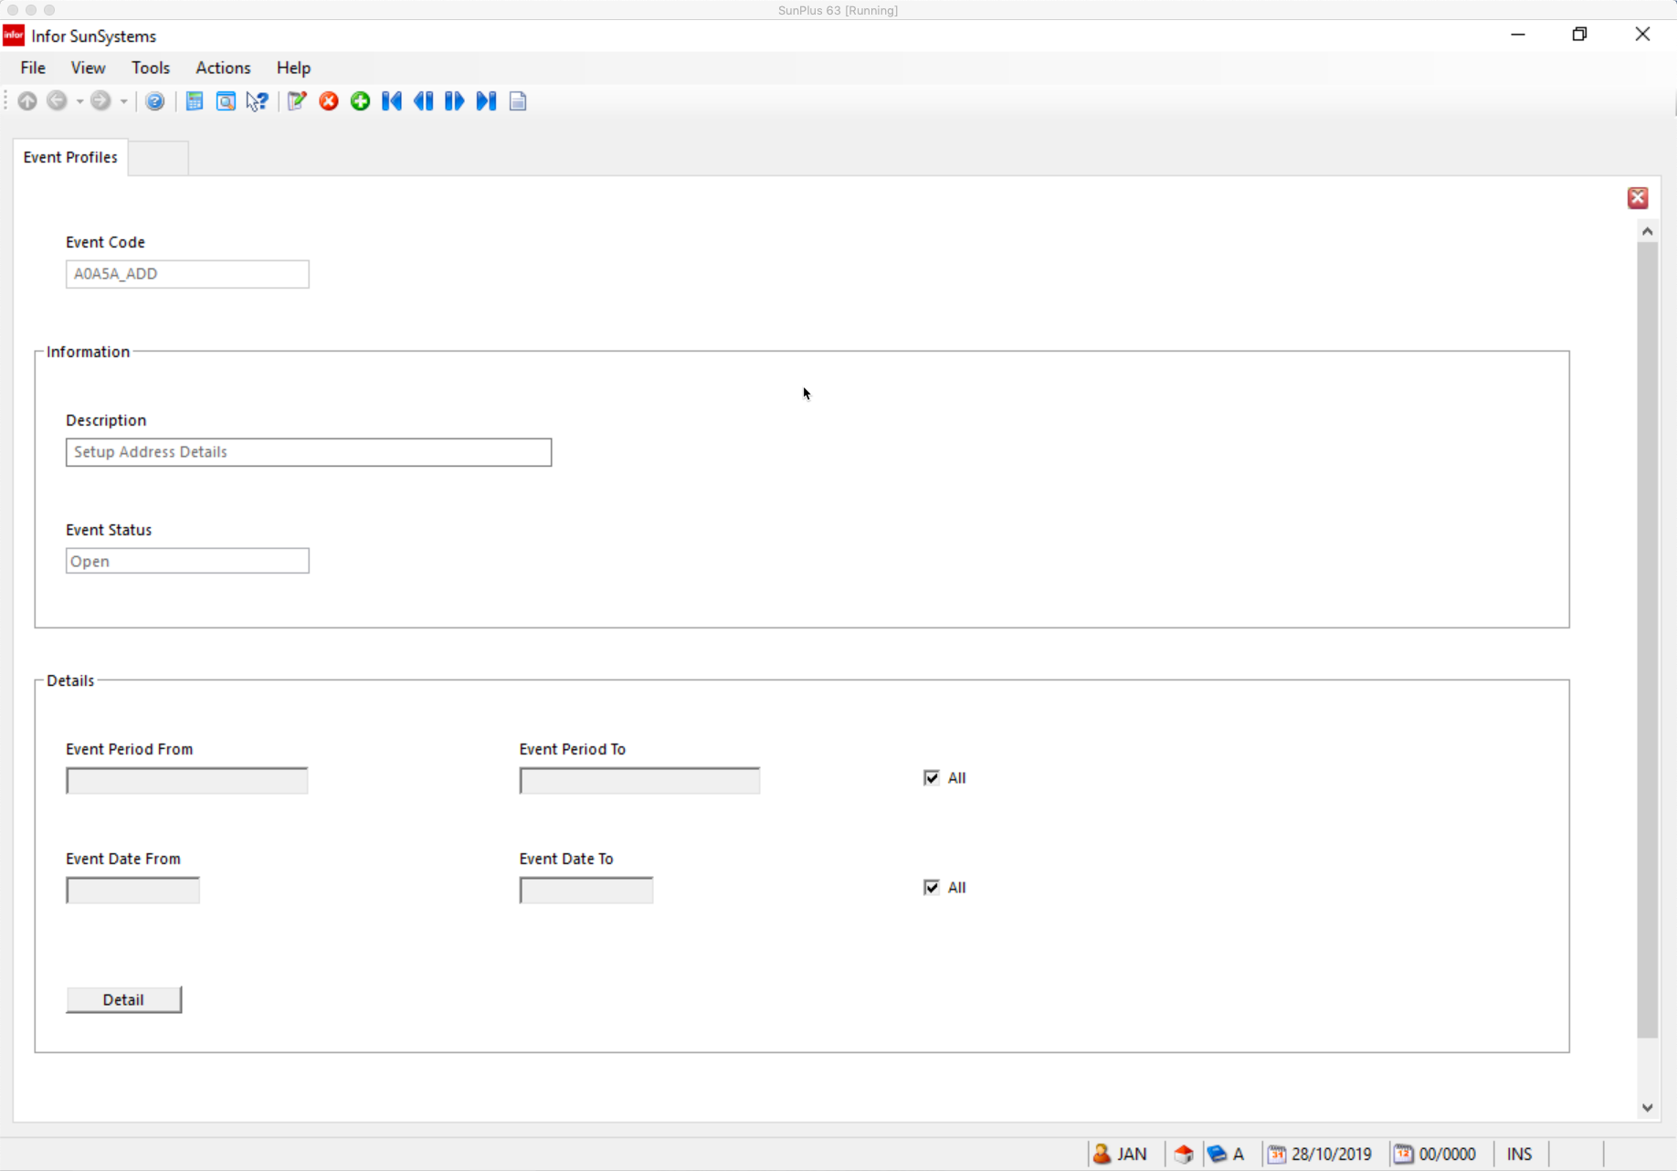
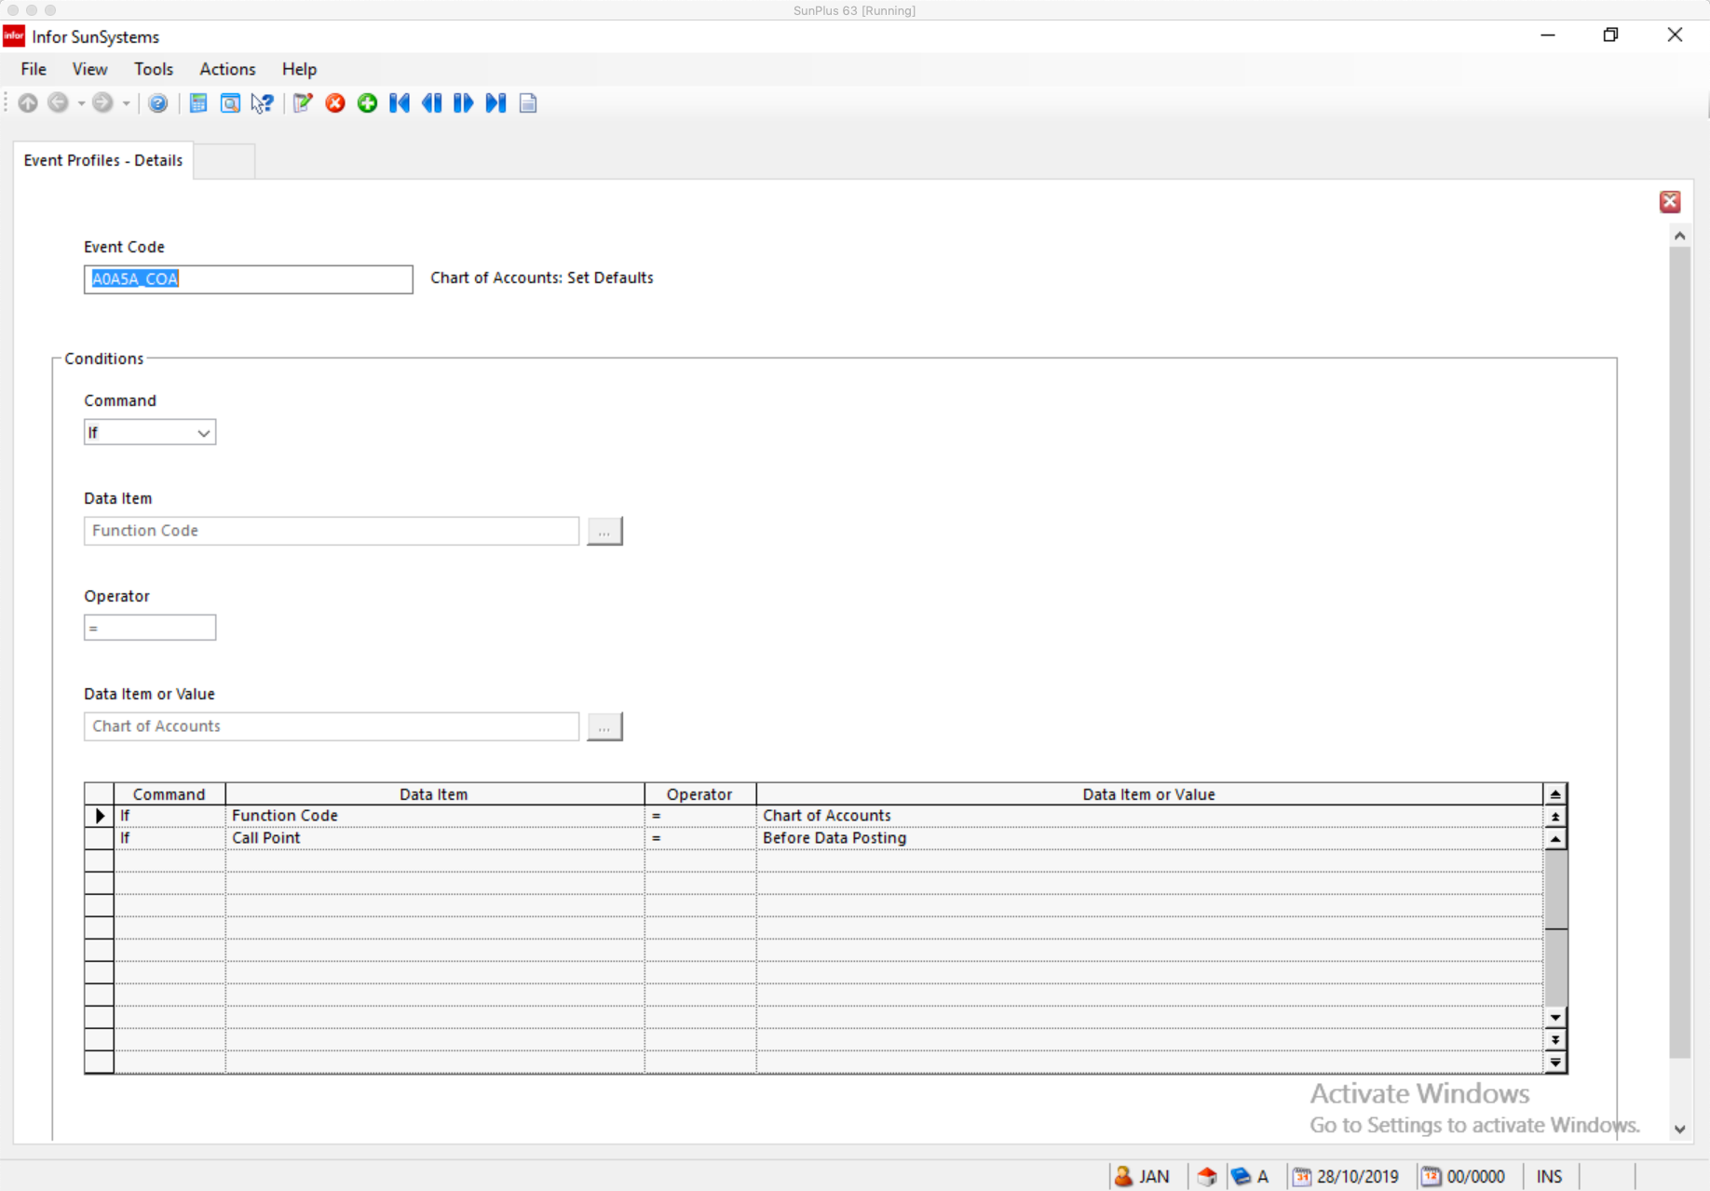

- Event Code Must be a unique code
- Description
- Event Status Select
        - Suspended to suspend processing of this profile
        - Open to keep the profile active
          - Default
- Event Period From/To/All Enter effective range of Accounting Period for the profile
        - Check All for all Periods
        - Event Period setting determines the period of time in which the profile will be valid
- Event Date From/To/All Enter effective range of dates for the profile
        - For a specific date, click dropdown box and use the calendar to select the required date
        - Check All to select all dates
        - Event Date setting determines the period of time when the event profile will be valid
- Click Detail to display the Event Profile Conditions form

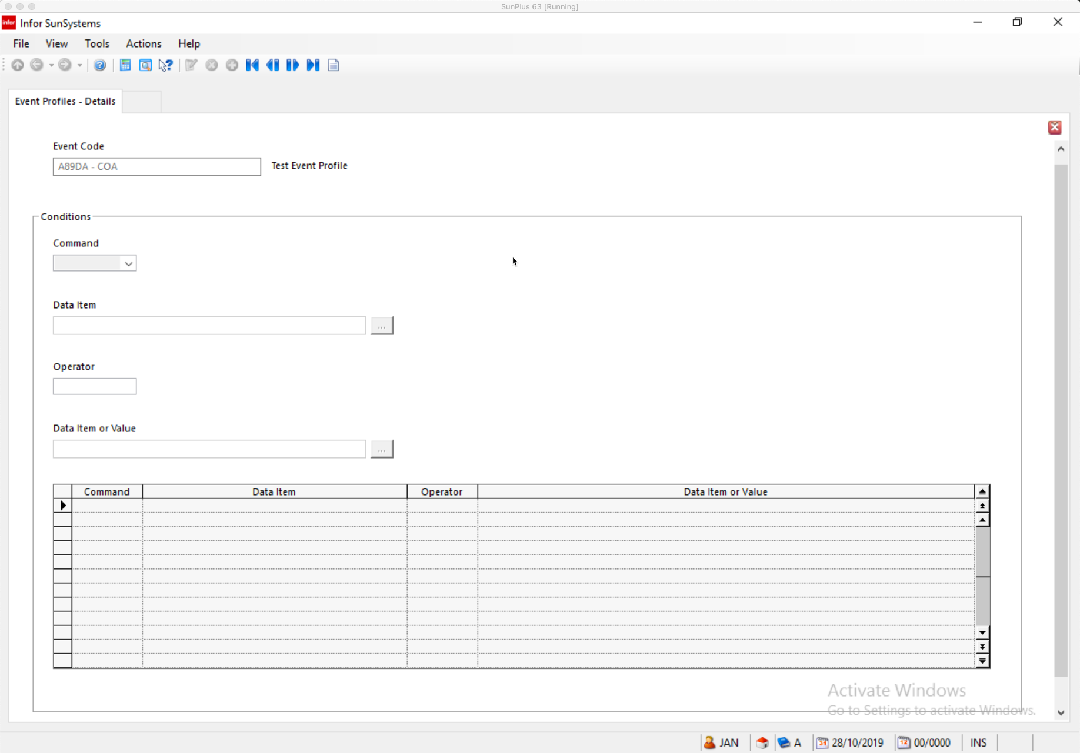
- Click the Create button at the bottom of the screen to add a condition to the profile
- Command Select IF or OR
        - The first statement must be an IF statement
- Click OK

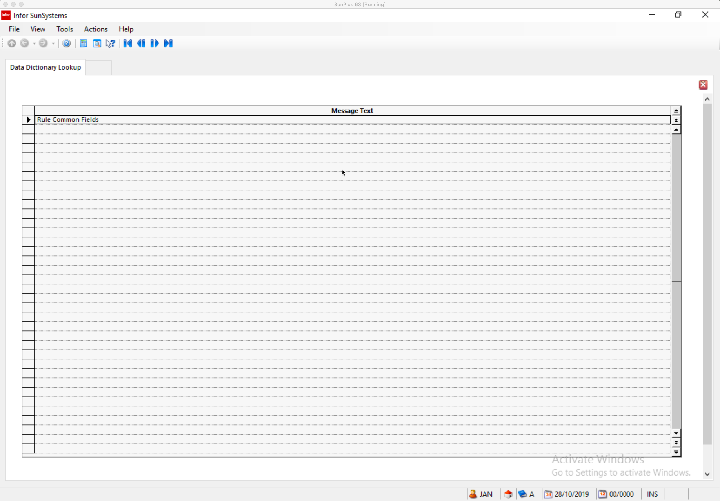
- Click OK

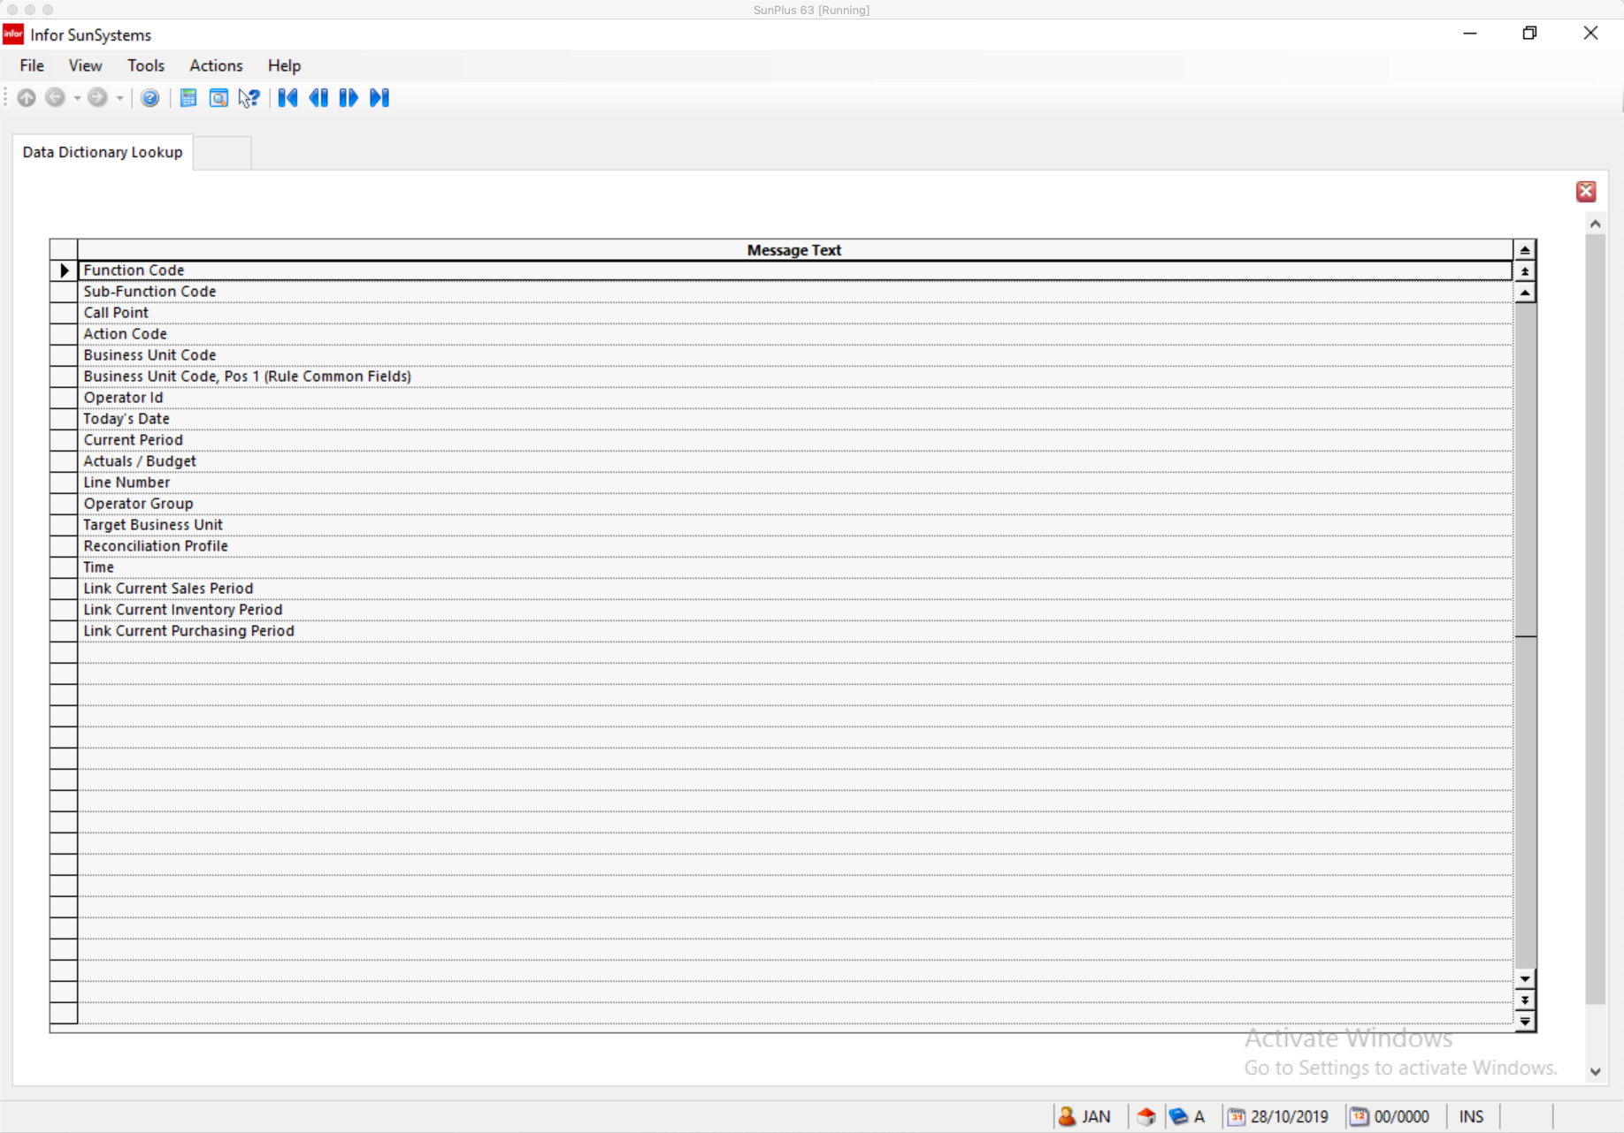
- Select Data Item
- Click OK
- Data Item Select the data item required from the Data Dictionary Lookup
window, which lists the available options
- Operator Enter operator to be used with the statement
        - For the first condition to identify the system function only ‘ = ’ equals to can be selected
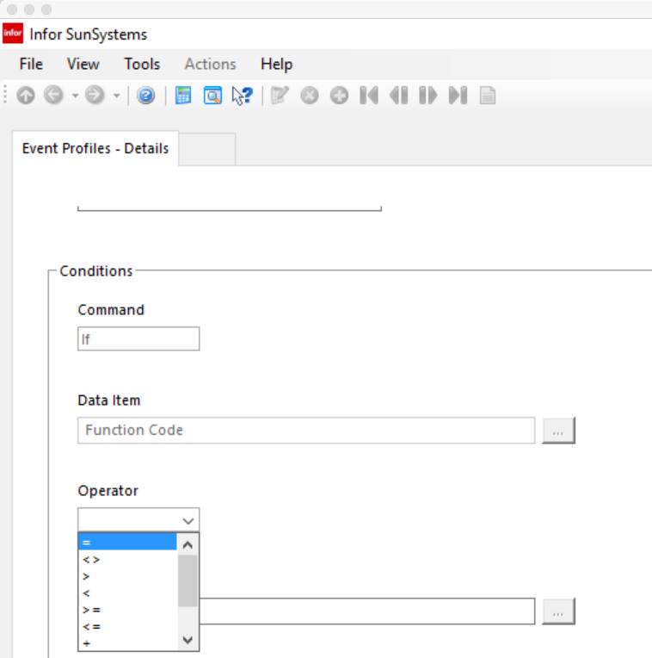
- Select the Operator For the first condition, this must be ‘=’
- Click OK
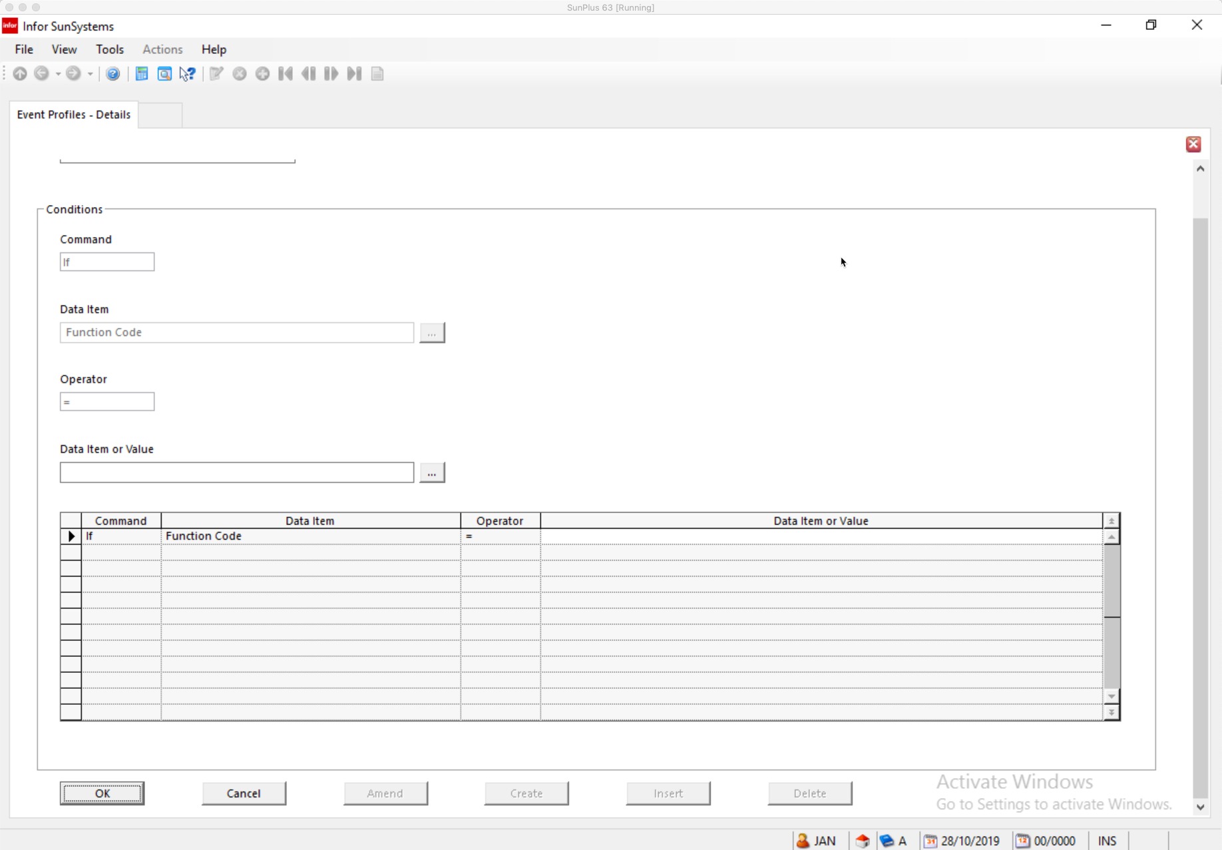

- Data Item or Value Select data item from the Data Dictionary Lookup dialog, which lists
the valid data item groups or data items
        - The list of data items available is determined by the selection made in the first Data Item field

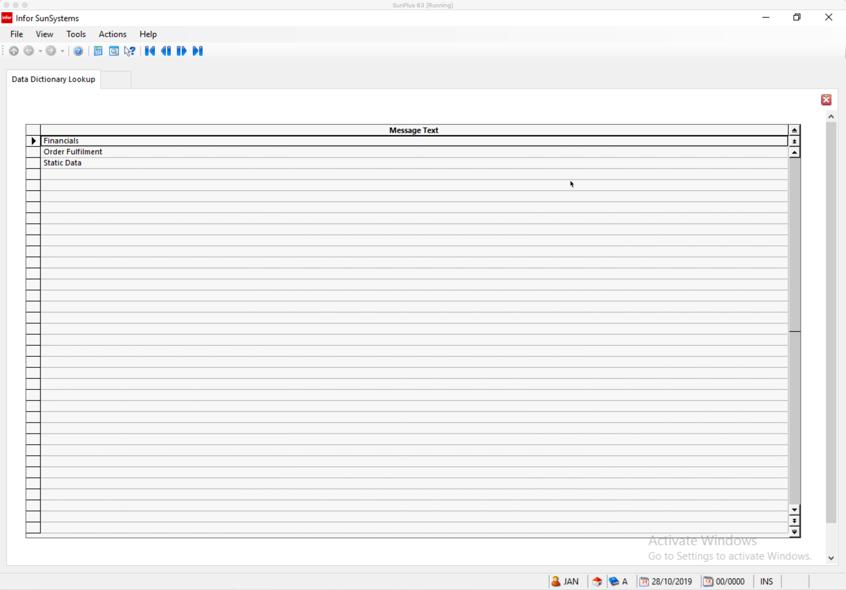
- Click OK
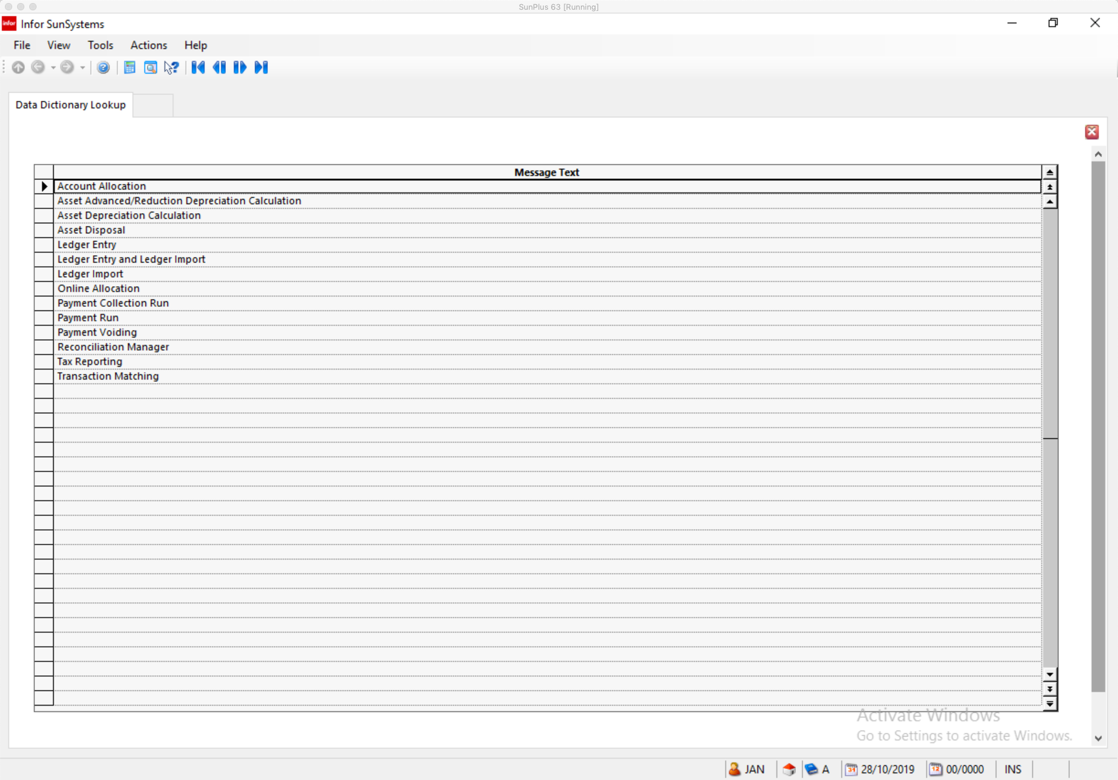

- Save the changes
            - Create any Rule Messages
              - A Business Rule can be error or warning messages
              - Rule Messages display information to the user
              - They used by DISPLAY and ERROR action statements
                - DISPLAY shows the Rule Message and allows the entry to continue processing
                - ERROR shows the Rule Message and stops entry from processing
              - Messages are defined separately and can be attached to multiple Rule Sets
              - Messages must be defined before the Rule Sets
              - To create a Rule Message, go to Rule Messages
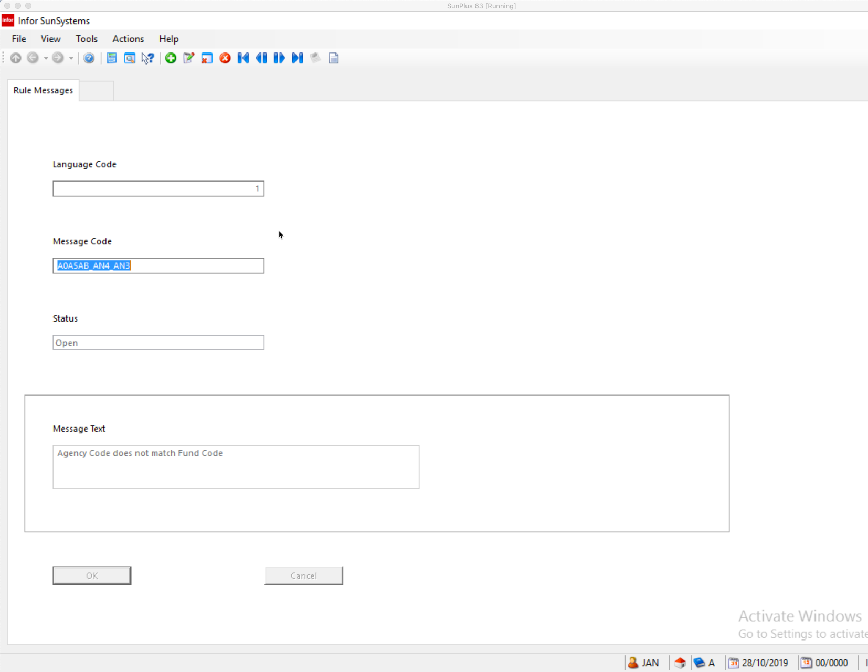
- Language Code Code for the required language
- Message Code Enter a meaningful code to identify the message
- Status
- Message Text Enter a message text of up to 80 characters
        - If you need more characters, define several messages and reference them one after the other in the Rule Set in the correct order
            - Create a Rule Set
              - A Rule Set consists of a series of condition statements followed by a series of action statements; although it can consist of only action statements if the actions apply in all conditions.
        - A Rule Set can consist of up to 50 Conditions and up to 50 Actions
                - Conditions
- IF
  - Enables a selected data item, identified in Value 1, to be compared against any of the following in Value 2
    - Another data item – i.e., Supplier Code
    - A literal value – 64000
      - Enter the value exactly as it appears in the Data Item
        - Don’t embed in quotes
        - If the value should be uppercase, the value you enter should be uppercase – i.e., Business Unit Code
    - A masked literal value – 64***
      - Masking character * (asterisk) can be used to ignore parts of the literal value
        - 64*** - checks a five character account code for codes beginning with 81 with 3 other characters
    - A workspace value – Work Space Date 1
    - A keyword – SPACE
      - SPACE – checks for blank value
      - ZERO – checks for a value of zero
      - NUMERIC – checks for a numeric value
      - EXISTS – only for Rule Data Set
        - Determines if the codes entered on the current record are a valid combination for the Rule Data Set
        - The results of the IF statement, which are identified in the Decision Columns, are only entered on the IF statement
- OR
  - Continues the IF Condition Statement
  - Allows the IF statement to compare more than one value against the Value 1 Data Item, using the same Operator
  - An IF statement can be followed by one or more OR statements
    - Results of Conditions
      - Y – Yes
      - N – No
    - Actions
            - SET
            - DISPLAY
            - CALCULATE
              - Condition statements always begin with either an IF or an OR Command
                - Action statements always follow Condition statements
              - A Rule Set is defined as a decision table
                - Decision columns associate one or more actions with the result of one or more condition statements
                - A Rule Set contains up to 10 decision columns
              - The Action for a condition statement/result is indicated by an X in the decision column
            - Create Rule Set or Rule Sets
              - Go to Rule Sets
              - Enter or select Event Profile Code set up in the earlier step for this Business Rule
              - Enter a new Rule Set Code

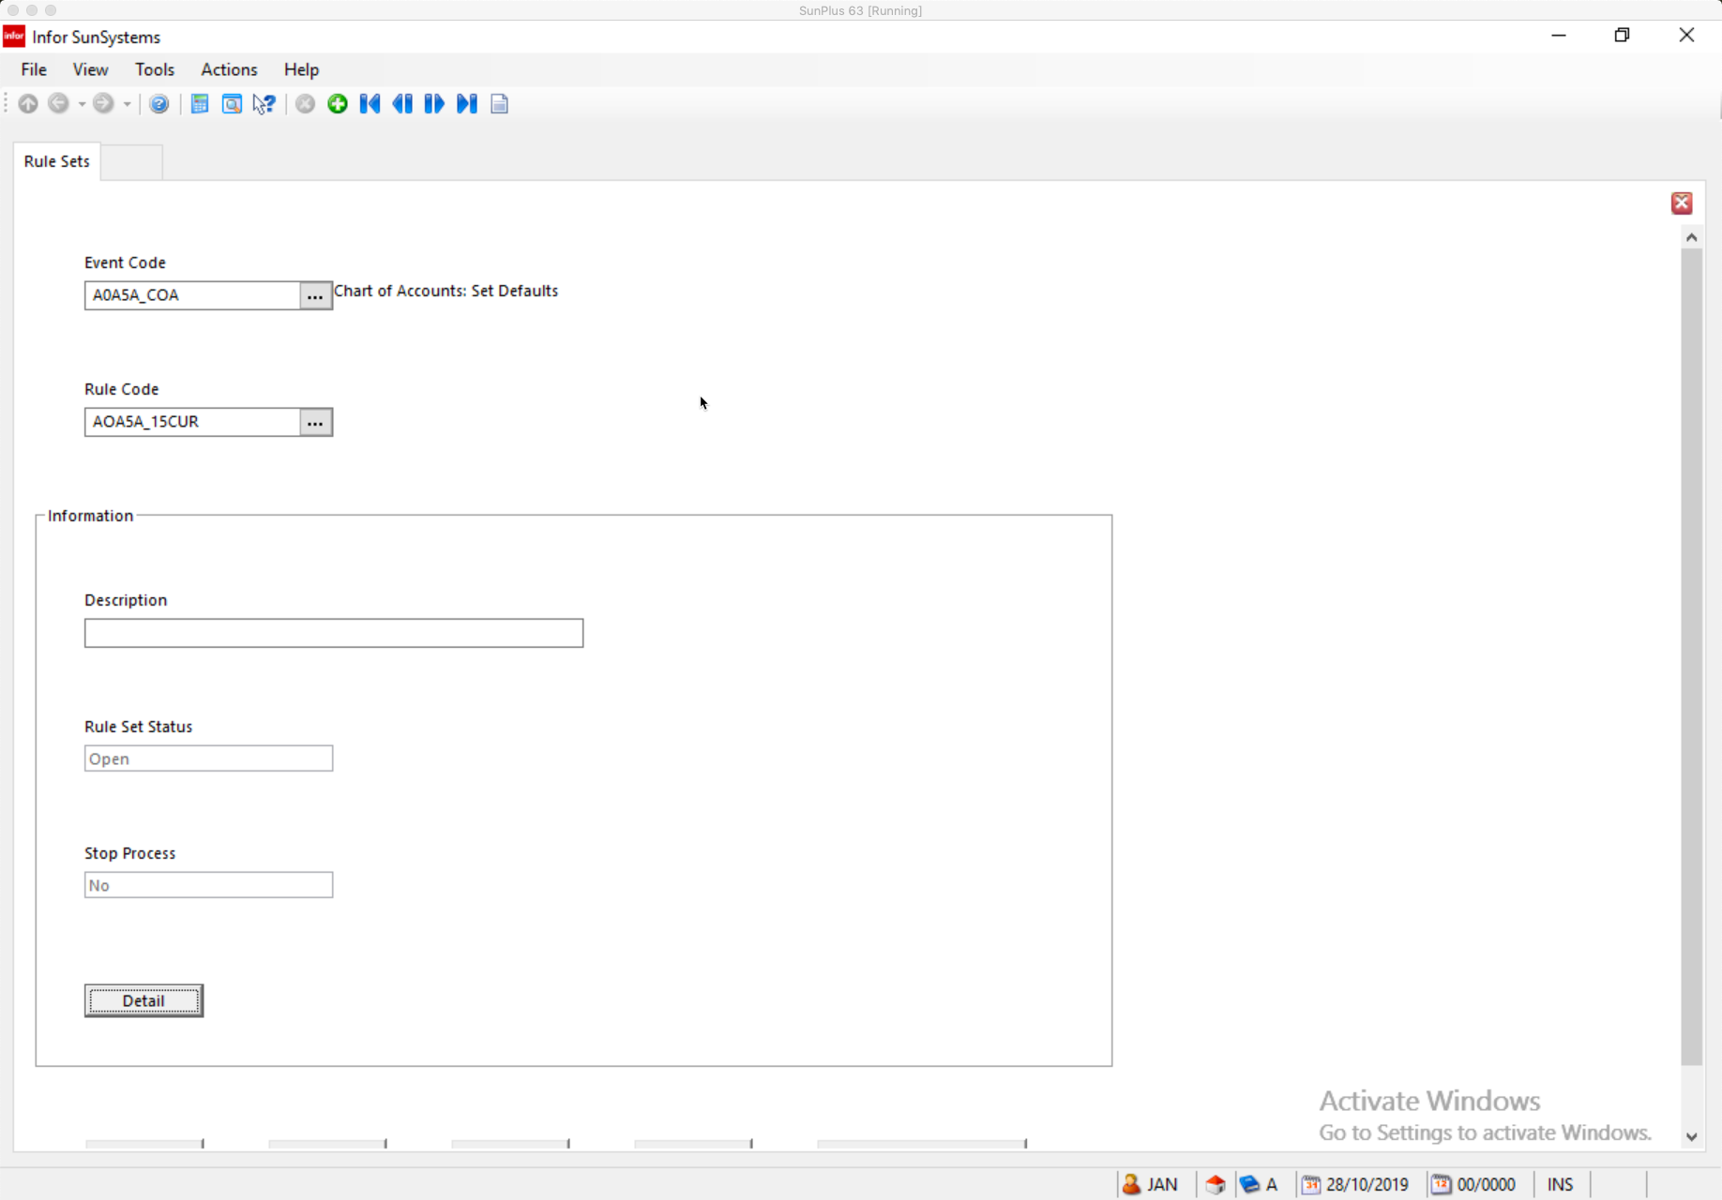
              - Enter a Description of the Rule Set
              - Click Detail to display the Rule Sets – Details form
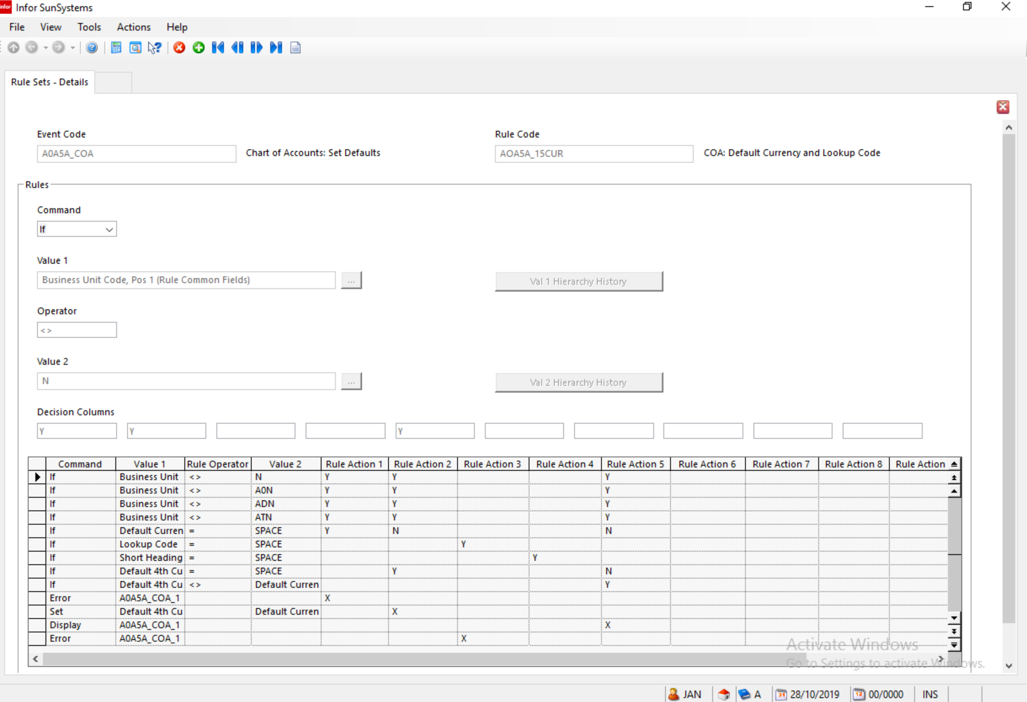
              - Click Create to add a new rule to the Rule Set
              - Enter
                - Command
                - Value 1
                - Operator
                - Value 2
                - Decision Columns
              - Click OK after entering each of the details
              - Enter Create to enter another rule statement after the final statement displayed on the form
              - Enter Rule Details
              - When all required rules have been entered, click Exit to return to Rule Sets form
              - You can add another Rule Set or click Exit to leave the function
            - Redefined Data Items – if a single system data item contains separate logical elements that need to be validated individually it can be redefined
              - This enables the logical elements to be identified as data items in their own right which makes the business rule much easier to define and maintain
              - Use Redefined Data Items to create new data items, as a subset of an existing standard data item. The new data items can be referenced in Rule Sets, Event Profiles, and Rule Data Set Keys
              - These is useful for structured codes, with different sections of a code have distinct meanings, and each part of the code needs to be referenced separately in a Rule Set
              - When a data item has been redefined, the original, unredefined data item is still available for reference in a Rule Set
                - A redefined data item can reference another redefined data item, if required

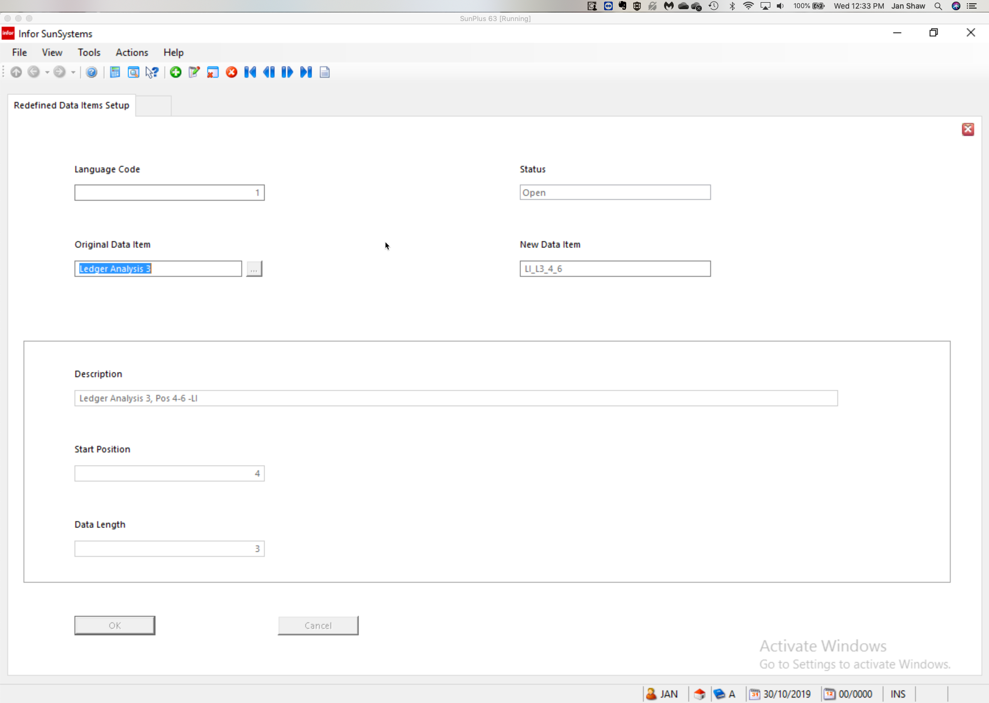
- To Redefine a Data Item
  - Open Redefined Data Item
  - Language Code Enter the language code for the Data Item
  - Status
  - Original Data Item The Data Item to be redefined
  - New Data Item The name of the new, redefined, data item
  - Description
  - Start Position The position of the character in the ‘parent’ data item that marks the beginning of the new data item
        - Default is 1 for the start of the data item
  - Data Length The number of characters, from the Start Position, to be included in
the new data item
        - Defaults to the length of the data item, if the data item being redefined is a standard SunSystems data item
  - Save
            - Rule Data Sets are used to define tables of allowable data, or valid combinations of codes, that the system can refer to while data is being entered
              - For example: in Ledger Entry, you want to restrict the Product codes allowed, depending on the specific Cost Centre entered
                - Define a table of valid combinations of Cost Centre and Product code in a Rule Data Set
              - SunSystems can be configured to ‘insert’ data, or force certain fields to take specific values while data is entered, by defining those specific values in Rule Data Presets
              - Rule Data Sets are used in conjunction with Rule Data Set Keys to maintain indexed lists of valid combinations of selected data item values. Rule Data Sets are then used in Rule Sets as a simple method of referring to, and checking for, valid code combinations on the transactions being processed. Items in a Rule Data Set Key should be related to the same function
              - A Rule Data Set is a list of predefined valid values for 1 to 3 Key Data Items; Key Data Items are defined in the Rule Data Set Key, which must be set up first to identify the Data Items that make up the combination
              - To define codes from two separate Ledger Analysis Dimensions:
                - Use Rule Data Set Keys
      - Select Ledger Analysis Dimensions containing the codes that will be Key Data Items
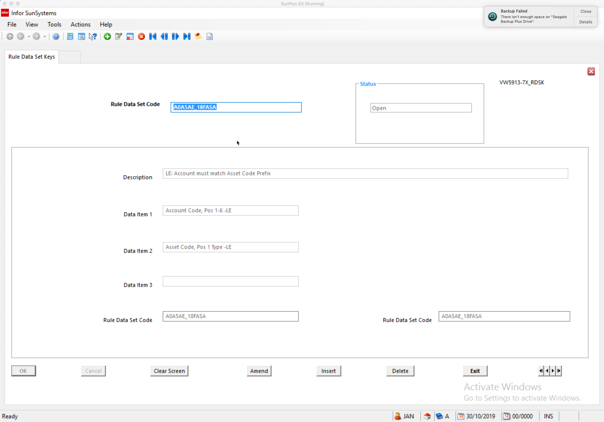
- Rule Data Set Code Unique code to identify this Rule Data Set Key
- Status
- Description
- Data Item 1-3 Select up to three Data Items to be included in the
Rule Data Set
- Save
                - Use Rule Data Sets to define the valid code combinations
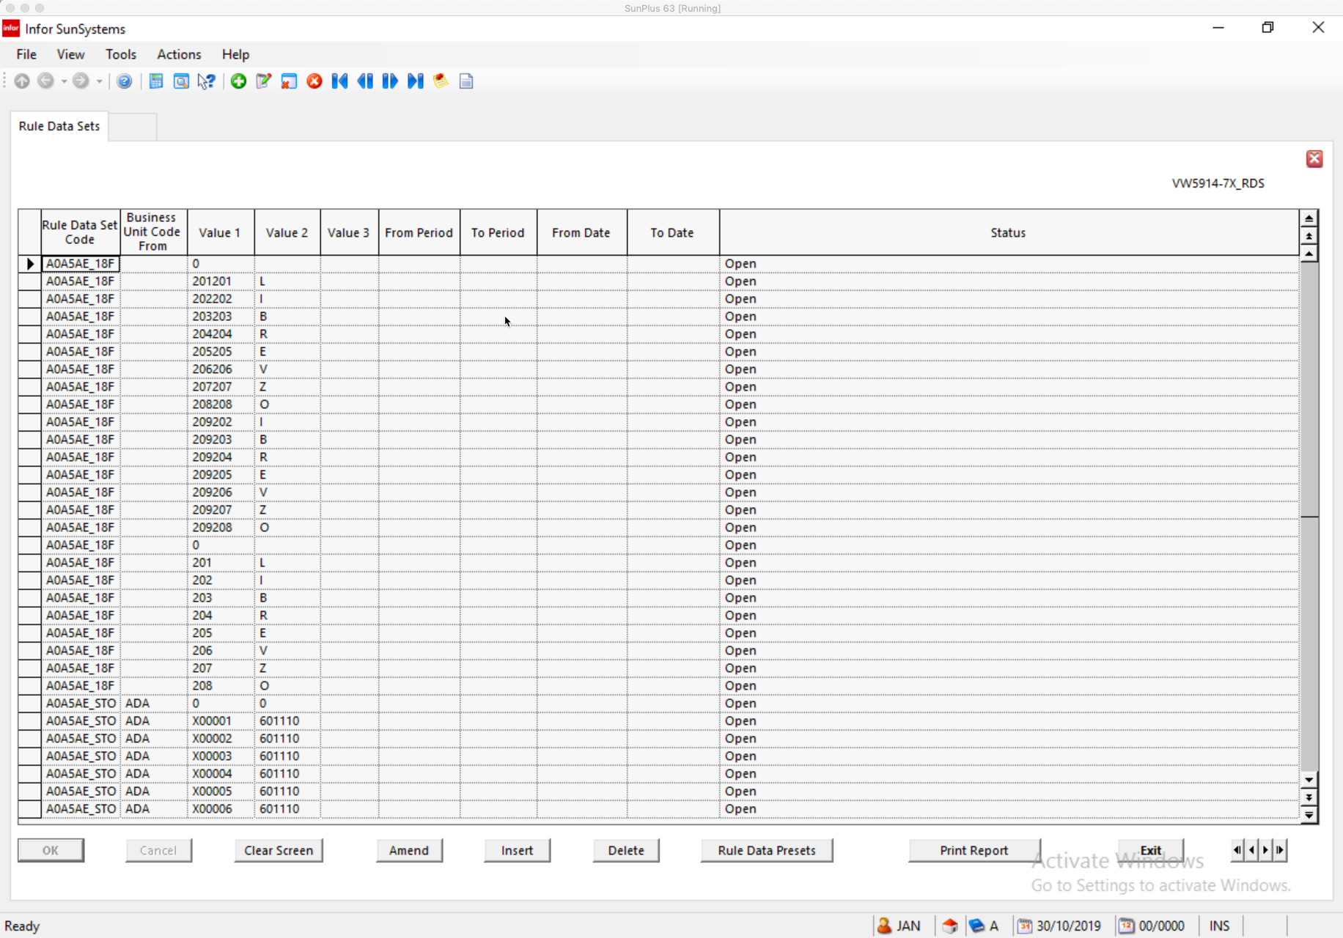
                - Rule Data Set Code Enter the code for the Rule Data Set Key
                - Determines the combination of Key Data Items for which values can be predefined
                - Business Unit Code Enter a Business Unit Code to restrict the Rule Data Set to one Business Unit
                - Leave blank for all Business Units
                - Value 1-3 Enter a set of valid values, one for each of the Key Data Items
selected for the Rule Data Set
                - Key Data Items are determined by the Rule Data Set Keys
                - From/To Period Enter effective range of periods for this code combination
                - Leave blank for all
                - From/To Date Enter effective range of dates for this code combination
                - Status
                - Save

SunSystems Features Available, But Rarely Used in SunPlus World

Standard Text
Overview

To add commentary, especially standard comments, to a variety of functions throughout SunSystems, set up the text as Standard Text, then store it in the system. It will be available for use whenever it is needed.

In multi-lingual systems, languages can be specified for that comment. If language is specified, the operator’s default language will determine which language the system will select.

Up to five paragraphs of text can be attached to any transaction row of activity, to any Asset record, or report. The text will be resized to fit the width of the report space allocated to this field. To indent, place leading spaces in front of text. Separate message into separate paragraphs when needed, as there is no other control of line feed, except through escape sequence coding.

Steps in Setting up Standard Text

- Set up Standard Text Classes

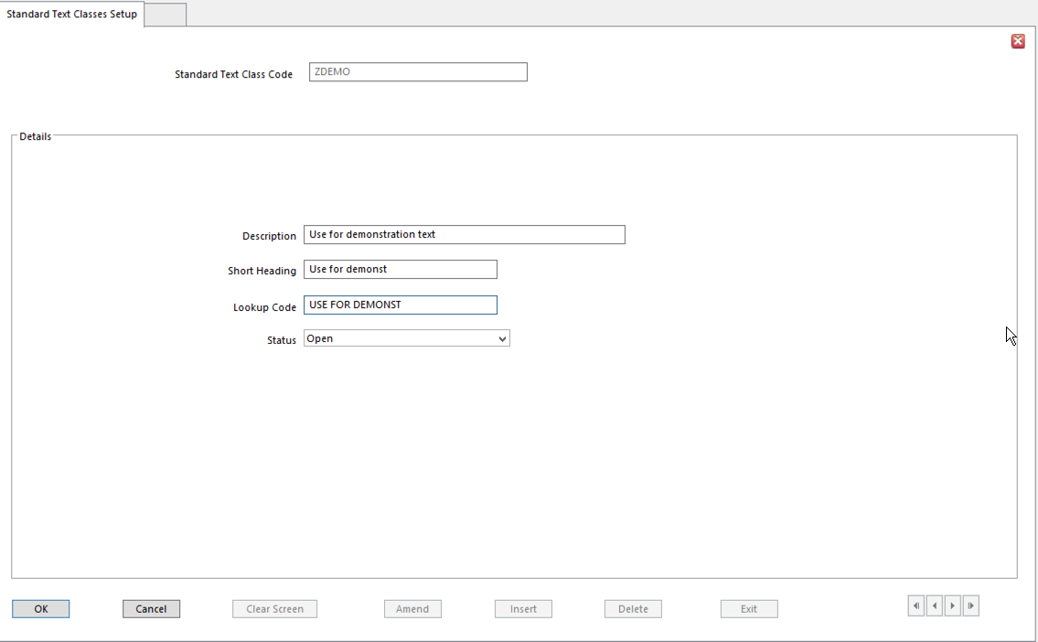
- The fields in the Standard Text Classes interface are self-explanatory

- Standard Text Language Variants
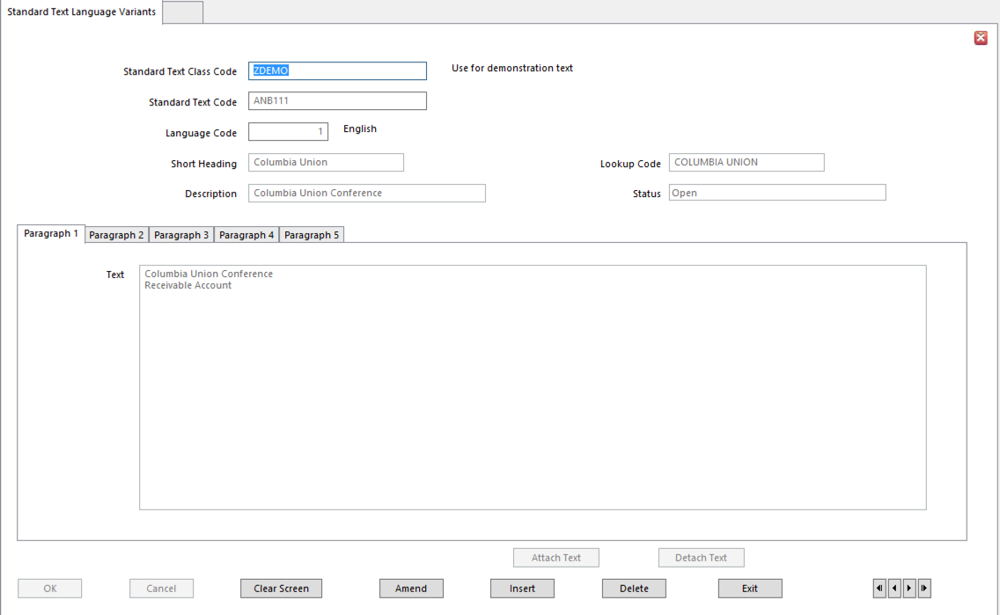
- Standard Text Class Code Attach Class Code for this type of Standard Text
- Standard Text Code Code for specific instance of text
- Language Code
- Short Heading
- Lookup Code
- Description
- Status
- Paragraph 1-5 Enter text to be displayed in each paragraph

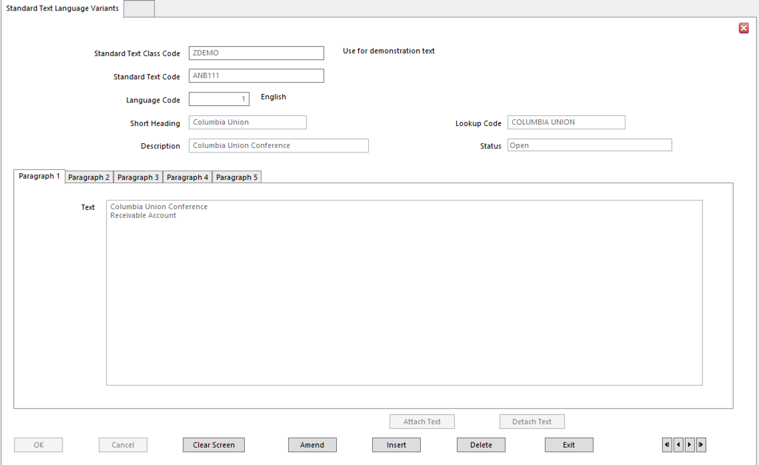
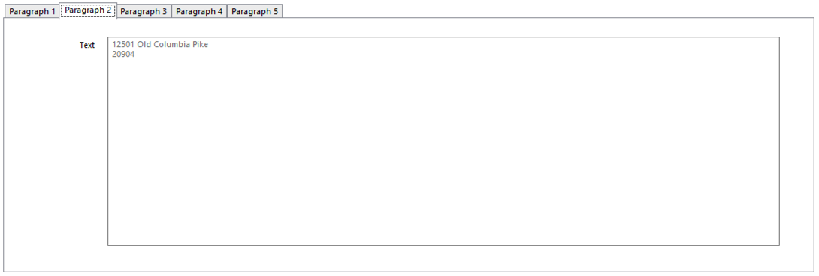
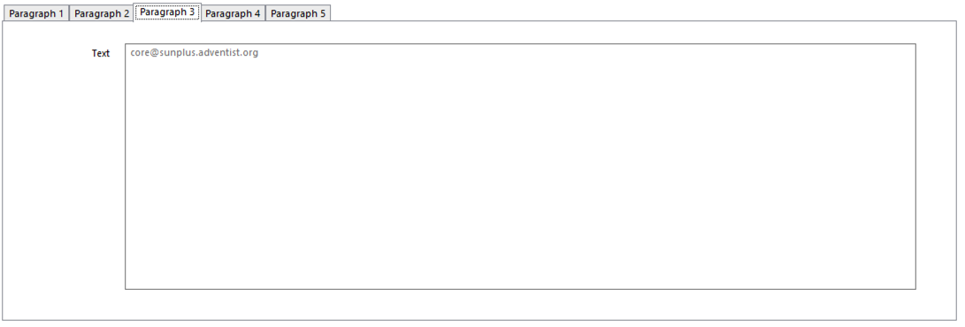
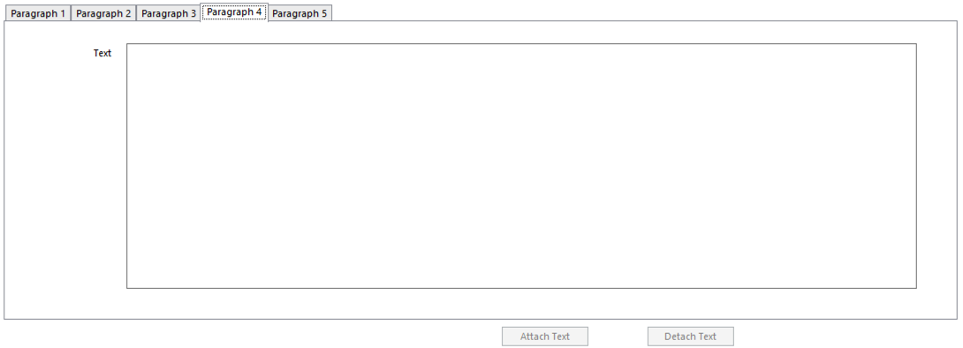
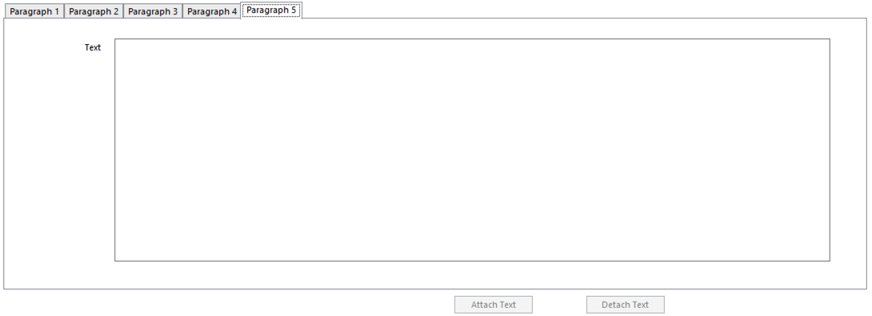
- For an idea of how Standard Text Can be Used, please refer to Mack Tennyson’s Notes on Analysis – Standard Text video and/or the related transcript.

