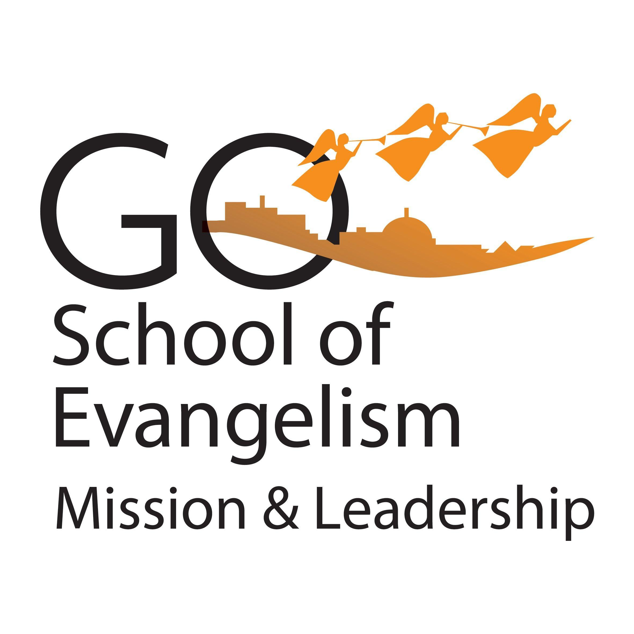

THE SOUTH ENGLAND CONFERENCE

‘Go…. SEC’
SCHOOL of EVANGELISM, MISSIONS & LEADERSHIP
_________________________________________________________________________________________________________________________
COURSE APPLICATION FORM

SEPTEMBER 2026 to JUNE 2027

Method/Location: Hybrid (H)/ In House (IH)/ Virtual (VM)

Please select course: Individual course fee £50

[ ] Lay Preaching (VM) [ ] Lay Bible Worker/Instruction (VM)

[ ] Christian Theology: Reaching Secular Minds (VM [ ] Chaplaincy (H)

[ ] Ellen G White Writings and Her Critics (VM [ ] *Counselling – Level 2 (VM)

[ ] Leadership Transformation for Mission (VM) [ ] *Counselling – Level 3 (VM)

[ ] Conflict Resolution (VM) [ ] *Counselling – Level 4 Diploma (VM)

* Accredited course (Christian Counselling) – offered at different price: https://www.ccscounselling.org.uk/trainings

Name: Pastor/Mr/Mrs/Miss/Ms:

Church:

Home Address: Post Code:

Telephone: Mobile:

E-mail:

Signature: Signature of Pastor:

Please return your application: pmle@secadventist.org.uk [ ] Payment Via Bank Transfer

Account Name: South England Conference of Seventh Day Adventists/ Account No: 41144103/ Sort Code: 40-45-28
(Reference Code: SoEML2627) (credit/debit card payment via phone)

Mailing Address: Personal Ministries Department, South England Conference, 25 St John’s Road, Watford, Herts. WD17 1PZ

Contact: Pr Kwadwo Kwarteng-Ampofo/SoEML Director Mavis Bramble/Secretary/01923 232728
pmle@secadventist.org.uk mbramble@secadventist.org.uk

